Acaricides in Agriculture: Balancing Livestock Health and Environmental Well-being in Tans- Nzoia County, Kenya.

Douglas Bukhebi Sifuna¹*; Anthony Pembere¹; Silas Lagat¹, Godfrey Barasa¹; Timothy Manda¹, Emily Ngeno²; Patrick Ssebugere³; Christine Betty Nagawa⁴; Christine Kyarimpa⁵ and Solomon Omwoma¹

¹Department of Physical Sciences, Jaramogi Oginga Odinga University of Science and Technology, Bondo (Main) Campus, P.O. Box 210 - 40601 Bondo – Kenya.
²Department of Physical Sciences, Kaimosi Friends University, P.O BOX 385 – 50309, Kaimosi- Kenya
³Department of Chemistry, Makerere University, P.O Box 7260 Kampala – Uganda
⁴Department of Forestry, Bio-Diversity and Tourism, Makerere University, P.O Box 7260 Kampala – Uganda
⁵Department of Chemistry, Kyambogo University, P.O Box 1, Kyambogo- Uganda

*Corresponding: dougy302@gmail.com
Supporting Information

Table S1: Descriptive characteristics of livestock farmers in Trans- Nzoia County, Kenya.
Variables | n | %
Sex
Male | 66 | 66
Female | 34 | 34
Age group
20 – 39 | 24 | 24
40 – 59 | 56 | 56
60 and above | 20 | 20
Educational level
Illiterate | 6 | 6
Primary school | 38 | 38
Secondary school | 32 | 32
Tertiary | 24 | 24
Farming experience(years)
0 – 9 | 42 | 42
10 – 19 | 24 | 24
20 and over | 34 | 34
Total | 100 | 100

Table S2: Descriptive characteristics of agrovet attendants, Trans- Nzoia County, Kenya.
Variables | N | %
Sex
Male | 26 | 57.78
Female | 19 | 42.22
Age group
20 - 39 | 34 | 75.56
40 - 59 | 10 | 22.22
60 and above | 1 | 2.22
Educational level
Primary school | 1 | 2.22
Secondary school | 18 | 40
Tertiary | 26 | 57.78
Selling experience(years)
0-9 | 37 | 82.22
10 - 19 | 8 | 17.78
20 and over | 0 | 0
Total | 45 | 100.00

Table S3: Acaricide availability and preference ranking to be bought and used by farmers
Brand name | Active ingredient | Order of priority to be bought by farmers(n) |  |  |  | Order of priority to be used by farmers(n) |  |  |  |  | Overall score
 |  | 4 | 3 | 2 | 1 | 4 | 3 | 2 | 1
Actraz | Amitraz |  |  |  |  |  |  |  |  |  | 0
Bayticol | Flumethrin |  |  |  |  |  |  |  |  |  | 0
Cyperdip | Cypermethrin + Chlorpyrifos |  |  | (1) |  | (1) |  |  |  |  | 6
Cypertix | Cypermethrin |  | (2) |  |  | (1) |  |  |  |  | 10
Dabotik | Chlorpyrifos + Cypermethrin |  | (6) | (3) |  |  |  |  |  |  | 24
Delete | Deltamethrin |  | (2) |  |  | (2) | (1) |  |  |  | 17
Duodip | Chlorpyrifos + Cypermethrin | (39) | (3) |  |  | (57) | (10) |  |  |  | 423
Ectomin | Cypermethrin |  |  |  | (1) | (4) | (2) |  |  |  | 23
Eprinex | Epriomectin |  |  |  |  |  |  |  |  |  | 0
Farmtraz | Amitraz |  |  |  |  |  |  |  |  |  | 0
Grenade | Cyhalothrin |  | (6) | (4) |  | (3) | (4) | (1) |  |  | 52
Mostraz | Amitraz |  |  |  |  |  |  |  |  |  | 0
Norotraz | Amitraz |  | (3) | (4) | (1) | (5) | (2) | (2) |  |  | 48
Steladone | Chlorfenvinphos | (1) | (10) | (5) |  | (1) | (5) | (1) |  |  | 65
Taktik | Amitraz |  |  |  | (1) | (2) | (1) | (1) |  |  | 14
Tickstop | Chlorpyrifos + Cypermethrin
Tikdip | Amitraz |  | (1) | (1) |  | (2) |  |  |  |  | 13
Tixfix | Fluazuron |  |  | (1) |  | (2) |  |  |  |  | 10
Triatix | Amitraz | (5) | (9) | (12) |  | (8) | (22) | (1) | (1) |  | 172
Twigatraz | Amitraz |  |  | (1) |  |  | (1) |  |  |  | 5
Ultradip | Chlorhexidine acetate |  |  | (1) |  |  |  |  |  |  | 2
Vectoclor | Cypermethrin +Chlorpyrifos +Piperonyl butoxide +  Citronella | (1) | (1) |  |  | (2) | (1) |  |  |  | 15
Unknown |  |  |  |  |  |  |  |  |  | (10)
Key: 4 represents 1st priority, 3 represents 2nd priority, 2 represents 3rd priority, 1 represents 4th priority, 0 represents not preferred; (n) = number of observations from respondents

Table S4: Knowledge and preventive measures taken by agrovet dealers when handling acaricides
 | Yes |  | No
Variable | n | % | n | %
Knowledge of active ingredients in acaricides | 29 | 64.44 | 16 | 35.56
Training on handling acaricides | 30 | 66.67 | 15 | 33.33
Disposal of broken/ damaged acaricides
Dust bin | 18 | 40 | 27 | 60
Pit latrine | 27 | 60 | 18 | 40
Use of personal protective equipment
Gloves | 15 | 33.33 | 30 | 66.67
Overalls | 23 | 51.11 | 22 | 48.89
Safety glasses/goggles | 0 | 0 | 45 | 100
Mask | 19 | 42.22 | 26 | 57.78
Selling of personal protective equipment | 14 | 31.11 | 31 | 68.89

Table S5: Knowledge and preventive measures taken by farmers when handling acaricides
 | Yes |  | No
Variable | n | % | n | %
Training on handling acaricides | 10 | 10 | 90 | 90
Disposal of used acaricides containers
Dust bin | 4 | 4 | 96 | 96
Pit latrine | 90 | 90 | 10 | 10
Burning | 6 | 6 | 94 | 94
Use of personal protective equipment
Gloves | 8 | 8 | 92 | 92
Overalls | 48 | 48 | 52 | 52
Safety glasses /goggles | 2 | 2 | 98 | 98
Mask | 28 | 28 | 72 | 72

Table S6: Application, storage and disposal of acaricide by farmers
Variable | n | %
Livestock breeds
Hybrid | 98 | 98
Native | 2 | 2
Mode of application
Spray race | 3 | 3
Hand spray | 97 | 97
Spraying site location
Permanent | 81 | 81
Temporary | 19 | 19
Frequency of application
Weekly | 74 | 74
Fortnightly | 23 | 23
Once per month | 3 | 3
Accessibility to spraying site by other animals
Accessible | 85 | 85
Not accessible | 15 | 15
Storage of acaricides
House | 60 | 60
Store | 29 | 29
No storage | 11 | 11

Consent form
Introduction
My name is Douglas Sifuna, a PhD student at Jaramogi Oginga Odinga University of Science and Technology doing research on ‘Assessment of Acaricide Residues in Trans Nzoia County and Mechanism of their Adsorption by Zeolites’. I kindly ask you to participate in this study by answering some questions related to your field of work.

About the study
The aim of this study is to determine the type of acaricide(s) that is predominantly used in the management of ticks through cattle homemade spraying and the frequency of application.

Procedures and duration
If you decide to participate, you will be required to fill the attached questions that may take approximately 5 minutes of your time. The answers are voluntary and you may choose to move to the next question without answering the previous question.
Benefits and/or compensation
There are no direct benefits from the research. The results from this study will help the policy makers to come up with policies that will help farmers use acaricides sustainably. The information gathered will be used to make recommendation for intervention measures on the residue levels of acaricides in Trans- Nzoia ecosystem.
Confidentiality
The information you give will be treated with outmost confidentiality and no information will be linked to their source by name or thereby implied unless express permission is sought from the owner (you).
Voluntary participation
Participation in this study is voluntary. If participants decide not to participate in this study, their decision will not affect their future relationship with the researcher or the University. If they choose to participate, they are free to withdraw their consent and to discontinue participation without penalty.
Offer to answer questions
Before you sign this form, please ask any questions on any aspect of this study that is not clear to you. You may take as much time as possible to think it over.
Authorization
If you have decided to participate in this study, please sign this form in the space provided below as an indication that you have read and understood the information provided above and have agreed to participate.
………………………………………………………… ………………………………..
Name of Research Participant Date
………………………………
Signature of Research Participant

If you have any complaints/questions concerning this study including questions about the research, your rights as a research participant, or if you feel that you have been treated unfairly and would like to talk to someone other than the researcher, please feel free to contact Jaramogi Oginga Odinga University of Science and Technology Research Ethics Committee ………………………………………………………………………………………………

Name of Researcher …………………………………………………………….

Questionnaire for Agro- Chemical shops
- Kindly provide the following information
Age
…………………………………………………………………………………………….
Sex
………………………………………………………………………………………………
Level of Education
………………………………………………………………………………………………
Shop location
…………………………………………………………………………………………….
- Are you the shop owner or employee?
……………………………………………………………………………………………
- How long have you operated this shop?
……………………………………………………………………………………………..
- Which acaricide are available for sale?
………………………………………………………………………………………………………………………………………………………………………………………………
- Where do you buy the acaricides from?
……………………………………………………………………………………………..

- Which is the preferred acaricide bought by farmers? Fill in the table below.
No. | Acaricide name | Quantity sold in 1 month | Consumer cost | Comment
1.
2.
3.
4.
5.
6.

- Are you conversant with the active ingredients (AI) in the acaricides?
………………………………………………………………………………………………
- What information do farmers seek when buying acaricides?
………………………………………………………………………………………………………………………………………………………………………………………………

- What advice do you give farmers buying acaricides?
………………………………………………………………………………………………………………………………………………………………………………………………
- Do you suffer from any kind of poisoning when handling acaricides?
………………………………………………………………………………………………………………………………………………………………………………………………
- What protective measures do you take to protect yourself from poisoning?
………………………………………………………………………………………………………………………………………………………………………………………………
- Where do you dispose damaged or expired acaricides?
………………………………………………………………………………………………………………………………………………………………………………………………
- What advice do you give farmers on disposal of used packaging containers/damaged/expired acaricides?
………………………………………………………………………………………………………………………………………………………………………………………………
- Have you had any training on handling acaricides?
………………………………………………………………………………………………………………………………………………………………………………………………
- Do you sell Personal Protective Equipment (PPE)? If yes, which ones.
………………………………………………………………………………………………………………………………………………………………………………………………
- What is your opinion about government policy on handling of these chemicals?
………………………………………………………………………………………………………………………………………………………………………………………………………………………………………………………………………………………………

Questionnaire for livestock farmers

- Kindly provide the following information
Age
…………………………………………….
Sex
………………………………………………..
Level of Education
………………………………………………………………………………………………
- For how long have you been practicing livestock farming?
………………………………………………………………………………………………
- What is the number of livestock you keep?
……………………………………………………………………………………………
- What kind of livestock do you keep? (native/hybrid).
………………………………………………………………………………………………………………………………………………………………………………………………
- Which livestock diseases do your livestock get infected with?
………………………………………………………………………………………………………………………………………………………………………………………………
- What is the frequency of application of acaricides on your farm (per week/per month)?
………………………………………………………………………………………………………………………………………………………………………………………………
- Who sprays your livestock? (Do you spray yourself or you hire)
………………………………………………………………………………………………
- If you hire, how long have you used the same spraying person?
……………………………………………………………………………………………
- If you hire a sprayer, does he use protective clothing?
………………………………………………………………………………………………
- What kind of protective clothing does the sprayer or you use?
………………………………………………………………………………………………………………………………………………………………………………………………
- Do you use gas masks when spraying of handling acaricides?
………………………………………………………………………………………………
- Have you had any training on handling acaricides?
……………………………………………………………………………………………..

- Do you have a specific spraying site?
………………………………………………………………………………………………
- Is the spraying site protected from access by other animals?
………………………………………………………………………………………………
- Where do you buy your acaricides?
………………………………………………………………………………………………

- Which acaricide do prefer using on your livestock?
………………………………………………………………………………………………………………………………………………………………………………………………
- Where do you dispose used acaricides containers?
………………………………………………………………………………………………………………………………………………………………………………………………
- Where do you store remaining acaricides?
………………………………………………………………………………………………………………………………………………………………………………………………………………………………………………………………………………………………

Table S7: Description of shops and farm locations sampled
Shops
Latitude (N) | Longitude (E) | Shop description
1.0190281 | 35.0018557 | well stocked shop
1.0166802 | 35.0020407 | well stocked shop
1.0170767 | 35.0013487 | well stocked shop
1.0169104 | 35.0012369 | well stocked shop
1.0175988 | 35.0018601 | well stocked shop
1.0154424 | 35.0024316 | well stocked shop
1.0164399 | 35.001295 | well stocked shop
1.0139995 | 35.0033612 | well stocked shop
1.0140082 | 35.0029124 | well stocked shop
1.0142777 | 35.0026853 | well stocked shop
1.0140129 | 35.0028841 | well stocked shop
0.8916977 | 34.9236124 | well stocked shop
0.8931638 | 34.9243017 | well stocked shop
0.8947779 | 34.9240134 | well stocked shop
0.8892082 | 34.9267141 | well stocked shop
0.8894613 | 34.9260249 | well stocked shop
0.8897805 | 34.9262625 | well stocked shop
1.2522156 | 34.9201659 | well stocked shop
1.1605605 | 34.9680595 | well stocked shop
1.1386914 | 34.9759817 | well stocked shop
1.1206524 | 35.0117946 | well stocked shop
1.1191752 | 35.0114503 | well stocked shop
0.9852178 | 35.2236043 | well stocked shop
0.9837788 | 35.220857 | well stocked shop
0.9818478 | 35.220641 | well stocked shop
0.9867627 | 35.2225741 | well stocked shop
1.078959 | 34.8575417 | well stocked shop
1.0734598 | 34.8646583 | less stocked shop
0.9747281 | 34.8474125 | well stocked shop
0.9837973 | 34.8515518 | well stocked shop
0.9867674 | 34.850517 | well stocked shop
0.9867627 | 34.8505217 | well stocked shop
0.9837973 | 34.8515518 | well stocked shop
0.9988499 | 34.9112044 | well stocked shop
0.9974636 | 34.9036209 | well stocked shop
1.2107812 | 34.9039656 | less stocked shop
1.2147812 | 34.9029656 | well stocked shop
1.000098 | 35.0510336 | well stocked shop
1.0278503 | 35.1208801 | well stocked shop
1.0246678 | 35.1325507 | less stocked shop
1.0285552 | 35.1205347 | well stocked shop
0.9745564 | 35.1304879 | well stocked shop
0.8796055 | 34.8957084 | well stocked shop
0.9745584 | 35.1304779 | well stocked shop
0.9865783 | 35.0918423 | well stocked shop

Farmers
Latitudes(N) | Longitudes(E) | Farm description
1.0985451 | 34.8370634 | Large scale farm
0.8805961 | 34.9284372 | Large scale farm
0.8691999 | 34.9615145 | Large scale farm
0.8898301 | 34.9146513 | Large scale farm
0.9689021 | 35.0482806 | Small scale farm
0.9664891 | 35.044495 | Small scale farm
1.216273 | 34.9349848 | Small scale farm
1.1625751 | 34.9659927 | Small scale farm
1.1251364 | 34.8467226 | Small scale farm
1.15916 | 34.9625479 | Small scale farm
1.216273 | 34.9349848 | Small scale farm
1.1260393 | 35.0152373 | Small scale farm
1.0886501 | 35.0049087 | Small scale farm
1.093224 | 35.013516 | Large scale farm
1.0433733 | 34.9969892 | Large scale farm
1.2132099 | 34.9074127 | Large scale farm
1.1613955 | 34.9094809 | Large scale farm
1.1625751 | 34.9659927 | Large scale farm
1.216273 | 34.9349848 | Large scale farm
1.1534649 | 34.945322 | Small scale farm
1.1623717 | 34.9628924 | Small scale farm
1.0909566 | 34.8498377 | Small scale farm
1.0909564 | 34.8398272 | Small scale farm
1.0877469 | 34.8494822 | Small scale farm
1.0740434 | 34.8767283 | Small scale farm
1.0902147 | 34.8498272 | Small scale farm
1.086987 | 34.850862 | Small scale farm
1.0908595 | 34.8198121 | Small scale farm
1.1154897 | 34.8463777 | Small scale farm
1.0877469 | 34.8494822 | Small scale farm
0.9908268 | 35.2466096 | Small scale farm
1.0220547 | 35.2424897 | Small scale farm
1.024137 | 35.2624006 | Small scale farm
1.0961904 | 34.8467226 | Small scale farm
1.1024982 | 34.8374084 | Small scale farm
1.1032079 | 34.8398233 | Small scale farm
1.0956545 | 34.8498272 | Small scale farm
1.1048495 | 34.8280932 | Small scale farm
1.1053258 | 34.8294733 | Small scale farm
1.1048495 | 34.8280932 | Small scale farm
1.0914372 | 34.850862 | Small scale farm
1.1534455 | 34.9467002 | Large scale farm
1.0895635 | 34.8242978 | Large scale farm
1.1064221 | 34.8215374 | Large scale farm
1.1048495 | 34.8280932 | Small scale farm
1.1045373 | 34.8329234 | Small scale farm
1.0908495 | 34.8198121 | Small scale farm
1.0809093 | 34.89994841 | Small scale farm
1.1163162 | 34.8401683 | Small scale farm
1.0908595 | 34.8198121 | Small scale farm
0.9214614 | 34.8767283 | Small scale farm
0.9520507 | 34.8912099 | Small scale farm
0.9347812 | 34.8518968 | Large scale farm
1.0000386 | 34.9349848 | Large scale farm
1.0080104 | 34.9278478 | Large scale farm
1.1387266 | 34.955658 | Large scale farm
1.1623717 | 34.9628924 | Large scale farm
1.1392211 | 34.955658 | Small scale farm
1.1625751 | 34.9659927 | Large scale farm
1.1623717 | 34.9628924 | Large scale farm
1.1367758 | 34.971504 | Small scale farm
1.2107812 | 34.9039656 | Large scale farm
1.1983871 | 34.9208552 | Large scale farm
1.1623717 | 34.9628924 | Small scale farm
1.123786 | 34.8318884 | Large scale farm
1.2142476 | 34.9043103 | Large scale farm
1.1256008 | 34.8308533 | Small scale farm
1.1392211 | 34.955658 | Small scale farm
1.1370995 | 34.9659927 | Small scale farm
1.1370885 | 34.9657727 | Small scale farm
1.1269965 | 34.8374084 | Small scale farm
1 | 34.9039656 | Small scale farm
1.2003474 | 34.8884517 | Small scale farm
1.2052508 | 34.9091362 | Small scale farm
1.216044 | 34.9463557 | Small scale farm
1.0151548 | 35.0472482 | Small scale farm
0.9835683 | 35.0348583 | Small scale farm
0.9890376 | 35.0300396 | Small scale farm
0.9912721 | 35.0486247 | Large scale farm
0.987542 | 35.0524035 | Large scale farm
1.000098 | 35.0510336 | Large scale farm
0.9887877 | 35.0506895 | Large scale farm
1.000998 | 35.0510338 | Large scale farm
0.9897196 | 35.1359885 | Small scale farm
0.969043 | 35.0985089 | Small scale farm
0.96677379 | 34.9370523 | Small scale farm
1.0043719 | 34.9432547 | Small scale farm
0.979081 | 34.930523 | Small scale farm
0.9827988 | 34.9349848 | Small scale farm
1.0051996 | 34.9360186 | Small scale farm
1.0051996 | 34.9360186 | Small scale farm
1.0041888 | 34.9380891 | Small scale farm
1.0041888 | 34.9380661 | Small scale farm
1.0043719 | 34.9432547 | Small scale farm
1.0041866 | 34.9380877 | Small scale farm
1.0043819 | 34.9433543 | Large scale farm
1.0051996 | 34.9360186 | Large scale farm
1.0045917 | 34.9432574 | Large scale farm
1.0053619 | 34.9532547 | Large scale farm
1.0041888 | 34.9380861 | Large scale farm

Table S8 : Assorted photographs from the study area.
Drainage of acaricide residues into a farm. | 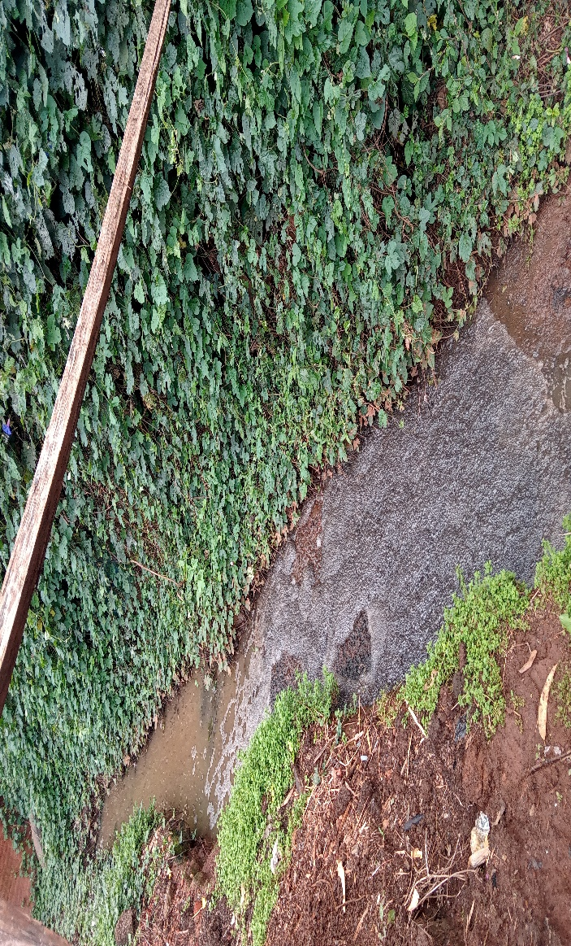
Acaricide mixing tanks, open to insects and other animals | 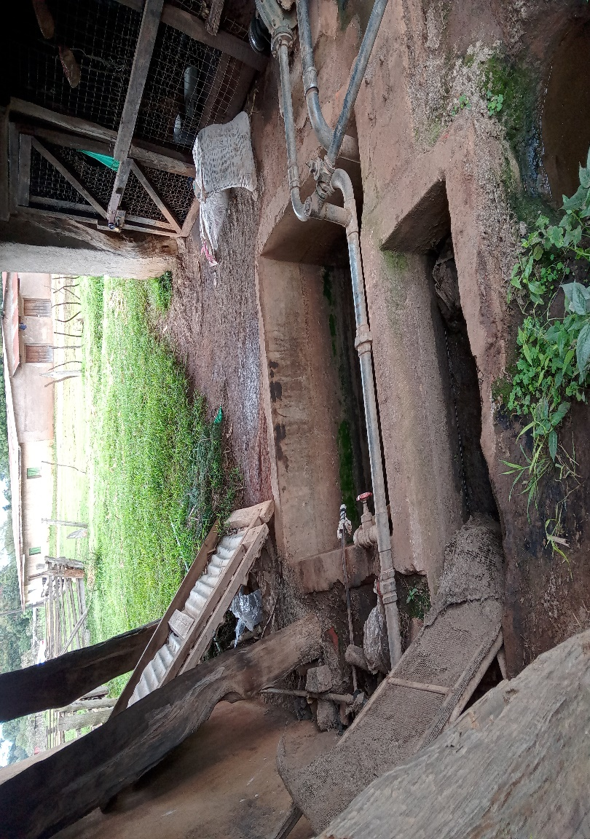
An acaricide spraying area, close to where the livestock feed from | 