Supplementary figure AUC:

Sup. figure 1a: ROC Curve for 10 days mortality
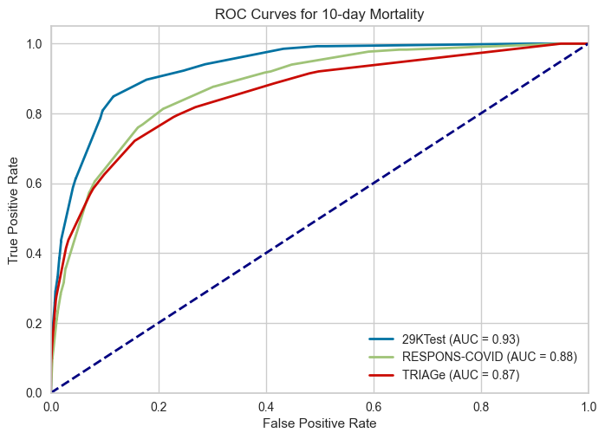

Sup. figure 2a: ROC Curve for 30 days mortality

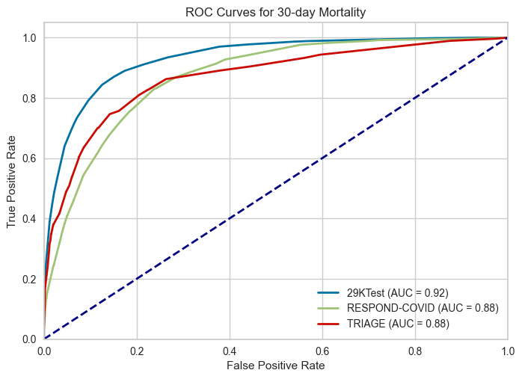

Sup. figure 3a: ROC Curve for 90 days mortality
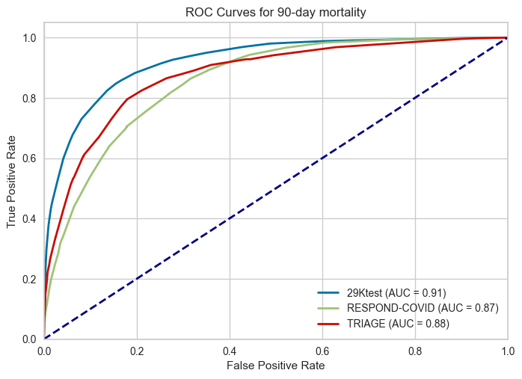

Sup. figure 4a: ROC Curve for 365 days mortality
