A confirmatory factor analysis was conducted using the maximum likelihood estimation procedure and oblimin rotation method, assuming three factors. The Kaiser-Meyer-Olkin sampling adequacy was 0.60, sphericity was significant (p<.001), and the goodness-of-fit statistic was significant (𝜒²₍₅₅₈₎=728.54, p<.0001). A three-factor structure was confirmed (see Scree Plot) that explained 25.4% of the total variance. The three factors were Factor 1, Displays of negative affect (13 items, 8.0% of total variance, Cronbach α=.825), which included items from the Negative Emotionality and Surgency dimensions, describing behaviors of frustration with limitations and distress either internally generated (e.g., “When the baby wanted something, how often did s/he become upset when s/he could not get what s/he wanted?”) or in response to stimuli (e.g., “In the last week, while being fed in your lap, how often did the baby seem eager to get away as soon as the feeding was over?”). Factor 2, Displays of positive affect (19 items, 10.9% of total variance, Cronbach α=.729), also included items from the Surgency dimension and the Regulatory Capacity dimension. The items described high-intensity pleasure and approach behaviors (e.g., “How often during the week did your baby move quickly toward new objects?”; “When put into the bath water, how often did the baby laugh?”). Factor 3, Displays of fear of strangers (3 items, 6.5% of total variance, Cronbach α=.563) included items describing fear of strangers (e.g., “When introduced to an unfamiliar adult, how often did the baby refuse to go to the unfamiliar person?”).

Table 1: Exploratory Factor Analysis on the IBQ
Item | F1 | F2 | F3
1. When being dressed or undressed during the last week, how often did the baby squirm and/or try to roll away? [S] | 0.322
3. When tired, how often did your baby show distress? [NE] | 0.496
9. When it was time for bed or a nap and your baby did not want to go, how often did s/he whimper or sob? [NE] | 0.348
10. After sleeping, how often did the baby cry if someone doesn’t come within a few minutes? [NE] | 0.434
11R. In the last week, while being fed in your lap, how often did the baby seem eager to get away as soon as the feeding was over? [S] | 0.426
13. When placed on his/her back, how often did the baby squirm and/or turn body? [S] | 0.266
16. How often did the baby seem angry (crying and fussing) when you left her/him in the crib? [NE] | 0.484
17. How often during the last week did the baby startle at a sudden change in body position (e.g., when moved suddenly)? [NE] | 0.309
22. At the end of an exciting day, how often did your baby become tearful? [NE] | 0.592
23. How often during the last week did the baby protest being placed in a confining place (infant seat, play pen, car seat, etc.)? [NE] | 0.776
29. When you were busy with another activity, and your baby was not able to get your attention, how often did s/he cry? [NE] | 0.62
32. When the baby wanted something, how often did s/he become upset when s/he could not get what s/he wanted? [NE] | 0.509
37. When placed in an infant seat or car seat, how often did the baby squirm and turn body? [S] | 0.54
2. When tossed around playfully how often did the baby laugh? [S] |  | 0.38
5. How often during the last week did the baby enjoy being read to? [RC] |  | 0.322
6. How often during the last week did the baby play with one toy or object for 5-10 minutes? [RC] |  | 0.439
7. How often during the week did your baby move quickly toward new objects? [S] |  | 0.305
8. When put into the bath water, how often did the baby laugh? [S] |  | 0.332
12. When singing or talking to your baby, how often did s/he soothe immediately? [RC] | -0.253 | 0.341
14. During a peekaboo game, how often did the baby laugh? [S] |  | 0.256
15. How often does the infant look up from playing when the telephone rings? [S] |  | 0.346
18. How often during the last week did the baby enjoy hearing the sound of words, as in nursery rhymes? [RC] |  | 0.538
19. How often during the last week did the baby look at pictures in books and/or magazines for 5 minutes or longer at a time? [RC] |  | 0.505
20. When visiting a new place, how often did your baby get excited about exploring new surroundings? [S] |  | 0.453
21. How often during the last week did the baby smile or laugh when given a toy? [S] |  | 0.715
24. When being held, in the last week, did your baby seem to enjoy him/herself? [RC] |  | 0.308
25. When showing the baby something to look at, how often did s/he soothe immediately? [RC] |  | 0.688
30. How often during the last week did the baby enjoy gentle rhythmic activities, such as rocking or swaying? [RC] |  | 0.478
31. How often during the last week did the baby stare at a mobile, crib bumper or picture for 5 minutes or longer? [RC] |  | 0.494
34. When rocked or hugged, in the last week, did your baby seem to enjoy him/herself? [RC] |  | 0.687
35. When patting or gently rubbing some part of the baby’s body, how often did s/he soothe immediately? [RC] |  | 0.507
36. How often did your baby make talking sounds when riding in a car? [S] |  | 0.411
4. When introduced to an unfamiliar adult, how often did the baby cling to a parent? [NE] |  |  | 0.492
28. When introduced to an unfamiliar adult, how often did the baby refuse to go to the unfamiliar person? [NE] |  |  | 0.918
33. When in the presence of several unfamiliar adults, how often did the baby cling to a parent? [NE] |  |  | 0.731
 | R | R | R
Correlation with Surgency | .400** | .438** | .237*
Correlation with Negative Emotionality | .846** | .082 | .635**
Correlation with Regulatory Capacity | -.078 | .929** | .118
Note: Items are numbered as they appear in original questionnaire. In square brackets is the dimension in the original scale, S=surgency, NE=negative emotionality, RC=regulatory capacity; **=significance below 0.01; *=significance below 0.05.

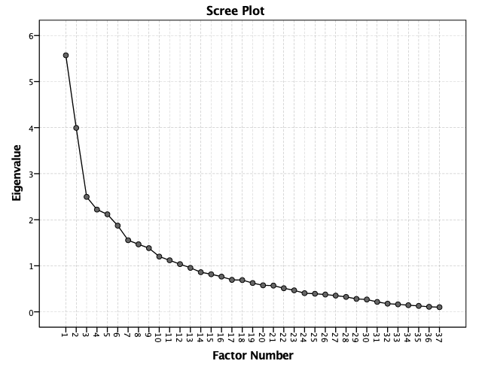
Table 2: Zero-order correlations

Note: EPDS=Edinburgh Postnatal Depression Scale; PSQI=Pittsburgh Sleep Quality Index; PBQ=Postpartum bonding questionnaire; ISQ = infant sleep questionnaire; TST=total sleep time; WASO=wake after sleep onset; # wake = number of awakenings; overall prob.= Overall sleep difficulty item; ISQ F1=nighttime problems; ISQ F2=bedtime resistance; IBQ F1/F2/F3=infant behaviors questionnaire, factors from factor analysis. *=p < .05, **=p < .01, ***= p < .001, in a square – correlations across time points.

