Extended Data Figures and Tables

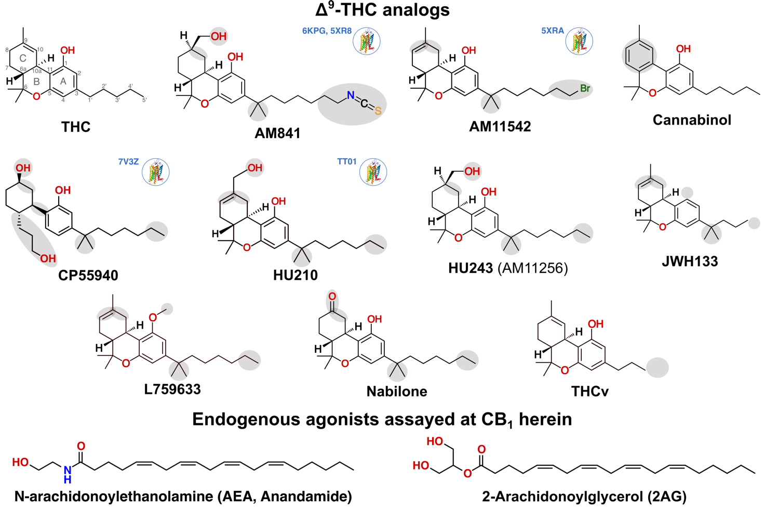

Extended Data Fig. 1 | Chemical structures of Δ⁹-THC analogs and additional agonists assayed at CB₁. A structure icon and PDB identifiers denote ligands with experimental structures.

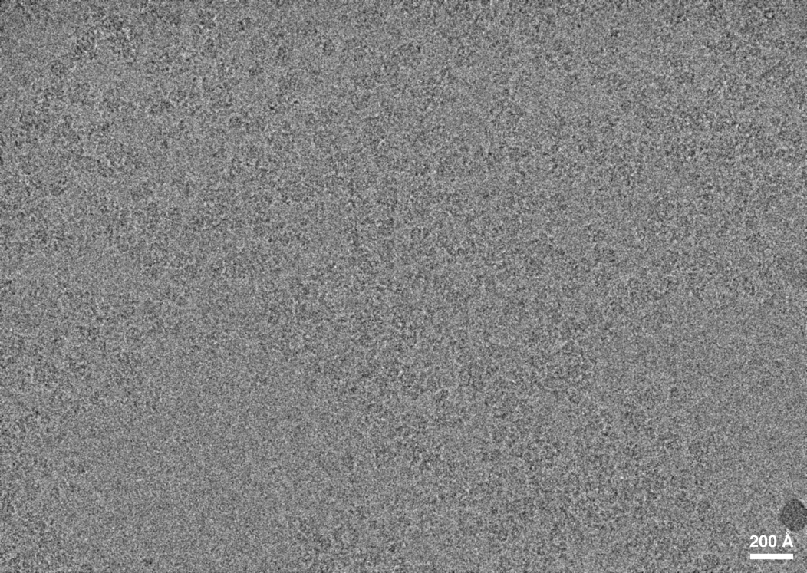

Extended Data Fig. 2 | Raw cryo-EM micrograph.

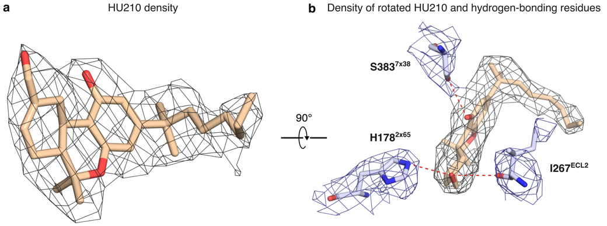

Extended Data Fig. 3 | Cryo-EM density for the ligand HU210 and hydrogen-bonding residues in the CB₁ receptor. a, Cryo-EM density (contoured at 0.6 σ) for HU210. b, Cryo-EM density (contoured at 0.6 σ) for HU210 and surrounding hydrogen-bonding CB1 residues.
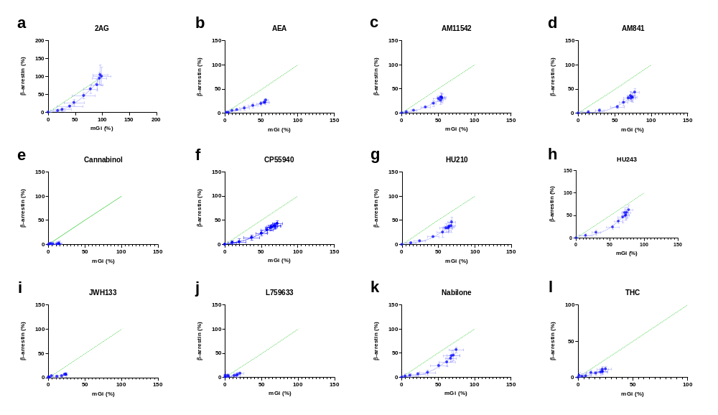
Extended Data Fig. 4 | Bias plots for Δ⁹-THC analogs and endogenous agonists. mG_{i} and β-arrestin recruitment at equimolar ligand concentrations expressed as percent of the maximal response elicited by the endogenous cannabinoid 2AG. The green dotted line depicts a (theoretical) pathway-balanced ligand. Data is shown as mean ± S.E.M. of at least three independent experiments and were fitted to a second-order polynomial.

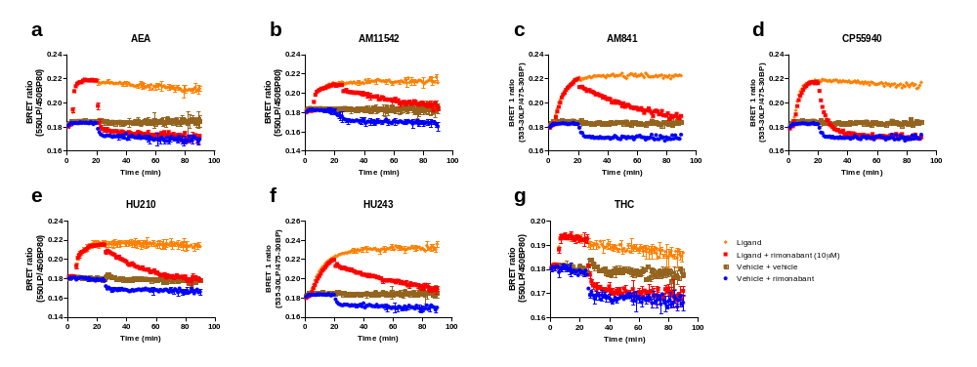
Extended Data Fig. 5 | Recruitment of mG_{i} by agonists and its reversal upon addition of the CB₁ specific antagonist rimonabant. HEK293-TR cells stably expressing CB1R-NlucC and NES-venus-mGsi, stimulated with an EC₈₀ concentration of the agonists AEA (a), AM11542 (b), AM841 (c), CP55940 (d), HU210 (e), HU243 (f), and THC (g). The change in basal BRET is plotted versus time, mG_{i} recruitment reversal was initiated by the addition of an excess concentration of the CB₁-specific antagonist rimonabant (10 μM). mG_{i} responses are shown as mean ± S.D. and are representative of at least three independent experiments performed in duplicate.
Extended Data Table 1 | Active state structures of CB₁ and the AM12033/CB₂ complex¹⁷. *Tanimoto coefficients.
PDB  ID | Ref | Res  (Å) | Method | Ligand | THC-  analog | *Ligand  similarity  to Δ⁹-THC | *Ligand  similarity  to HU210 | G  prot  -ein | Pref-  erred  chain | RMSD  to 9ERX (7TM, Å) | Receptor residues  (%) | Receptor backbones  (complete) | Receptor sidechains (complete) | Receptor  mutations
8GHV | ³⁸ | 2.8 | Cryo-EM | AMG315 | No | 0.11 | 0.12 | G_{i1} | D | 0.82 | 59 | 280 | 217 | -
6N4B | ³⁹ | 3.0 | Cryo-EM | MDMB-Fubinaca (FUB) | No | 0.33 | 0.34 | G_{i1} | R | 0.90 | 58 | 276 | 205 | -
9ERX | - | 2.9 | Cryo-EM | HU210 | Yes | 0.82 | 1.00 | G_{i1} | R | - | 62 | 294 | 294 | -
6KPG | ¹⁷ | 3.0 | Cryo-EM | AM841 | Yes | 0.77 | 0.82 | G_{i1} | R | 0.81 | 60 | 285 | 270 | E273^{5x37}  T283^{5x47}  R340^{6x32}
7WV9 | ¹⁹ | 3.4 | Cryo-EM | CP55940 + PAM | Yes | 0.46 | 0.49 | G_{i2} | R | 0.94 | 61 | 290 | 287 | -
5XRA | ¹⁶ | 2.8 | X-ray | AM11542 | Yes | 0.84 | 0.96 | - | A | 1.14 | 60 | 280 | 276 | T210^{3x46}  E273^{5x37}  T283^{5x47}  R340^{6x32}
5XR8 | ¹⁶ | 3.0 | X-ray | AM841 | Yes | 0.77 | 0.82 | - | A | 1.28 | 60 | 284 | 277 | T210^{3x46}  E273^{5x37}  T283^{5x47}  R340^{6x32}
7V3Z | ¹⁸ | 3.3 | X-ray | CP55940 | Yes | 0.46 | 0.49 | - | A | 1.18 | 60 | 284 | 277 | H154^{2x41}  T210^{3x46}  E273^{5x37}  T283^{5x47}  R340^{6x32}
6KPF | ¹⁷ | 2.9 | Cryo-EM | AM12033 | Yes | 0.77 | 0.83 | G_{i1} | R | 1.09 | 62 | 291 | 290 | -

Extended Data Table 2 | Cryo-EM data collection, refinement, and validation statistics.
(EMDB-19929)
(PDB 9ERX)
Data collection and processing
Magnification | 130,000
Voltage (kV) | 300
Electron exposure (e–/Å²) | 62
Defocus range (μm) | 600-1800
Pixel size (Å) | .6435
Symmetry imposed | none
Initial particle images (no.) | 603,000
Final particle images (no.) | 187,000
Map resolution (Å)  FSC threshold | 2.9  0.143
Map resolution range (Å) | 1.54-4.19
Refinement
Initial model used (PDB code) | 6KPG, 6CRK
Model resolution (Å)  FSC threshold | 3.0  0.143
Model resolution range (Å) | 1.29-4.38
Map sharpening B factor (Å²) | 0
Model composition  Non-hydrogen atoms  Protein residues  Ligands | 9021  1150  1
B factors (Å²)  Protein  Ligand | 55.3  45.2
R.m.s. deviations  Bond lengths (Å)  Bond angles (°) | 0.004  0.746
Validation  MolProbity score  Clashscore  Poor rotamers (%) | 1.6  5
Ramachandran plot  Favored (%)  Allowed (%)  Disallowed (%) | 95  5  0

Extended Data Table 3 | Pharmacological parameters of studied CB₁ agonists.
Ligand | mG_{i}  pEC₅₀ | SEM | mG_{i}  E_{max} | SEM | mG_{i}  slope | SEM | n | Arr  pEC₅₀ | SEM | Arr  E_{max} | SEM | Arr  slope | SEM | n
2AG | 6.00 | 0.22 | 100.0 | 4.9 | 0.59 | 0.04 | 6 | 5.28 | 0.18 | 100.0 | 15.4 | 0.63 | 0.03 | 6
AEA | 6.35 | 0.10 | 57.9 | 1.6 | 0.81 | 0.06 | 9 | 5.85 | 0.23 | 30.5 | 4.0 | 1.15 | 0.25 | 9
AM11542 | 8.47 | 0.07 | 54.6 | 1.9 | 1.09 | 0.06 | 6 | 8.16 | 0.07 | 31.7 | 3.5 | 1.13 | 0.15 | 6
AM841 | 8.47 | 0.06 | 61.1 | 2.4 | 1.16 | 0.06 | 6 | 8.08 | 0.11 | 39.3 | 3.4 | 0.80 | 0.07 | 5
Cannabinol | 6.89 | 0.07 | 15.0 | 1.4 | 1.37 | 0.22 | 6 |  |  | No response
CP55940 | 8.42 | 0.05 | 69.0 | 1.6 | 0.86 | 0.04 | 17 | 7.97 | 0.08 | 41.1 | 1.8 | 1.00 | 0.13 | 12
HU210 | 8.62 | 0.07 | 66.5 | 2.3 | 1.02 | 0.13 | 6 | 8.10 | 0.12 | 40.2 | 4.7 | 0.91 | 0.11 | 6
HU243 | 8.69 | 0.09 | 74.1 | 2.0 | 1.04 | 0.10 | 6 | 8.11 | 0.15 | 58.5 | 4.4 | 0.76 | 0.08 | 6
JWH133 | 5.94 | 0.10 | 23.7 | 1.5 | 1.40 | 0.23 | 5 | 6.05 | 0.42 | 9.1 | 3.1 | 4.95 | 4.38 | 3
L759633 | 6.38 | 0.26 | 21.5 | 4.4 | 0.89 | 0.24 | 3 |  |  | No fit
Nabilone | 7.86 | 0.11 | 75.8 | 3.9 | 0.78 | 0.04 | 6 | 7.11 | 0.16 | 58.8 | 4.8 | 0.96 | 0.34 | 4
THC | 8.29 | 0.10 | 24.0 | 1.4 | 0.93 | 0.11 | 12 | 7.90 | 0.24 | 14.1 | 2.9 | 0.63 | 0.15 | 6
THCv | 6.70 | 0.15 | -13.3 | 1.3 | 1.01 | 0.10 | 6 |  |  | No fit

Extended Data Table 4 | Slow or fast dissociation of Δ⁹-THC analogs and AEA to CB₁ in this study and in literature. Data from our study is from HEK293-TR cells stably expressing CB₁-NlucC and NES-venus-mG_{i}. mG_{i} responses are shown as mean ± S.E.M. from at least three independent experiments. The underlying graph, including controls, for each ligand is provided in Extended Data Figure 5.
Ligand | Published qualitative description | Our qualitative description | k_{off}  (min⁻¹) | Half-life (min)
Δ⁹-THC | - | ”Fast” (BRET) | 0.5718 ± 0.0560 | 1.2 ± 0.1
AEA | - | “Fast” (BRET) | 0.5976 ± 0.0231 | 1.2 ± 0.0
AM11245 | “Tight” (Washout)⁴⁴ | - | - | -
AM11542 | “Wash-resistant” (Radioligand binding assay)¹⁶ | “Very slow” (BRET) | 0.0115 ± 0.0003 | 60.6 ± 1.4
AM841 | “Wash-resistant” (Radioligand binding assay)¹⁶  “Tight” (Washout)⁴⁴  “Irreversible” (Washout)⁴¹  “Covalent” (Washout + mass spectrometry)⁴³ | “Very slow” (BRET) | 0.0140 ± 0.0002 | 49.6 ± 0.7
CP55940 | - | “Fast” (BRET) | 0.1681 ± 0.0041 | 4.1 ± 0.1
HU210 | “Pseudo-irreversible” (Drug discrimination, ED₅₀)⁴⁵ | “Very slow” (BRET) | 0.0224 ± 0.0002 | 31.0 ± 0.2
HU243 | “Incapable of irreversible association” (Washout)⁴¹ | “Very slow” (BRET) | 0.0123 ± 0.0002 | 56.5 ± 0.8

