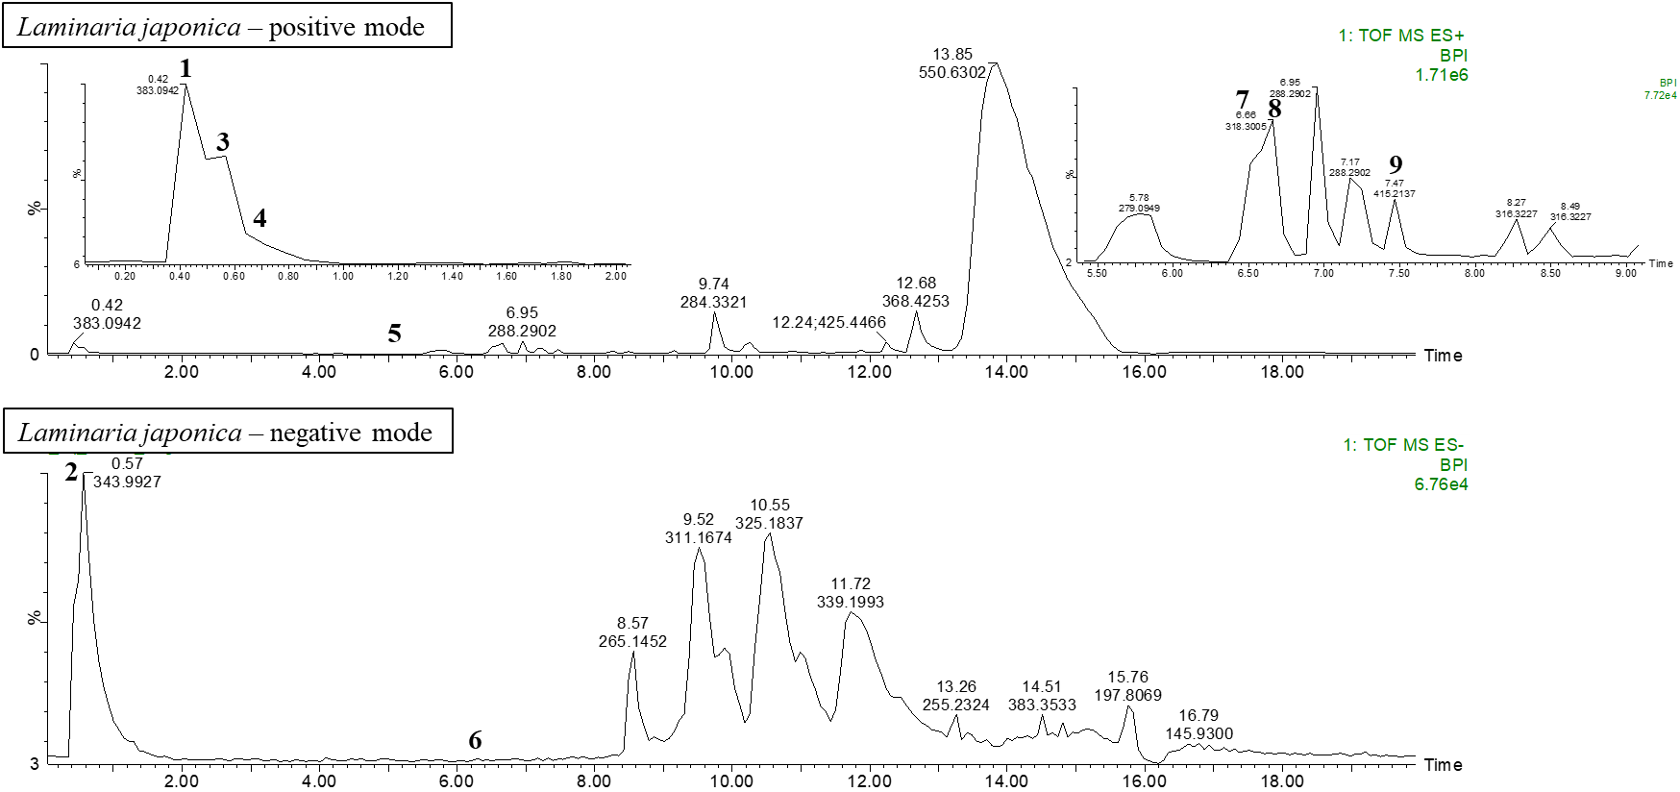
Fig S1. Chromatography of Laminaria japonica liquid extracts (LLE) with positive and negative mode.

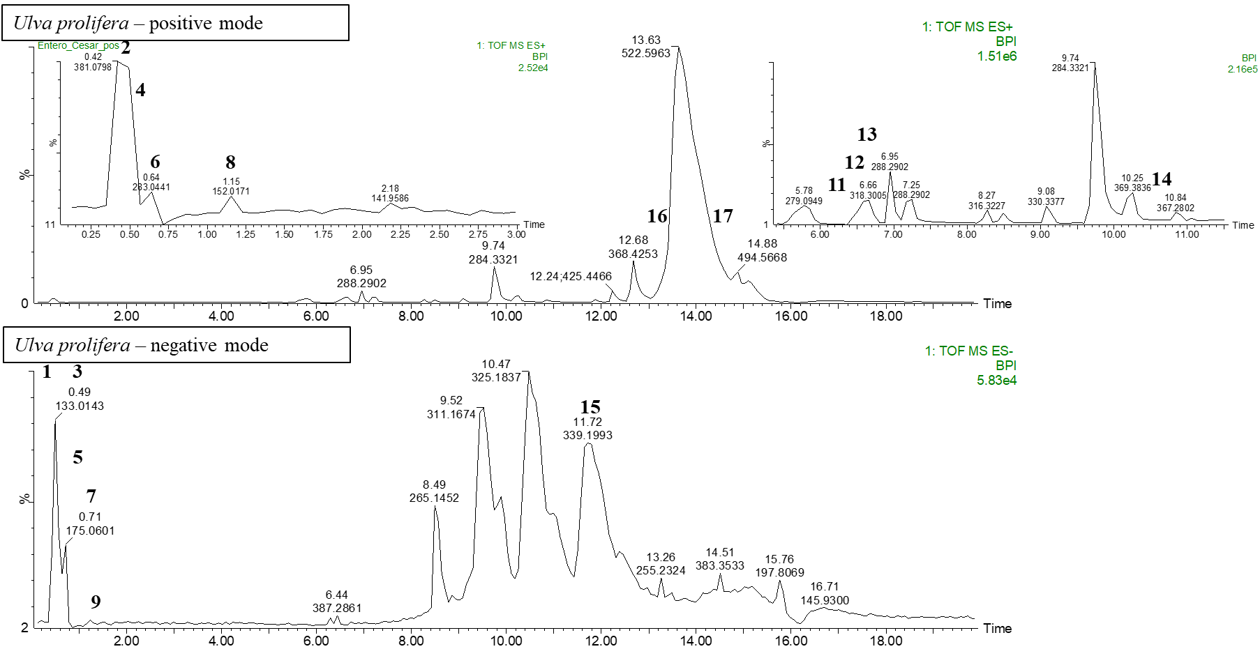
Fig S2. Chromatography of Ulva prolifera liquid extract (ULE) with positive and negative mode.

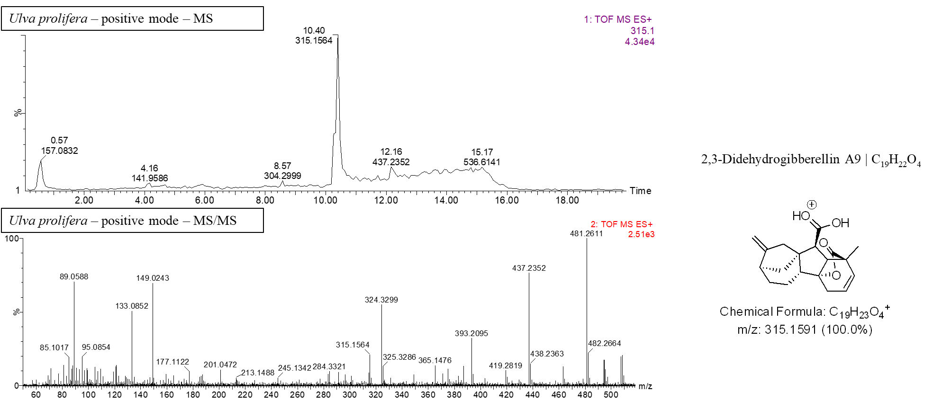
Fig. S3. Chromatography of Ulva prolifera liquid extract (ULE) indicating position and structural formula of 2,3 didehydro-Gibberellin A₉.

