Supplementary data
Description of Neorhizobium ytuae sp. nov., a non-symbiotic bacterium isolated from the deep-sea cold seep sediment of South China Sea

Binzhe Zhang¹, Dandan Zhou¹, Yulie Qiu, Xuepeng Li, Yan Gao²*, Jian Zhang¹*

¹School of Ocean, Yantai University, Yantai, China
²Yantai Marine Economic Research Institute, Yantai, China

*To whom correspondence should be addressed
Mailing address:

School of Ocean
Yantai University
30 Qingquan Road
Yantai 264005, China

Email: zhangjian@ytu.edu.cn

Ms. Yan Gao
Yantai Marine Economic Research Institute
32 Yinhai Road
Yantai 264000, China

Email: 455386466@qq.com

Table S1. Acid production substrates of the strain CSC1952^{T} and the reference strains.
Characteristic | 1 | 2 | 3
Mannitol, glycogen, 5-keto-gluconate, d-tagatose | - | + | -
d-arabinose, d-gentiobiose, 2-keto-gluconate, d-galactose | + | - | -
d-ribose, l-fucose, d-arabitol | + | - | +
Dulcitol, mannitol, N-acetyl- d-glucosamine, d-maltose, d-lactose, d-melibiose, D-trehalose, gluconate | - | + | +
d-cellobiose | + | + | -

Strains: 1, CSC1952^{T}; 2, 2, Neorhizobium petrolearium SL-1^{T}; 3, Rhizobium deserti SPY-1^{T}. +, positive; –, negative. Acid can be produced from l-arabinose, d-xylose, d-glucose, d-fructose, d-mannose, l-rhamnose，sorbitol，esculin ferric citrate, d-fucose, d-lyxose, and acid cannot be produced from erythritol, l-xylose, d-side-marigold alcohol, methyl-β-d-xylopyranoside, l-sorbose, inositol, methyl-α-d-mannopyranoside, methyl-α-d-glucopyranoside, amygdalin, arbulin, salicin, d-sucrose, d-melezitose, d-raffinose, starch, xylitol, d-turanose, and l-arabitol.
Table S2. Cellular fatty acid compositions of the strain CSC1952^{T} and the reference strain.

Fatty acid | 1 | 2 | 3
C16:0 | 7.9 | 10.0 | 9.2
C16:0 3OH | 2.7 | 3.8 | 1.4
C18:0 | 2.1 | 0.9 | 0.6
C18:1 ω 7c 11-methyl | 0.76 | - | -
C19:0 cyclo ω 8c | 43.9 | 26.7 | 3.2
C18:0 3OH | 1.6 | 2.3 | -
C18:1 2OH | - | 2.1 | 2.4
Summed Feature*
2 | 5.2 | 5.2 | 4.7
3 | 0.6 | 0.6 | 3.5
8 | 32.0 | 45.6 | 73.4
Strains: 1, CSC1952^{T}; 2, Neorhizobium petrolearium SL-1^{T}; 3, Rhizobium deserti SPY-1^{T}. Only fatty acids accounting for at least 0.5 % of the total acid content are listed. Fatty acids that represent ≥ 5.0 % are indicated as bold. Symbols: -, not detected.* Summed Features are fatty acids that cannot be resolved reliably from another fatty acid using the chromatographic conditions chosen. The MIDI system groups these fatty acids together as one feature with a single percentage of the total. Summed feature 2 consists 12:0 aldehyde; summed feature 3 consists of C_{16:1} ω 7c and/or C_{16:1} ω 6c; summed feature 8 consists of C_{18:1} ω 7c or/and C_{18:1} ω 6c.

Table S3 Summary of the genome information of strain CSC1952^{T}.
Genome feature | Number
Genome size (bp) | 4,909,874
Encoded genes | 4,847
Annotated genes | 4,656
5S rRNA | 3
16S rRNA | 3
23S rRNA | 3
tRNA | 59
Genomics islands | 8
Prophage | 4
Secreted protein | 243
Secondary metabolites:
T1PKS | 1
Terpene | 1
Siderophore | 1
Redox-cofactor | 1

Table S4 Clusters of Orthologous Group (COG) annotations of strain CSC1952^{T} genome.
Categories | Function | Gene number | Ratio (%)
C | Energy production and conversion | 236 | 5.47
D | Cell cycle control, cell division, chromosome partitioning | 39 | 0.90
E | Amino acid transport and metabolism | 517 | 11.98
F | Nucleotide transport and metabolism | 112 | 2.59
G | Carbohydrate transport and metabolism | 370 | 8.57
H | Coenzyme transport and metabolism | 233 | 5.40
I | Lipid transport and metabolism | 186 | 4.31
J | Translation, ribosomal structure and biogenesis | 231 | 5.35
K | Transcription | 369 | 8.55
L | Replication, recombination and repair | 127 | 2.94
M | Cell wall/membrane/envelope biogenesis | 261 | 6.05
N | Cell motility | 46 | 1.07
O | Posttranslational modification, protein turnover, chaperones | 179 | 4.15
P | Inorganic ion transport and metabolism | 300 | 6.95
Q | Secondary metabolites biosynthesis, transport and catabolism | 73 | 1.69
R | General function prediction only | 377 | 8.73
S | Function unknown | 222 | 5.14
T | Signal transduction mechanisms | 214 | 4.96
U | Intracellular trafficking, secretion, and vesicular transport | 43 | 1.00
V | Defense mechanisms | 131 | 3.04
W | Extracellular structures | 14 | 0.32
X | Mobilome: prophages, transposons | 36 | 0.83

Figure S1. The neighbor-joining phylogenetic tree based on 16S rRNA gene sequences showing the phylogenetic position of CSC1952^{T}. Bootstrap values (greater than 50%) based on 1000 replications are shown at branching points. Solid circle indicate that the corresponding nodes were also recovered in the trees generated with the maximum likelihood and minimum-evolution algorithms. Bradyrhizobium japonicum USDA6^{T} (GenBank accession no. AB231927) was used as an outgroup. Scale bar, 0.01 substitutions per nucleotide position.

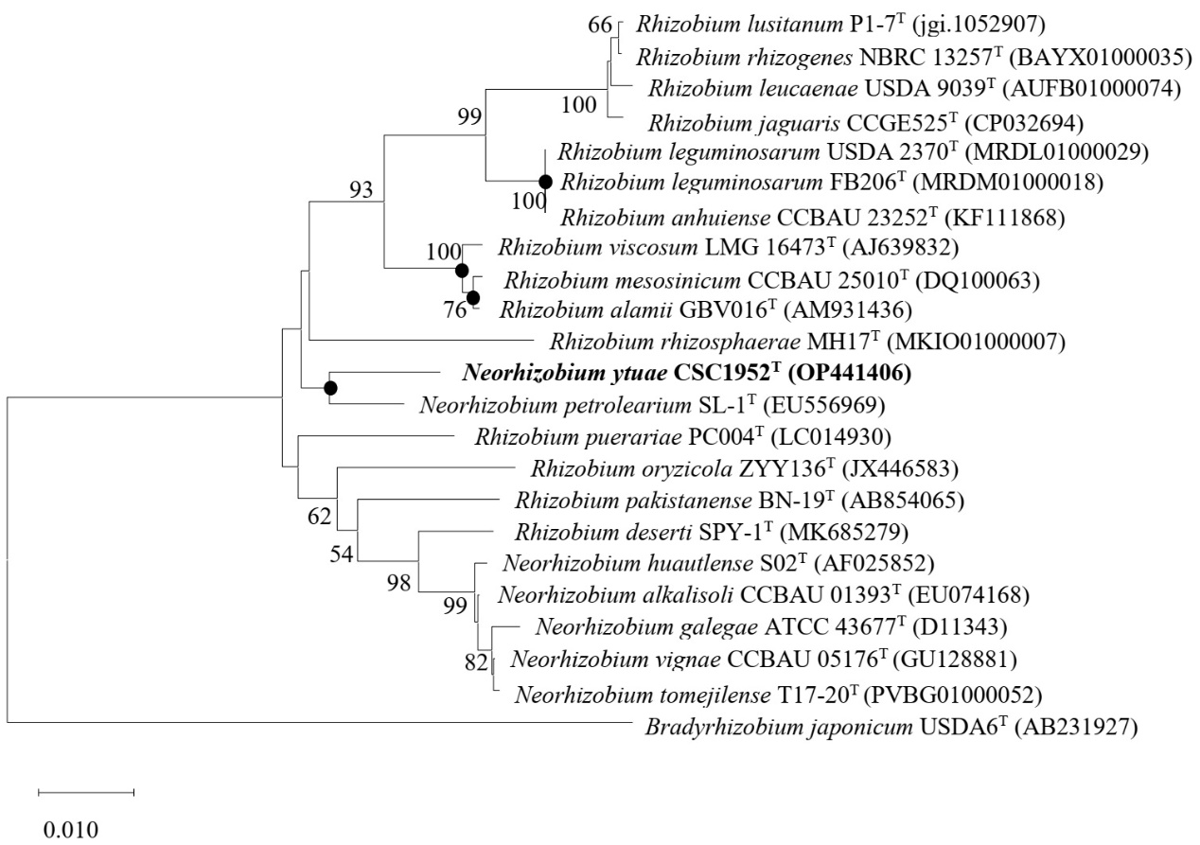

Figure S2. Two-dimensional thin-layer chromatogram of the total polar lipid profile of strain CSC1952^{T}. Phosphatidylglycerol (PG), phosphatidylethanolamine (PE), phosphatidylcholine (PC), unidentified aminolipid (AL), phosphatidylmethylethanolamine (PME); diphosphatidylglycerol (DPG); unidentified glycolipid (GL); unidentified phospholipids (PL1-2) are shown.
