Supporting Information
Designing biodegradable and antibacterial cellulose-based superhydrophobic packaging materials via large-scale self-assembly

Qiang Li ª, Xiaofan Jiang ª, Mingjun Huang ª, Jiachen Lv ª, Zhe Ling ^{b}, Songlin Wang ª, Fushan Chen ª, Zhe Ji ^{a,}*

ª College of Marine Science and Bioengineering, Qingdao University of Science and Technology, Qingdao 266042, China
^{b} Jiangsu Co-Innovation Center of Efficient Processing and Utilization of Forest Resources, College of Chemical Engineering, Nanjing Forestry University, Nanjing 210037, China
* Corresponding author’s e-mail address: jizhe@qust.edu.cn

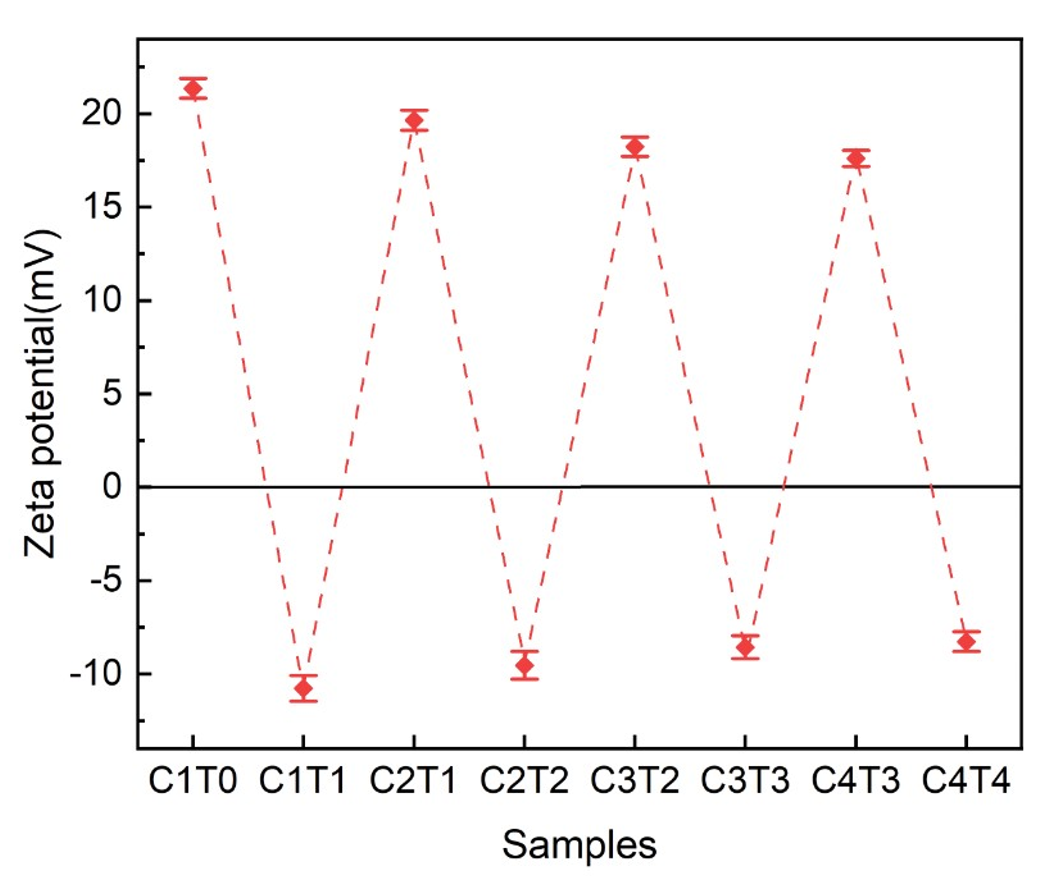
Fig. S1. The corresponding Zeta potential value of samples.

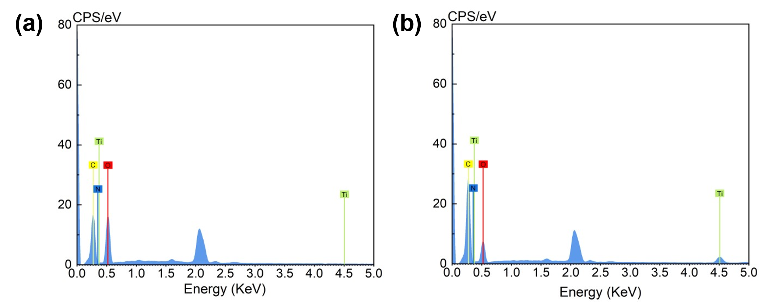
Fig. S2. EDS diagrams of filter paper and superhydrophobic paper: (a) Paper and (b) CW@(CT)₁₀.

Table S1. Physical properties table of (CT)_{n}.
Sample | Thickness  (μm) | Weight  (g/m²) | Tearing Strength  (mN) | Elongation at break  (%) | Folding strength  (Times) | Tensile Strength  (MPa) | Tensile Force  (N)
(CT)₀ | 167 | 83.86 | 191.55 | 2.3 | 20 | 3.04 | 45.37
(CT)₁ | 169 | 85.64 | 172.24 | 2.45 | 22 | 3.47 | 48.58
(CT)₂ | 175 | 86.57 | 175.46 | 2.5 | 24 | 3.95 | 52.39
(CT)₃ | 176 | 87.22 | 178.37 | 2.6 | 23 | 4.18 | 57.85
(CT)₄ | 175 | 87.94 | 182.37 | 2.65 | 25 | 4.23 | 58.67
(CT)₅ | 177 | 88.37 | 186.59 | 2.75 | 27 | 4.47 | 60.25
(CT)₆ | 178 | 88.34 | 193.54 | 2.85 | 30 | 4.25 | 61.88
(CT)₇ | 179 | 89.01 | 195.44 | 2.8 | 35 | 4.51 | 64.24
(CT)₈ | 181 | 89.95 | 225.37 | 2.85 | 39 | 4.77 | 68.49
(CT)₉ | 180 | 91.86 | 256.74 | 2.9 | 45 | 4.89 | 70.46
(CT)₁₀ | 183 | 91.8 | 267.17 | 2.9 | 47 | 4.96 | 72.43

Table S2. Physical properties table of CW@(CT)_{n}.
Sample | Thickness  (μm) | Weight  (g/m²) | Tearing Strength  (mN) | Elongation at break  (%) | Folding strength  (Times) | Tensile Strength  (MPa) | Tensile Force  (N)
CW@(CT)₁ | 175 | 92.02 | 141.52 | 2.30 | 17 | 3.74 | 51.37
CW@(CT)₂ | 177 | 94.71 | 146.22 | 2.25 | 19 | 3.96 | 58.98
CW@(CT)₃ | 179 | 95.84 | 145.25 | 2.30 | 21 | 4.75 | 63.72
CW@(CT)₄ | 182 | 96.56 | 152.33 | 2.50 | 24 | 4.97 | 65.62
CW@(CT)₅ | 185 | 97.71 | 165.27 | 2.65 | 22 | 5.11 | 69.77
CW@(CT)₆ | 184 | 97.25 | 175.55 | 2.55 | 25 | 5.27 | 75.47
CW@(CT)₇ | 188 | 98.31 | 179.11 | 2.75 | 23 | 5.42 | 79.82
CW@(CT)₈ | 192 | 98.54 | 186.78 | 2.82 | 26 | 5.69 | 84.11
CW@(CT)₉ | 195 | 99.27 | 210.86 | 2.85 | 28 | 5.72 | 87.45
CW@(CT)₁₀ | 197 | 99.83 | 215.85 | 2.90 | 28 | 5.86 | 89.27

