Supplementary Material

Supplementary Table 1: Variations in the binding energy of Hesperidin 7KBV complex till 100nsecs obtained by M.D. simulation assay using Desmond:
Time Frames (ns) | dG (kcal/mol)
10 | -32.829
20 | -28.942
30 | -14.161
40 | -29.495
50 | -41.868
60 | -19.479
70 | -50.153
80 | -28.148
90 | -19.569
100 | -12.796

Fig S1: Raman Shift (a) and Circular Dichroism spectra (b) of PU27 oligo conditioned for G4 formation in the presence (blue) or absence of K⁺ ion (orange)

Fig S2: Time dependent quenching of FA-PU27 increasing concentrations of Hesperidin

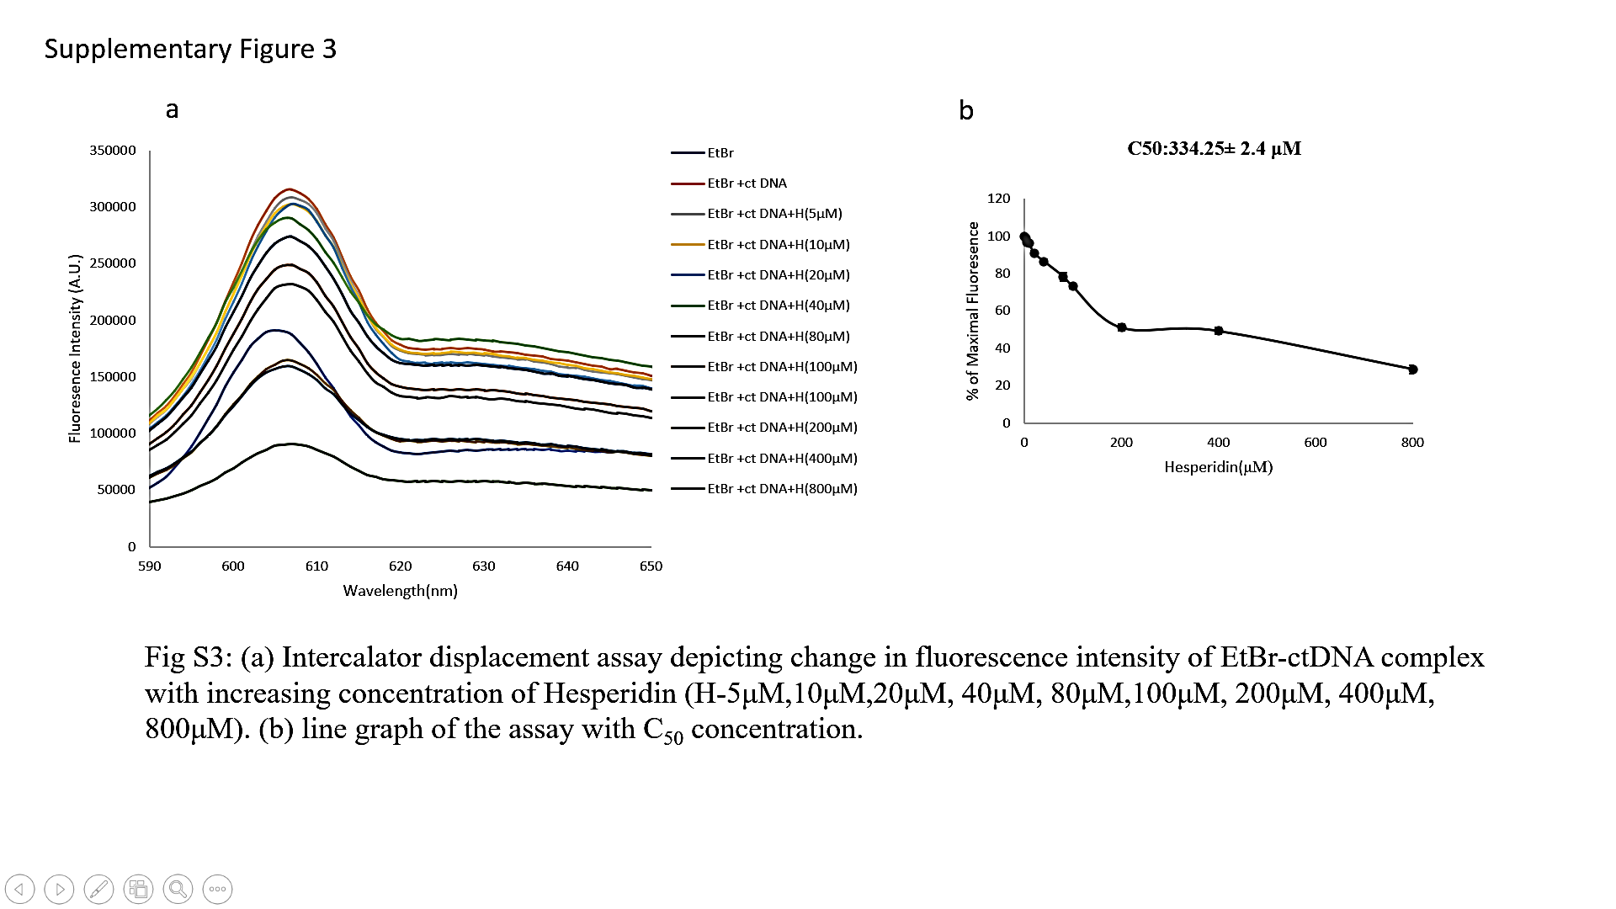
Fig S3: (a) Intercalator displacement assay depicting changes in fluorescence of EtBr-ctDNA complex with increasing concentration of Hesperidin (5, 10, 20, 40, 80, 100, 200, 400 and 800 μM) (b) Line graph of the assay with C₅₀ concentration.

