Comparative Study of Thermal Stability and Thermal Degradation Kinetics of Poly(Vinyl Ethers) with Different Side Groups

Nikolaos V. Plachouras, Kosmas Michos–Stavridis, Stavros Zouganelis and Marinos Pitsikalis*
Industrial Chemistry Laboratory, Department of Chemistry, National and Kapodistrian University of Athens, Panepistimiopolis Zografou, Athens 15771, Greece.

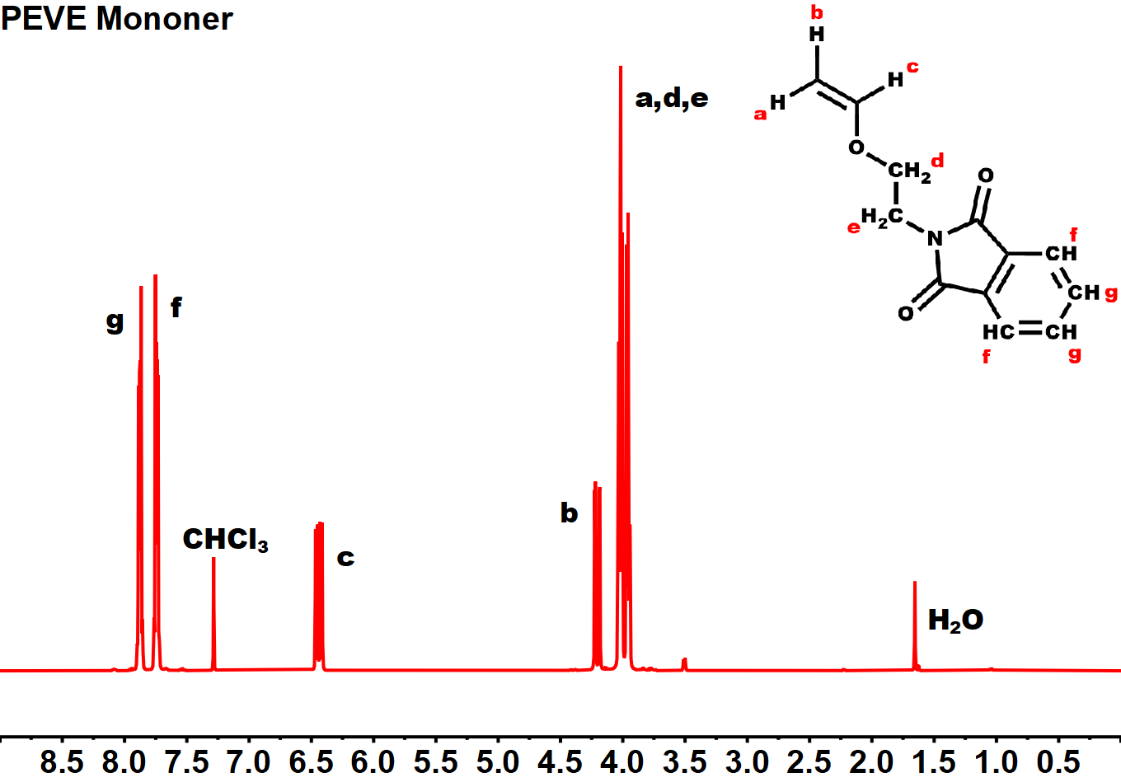
Figure S1. ¹H–NMR spectrum of the monomer PEVE in CDCl₃.

PPEVE 2K compared to PPEVE 8K at 3 ℃/min heating rate:
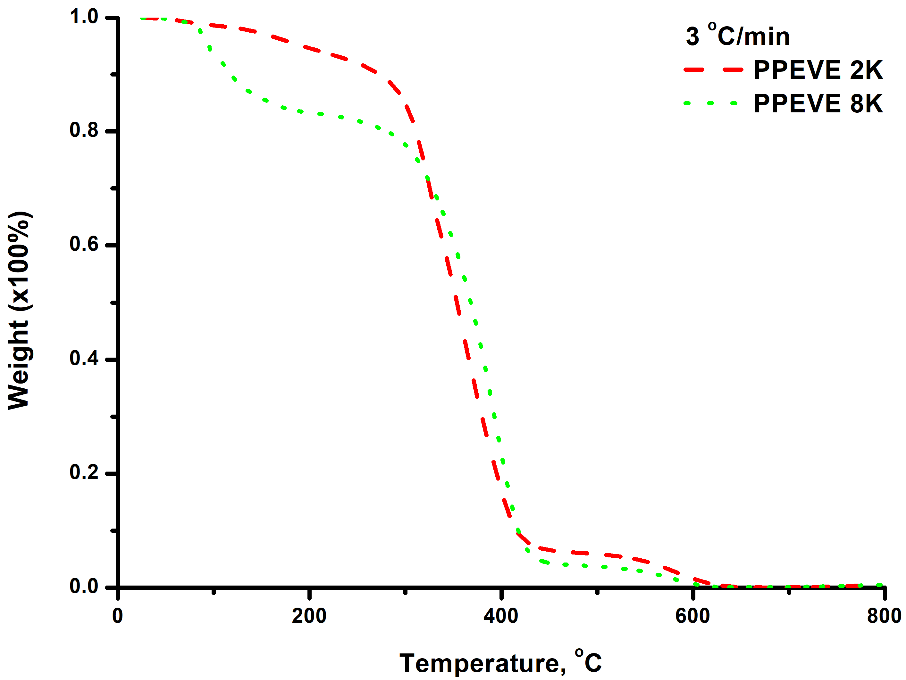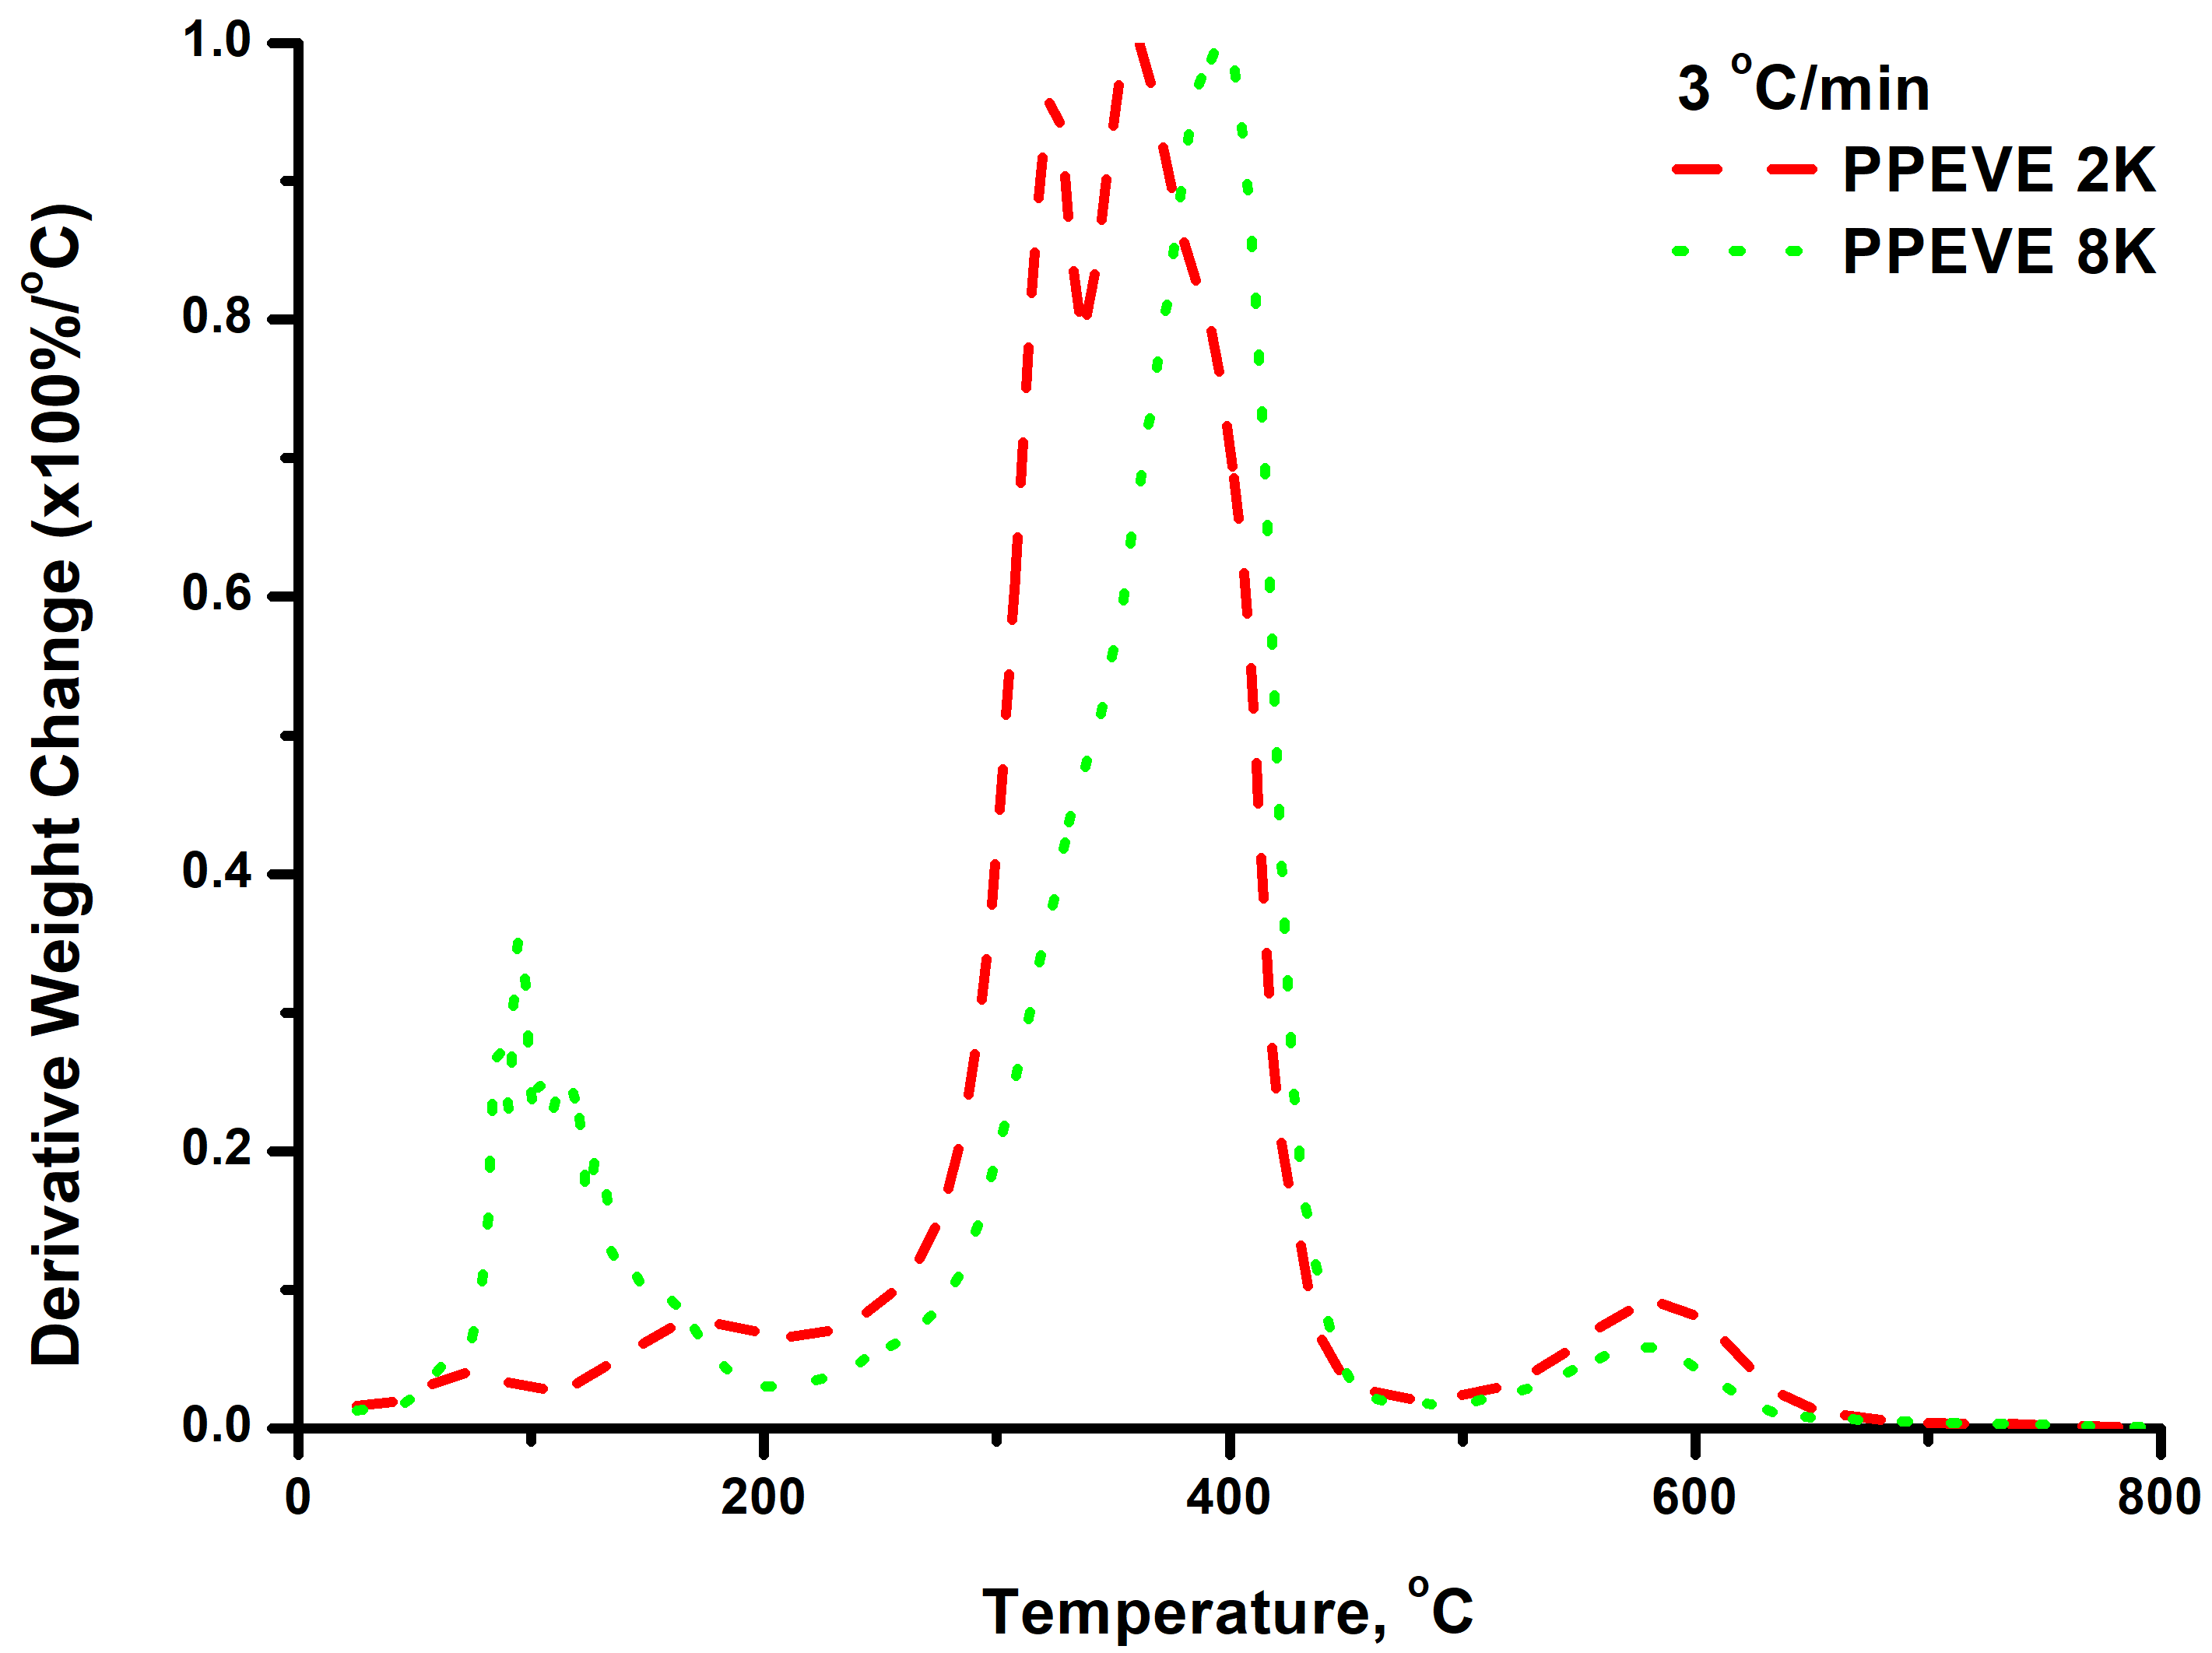
PPEVE 2K compared to PPEVE 8K at 5 ℃/min heating rate:
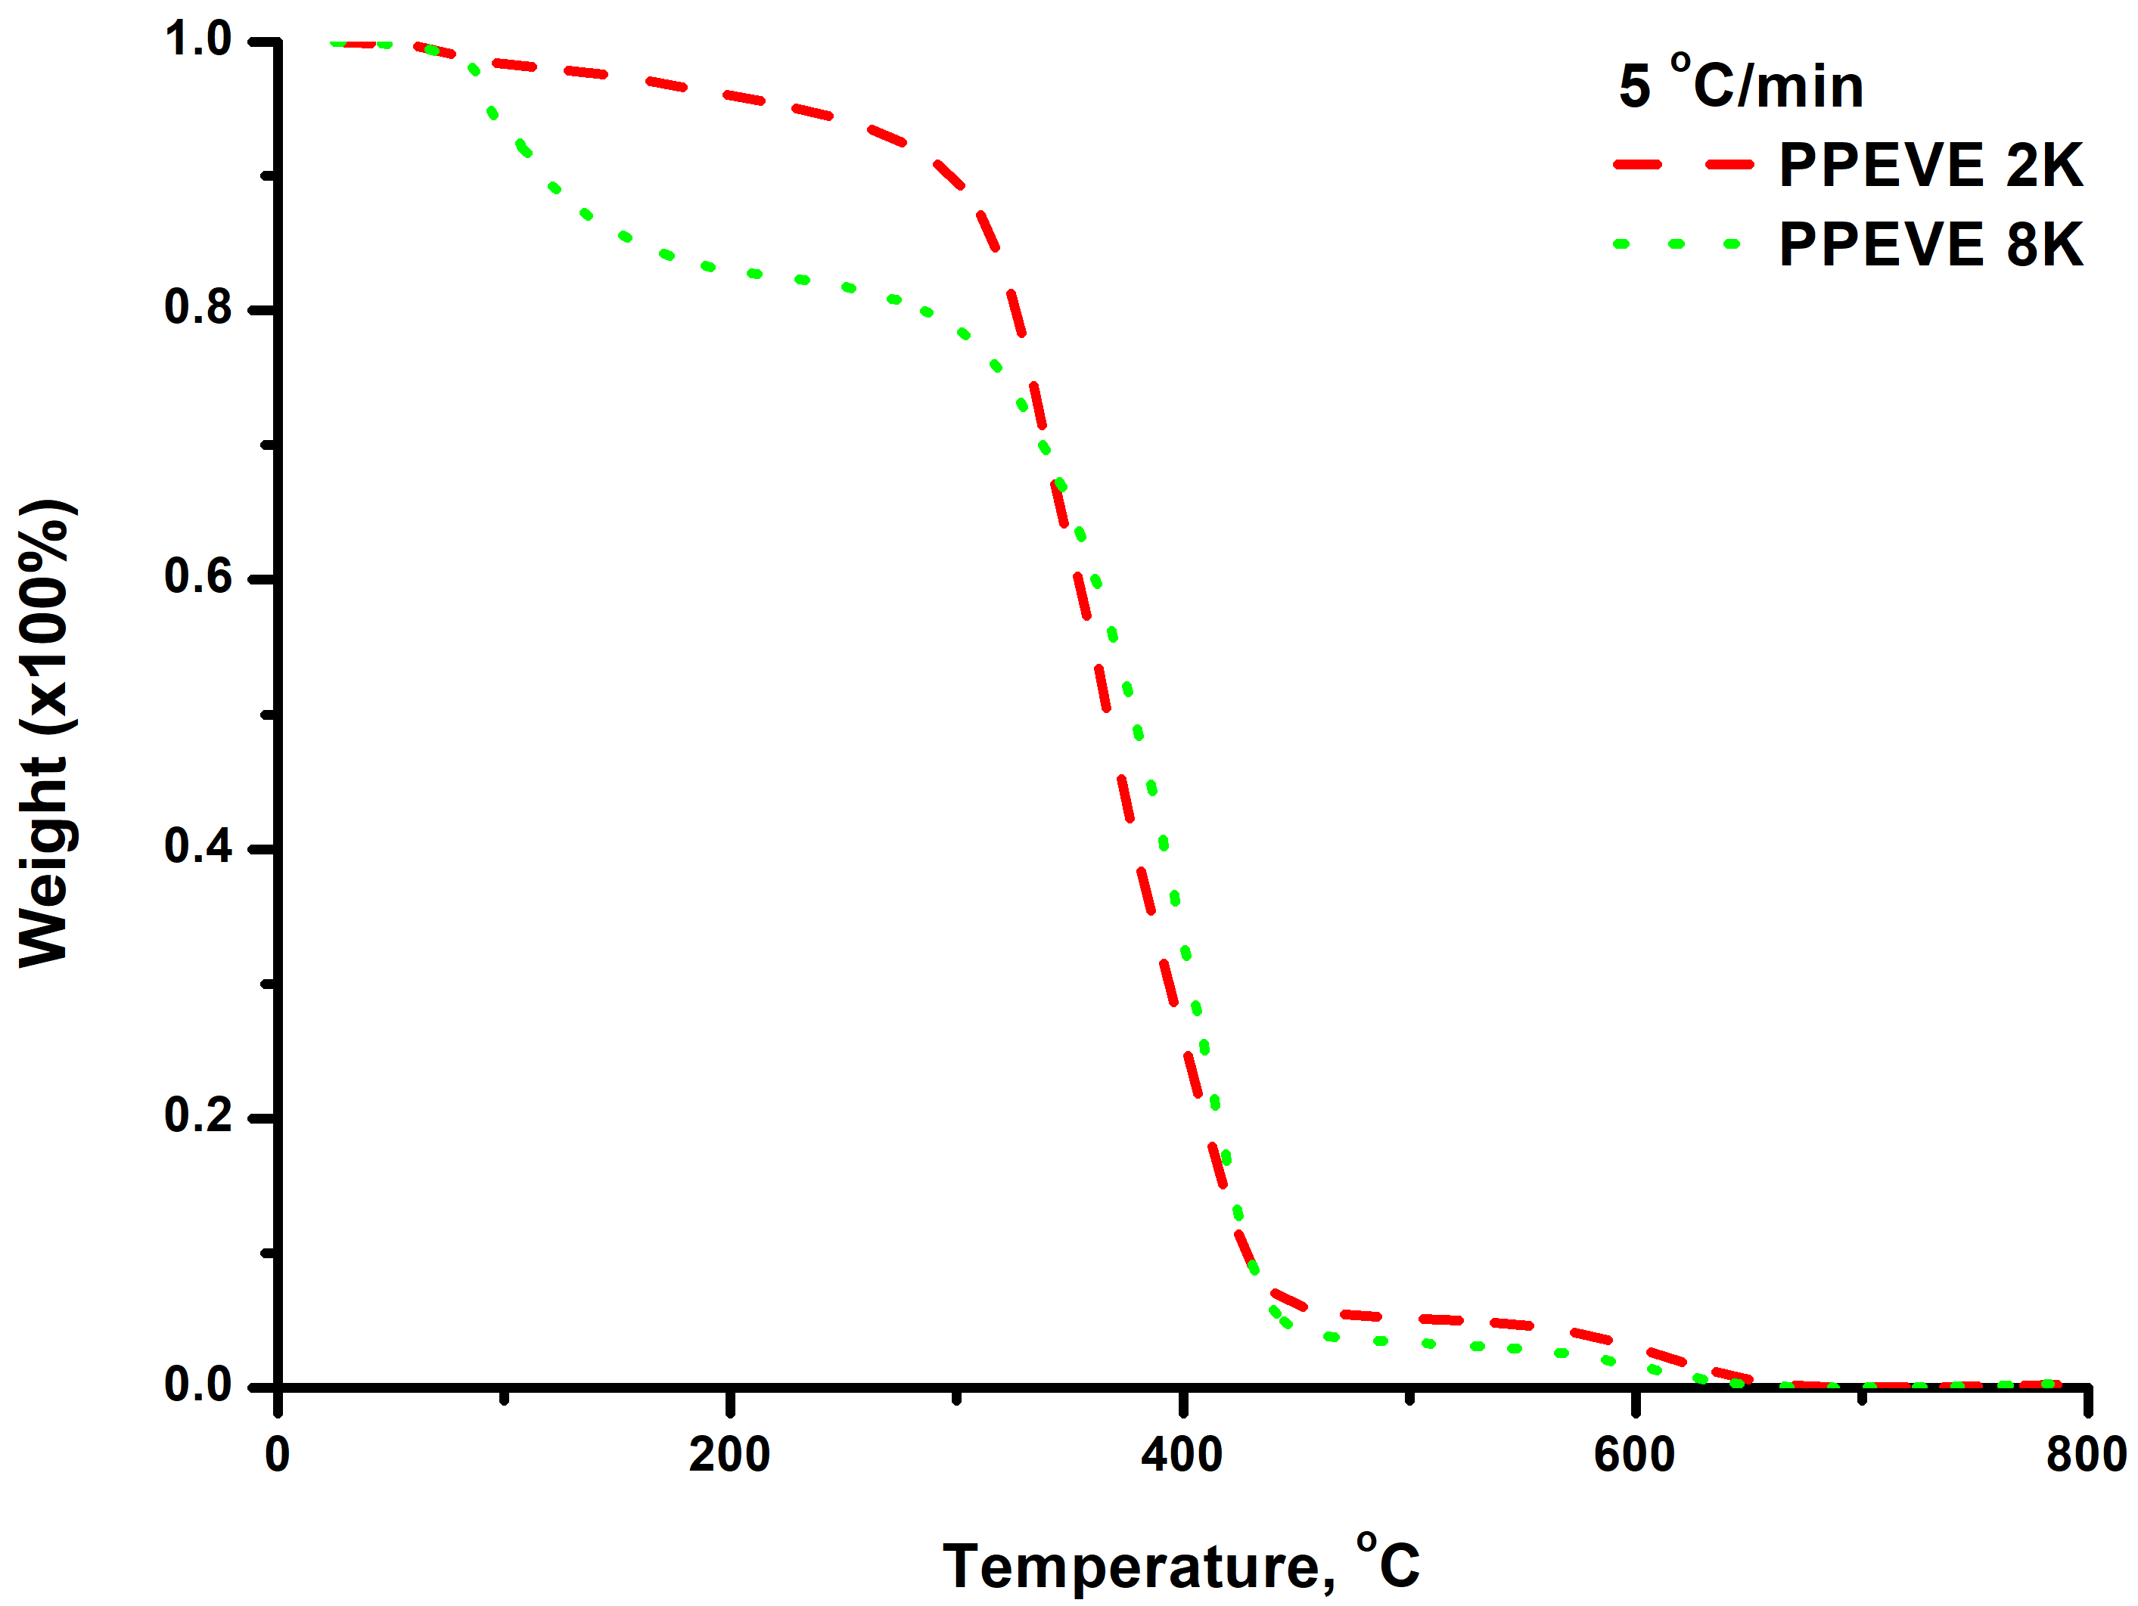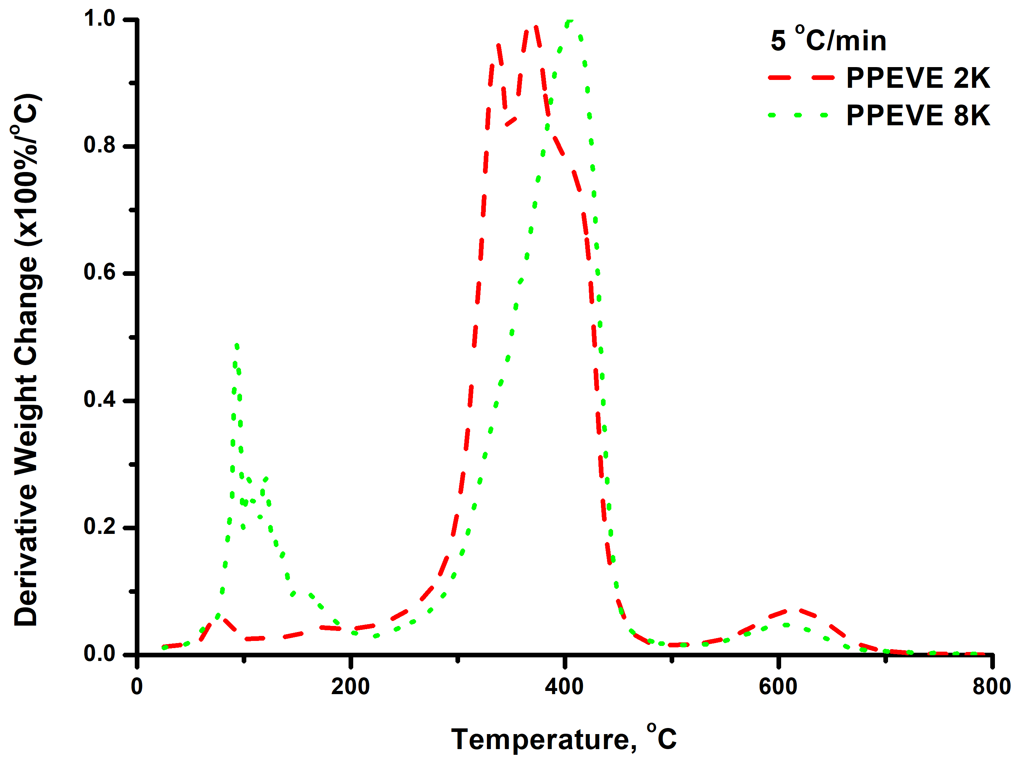
PPEVE 2K compared to PPEVE 8K at 7 ℃/min heating rate:
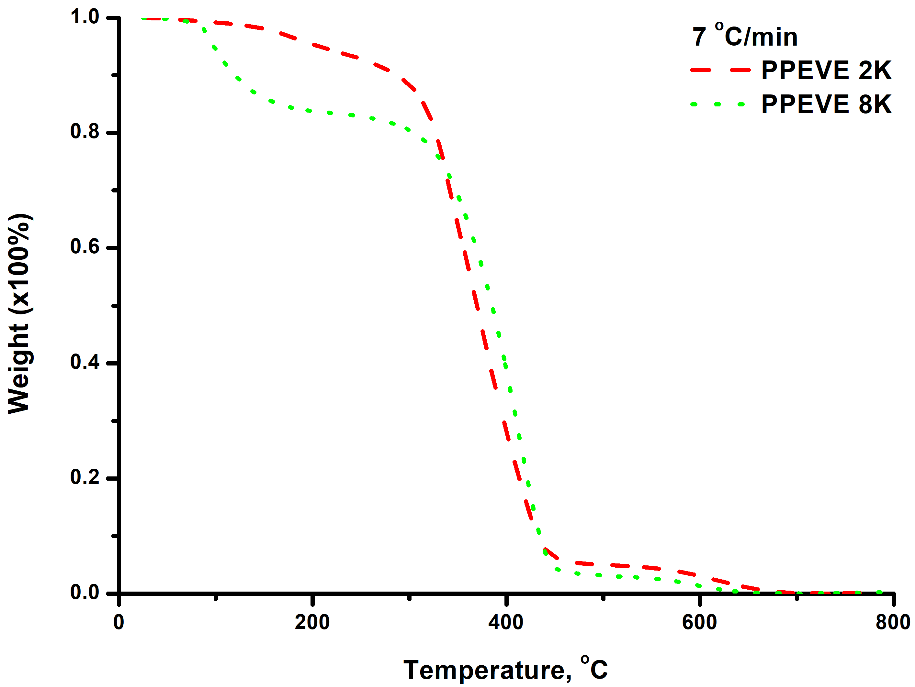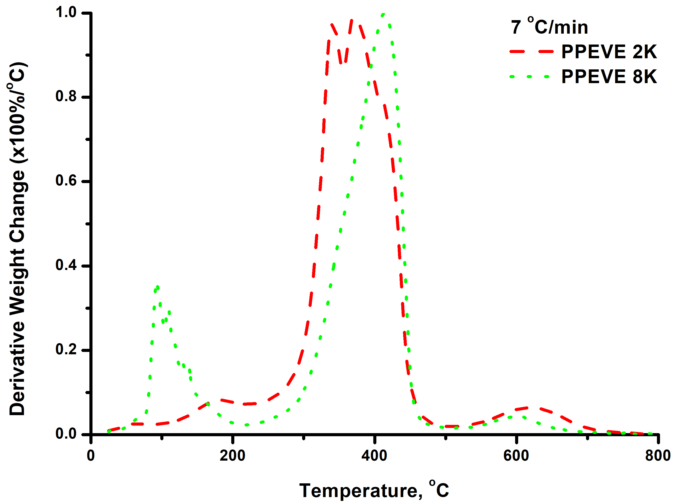
PPEVE 2K compared to PPEVE 8K at 10 ℃/min heating rate:
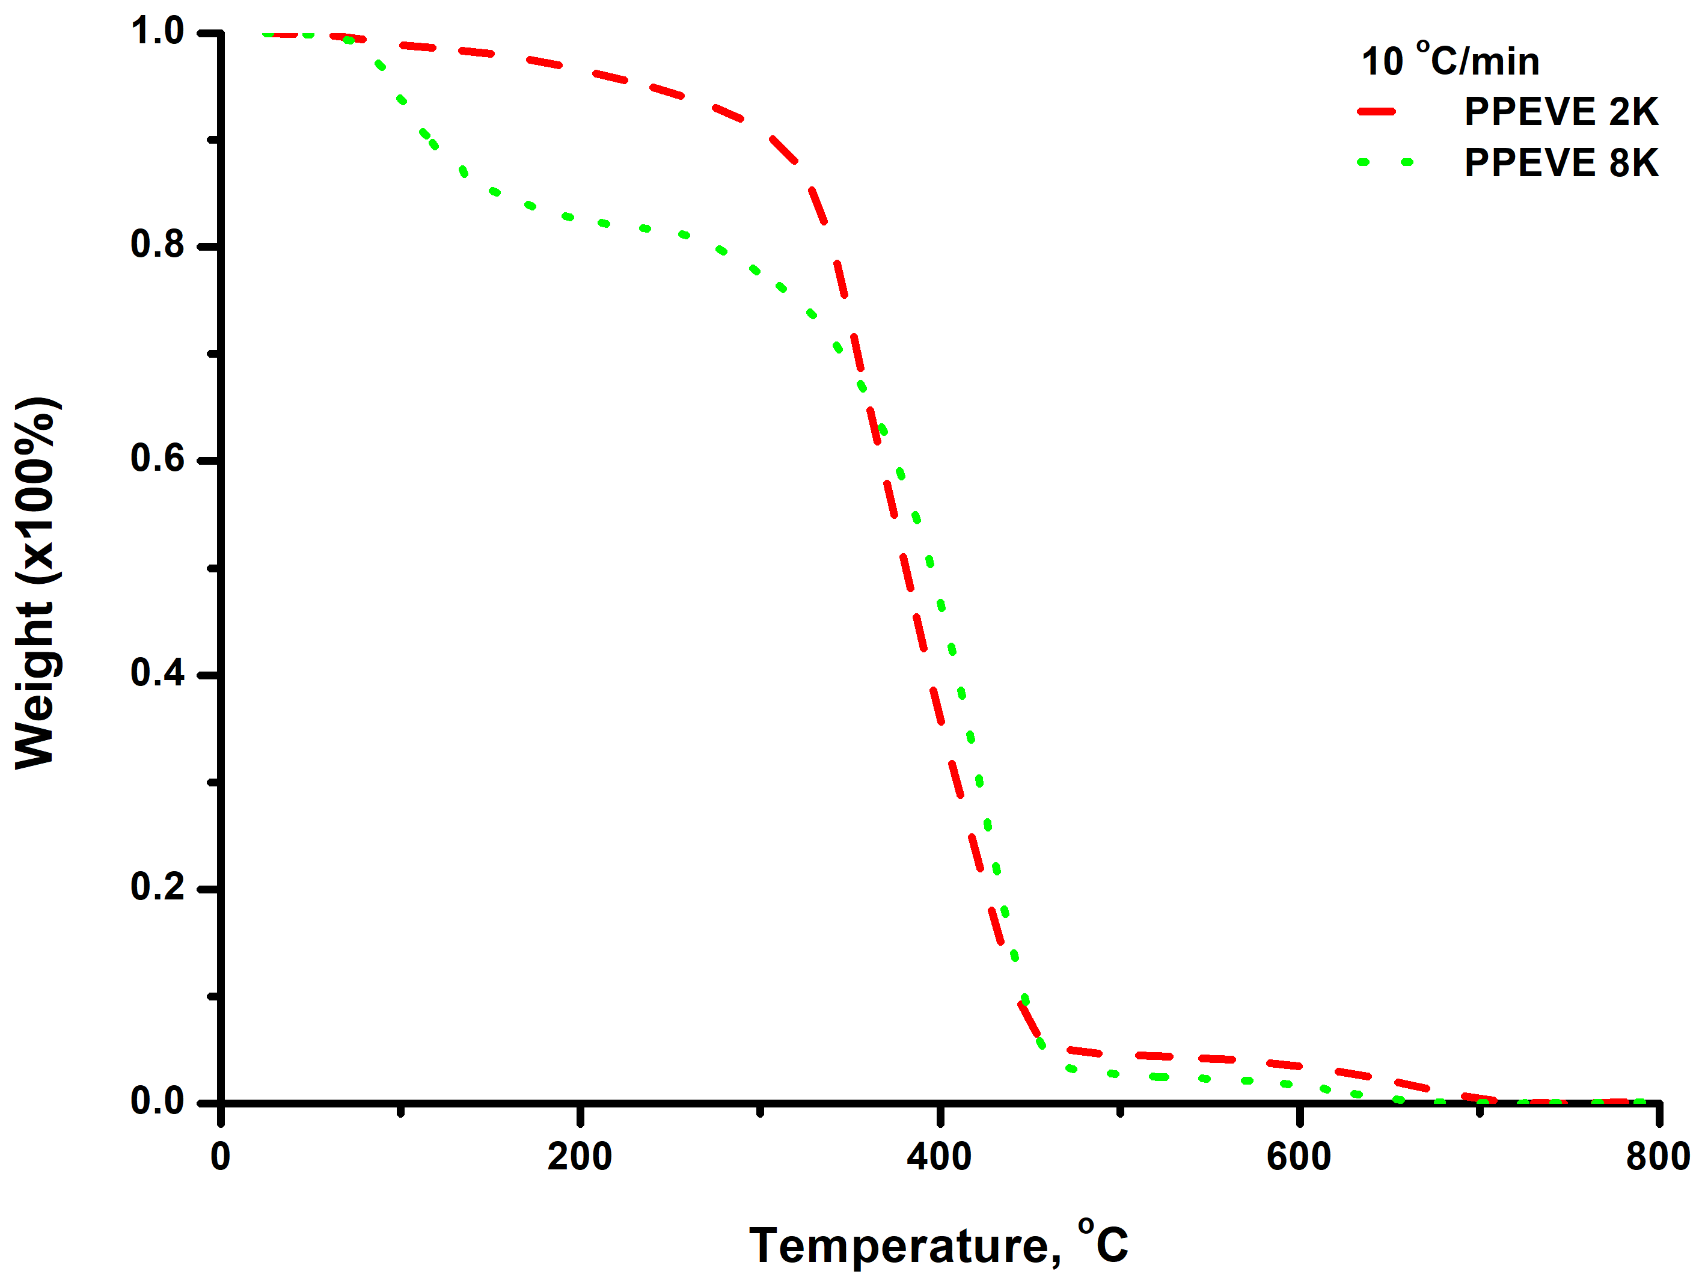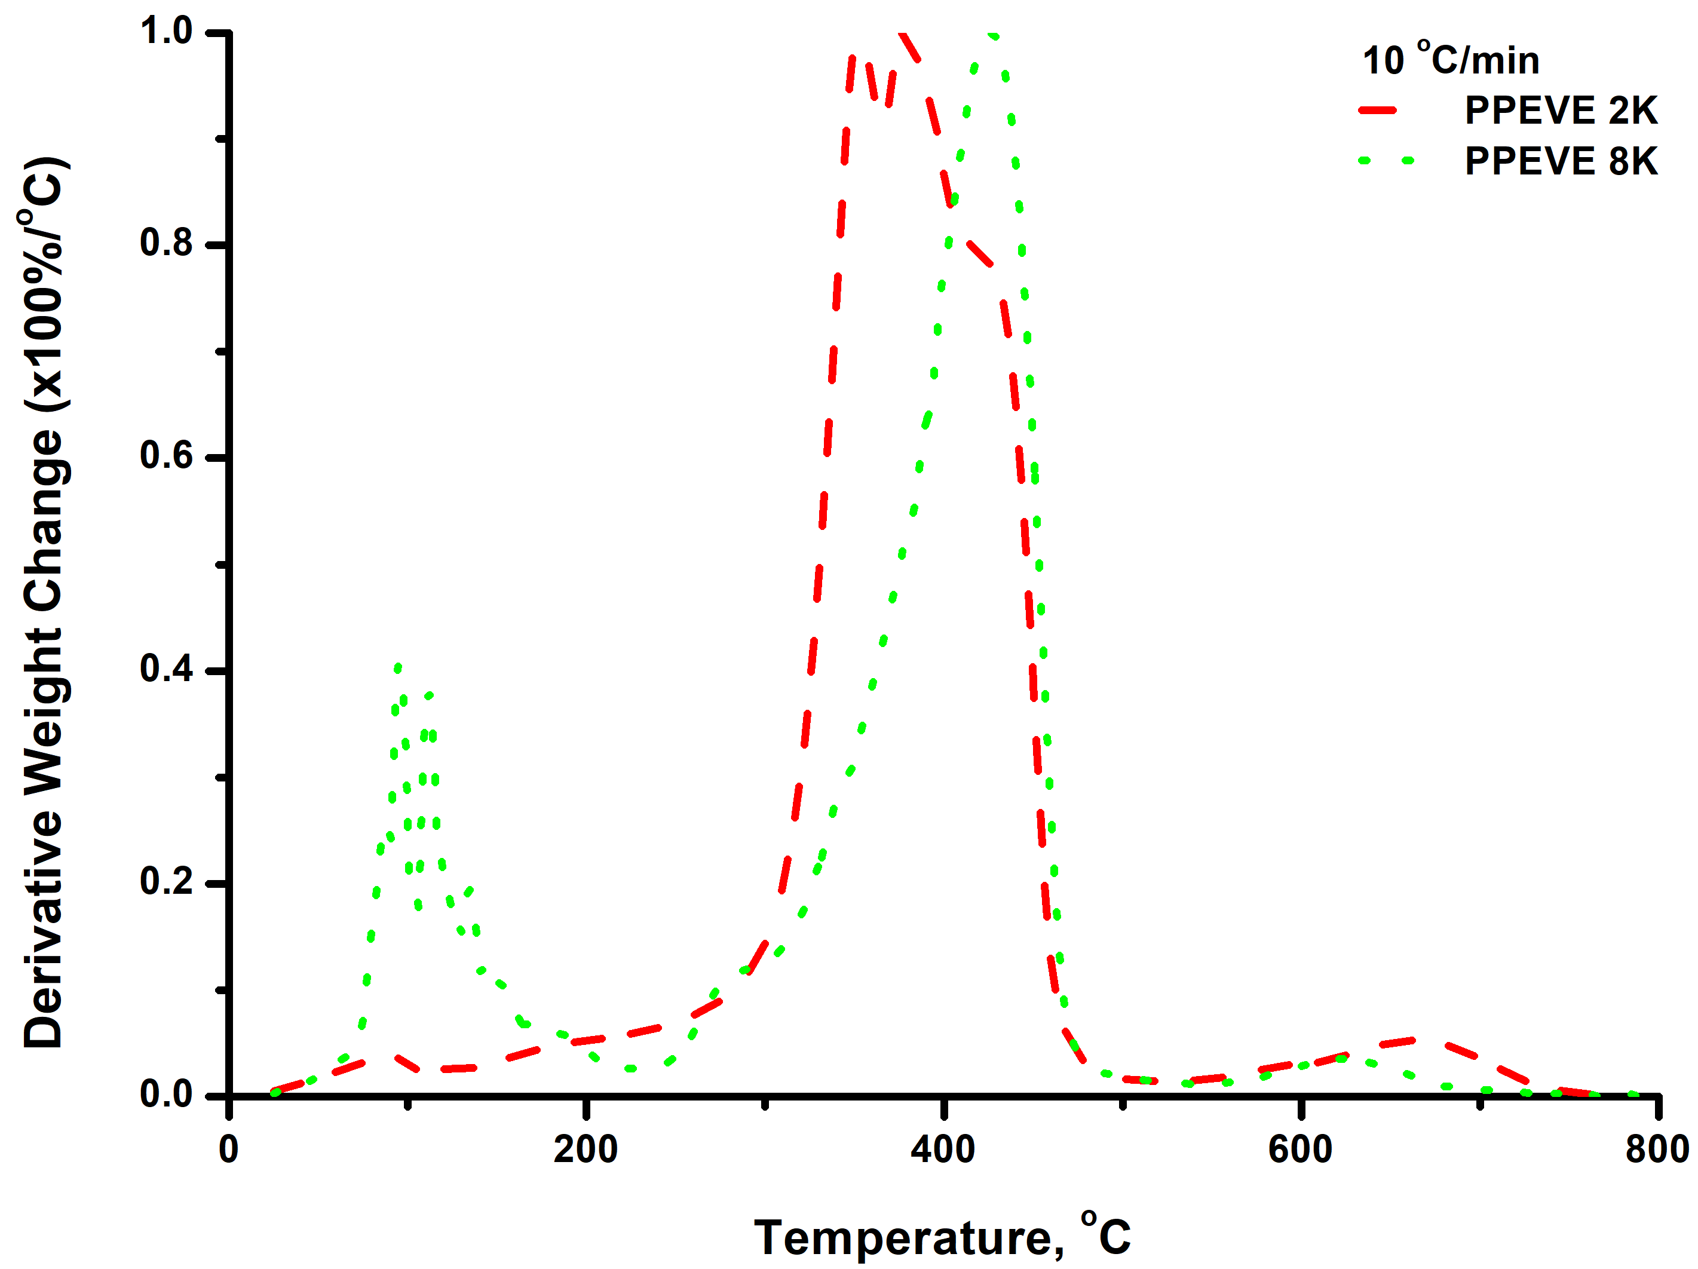
PPEVE 2K compared to PPEVE 8K at 15 ℃/min heating rate:
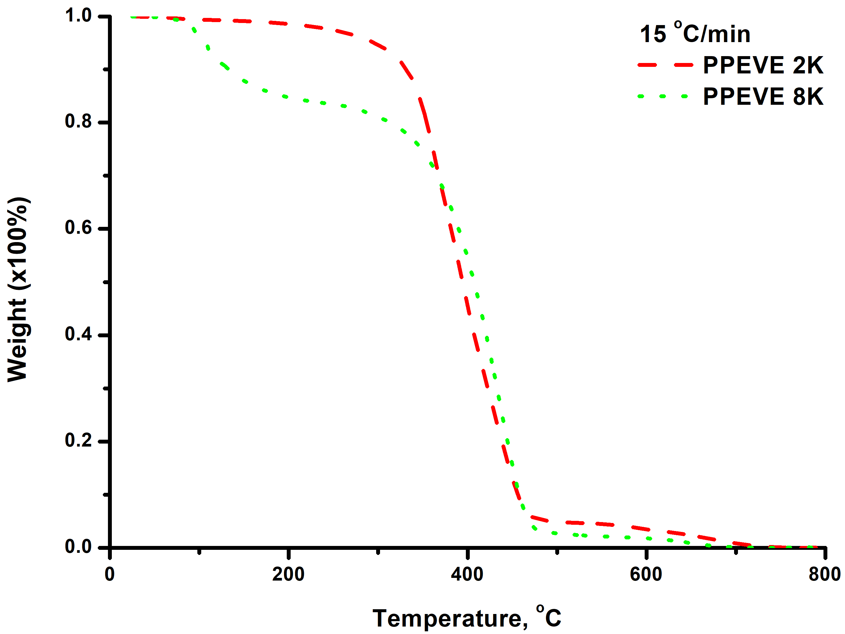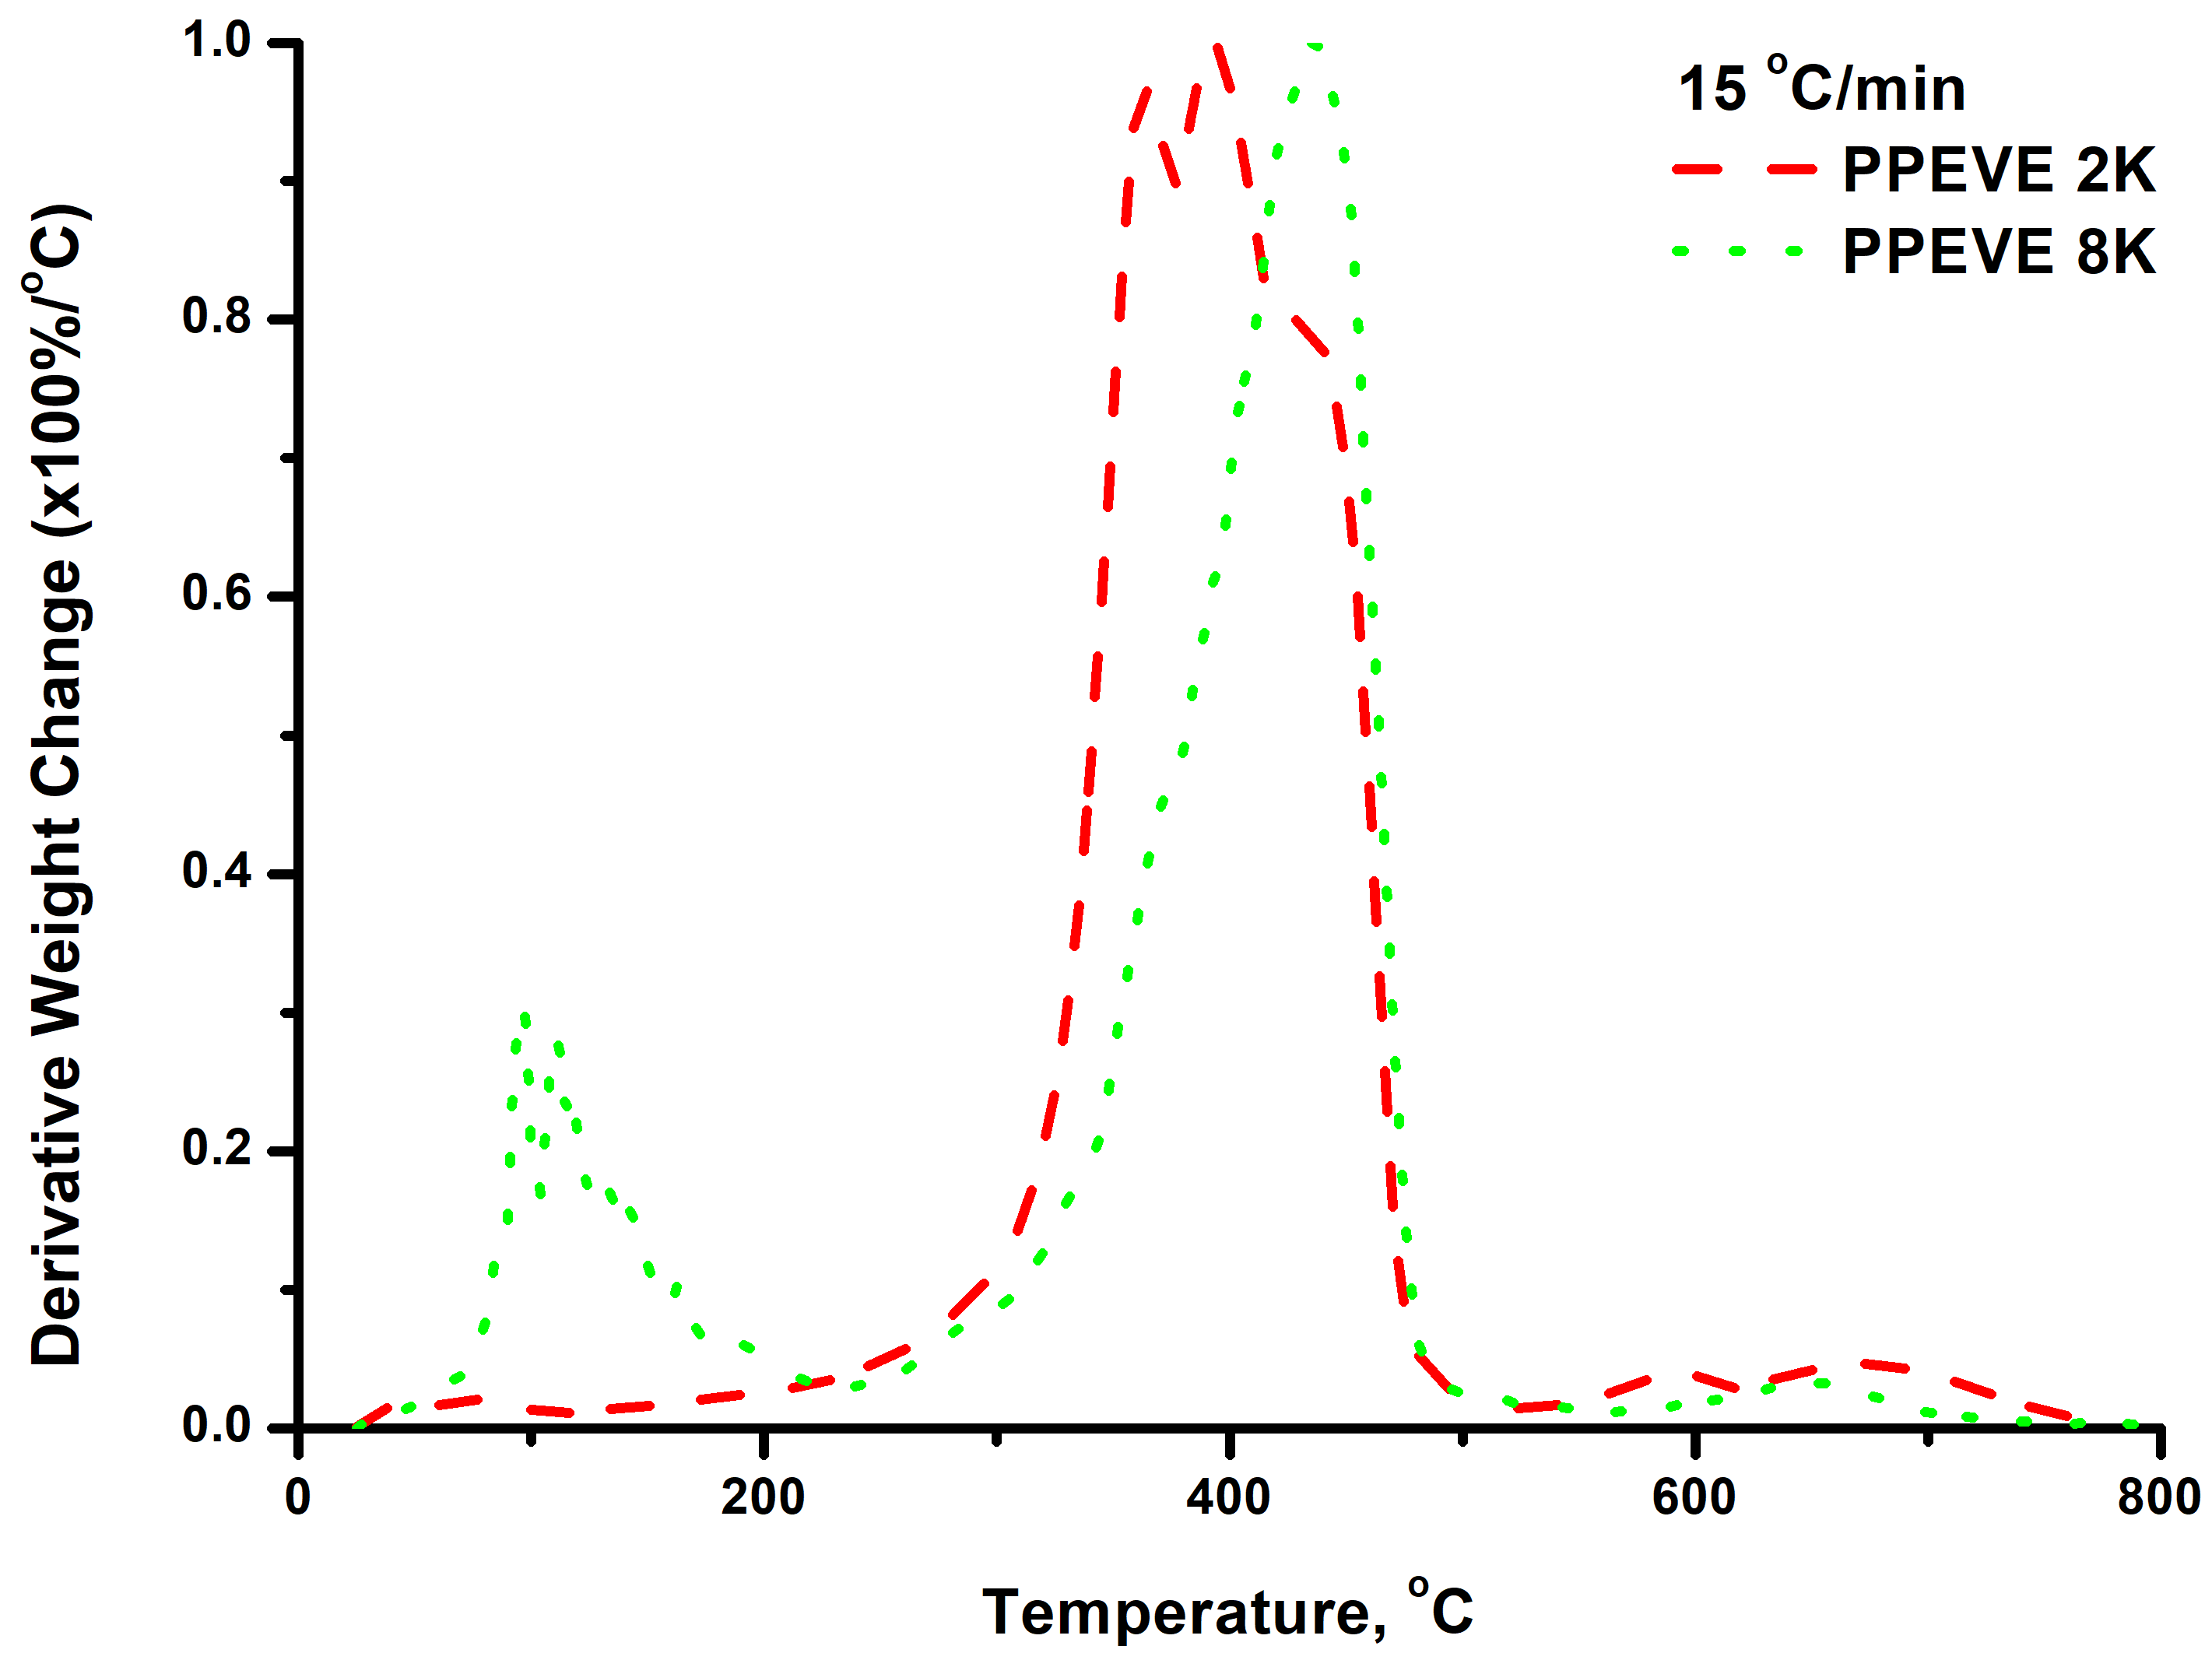
PPEVE 2K compared to PPEVE 8K at 20 ℃/min heating rate:
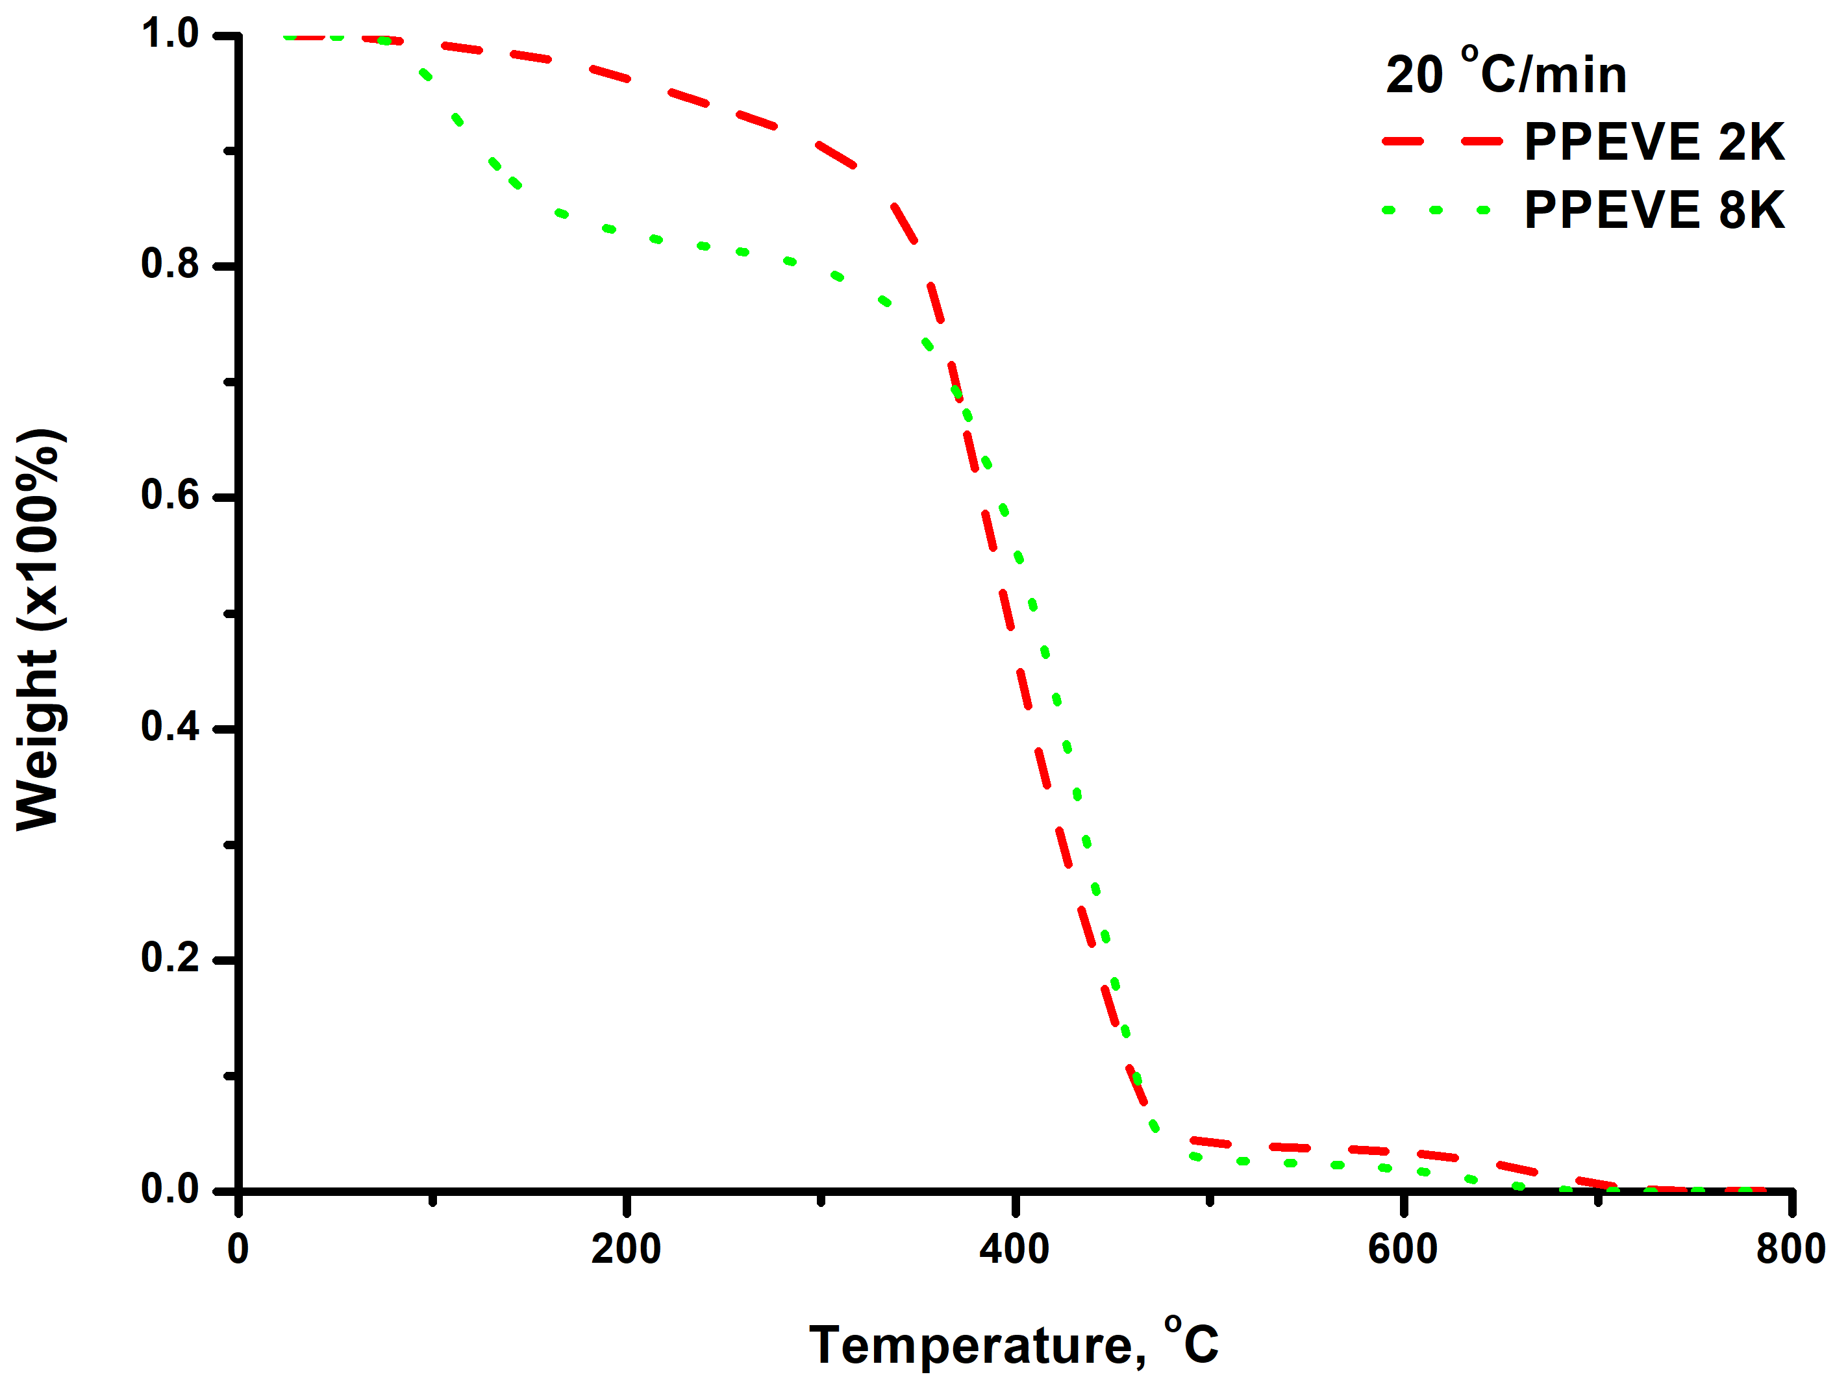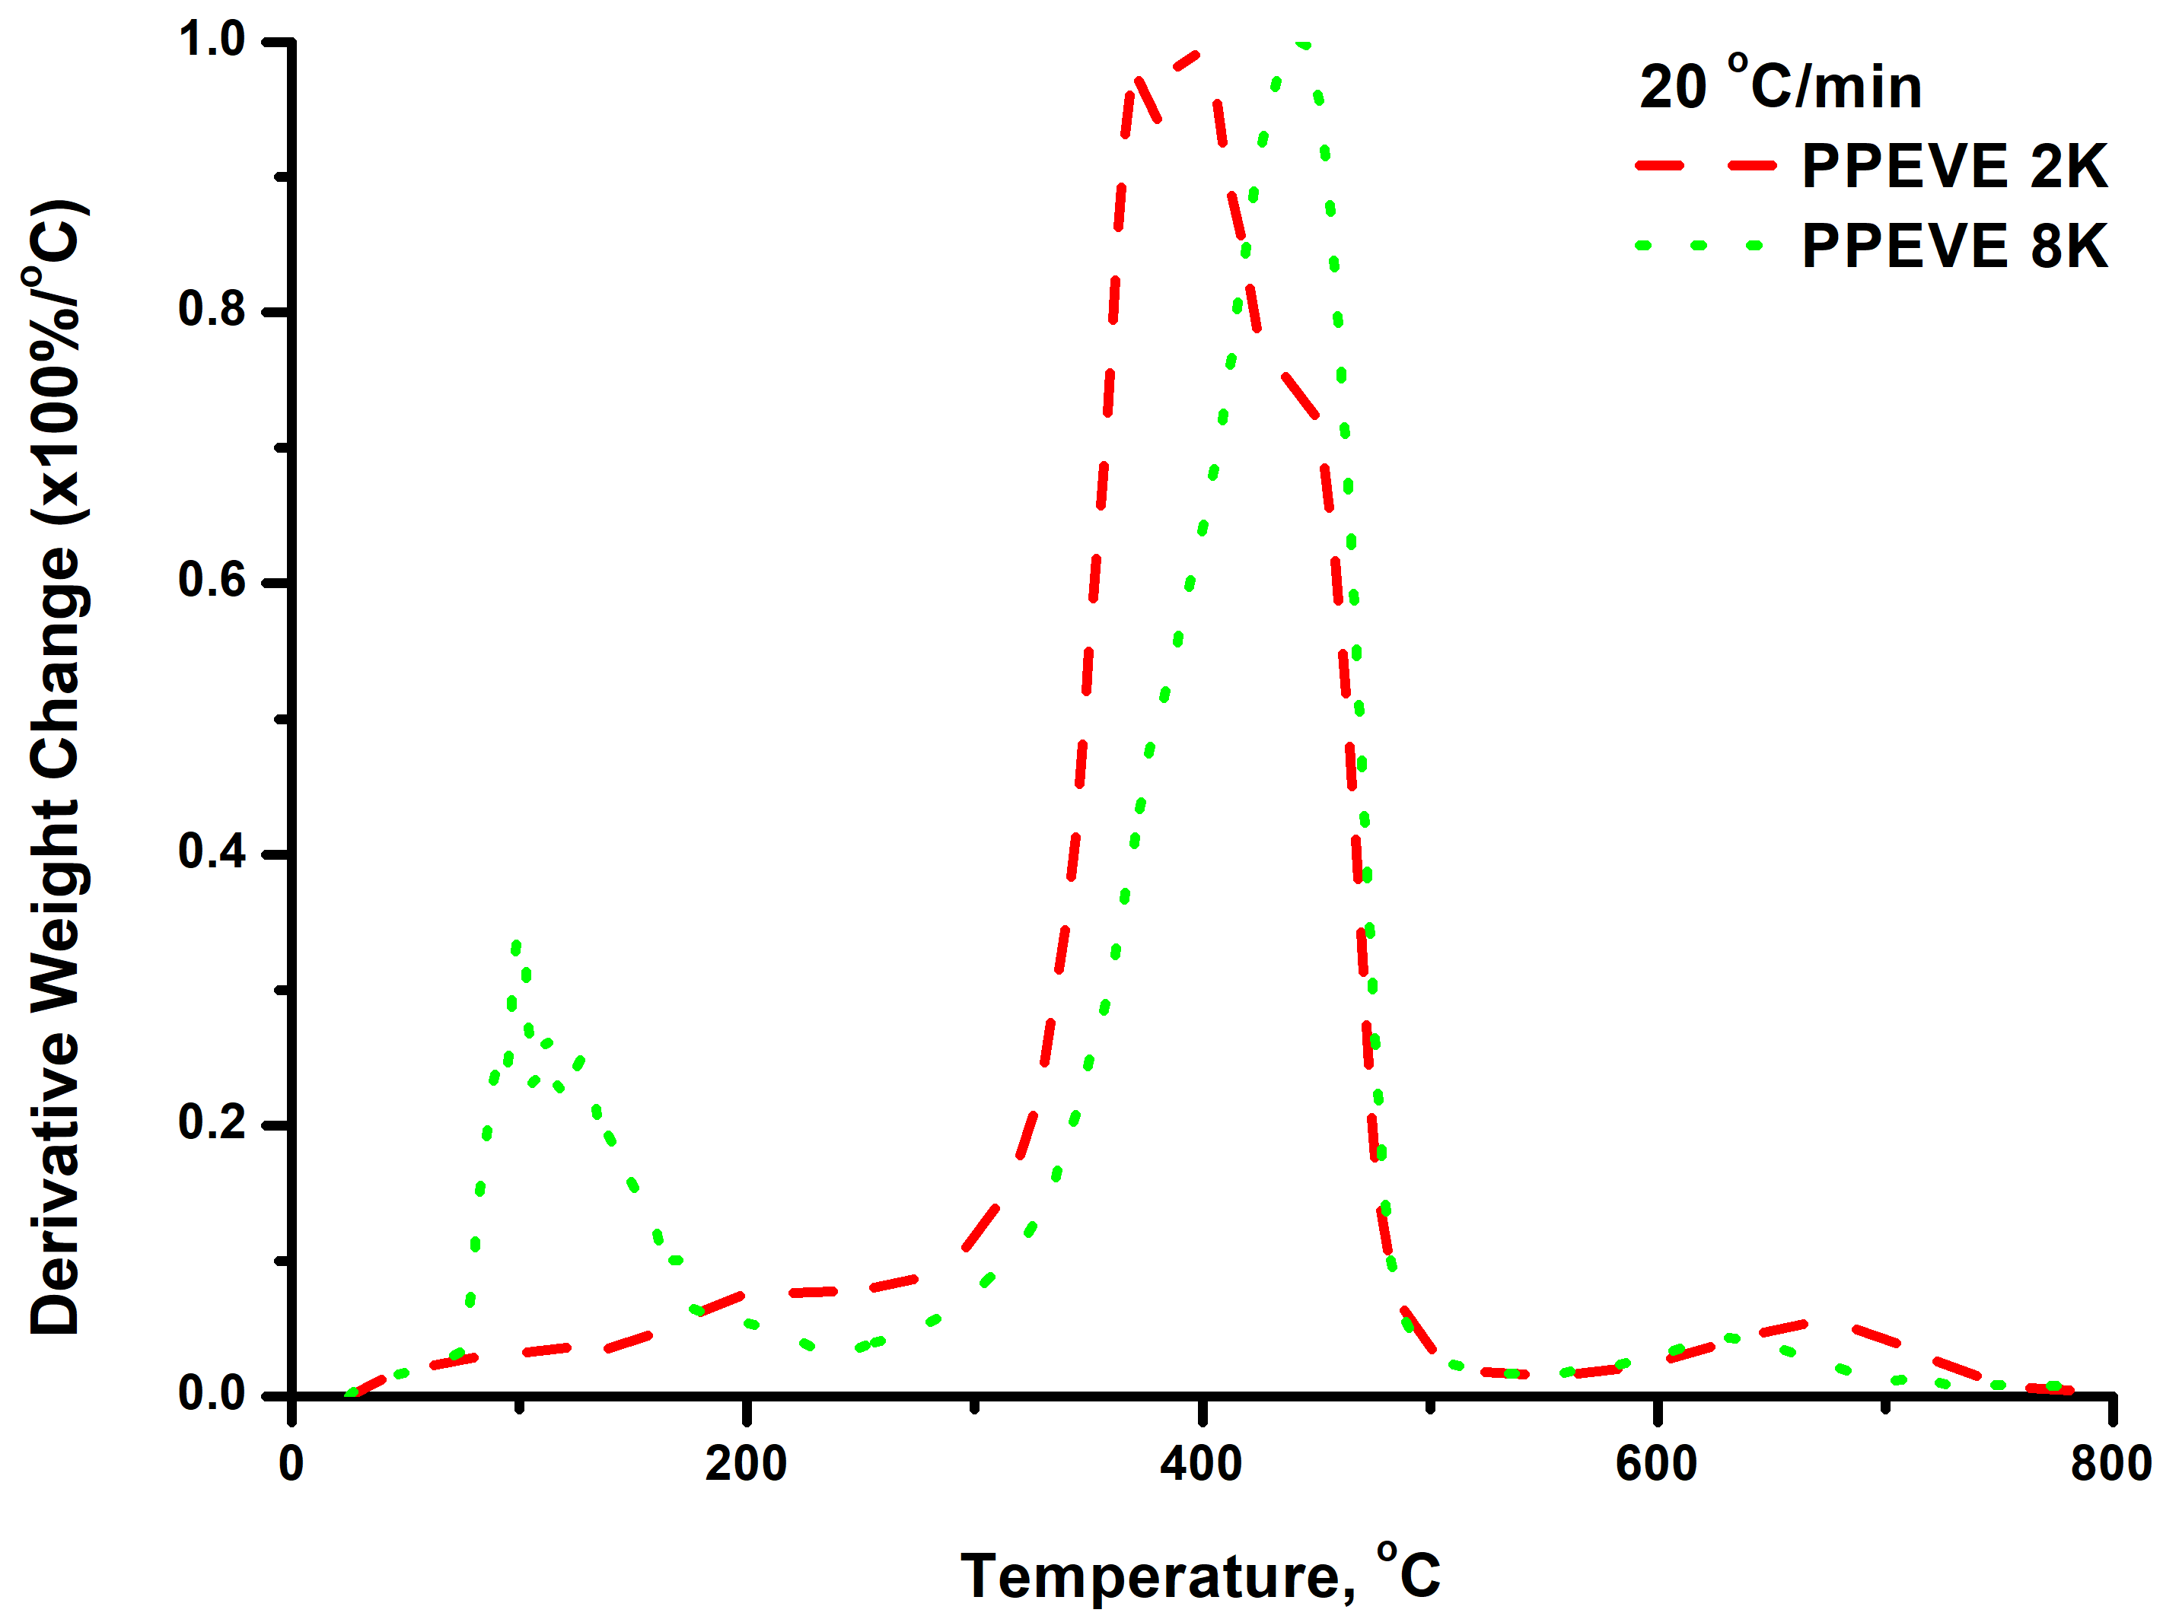
Figure S2. Comparative TGA and DTG plots for samples PPEVE 2K and PPEVE 8K at various heating rates

PPEVE 2K compared to PAEVE 8K at 3 ℃/min heating rate:
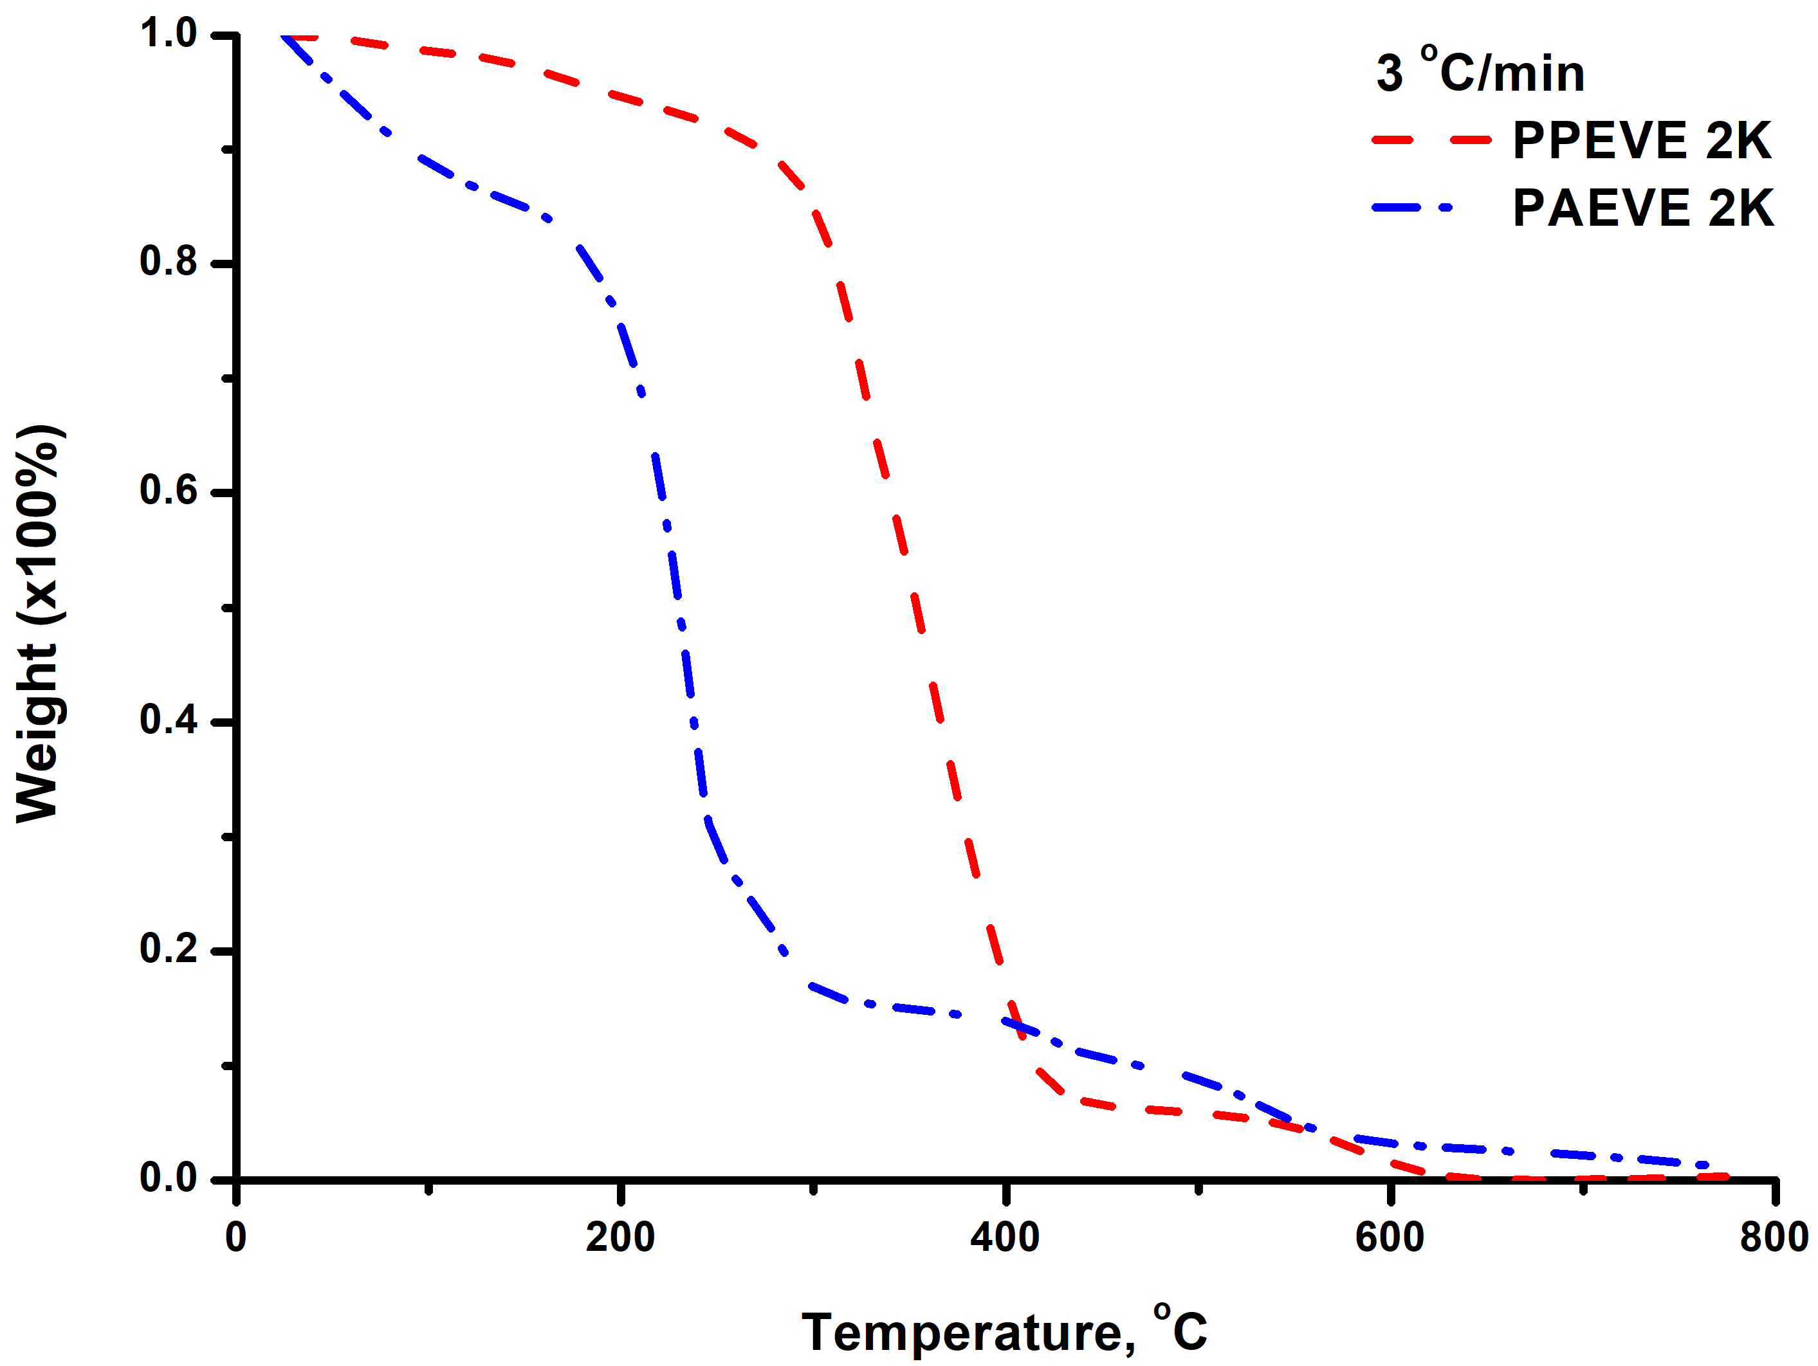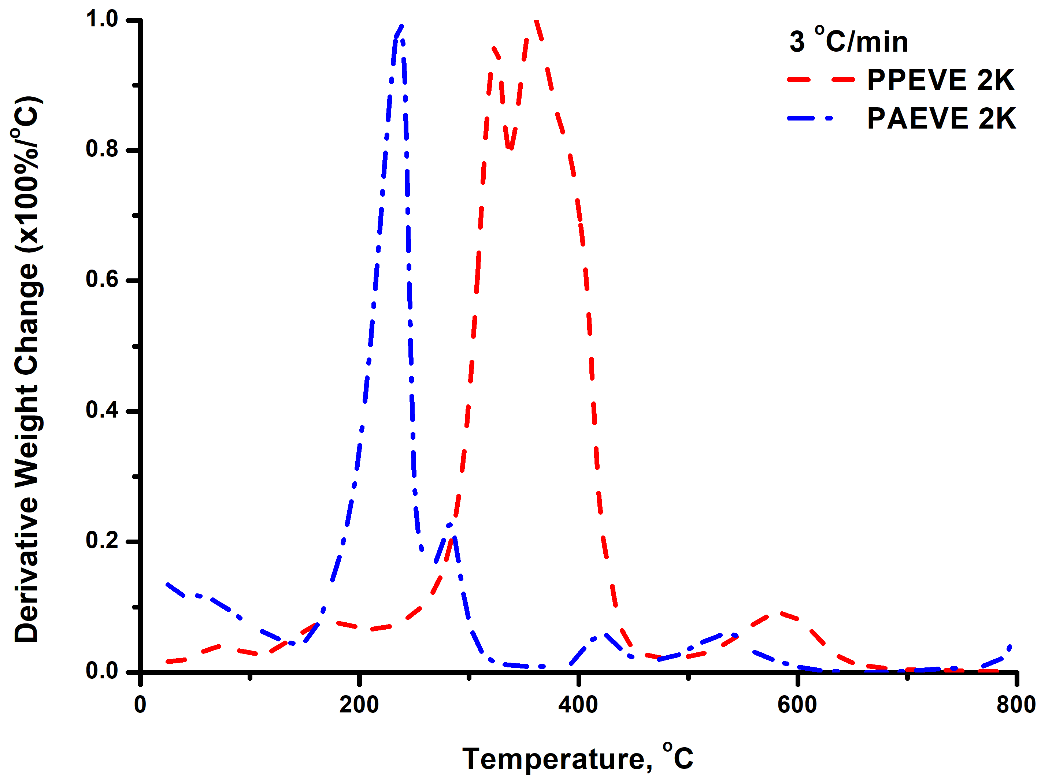
PPEVE 2K compared to PAEVE 8K at 5 ℃/min heating rate:
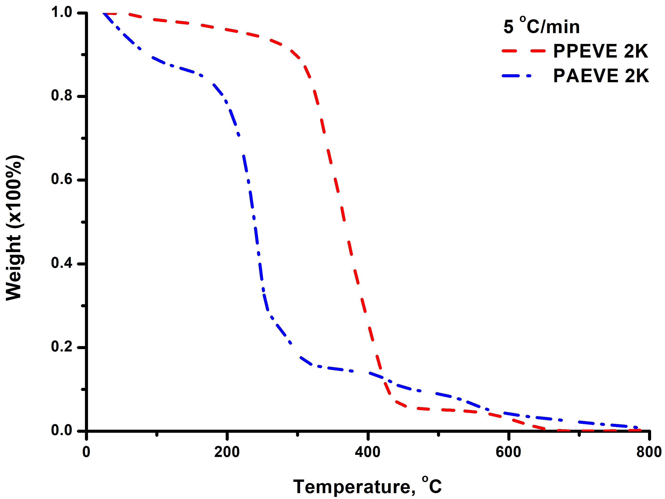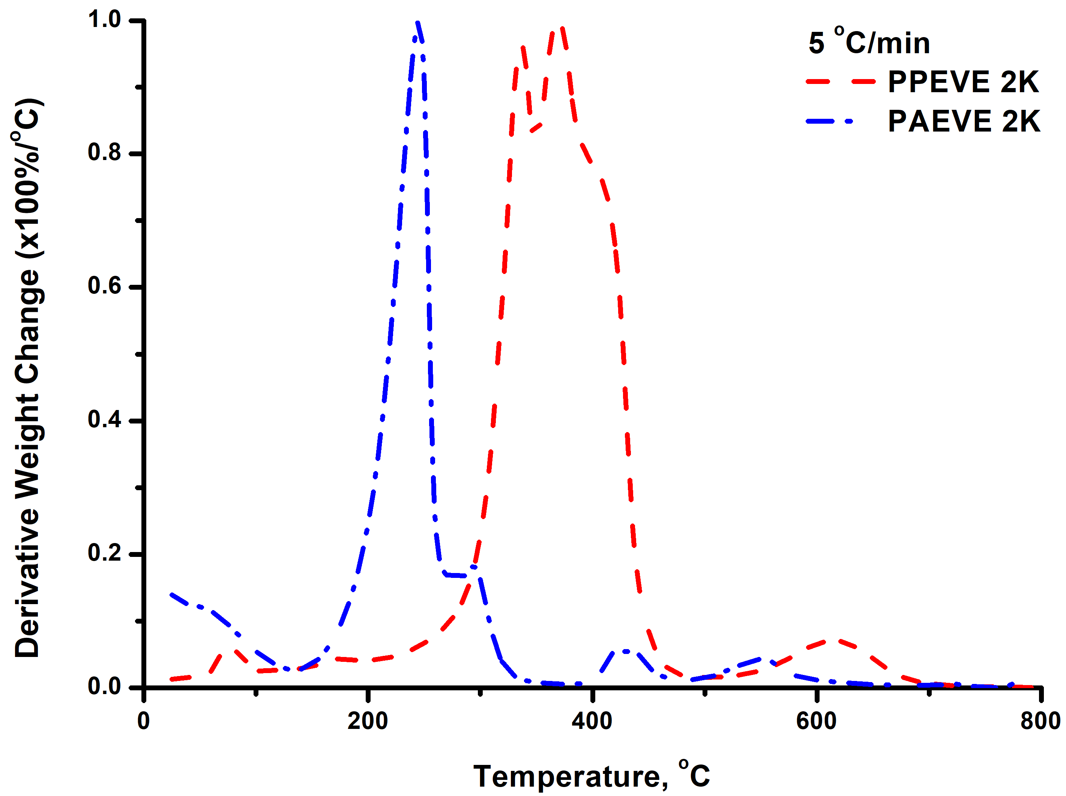
PPEVE 2K compared to PAEVE 8K at 7 ℃/min heating rate:
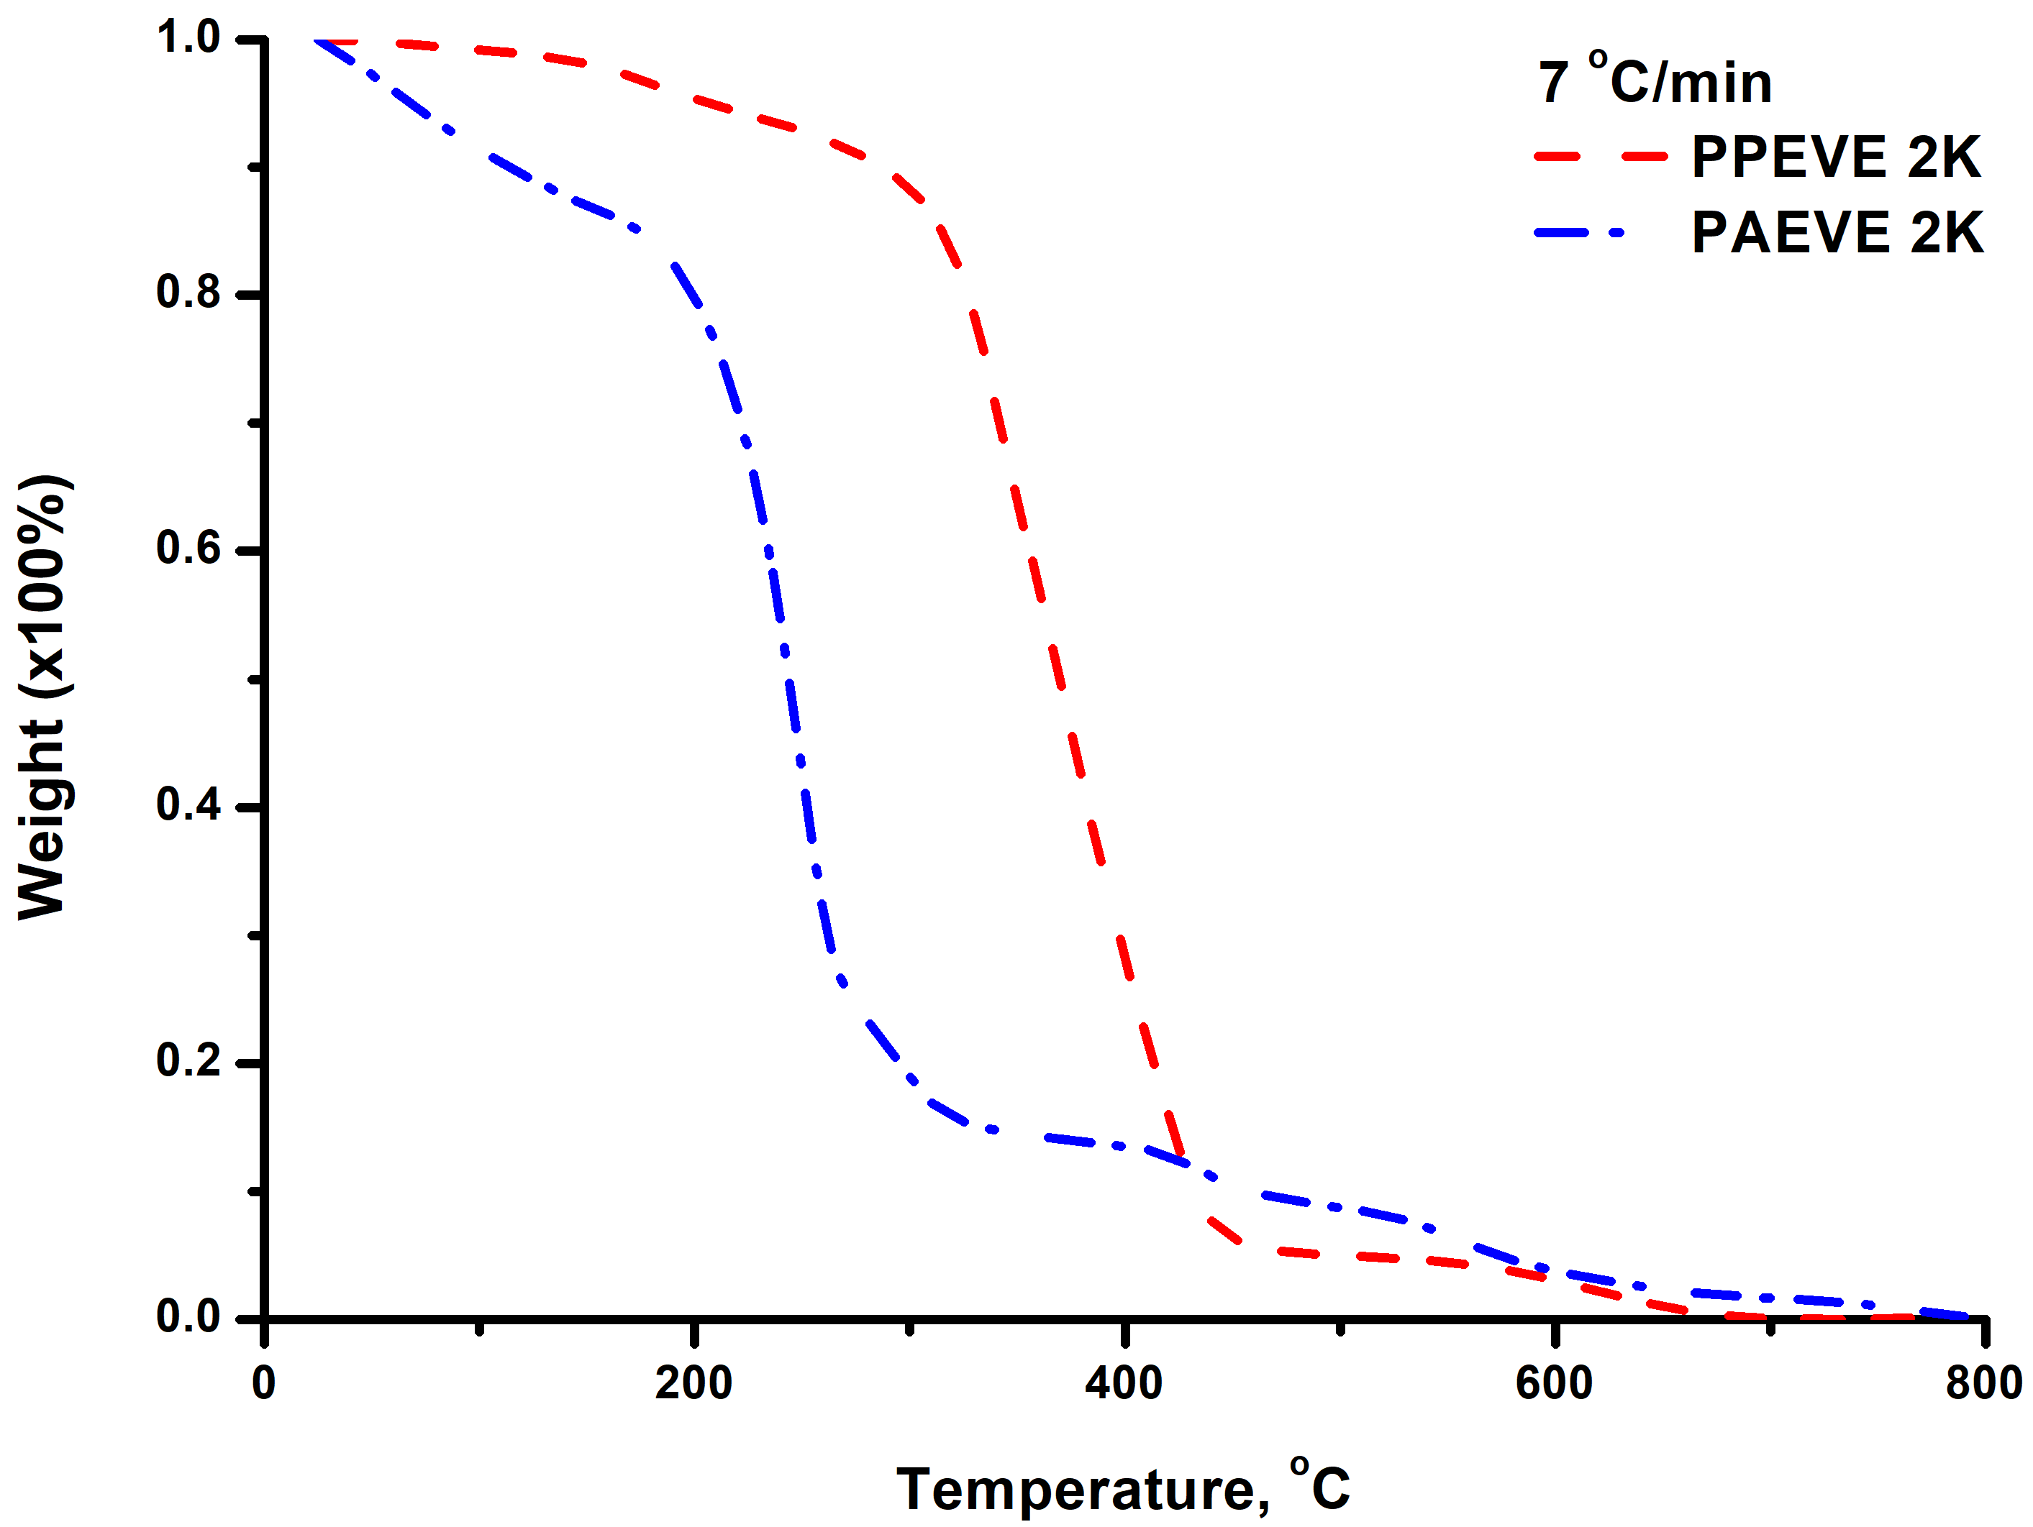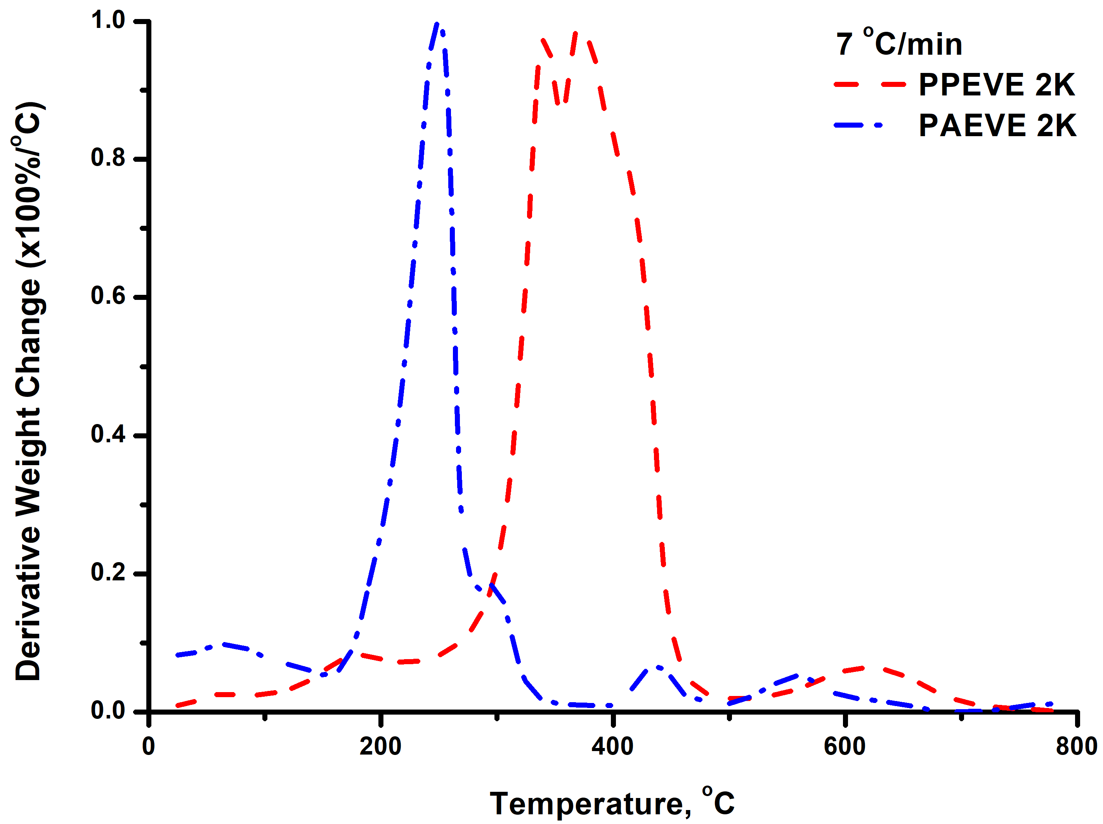
PPEVE 2K compared to PAEVE 8K at 10 ℃/min heating rate:
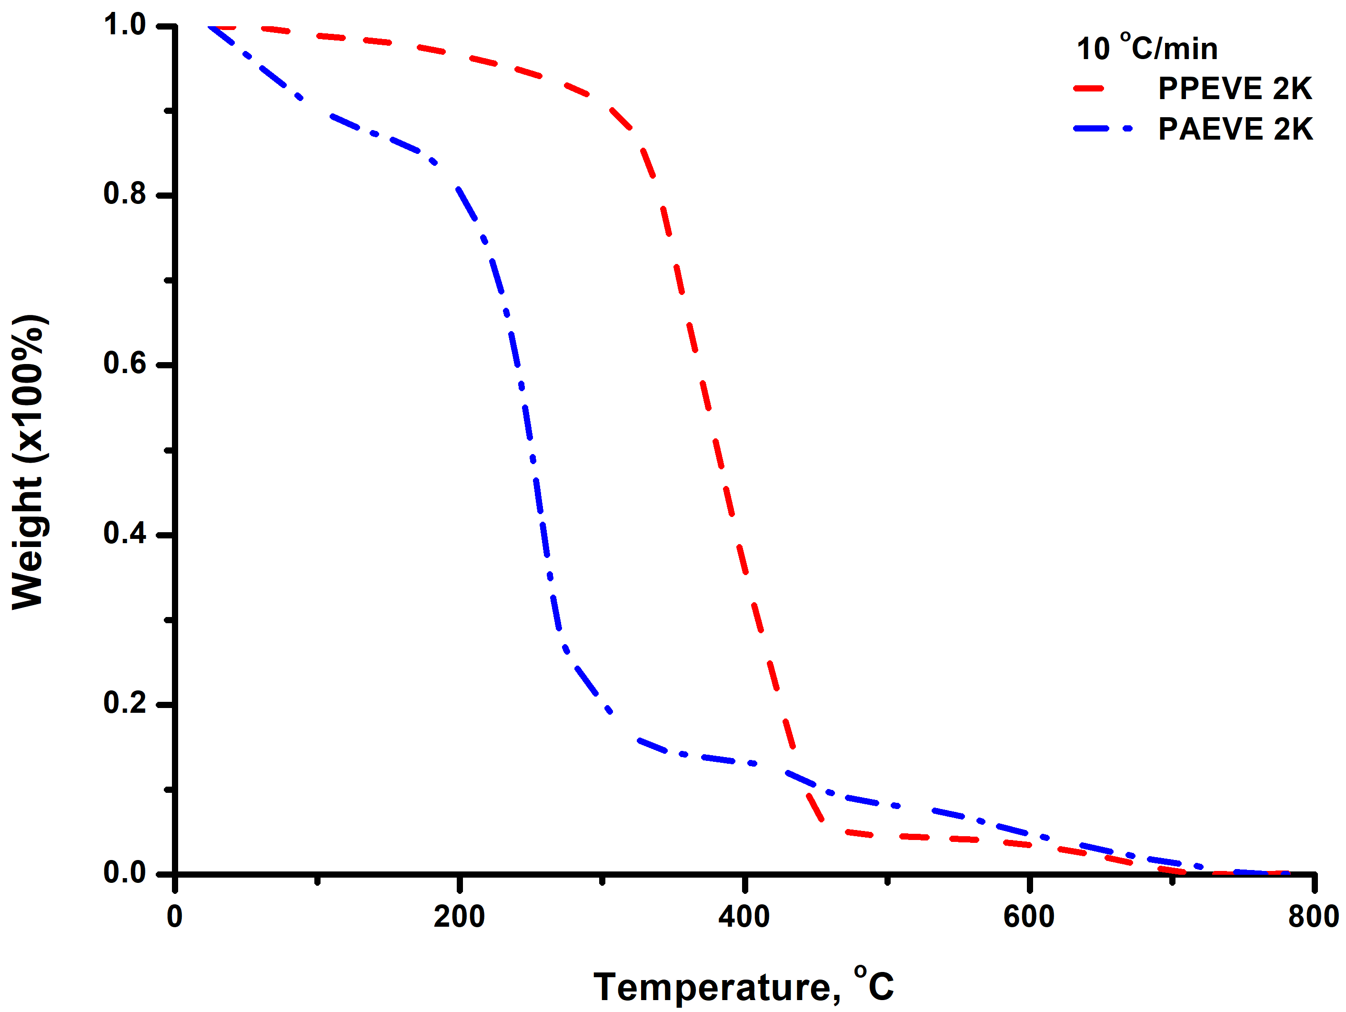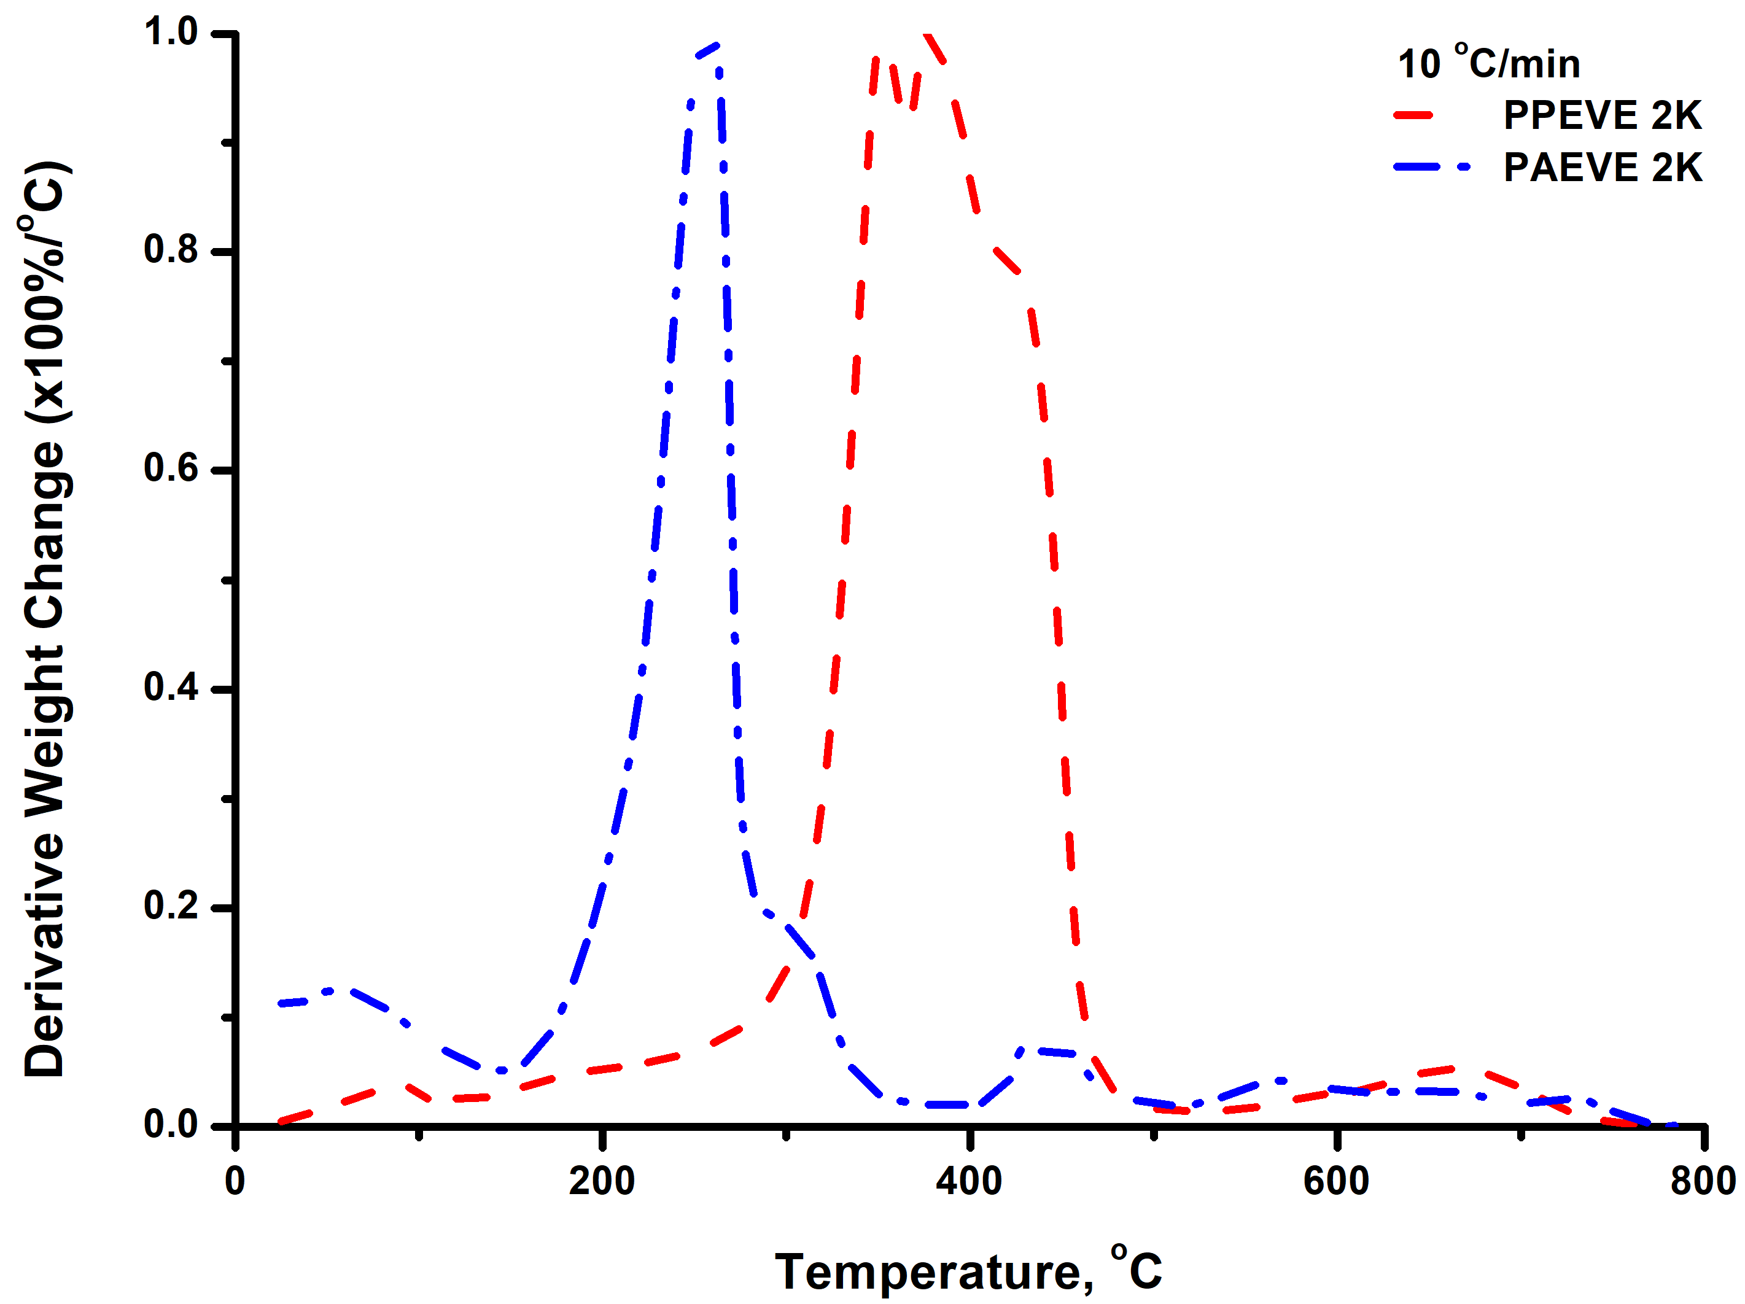
PPEVE 2K compared to PAEVE 8K at 15 ℃/min heating rate:
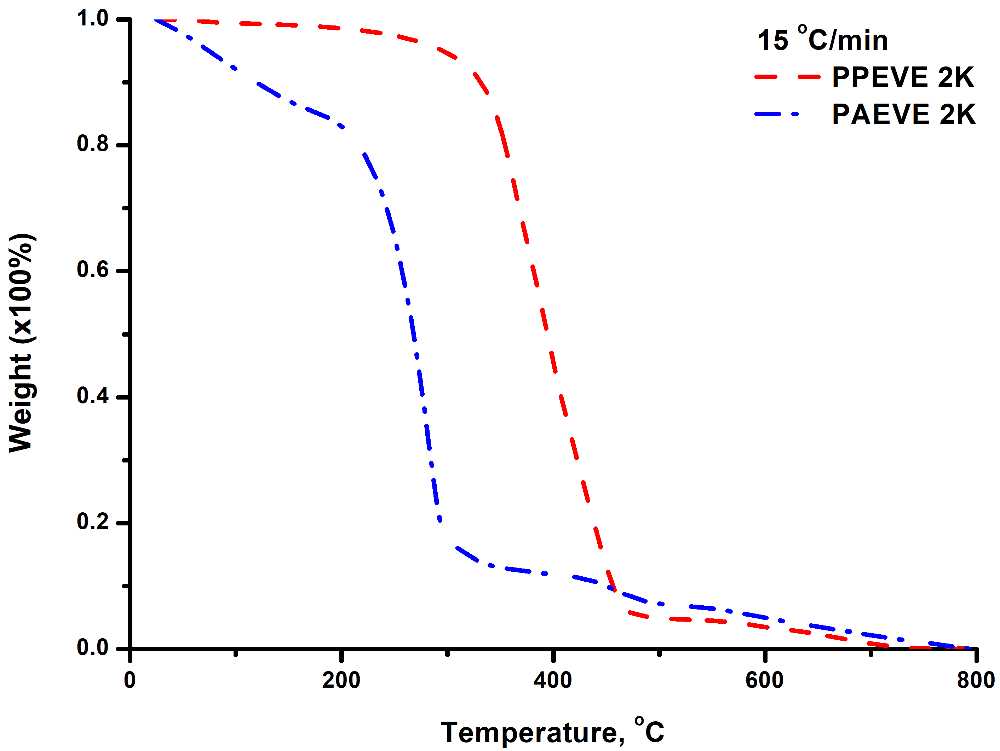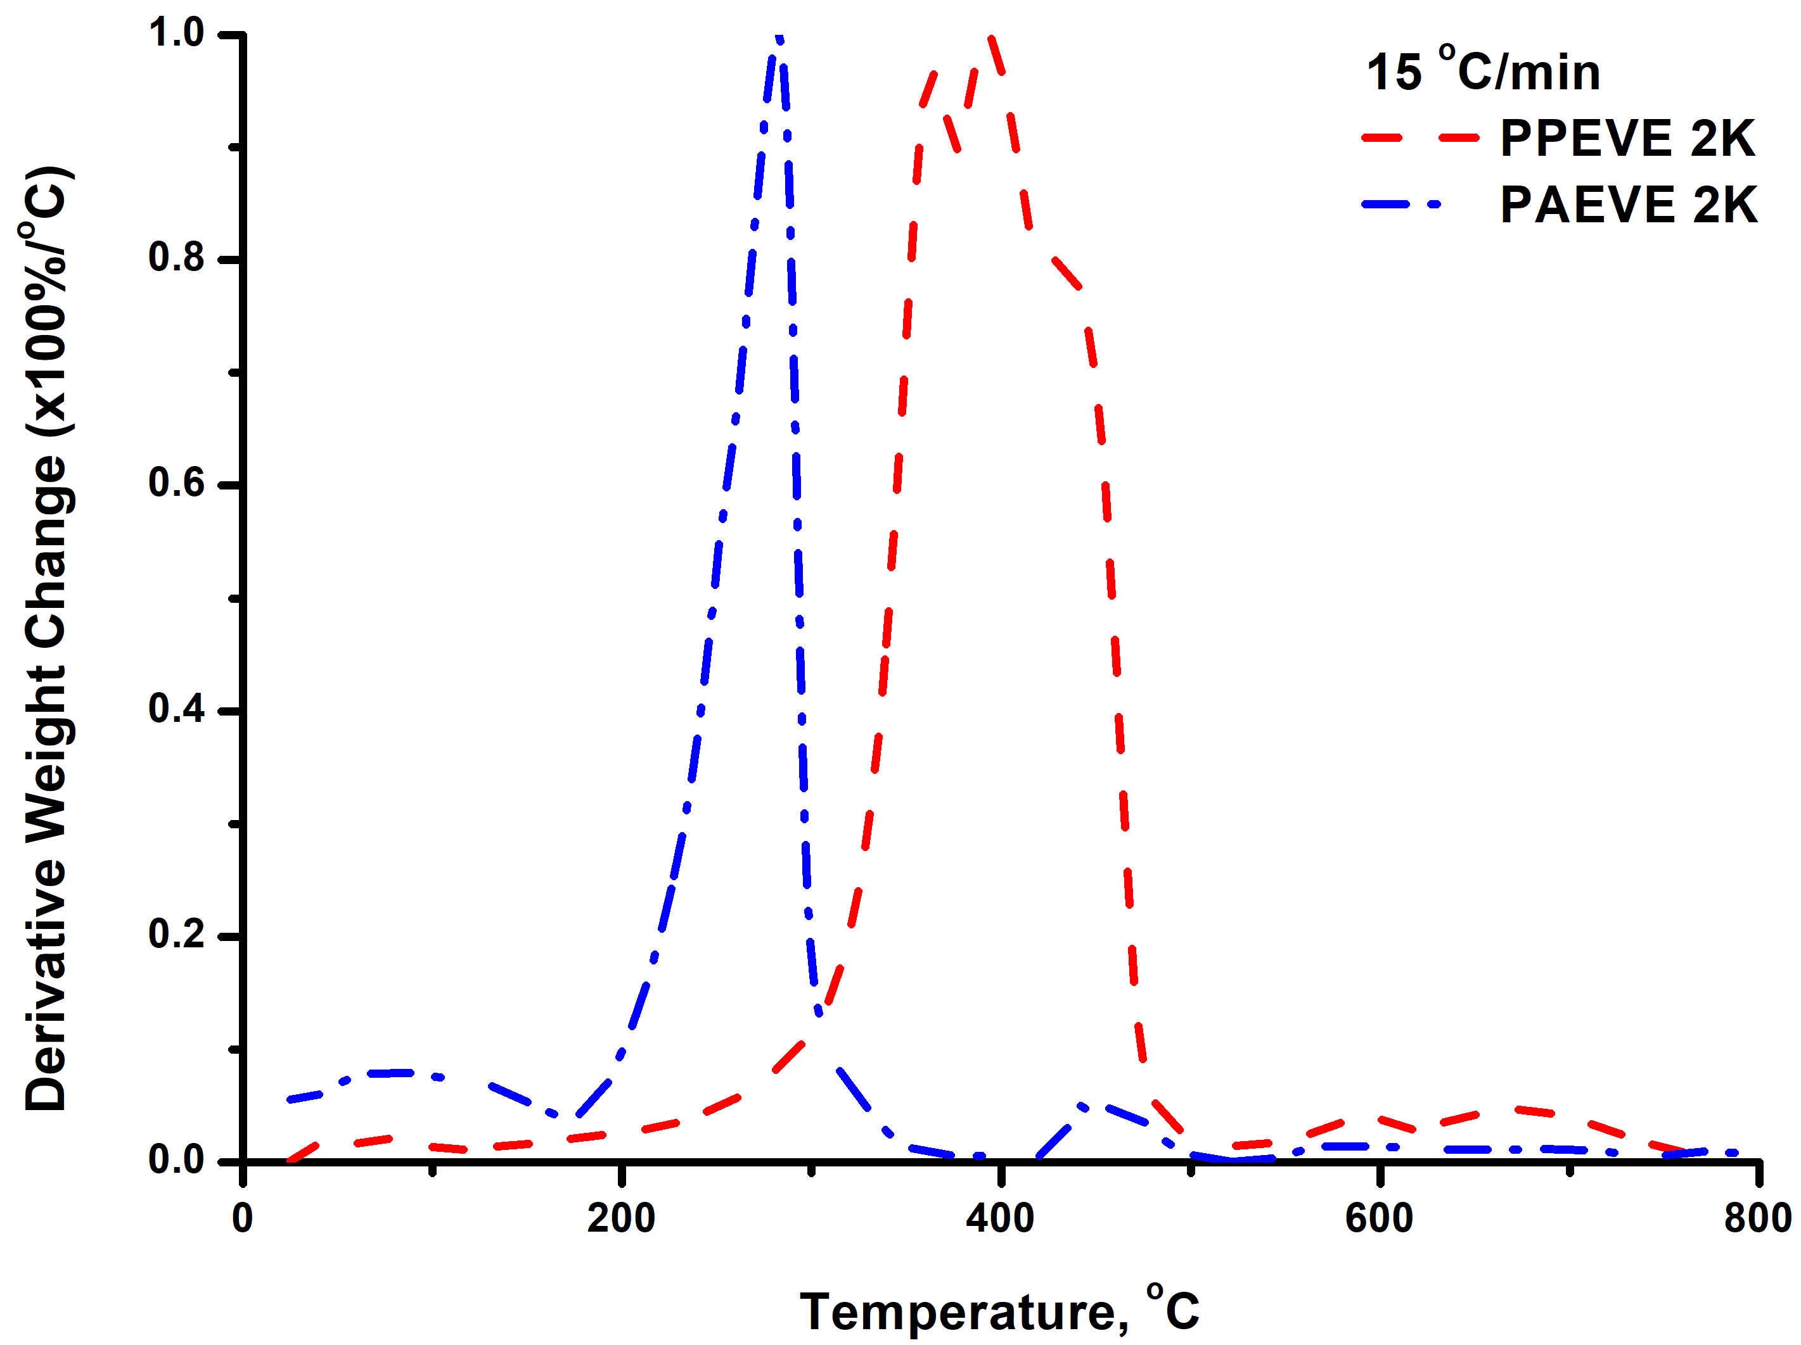
PPEVE 2K compared to PAEVE 8K at 20 ℃/min heating rate:
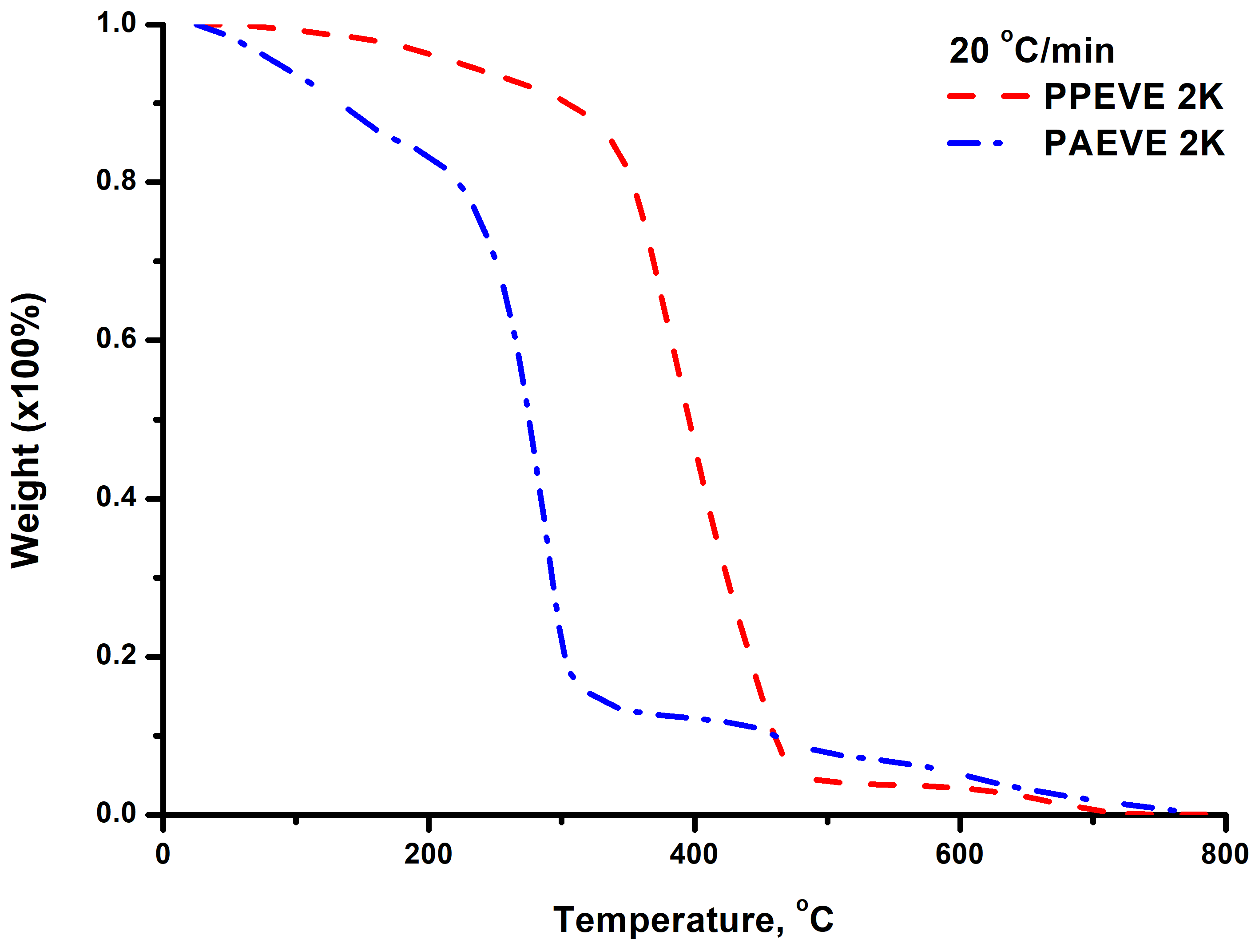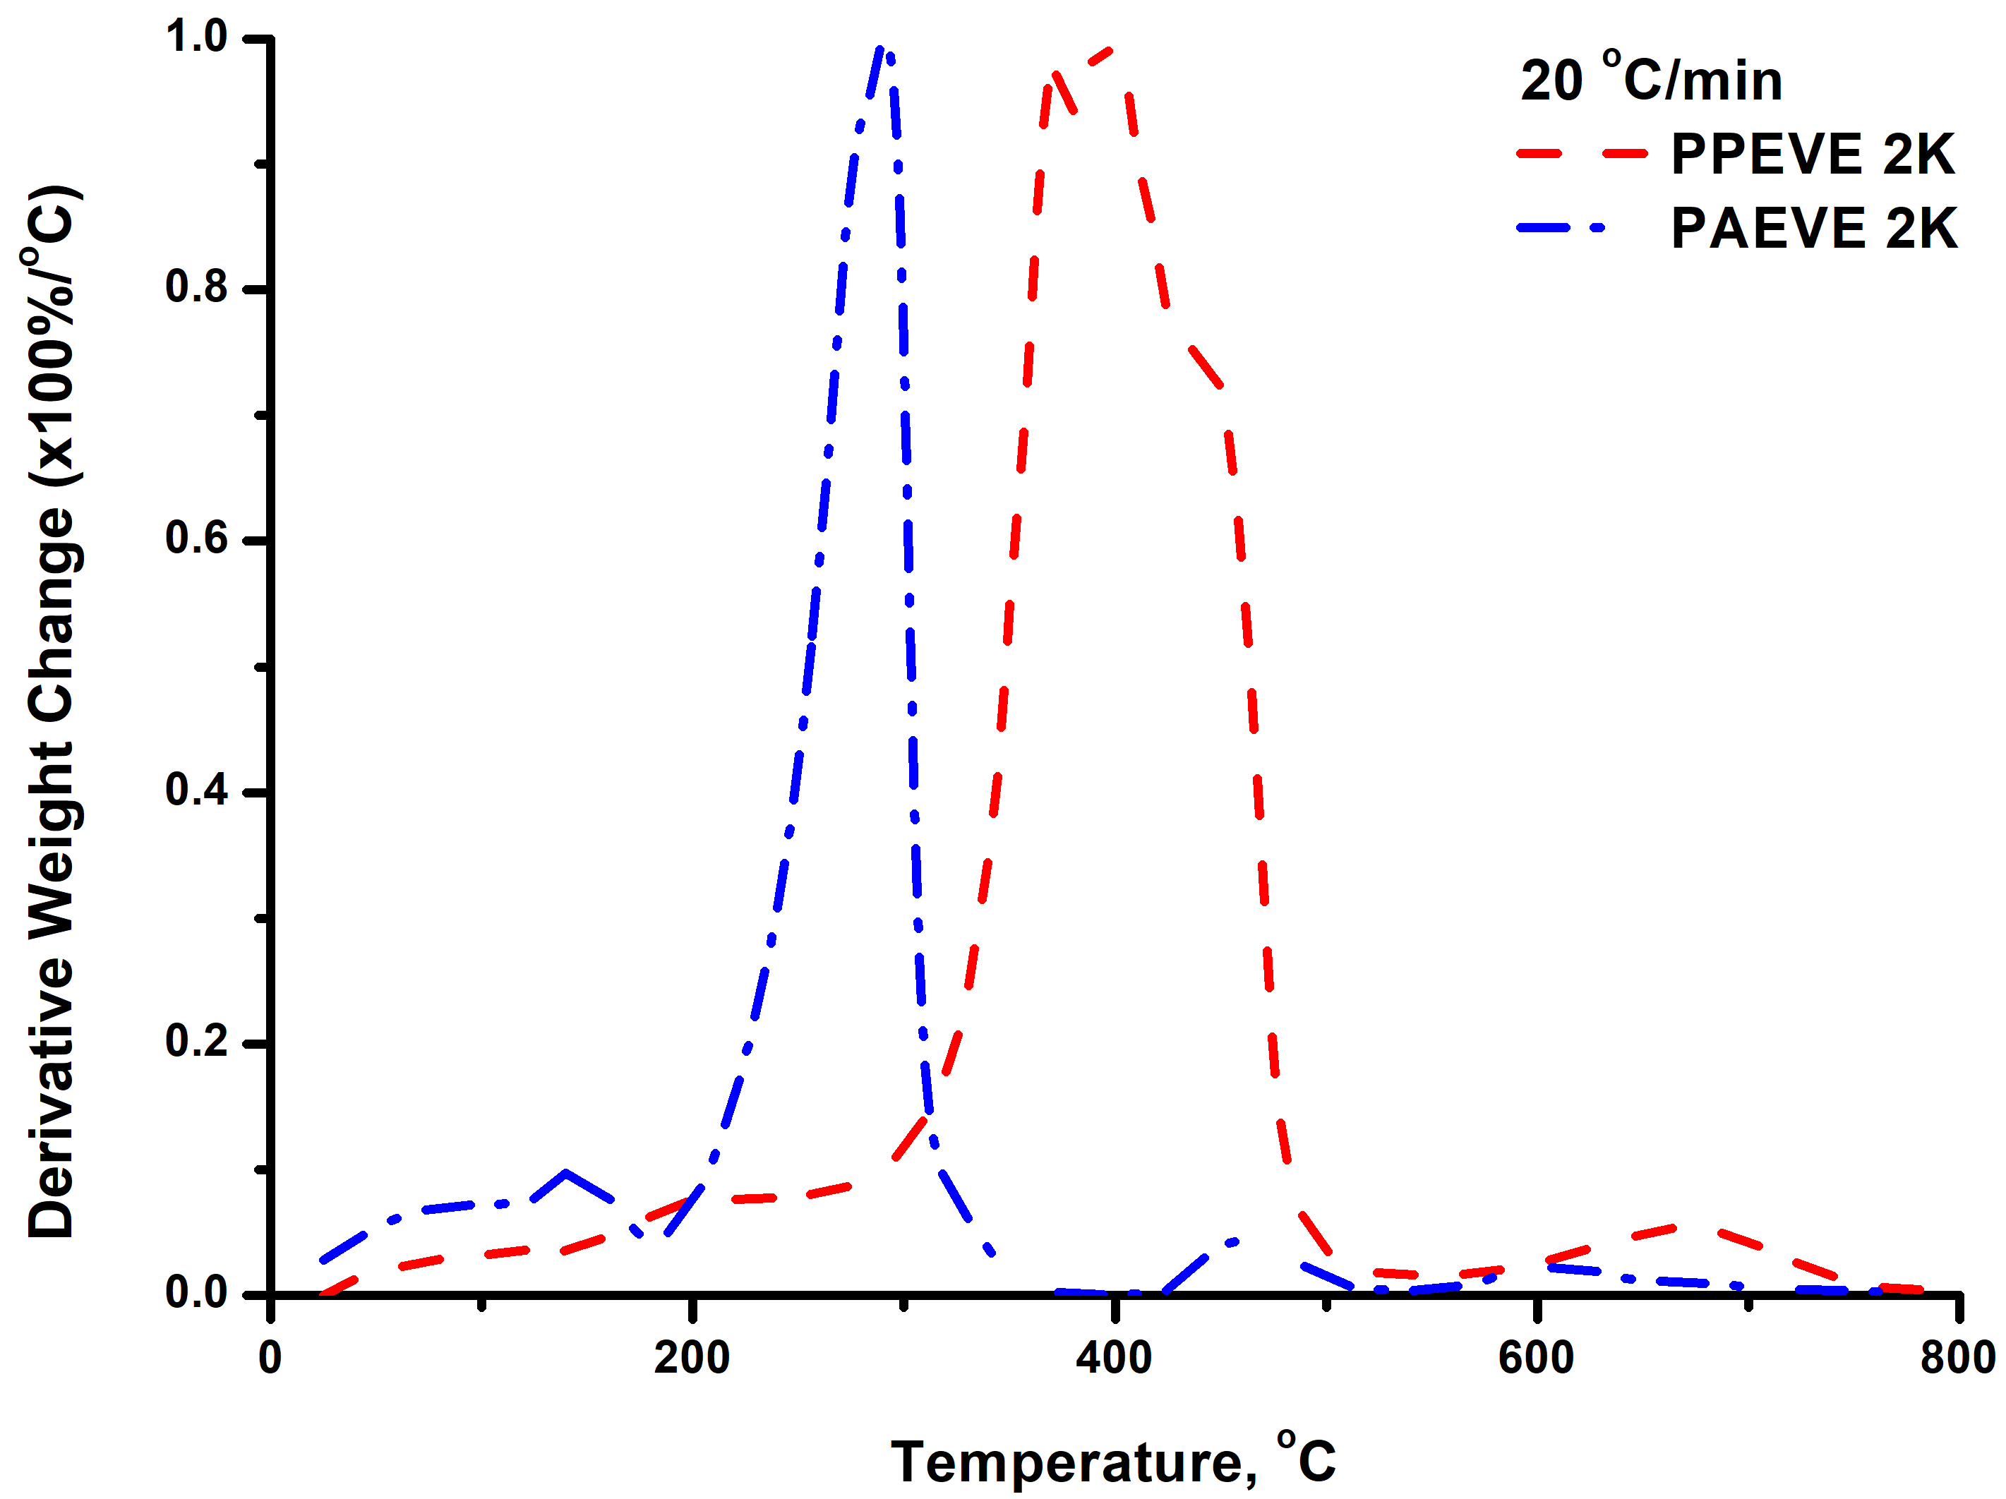
Figure S3. Comparative TGA and DTG plots for samples PPEVE 2K and PAEVE 2K at various heating rates

Table S1. Models for the analysis of the thermal decomposition
No. | Model | g(a) | f(a) | Rate-determining mechanism
1. Chemical process or mechanism non-involving equations
1 | F _{1/3} | 1−(1−a)^{2/3} | (3/2)(1−a)^{1/3} | Chemical reaction
2 | F _{¾} | 1−(1−a)^{1/4} | 4(1−a)^{3/4} | Chemical reaction
3 | F _{3/2} | (1−a)^{−1/2}−1 | 2(1−a)^{3/2} | Chemical reaction
4 | F ₂ | (1−a)⁻¹−1 | (1−a)² | Chemical reaction
5 | F ₃ | (1−a)⁻²−1 | (1/2)(1−a)³ | Chemical reaction
6 | F ₄ | (1−a)⁻³−1 | (1/3)(1−a)⁴ | Chemical reaction
7 | G ₁ | 1−(1−a)² | 1/[2(1−a)] | Chemical reaction
8 | G ₂ | 1−(1−a)³ | 1/[3(1−a)²] | Chemical reaction
9 | G ₃ | 1−(1−a)⁴ | 1/[4(1−a)³] | Chemical reaction
2. Acceleratory rate equations
10 | P _{3/2} | a^{3/2} | (2/3)a^{−1/2} | Nucleation (power law)
11 | P _{½} | a^{1/2} | 2a^{1/2} | Nucleation (power law)
12 | P _{1/3} | a^{1/3} | 3a^{2/3} | Nucleation (power law)
13 | P _{¼} | a^{1/4} | 4a^{3/4} | Nucleation (power law)
14 | P ₂ | a² | (1/2)a⁻¹ | Nucleation (parabolic law)
15 | E ₁ | lna | a | Nucleation (exponential law)
16 | E ₂ | lna² | a/2 | Nucleation (exponential law)
3. Sigmoidal rate equations or random nucleation and subsequent growth
17 | A ₁, F ₁ | −ln(1−a) | 1−a | Random nucleation/first order (Mampel)
18 | A _{2/3} | [−ln(1−a)]^{3/2} | (2/3)(1−a)[−ln(1−a)]^{−1/2} | Random nucleation (Avrami-Erofeev)
19 | A _{3/2} | [−ln(1−a)]^{2/3} | (3/2(1−a)[−ln(1−a)]^{1/3} | Random nucleation (Avrami-Erofeev)
20 | A _{¾} | [−ln(1−a)]^{4/3} | (3/4)(1−a)[−ln(1−a)]^{−1/3} | Random nucleation (Avrami-Erofeev)
21 | A _{5/2} | [−ln(1−a)]^{2/5} | (5/2)(1−a)[−ln(1−a)]^{3/5} | Random nucleation (Avrami-Erofeev)
22 | A ₂ | [−ln(1−a)]^{1/2} | 2(1−a)[−ln(1−a)]^{1/2} | Random nucleation (Avrami-Erofeev)
23 | A ₃ | [−ln(1−a)]^{1/3} | 3(1−a)[−ln(1−a)]^{2/3} | Random nucleation (Avrami-Erofeev)
24 | A ₄ | [−ln(1−a)]^{1/4} | 4(1−a)[−ln(1−a)]^{3/4} | Random nucleation (Avrami-Erofeev)
25 | A _{½} | [−ln(1−a)]² | 1/2(1−a)[−ln(1−a)]⁻¹ | Random nucleation (Avrami-Erofeev)
26 | A _{1/3} | [−ln(1−a)]³ | 1/3(1−a)[−ln(1−a)]⁻² | Random nucleation (Avrami-Erofeev)
27 | A _{¼} | [−ln(1−a)]⁴ | 1/4(1−a)[−ln(1−a)]⁻³ | Random nucleation (Avrami-Erofeev)
28 | B ₁ | ln[a/(1−a)] | a/(1−a) | Branching nuclei (Prout–Tompkins)
4. Deceleratory rate equations (phase boundary reaction)
29 | R ₁, F ₀, P ₁ | a | 1 | Contracting disk
30 | R ₂, F _{1/2} | 1−(1−a)^{1/2} | 2(1−a)^{1/2} | Contracting cylinder
31 | R ₃, F _{2/3} | 1−(1−a)^{1/3} | 3(1−a)^{2/3} | Contracting sphere
5. Deceleratory rate equations (equations based on the diffusion mechanism)
32 | D ₁ | a² | 1/(2a) | One-dimensional diffusion
33 | D ₂ | a+(1−a)ln(1−a) | [−ln(1−a)]⁻¹ | Three-dimensional diffusion
34 | D ₃ | [1−(1−a)^{1/3}]² | (3/2)(1−a)^{2/3}[1−(1−a)^{1/3}]⁻¹ | Three-dimensional diffusion (Jander)
35 | D ₄ | 1−(2/3)a−(1−a)^{2/3} | (3/2)[(1−a)^{−1/3}−1]⁻¹ | Three-dimensional diffusion (Ginstling–Brounshtein)
36 | D ₅ | [(1−a)^{−1/3}−1]² | (3/2)(1−a)^{4/3}[(1−a)^{−1/3}−1]⁻¹ | Three-dimensional diffusion (Crank)
37 | D ₆ | [(1+a)^{1/3}−1]² | (3/2)(1+a)^{2/3}[(1+a)^{1/3}−1]⁻¹ | Three-dimensional diffusion
38 | D ₇ | 1+(2/3)a−(1+a)^{2/3} | 3/2[(1+a)^{−1/3}−1]⁻¹ | Three-dimensional diffusion
39 | D ₈ | [(1+a)^{−1/3}−1]² | 3/2(1+a)^{4/3}[(1+a)^{−1/3}−1]⁻¹ | Three-dimensional diffusion
6. Other kinetic equations with unjustified mechanism
40 | G ₇ | [1−(1−a)^{1/2}]^{1/2} | 4{(1−a)[1−(1−a)^{1/2}]}^{1/2}
41 | G ₈ | [1−(1−a)^{1/3}]^{1/2} | 6(1−a)^{2/3}[1−(1−a)^{1/3}]^{1/2}

Table S2. TGA data at different heating rates
3 °C/min
 | 1st Peak |  |  | 2nd Peak |  |  | 3rd Peak |  |  | 4th Peak
Sample | Start  (°C) | End  (°C) | Peak  (°C) | Start  (°C) | End  (°C) | Peak  (°C) | Start  (°C) | End  (°C) | Peak  (°C) | Start  (°C) | End  (°C) | Peak  (°C)
PPEVE  2K | 224.27 | 336.32 | 324.20 | 338.03 | 475.20 | 359.37 | - | - | - | 493.15 | 691.07 | 583.76
PPEVE  8K | - | - | - | - | - | - | 217.78 | 478.07 | 398.09 | 492.21 | 673.89 | 577.94
PAEVE  2K | 143.98 | 263.31 | 236.64 | 269.08 | 338.83 | 282.28 | 383.99 | 460.19 | 426.20 | 483.78 | 624.09 | 537.19

5 °C/min
 | 1st Peak |  |  | 2nd Peak |  |  | 3rd Peak |  |  | 4th Peak
Sample | Start  (°C) | End  (°C) | Peak  (°C) | Start  (°C) | End  (°C) | Peak  (°C) | Start  (°C) | End  (°C) | Peak  (°C) | Start  (°C) | End  (°C) | Peak  (°C)
PPEVE  2K | 214.87 | 346.95 | 337.25 | 349.87 | 488.46 | 369.91 | - | - | - | 524.32 | 697.60 | 617.36
PPEVE  8K | - | - | - | - | - | - | 227.55 | 493.27 | 407.52 | 533.37 | 706.09 | 603.70
PAEVE  2K | 137.45 | 274.72 | 245.00 | 283.21 | 353.18 | 293.72 | 397.23 | 468.68 | 435.83 | 502.44 | 651.31 | 549.26

7 °C/min
 | 1st Peak |  |  | 2nd Peak |  |  | 3rd Peak |  |  | 4th Peak
Sample | Start  (°C) | End  (°C) | Peak  (°C) | Start  (°C) | End  (°C) | Peak  (°C) | Start  (°C) | End  (°C) | Peak  (°C) | Start  (°C) | End  (°C) | Peak  (°C)
PPEVE  2K | 231.94 | 354.10 | 340.80 | 356.71 | 500.12 | 370.78 | - | - | - | 522.47 | 745.28 | 620.43
PPEVE  8K | - | - | - | - | - | - | 227.57 | 50140 | 414.03 | 534.61 | 706.41 | 598.07
PAEVE  2K | 158.35 | 284.02 | 249.78 | 291.25 | 353.51 | 297.72 | 401.00 | 486.87 | 438.77 | 509.10 | 677.10 | 559.24

10 °C/min
 | 1st Peak |  |  | 2nd Peak |  |  | 3rd Peak |  |  | 4th Peak
Sample | Start  (°C) | End  (°C) | Peak  (°C) | Start  (°C) | End  (°C) | Peak  (°C) | Start  (°C) | End  (°C) | Peak  (°C) | Start  (°C) | End  (°C) | Peak  (°C)
PPEVE  2K | 136.76 | 364.14 | 351.55 | 365.80 | 505.16 | 376.39 | - | - | - | 539.29 | 761.06 | 663.23
PPEVE  8K | - | - | - | - | - | - | 235.37 | 529.34 | 425.49 | 553.95 | 731.62 | 621.84
PAEVE  2K | 152.83 | 380.89 | 259.69 | - | - | - | 391.98 | 506.32 | 448.44 | - | - | -

15 °C/min
 | 1st Peak |  |  | 2nd Peak |  |  | 3rd Peak |  |  | 4th Peak
Sample | Start  (°C) | End  (°C) | Peak  (°C) | Start  (°C) | End  (°C) | Peak  (°C) | Start  (°C) | End  (°C) | Peak  (°C) | Start  (°C) | End  (°C) | Peak  (°C)
PPEVE  2K | 122.95 | 375.91 | 363.65 | 376.66 | 522.71 | 392.80 | 542.99 | 616.10 | 592.69 | 618.98 | 800.00 | 675.93
PPEVE  8K | - | - | - | - | - | - | 244.23 | 544.35 | 435.07 | 588.54 | 745.24 | 659.76
PAEVE  2K | 176.47 | 365.55 | 282.12 | - | - | - | 413.60 | 511.60 | 464.94 | - | - | -

20 °C/min
 | 1st Peak |  |  | 2nd Peak |  |  | 3rd Peak |  |  | 4th Peak
Sample | Start  (°C) | End  (°C) | Peak  (°C) | Start  (°C) | End  (°C) | Peak  (°C) | Start  (°C) | End  (°C) | Peak  (°C) | Start  (°C) | End  (°C) | Peak  (°C)
PPEVE  2K | 241.03 | 378.56 | 370.57 | 382.90 | 526.80 | 393.08 | - | - | - | 567.06 | 776.58 | 667.90
PPEVE  8K | - | - | - | - | - | - | 250.50 | 531.94 | 443.79 | 559.16 | 720.96 | 631.63
PAEVE  2K | 183.68 | 372.13 | 291.06 | - | - | - | 421.02 | 423.36 | 465.44 | 553.94 | 764.33 | 608.54

