Supporting Information for “Multichannel meta-imager for parallel front-end optical computations”

Xinyi Bi¹, Xuanguang Wu¹, Xinhao Fan¹, Chenyang Zhao², Dandan Wen¹, Sheng Liu¹, Xuetao Gan¹, Jianlin Zhao¹, Peng Li^{1*}
¹Key Laboratory of Light Field Manipulation and Information Acquisition, Ministry of Industry and Information Technology, Shaanxi Key Laboratory of Optical Information Technology, School of Physical Science and Technology, Northwestern Polytechnical University, Xi’an, Shaanxi, 710129, China
²Analytical and Testing Center, Northwestern Polytechnical University, Xi’an, Shaanxi, 710129, China
*Corresponding author. Email: pengli@nwpu.edu.cn

S1. Influences of wavelength on convolution operation
For these designed metasurfaces, the geometric phases at different wavelengths solely depend on the rotation angle of the nanopillar unit. Consequently, the metasurface's geometric phase delay response remains consistent across different wavelengths, so the polarization rotation angle of linearly polarized light and the relative intensity distribution of the coherent transfer function after polarization detection are also the same.
Within the 4f system, during the Fourier transform process, the spatial spectrum position coordinate x, y and spatial spectrum component k_{x}, k_{y} satisfy k_{x}=x/λf and k_{y}=y/λf, where λ signifies the wavelength, and f is the focal length of the Fourier transform lens. Therefore, the spatial spectral position distribution of the same incident image at different wavelengths is proportional to the wavelength. Due to the fact that the relative intensity distribution of the metasurface is the same at different wavelengths, the local relative intensity transmittance of the same spatial spectral component varies when incident at different wavelengths. The dependence of intensity transmittance on the spatial spectrum under different wavelengths is shown in Fig. S1. Where the red, green, and blue curves depict the wavelengths of 633 nm, 532 nm, and 473 nm, respectively. According to these curves, we can see that in the integral operation, the shorter the wavelength, the fewer higher spatial spectrum components are eliminated. In differential operation, the shorter the wavelength, the fewer higher spatial spectrum components are retained. Therefore, for the calculation results, the shorter the wavelength of the incident light, the lower the smoothness of the integral operation, and the higher the resolution of the differential operation. In practical applications, the optimization of metasurface design and adjustment of the working wavelength should be tailored to the resolution of the detection system and specific requirements.

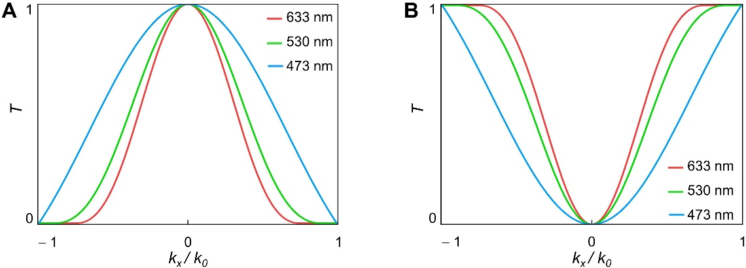
Fig. S1. Transmittance distributions of transfer function vs. spatial spectrum at different wavelengths. (A) Integration; (B) Differentiation.

S2. Experiment results of integral operation imaging under multiple wavelengths
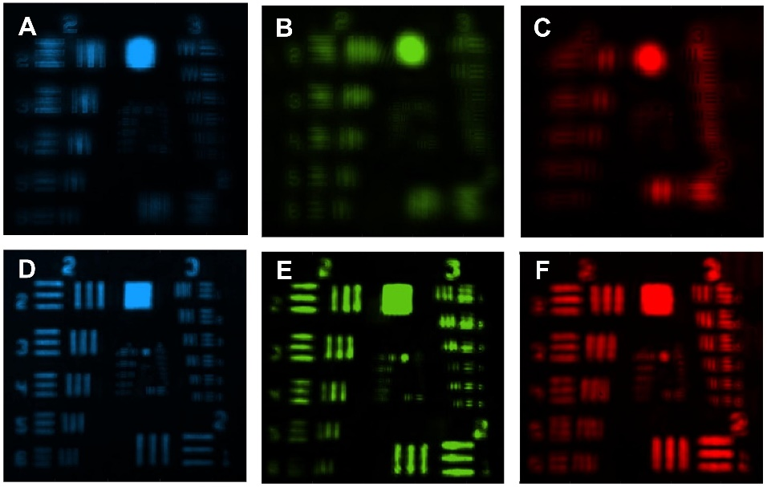
Fig. S2. Experimental results of integral operation on the resolution test chart at multiple wavelengths. Experimental results with a denoising diameter of 250 μm: (A) 473 nm, (B) 530 nm, (C) 633 nm; Experimental results with a denoising diameter of 88.39 μm: (D) 473 nm, (E) 530 nm, (F) 633 nm.

S3. Experiment results of differential operation imaging under multiple wavelengths
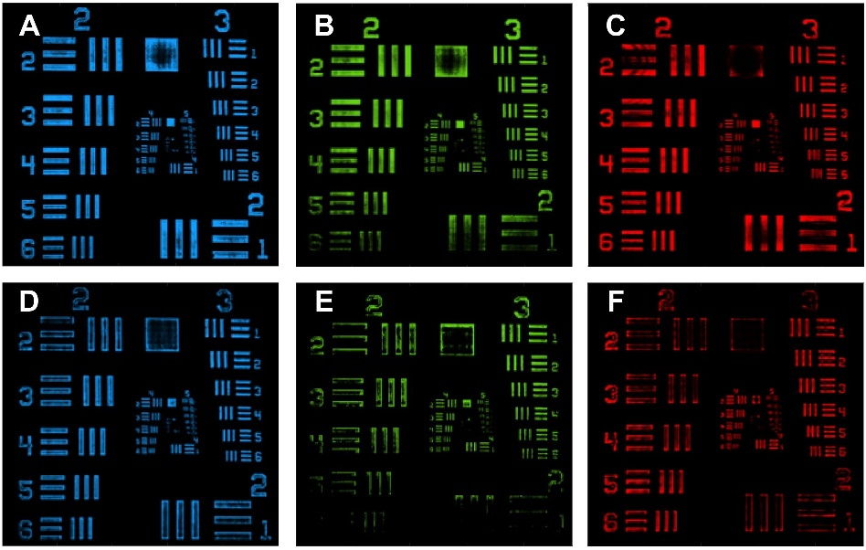
Fig. S3. Experimental results of differential operation of the resolution test chart at multiple wavelengths. Experimental results with a denoising diameter of 250 μm: (A) 473 nm, (B) 530 nm, (C) 633 nm; Experimental results with a denoising diameter of 88.39 μm: (D) 473 nm, (E) 530 nm, (F) 633 nm.

S4. Experiment results of edge detection of onion cells at multiple wavelengths
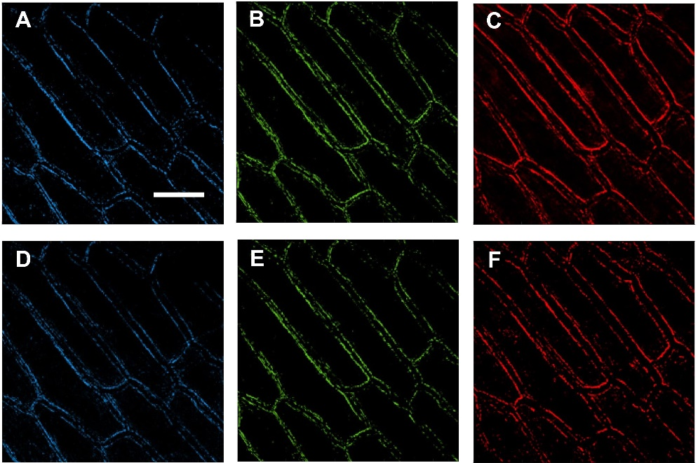
Fig. S4. Edge detection results of onion cells at multiple wavelengths. Experimental results with a denoising diameter of 250 μm: (A) 473 nm (scale: 100 μm), (B) 530 nm, (C) 633 nm; Experimental results with a denoising diameter of 88.39 μm: (D) 473 nm, (E) 530 nm, (F) 633 nm

