Supplementary appendix 1

Appendix materials
Contents
Number | Title of files | Page
1 | Figure S1. Study design of FKD-CSS. | 3
2 | Figure S2. Flow chart of the corneal staining images annotation. | 4
3 | Table S1. The Standard practice for corneal staining and photography (version 1.0) | 5
4 | Table S2A. Distribution of corneal staining images by hospitals in DE development and internal validation datasets（Eastern China）. | 6
5 | Table S2B. Distribution of corneal staining images by provinces or municipalities in development and internal validation datasets（Eastern China）. | 7
6 | Table S2C. Corneal staining score distributions in the development & internal validation dataset. | 8
7 | Table S3A. Distribution of corneal staining images by hospitals in DE external test datasets. | 9
8 | Table S3B. Distribution of corneal staining images by provinces or municipalities in DE external test datasets. | 10
9 | Table S4. CSS distributions in DE development, internal validation, and external test datasets. | 11
10 | Table S5A. Distributions of diseases in external test datasets of multiple ocular surface diseases. | 12
11 | Table S5B. Corneal staining scores distributions in the external test sets of multiple ocular surface diseases. | 13
12 | Table S6. Known manufacturers and types of cameras in all the datasets | 14

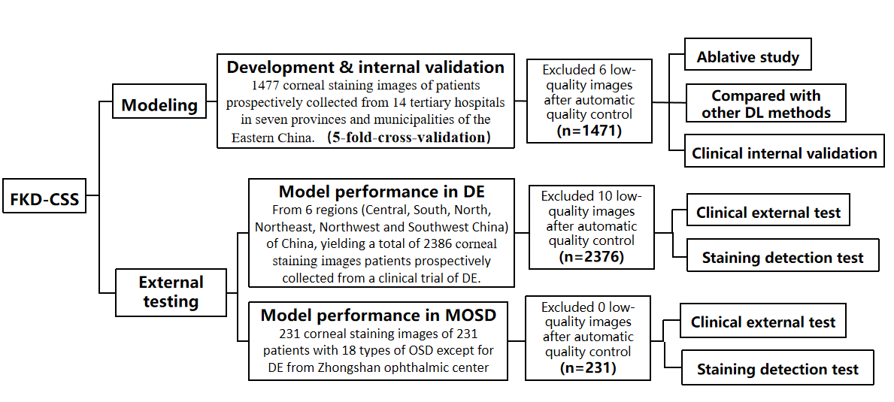
Figure S1. Study design of FKD-CSS. Clinical internal validation and external tests including comparison of model with the ground-truth and with different ophthalmologists. DL: deep learning. OSD: ocular surface disease.

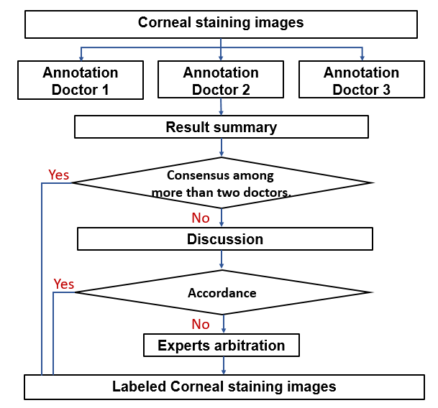
Figure S2. Flow chart of the corneal staining images annotation. Firstly, original corneal fluorescein staining images were assigned separately to three authorized ophthalmologists, who then worked individually to annotated the corneal staining lesions and grade the images into corneal staining score. When two of the ophthalmologists have the same annotations and scores, the results will be the final labels and scores. If the results of three ophthalmologists were contradictory, the three ophthalmologists would discuss together until a consensus is reached. If the reading group encountered difficult cases, they could apply for expert arbitration done by two ocular surface experts.

Table S1. The Standard practice for corneal staining and photography (version 1.0)
- Corneal fluorescein staining and photographing
- Instilled 1-2 drops of sterile onto the fluorescein-impregnated strip (Liaoning Meizilin Pharmaceutical Co., Ltd), which contains 0.30-0.40mg of sodium fluorescein. (NOTE: The drops are allowed to just saturate the impregnated tip, at which point the excess is immediately shaken free into a waste bin.)
- The lower eyelid of the subject is then pulled downward, gently tap the strip onto the lower tarsal conjunctival surface. Ask the subject to blink more than 3 times until the dye is evenly coated. (NOTE: The corneal fluorescein staining should be shot within 1-3 minutes after staining.)
- Use a digital camera in automatic mode with at least 2 million pixels.
- Set diffuse light illumination of slit-lamp.
- Set magnification to × 10.
- Set the microscope straight ahead and light tower to 15 degrees temporal.
- Assure patient comfort and position in slit lamp, and look straight ahead, fix the subject's upper and lower eyelids to fully expose the cornea,
- Focus on the corneal epithelium, take at least 2 photos of the fully exposed cornea.

- Images quality assessment and upload
- Capture images from a perpendicular angle to the cornea.
- Ensure proper exposure and brightness.
- The limbus should be visible.
- The stained corneal epithelium area is evenly colored without dye residue on the eyelid or corneal edge, and the staining is obvious.
- Select a qualified image from multiple photos of the same eye and upload it to the Medidata as required.

- Re-staining and photographing
- If all images of the same eye fail to meet the requirements mentioned in Part 2, the eye needs to be re-stained and photographed. For cases with obvious secretions and filaments, it is necessary to re-staining and photographing after gently removing the secretions and the filaments. (NOTE: Re-staining and photographing should be repeated at least five minutes after washing the unqualified eye with saline until a qualified image was obtained.)

Table S2A. Distribution of corneal staining images by hospitals in DE development and internal validation datasets（Eastern China）.
No | Hospitals | Number of Images | Percentage（%）
1 | Xiamen Eye Center of Xiamen University | 129 | 8.73
2 | Shanghai Tongji Hospital | 103 | 6.97
3 | The First Affiliated Hospital of Bengbu Medical College | 61 | 4.13
4 | Wuxi People's Hospital | 94 | 6.36
5 | Eye & Ent Hospital of Fudan University | 56 | 3.79
6 | Huai 'an First People's Hospital | 47 | 3.18
7 | The Second Affiliated Hospital of Anhui Medical University | 102 | 6.91
8 | Zhejiang Provincial People's Hospital | 185 | 12.53
9 | The Second Affiliated Hospital of Zhejiang University School of Medicine | 187 | 12.66
10 | Eye Hospital, WMU Zhejiang Eye Hospital | 110 | 7.45
11 | The Second Affiliated Hospital of Nanchang University | 168 | 11.37
12 | Lishui Municipal Central Hospital | 85 | 5.75
13 | Ningbo Eye Hospital | 64 | 4.33
14 | Affiliated Eye Hospital of Shandong University of Chinese Medicine | 86 | 55.82
Total | - | 1477 | 100

Table S2B. Distribution of corneal staining images by provinces or municipalities in development and internal validation datasets（Eastern China）.
No | Provinces or municipalities | Number of Images | Percentage（%）
1 | Fujian | 129 | 8.73
2 | Shanghai | 159 | 10.77
3 | Anhui | 210 | 14.22
4 | Jiangsu | 94 | 6.36
5 | Zhejiang | 631 | 42.72
6 | Jiangxi | 168 | 11.37
7 | Shandong | 86 | 5.82
Total | - | 1477 | 100

Table S2C. Corneal staining score distributions in the development & internal validation dataset.
CSS* | Number of images | Percentage（%）
0 | 421 | 28.50
0.5 | 123 | 8.33
1 | 118 | 7.99
1.5 | 116 | 7.85
2 | 184 | 12.46
2.5 | 201 | 13.61
3 | 155 | 10.49
3.5 | 112 | 7.58
4 | 47 | 3.18
Total | 1477 | 100
*SNWC：Staining Negative or Without Clinical Significance. CSS：Corneal Staining Score.

Table S3A. Distribution of corneal staining images by hospitals in DE external test datasets.
Dataset | No | Hospitals | Number of Images | Percentage（%）
Northeast China  （119） | 1 | Shenyang He's Eye Hospital | 46 | 38.66
Northeast China  （119） | 2 | Tonghua Central Hospital | 6 | 5.04
Northeast China  （119） | 3 | The First Affiliated Hospital of Harbin Medical University | 67 | 56.30
North China  （595） | 1 | Peking Union Medical College Hospital | 54 | 9.08
North China  （595） | 2 | Beijing Hospital | 161 | 27.06
North China  （595） | 3 | Shanxi Eye Hospital | 131 | 22.02
North China  （595） | 4 | Hebei Eye Hospital | 54 | 9.08
North China  （595） | 5 | Beijing Tongren Hospital | 195 | 32.77
South China  （251） | 1 | Zhongshan Ophthalmic center of Sun Yat-sen University | 189 | 75.30
South China  （251） | 2 | Joint Shantou International Eye Centre of Shantou University and The Chinese University of Hong Kong | 62 | 24.70
Central China  （718） | 1 | Xiangya Hospital of Central South University | 122 | 16.99
Central China  （718） | 2 | Henan Provincial Eye Hospital | 253 | 35.24
Central China  （718） | 3 | The Third Affiliated Hospital of Xinxiang Medical University | 17 | 2.37
Central China  （718） | 4 | The First Affiliated Hospital of Zhengzhou University | 75 | 10.45
Central China  （718） | 5 | Wuhan Puren Hospital | 165 | 22.98
Central China  （718） | 6 | Wuhan Aier Eye Hospital | 38 | 5.29
Central China  （718） | 7 | The First Affiliated Hospital of Xinxiang Medical College | 48 | 6.69
Northwest China  （212） | 1 | Xi’an Fourth Hospital | 105 | 49.53
Northwest China  （212） | 2 | The First Affliated Hospital of Xi’an Jiaotong University | 37 | 17.45
Northwest China  （212） | 3 | Ningxia People's Hospital | 70 | 33.02
Southwest China  （491） | 1 | Chengdu Aier Eye Hospital | 230 | 46.84
Southwest China  （491） | 2 | Panzhihua Hospital of Integrated Chinese and Western Medicine | 47 | 9.57
Southwest China  （491） | 3 | Chongqing Aier Eye Hospital | 214 | 43.58
Total | 23 | - | 2386 | -

Table S3B. Distribution of corneal staining images by provinces or municipalities in DE external test datasets.
Dataset  （No. of images） | No | Provinces or municipalities | Number of Images | Percentage（%）
Northeast China  （119） | 1 | Liaoning | 46 | 38.66
Northeast China  （119） | 2 | Jiling | 6 | 5.04
Northeast China  （119） | 3 | Heilongjiang | 67 | 56.30
North China  （595） | 1 | Beijing | 54 | 9.08
North China  （595） | 2 | Shanxi | 161 | 27.06
North China  （595） | 3 | Hebei | 131 | 22.02
South China  （251） | 1 | Guangdong | 189 | 75.30
South China  （251） | 2 | Hong Kong | 62 | 24.70
Central China  （718） | 1 | Hunan | 122 | 16.99
Central China  （718） | 2 | Henan | 253 | 35.24
Central China  （718） | 3 | Hubei | 17 | 2.37
Northwest China  （212） | 1 | Shanxi | 105 | 49.53
Northwest China  （212） | 2 | Ningxia | 37 | 17.45
Southwest China  （491） | 1 | Shichuan | 230 | 46.84
Southwest China  （491） | 2 | Chongqing | 214 | 43.58
Total | 15 | - | 2386 | -

Table S4. CSS distributions in DE development, internal validation, and external test datasets.
CSS* | Development & Internal validation set | External validation sets
CSS* | Development & Internal validation set | North | Northeast | Northwest | Central | Southwest | South
0 | 421 | 68 | 11 | 28 | 209 | 124 | 50
0.5 | 123 | 29 | 7 | 20 | 73 | 28 | 34
1 | 118 | 32 | 17 | 13 | 46 | 14 | 17
1.5 | 116 | 64 | 18 | 11 | 58 | 37 | 23
2 | 184 | 105 | 24 | 42 | 98 | 74 | 36
2.5 | 201 | 108 | 21 | 35 | 74 | 59 | 32
3 | 155 | 84 | 8 | 18 | 67 | 56 | 27
3.5 | 112 | 61 | 6 | 22 | 59 | 68 | 23
4 | 47 | 44 | 7 | 23 | 34 | 31 | 9
Total | 1477 | 595 | 119 | 212 | 718 | 491 | 251
*CSS：corneal staining score.

Table S5A. Distributions of diseases in external test datasets of multiple ocular surface diseases.
No | Disease | Number of photographs | Percentage (%)
1 | Blepharokeratoconjunctivitis | 12 | 55.19
2 | Iridocorneal Endothelial Syndrome | 7 | 3.03
3 | Vernal Keratoconjunctivitis | 3 | 1.30
4 | Viral Keratitis | 48 | 20.78
5 | Bacterial Keratitis | 8 | 3.46
6 | Fungal Keratitis | 2 | 0.87
7 | Acanthamoeba keratitis | 12 | 5.91
8 | Recurrent corneal epithelial defects | 9 | 3.90
9 | Keratoscleritis | 4 | 1.73
10 | Corneal degeneration | 17 | 7.36
11 | Corneal Dystrophy | 10 | 4.33
12 | Endothelial decompensation | 23 | 9.96
13 | Corneal Trauma（chemical injuries，explosive injuries，Mechanical Injuries） | 8 | 3.46
14 | Ocular surface  squamous neoplasia | 9 | 3.90
15 | Autoimmune keratitis（superficial punctate keratitis，Sjogren Syndrome，Mooren ulcer， Steven-Johnson） | 18 | 7.79
16 | Neurotrophic keratopathy | 29 | 12.55
17 | Drug-induced keratopathy | 7 | 2.88
18 | Keratoconus | 5 | 3.03
Total | - | 231 | 100
For all diseases, only the first diagnosis was recorded, and the combined diagnosis was not counted.

Table S5B. Corneal staining scores distributions in the external test sets of multiple ocular surface diseases.
CSS * | Number of images | Percentage（%）
0.5 | 25 | 10.82
1 | 11 | 4.76
1.5 | 13 | 5.63
2 | 25 | 10.82
2.5 | 36 | 15.58
3 | 32 | 13.85
3.5 | 45 | 19.48
4 | 44 | 19.05
Total | 231 | 100
*SNWC：Staining Negative or Without Clinical Significance. CSS：Corneal Staining Score.

Table S6. Known manufacturers and types of cameras in all the datasets
Manufacturer | Type of camera | Number of hospitals
Canon | EOS 1500D | 8
Canon | EOS 1300D | 3
Canon | EOS 800D | 1
Canon | EOS 750D | 6
Canon | EOS 700D | 1
Canon | EOS 600D | 1
Canon | EOS 7D Mark II | 2
Chongqing Kanghua Rueming Tech. Co.,Ltd. | LS-6 | 1
Chongqing Kanghua Rueming Tech. Co.,Ltd. | SLM A | 2
Chongqing Kanghua Rueming Tech. Co.,Ltd. | SLM B | 3
Chongqing Kanghua Rueming Tech. Co.,Ltd. | SLM -4er | 1
Costruzione Strumenti Oftalmici | SL9900 | 3
Topcon | DC-4 SL-D2 | 1
Unknown | - | 4

