Supplementary file for “Potential Roles of Cigarette Smoking on Gut Microbiota Profile among Chinese Men”
Supplementary Methods
Description of studies and participants
Statistical analysis

Supplementary Tables
Supplementary Table 1 Detailed information on stool sample collection, processing, and 16 rRNA/Shotgun metagenome sequencing of each study.

Supplementary Figures
Supplementary Figure 1 Details regarding eventually included genera (16S rRNA).
Supplementary Figure 2 Variations in the microbial alpha diversity in participants with different smoking status.
Supplementary Figure 3 The relationship between smoking cessation and gut microbes at genus level (16S rRNA).
Supplementary Figure 4 Differences in the abundance of identified genera in groups with different smoking status in each study.
Supplementary Figure 5 Details regarding eventually included species (Metagenome).
Supplementary Figure 6 Variations in the gut microbial diversity in participants with different smoking status (Metagenome).
Supplementary Figure 7 The relationship between cigarette smoking and gut microbes at species level (Metagenome, excluding species with an average relative abundance less than 0.01).
Supplementary Figure 8 Details regarding eventually included microbial pathway (Metagenome) and its associations with smoking.

Supplementary Methods
Description of studies and participants
ZMSC is a community-cluster prospective cohort that enrolled residents from Zhoushan Islands and Hangzhou City, initiated between 2010 and 2014 [1]. In 2020, a subset of 1,382 participants (aged 33-87 years) underwent 16S rRNA and shotgun metagenomic sequencing on stool samples. Additionally, a portion of ZMSC participants from 2015 survey also underwent widely targeted metabolomic measurements, involving 1,912 blood metabolites. Health-related outcomes for the majority of ZMSC participants were followed up through the linkage with regional medical health insurance records as well as corresponding chronic disease registries from the Centers for Disease Control and Prevention (CDC). The study protocol received approval from the Ethics Committee of Zhejiang University School of Medicine.
Another community-based prospective cohort is GNHS [2]. The GNHS enrolled a total of 4,048 participants aged 45-70 years between 2008 and 2013, who had resided in Guangzhou for a minimum of 5 years. Participants underwent follow-up approximately every 3 years for the collection of phenotypic measurements and biological samples. Stool samples were collected during the follow-up period spanning 2014 to 2018. A total of 1,933 participants (aged 44-83 years) underwent 16S rRNA sequencing on stool samples. The study protocol received ethical approval from both the Ethics Committee of the School of Public Health, Sun Yat-sen University, and the Ethics Committee of Westlake University.
GGMP is a cross-sectional study conducted from 2015 to 2016, involving the recruitment of 7,009 participants aged 18-97 with stool samples from 14 districts in Guangdong Province [3]. Participants were selected from three randomly chosen neighborhoods in a district, with each neighborhood containing two randomly selected communities or villages. The sampling strategy was probability proportional to size sampling. Stool samples from all eligible participants were underwent 16S rRNA sequencing. The present study was approved by the Ethical Review Committee of the Chinese Center for Disease Control and Prevention under Approval Notice No. 201519-A. Written consent was obtained from all participants.
SRRSHS is a hospital-based cross-sectional study that recruited 215 healthy subjects aged between 22 and 75 years between December 2016 and March 2019 [4]. All participants completed a questionnaire assessing general characteristics, including age, gender, body mass index (BMI), and cigarette and alcohol consumption. Exclusions comprised 54 female subjects, 22 with diabetes mellitus, 9 with severe obesity, 4 under probiotic treatment, and 10 who declined to provide samples, resulting in 116 subjects with 16S rRNA sequence data included in the study. This study was conducted under the guidelines of the Ethics Committee of Sir Run Run Shaw Hospital and the China Association for Clinical Research. All subjects provided informed consent before sample collection.

Statistical analysis
The alpha diversity indicators were estimated using the ‘diversity’ function, and the beta diversity, quantified by the Bray-Curtis distance between samples, was estimated the ‘vegdist’ function. Both of these functions were employed from the “vegan” package (version 2.6-4).
In ZMSC, we examined 14 common chronic diseases and 22 biochemical markers. The diseases included stroke, coronary heart disease, peptic ulcer, chronic gastritis, chronic enteritis, cholecystitis, reflux disease, gastroenteritis, gastrointestinal polyps, constipation, gastrointestinal hemorrhage, chronic lung disease, chronic kidney disease, and type 2 diabetes. Disease diagnosis in ZMSC were extracted from record-level regional medical health insurance data. Cases were identified as participants with relevant diagnostic descriptions from 2010 until June 2020, while controls were defined as individuals without the same type of disease. The continuous markers included systolic blood pressure (SBP), diastolic blood pressure (DBP), carotid artery thickness (left, right), carotid plaque count (left, right), alanine transaminase (ALT), aspertate aminotransferase (AST), AST/ALT, total cholesterol, high density lipoprotein cholesterol (HDL), low density lipoprotein cholesterol (LDL), triglyceride, fasting blood glucose, glycated hemoglobin, erythrocyte count, hematokrit (HCT), hemoglobin, mean corpuscular hemoglobin (MCH), mean corpuscular hemoglobin concentration (MCHC), mean corpuscular volume (MCV), white blood cell count. Above variables were utilized directly on their raw scale due to their close proximity to normality.
For the metabolomic data consisting of 1,912 blood metabolites across 23 classes, we followed common practice. This involved initially applying a log transformation and subsequently eliminating outliers exceeding three times the standard deviation. Following this, another round of standardization process was carried out before doing a linear regression with microbial data.
In MR analysis, we selected the independent single-nucleotide polymorphisms (SNPs) (LD r² < 0.01 and clumping distance = 1000 kb, based on the Asian-based 1,000 Genome Projects reference panel) at a compromised significant level (5E-06). These choices were made given the relatively small sample size of microbial GWAS. The primary MR results were estimated by inverse-variance weighted (IVW) method. Sensitivity analyses included weighted median method, MR-Egger regression, and MR pleiotropy residual sum and outlier (MR-PRESSO) method. The Cochran’s Q test in IVW was adopted to test the heterogeneity among SNPs within each analysis. The intercept from MR-Egger method was used to assess the horizontal pleiotropic effects. Additionally, the MR-PRESSO global test assessed overall horizontal pleiotropy, with subsequent correction performed through outlier removal. The MR analyses were implemented using the “TwoSampleMR” package (version 0.5.6).

Supplementary Tables
Supplementary Table 1 Detailed information on stool sample collection, processing, and 16 rRNA/Shotgun metagenome sequencing of each study.
Study | Sample collection | Sample preservation and processing | DNA extraction | Region; Barcoded primers | 16S rRNA amplicon sequencing | Shotgun metagenomic sequencing
ZMSC | Stool samples were collected at Second People's Hospital, Putuo District, Zhoushan. | The samples were stored at -20 ℃ within 3 h after collection and subsequently transported to the laboratory at Westlake University by dry ice and stored at -80 ℃ until further processing. | QIAamp® DNA Stool Mini Kit (Qiagen, Hilden, Germany). | V3-V4;  341F (5′-CCTACGGGNGGCWGCAG-3′);  805R (5′-GACTACHVGGGTATCTAATCC-3′) | Illumina MiSeq System (Illumina Inc., CA, USA); MiSeq Reagent Kits v2 (Illumina Inc.) | Illumina HiSeq platform (Illumina Inc., CA, USA); the 2×300-bp paired-end read protocol
GNHS | Stool samples were collected on-site at Sun Yat-sen University. | The collected samples were transferred to the laboratory at Westlake University and stored at -80 ℃ freezers within 4 h. | Same as ZMSC | Same as ZMSC | Same as ZMSC | Same as ZMSC
GGMP | Stool samples were collected at home, stored in iced boxes, and promptly sent to a nearby collection point within one day. | The collected samples were temporally stored in a -20 ℃ freezer, and then transported to the research laboratory of the Guangdong CDC through a cold-chain vehicle and stored in -80 ℃ freezers. | Fecal DNA Bead Isolation kit (Bioeasy, Shenzhen) | V4;  V4F (5′-GTGYCAGCMGCCGCGGTAA-3′);  V4R (5′-GGACTACNVGGGTWTCTAAT-3′) | the Illumina HiSeq 2500 platform; 500 cycle version 2 reagent kits (Beijing Genome Institute, BGI; Beijing, China) | -
SSRSHS | Fresh stool samples were collected on the day of subject recruitment at Sir Run Run Shaw Hospital. | The collected samples were subsequently mixed, transferred into three or four 2 ml micro-centrifuge tubes (200–300 mg/tube), immediately frozen, and stored at -80 ℃ until DNA extraction. | TIANamp Stool DNA Kit (Tiangen Biotech, cat. #DP328-02) | V3-V4;  338F (5′-ACTCCTACGGGAGGCAGCAG-3′);  806R (5′-GGACTACHVGGGTWTCTAAT-3′) | Illumina MiSeq platform (Illumina); Majorbio BioPharm Technology Co., Ltd.. | -
ZMSC, Zhejiang Metabolic Syndrome Cohort; GNHS, Guangzhou Nutrition and Health Study; GGMP, Guangdong Gut Microbiome Project; SRRSHS, Sir Run Run Shaw Hospital Study; CDC, Centers for Disease Control and Prevention.

References
1. Zhou Y, Zhang X, Zhang L, Li Z, Wu Q, Jin Z, Chen S, He D, Wu S, Zhu Y: Increased Stroke Risk in Metabolically Abnormal Normal Weight: a 10-Year Follow-up of 102,037 Participants in China. Transl Stroke Res 2021, 12(5):725-734.
2. Ling CW, Zhong H, Zeng FF, Chen G, Fu Y, Wang C, Zhang ZQ, Cao WT, Sun TY, Ding D et al: Cohort Profile: Guangzhou Nutrition and Health Study (GNHS): A Population-Based Multi-Omics Study. J Epidemiol 2023.
3. He Y, Wu W, Zheng HM, Li P, McDonald D, Sheng HF, Chen MX, Chen ZH, Ji GY, Zheng ZD et al: Author Correction: Regional variation limits applications of healthy gut microbiome reference ranges and disease models. Nat Med 2018, 24(12):1940.
4. Lin R, Zhang Y, Chen L, Qi Y, He J, Hu M, Zhang Y, Fan L, Yang T, Wang L et al: The effects of cigarettes and alcohol on intestinal microbiota in healthy men. J Microbiol 2020, 58(11):926-937.

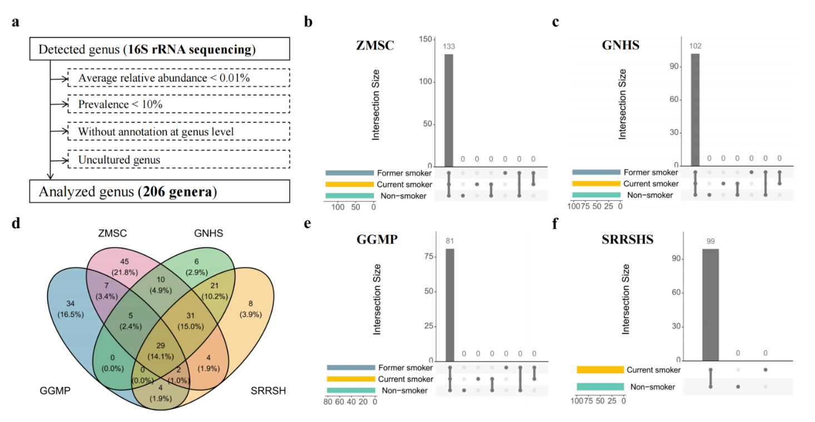
Supplementary Figures
Supplementary Figure 1 Details regarding eventually included genera (16S rRNA). (a) The flowchart illustrates the inclusion of genera (consistent across all studies). The counts of genera included in the final analysis for three/two groups (non-smokers, current smokers, and former smokers) were visually presented in Venn plots for (b) ZMSC, (c) GNHS, (e) GGMP, and (f) SRRSHS. (d) Venn plots illustrate the number of shared and unique genera included in each of the four studies.

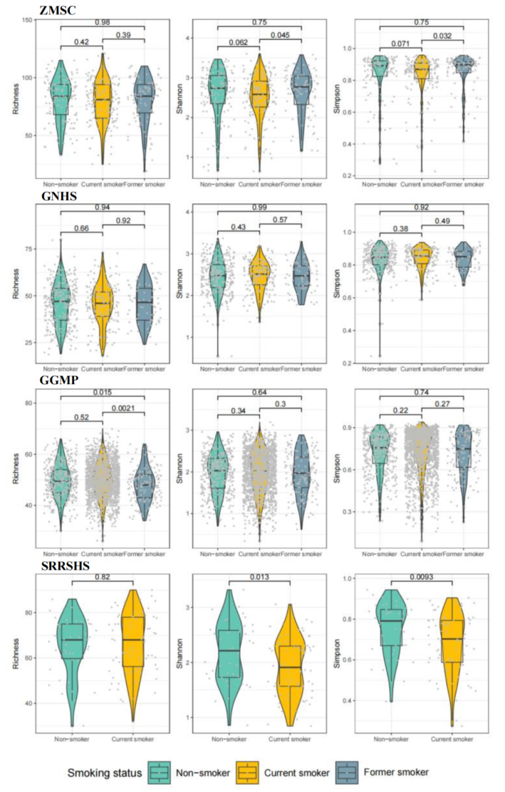
Supplementary Figure 2 Variations in the microbial alpha diversity in participants with different smoking status. The difference of microbial alpha diversity parameter Richness, Shannon index, and Simpson index between three/two groups was evaluated using a Wilcoxon test in each study. Box plots depict their median and interquartile range, while gray dots represent individual samples, and violin plots illustrate the distribution of these samples.

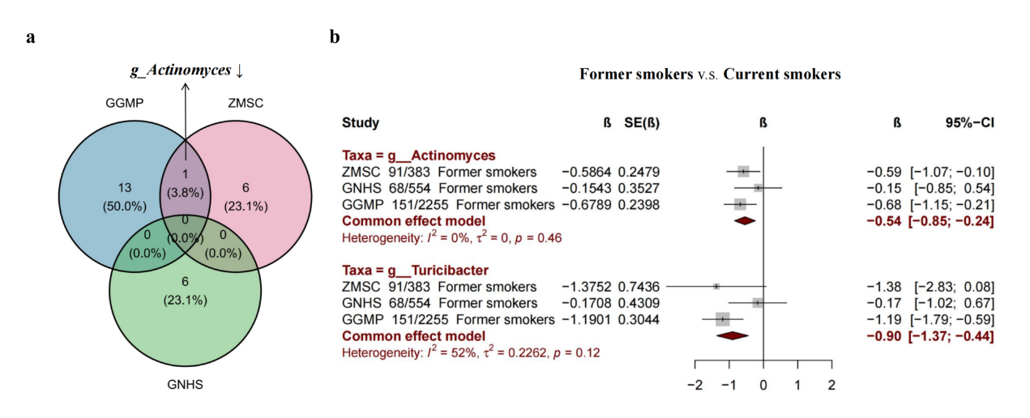Supplementary Figure 3 The relationship between smoking cessation and gut microbes at genus level (16S rRNA). (a) Venn plots illustrate the number of genera with p less than 0.05 in each of the three studies using Microbiome Multivariable Association with Linear Models (MaAsLin2). The estimation involved a comparison between former smokers and current smokers, with adjustments for age and BMI. (b) Forest plot displays the meta-analysis results that integrate findings from the three studies. Genera with Bonferroni-corrected p less than 0.05 or showing overlap between studies are showed. The fixed-effects model was utilized, and heterogeneity was assessed using I² and Cochran-Q test.
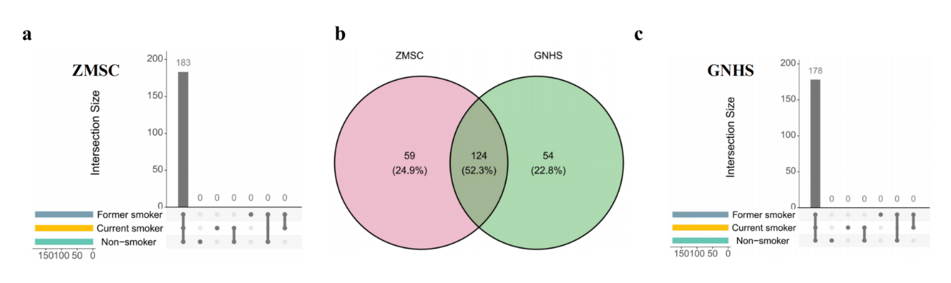
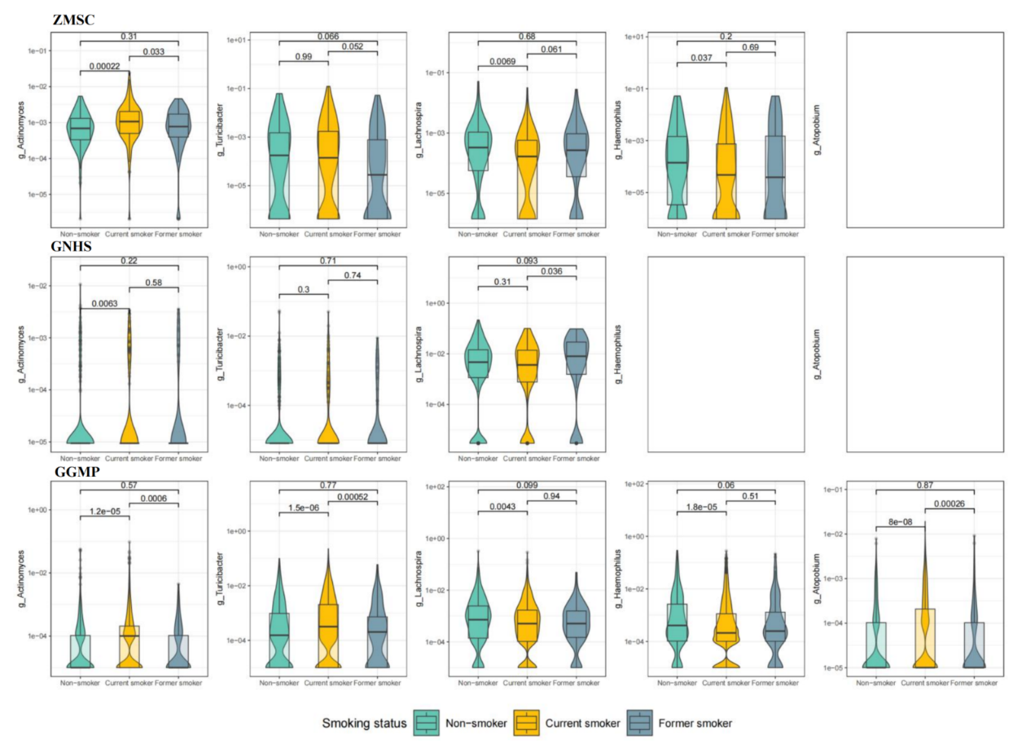
Supplementary Figure 4 Differences in the abundance of identified genera in groups with different smoking status in each study. The differences in abundance were evaluated using a Wilcoxon test. Box plots depict their median and interquartile range, while violin plots illustrate the distribution of participants.
Supplementary Figure 5 Details regarding eventually included species (Metagenome). The counts of species included in the final analysis for three groups (non-smokers, current smokers, and former smokers) were visually presented in Venn plots for (a) ZMSC and (c) GNHS. (b) Venn plots illustrate the shared and unique species included in each of the two studies.
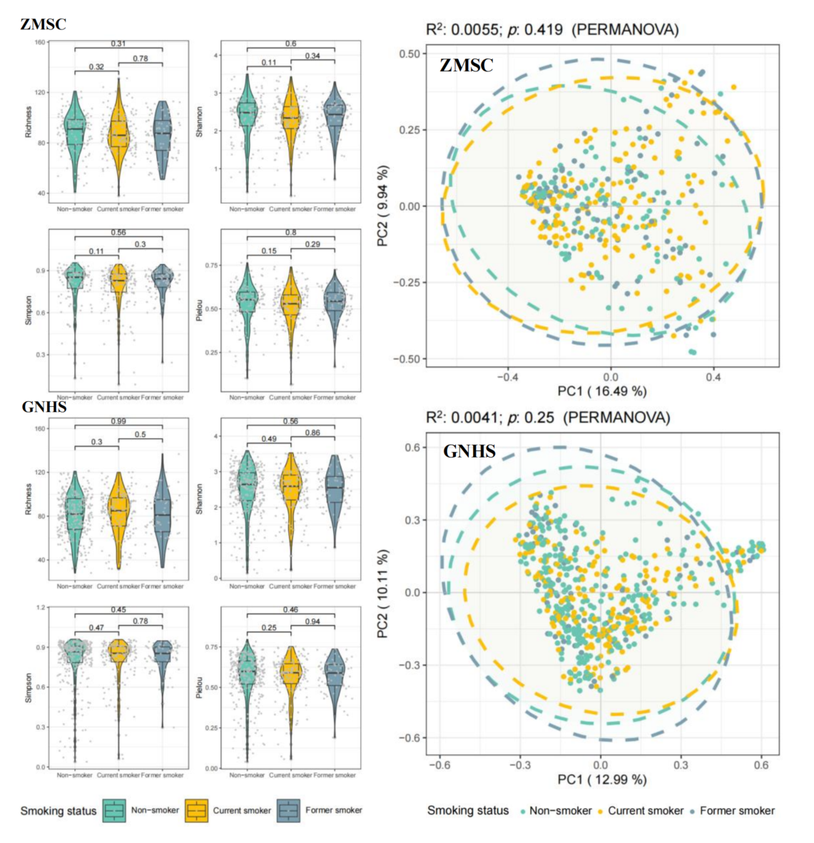
Supplementary Figure 6 Variations in the gut microbial diversity in participants with different smoking status (Metagenome). (a) The difference of microbial alpha diversity parameter Richness, Shannon index, Simpson index, and Pielou between three groups was evaluated using a Wilcoxon test in each study. Box plots depict their median and interquartile range, while gray dots represent individual samples, and violin plots illustrate the distribution of these samples. (b) The difference of microbial beta diversity was evaluated using principal coordinate analysis (PCoA) plot based on Bray-Cutis distance at species level. Permutational ANOVA (PERMANOVA) with 999 permutations was employed to identify the variation of beta diversity among the three groups, adjusting for age and BMI.
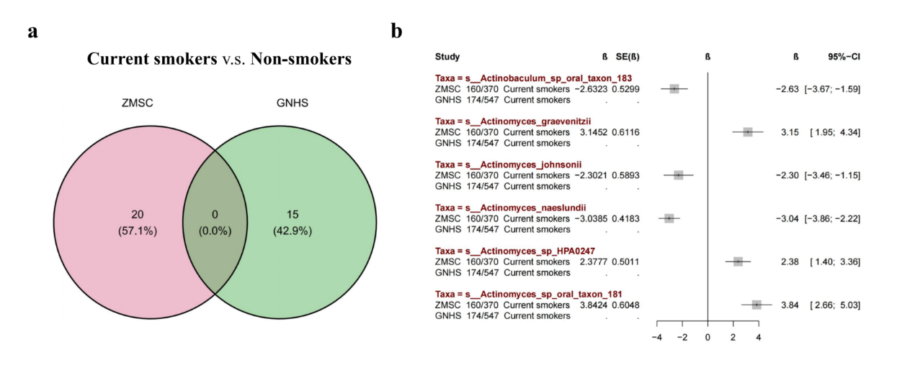Supplementary Figure 7 The relationship between cigarette smoking and gut microbes at species level (Metagenome, excluding species with an average relative abundance less than 0.01). (a) Venn plots illustrate smoking-associated species identified in ZMSC and GNHS using Microbiome Multivariable Association with Linear Models (MaAsLin2). Species with p less than 0.05 are presented. The estimation involved a comparison between current smokers and non-smokers, with adjustments for age and BMI. (b) Forest plot displays the meta-analysis results that integrate findings from the two studies. Species with Bonferroni-corrected p less than 0.05 are showed. The fixed-effects model was utilized, and heterogeneity was assessed using I² and Cochran-Q test.
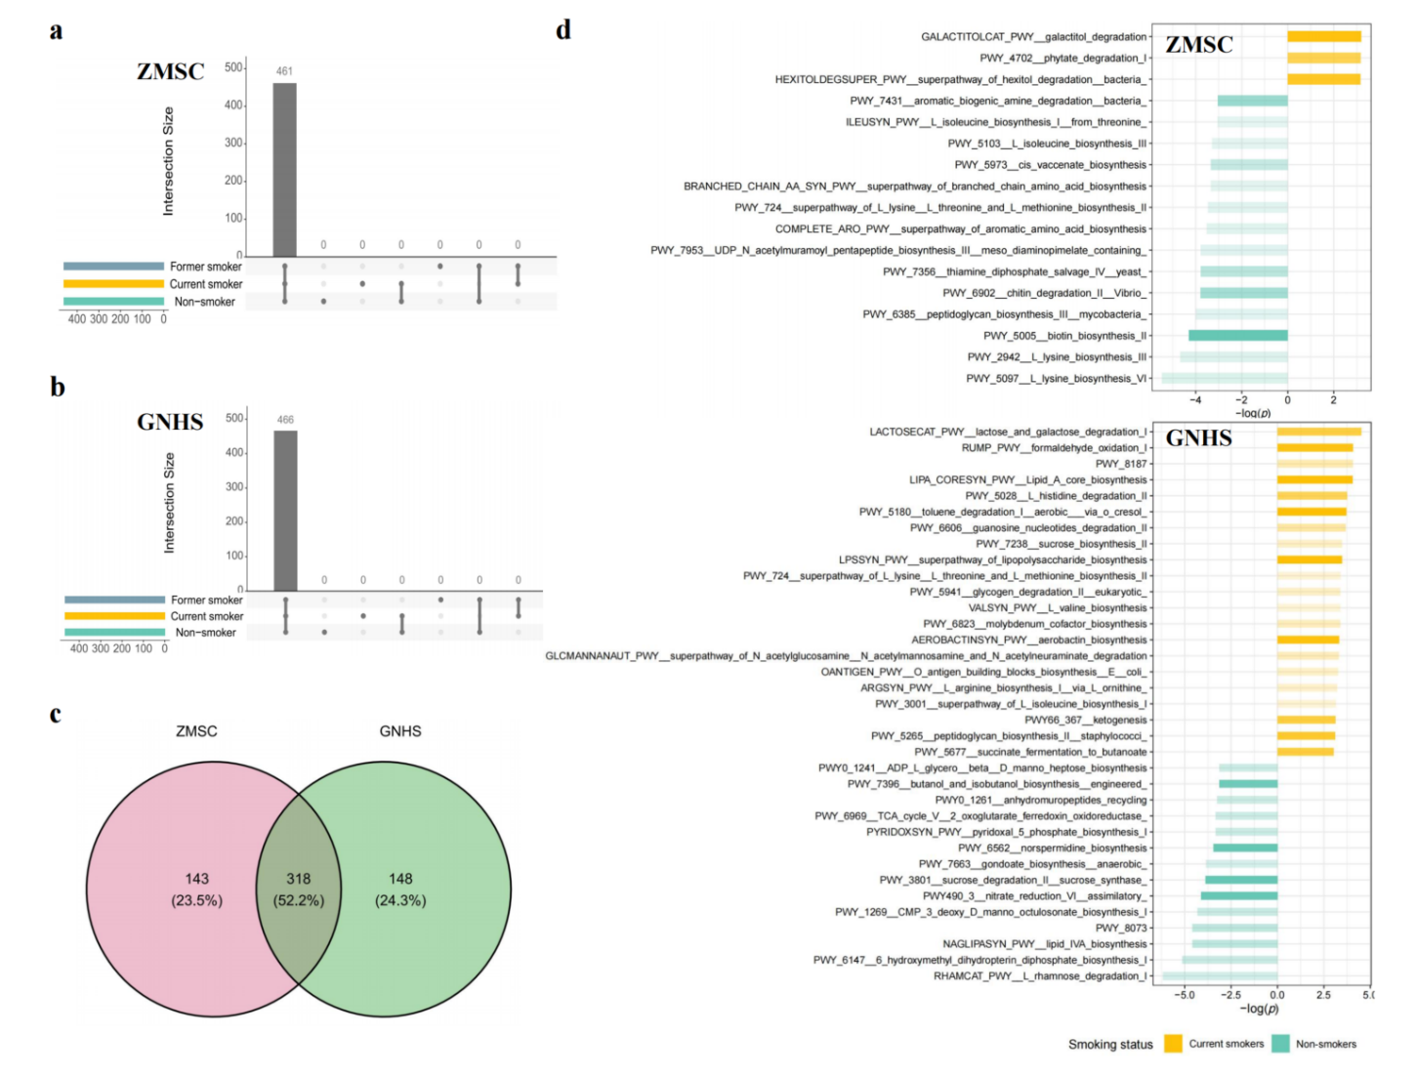
Supplementary Figure 8 Details regarding eventually included microbial pathway (Metagenome) and its associations with smoking. The counts of pathway included in the final analysis for three groups (non-smokers, current smokers, and former smokers) were visually presented in Venn plots for (a) ZMSC and (b) GNHS. (c) Venn plots illustrate the shared and unique species included in each of the two studies. (d) Bar plots illustrate the MaAsLin2’s results on the association between smoking and pathway. The x axis denotes the minus logarithms of the p values., and the color depth and direction of the bars indicate the estimated size and direction of the effect value, respectively.

