Supplementary data: Additional file 2 (Written consent)
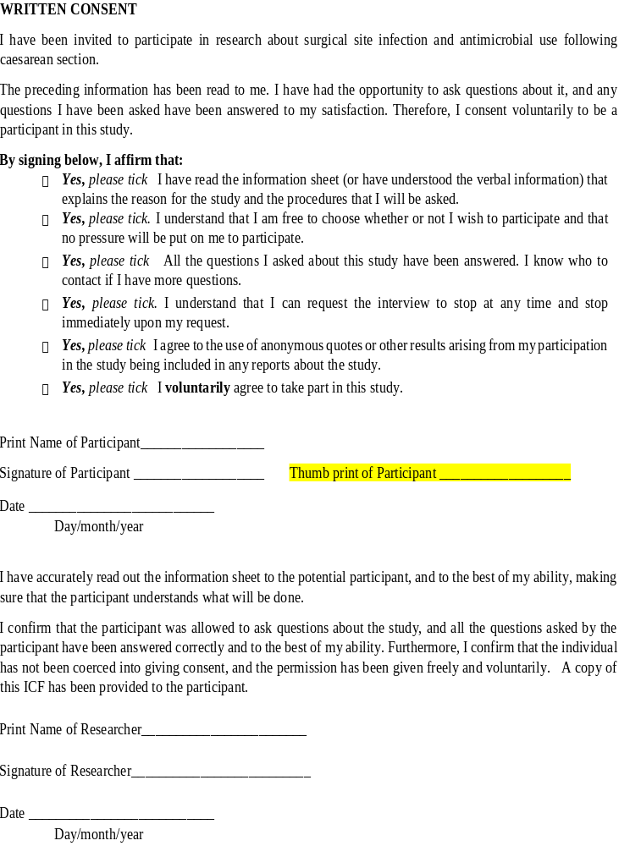

Supplementary data: Data Collection Tool, Pre-Op Surgical Site Infection Surveillance Tool
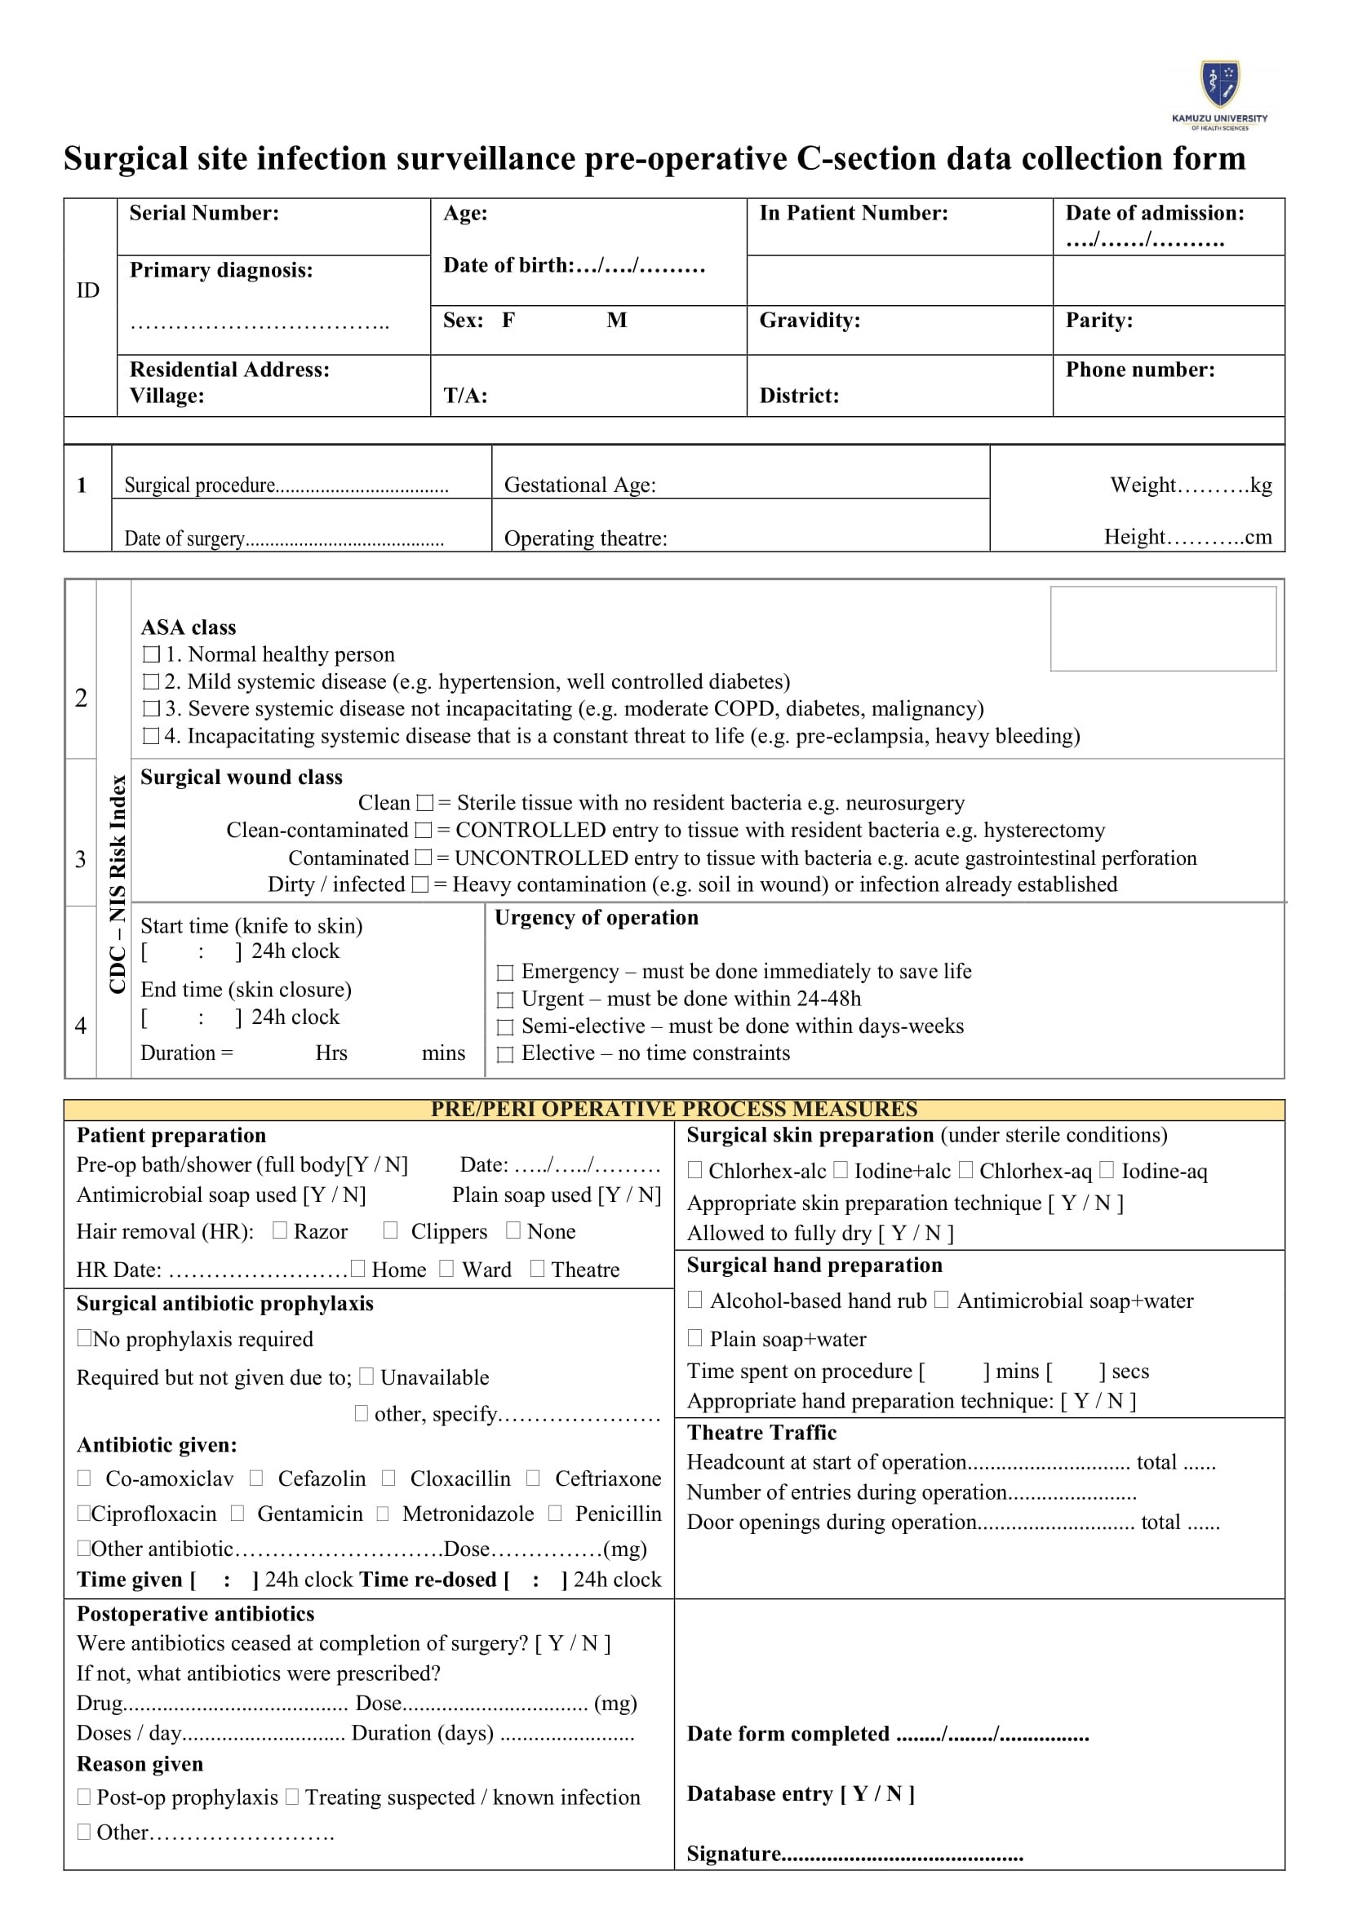
Supplementary data: Data Collection Tool_Post_Op Surgical Site Infection Surveillance Tool
