Tables
Table S1 Blood biochemical assays in the mouse serum at 6, 12, and 25 weeks
Weeks | Diet | SNPs  (mg/kg) | T-CHO  (mg/dL) | TG  (mg/dL) | HDL-C  (mg/dL) | LDL  (mg/dL) | AST  (U/L) | ALT  (U/L)
6 | Normal | 0 | 176.83±13.20 | 120.66±12.22 | 148.15±11.79 | 21.83±2.45 | 64.20±7.94 | 35.80±5.82
6 | Normal | 100 | 199.50±11.47 | 139.50±31.27 | 182.91±15.11 | 28.60±2.05 | 54.80±4.92 | 34.00±5.01
6 | Normal | 200 | 197.33±14.23 | 125.50±21.39 | 160.00±13.67 | 22.00±2.78 | 55.33±5.28 | 35.17±7.73
6 | Normal | 300 | 187.83±12.27 | 122.50±26.07 | 158.83±10.83 | 24.33±1.63 | 61.00±6.08 | 31.17±4.70
6 | High-fat | 0 | 228.60±4.87 | 112.00±12.09 | 189.33±9.51 | 29.33±2.40 | 50.17±3.63 | 27.17±1.52
6 | High-fat | 100 | 207.40±7.91 | 118.83±25.62 | 187.18±9.99 | 30.66±0.76 | 51.50±2.37 | 33.83±3.63
6 | High-fat | 200 | 219.00±10.63 | 112.00±23.16 | 200.21±13.99 | 30.20±2.52 | 59.17±3.09 | 34.00±2.87
6 | High-fat | 300 | 207.60±10.55 | 86.00±6.28 | 184.14±10.10 | 26.00±0.91 | 56.40±6.77 | 37.2±7.95
12 | Normal | 0 | 185.25±16.00 | 189.66±22.23 | 165.18±13.25 | 23.50±2.13 | 85.20±13.15 | 55.33±6.43
12 | Normal | 100 | 191.50±12.35 | 226.75±35.26 | 159.15±9.54 | 23.67±3.82 | 73.00±7.15 | 45.16±11.83
12 | Normal | 200 | 210.00±25.07 | 143.50±21.11 | 190.10±18.73 | 34.60±7.82 | 84.80±16.19 | 45.33±8.47
12 | Normal | 300 | 203.20±8.24 | 126.75±11.15 | 164.20±9.65 | 24.33±3.42 | 80.00±6.72 | 40.20±3.88
12 | High-fat | 0 | 229.50±20.11 | 108.80±41.44 | 192.23±17.69 | 27.00±5.65 | 59.20±2.27 | 41.83±4.49
12 | High-fat | 100 | 270.00±23.62 | 169.00±16.91 | 208.75±16.94 | 38.00±7.03 | 62.40±6.98 | 47.80±11.72
12 | High-fat | 200 | 257.40±15.70 | 130.33±32.21 | 205.18±10.76 | 36.33±6.86 | 61.67±3.76 | 38.60±6.63
12 | High-fat | 300 | 220.25±17.77 | 125.83±21.64 | 159.00±12.33 | 31.17±3.99 | 119.20±18.61 | 47.50±6.37
25 | Normal | 0 | 176.33±5.51 | 121.00±23.21 | 176.33±6.01 | 25.67±1.44 | 67.00±6.52 | 49.75±5.50
25 | Normal | 100 | 191.60±7.67 | 120.16±17.59 | 184.83±10.07 | 23.25±2.08 | 80.25±12.93 | 50.00±16.11
25 | Normal | 200 | 201.40±16.31 | 104.16±17.12 | 191.66±18.00 | 28.83±3.39 | 91.50±14.38 | 56.25±4.35
25 | Normal | 300 | 190.75±11.33 | 88.83±7.55 | 174.00±14.11 | 26.67±2.68 | 128.00±27.29$ | 42.50±12.12
25 | High-fat | 0 | 205.20±12.42 | 135.66±45.84 | 222.12±21.60 | 37.83±5.84 | 86.25±4.77# | 76.75±1.56#
25 | High-fat | 100 | 193.60±16.74 | 97.83±21.13 | 211.50±24.60 | 33.00±5.15 | 62.25±12.52 | 62.75±7.17
25 | High-fat | 200 | 224.83±6.61 | 106.33±21.46 | 224.83±7.20 | 32.67±2.27 | 155.75±18.82* | 161.00±9.24**
25 | High-fat | 300 | 222.25±14.12 | 144.00±30.35 | 194.68±21.28 | 31.40±5.36 | 125.25±6.26** | 163.00±4.17***
Note: Data are expressed as the means ± standard error of the means (n=6). $, p < 0.05 when the ND-SNP300 group was compared with the ND-SNP0 group using ANOVA at 25 weeks. #, p < 0.05 when the HFD-SNP0 group was compared with the ND-SNP0 group using ANOVA at 25 weeks. *, p < 0.05 when the HFD-SNP200 group was compared with the HFD-SNP0 group using ANOVA at 25 weeks. **, p < 0.01 when the HFD-SNP200 or HFD-SNP300 group was compared with the HFD-SNP0 group using ANOVA at 25 weeks. ***, p < 0.001 when the HFD-SNP300 group was compared with the HFD-SNP0 group using ANOVA at 25 weeks.

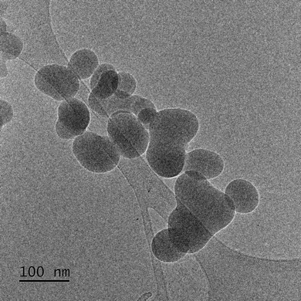
Fig. S1 TEM image of the SiO₂ nanoparticle by field emission transmission electron microscope. Scale bar, 100nm.

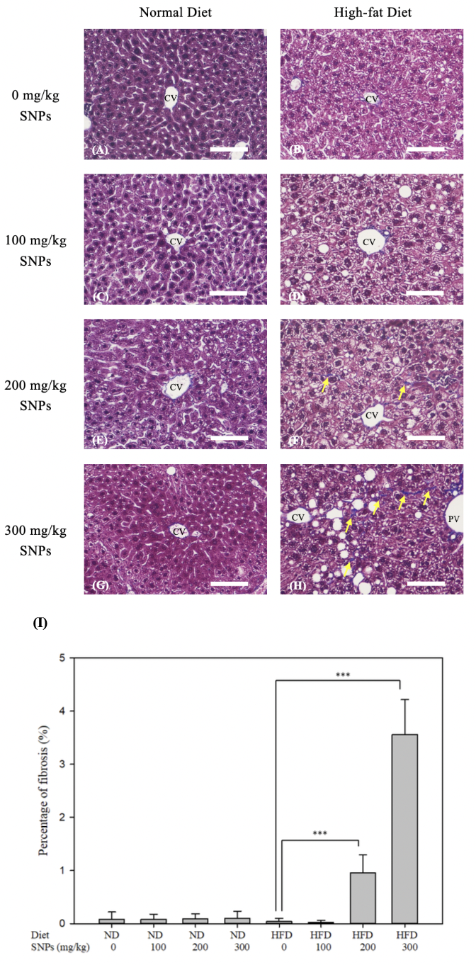
Figure. S2 The degree of fibrosis is shown by the Masson’s Trichrome stain. Mice were fed the ND (A, C, E, G) or HFD (B, D, F, H) for 25 weeks. The mice were treated with 0 (A, B), 100 (C, D), 200 (E, F), and 300 (G, H) mg of SNPs/kg mouse body weight twice per week. The arrow is the fibrosis. The CV and PV are indicated. Scale bars are 100 µm (A-H). The quantitative fibrosis levels were analyzed by image pro (I). Data are expressed as the means ± standard error of the means (n=6).
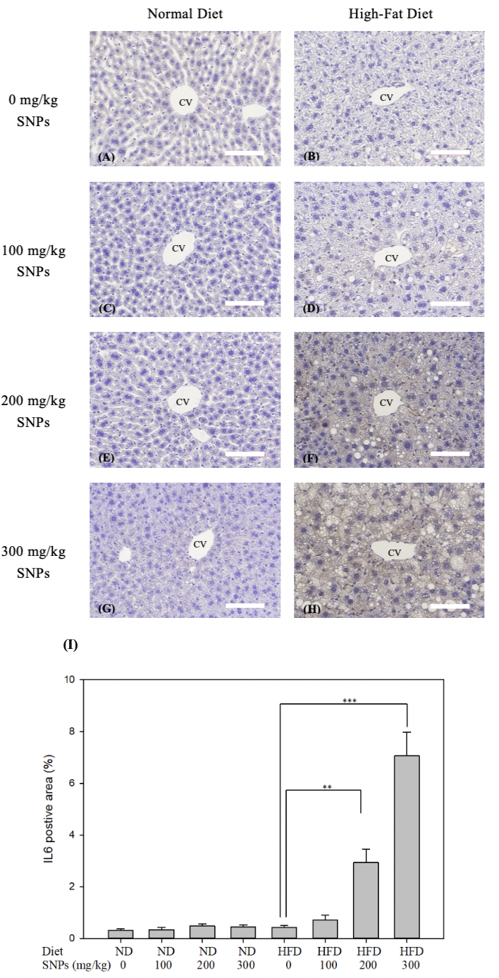
Fig. S3 The level of IL-6 is shown by using immunohistochemical staining. Mice were fed the ND (A, C, E, G) or HFD (B, D, F, H) for 25 weeks. The mice were treated with 0 (A, B), 100 (C, D), 200 (E, F), and 300 (G, H) mg of SNPs/kg mouse body weight twice per week. The CV is indicated. Scale bars are 100 µm (A-H). The percentage of positive IL-6 staining/area was analyzed by Image-Pro (I). Data are expressed as the means ± standard error of the means (n=6).
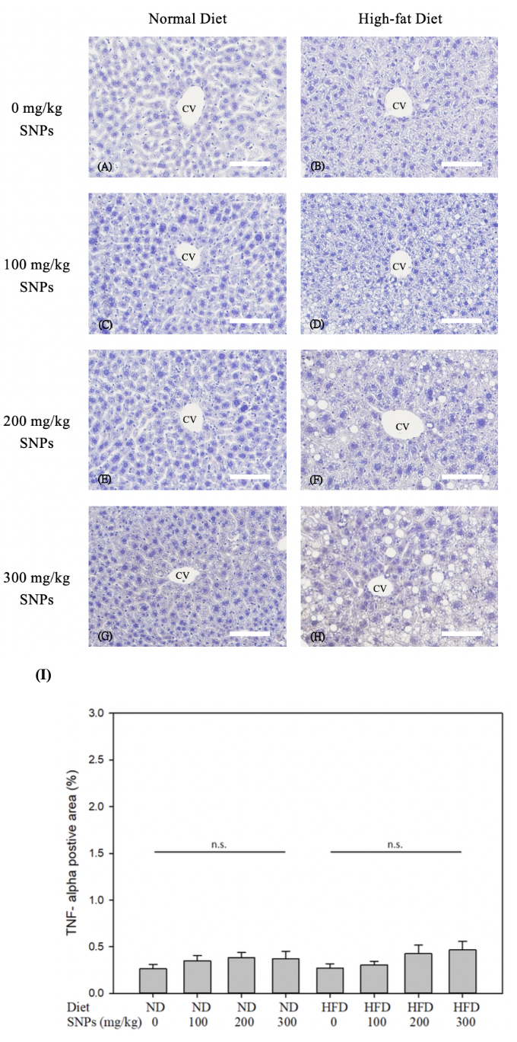
Figure. S4 The degree of TNF-α was shown by the immunohistochemistry stain. Mice were fed the ND (A, C, E, G) or HFD (B, D, F, H) for 25 weeks. The mice were treated with 0 (A, B), 100 (C, D), 200 (E, F), and 300 (G, H) mg of SNPs/kg mouse body weight twice per week. The CV is indicated. Scale bars are 100 µm (A-H). The quantitative level of the TNF-α positive area is analyzed by image pro (I). No significance (n.s.). Data are expressed as the means ± standard error of the means (n=6).

