Supplementary Appendix

The effect of conditional cash transfers on tuberculosis incidence and mortality is determined by ethnoracial and socioeconomic factors: a cohort study of 54 million individuals in Brazil

Table of contents

1.Definitions................................................................................................................................................... | 3
2. Descriptive analysis by outcome............................................................................................................... | 4
Table S1......................................................................................................................................................... | 5
Table S2......................................................................................................................................................... | 6
3. Estimation of logistic regression by outcome…………………………………………………………… | 7
Table S3....................................................................................................................................................... | 8
4. Sensitivity Analyses................................................................................................................................... | 9
Table S4....................................................................................................................................................... | 10
Table S5....................................................................................................................................................... | 10
Table S6....................................................................................................................................................... | 10
Table S7....................................................................................................................................................... | 11
Table S8....................................................................................................................................................... | 11
Table S9....................................................................................................................................................... | 11
Table S10....................................................................................................................................................... | 11
Table S11....................................................................................................................................................... | 12
5. Triangulation Analyses.............................................................................................................................. | 13
Table S12....................................................................................................................................................... | 13
6. IPTW Poisson regression unadjusted......................................................................................................... | 16
Table S13....................................................................................................................................................... | 16
7. IPTW Poisson regression stratified models……………………………………………………………... | 17
Table S14....................................................................................................................................................... | 17
References...................................................................................................................................................... | 18

Definitions

The Cadastro Único (CadUnico) database and the 100 Million Brazilian Cohort

The 100 Million Brazilian Cohort was based on the baseline information of families, during the period from January 1, 2001 to December 31, 2017, who sought to benefit from the Brazilian government's social programs through registration in the Unified Registry for Social Programs (in Portuguese: Cadastro Único para Programas Sociais – CadUnico). The CadUnico is an administrative database, to which Brazilians aged 16 or over can apply by registering their personal information (age, sex, race, education and others) and household information (household density, familiar income, structural characteristics of the residence and others), as long as they are within one of these categories: (i) belong to a family with a monthly per capita income of up to half a minimum wage; (ii) belong to a family with a total monthly income of up to three minimum wages; (iii) belong to a family with an income greater than three minimum wages, provided that the registration is linked to inclusion in social programs in the three spheres of government; (iv) be the only resident of the household, or; (v) living on the streets (alone or with the family).
Upon registration, individuals receive a unique identifier code and are searched for socioeconomic characteristics. At the end of 2017, CadÚnico had approximately 114 million individuals on its register, which represents around 50% of the Brazilian population. It is a social tool that identifies and characterizes especially low-income families, allowing the government to know the socioeconomic aspect of the poorest and use it for the selection of social programs.^{1,2}
In addition to the information from CadÚnico, the Cohort is also composed of health-related databases. For our study, the information used to identify morbidity and mortality from Tuberculosis comes from the National System of Disease Notification (in Portuguese: Sistema de Informação de Agravos de Notificação - SINAN) and the Mortality Information System (in Portuguese: Sistema de Informações Sobre Mortalidade - SIM)³. Created by the Center for Integration of Data and Knowledge for Health (CIDACS / FIOCRUZ)², the Cohort aims to facilitate research and continuous assessment of social determinants and the effects of social policies and programs in health contexts in Brazil. It has 246 variables with demographic and socioeconomic information at the individual and family level.The codes and linking algorithms between the databases were built to make efficient and specific links through five identifiers: the date of birth, the municipality of residence, the sex, the name and the mother’s name of each individual presented in each of the databases^{2,4,5}. The linkage was performed at the individual level in two stages using the CIDACS-RL (https://gitHub.com/gcgbarbosa/cidacs-rl). First, the inputs were linked deterministically. In the second step, for cases that were not deterministically linked, they were linked based on a similarity score for all pairwise comparisons, ranging from 0 to 1. The entries with the highest similarity scores were considered as linked pairs. The quality of each link for all causes between CadUnico, SINAN e SIM has been extensively evaluated and validated. ^{6,7}
The variables at the municipal level of the resident individual's baseline were linked to the CadÚnico records by the municipality code and the year of information. The average variables for the period that capture the level of health surveillance and the risk of Tuberculosis endemicity were linked only by the municipal identifier.

New case of tuberculosis

We consider a new case of tuberculosis to be those cases of active tuberculosis that have never used antituberculosis medication or that have been using it for less than 30 days, relapse, which is a case of active tuberculosis that was previously treated and was discharged due to proven cure or having concluded the treatment; re-entry after abandonment, which is the case of active tuberculosis, previously treated for more than 30 days, but who stopped taking the medication for 30 consecutive days or more.

The Programa Bolsa Família (PBF)

This conditional cash tranfer (CCT) is a direct income transfer program for families living in poverty and extreme poverty in Brazil. Created in 2003, the program was originated from the unification of Other four government social protection policies (In portuguese: Bolsa Escola (2001), Bolsa Alimentação (2001), Auxílio-Gás (2002) e Fome-Zero (2003))⁸. The program's objectives are: to fight against hunger and to promote nutritional and food security; alleviate poverty and other forms of deprivation; and toprovide easy access to public health, education, social assistance. The PBF seeks to ensure that these families are able to get out of poverty and vulnerability conditions in the short-long term. The target beneficiaries of the program are made up of poor or extremely poor families. Extremely poor families are considered to have a monthly per capita income of up to US$12 (BRL 60) in 2007-2008 period, up to US$14 (BRL 70) from 2009 to 2013, and up to US$15.4 (BRL 77) in 2014 and 2015. Poor families are those with a per capita income between US$12 (BRL 60.01) and US$24 (BRL 120) in 2007 and 2008, between US$14 (BRL 70.01) and US$28 (BRL 140) from 2009 to 2013, and between US$15.4 (BRL 77.01) and US$30.8 (BRL 154) in 2014 and 2015. Poor families are allowed to participate in the program as long as they include in the registry children or adolescents between 0 and 17 years old, or pregnant women of any age. The registration on the CadUnico is a prerequisite for receiving the PBF (or any other federal social protection program), but it does not imply approval or immediate receipt. After registering with CadUnico and fulfilling the aforementioned requirements, the Ministry of Citizenship (in Portuguese: Ministério da Cidadania) elects the beneficiaries of the program by following the previously described criteria. Once the income transfer is approved, there are conditions for its maintenance according to each family composition. For pregnant women, for instance, the attendance to prenatal appointments is required. For mothers who breastfeed, they must participate in educational activities provided by the Ministry of Health – MoH (In Portguese: Ministério da Saúde). For children aged from 0 to 7, their parents must follow the vaccination schecule of them. In the case of women aged 14 to 44 years, they must be monitored by the health team. Finally, is required the guarantee of minimum school attendance of 85% for children and 75% for teenagers. The monthly amount received per family is the sum of the types of benefits provided by the PBF. There are two types, the first one is the basic benefit referring to extreme poor only (amount of US$17.8; BRL 89) and the second is the variable benefit, in which poor families can accumulate up to 5 benefits, depending on the number of breastfeeding mothers, pregnant women, or the number of children and adolescents from 0 to 16 years old (amount varies between US$8.2 and US$9.6; BRL 41 and BRL 48, respectively). Families covered by the PBF are required to update their information every two years. The Ministry of Citizenship periodically carries out an inspection of the suitable profiles for the maintenance of the benefit.

Criteria for classifying the exposition status of the individuals under study

In our study the beneficiary group was defined as eligible individuals who received PBF benefits within the required administrative period, and their exposure started with receipt of the benefit until the end of their cohort follow-up. While the majority of them was receiving the benefits until the end of the cohort follow-up, some individuals ended their receipt before, but still we considered the end of the cohort follow-up as end of their exposure period. This was because individuals that improve their economic conditions -and are not eligible anymore for PBF- should exit the PBF, but we considered this period of improved economic situation and its reduced probability of Tuberculosis incidence and mortality as a long-term PBF effect. The non-beneficiary group was defined as individuals who had never benefited from the program throughout their follow-up period. In cases where an eligible individual did not receive the PBF benefit at all, or did not receive it within the required administrative period following the enrollment on Unified Registry (6 months)⁹, it was classified in the non-beneficiary group and, in case the benefits arrived later, the start date of PBF receipt was considered the end of his follow-up period as non-beneficiary.

Descriptive analysis by outcome

The number of observations by new Tuberculosis (TB) cases, TB deaths and TB deaths/new TB cases are presented in Table S1. The number of observations of TB cases, TB deaths, and TB deaths/new TB cases by wealth quartile are shown in Table S2. Analyzes stratified by wealth quartile were constructed according to measures of per capita expenditure proportional to the minimum wage (SM): quartile 1: 0% to 0.1%; 2nd quartile: 0.1%< to 18.5%; 3rd quartile: 18.5% < to 56.5%; quartile 4: 56.5% < (Table S2).

Table S1. Number of observations per Tuberculosis new case, death from Tuberculosis and death from Tuberculosis/Tuberculosis new case by Bolsa Família Program (BFP) beneficiaries (BF) and non-beneficiaries (N-BF).
Variables | Bolsa Familia Program (BFP) |  | Total
Variables | N-BF | BF | Total
New TB casesª
No | 30,584,786 | 23,821,172 | 54,405,958
Yes | 75,956 | 83,821 | 159,777
Total | 30,660,742 | 23,904,993 | 54,565,735
TB deaths^{b}
No | 30,659,117 | 23,904,324 | 54,563,441
Yes | 4,359 | 3,634 | 7,993
Total | 30,663,476 | 23,907,958 | 54,571,434
TB deaths/ new TB cases ^{a,b}
No | 14,496 | 30,606 | 45,102
Yes | 495 | 751 | 1,246
Total | 14,991 | 31,357 | 46,348

Notes: ª Notes: a New Tuberculosis cases, defined with new cases, relapse cases of TB and re-entry by adapted health ministery criteria the Brazil; ^{b} deaths from tuberculosis, considering as underlying cause the ICD-10 codes A15 to A19, J65, 0980 and P370.

Table S2. Estimates of the average effect of the Bolsa Famlília Program (BFP) adjusted Poisson models on Tuberculosis incidence, mortality and case-fatality stratified by wealth quartile rate in Brazil, 2004-2015).
Wealthª | Incidence^{f} |  |  | Mortality^{f} |  | Case-Fatality^{f}
Wealthª | RR | 95% CI |  | RR | 95% CI | RR | 95% CI
Wealth ^{c}
Quartile 1^{b} | 0.49*** |  | (0.49-0.50) | 0.60*** | (0.55-0.61) | 0.80 | (0.64-1.01)
Obs. | 18,476,834 |  |  | 18,479,518 |  | 20,752
Quartile 2^{c} | 0.48*** |  | (0.47-0.49) | 0.56*** | (0.50-0.63) | 0.86 | (0.60-1.22)
Obs. | 10,565,846 |  |  | 10,567,091 |  | 10,350
Quartile 3^{d} | 0.71*** |  | (0.69-0.73) | 0.86*** | (0.76-0.99) | 1.20 | (0.82-1.75)
Obs. | 11,599,362 |  |  | 11,600,410 |  | 8,865
Quartile 4e | 0.99 |  | (0.96-1.02) | 1.01 | (0.83-1.23) | 0.86 | (0.53-1.40)
Obs. | 14,145,583 |  |  | 14,146,327 |  | 6,460
Notes: a Measured by capita expenses proportional to the baseline minimum wage (MW). b Quartile 1: 0% a 0.1%. c Quartile 2: > 0.1% a 18.5%. d Quartile 3: >18.5% a 56.5%. e Quartile 4: > 56.5%. ^{f} Calculated by person-years.

3. Estimation of logistic regression by outcome

For each dataset by outcome variable, we estimated the probability of the individual being exposed to BFP using multivariate logistic regression adjusted for relevant demographic and socioeconomic covariates (Table S3). Covariates include sex, race/ethnicity, age, education, per capita wealth, water supply, housing material, lighting, year of entry into the cohort, and municipal level covariates such as mean incidence of tuberculosis in the cohort, sanitation, coverage of ESF, unemployment rate and rate of doctors, nurses and beds per 1,000 inhabitants. For the case fatality rate outcome, the following covariates: diagnosis of AIDS, diabetes, types of tuberculosis and directly observed treatment are added.

Table S3. Logistic regression prediction models for individuals benefiting or not from the Programa Bolsa Família (PBF), for Tuberculosis incidence, mortality, and case-fatality rate, 2004-2015. Estimates for the Propensity Score (PS).
 |  | Outcomes (RRª – CI^{b} 95%)
Adjusted Model |  | Incidence and Mortality | Case-Fatality
Sex
Male |  | 1 (base) | 1 (base)
Female |  | 1.17 (1.17-1.18) | 1.73 (1.65-1.81)
Age (years) |  | 0.84 (0.84 - 0.85) | 0.76 (0.75-0.77)
Race or ethnicity
White |  | 1 base | 1 (base)
Black and Mixed-race |  | 1.15 (1.15-1.16) | 1.25 (1.19-1.32)
Indigenous |  | 3.09 (3.06-3.12) | 3.50 (2.68-4.58)
Education
Illiterate, never attended school |  | 1 (base) | 1 (base)
Elementary school |  | 1.07 (1.07-1.08) | 1.06 (0.99-1.14)
High school |  | 1.08 (1.08-1.09) | 0.93 (0.86-0.99)
More than high school |  | 0.83 (0.83-0.84 | 0.65 (0.59-0.70)
Construction material Household
Bricks/cement |  | 1 (base) | 1 (base)
Wood, other vegetal materials |  | 0.94 (0.93-0.94) | 0.91 (0.86-0.97)
Number of people in the family |  | 1 (base) | 1 (base)
2
3 a 4 |  | 1.52(1.51-1.52) | 2.03 (1.93-2.14)
> 5 |  | 2.03 (2.02-2.04) | 3.56 (3.33-3.80)
Per salary expenses - % MW ^{c}
below median |  | 1 (base) | 1 (base)
above median |  | 0.88 (0.88-0.89) | 0.51 (0.48-0.54)
Lighting
Electricity |  | 1 (base) | 1 (base)
Non-electric ^{d} |  | 1.22 (1.21-1.22) | 1.53 (1.43-1.64)
Inadequate sanitation ^{e} |  | 1.02 (1.02-1.03) | 1.06 (1.00-1.12)
Garbage disposal ^{f} |  | 1.08 (1.08-1.09) | 1.04 (0.96-1.12)
Water supply
Public network |  | 1 (base) | 1 (base)
Other^{g} |  | 1.11 (1.11-1.12) | 1.17 (1.10-1.25)
Incidence Cohort |  | 1.00 (1.00- 1.00) | 1.00 (1.00- 1.00)
AIDS |  | - | 0.93 (0.86-1.01)
Diabetes |  | - | 0.94 (0.86-1.03)
TDO |  | - | 0.99 (0.94-1.04)
Form TB |  | - | 0.91 (0.85-0.97)
Primary Health Care
Coverage |  | 1 (base) | 1 (base)
no coverage ^{h} |  | 0.99 (0.99-0.99) | 0.99 (0.99-0.99)
Specialized clinics per 1,000 inhabitants ^{i} |  | 0.27 (0.26-0.27) | 0.27 (0.21-0.34)
Doctors per 1,000 inhabitants ^{i} |  | 1.14 (1.13-1.14) | 1.17 (1.11-1.22)
Nurses per 1,000 inhabitants ^{i} |  | 0.99 (0.98-0.99) | 0.84 (0.73-0.97)
Unemployment rate (%) ^{i} |  | 1.01 (1.01- 1.01) | 1.01 (1.01- 1.02)
Gini index |  | 1.01 (1.01- 1.01) | 1.01 (1.01- 1.02)
Year of entry into the cohort |  | yes | yes
Obs.: |  | 54,571,434 | 46,344
Notes: *** p-value <0.001; **p-value <0.01; *p-value <0.05.
Abbreviations: ª Incidence-rate ratios. ^{b} Confidence interval.

4. Sensitivity Analyses

First, to investigate the influence of the level of endemicity among individuals with tuberculosis in the cohort on the estimates, the same regressions described in the methods section were performed under different conditions: (i) estimates without the incidence mean rate in the cohort keeping the other variables aggregated in the models (Table S4); (ii) in addition to the variables at the individual level, only the endemic variable (Table S5), and; (iii) without considering any aggregated variables (results of unadjusted and adjusted models for relevant covariates are presented in Table S6).
Second, to verify the effect of adopting the per capita wealth variable, estimates were made for the three outcomes using the per capita income variable instead of per capita wealth (Table S7). The per capita wealth variable was adopted as a proxy for per capita income because the income variable is self-declared by individuals when registering in CadÚnico and, considering that having a per capita income below certain limits is one of the main prerequisites for receiving any government social program, it may be underreported. Wealth, measured by per capita expenditure, is not considered, and is not perceived by the interviewees as a criterion for eligibility of the interviewee and therefore could suffer less from the underreporting bias.
Third, to verify the relevance of IPTW to unbiased estimates of PBF, we performed the same multivariate Poisson regressions without IPTW and compared the results with IPTW (Table S8). All PBF effects found on outcomes were similar to the main outcomes.
Fourth, we estimate a specific model without robust cluster standard errors at the individual level (Table S9).
Fifth, in Table S10, we estimate the models only with the selection of entities with adequate quality of vital information. Despite the 19,61% reduction in the number of observations (about 10,745,484 individuals) in the incidence and mortality models and 19,61% (10,746,352 individuals) in lethality 12,44% (about 5,769 individuals).
Sixth, additionally, in Table S11, we estimate the BFP association for all subjects, ie, participants with complete data on all covariates and participants with missing data for one or more variables in the PS estimation and adjusted Poisson model.

Table S4. Estimates of the average effect of the Bolsa Família Program (BFP) in unadjusted and adjusted Poisson models on Tuberculosis incidence, mortality and case-fatality rate in Brazil, 2004-2015 – without endemic variable.
 | Outcomes (RRª – CI^{b} 95%)
Models | Incidence | Mortality | Case-Fatality
Adjusted | 0.63*** (0.62-0.63) | 0.73*** (0.69-0.77) | 0.90 (0.76-1.06)
Unadjusted | 0.59*** (0.58-0.60) | 0.56*** (0.54-0.59) | 0.79 (0.68-0.91)
Obs | 54,565,735 | 54,571,434 | 46,344
Notes: *** p-value <0,001. a Incidence Rate Ratios. b Confidence Interval.

Table S5. Estimates of the average effect of the Bolsa Família Program (BFP) in unadjusted and adjusted Poisson models on Tuberculosis incidence, mortality and case-fatality rate in Brazil, 2004-2015 – Only with the endemic variable.

 | Outcomes (RRª – CI^{b} 95%)
Models | Incidence | Mortality | Case-Fatality
Adjusted | 0.60*** (0.59-0.60) | 0.71*** (0.67-0.75) | 0.91 (0.77-1.06
Unadjusted | 0.56*** (0.55-0.57) | 0.55*** (0.52-0.58) | 0.80 (0.69-0.92
Obs | 54.707.995 | 54.713.723 | 46,445
Notes: *** p-value <0,001; **p-valor <0,01; *p-valor <0,05. ª Incidence Rate Ratios. ^{b} Confidence Interval.

Table S6. Estimates of the average effect of the Bolsa Família Program (BFP) in unadjusted and adjusted Poisson models on Tuberculosis incidence, mortality and case-fatality rate in Brazil, 2004-2015 – Without the aggregated variables at the municipal level and endemic variable.

 | Outcomes (RRª – CI^{b} 95%)
Models | Incidence | Mortality | Case-Fatality
Adjusted | 0.67*** (0.66-0.68) | 0.79*** (0.75-0.84) | 0.91 (0.77-1.06)
Unadjusted | 0.62*** (0.62-0.63) | 0.61*** (0.58-0.63) | 0.80*** (0.69-0.92)
Obs | 54,707,995 | 54.713.723 | 46,445
Notes: *** p-value <0,001; **p-valor <0,01; *p-valor <0,05. ª Incidence Rate Ratios. ^{b} Confidence Interval.

Table S7. Estimates of the average effect of the Bolsa Família Program (BFP) in unadjusted and adjusted Poisson models on Tuberculosis incidence, mortality and case-fatality rate in Brazil, 2004-2015 – With per capita income.
 | Outcomes (RRª – CI^{b} 95%)
Models | Incidence | Mortality | Case-Fatality
Adjusted | 0.53*** (0.52-0.54) | 0.58*** (0.55-0.62) | 0.89 (0.75-1.06)
Unadjusted | 0.53*** (0.53-0.54) | 0.61*** (0.58-0.63) | 0.78*** (0.67-0.90)
Obs | 54,575,007 | 54,580,706 | 46,348
Notes: *** p-value <0,001; **p-valor <0,01; *p-valor <0,05. ª Incidence Rate Ratios. ^{b} Confidence Interval.

Table S8. Estimates of the average effect of the Programa Bolsa Família (BFP) adjusted Poisson model on Tuberculosis incidence, mortality, and the case-fatality rate, 2004-2015 – Without IPTW.
 | Outcomes (RRª – CI^{b} 95%)
Models | Incidence | Mortality | Case-Fatality
Adjusted | 0.58*** (0.57-0.58) | 0.65*** (0.62-0.69) | 0.90 (0.77-1.03)
Unadjusted | 0.59*** (0.58-0.59) | 0.44*** (0.42-0.46) | 0.49*** (0.44-0.56)
Obs | 54,565,735 | 54,571,434 | 46,344
Notes: *** p-value <0,001; **p-valor <0,01; *p-valor <0,05. ª Incidence Rate Ratios. ^{b} Confidence Interval.

Table S9. Estimates of the average effect of the Programa Bolsa Família (BFP) adjusted Poisson model on Tuberculosis incidence, mortality, and the case-fatality rate, 2004-2015 - without robust cluster standard errors at the individual level
 | Outcomes (RRª – CI^{b} 95%)
Models | Incidence | Mortality | Case-Fatality
Adjusted | 0.59*** (0.58-0.60) | 0.71*** (0.67-0.75) | 0.90 (0.77-1.06)
Unadjusted | 0.56*** (0.55-0.57) | 0.54*** (0.52-0.57) | -
Obs | 54,707,995 | 54,713,723 | 46,344
Notes: *** p-value <0,001; **p-valor <0,01; *p-valor <0,05. ª Incidence Rate Ratios. ^{b} Confidence Interval.

Table S10. Estimates of the average effect of the Programa Bolsa Famlília (BFP) adjusted Poisson model on Tuberculosis incidence, mortality, and case-fatality rate, 2004-2015 - with municipalities with adequate vital information.
 | Outcomes (RRª – CI^{b} 95%)
Models | Incidence | Mortality | Case-Fatality
Adjusted | 0.60*** (0.59-0.61) | 0.71*** (0.67-0.76) | 0.93 (0.78-1.10)
Unadjusted | 0.57*** (0.56-0.58) | 0.56*** (0.54-0.60) | 0.82*** (0.70-0.96)
Obs | 44,032,834 | 44,037,687 | 40,575
Notes: *** p-value <0,001; **p-valor <0,01; *p-valor <0,05. ª Incidence Rate Ratios. ^{b} Confidence Interval.

Table S11. Estimates of the average effect of the Bolsa Família Program (BFP) in unadjusted and adjusted Poisson models on Tuberculosis incidence, mortality and case-fatality rate in Brazil, 2004-2015 - with missings category.

 | Outcomes (RRª – CI^{b} 95%)
Models | Incidence | Mortality | Case-Fatality
Adjusted | 0.64*** (0.63-0.65) | 0.74*** (0.75-0.84) | 0.89* (0.80-0.99)
Unadjusted | 0.59*** (0.58-0.59) | 0.61*** (0.58-0.63) | 0.76 (0.69-0.84)
Obs | 63,300,651 | 63,307,391 | 89,638
Notes: *** p-value <0,001; **p-valor <0,01; *p-valor <0,05. ª Incidence Rate Ratios. ^{b} Confidence Interval.

5.Triangulation Analyses
Methodological triangulation is a practice adopted to obtain more reliable answers to research problems¹⁰. Through the integration of different methods, if the results of different approaches point to the same conclusion, this strengthens the confidence of the findings, mainly in the scope of causal inference. In our study, in addition to the Poisson model (main model), as a complementary analysis, we included survival models and propensity score matching to verify the robustness of the results. With the same set of covariates for adjustment, the three models showed, on average, the same magnitude of the effect of the BFP on the incidence, mortality and lethality due to Tuberculosis in the most socioeconomically vulnerable population in Brazil, between 2004 and 2015 (Table S12). For the survival model, being exposed to PBF reduces the relative risk (hazard ratio) of incidence {46% [= (0.54-1) *100%]}, mortality {35% [= (0.65-1) *100%]} and lethality {14% [= (0.86-1) *100%]} from Tuberculosis. In the PSM, in the overall paired data set, individuals who received cash transfers were less likely to have incidence [32% (OR 0.68, 95% CI 0.65-0.70)], mortality [32% (OR 0.68, 95% CI 0.64-0.71)] and fatality [54% (OR 0.46, 95% CI 0.35-0.55)] than those who received no.
Table S12. Estimates of the average effect of the Programa Bolsa Famlília (PBF) Survival Analysis and Propensity Score Matching models on Tuberculosis incidence, mortality, and the case-fatality rate, 2004-2015.
Adjusted Model | Survival Analysis (Hazard Ratio) |  |  | Propensity Score Matching Analysis (Odds Ratio)
Adjusted Model | Incidence | Mortality | Case-Fatality | Incidence | Mortality | Case-Fatality
PBF | 0.54***(0.54-0.55) | 0.65***(0.61-0.69) | 1.04 (0.89-1.22) | 0.43*** (0.29-0.55) | 0.32*** (0.30-0.34) | 0.53 (0.18-1.50)
Sex |  |  |  | Logistic regression
Male | 1 (base) | 1 (base) | 1 (base) | 1 (base) | 1 (base) | 1 (base)
Female | 0.58***(0.58-0.59) | 0.39***(0.37-0.41) | 0.69***(0.60-0.79) | -0.16***(-0.17:-0.16) | -0.16***(-0.17:-0.16) | 0.69***(0.60-79)
Age^{c} | 1.18 (1.18-1.19) | 1.62***(1.61-1.64) | 1.47***(1.41-1.53) | 0.16***(-0.17:-0.16) | 0.16***(-0.17:-0.16) | 1.47***(1.41-1.53)
Race or ethnicity
White | 1 (base) | 1 (base) | 1 (base) | 1 (base) | 1 (base) | 1 (base)
Mixed-race/Black^{d} | 1.42***(1.41-1.45) | 1.70***(1.60-1.81) | 1.03 (0.86-1.22) | 0.14***(0.14-0.15) | 0.14***(0.14-0.15) | 1.03 (0.87-1.22)
Indigenous | 3.70***(3.49-3.91) | 4.56***(3.63-5.72) | 1.38 (0.81-2.33) | 1.13***(1.12-1.14) | 1.13***(1.12-1.14) | 1.38 (0.81-2.33)
Education
Illiterate, never attended school | 1 (base) | 1 (base) | 1 (base) | 1 (base) | 1 (base) | 1 (base)
Elementary school | 1.82 (1.79-1.85) | 1.04 (0.98-1.10) | 0.93 (0.78-1.10) | 0.07***(0.71-0.74) | 0.07***(0.71-0.74) | 0.93 (0.78-1.10)
High school | 2.20***(2.16-2.24) | 0.98 (0.92-1.05) | 0.78* (0.63-0.95) | 0.08***(0.08-0.08) | 0.08***(0.08-0.08) | 0.78 (0.63-0.95)
More than high school | 1.72 (1.68-1.75) | 0.60***(0.53-0.67) | 0.53***(0.38-0.75) | -0.18***(-0.18:-0.17) | -0.18***(-0.18:-0.17) | 0.53*** (0.38-0.75)
Housing material (brick)
Yes | 1 (base) | 1 (base) | 1 (base) | 1 (base) | 1 (base) | 1 (base)
No ^{e} | 1.22***(1.20-1.24) | 1.21***(1.13-1.29) | 1.14 (0.97-1.34) | -0.06***(-0.06:-0.05) | -0.06***(-0.06:-0.05) | 1.14 (0.97-1.34)
Number of people in the family
2 | 1 (base) | 1 (base) | 1 (base) | 1 (base) | 1 (base) | 1 (base)
3 a 4 | 0.98***(0.97-0.99) | 0.83***(0.78-0.88) | 0.91 (0.78-1.07) | 0.41***(0.41-0.42) | 0.41***(0.41-0.42) | 0.91 (0.78-1.07)
> 5 | 1.21***(1.19-1.23) | 1.00 (0.93-1.07) | 1.05 (0.89-1.25) | 0.70***(0.70-0.71) | 0.70***(0.70-0.71) | 1.05 (0.89-1.25)
Per salary expenses - % MW ^{f}
below median | 1 (base) | 1 (base) | 1 (base) | 1 (base) | 1 (base) | 1 (base)
above median | 0.77 (0.76-0.78) | 0.70***(0.65-0.74) | 0.89 (0.75-1.05) | -0.12***(-0.12:-0.12) | -0.12***(-0.12:-0.12) | 0.89 (0.75-1.05)
Lighting
Electricity | 1 (base) | 1 (base) | 1 (base) | 1 (base) | 1 (base) | 1 (base)
Non-electric ^{g} | 1.35***(1.33-1.37) | 1.55*** (1.45-1.67) | 1.19* (1.03-1.38) | 0.19***(0.19-0.20) | 0.22***(0.22-0.23) | 1.10 (0.92-1.31)
Inadequate sanitation ^{h} | 1.00 (0.99-1.02) | 1.08*** (1.02-1.14) | 1.00 (0.99-1.01) | 0.29***(0.27-0.30) | 0.29***(0.27-0.30) | 0.98 (0.83-1.15)
Garbage disposal | 0.78*** (0.77-0.80) | 0.76***(0.70-0.82) |  | 0.08***(0.07-0.08) | 0.08***(0.07-0.08) | 1.00 (0.80-1.26)
Water supply
Public network | 1 (base) | 1 (base) | 1 (base) | 1 (base) | 1 (base) | 1 (base)
Other ^{i} | 0.95*** (0.93-0.97) | 0.99 (0.92-1.06) |  | 0.11***(0.11-0.11) | 0.11***(0.11-0.11) | 0.98 (0.82-1.15)
Mun. average Tuberculosis incidence rate | 1.00***(1.00-1.00) | 1.00***(1.00-1.00) | 1.00 (0.99-1.00) | 0.01***(0.01-0.01) | 0.00***(0.00-0.00) | 1.00 (0.99-1.00)
Primary Health Care ^{j}
Coverage | 1 (base) | 1 (base) | 1 (base) | 1 (base) | 1 (base) | 1 (base)
no coverage | 1.00***(0.99-1.00) | 0.99 ***(0.99-0.99) | 1.00**(0.99-1.00) | -0.00***(-0.00:-0.00) | -0.00***(-0.00:-0.00) | 1.00 (0.99-1.00)
Specialized clinics per 1,000 inhabitants | 0.64*** (0.60-0.68) | 0.54***(0.39-0.73) | 1.09 (0.52-2.26) | -1.30***(-1.31:-1.30) | -1.30***(-1.31:-1.30) | 1.09 (0.52-2.26)
Doctors per 1,000 inhabitants | 1.01 (1.01-1.13) | 1.19***(1.14-1.25) | 1.04 (0.91-1.20) | 0.12***(0.12-0.13) | 0.12***(0.12-0.13) | 1.04 (0.91-1.20)
Nurses per 1,000 inhabitants | 0.93*** (0.90-0.96) | 0.78***(0.69-0.89) | 1.12 (0.76-1.65) | -0.00***(-0.01:-0.00) | -0.00***(-0.01:-0.00) | 1.12 (0.76-1.65)
Unemployment rate (%) | 1.01*** (1.01-1.02) | 1.03***(1.02-1.03) | 1.01 (0.99-1.02) | 0.01***(0.01-0.02) | 0.01***(0.01-0.02) | 1.01 (0.99-1.02)
Gini index | 0.99 (0.99-1.00) | 1.00 (0.99-1.00) | 0.99 (0.98-1.00) | 0.01***(0.01-0.01) | 0.01***(0.01-0.01) | 0.99 (0.98-1.00)
Individual`s year of entry into the cohort | yes | yes | yes | yes | yes | yes
Obs.: | 54,571,434 | 54,571,434 | 46,344 | 54,571,434 | 54,571,434 | 46,344
Notes: *** p-value <0.001; **p-value <0.01; *p-value <0.05. ª Incidence Rate Ratios. ^{b} Confidence interval. ^{c}Age categorized every 10 years. ^{d} Race or ethnicity: Black/pardo self-declared black or mixed race people. ^{e} Housing Material: No – Coated clay, uncoated clay, wood, and others. ^{f} Proportional to the baseline minimum wage (MW). ^{g}Lighting: Non-electric – No meter, lamps, candles, and others. ^{h} % of the municipal population with inadequate baseline sanitation. ^{i} Water supply: Other – well, spring, and others. ^{j} PHC percentage coverage.

Propensity score graph demonstrating common support for incidence and mortality stages figure S1 and S2.

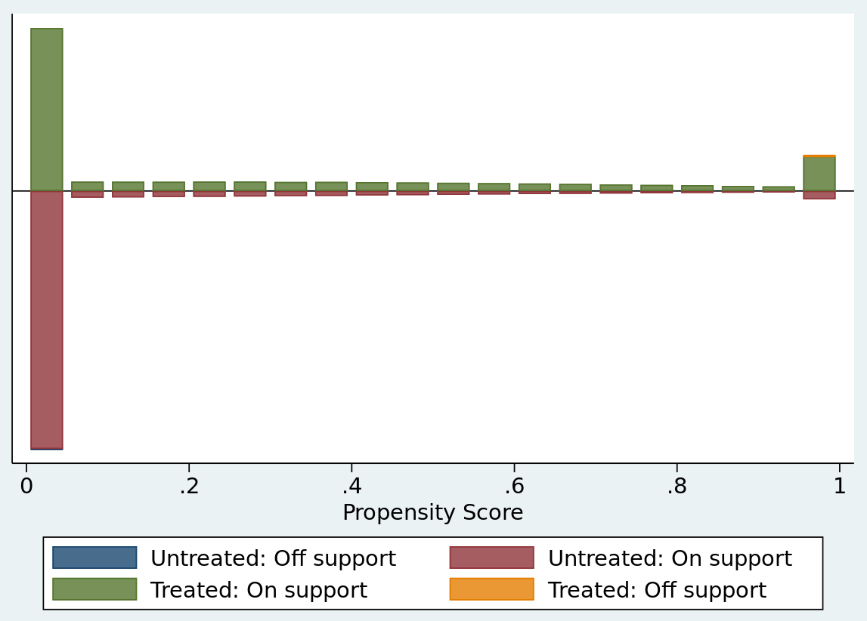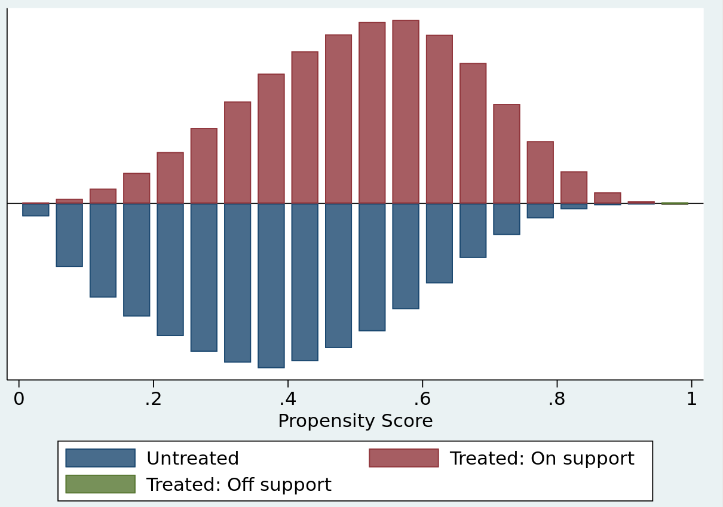
Figure S1. Tuberculosis incidence Propensity score graph Figure S2. Tuberculosis mortality Propensity score graph

6. IPTW Poisson regression unadjusted

To verify the importance of adjusting for all covariates in Poisson multivariate regression with IPTW, we performed the regressions of Poisson bivariate models with IPTW only between Tuberculosis outcomes and PBF exposure, that is, unadjusted models (Table S13).

Table S13. Estimates of the average effect of the Programa Bolsa Famlília (PBF), unadjusted Poisson model (with robust standard error), on Tuberculosis incidence, mortality and case-fatality rate, 2004-2015

 | Outcomes (RRª – CI^{b} 95%)
Models | Incidence | Mortality | Case-Fatality
Unadjusted | 0.59*** (0.58-0.59) | 0.44*** (0.42-0.46) | 0.49*** (0.44-0.56)
Obs | 54,565,735 | 54,571,434 | 46,344
Notes: *** p-value <0,001; **p-valor <0,01; *p-valor <0,05. ª Incidence Rate Ratios. ^{b} Confidence Interval.

7. IPTW Poisson regression stratified models

Table S14 present Poisson regression model with IPTW adjusted, for the association between Tuberculosis incidence, mortality and lethality rates and the Bolsa Família Program (PBF) by subpopulation of age (Brazil, 2004-2015).

S14. Estimates of the average effect of the Programa Bolsa Famlília (PBF), adjusted Poisson model (with robust standard error), on Tuberculosis incidence, mortality and case-fatality rate in Brazil, 2004-2015 – by age subpopulation.
 | Incidence |  | Mortality |  | Case-Fatality
Age | IRRª | 95% CI^{b} | IRRª | 95% CI^{b} | IRRª | 95% CI^{b}
Children and Adolescents^{h} | 0.49*** | 0.48-0.50 | 0.36*** | 0.30-0.42 | 0.52** | 0.30-0.87
Obs. | 29,080,939 |  | 29,082,492 |  | 11,962
Adults^{i} | 0.60*** | 0.59-0.61 | 0.57*** | 0.54-0.61 | 0.82* | 0.68-0.99
Obs. | 21,910,730 |  | 21,914,365 |  | 30,388
Elderly^{j} | 1.09** | 1.02-1.15 | 1.04 | 0.90-1.19 | 1.19 | 0.86-1.66
Obs. | 3,583,338 |  | 3,583,849 |  | 3,994
Notes: *** p-value <0,001; **p-valor <0,01; *p-valor <0,05. ª Incidence Rate Ratios. ^{b} Confidence Interval.

REFERENCES

1. Sanni Ali M, Ichihara MY, Lopes LC, et al. Administrative data linkage in Brazil: Potentials for health technology assessment. Front Pharmacol 2019;10(SEP):1–20.
2. Barreto ML, Ichihara MY, Pescarini JM, et al. Cohort profile: The 100 Million Brazilian Cohort. 2021;1–12.
3. DATASUS. Ministério da Saúde [Internet]. [cited 2021 Dec 20];Available from: https://datasus.saude.gov.br/
4. Pita R, Pinto C, Sena S, et al. On the Accuracy and Scalability of Probabilistic Data Linkage over the Brazilian 114 Million Cohort. IEEE J Biomed Heal Informatics 2018;22(2):346–53.
5. Pinto C, Pita R, Barbosa G, et al. Probabilistic Integration of Large Brazilian Socioeconomic and Clinical Databases. Proc - IEEE Symp Comput Med Syst 2017;2017–June:515–20.
6. Barreto, Marcos1, Alves, André, Sena, Samila, Fiaccone, Rosemeire, Amorim, Leila, Ichihara, Maria Yuri, and Barreto M. Assessing the accuracy of probabilistic record linkage of social and health databases in the 100 million Brazilian cohort. Int J Popul Data Sci 2017;0(August 2016):23889.
7. Pita R, Pinto C, Barreto M, et al. Design and evaluation of probabilistic record linkage methods supporting the Brazilian 100-million cohort initiative. Int J Popul Data Sci 2017;1(1):23889.
8. Bolsa Família — MINISTÉRIO DA CIDADANIA Secretaria Especial do Desenvolvimento Social [Internet]. [cited 2022 Jan 14];Available from: http://mds.gov.br/assuntos/bolsa-familia
9. Lindert K, Linder A, Hobbs J, de la Brière B. The Nuts and Bolts of Brazil’s Bolsa Família Program: Implementing Conditional Cash Transfers in a Decentralized Context. Soc Prot Discuss Pap Ser 2007;(0709):144.
10. Lawlor DA, Tilling K, Smith GD. Triangulation in aetiological epidemiology. Int J Epidemiol 2016;45(6):1866–86.

