Appendix

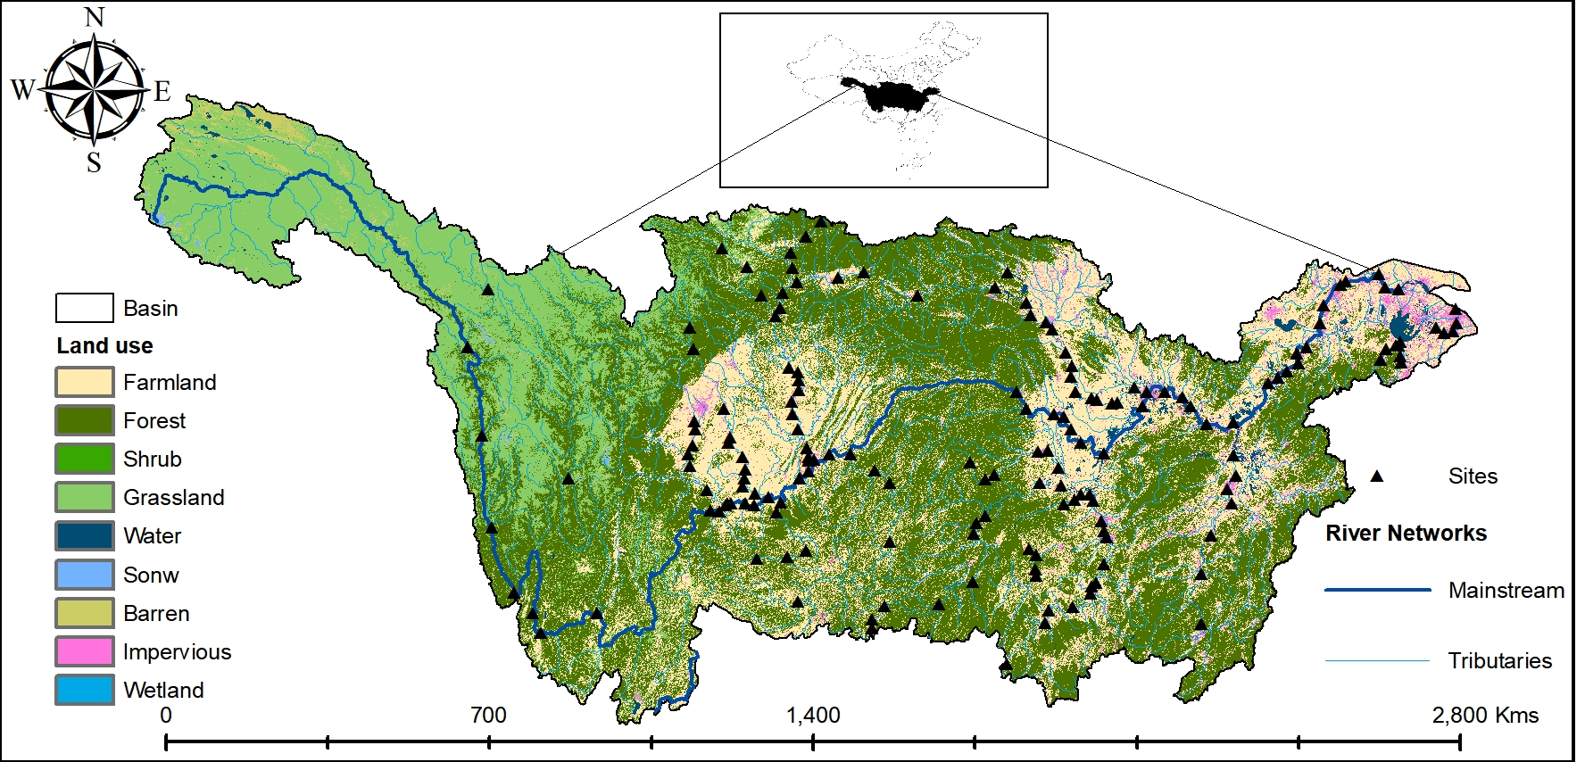
Appendix Figure 1 Land use types in the study area.

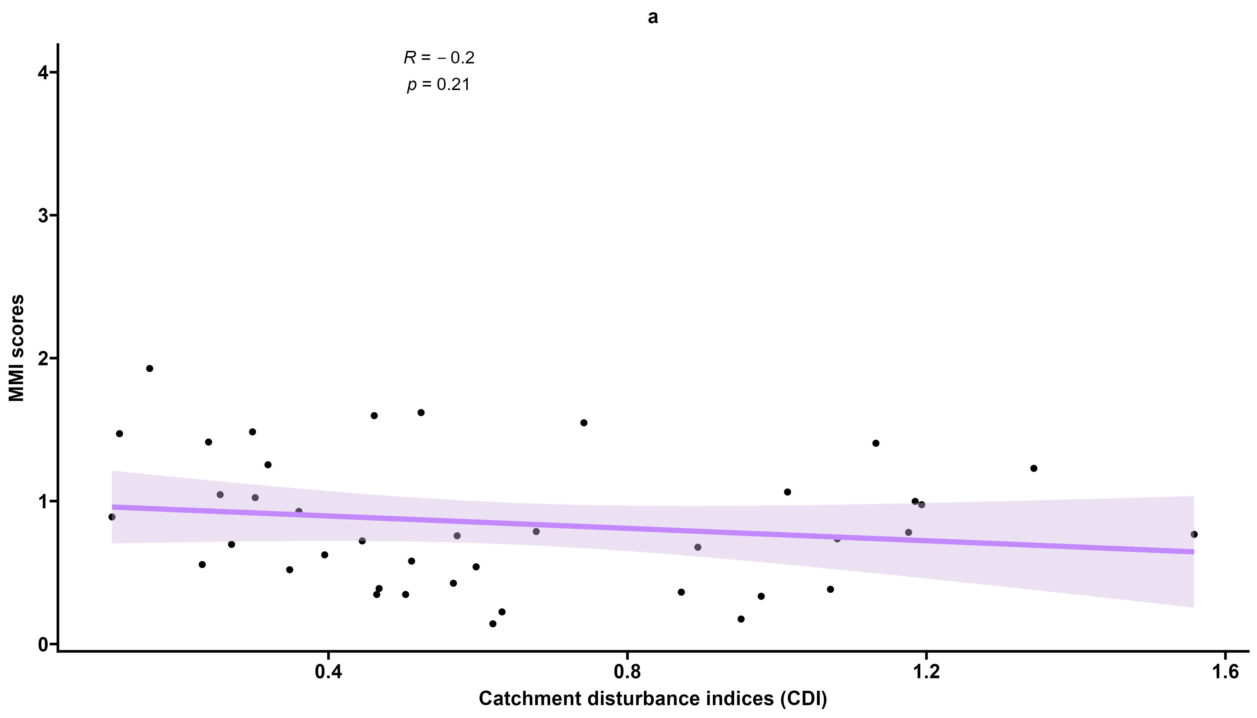
Appendix Figure 2 shows the results of Spearman's correlation analysis between MMI scores and CDIs.

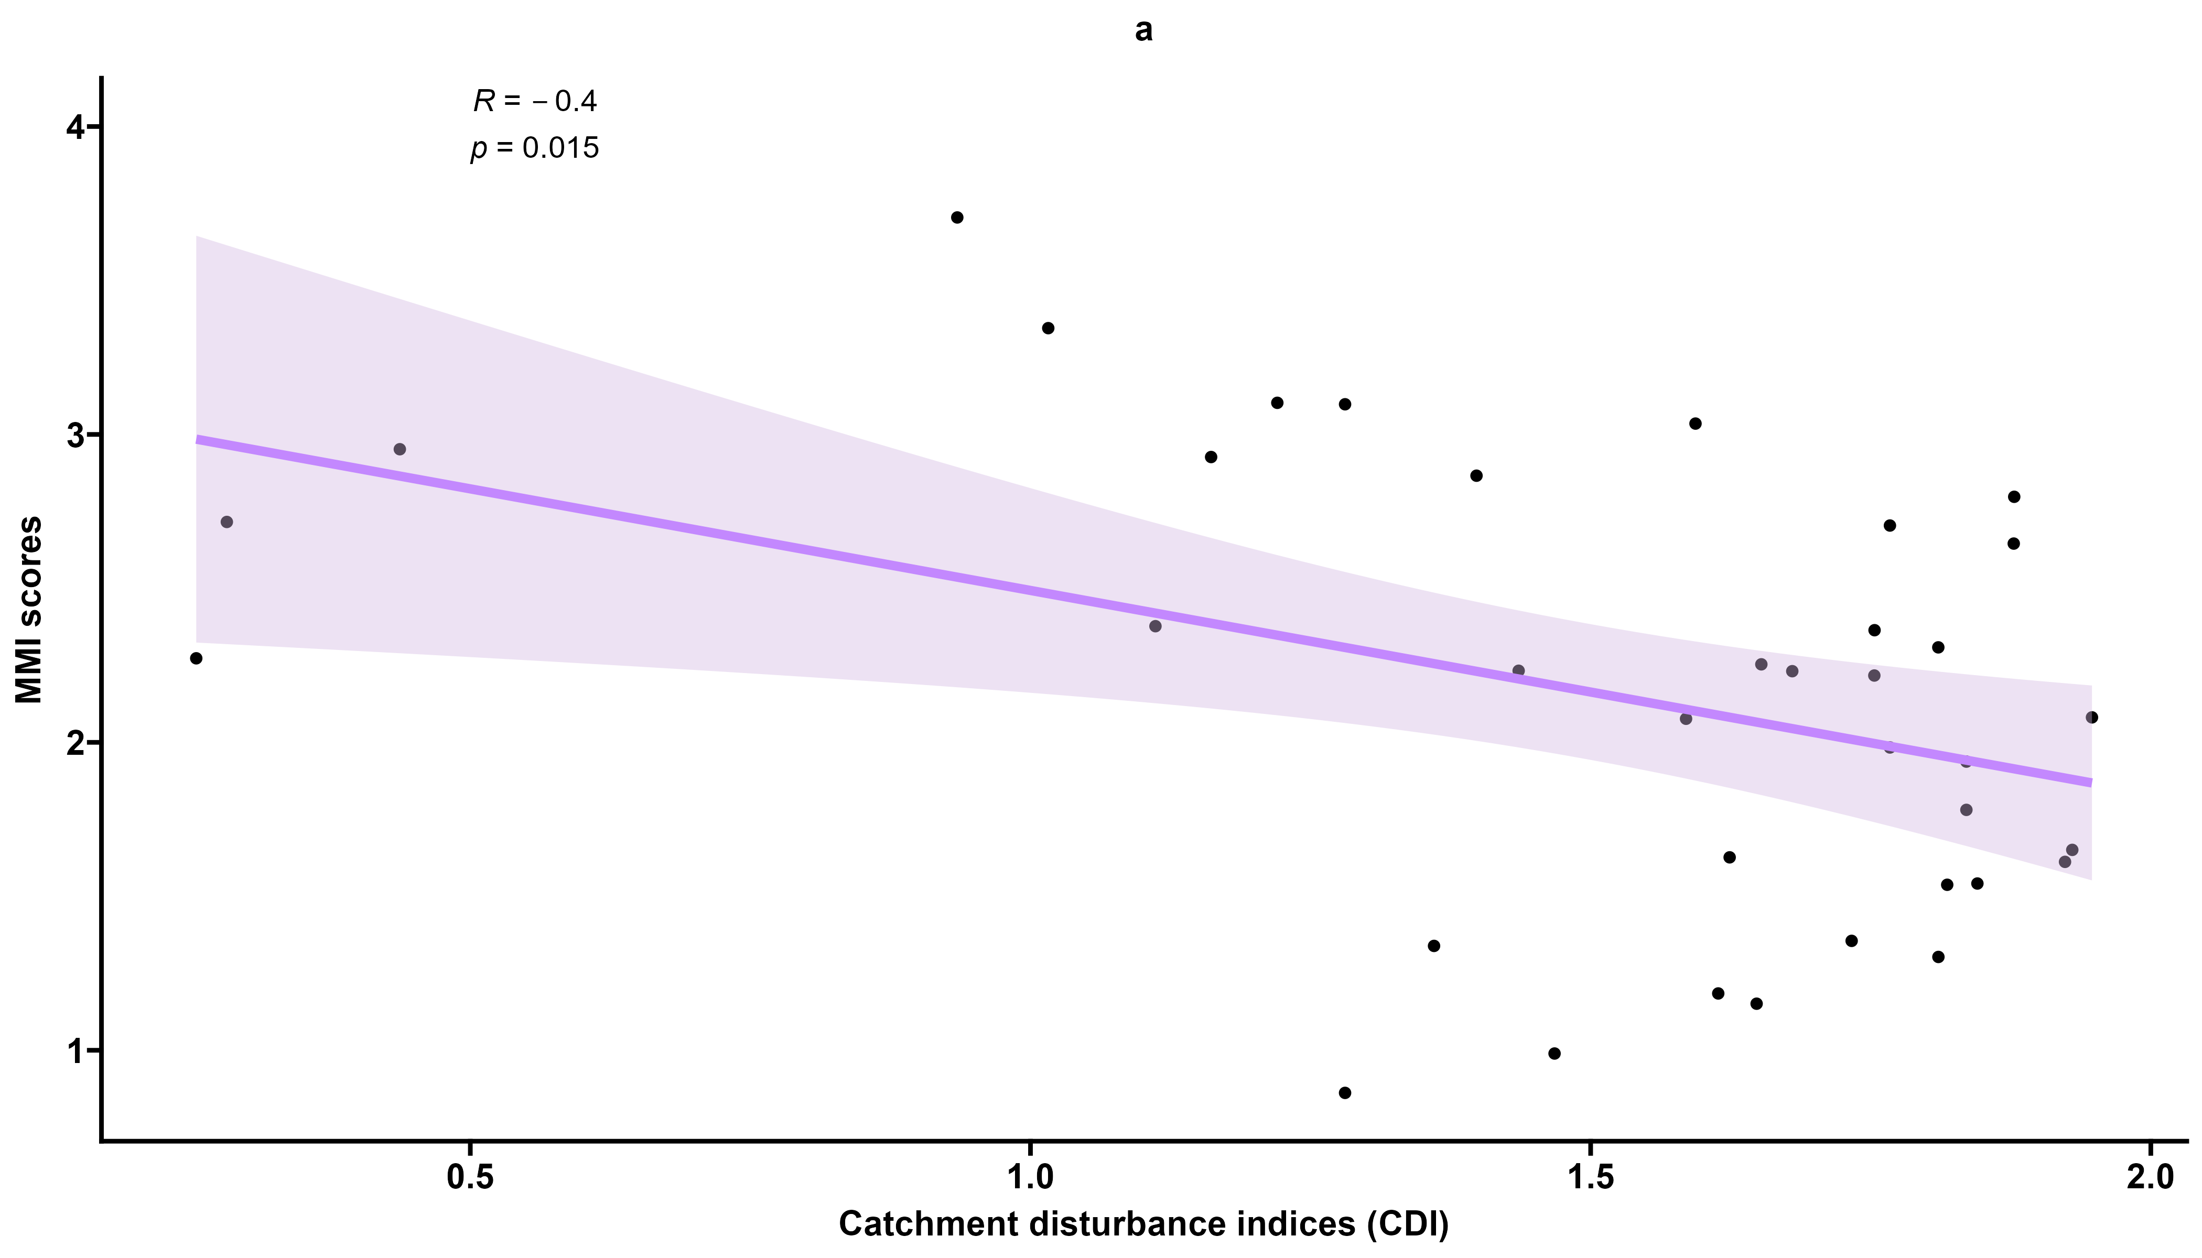
Appendix Figure 3 shows the results of Spearman's correlation analysis between MMI scores and CDIs.

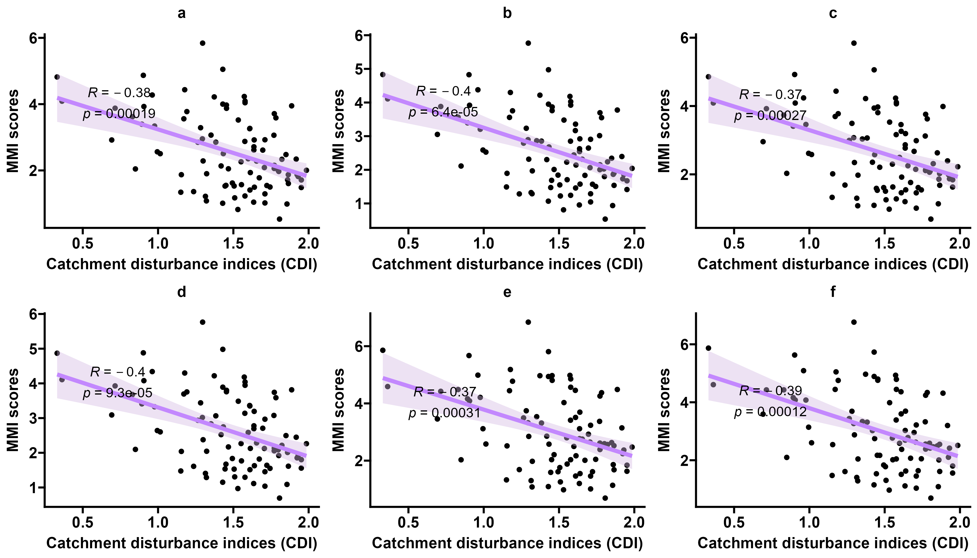
Appendix Figure 4 shows the results of Spearman's correlation analysis between MMI scores and CDIs.

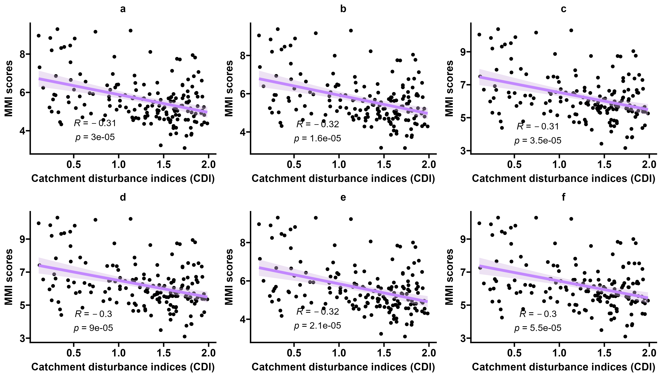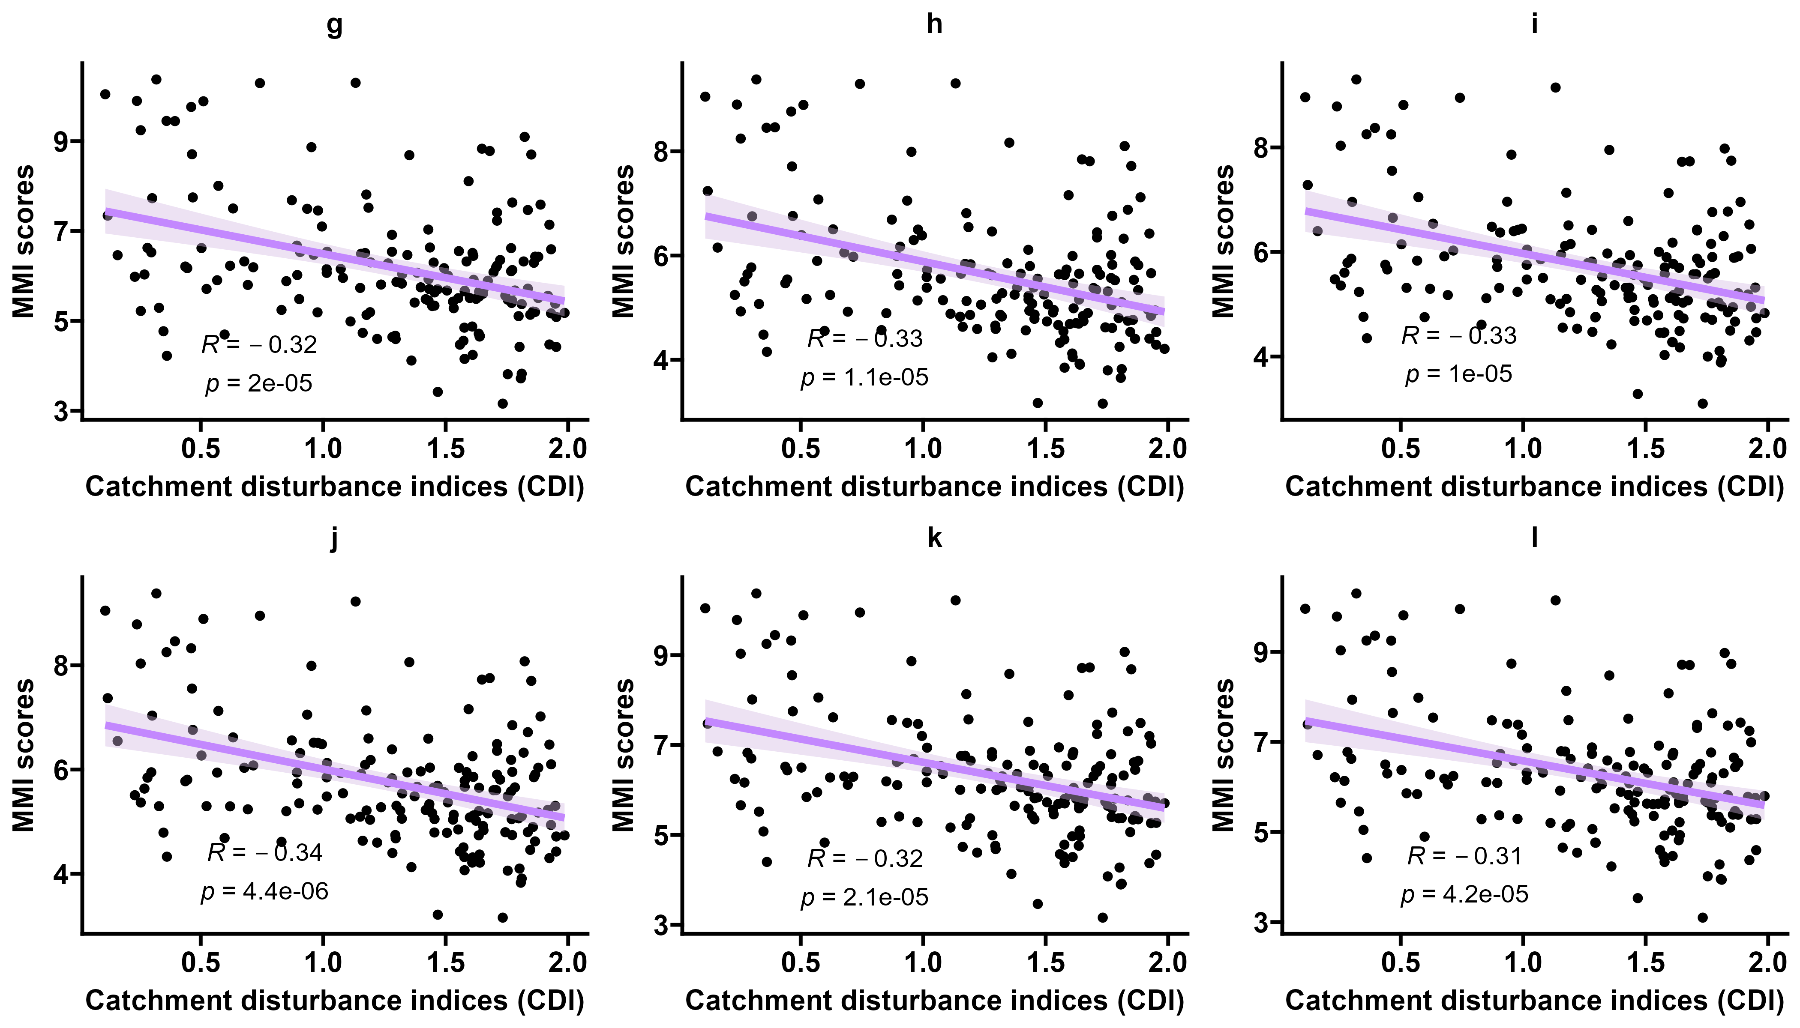
Appendix Figure 5 shows the results of Spearman's correlation analysis between MMI scores and CDIs.

Appendix Table 1 List of MMI Candidate Indicators.
Code | Indicator name
M1 | Number of taxonomic units within the Diptera order
M2 | Number of taxonomic units within the Ephemeroptera order
M3 | Number of taxonomic units within the Plecoptera order
M4 | Number of taxonomic units within the Trichoptera order
M5 | Number of taxonomic units within the Hemiptera order
M6 | Number of taxonomic units within the Megaloptera order
M7 | Number of taxonomic units within the Lepidoptera order
M8 | Number of taxonomic units within the Coleoptera order
M9 | Number of taxonomic units within the Odonata order
M10 | Number of taxonomic units within the aquatic insects order
M11 | Number of taxonomic units within the non-Chironomidae family Diptera order
M12 | Number of taxonomic units within the non-Chironomidae aquatic insects order
M13 | Number of taxonomic units within the Chironomidae order
M14 | Number of taxonomic units within the Oligochaeta order
M15 | Number of taxonomic units within the Clitellata order
M16 | Number of taxonomic units within the Gastropoda order
M17 | Number of taxonomic units within the Bivalvia order
M18 | Number of taxonomic units within the Polychaeta order
M19 | Number of taxonomic units within the Crustacea order
M20 | Number of taxonomic units within the EPT order
M21 | Number of taxonomic units within the crustaceans and molluscs order
M22 | Number of taxonomic units within the telopods and molluscs order
M23 | Total number of classification units
M24 | Percentage of EPT individuals
M25 | Percentage of individuals in dominant taxonomic units
M26 | Percentage of individuals in the order Ephemeroptera
M27 | Percentage of Chironomidae individuals
M28 | Percentage of Plecoptera individuals
M29 | Percentage of Megaloptera individuals
M30 | Percentage of Hemiptera individuals
M31 | Percentage of Diptera individuals
M32 | Percentage of Odonata individuals
M33 | Percentage of Trichoptera individuals
M34 | Percentage of Coleoptera individuals
M35 | Percentage of number of Lepidoptera individuals
M36 | Percentage of individuals in the order Tubificida
M37 | Percentage of number of Perlidae individuals
M38 | Percentage of individuals of Tipulidae
M39 | Percentage of individuals of Ephemerellidae
M40 | Percentage of individuals of Heptageniidae
M41 | Percentage of individuals of Leptophlebiidae
M42 | Percentage of individuals of Siphlonuridae
M43 | Percentage of individuals of Baetidae
M44 | Percentage of individuals of Atyidae
M45 | Percentage of individuals of Leptoceridae
M46 | Percentage of individuals of Gammaridae
M47 | Percentage of individuals of Lymnaeidae
M48 | Percentage of Palaemonidae individuals
M49 | Percentage of individuals of Heteroceridae
M50 | Percentage of Corophiidae individuals
M51 | Percentage of individuals in non-Chironomidae Diptera
M52 | Percentage of individuals of crustaceans and molluscs
M53 | Percentage of individuals in telopods and molluscs
M54 | Percentage of Oligochaeta individuals
M55 | Percentage of individuals of aquatic insects
M56 | Number of taxonomic units for sensitive taxa
M57 | Number of taxonomic units of pollution-tolerant taxa
M58 | Percentage of predator individuals
M59 | Percentage of filter feeders
M60 | Percentage of the number of individual collectors
M61 | Percentage of the number of individual tearers
M62 | Percentage of the number of individual scrapers
M63 | Percentage of the number of individuals in the sprawler
M64 | Percentage of number of individuals in cave dwellers
M65 | Percentage of the number of individual climbers
M66 | Percentage of individual swimmers
M67 | Shannon Diversity.
M68 | Margalef Richness Diversity
M69 | Evenness Diversity
M70 | Biological Monitoring Working Party(BMWP)
M71 | Biological Index(BI)
M72 | Biological Pollution Index(BPI)
M73 | Functional richness(FRic)
M74 | Functional evenness(FEve)
M75 | Functional divergence(FDiv)
M76 | Functional dispersion(FDis)
M77 | Rao's quadratic entropy index(RaoQ)
M78 | voltinism
M79 | dispersal
M80 | drift
M81 | respiration
M82 | size
M83 | rheophily
M84 | thermal tolerance
M85 | activity habits
M86 | functional feeding group
M87 | Local contributions to beta diversity

