Statistical Analysis Plan (SAP)
The trial was designed as a double blinded randomized controlled trial (RCT). To avoid bias in the interpretation of the results, the colposcopist and the pathologist were blinded about which patient received one treatment or another. On the basis of previous trials, the primary efficacy outcome was tested for a difference between the groups at an overall two-sided type I error rate of 5%. The sample size was initially estimated to be 100 patients but was finally increased to 106 patients. The control group (n=49) received local estrogen-based hormonal therapy, applied to the vagina mucosa on Monday, Wednesday, and Friday of each week, for 3 months, while the experimental group (n=57) received local salmon PDRNs on vaginal suppositories, applied solely for six days every night in the first week. The follow-up assessment was done after 3 months. No alpha was spent as a result of this analysis.
To investigate the real clinical significance of the therapies, the Menopause Rating Scale (MRS) was used to assessed the severity of the GSM symptoms. MRS is a health-related quality of life (HRQoL) scale, which aims to have a standardized way of measuring the severity of ageing symptoms and their impact on the quality of life. The GSM symptoms was evaluated by items 9 to 11 of the MRS. These items evaluate the entire urogenital domain. Item 9 assesses sexual problems (libido, sexual activity, and dyspareunia). Item 10 evaluates bladder problems (polyuria, urinary urgency, bladder instability, and urinary incontinence). Item 11 evaluates vaginal dryness, including the sensation of vaginal dryness or vaginal burning, and the difficulty of having sexual intercourse. The severity of symptoms in each item was rated as follows: 0= asymptomatic, 1 = mild overall symptoms, 3 = severe overall symptoms and 4 = very severe overall symptoms. Because these values represent categories with some intrinsic classification, the scores obtained from each item were classified as ordinal variables. Therefore, it would be possible to carry out its analysis using non-parametric tests such as the Mann-Whitney test. Using this approach, it would be possible to find statistically significant differences between groups. However, we considered that this statistical significance would not really show the clinical significance, since one group could present significant differences in some item, but could find themselves with clinically significant symptoms. Consequently, we decided to categorize the scores obtained into " clinically non-significant symptoms" and " clinically significant symptoms". To do this, we classified all item´s punctuations of 0 and 1, as clinically non-significant symptoms, while scores from 2 to 4, as clinically significant symptoms (Table S1).
Likewise, we categorized the vaginal pH, considering it "normal" when the values were 4 to 5 and "altered" when the value was >5. To evaluate the contraction of the pelvic floor muscles, the Modified Oxford Scale (MOS) was used. This scale ranges from 0 to 5 where: 0 = no contraction; 1 = minor muscle 'flicker'; 2 = weak muscle contraction; 3 = moderate muscle contraction; 4 = good muscle contraction and 5 = strong muscle contraction. To convert this value into a dichotomous nominal variable, “poor pelvic floor contraction” was considered when the values ranged between 0 and 2 and “adequate pelvic floor contraction” when the values ranged between 3 and 5. Finally, Lugol staining in colposcopy helps us to indirectly evaluate the presence of glycogen in the intermediate cell layer, which was interpreted as trophism of the vaginal epithelium. It was assigned + when the uptake was very weak, ++ when it was weak, +++ when it was moderate and ++++ when it was strong. We categorize this variable considering “trophism of vaginal epithelium” when +++ or ++++ were present and “atrophy of the vaginal epithelium” when + or ++ were present.
In this way, we converted the ordinal variables into dichotomous nominal variables and were able to calculate ratio quantities, such as the relative risk (RR) and odds ratio (OR), which allowed to see the real clinical effect of PDRNs therapy on the primary clinical outcomes compared with the gold standard therapy with local estrogens (Figure S1). The calculation of the RR and OR was performed at the beginning of the study and at 3 months of follow-up after the treatment. We computed RRs and ORs, with their respective confidence intervals (CI) using the data software package of PAST 3.0 and we constructed the Forest Plots using the GraphPad Prism 8.4.3 software.
RR is used to calculate the probability of occurrence of an adverse event and OR is used to know the probability of the event occurring divided by the probability of the event not occurring. Despite some authors claim that OR and RR are mathematically not equivalent from the point of statistical interpretation (because OR can exaggerates the RR), this does not affect the qualitative inference of the results. In support of this, one study reviewed 580 RCTs published in the New England Journal of Medicine between January 2004 and June 2014. In this study, 107 RCTs were identified reporting unadjusted RR (n = 76) or OR (n = 31) for the primary outcome. For all those studies reporting ORs the RRs were calculated and vice versa. The percentage of divergence between the reported and calculated effect size estimates was analyzed, finding that none of the RCTs showed a statistically significant result becoming insignificant or vice versa depending on the effect size estimate. With this argument we suggested that it was better to calculate both RRs and ORs so that clinicians could take both parameters to interpret the effect of therapies.

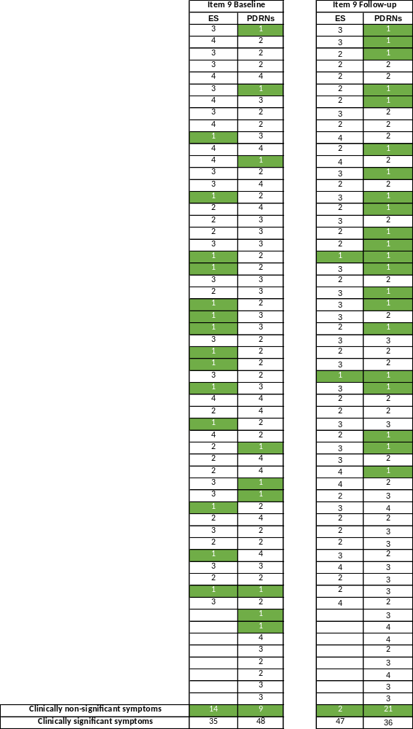
Table 1. Example of the categorization of the MRS item 9 scores into clinically non-significant symptoms and clinically significant symptoms at baseline and after 3 months of follow-up.

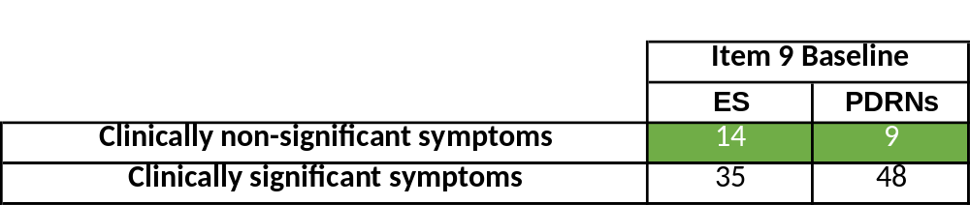
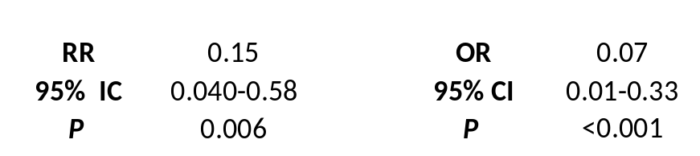
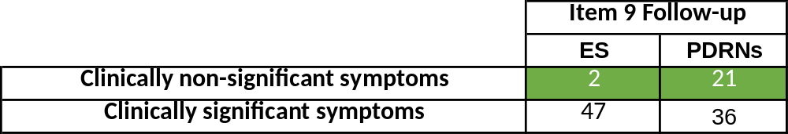
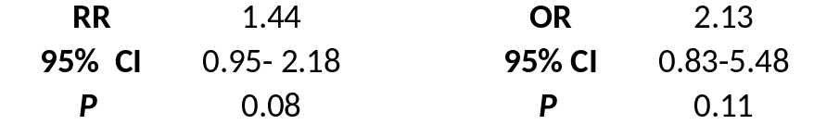

Figure S1. Converted ordinal variables into dichotomous nominal variables enable the calculation of the relative risk (RR) and odds ratio (OR).

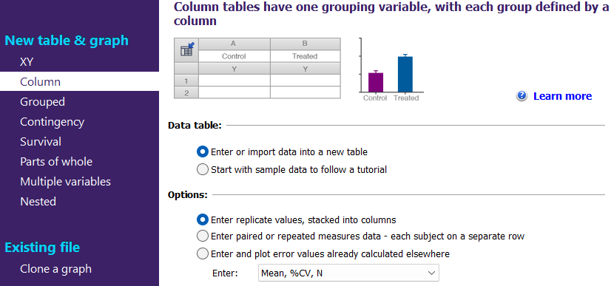
CI
OR
CI

Figure S2.

