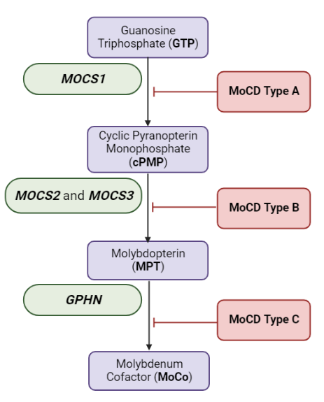
Figure S1: Molybdenum cofactor biosynthetic pathway

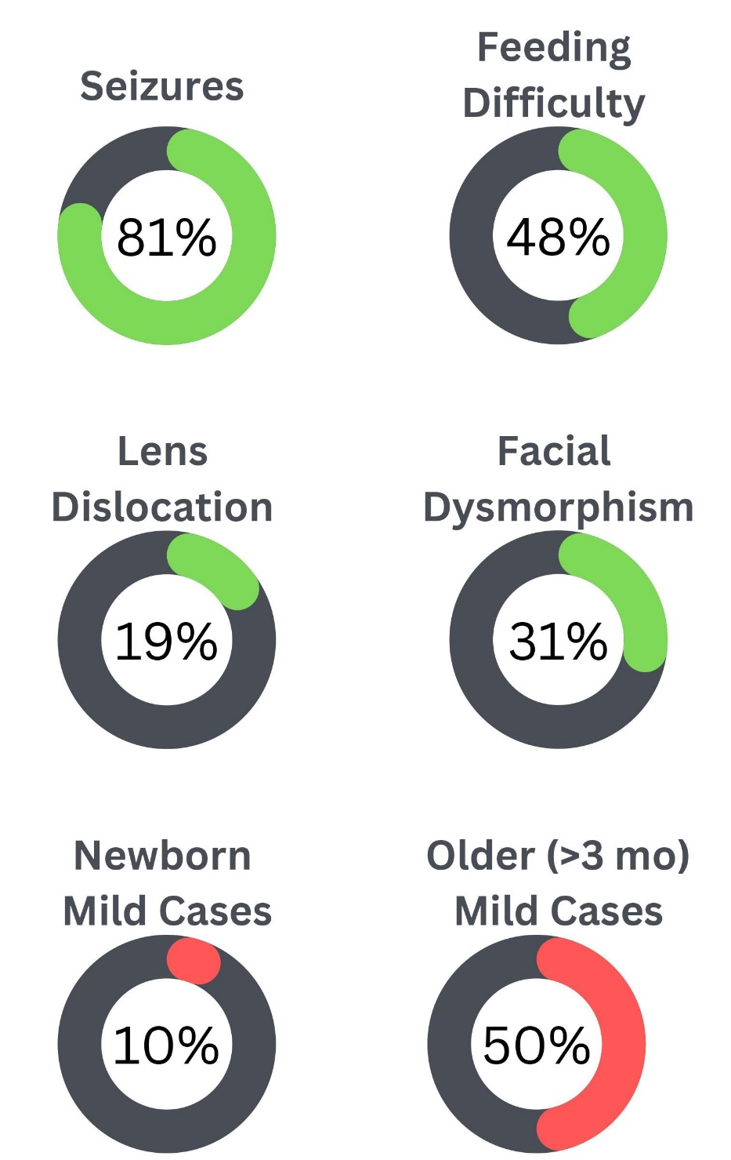
Figure S2: Summary of clinical phenotypes

