Urban Ecosystems

Whiskers in the city: Domestic cat predation in Ecuadorian coastal cities and associated factors

SUPPLEMENTARY FIGURES

Kevin Panchana¹, Ileana Herrera^{1,2*}, Anahí Vargas¹, Isac Mella-Méndez³, Rafael Flores-Peredo³

¹Escuela de Ciencias Ambientales, Universidad Espíritu Santo, 091650, Guayaquil, Ecuador
²Instituto Nacional de Biodiversidad (INABIO), 170501, Quito, Ecuador
³Laboratorio de Ecología, Instituto de Investigaciones Forestales, Universidad Veracruzana, 91090, Xalapa, México
*Corresponding author: herrera.ita@gmail.com

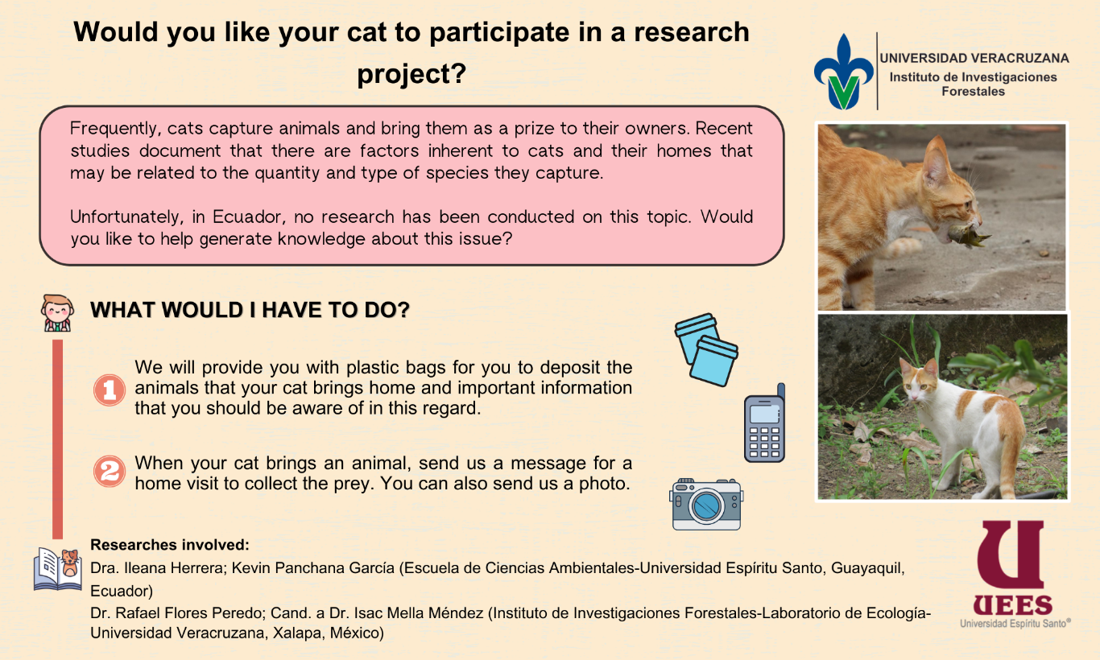Fig. S1. Research project descriptive sheet provided to the participants.

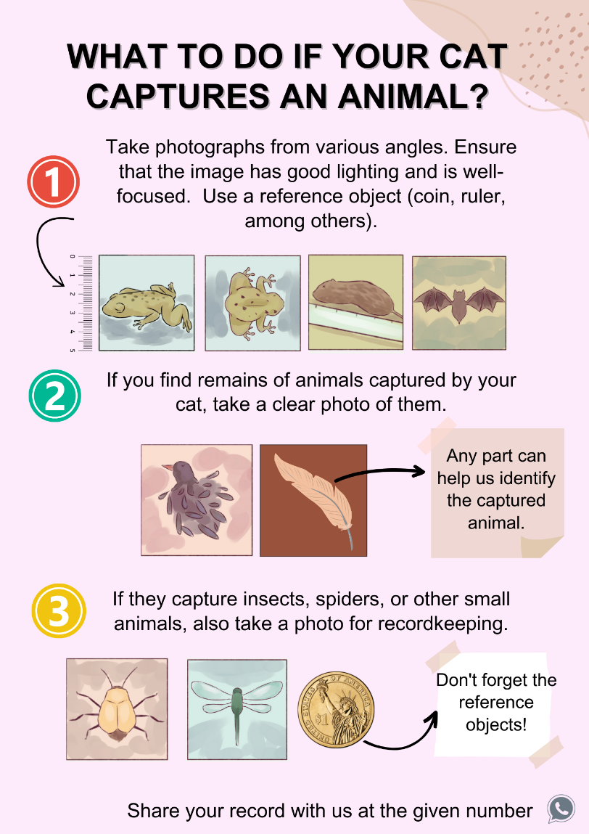
Fig. S2. Brief guide for photographing animals captured by cats shared with the participants.
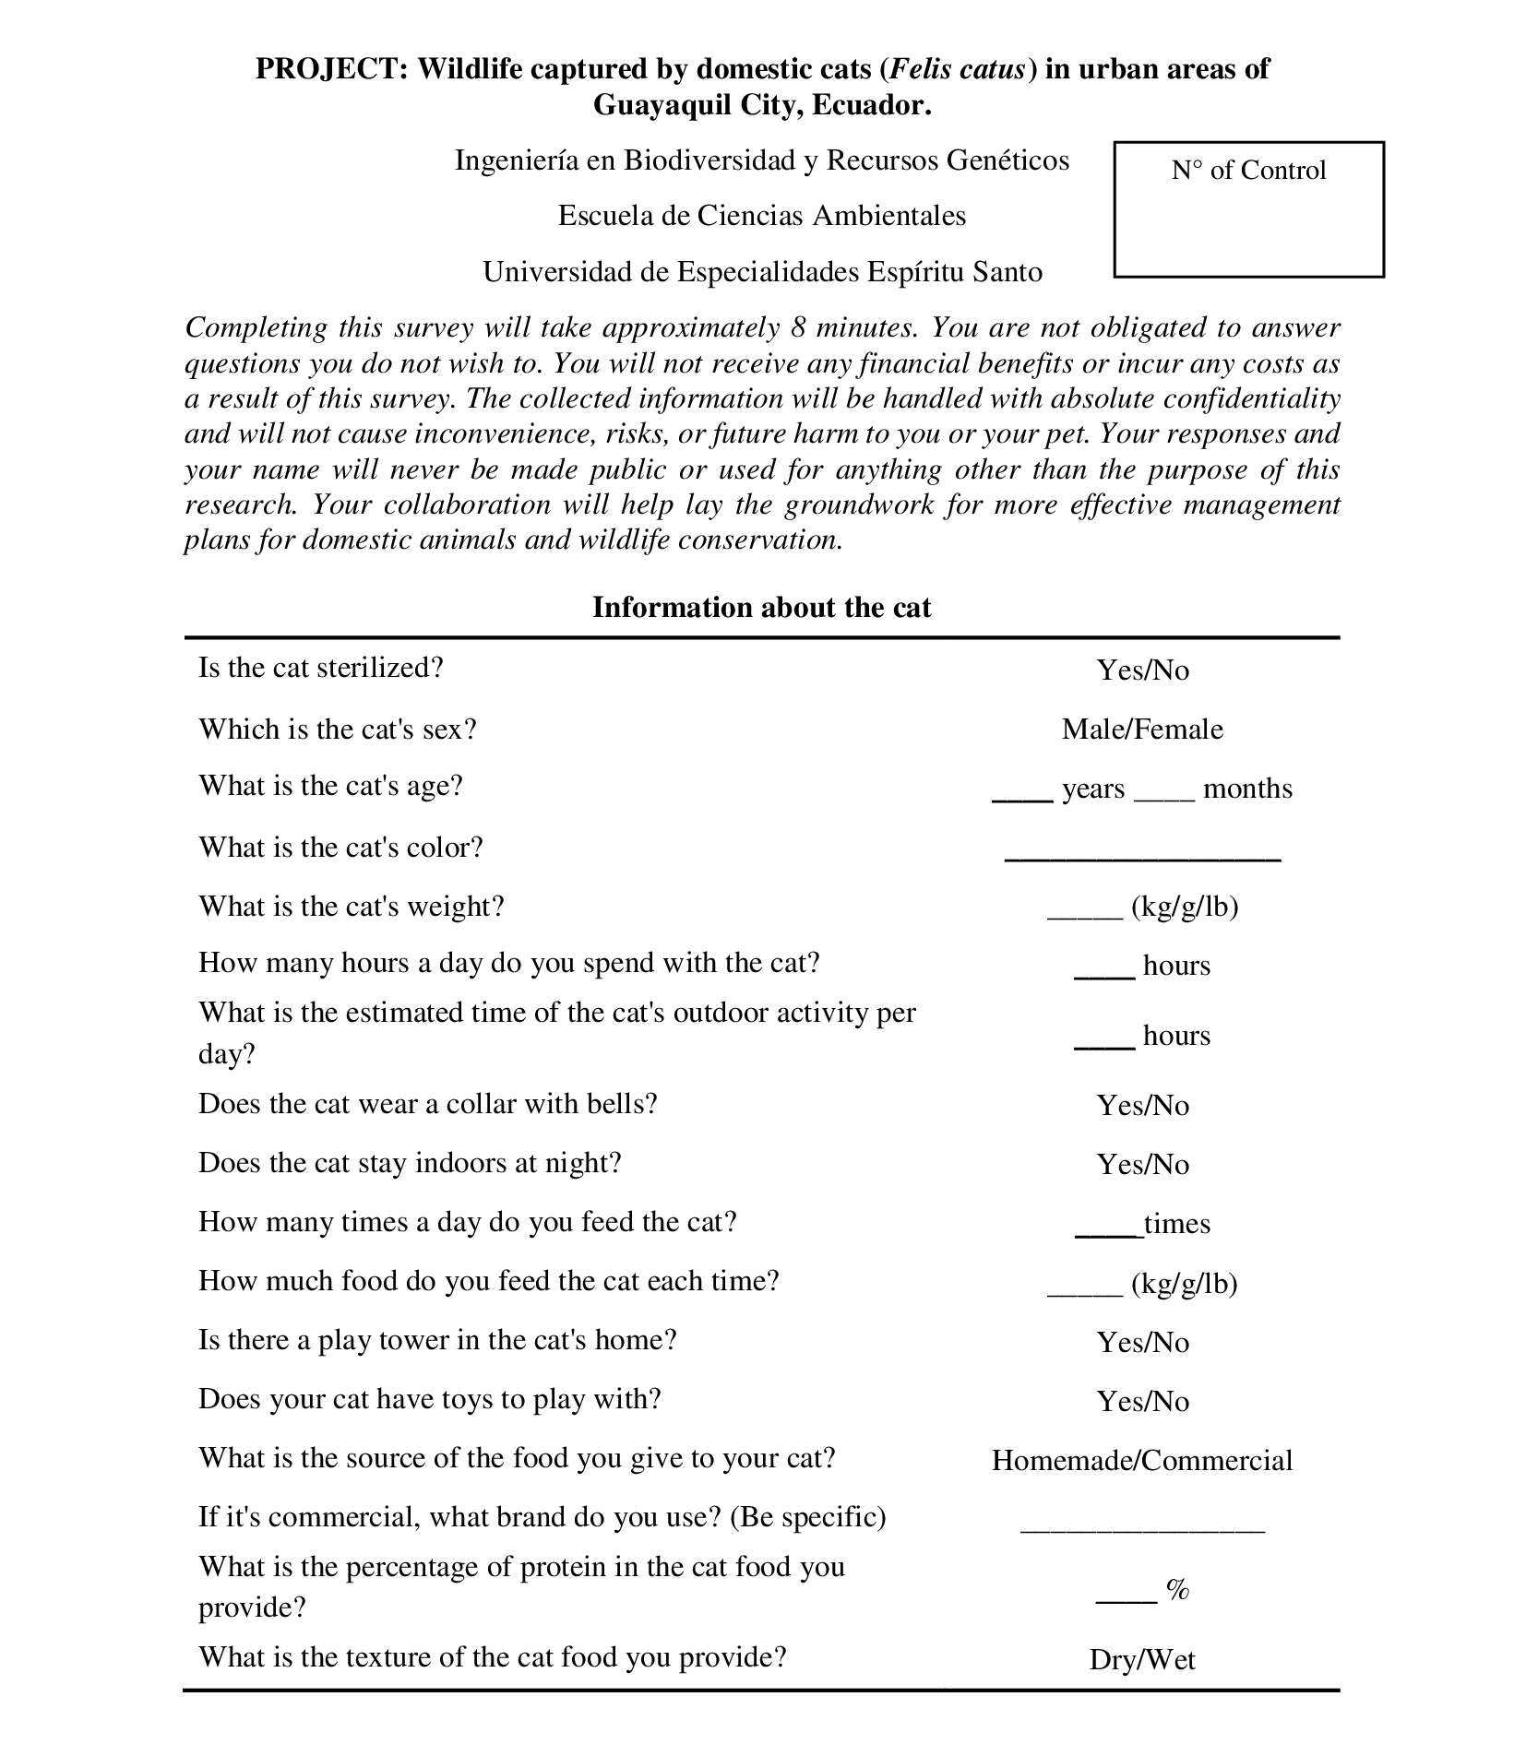
Fig. S3. Structure of the survey conducted with participants to gather information on the intrinsic and extrinsic factors of the cats.

