Supplementary Figures

Figure S1. Drug susceptibility testing of Leishmania strains. Intracellular susceptibility testing to pentavalent antimony (Sb^{V}, 32 µg/mL) was performed for all Leishmania strains isolated from study participants. Data are expressed as % reduction of intracellular parasite load when exposed to SbV vs. untreated controls. Strains where % reduction was <78% were deemed resistant. Fisher´s statistic corresponds to the contrast of the 2x2 contingency table of TF and cured patients infected with either Sb^{V}-susceptible or Sb^{V}-resistant Leishmania strains.

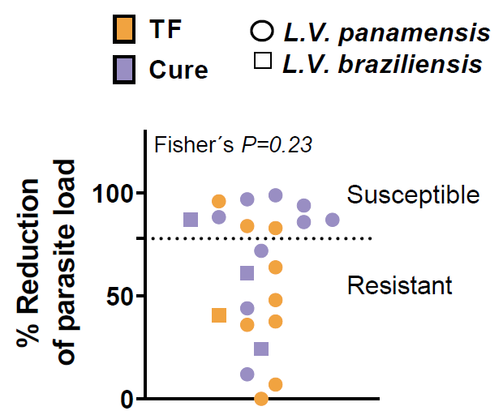

Figure S2. Evaluation of sequencing depth per sample. Plot of reads mapped (sequencing depth) vs. number of genes detected. The plot includes a total of 186 samples collected and sequenced in the study. The samples that stood out as outliers appear at the bottom of the graph and suggest a minimal number of acceptable genes as approx. 11,000. The high depth of sequencing for the samples shown in the right half of the plot was a result of samples were loaded on a production scale platform, but illustrates well the diminishing returns beyond 50 M reads per sample.

Figure S3. Assessment of clinic-associated batch effect. Principal Component Analysis (PCA) plots of the global gene expression profiles of all samples combined (Panel A), individual blood cells (eosinophils, monocytes, and neutrophils) and lesion biopsies collected from study participants (Panels B-E) at two different clinics (one in Tumaco, the South Pacific coast of Colombia, and another in the urban center of Cali), and three visits (pre-treatment and twice during the course of treatment).The analyses were performed using all annotated protein-coding genes following filtering for low counts, quantile/cpm normalization and log2 transformation. In the PCA plots, the first two principal components are shown on the X and Y axes respectively, with the proportion of total variance attributable to that PC indicated. Each sample is represented as a single point with color indicating either the clinic (Panel A), or clinic_treatment_outcome (Panels B-E). The inner and outer ellipses represent the 90% and 95% confidence intervals, respectively.

Figure S4: PCA plots of innate cell transcriptomes during the course of treatment. Principal component analyses for all samples were performed using log2 transformed, quantile, cpm and filtered counts of annotated protein-coding genes. The first two principal components are shown on the X and Y axes, respectively, with the proportion of total variance attributable to that PC indicated. Colors indicate visit and shapes clinical outcome. The inner and outer ellipses represent the 90% and 95% confidence intervals, respectively.

Figure S5. WGCNA analysis of the response of the three innate immune cells in CL patients. Genes in WGCNA modules that were significantly associated with TF from monocytes (Panel A) or neutrophils (Panel B) were used to construct protein-protein interaction networks using the STRING plug-in in Cytoscape. Genes within clouds were manually grouped based on functional categories. Nodes represent gene products and node colors represent up- or -downregulation in TF. Darker gray halos around the nodes indicate gene products in common between WGCNA and DE analyses. Protein networks with ≤ 3 nodes are not shown. The Venn diagram (Panel C, left) shows the overlap of genes among enriched modules from Mo: monocytes, Nφ: neutrophils, Eφ: eosinophils. The 36 gene products common to the three cell types were used as input to derive a protein-protein interaction network from existing data (right).

Figure S6 Score. Monocyte and eosinophil scores in cures and TF. RPKM data of the 10 innate signature genes from Pre-Tx samples was used to construct monocyte (Panels A, B) and eosinophil (Panels C, D) composite scores. Raw (A, C) and normalized (Z-scores) (B, D) are shown. Statistical significance was evaluated by analysis of variance. P values from two-tailed analyses of variance are shown.

