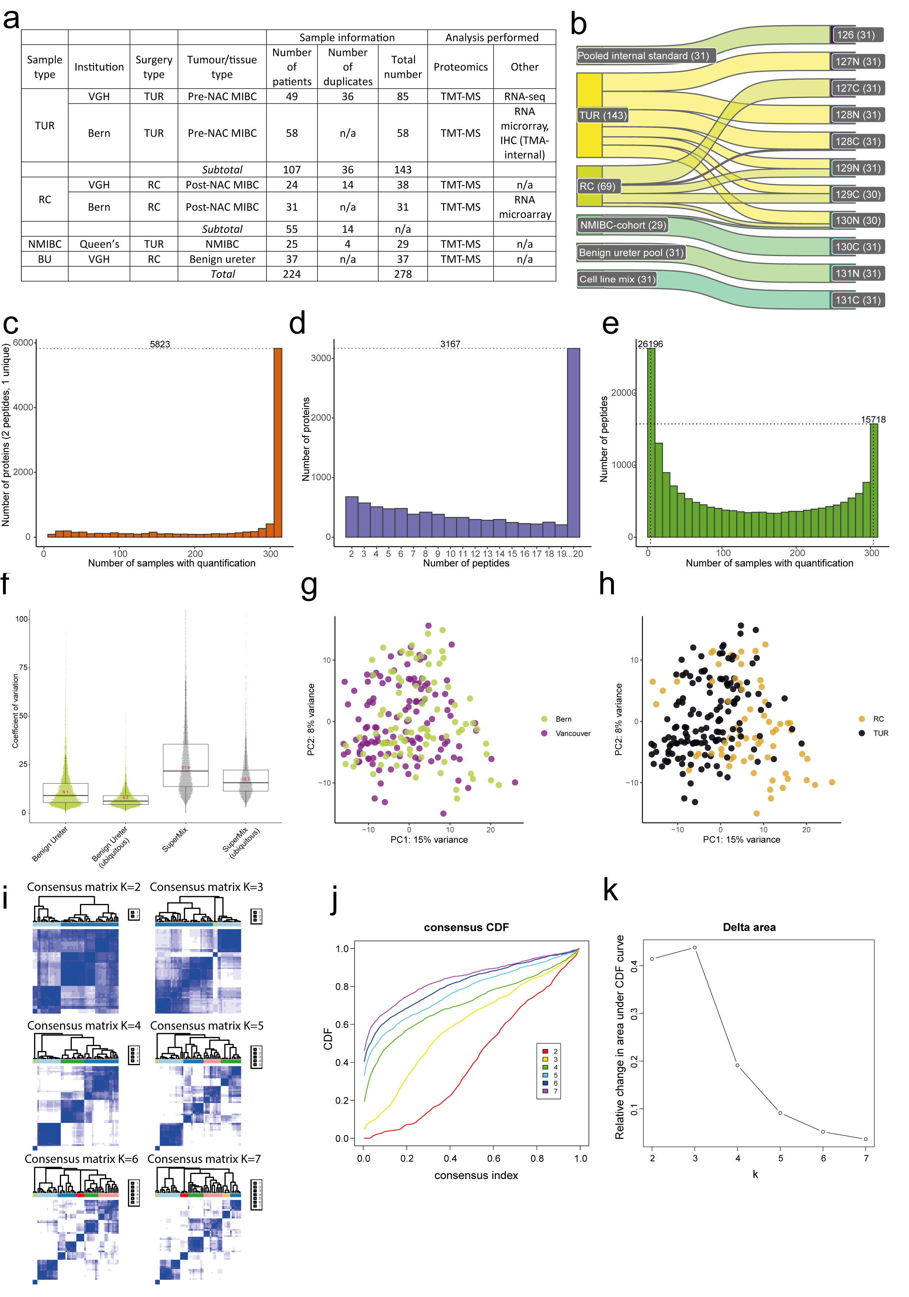
Supplementary Fig. 1 Sample workflow and quality control of the study.
a Summary of study samples by sample type, institution, surgery type, tumour/tissue type, patient count, duplicate availability, and analyses performed. BU samples were pooled for analysis. An additional unmatched validation TMA (TMA-validation, see Supplementary Table 3) is not shown.
b Distribution of sample types in 31 x 11-plex TMT sets. Numbers on the left indicate sample types. TMT label assignments are on the right. Each plex included one pooled internal standard, TUR, RC, NMIBC, BU, and cell line mix samples (where isoDoping peptides are spiked-in).

c Number of peptides quantified across the proteomics cohort. Bars in histogram show the number of peptides identified per sample with quantification. 26,196 peptides were identified only in one TMT plex and 15,718 were identified in all the TMT plexes.
d Number of proteins, identified by at least two peptides of which at least one uniquely mapping, quantified across the proteomics cohort. 5,823 proteins were quantified in all the samples.
e Number of peptides identified per protein. 3,167 proteins were quantified by 20 or more peptides.
f CV for all proteins and for proteins identified in every sample (ubiquitous) across all 31 plexes.
G PCA showing the separation of samples according to centre of origin.
h PCA showing the separation of samples according to sample type.
i Consensus matrices exploring the range of two to seven K-means clusters for pre-NAC TUR tumors using consensus clustering on the 1,170 most variable proteins.
j Robust segregation of pre-NAC TUR samples and consensus CDF.
k Delta area analysis identified four robustly segregated groups with a clear cluster separation based on visual inspection and the largest change in area under the CDF curve in the delta plot. This was explored in the range of two to seven K-means clusters
Abbreviations: Affymetrix, Affymetrix GeneChip Exon Array; CDF, cumulative distribution function; CV, coefficient of variation; HG, high grade; IHC, immunohistochemistry; MIBC, muscle-invasive bladder cancer; NAC, neoadjuvant chemotherapy; NMIBC, non-muscle invasive bladder cancer; PCA, principal component analysis; Prot, global proteomics; RC, radical cystectomy; TMA, tissue microarray; TMT-MS, Tandem Mass Tag Mass Spectrometry; TUR, transurethral resection. Source data are provided as Source Data file.

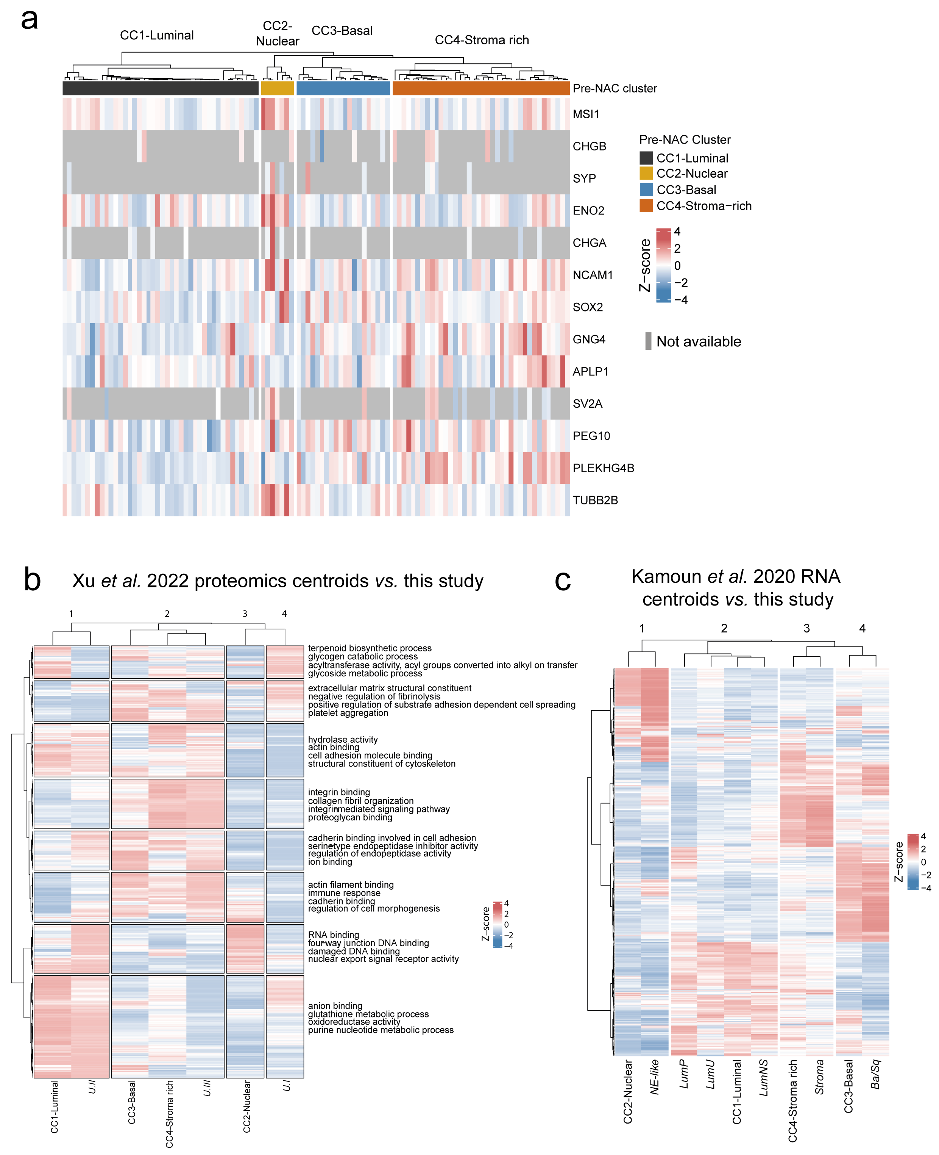
Supplementary Fig. 2 Neuroendocrine markers and proteomic centroids in pre-chemotherapy tissue compared to other published landmark muscle-invasive bladder cancer (MIBC) cohorts with proteomic and transcriptomic data.
a Proteomic expression of neuroendocrine markers commonly used in IHC and in the neuroendocrine-like RNA-based classifier of Batista da Costa et al. 2019⁶⁶ in the pre-NAC TUR MIBC cohort stratified by proteomic pre-NAC TUR clusters. The CC2-Nuclear cluster expresses high levels of most neuroendocrine markers compared to other proteomic clusters.
b Columns represent proteomic centroids from the clustering analysis of Xu et al. 2022³¹ (MIBC clusters: U.I, U.II, and U.III) and this proteomics study (Pre-NAC TUR: CC1-Luminal, CC2-Nuclear, CC3-Basal, CC4-Stroma-rich, in bold and italics) with respect to selected biological pathways.
c Columns represent centroids derived from the 521 genes used by the RNA-based MIBC Consensus Classifier by Kamoun et al. 2020⁹ (NE-like, Ba/Sq, Stroma-rich, LumP, LumU, LumNS) in relation to the proteomic-based centroids of this study (Pre-NAC TUR: CC1-Luminal, CC2-Nuclear, CC3-Basal, CC4-Stroma-rich, in bold and italics).
Abbreviations: Ba/Sq, basal squamous; CC, Consensus Cluster; IHC, immunohistochemistry; LumNS, luminal non-specified; LumP, luminal papillary; LumU, luminal unstable; MIBC, muscle-invasive bladder cancer; NAC, neoadjuvant chemotherapy; NE-like, neuroendocrine-like; TUR, transurethral resection. Source data are provided as a Source Data file.

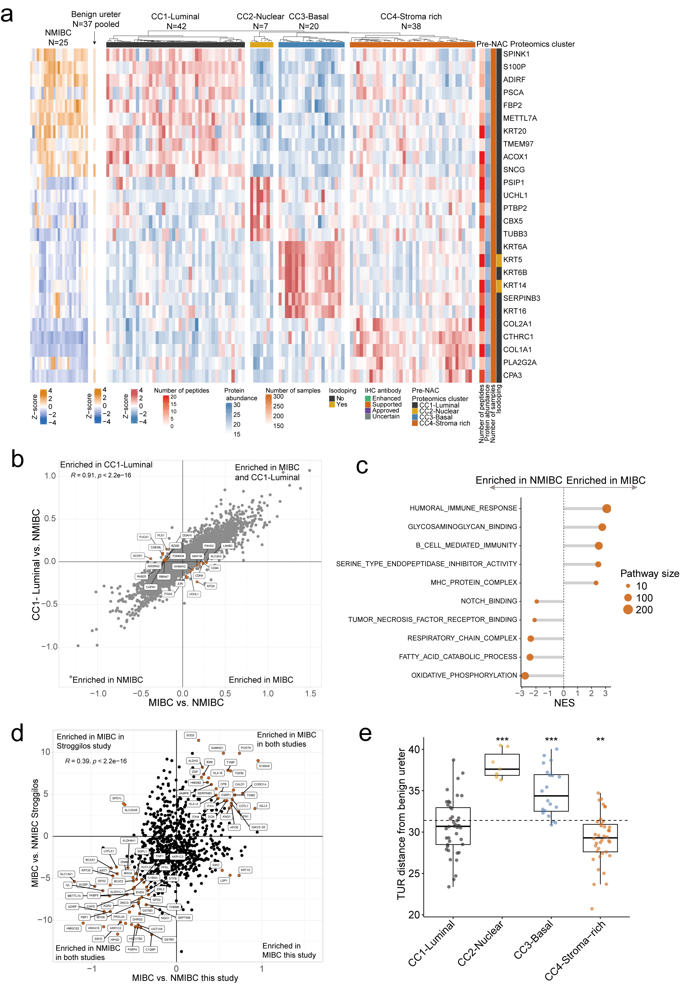
Supplementary Fig. 3 Unsupervised clustering of proteome in pre-chemotherapy muscle-invasive bladder cancer (MIBC) in relation to non-muscle invasive (NMIBC) and pooled benign ureteral samples.
a Unsupervised consensus clustering of pre-NAC TUR samples (N=107), pooled benign ureter, and NMIBC samples showing cluster-defining proteins on the right side of the panel. Cluster-defining proteins are defined as the most differentially expressed proteins (N=26, log2FC>0.20, adjusted Benjamini–Hochberg p<0.01) in each cluster after removal of proteins not identified in all clusters. Number of peptides detected per protein, protein abundance, number of samples with detected protein, and isoDoping status are also shown.
b Scatter plot highlighting top differentially expressed proteins in MIBC (all proteomic CCs) compared to NMIBC, and CC1-Luminal with NMIBC.
c Comparison of the top 10 GSEA pathways enriched in all pre-NAC TUR MIBC or NMIBC samples. Pathway size represents the number of proteins present in each pathway. NES, Normalized enrichment score.
d Scatter plot highlighting top differentially expressed proteins in MIBC compared to NMIBC in this study, and in a study from Stroggilos et al. 2020³⁷.
e Comparison of proteomic signal in TUR samples stratified by pre-NAC TUR proteomic clusters compared to benign ureter. Results are derived from a two-sided Wilcoxon signed rank test of the means of each cluster compared to the ureter average Euclidean distance as reference (**p<0.01), (***p<0.001).
Abbreviations: CC, consensus cluster; Log2FC, log2 fold-change; MIBC, muscle-invasive bladder cancer; NAC, neoadjuvant chemotherapy; NMIBC, non-muscle invasive bladder cancer; TUR, transurethral resection. Source data are provided as a Source Data file.

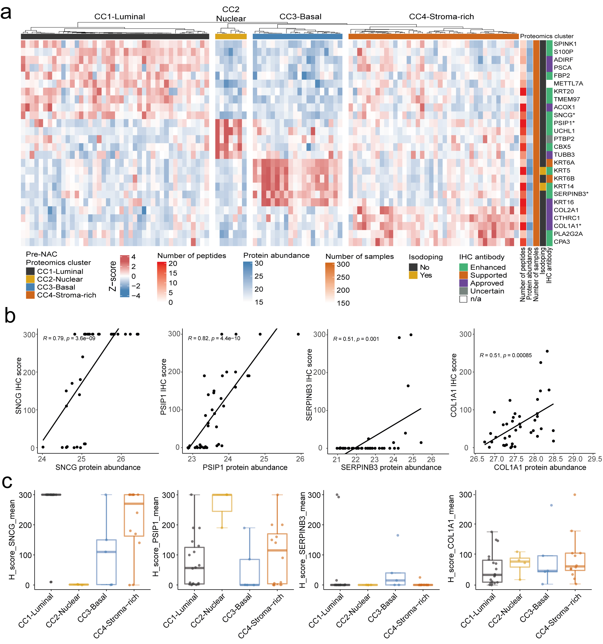
Supplementary Fig. 4 Immunohistochemical (IHC) validation of cluster-defining proteins in the pre-chemotherapy muscle-invasive bladder cancer (MIBC) samples.
a Cluster-defining proteins corresponding to the unsupervised consensus clustering of pre-NAC TUR samples (N=107) using the most upregulated proteins (N=26) in one cluster in relation to all others (log2 fold change >0.2, adjusted Benjamini-Hochberg of p<0.05, as related to Supplementary Fig. 2a) and including number of peptides per protein, protein abundance, isoDoping, and quality of the IHC antibodies available according the HPA database antibody criteria.
b Boxplots for SNCG, PSIP1, SERPINB3 and COL1A1 showing abundance of each cluster-defining protein by H-score (intensity by positivity in the cytoplasm or nucleus observed in the invasive bladder cancer cells) as identified in the Vancouver cohort-matched TMA-internal. In the case of COL1A1, all positively-stained cells (including tumour and stroma) were accounted for in the H-score calculation. Boxplot whiskers extend to the most extreme data point which is no more than 1.5 times the interquartile range from the box.
c Correlation plots showing protein abundance by mass spectrometry versus protein abundance by IHC mean H-score of the TMA-internal as in b). Spearman’s correlation (R) coefficient and p values are indicated in the plots.
Abbreviations: HPA, human protein atlas; IHC, immunohistochemistry; pre-NAC, pre-neoadjuvant chemotherapy; TMA, tissue microarray; TUR, transurethral resection. Source data provided as a Source Data file.

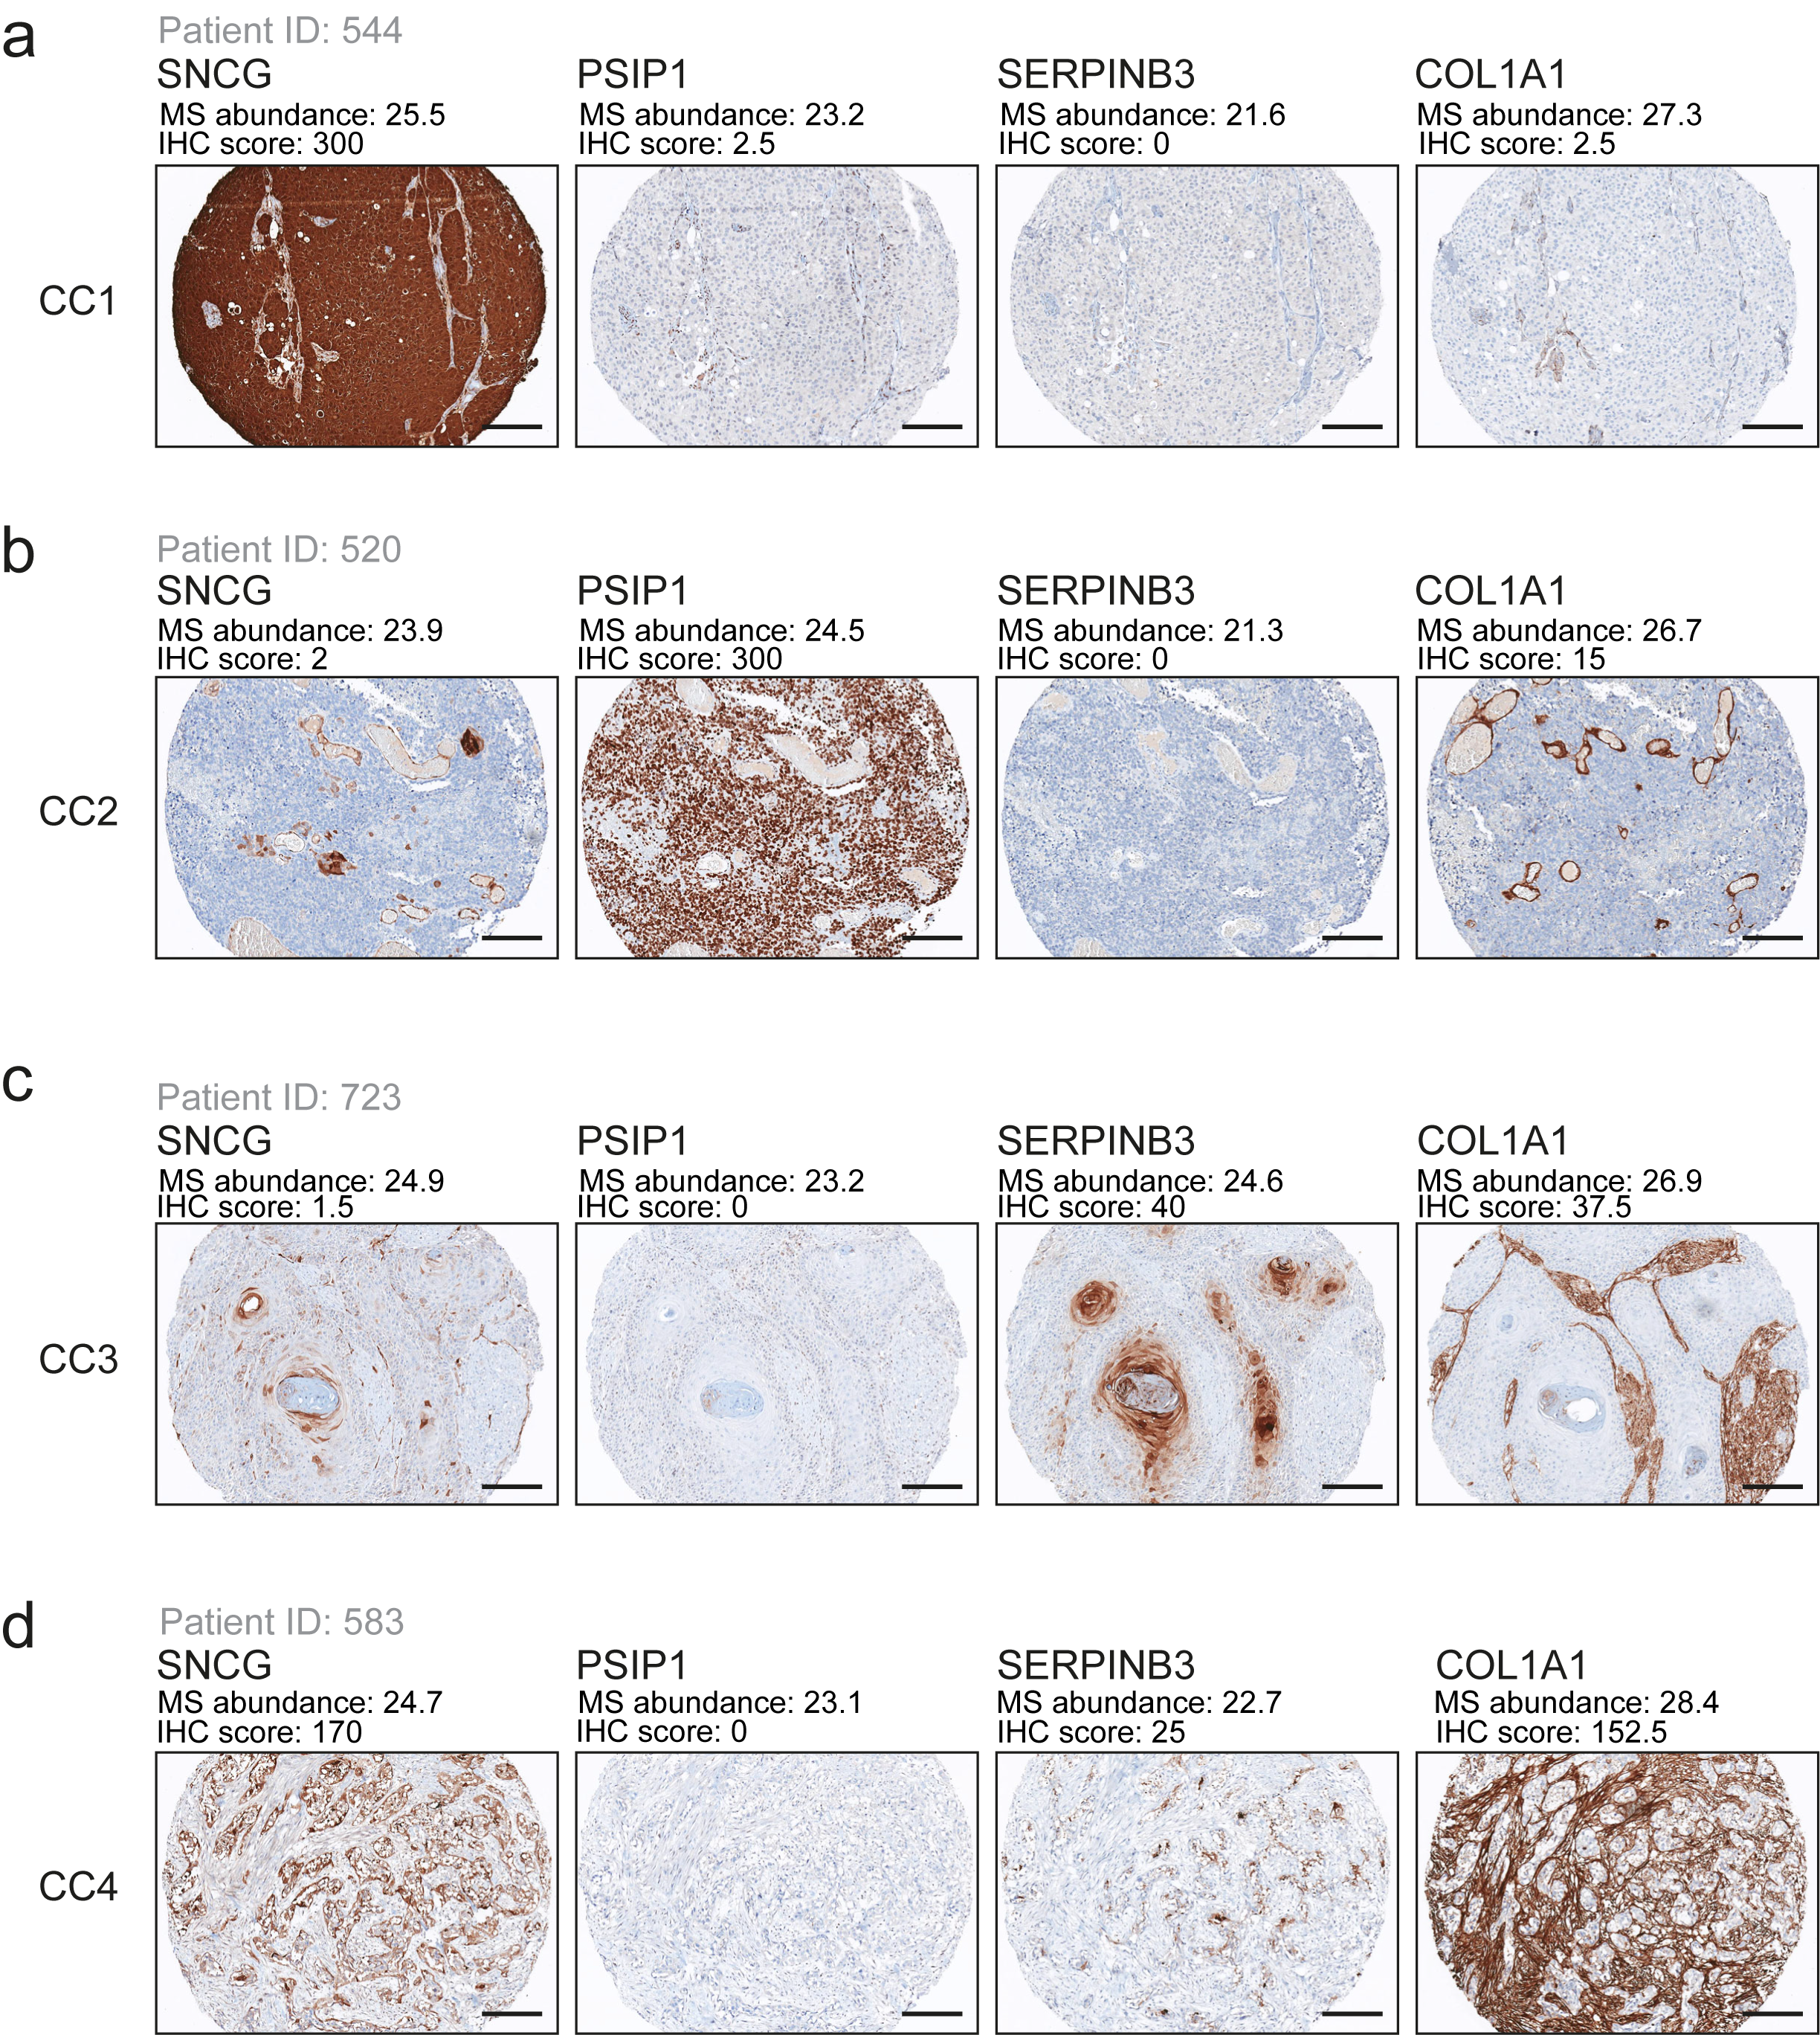
Supplementary Fig. 5 Representative images for immunohistochemical (IHC) validation of cluster-defining proteins in the pre-chemotherapy matched tissue microarray (TMA-internal).
Representative TMA cores from each pre-NAC TUR proteomic CC demonstrate IHC staining patterns for cluster-defining proteins with IHC H-score and mass spectrometry protein abundance (MS abundance) indicated for each core. Example tumors represent the (a) CC1-Luminal, (b) CC2-Nuclear, (b) CC3-Basal, and (d) CC4-Stroma-rich clusters.
Abbreviations: CC, consensus cluster; IHC, immunohistochemistry; MS, mass spectrometry; NAC, neoadjuvant chemotherapy; TMA, tissue microarray. Scale bars represent 200 µm. Source Data provide as Source Data file.

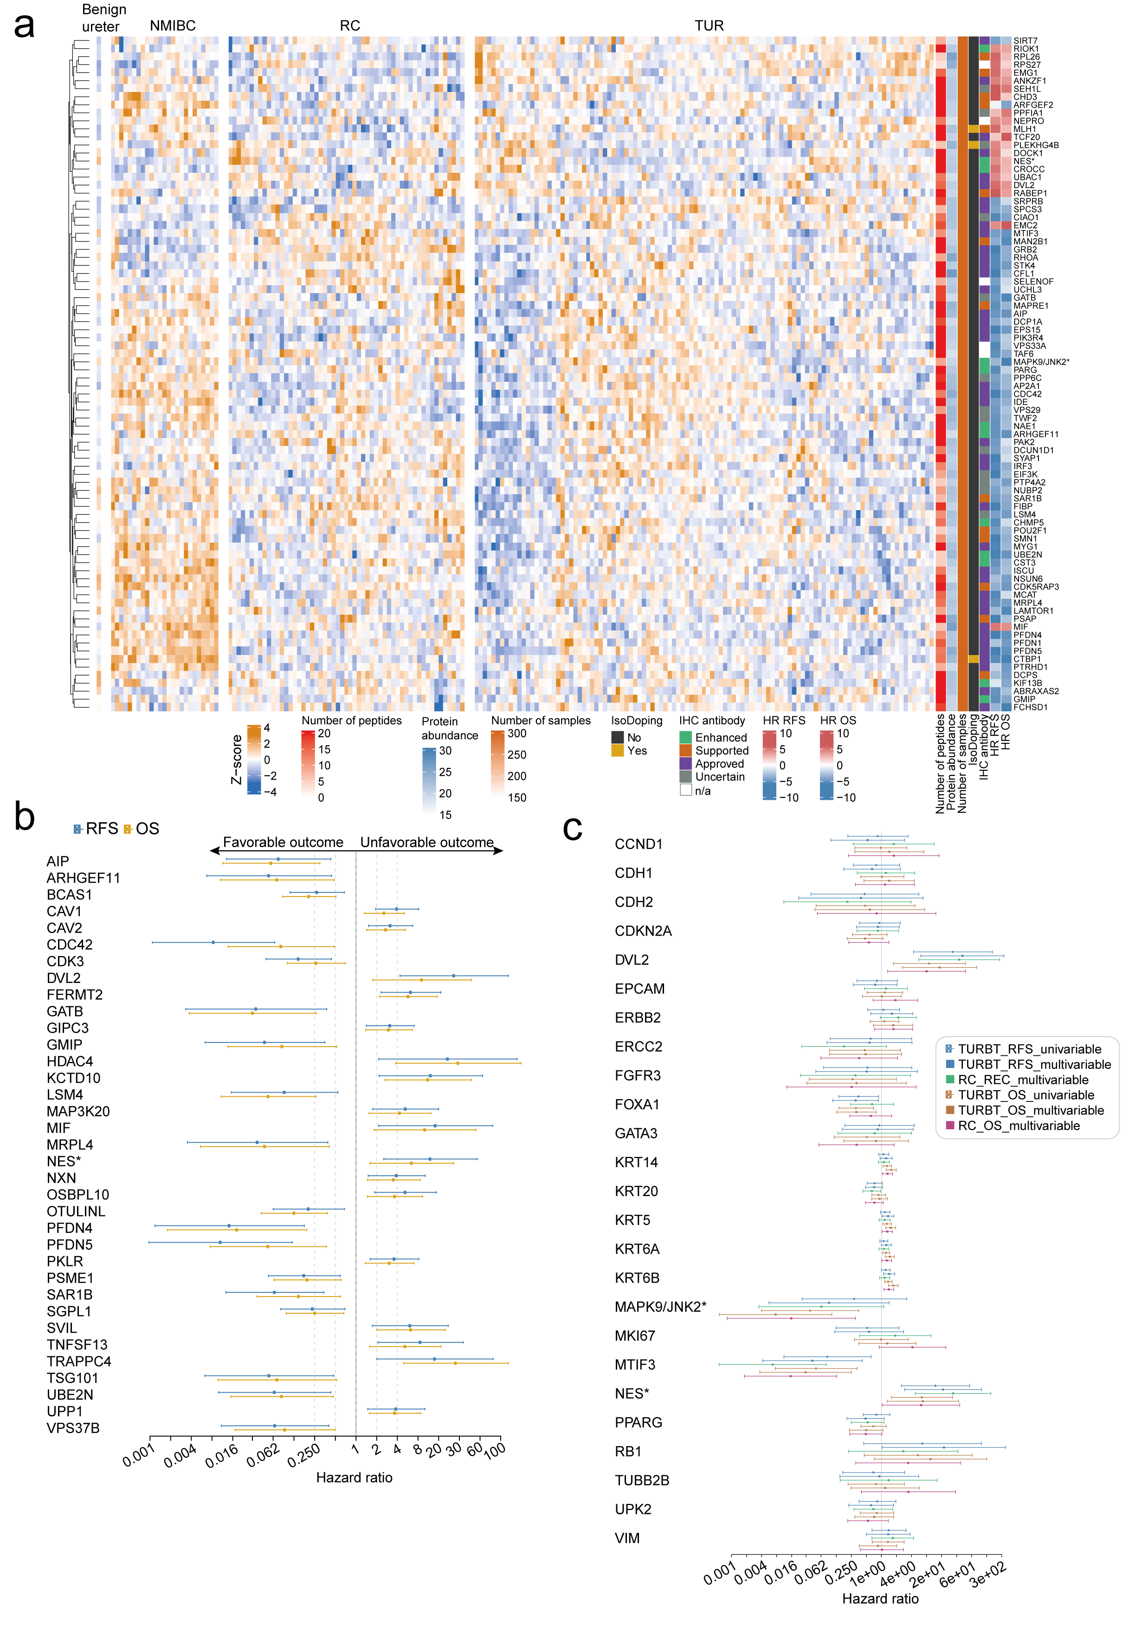
Supplementary Fig. 6 Identification of prognostic protein markers in pre-and post-chemotherapy tissue samples.
a Heatmap showing N=84 proteins with an absolute log2 HR >4 and a Wald p value <0.01 in a multivariable Cox proportional hazards regression model including cT, cN, age, NAC type, and sex as covariates in pre-NAC TUR specimens. Selected proteins are shown in relation to their number of peptides, protein abundance, isoDoping (details of isoDoped proteins can be found in the Supplementary files) and IHC antibody quality as per Supplementary Fig. 4. Pooled benign ureter and individual NMIBC samples are shown as reference.
b Hazard ratios associated with selected proteomic markers for OS and RFS in univariable analysis. Proteins with an absolute log2 HR>1 and an overall logrank p value <0.01 in a univariable Cox proportional hazards regression model are highlighted.
c Candidate proteins with relevance in bladder cancer and subtyping in relation to clinical outcomes (OS and RFS) according to their presence in the pre-NAC TUR and post-NAC RC specimens following univariate and MVA analysis (controlling for sex, cT, cN, age, and NAC type).
Further validation of selected proteins highlighted in bold in panels a, b and c was carried out by IHC and is shown in Supplementary Fig. 7 and Fig. 8.
Abbreviations: cN, clinical node stage; cT, clinical tumour stage; HR, hazard ratio; IHC, immunohistochemistry; MS, mass spectrometry; NAC, neoadjuvant chemotherapy; OS, overall survival; RC, radical cystectomy; RFS, recurrence free survival; TUR, transurethral resection. Source data provided as a Source Data file.
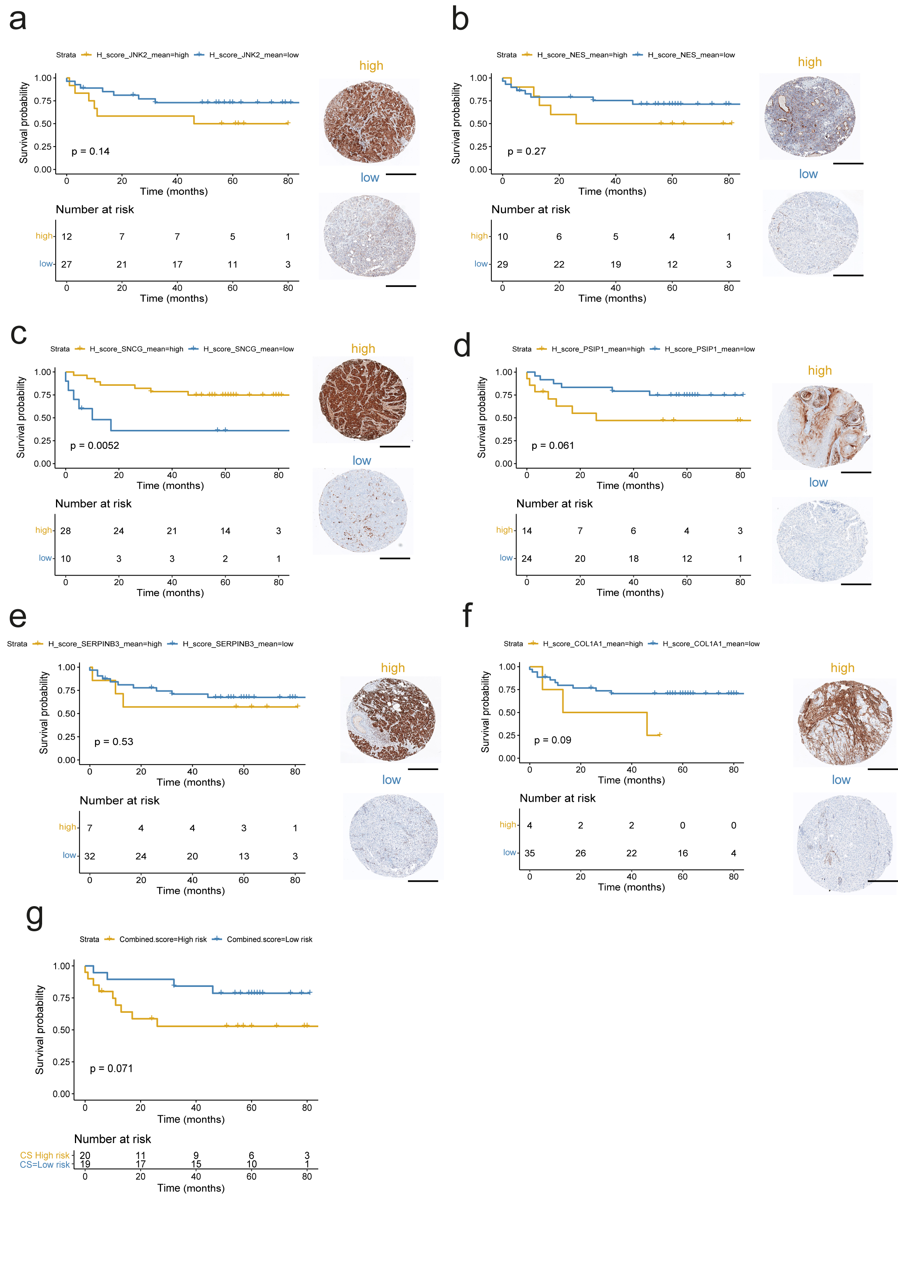
Supplementary Fig. 7 Immunohistochemical (IHC) validation of the prognostic value of cluster-defining proteins in the pre-chemotherapy matched tissue microarray (TMA-internal).
OS stratified by high and low H-score based on IHC staining for a MAPK9/JNK2, b NES, c SNCG, d PSIP1, e SERPINB3, and f COL1A1. g shows the Kaplan Meier OS plot stratified (high or low risk) using the combined pre-NAC TUR H-score of SNCG, SERPINB3, PSIP1 and COL1A H-scores.
Selection of cluster-identifying proteins is shown in Supplementary Figs. 4 and 5.
Abbreviations: IHC, immunohistochemistry; MS, mass spectrometry; NAC, neoadjuvant chemotherapy; OS, overall survival; TMA, tissue microarray; TUR, transurethral resection. Scale bar represents 500 μm. Source data provided as a Source Data file.
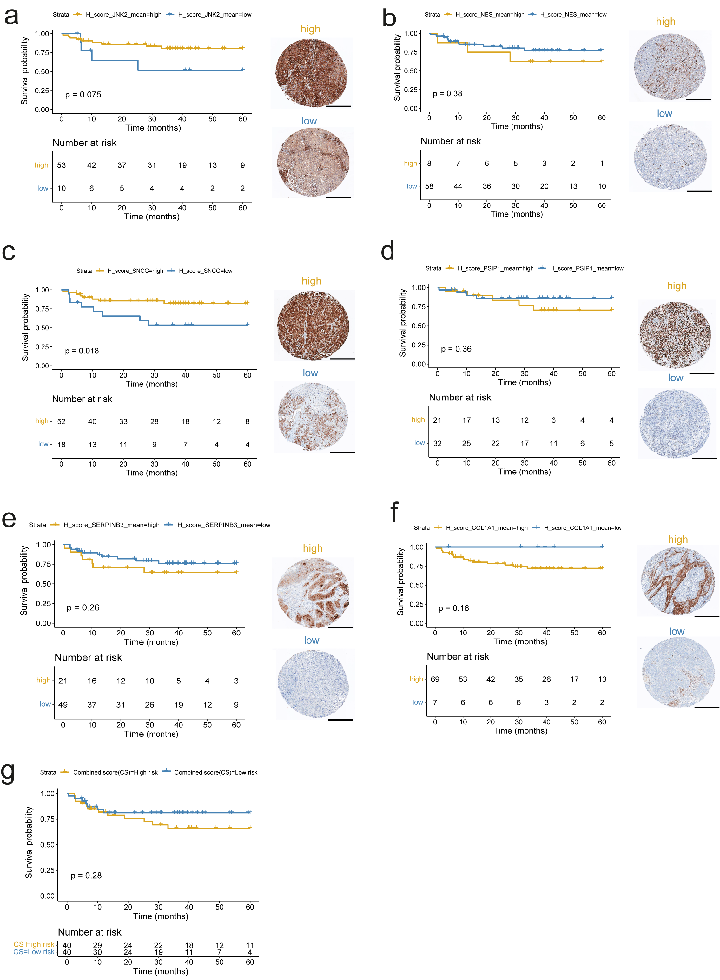
Supplementary Fig. 8 Testing prognostic value by immunohistochemistry (IHC) of cluster-defining proteins in the pre-chemotherapy unmatched tissue microarray (TMA-validation).
OS stratified by high and low H-score based IHC staining for a MAPK9/JNK2, b NES, c SNCG, d PSIP1, e SERPINB3, and f COL1A1. g shows the Kaplan Meier OS plot of patients stratified (high or low risk) using the combined pre-NAC TUR H-score of SNCG, SERPINB3, PSIP1, and COL1A. MAPK9/JNK2 and NES were selected based on their independent prognostic value as described in Supplementary Fig. 6, number of peptides, high protein abundance, lack of required isoDoping, and enhanced IHC antibody quality as per analyses shown in Supplementary Fig.5 and 6.
Abbreviations: IHC, immunohistochemistry; MS, mass spectrometry; NAC, neoadjuvant chemotherapy; OS, overall survival; TMA, tissue microarray; TUR, transurethral resection. Scale bar represents 500 μm. Source data provided as a Source Data file.
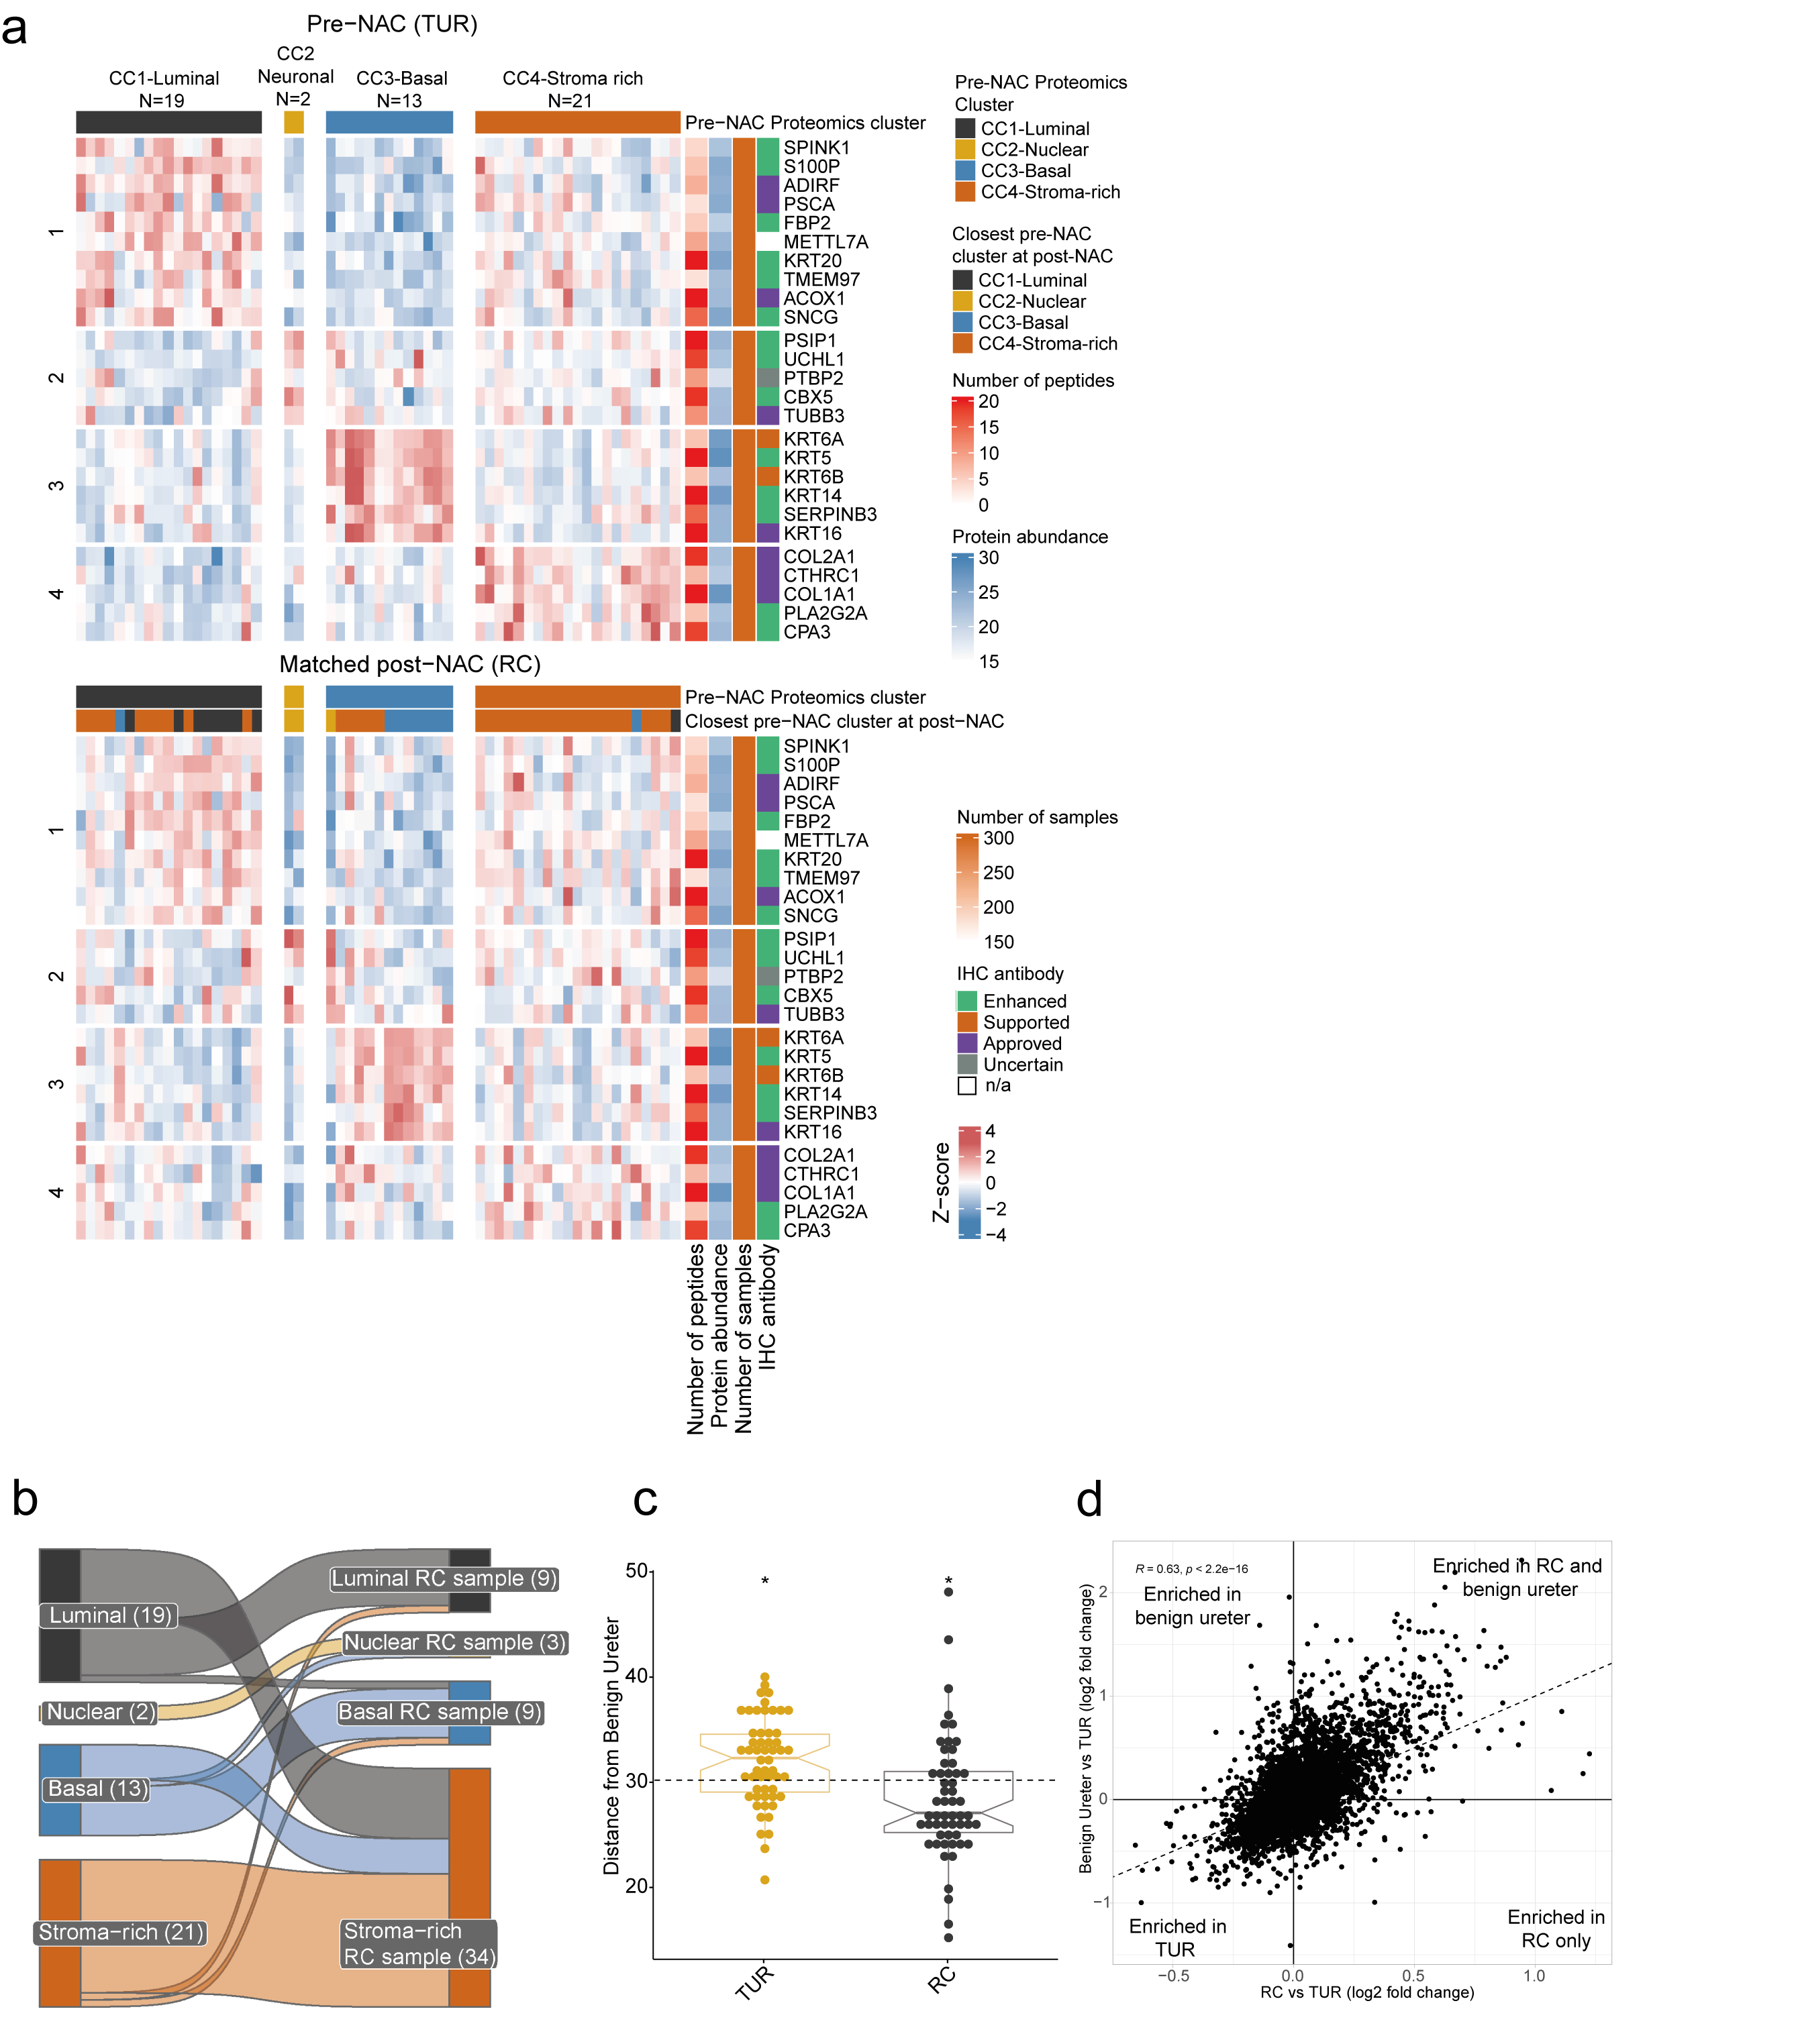
Supplementary Fig. 9 Cluster-defining proteins in matched pre- and post-chemotherapy tumour samples.
a Heatmaps of pre-NAC TUR cluster-defining protein expression in matched pre-NAC TUR and post-NAC RC samples organized according to proteomic clusters. Post-NAC RC clustering was calculated according to the distance to the closest pre-NAC TUR consensus clusters.
b Sankey-like plot showing consensus cluster switch from to post-NAC RC when the pre-NAC TUR clustering solution is applied to both the pre-NAC TUR and post-NAC RC samples. Post-NAC RC clustering was calculated according to the distance to the closest consensus clusters. The number of samples in each cluster is indicated in parenthesis.
c Euclidean distance from each TUR and RC sample to the median benign ureter for the 5,828 proteins quantified across all TUR and RC samples. Results are derived from a 2-sided Wilcoxon-signed rank test of the means of each sample type compared to the average distance to the benign ureter (*p<0.05).
d Correlation scatter plot depicts protein expression comparison of RC versus matched TUR, and pooled benign ureter versus. matched TUR. Figure represents a zoomed-out version of that shown in Fig. 3e.
Abbreviations: CDF, cumulative distribution function; NAC, neoadjuvant chemotherapy; RC, radical cystectomy; TUR, transurethral resection. Source data are provided as Source Data file.

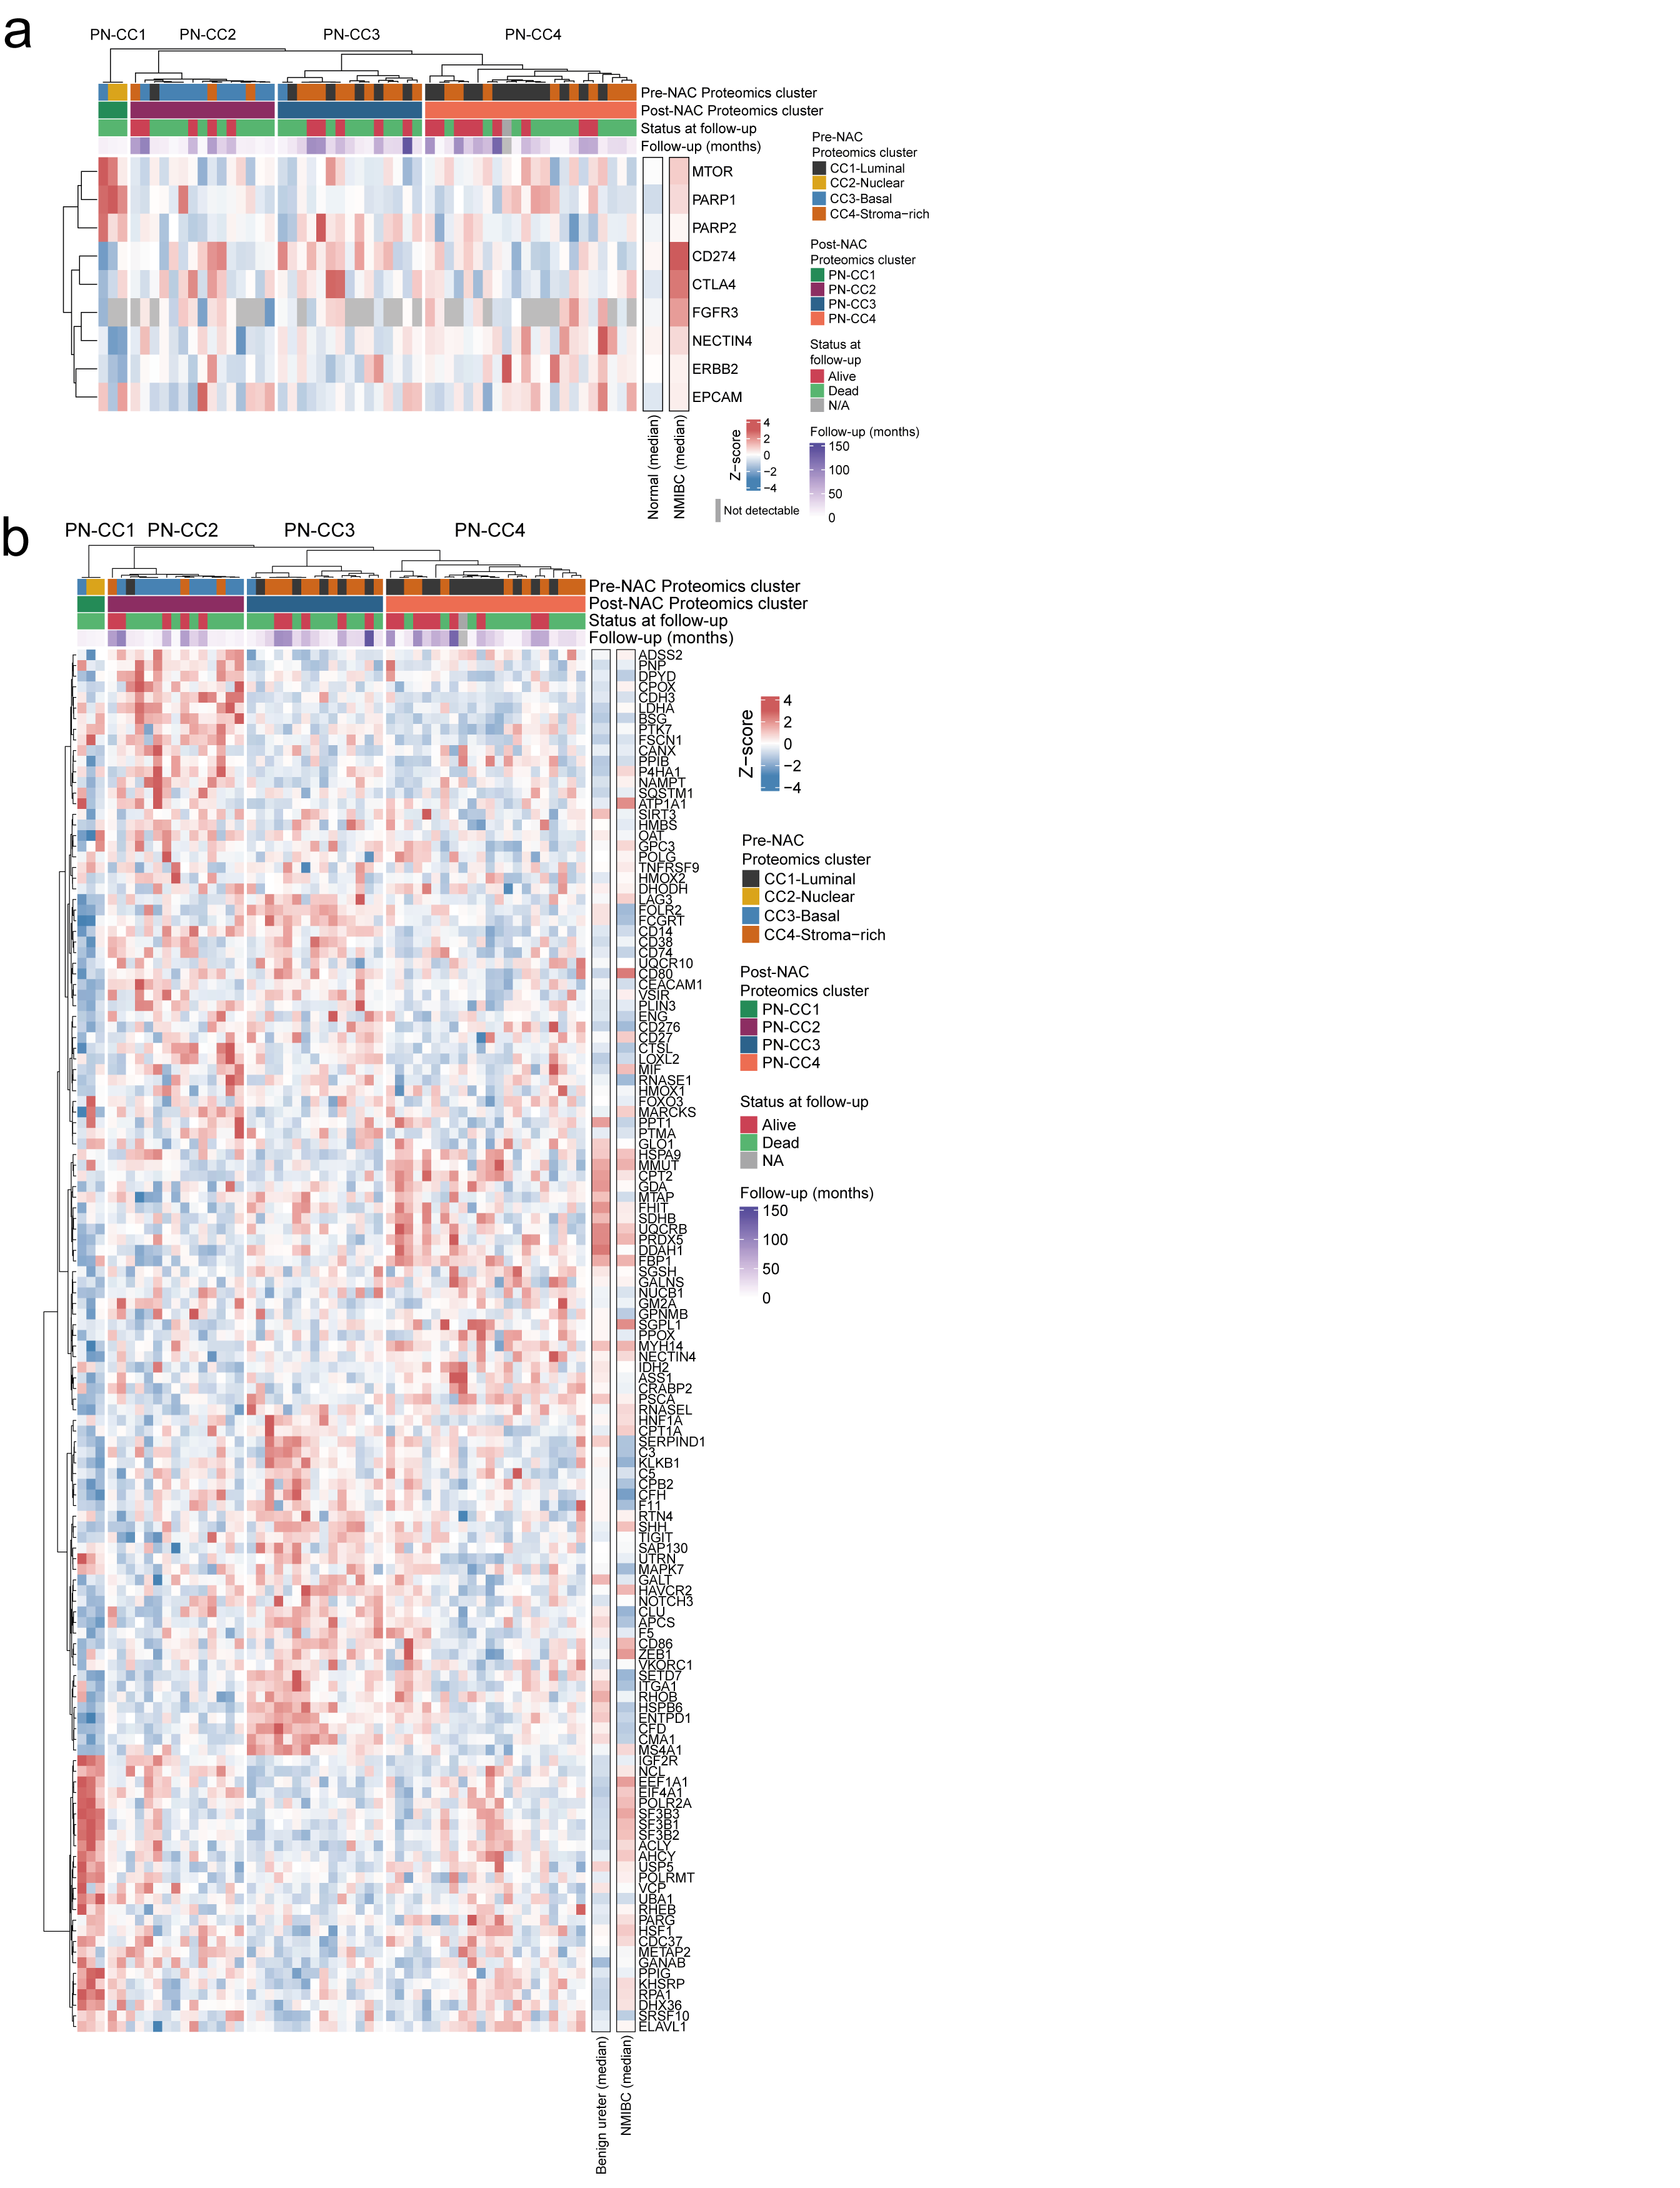
Supplementary Fig. 10 Druggable proteins in relation to their expression levels in the post-chemotherapy tumour samples.
a Heatmap indicates relative expression levels of nine FDA-approved drug targets used for urothelial carcinoma according to the post-NAC RC clusters. Pooled expression levels of the same proteins for the NMIBC cohort and benign ureter controls shown on the right panel.
b Heatmap showing expression levels of selected druggable targets (DGIdb Interaction Score >40) based on the Drug Gene Interaction Database (DGIdb) within the post-NAC RC clusters. Pooled expression levels of the same proteins for the NMIBC cohort and benign ureter controls shown on the right panel.
Abbreviations: NAC, neoadjuvant chemotherapy; RC, radical cystectomy; TUR, transurethral resection. Source data are provided as a Source Data file.
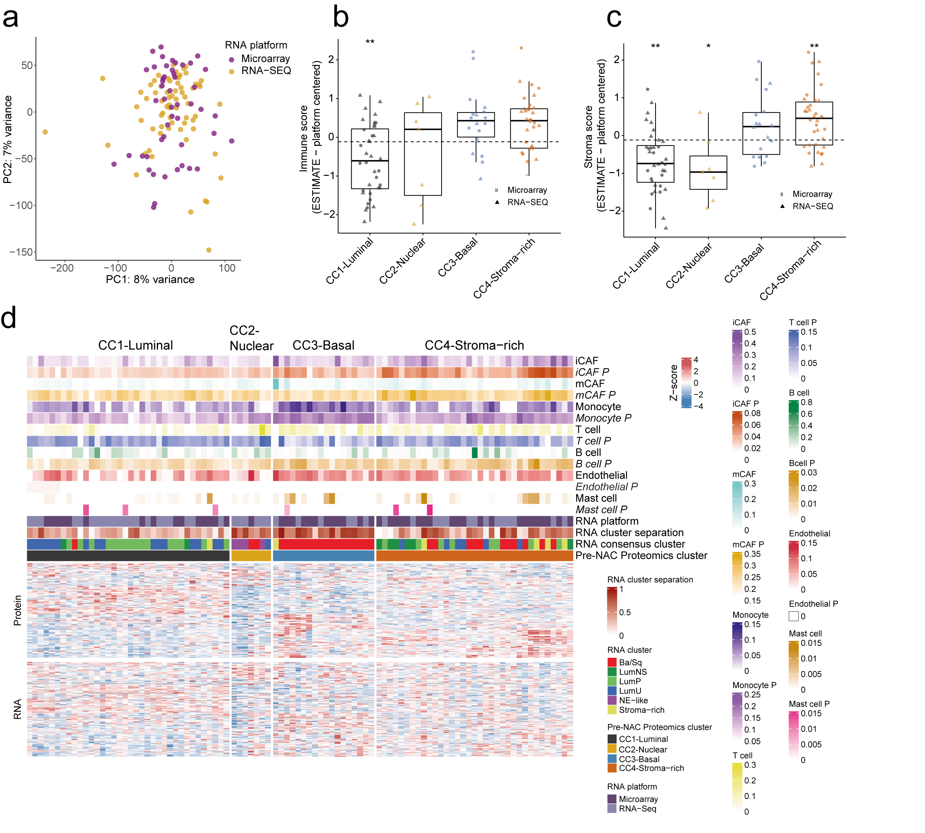
Supplementary Fig. 11 ESTIMATE and CybersortX analysis of pre-chemotherapy muscle-invasive bladder cancer (MIBC).
a Principal component analysis (PCA) plot showing relationship between pre-NAC TUR transcriptomic data by microarray in the Bern cohort and RNAseq in the Vancouver cohort.
b The Immune ESTIMATE scores (Yoshihara et al. 2013⁷⁷) using RNAseq and microarray data are shown according to the four pre-NAC TUR proteomic clusters. Boxplot whisker range extends to the most extreme data points which are not more than 1.5 times the interquartile range from the box.
c As in b but showing Stroma ESTIMATE scores.
d Heatmap showing the pre-NAC TUR proteomic clusters in relation to CybertsortX (Newman et al., 2019⁵²) analysis using whole proteome (N=1,170 proteins) and the corresponding RNAseq/microarray data (N=1,159 genes). The rows depict whether the cell population abundance score was derived from RNA (regular text, e.g. iCAF) or from protein data (italics and followed by ‘P’, e.g. iCAF P). Units are CibersortX score platform scaled values for all cell type variables. RNA platform type, RNA cluster separation levels and RNA cluster are indicated according to the consensus clustering (Kamoun et al., 2020⁹)
Abbreviations: iCAF, inflammatory cancer-associated fibroblasts; mCAF, Cancer-associated fibroblasts; NAC, neoadjuvant chemotherapy; PCA, Principal component analysis; TUR, transurethral resection. Source data are provided as Source Data file.

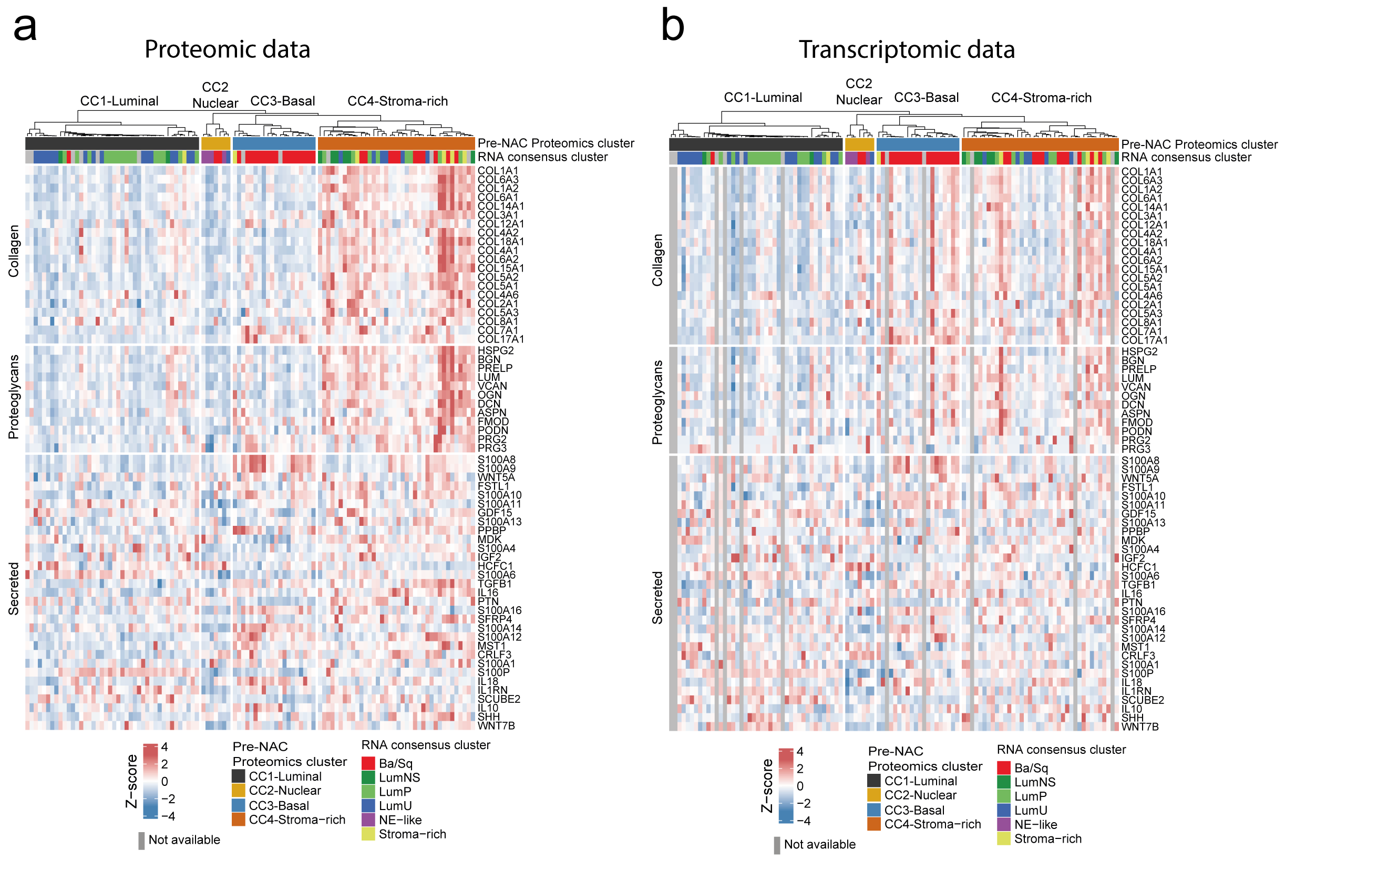
Supplementary Fig. 12 The matrisome of pre-chemotherapy muscle-invasive bladder cancer (MIBC) using proteomic and transcriptomic analysis.
a Proteomic-based expression of collagen-related proteins, proteoglycans, and secreted proteins (the matrisome, MatrisomeDB2.0, Shao et al. 2023⁵⁶) in relation to pre-NAC TUR proteomic clusters and RNA-based consensus subtypes according to the Consensus Classifier (Kamoun et al., 2020⁹).
b Transcriptomic-based expression of the matrisome in relation to proteomic clusters and transcriptomic -based consensus subtypes according to the Consensus Classifier (Kamoun et al. 2020⁹). Samples without matched RNA are shown in gray.
Abbreviations: NAC, neoadjuvant chemotherapy; TUR, transurethral resection. Source data are provided as Source Data file.
Supplementary Table 1. Patient and sample clinical characteristics for the non-muscle invasive high-grade Ta cohort
Clinical variable | Overall, N=25
Median age at TURBT, years (range) | 72 (45-88)
Sex, n=25 patients (%)  Male  Female | 21 (84%)  4 (16%)
Duplicate (independent) samples, n  (two per patient) | 4
BCG status per sample, n=29 samples  BCG-naïve  Post-BCG  Not available | 22 (76%)  6 (20%)  1 (0.03%)
Concurrent CIS¹, n=29 samples  Yes  No | 6 (20%)  23 (80%)
Recurrence at follow-up (N=25 patients)  Yes  No  Unknown | 17 (68%)  7 (28%)  1 (0.04%)
Progression to T2 at follow-up (N=25 patients)  Yes  No | 4 (16%)  21 (84%)
Median follow-up in months (years)  (n=25 patients) | 56.9 months (4.5 years)
¹ For the purposes of this study, only the high-grade Ta tumour was sampled.

Supplementary Table 2. Clinical characteristics of the TMA-internal cohort.
Clinical variable | Overall, N=40
Median age at RC, years (range) | 63 (range 36-77)
Sex, n (%)  Male  Female | 30 (77%)  9 (28%)
Prior NMIBC, n (%)  NMIBC  No history of NMBIC  Not available | 5 (12%)  42 (39.3%)  58 (54.2%)
Prior intravesical therapy, n (%)  BCG  Unknown | 4 (10%)  1 (2.5%)
cN-stage prior to NAC, n (%)  cN0  cN1  cN2  cN3  Not available | 32 (80%)  4 (10%)  1 (2.5%)  2 (5%)  1 (2.5%)
cT-stage prior to NAC, n (%)  cT2  cT3  cT4 | 27 (68%)  10 (25%)  3 (7.5%)
Smoking status, n (%)  Never  Past smoker  Current smoker  Median pack years  Not available | 8 (20%)  30 (75%)  2 (5%)  23 (range 10 – 40)  2 (5%)
Histology, n (%)  Primary Histology at TUR, n (%)  Urothelial carcinoma (UC)  Squamous cell carcinoma  Secondary Histology at TUR, n (%)  UC with squamous differentiation  Micropapillary  Small cell/ Neuroendocrine | 39 (98%)  1 (2.5%)  2 (5%)  3 (2.5%)  2 (5%)
NAC-regimen, n (%)  Gemcitabine/Cisplatin  Gemcitabine/Carboplatin | 38 (95%)  2 (5%)
Median number of NAC-cycles | 4 (range 2-8)
ypT-stage at RC, n (%)  ypT0  ypTa  ypTis  ypT1  ypT2  ypT3  ypT4 | 12 (30%)  2 (5%)  2 (5%)  1 (2.5%)  9 (22%)  9 (22%)  5 (12%)
ypN-stage at RC, n (%)  ypN0  ypN1  ypN2  ypN3 | 29 (72%)  5 (12%)  2 (5%)  4 (10%)
Response to NAC, n (%)  Complete responder (ypT0N0M0)  Partial responder (ypTis/a/1N0M0)  Non-responder (≥ypT2NXM0) | 12 (30%)  5 (12%)  23 (57%)
Recurrence after RC, n (%) | 12 (30%)
Follow-up, months (range)  Median follow-up (months from TUR)  Median time to recurrence (months from TUR) | 57 (range 6 – 91)  13 (range 7 - 59)

Supplementary Table 3. Clinical characteristics of the TMA-validation cohort
Clinical variable | Overall, N=80
Median age at RC, years (range) | 64.2 (range 35-83)
Sex, n (%)  Male  Female | 58 (72%)  22 (28%)
cN-stage prior to NAC, n (%)  cN0  cN1-3  Not available | 69 (86%)  8 (10%)  3 (4%)
cT-stage prior to NAC, n (%)  cT2  cT3  cT4 | 46 (57%)  28 (35)  6 (8%)
Histology, n (%)  Primary Histology at TUR, n (%)  Urothelial carcinoma (UC)  Squamous cell carcinoma  Secondary Histology at TUR, n (%)  UC with squamous differentiation  Micropapillary  Small cell/ Neuroendocrine | 39 (98%)  1 (2.5%)  2 (5%)  3 (2.5%)  2 (5%)
NAC-regimen, n (%)  Gemcitabine/Cisplatin  Gemcitabine/Carboplatin | 77 (96%)  3 (3.8%)
Median number of NAC-cycles | 4 (range 1-6)
ypT-stage at RC, n (%)  ypT0  ypTis  ypT1  ypT2  ypT3  ypT4 | 26 (32%)  3 (4%)  2 (3%)  21 (26%)  23 (29%)  5 (6%)
ypN-stage at RC, n (%)  ypN0  ypN1-3  Not available | 49 (61%)  8 (10%)  23 (29%)
Response to NAC, n (%)  Complete responder (ypT0N0M0)  Partial responder (ypTis/a/1N0-XM0)  Non-responder (≥ypT2N0-XM0) | 25 (31%)  6 (7.5%)  49 (61.5%)
Recurrence after RC, n (%) | 27 (34%)
Follow-up, months (range)  Median follow-up (months from TUR)  Median time to recurrence (months from TUR) | 30.7 (range 0.5 – 123)  27.7 (range 0.5 - 123)

Supplementary Table 4. Clinical characteristics of the MIBC-NAC proteomics post-NAC RC cohort.
Clinical variable | Overall, N=55 | Bern, N= 31 | Vancouver, N=24 | p-value*
Median age at RC, years (range) | 62.5 (range 38-78) | 66.1 (range 35-78) | 61.5 (range 38-78) | 0.2
Sex, n (%)  Male  Female | 40 (73%)  15 (27%) | 21 (68%)  10 (32%) | 19 (79%)  5 (21%) | 0.3
Prior NMIBC, n (%)  NMIBC  No history of NMBIC  Not available | 3 (5%)  21 (38%)  31 (56%) | -  -  31 (100%) | 3 (12.5%)  21 (87.5%)  - | -
Prior intravesical therapy, n (%)  BCG  No history of BCG  Not available | 2 (4%)  22 (40%)  31 (56%) | -  -  31 (100%) | 2 (9%)  22 (91%)  - | -
cN-stage prior to NAC, n (%)  cN0  cN1  cN2  cN3 | 29 (53%)  10 (18%)  3 (5%)  13 (24%) | 10 (32%)  6 (19%)  3 (10%)  12 (39%) | 19 (79%)  4 (17%)  -  1 (4%) | <0.001
cT-stage prior to NAC, n (%)  cT2  cT3  cT4 | 19 (35%)  27 (49%)  9 (16%) | 4 (13%)  20 (65%)  7 (23%) | 15 (62%)  7 (29%)  2 (9%) | <0.001
Smoking status, n (%)  Never  Past smoker  Current smoker  Median pack years  Not available | 1 (2%)  21 (38%)  2 (4%)  -  31 (56%) | -  -  -  -  31 (100%) | 1 (4%)  21 (88%)  2 (8%)  32.5 (range 6 – 50)  - | -
Histology, n (%)  Primary Histology at TUR, n (%)  Urothelial cell carcinoma (UC)  Squamous cell carcinoma  Secondary Histology at TUR, n (%)  UC with glandular differentiation  UC with squamous differentiation  Micropapillary  Sarcomatoid  Small cell/ Neuroendocrine | 54 (98%)  1 (1.8%)  1 (2 %)  6 (11%)  5 (9%)  2 (4%)  4 (7%) | 31 (100%)  -  1 (3%)  7 (23%)  8 (26%)  1 (3%)  2 (6%) | 23 (96%)  1 (4%)  -  2 (8%)  1 (4%)  1 (4%)  2 (8%) | 0.4  0.7
NAC-regimen, n (%)  Gemcitabine/Cisplatin  Gemcitabine/Carboplatin | 47 (85%)  8 (15%) | 24 (77%)  7 (23%) | 23 (98%)  1 (2%) | <0.001
Median number of NAC-cycles | 4 (range 1-8) | 4 (range 1-6) | 4 (range 2-8) | 0.7
ypT-stage at RC, n (%)  ypTa  ypT1  ypT2  ypT3  ypT4 | 1 (2%)  3 (5%)  19 (35%)  19 (35%)  13 (24%) | -  2 (6.5%)  10 (32%)  12 (39%)  7 (23%) | 1 (4.2%)  1 (4.2%)  9 (38%)  7 (29%)  6 (25%) | 0.9
ypN-stage at RC, n (%)  ypN0  ypN1  ypN2  ypN3  Not available | 26 (46%)  12 (22%)  5 (9%)  11 (20%)  1 (1.8%) | 11 (35%)  7 (23%)  4 (13%)  8 (26%)  1 (3.2%) | 15 (62%)  5 (21%)  1 (4.2%)  3 (12%)  - | 0.3
Response to NAC, n (%)  Partial responder (ypTis/a/1N0M0)  Non-responder (≥ypT2NXM0) | 4 (7%)  51 (93%) | 2 (6.5%)  29 (94%) | 2 (8.3%)  22 (92%) | 0.9
Recurrence after RC, n (%) | 32 (58%) | 22 (71%) | 10 (42%) | 0.05
Follow-up, months (range)  Median follow-up (months from TUR)  Median time to recurrence (months from TUR) | 28.6 (range 5.8 – 138.3)  5.8 (range 0.2 -54) | 20.4 (range 5.8 – 138.3)  5.8 (range 0.2 – 34) | 39 (range 6 - 91)  8 (range 1 – 54) | 0.3  0.2

Supplementary methods
Protein isolation, reduction, and alkylation, FFPE tissue
Tubes containing 10 µM slices of tissue were centrifuged for 1 minute at 20,000 xg. Xylenes (800 μL) was added to each tube, gently pipette mixed, and incubated for 5 min to deparaffinize the sample. Samples were centrifuged for 1 min at 20,000 xg and the supernatant discarded, then washed with an additional 800 μL of xylenes. 100 μL of lysis buffer (500 mM Tris-Cl pH 8, (CAT#C4706, Sigma), 2% w/v sodium dodecyl sulfate (Bio-Rad, CAT#1610302), 1% v/v NP40 (CAT#492016-100ML , Merck Millipore), 1% v/v Triton X100 (CAT#T8787, Sigma), 5 mM EDTA (Thermo Fisher, CAT#15575020), 50 mM sodium chloride (CAT#S7653, Sigma), 10 mM tris(2-carboxyethyl)phosphine hydrochloride, 40 mM chloroacetamide in HPLC water) was added to the sample and the solution was heated at 95°C for 90 min with mixing at 1000 rpm. Tubes were cooled to room temperature prior to sample cleanup by single pot solid phase enhanced sample preparation (SP3)³¹.

SP3 sample cleanup
SP3 was adapted from the published method³¹. Specifically, Sera-Mag SP3 1:1 bead mix (Sera-Mag Speed Beads, GE Life Sciences, CAT#45152105050350 and CAT#65152105050350) was rinsed once with HPLC water and diluted to a final working concentration of 20 μg/μL. 200 μg of this bead mixture was added 100 µg of protein (if cells) or the entire FFPE sample and mixed by pipetting to generate a homogeneous solution. To induce protein binding to the beads, ethanol (Sigma, CAT#34852) was added to achieve a final concentration of 50% (v/v). Bead-protein solutions were pipette mixed to ensure a homogeneous distribution of the beads and incubated for 5 min at room temperature. After incubation, tubes were placed on a magnetic rack for 1 min and the supernatant was removed and discarded. The beads were rinsed three times with 200 μL of 80% ethanol, and the supernatant was discarded. Rinsed beads were reconstituted in 100 μL 0.2 M HEPES pH 8 containing 2 μg trypsin/rLysC mix (Promega, CAT#V5071), and pipette mixed. Mixtures were incubated overnight (14+ hours) at 37 °C in a thermomixer (Eppendorf, CAT#05-400-205). The supernatants were recovered using a magnetic rack and transferred to fresh 1.5 mL polypropylene Eppendorf tubes with a snap-lock lid (Eppendorf, CAT#022363204). Samples were stored at -80 °C and 10% of the resulting peptide mixture was used for QC of the sample prior to labeling.

TMT labeling
TMT 11-plex labeling kits were obtained from Pierce (CAT#A34808). Each TMT label (5 mg per vial) was reconstituted in 500 μL of acetonitrile and frozen at -80 °C. Prior to labeling, TMT labels were removed from the freezer and allowed to equilibrate at room temperature. TMT label was added to the peptide sample in two volumetrically equal steps of 10 µL (100 µg), 30 min apart at room temperature. Reactions were quenched by addition of 10 µL of 1 M glycine (CAT#G8898, Sigma). Labeled peptides were concentrated in a Labconco centrivap concentrator (CAT#781001010234) with a ThermoSavant RVT400 refrigerated vapor trap (CAT#RVT400-230) to remove acetonitrile, and the differentially labeled peptides were combined (Supplemental Table XX).

SepPak Clean-Up
SepPak C18, 50 mg columns were purchased from Waters (CAT#WAT054960). TMT labeled samples were acidified with trifluoroacetic acid (Sigma, CAT#T6508-100ML) to a final concentration of 1%. Columns were washed with two aliquots of 1 mL 0.1% trifluoroacetic acid in HPLC grade acetonitrile (Sigma, CAT#34851) and conditioned using two aliquots of 1 mL 0.1% trifluoroacetic acid in HPLC grade water. Samples were loaded and rinsed with three aliquots of 1 mL of 0.1% formic acid (Sigma, CAT#33015) in HPLC grade water and peptides were eluted using two aliquots of 600 µL 0.1% formic acid in 20/80 HPLC water/HPLC acetonitrile. Sample volume was reduced to less than 200 µL by vacuum centrifugation.

HPLC fractionation
High-pH reversed phase separation was performed on an Agilent 1100 HPLC system equipped with a diode array detector (254, 260, and 280 nm). Fractionation was performed on a Kinetix EVO C18 column (2.1 x 150 mm, 1.7 μm core shell, 100Å, Phenomenex). Elution was performed at a flow rate of 0.25 mL/min using a gradient of mobile phase A (10 mM ammonium bicarbonate, pH 8) and B (acetonitrile), from 3% to 35% over 60 mi. Fractions were collected every minute across the elution window (8-52 min) for a total of 48 fractions which were concatenated to 12 final fractions (e.g. 1 + 13 + 25 + 37 = fraction 1). Fractions were dried in a vacuum centrifuge and reconstituted in 0.1% formic acid HPLC water prior to MS analysis.

MS analysis
Analysis of peptide fractions was carried out on an Orbitrap Eclipse Tribrid MS platform (Thermo Scientific). Samples were introduced using an Easy-nLC 1200 system (Thermo Scientific). Columns used for trapping and separations were packed in-house. Trapping columns were packed in 100 μm internal diameter capillaries to a length of 2.5-5 mm with C18 beads (Reprosil-Pur, Dr. Maisch, 3 μm particle size). Trapping was carried out for a total volume of 10 μL at a flow of 25 µL/min. After trapping, gradient elution of peptides was performed on a C18 (Reprosil-Pur, Dr. Maisch, 3 μm particle size) column packed in-house to a length of 25 cm in 100 μm internal diameter capillaries with a laser-pulled and fritted electrospray tip. Elution was performed at a flow rate of 450 nL/min. Mobile phase B (HPLC acetonitrile and 0.1% formic acid) was increased from 3-7% in mobile phase A (water and 0.1% formic acid) over 2 min, to 25% B over 94 min, to 40% B over 17 min, then a 1 min increase to 80% and the column was washed for 6 min.
Data acquisition on the ThermoFisher Orbitrap Eclipse was carried out using a data-dependent method. MS1 survey scans in positive ion mode covering the normal mass range of 400 – 1200 were acquired at a resolution of 120,000 (at m/z 200), with quadrupole isolation enabled, an RF Level of 30%, a maximum fill time of 100 ms, a single microscan, and an automatic gain control (AGC) target set to “Standard”. For MS2 scan triggering, peptide monoisotopic precursor selection was enabled, Intensity was filtered for 5e3 – 5e20, charge state filtering was limited to 2 – 6 and undetermined charge states were included and charge states of 25 and higher were excluded. Dynamic exclusion of previously selected masses after 1 observation was enabled for 60 s with a tolerance of 20 ppm. MS2 scans were acquired in the Orbitrap normal scan range mode at a resolution of 50,000 with a starting mass of 120 after HCD fragmentation. An automatic maximum fill, quadrupole isolation, isolation offset off, an isolation window of 0.7 m/z, fixed collision energy of 33%, and an AGC target value set to “Standard”. The total allowable cycle time was set to 3 s. MS1 scans were acquired in profile mode, and MS2 in centroid format.

