Temperature-mediated growth of helical polymer and chevron-type graphene nanoribbon from internally fluorinated precursor on Au(111)

Jacob D. Teeter,¹ Mamun Sarker,² Wenchang Lu,³ Chenggang Tao,^{1,4} Arthur P. Baddorf,¹ Jingsong Huang,^{1*} Kunlun Hong,¹ Jerry Bernholc,⁴ Alexander Sinitskii,² An-Ping Li^{1,4*}

¹Center for Nanophase Materials Sciences, Oak Ridge National Laboratory, Oak Ridge, Tennessee 37831, USA
²Department of Chemistry, University of Nebraska-Lincoln, Lincoln, Nebraska 68588, USA
³Department of Physics, North Carolina State University, Raleigh, North Carolina 27695, USA
⁴Department of Physics and Astronomy, University of Tennessee, Knoxville, Tennessee 37996, USA

Supporting Information
Table of contents
¹H and ¹⁹F nuclear magnetic resonance (NMR) spectra····················································S2
Additional experimental and simulated scanning tunneling microscopy (STM) images·············S4
Additional XPS data·······························································································S9

¹H and ¹⁹F nuclear magnetic resonance (NMR) spectra
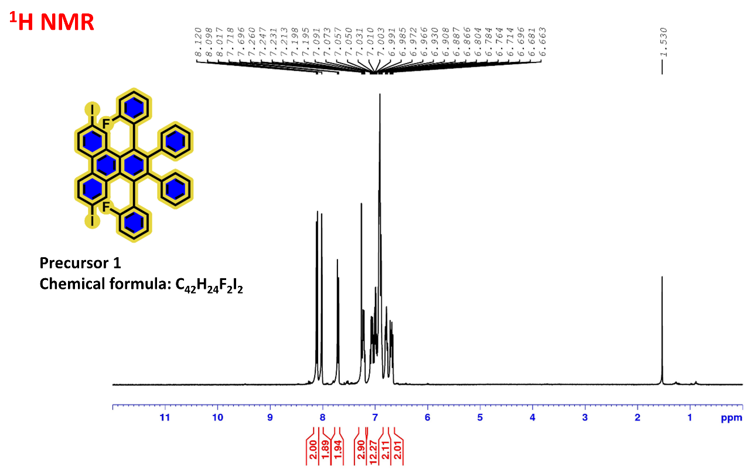
Figure S1. ¹H NMR of precursor 1.

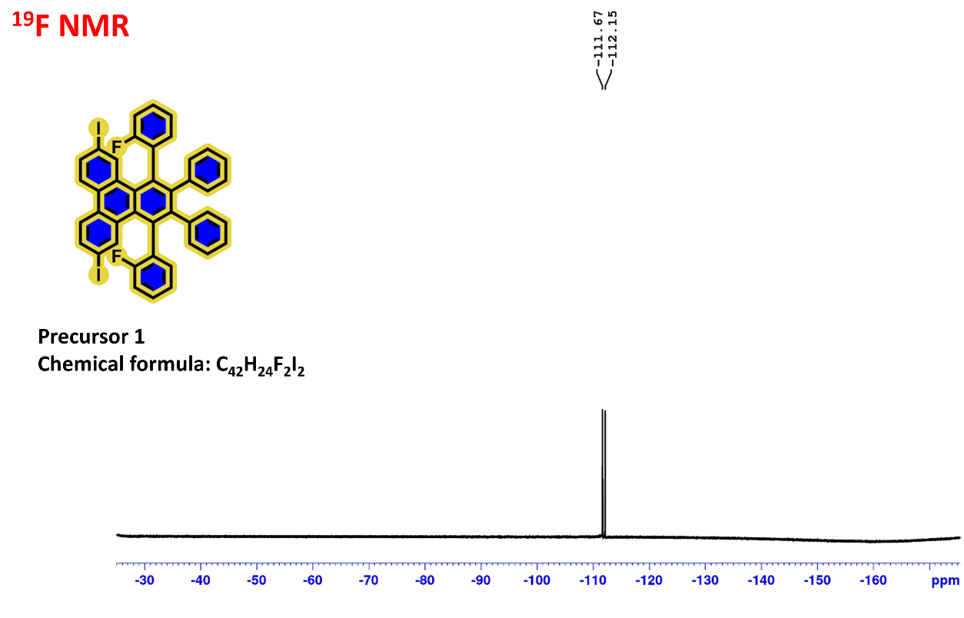
Figure S2. ¹⁹F NMR spectrum of precursor 1.

Additional experimental and simulated scanning tunneling microscopy (STM) images

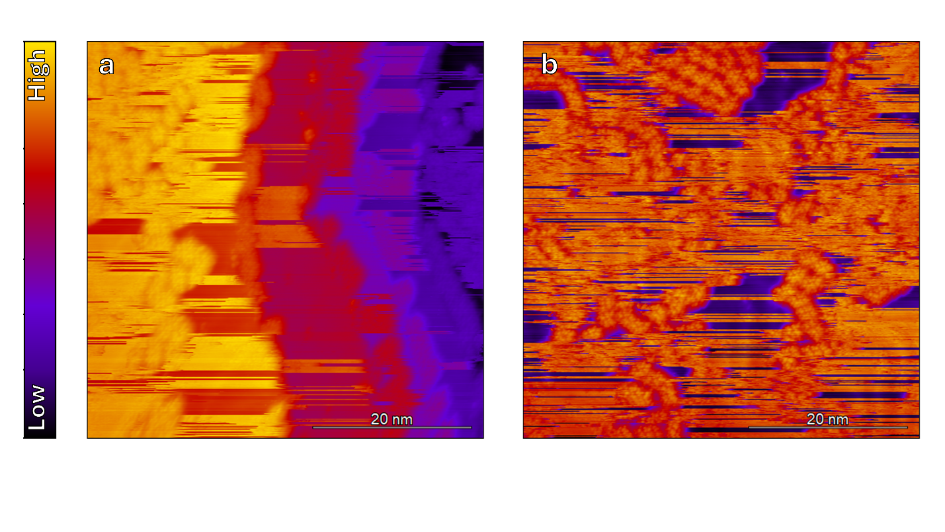
Figure S3. Adsorption of pristine, non-fluorinated precursors to the surface occurs at RT on Au(111). In contrast to precursor 1, the pristine chevron precursor adsorbs on Au(111) at step edges (a) and on terraces (b). The large streaks are attributed to weak adsorption of the molecules on the surface, allowing the tip to push them around during scanning. Some clusters of precursors form on terraces. This cluster-like formation is previously observed for brominated and iodinated precursors on Au(111), and is likely dominated by $π-π$ interactions (see Refs. 39-42 in the main text). Scan parameters: -0.5V, 500pA.

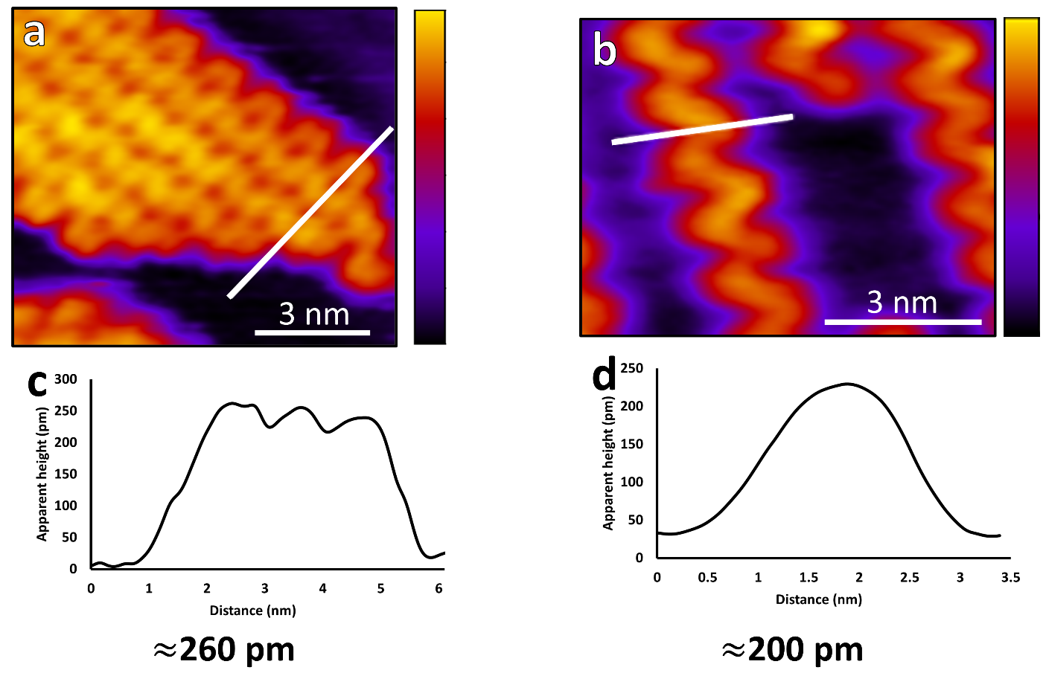
Figure S4. Height profiles for polymers and GNRs grown from precursor 1. STM images for polymers (a) and GNRs (b) grown from fluorinated precursor 1 on Au(111). White lines indicate height profiles shown in (c) and (d), where the apparent heights are very close in value to the polymers arising from the pristine precursors on Au(111), which necessitated complementary investigative methods. Scan parameters: -1.5V, 50 pA for both (a) and (b).
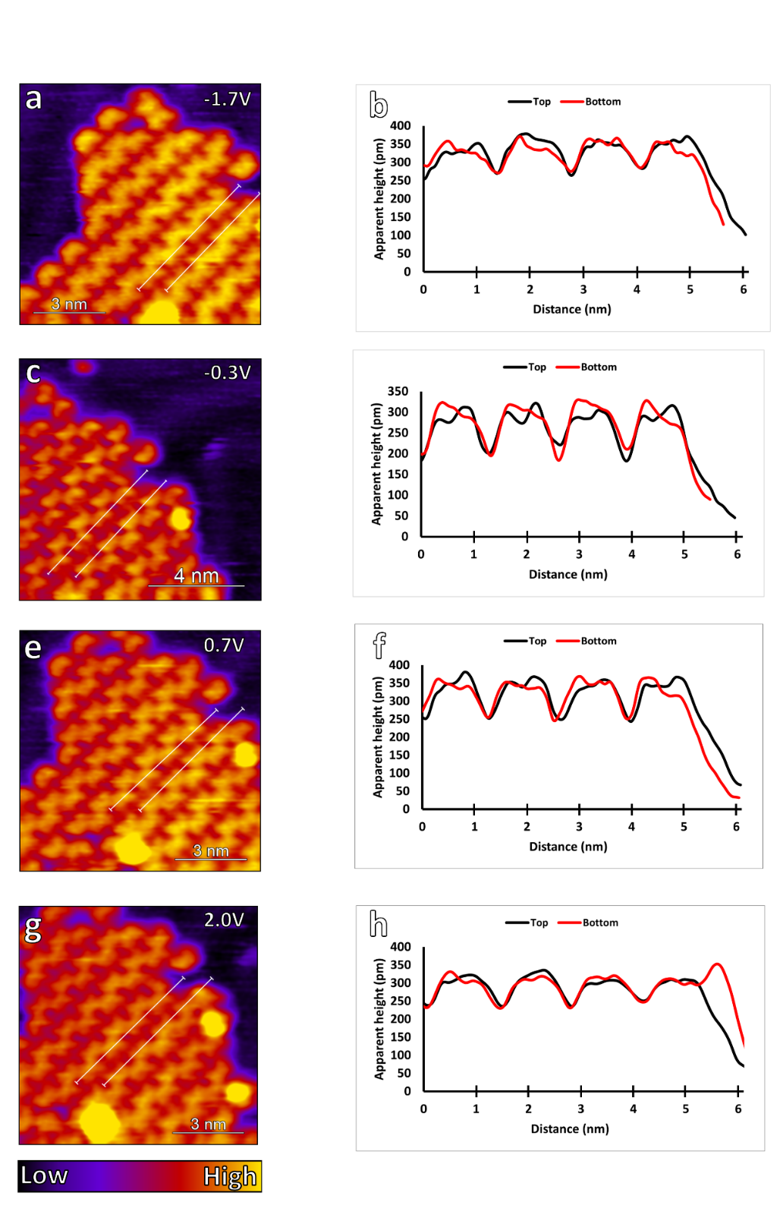
Figure S5. Comparing line profiles across the top and bottom of the same polymer under various biases. All STM scans (a,c,e,g) acquired at 55pA current setpoint. The -0.3V scan (c) displays features most similar to the asymmetric peaks present in the simulated P-type polymer STM images seen in Fig. S6a,b below, and so we assign it P-type helicity. As the magnitude of the bias increases, structural features are smeared out and the clarity of the asymmetric fringes decreases accordingly.
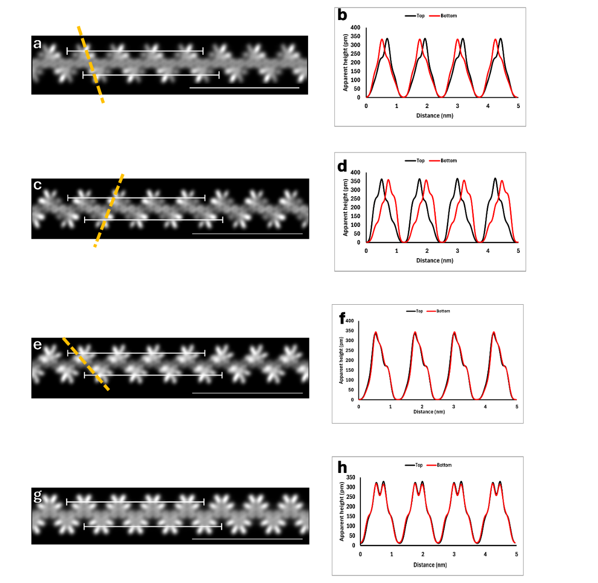
Figure S6. Comparisons of polymers with different enforced helicities. (a,c,e,g) are simulated pristine chevron polymers with the following characteristics: (a) p-type; (c) m-type; (e) meso; (g) nonhelical. Yellow lines are added to highlight the asymmetrically taller parts of each subunit, and each scale bar is 4 nm. (b,d,f,h) are height profiles across the polymers in (a,c,e,g) and each type exhibits a characteristic profile. (b) P-type, as seen in the main text Fig. 4, has an asymmetric appearance with the top (bottom) phenyl fringe exhibiting a higher right (left) than left (right) apparent height. (d) M-type, not observed for our polymers, has an asymmetric appearance with the top (bottom) phenyl fringe exhibiting a higher left (right) than right (left) apparent height. (f) Meso-type, not observed for our polymers, has an asymmetric appearance with the top and bottom phenyl fringes tilted such that the left side is greater in apparent height than the right. (h) Nonhelical chevron polymers exhibit symmetrical height profiles across the top and bottom phenyl fringes. Polymers scanned at higher absolute bias values tend to smear out and approach this in appearance (see fig. S5a,b,g,h).
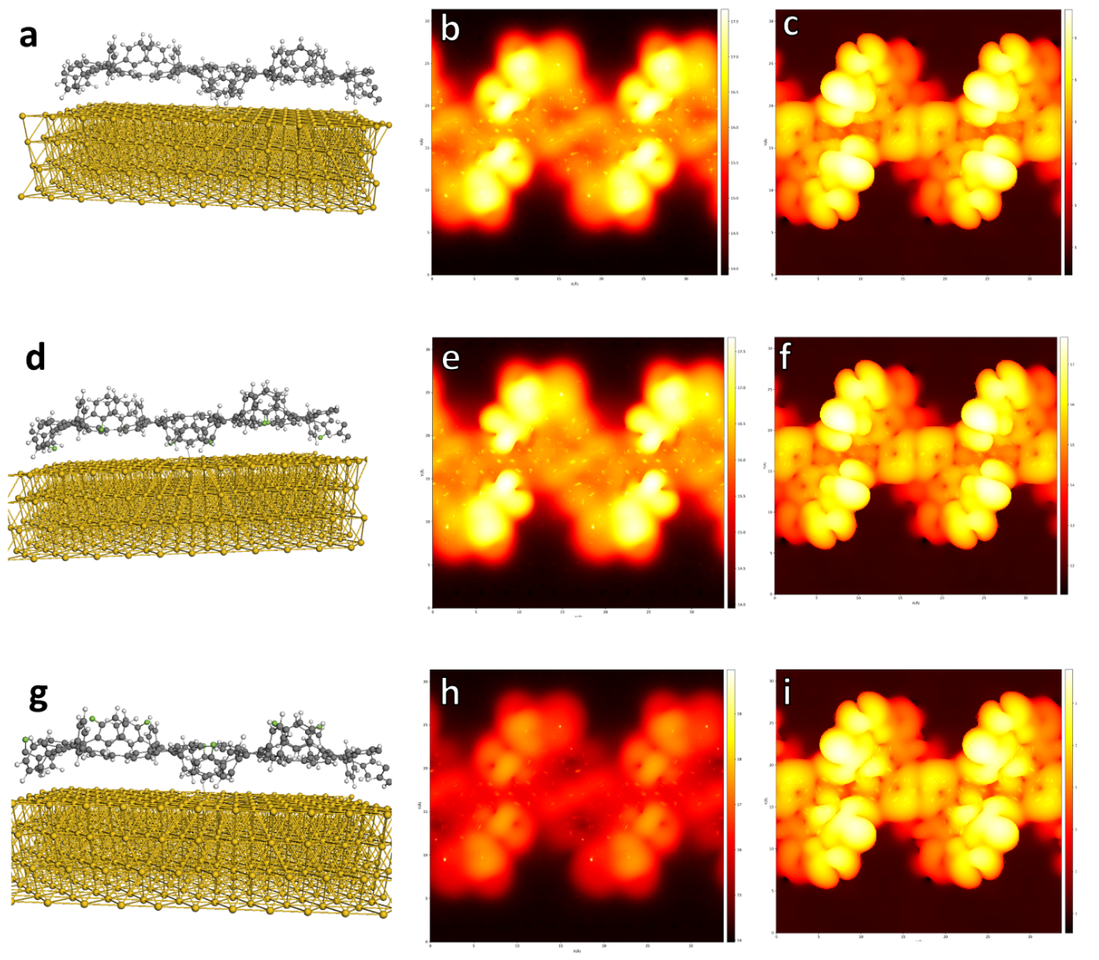
Figure S7. Calculated adsorption geometries and simulated STM images for the pristine chevron precursor (a-c) and possible configurations of the fluorinated chevron precursor 1 (d-i). (d-f) represent a geometry with the fluorine atoms pointing towards the Au(111) surface, and (g-i) represent the fluorine atoms pointed away from the Au(111) surface. (b,e,h) are simulated at -1.0V, and (c,f,i) at +1.0V.

Additional XPS data
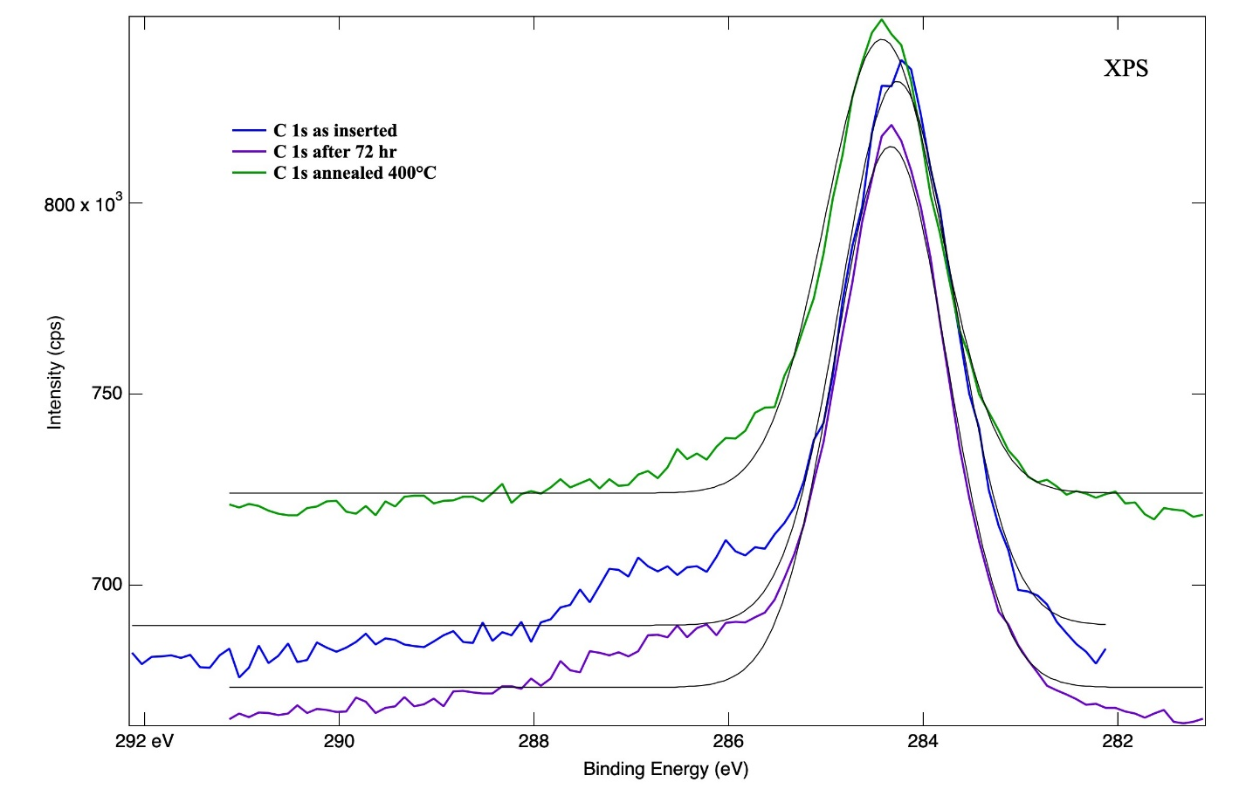
Figure S8. Carbon 1s XPS spectra acquired under various conditions on a sample grown on an Au(111)/mica substrate. Annealing took place after 72hr in vacuum. Gray lines represent a Gaussian fit.

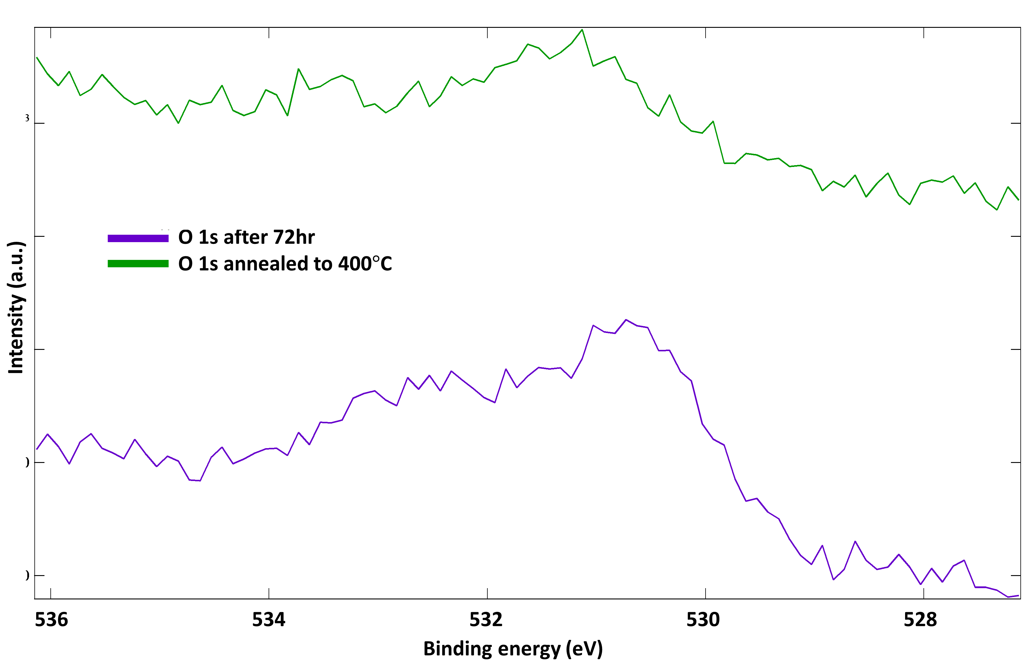
Figure S9. Oxygen 1s XPS spectra acquired under various conditions on a sample grown on an Au(111)/mica substrate. Annealing took place after 72hr in vacuum.

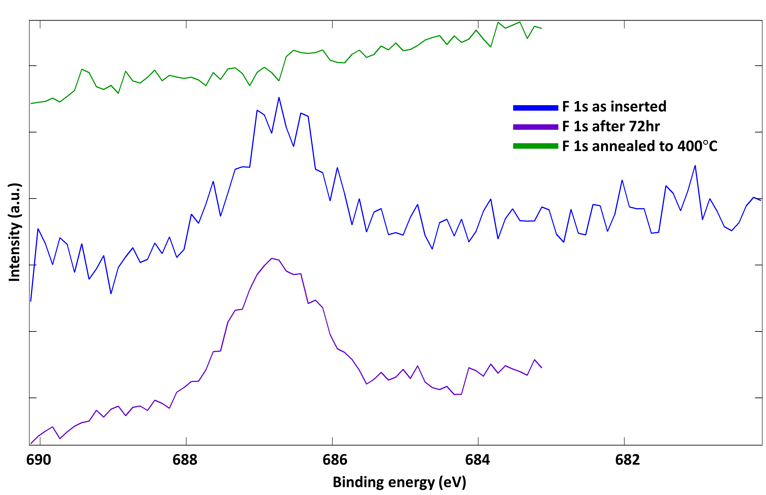
Figure S10. Fluorine 1s XPS spectra acquired under various conditions on a sample grown on an Au(111)/mica substrate. Annealing took place after 72hr in vacuum.

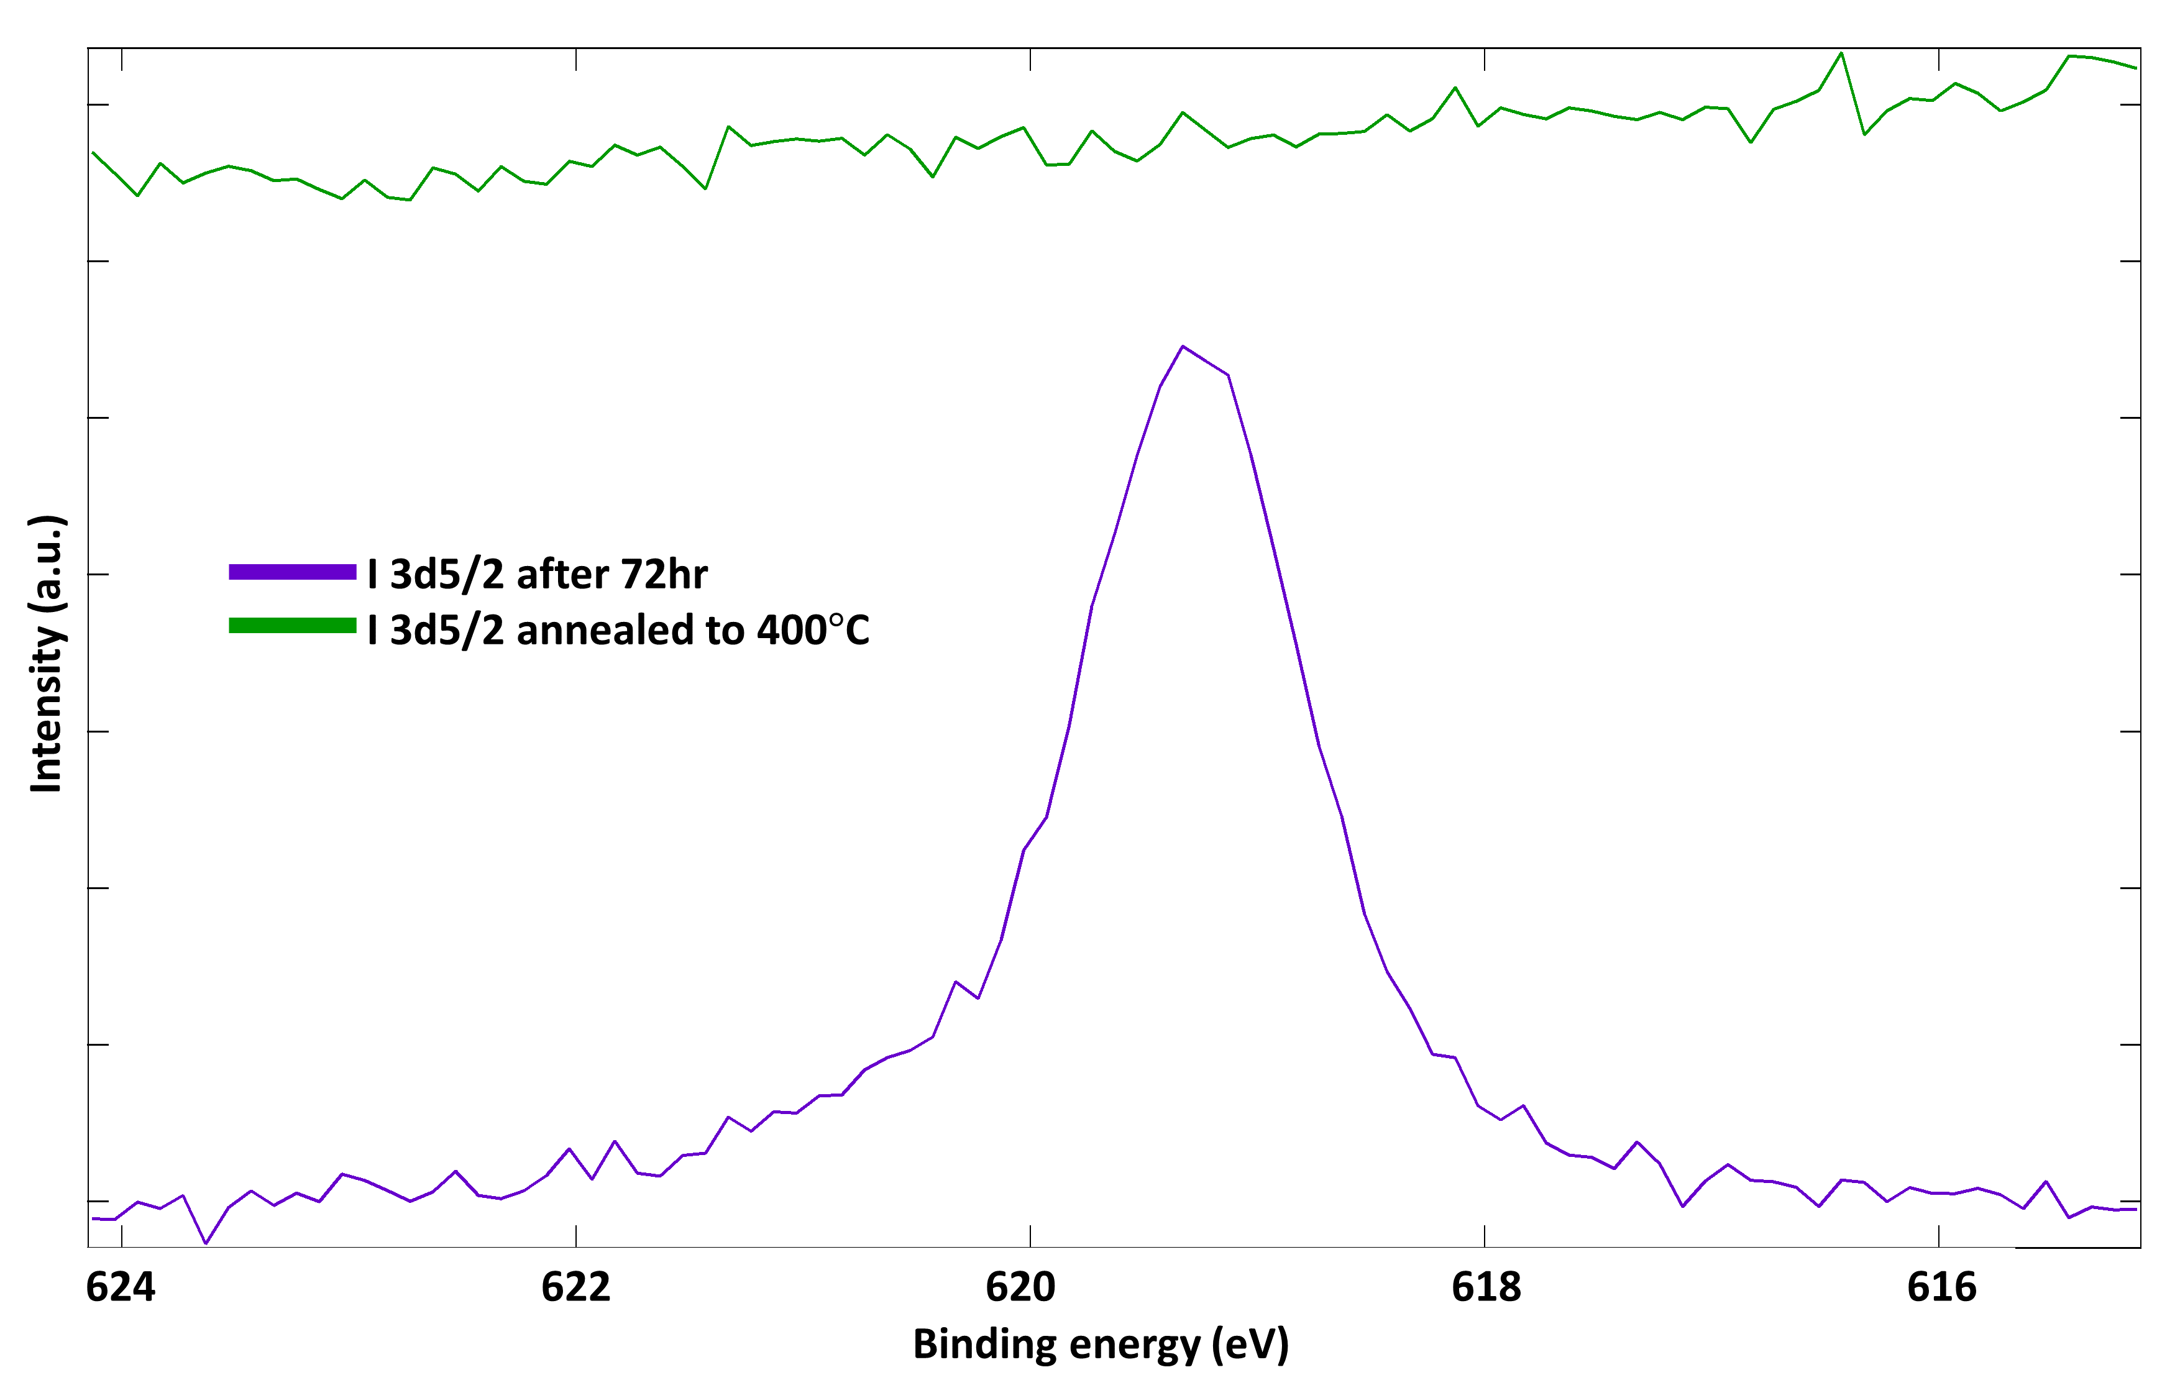
Figure S11. Iodine 3d^{5/2} XPS spectra acquired under various conditions on a sample grown on an Au(111)/mica substrate. Annealing took place after 72hr in vacuum.

