Supplementary Materials
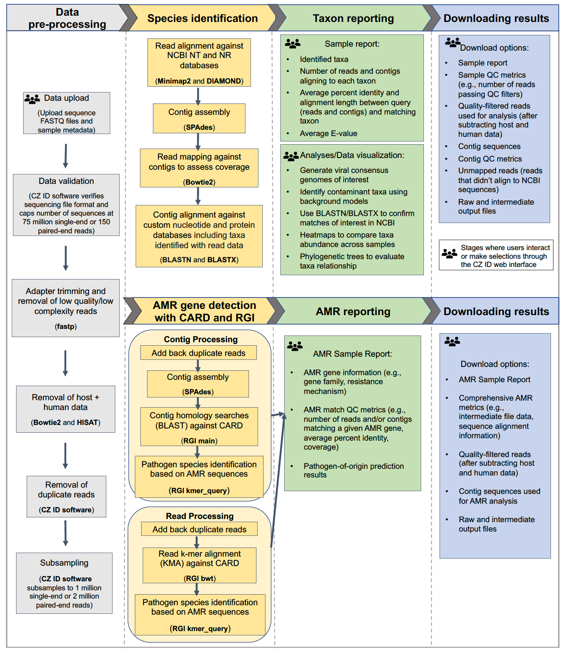
Figure S1. Detailed flow diagram highlighting the integrated AMR and mNGS modules within the CZ ID pipeline.

