The associations of circulating inflammatory-related proteins with asthma: a Mendelian randomization study
Supplementary Figure 1 Bidirectional MR analysis for (A) AOA and (B) COA on levels of potential inflammatory-related causal proteins.
Supplementary Figure 2 Colocalization plots of pQTLs and genetic associations of asthma.
Supplementary Figure 3 Protein-protein interaction network among the identified circulating inflammatory-related proteins (P < 0.05) and current asthma medications targets.
Supplementary Figure 4 Docking results of identified proteins and small molecules.

(A)AOA
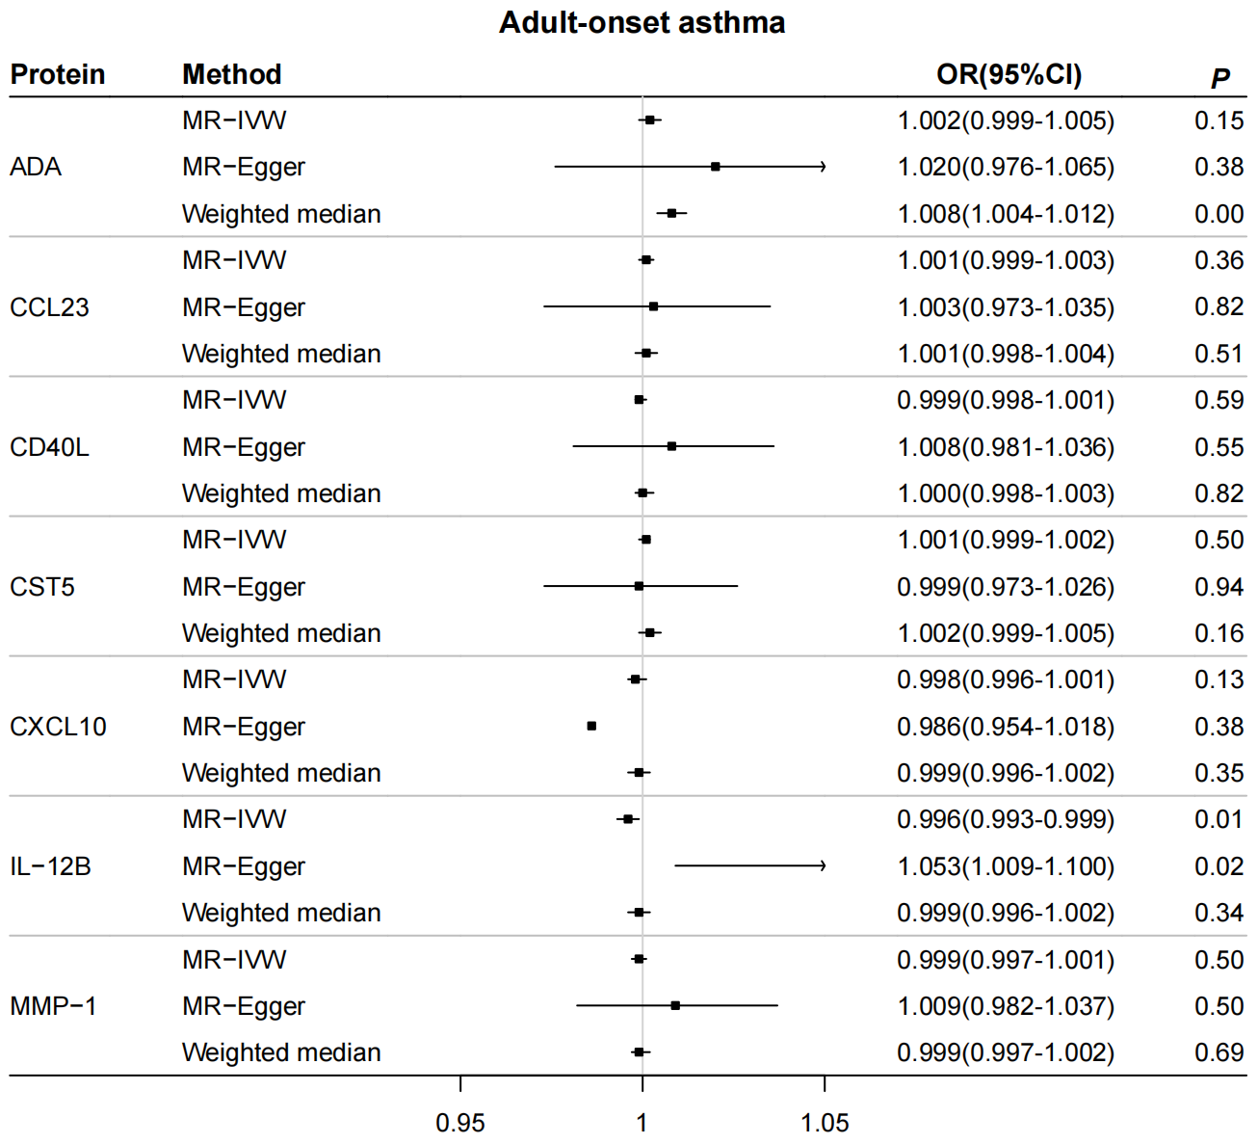
(B)COA
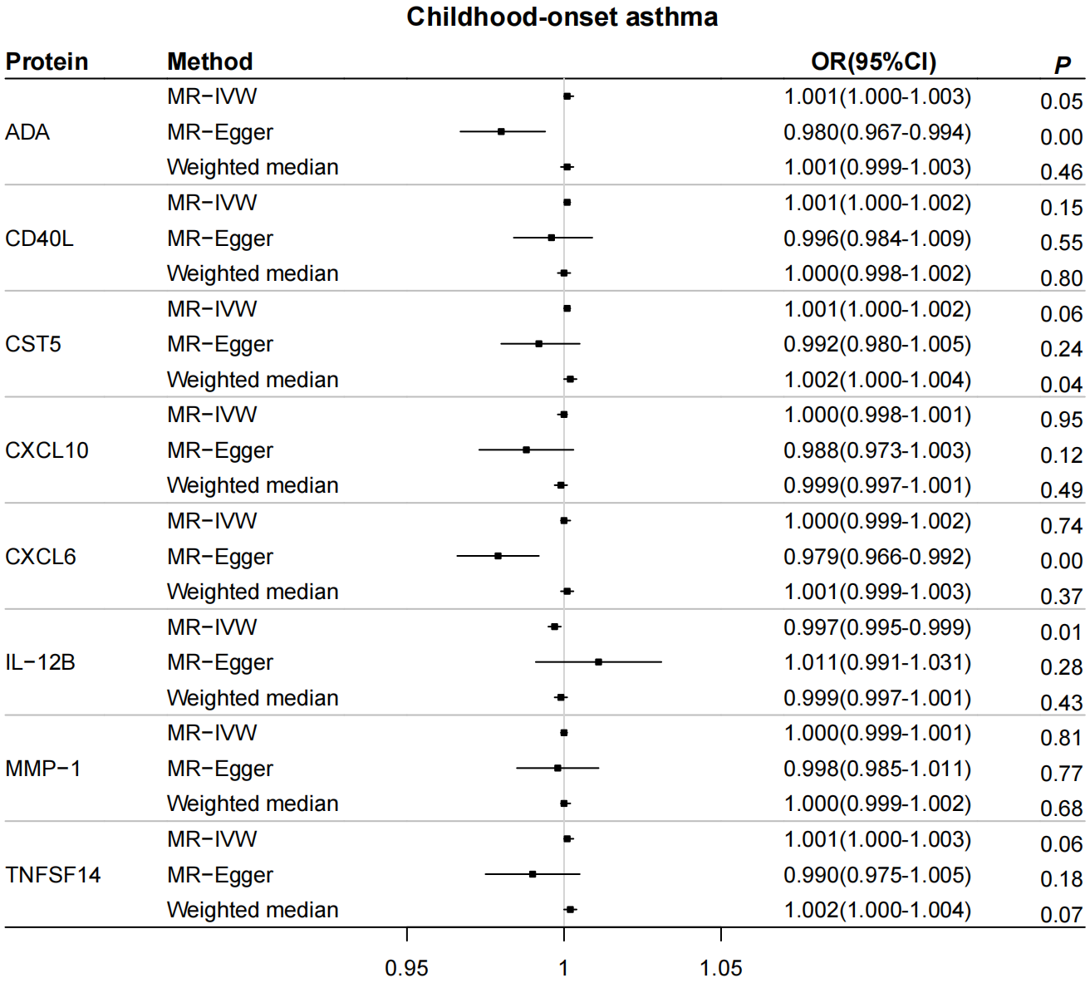
Supplementary Figure 1 Bidirectional MR analysis for (A) AOA and (B) COA on levels of potential inflammatory-related causal proteins. OR for increased risk of asthma were expressed as per SD increase in protein levels. OR: odds ratio; CI: confidence interval; MR-IVW: Mendelian randomization with inverse variance weighted method; SD: standard deviation; AOA: adult-onset asthma; COA: childhood-onset asthma.
(A)ADA-AOA (B) CD40L-AOA
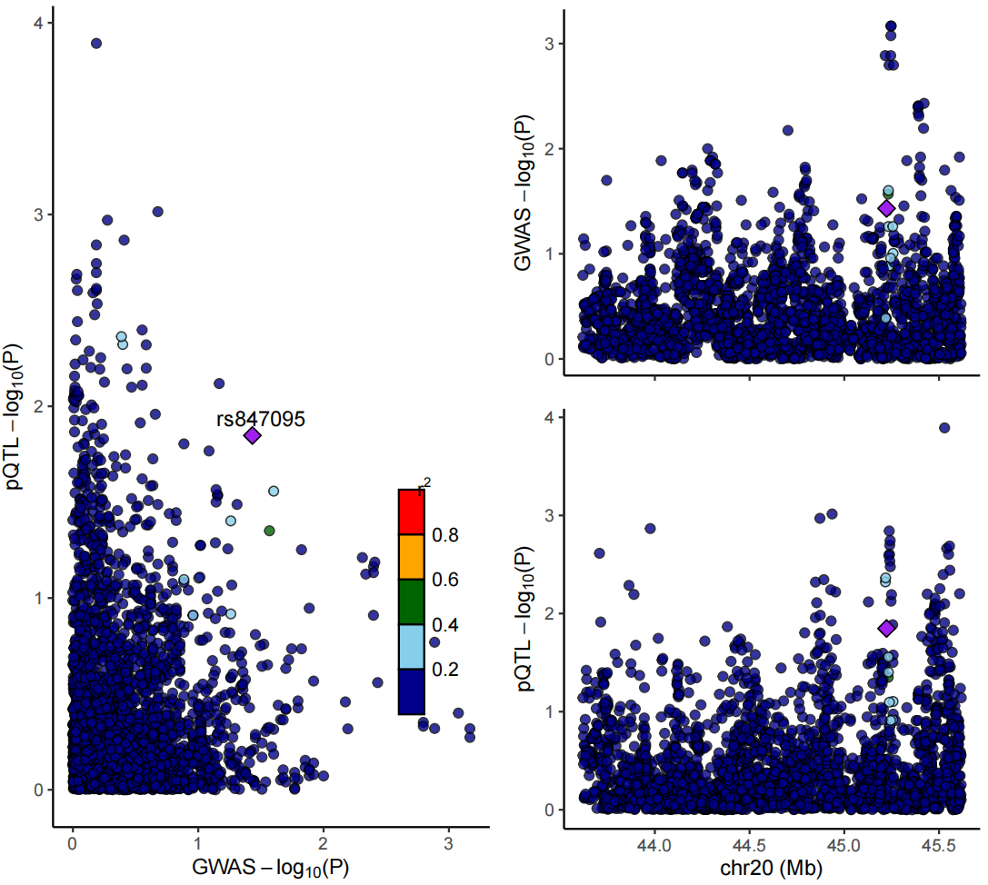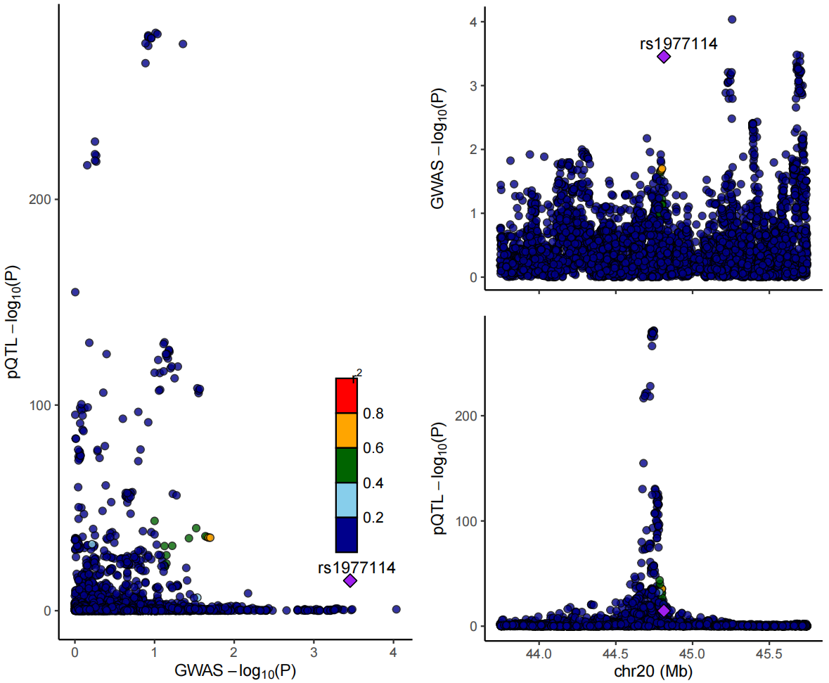
(C)CST5-AOA (D) IL12B-AOA
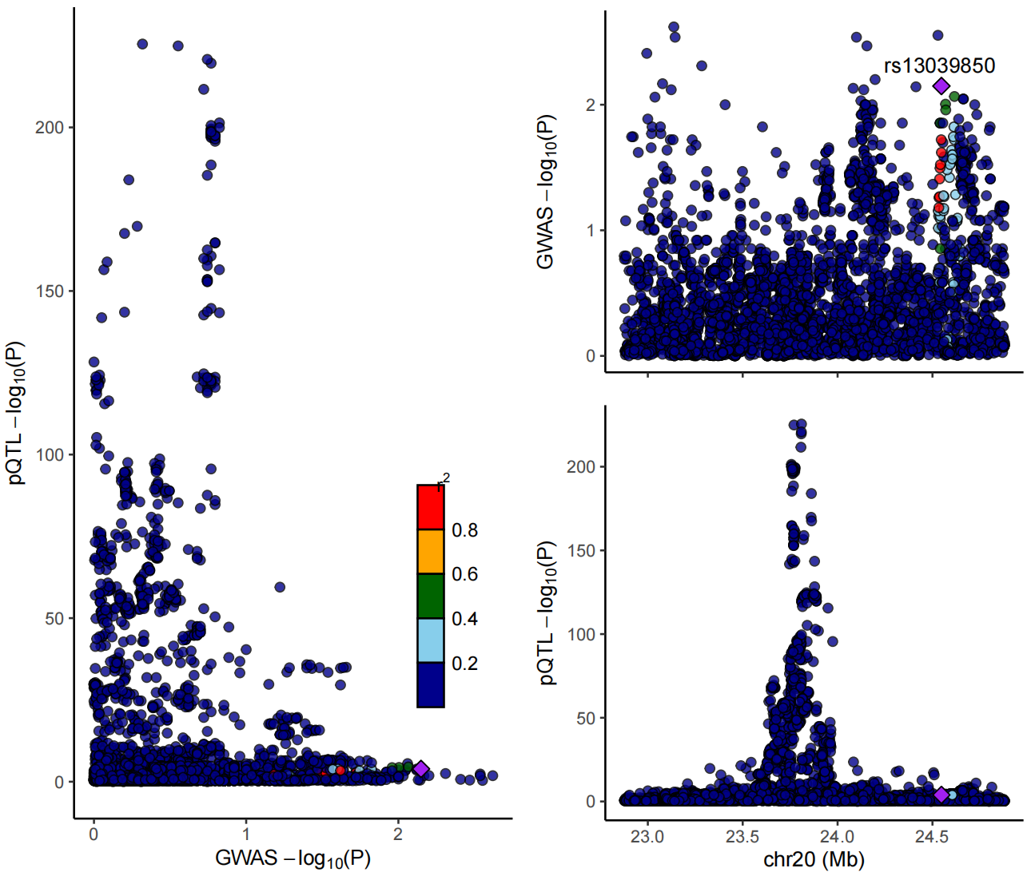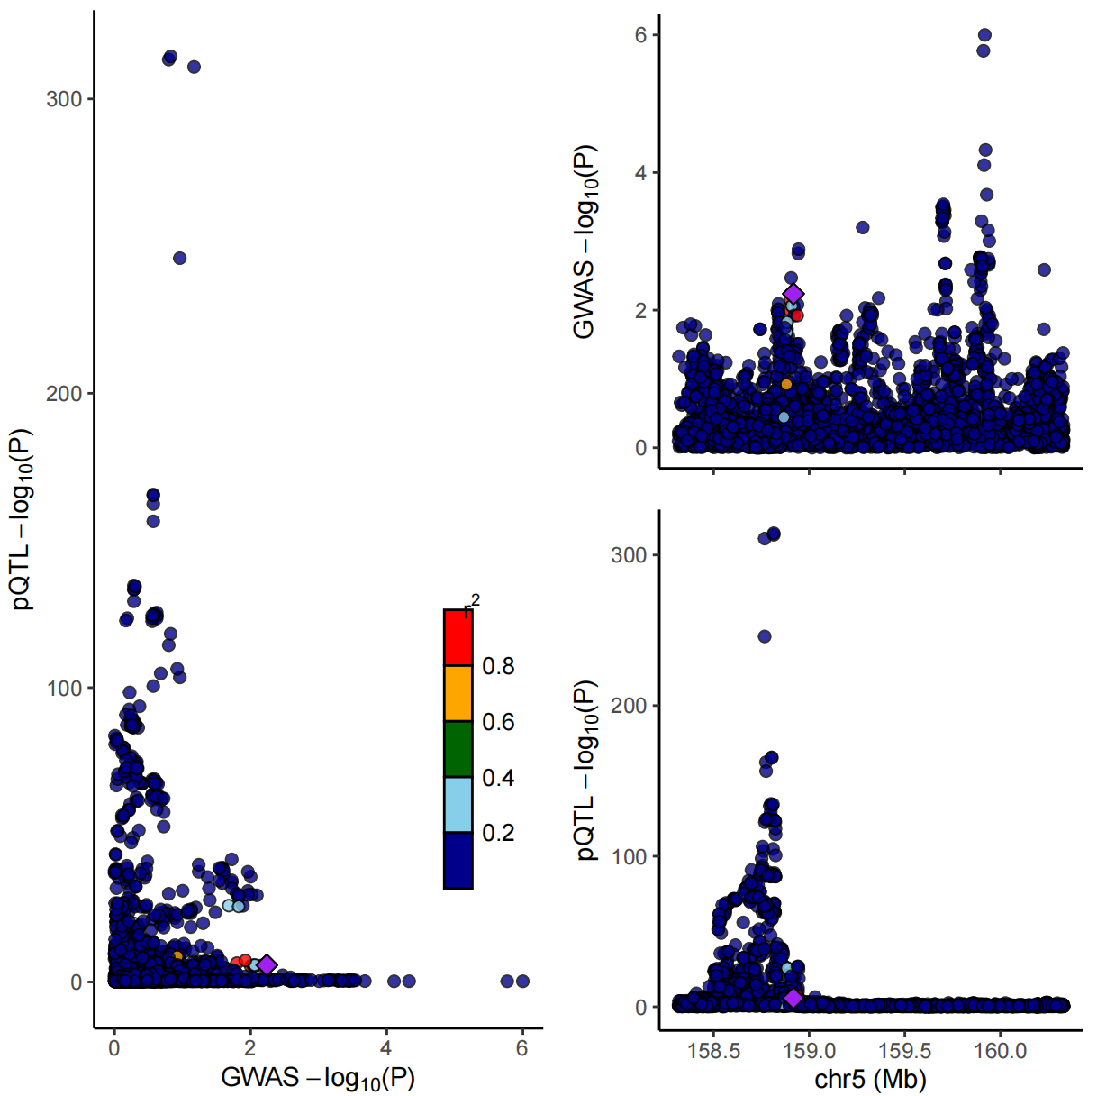
- MMP1-AOA (F) ADA-COA
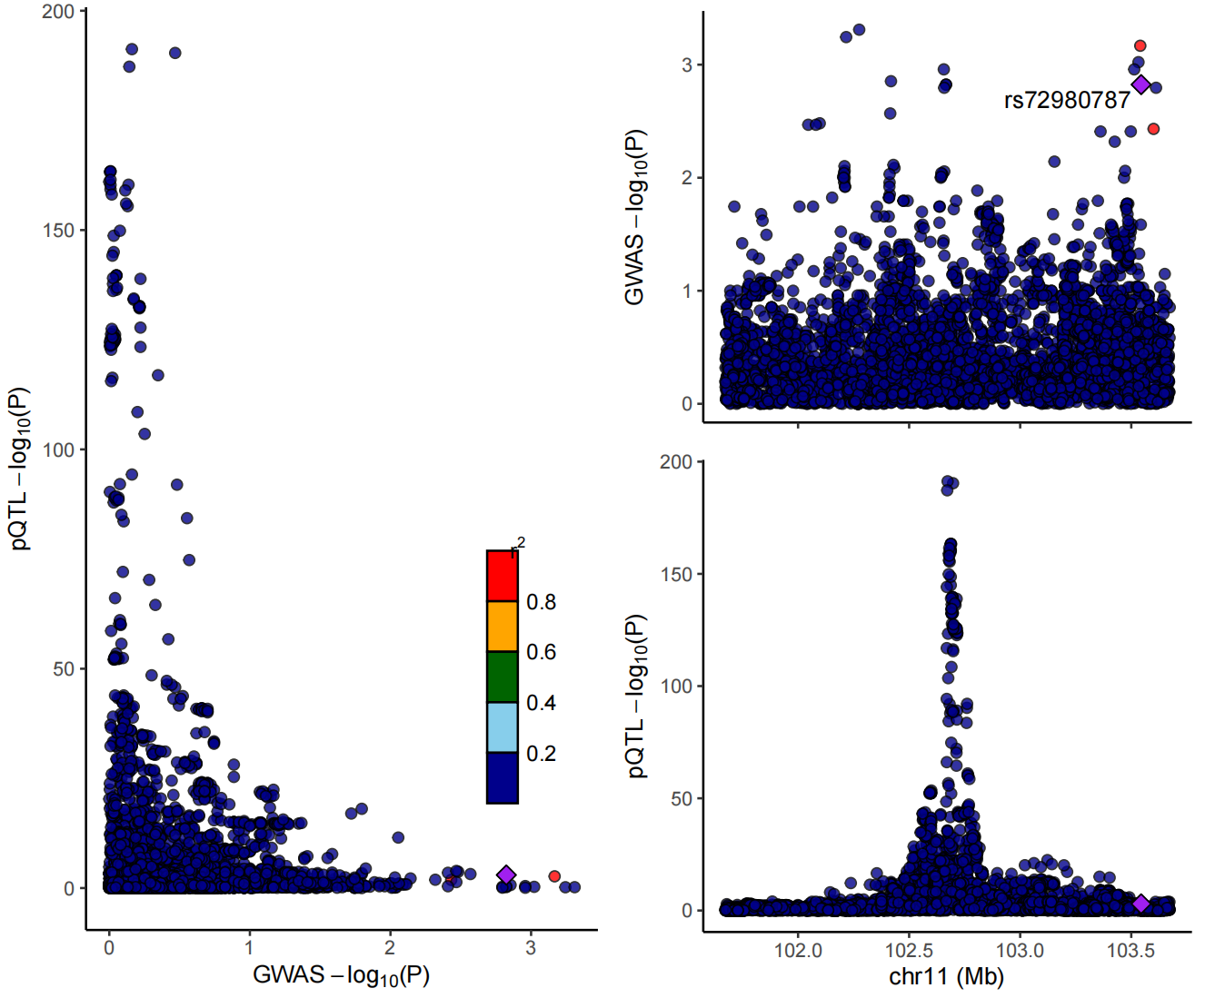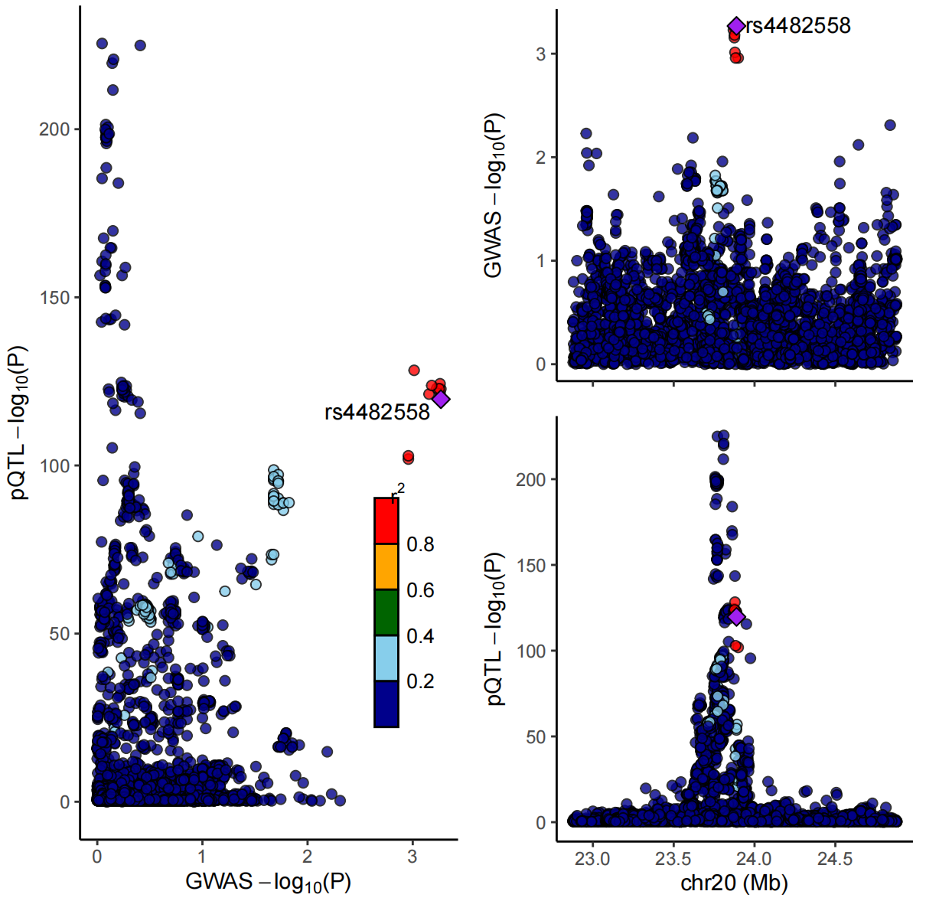
- CD40L-COA (H) CST5-COA
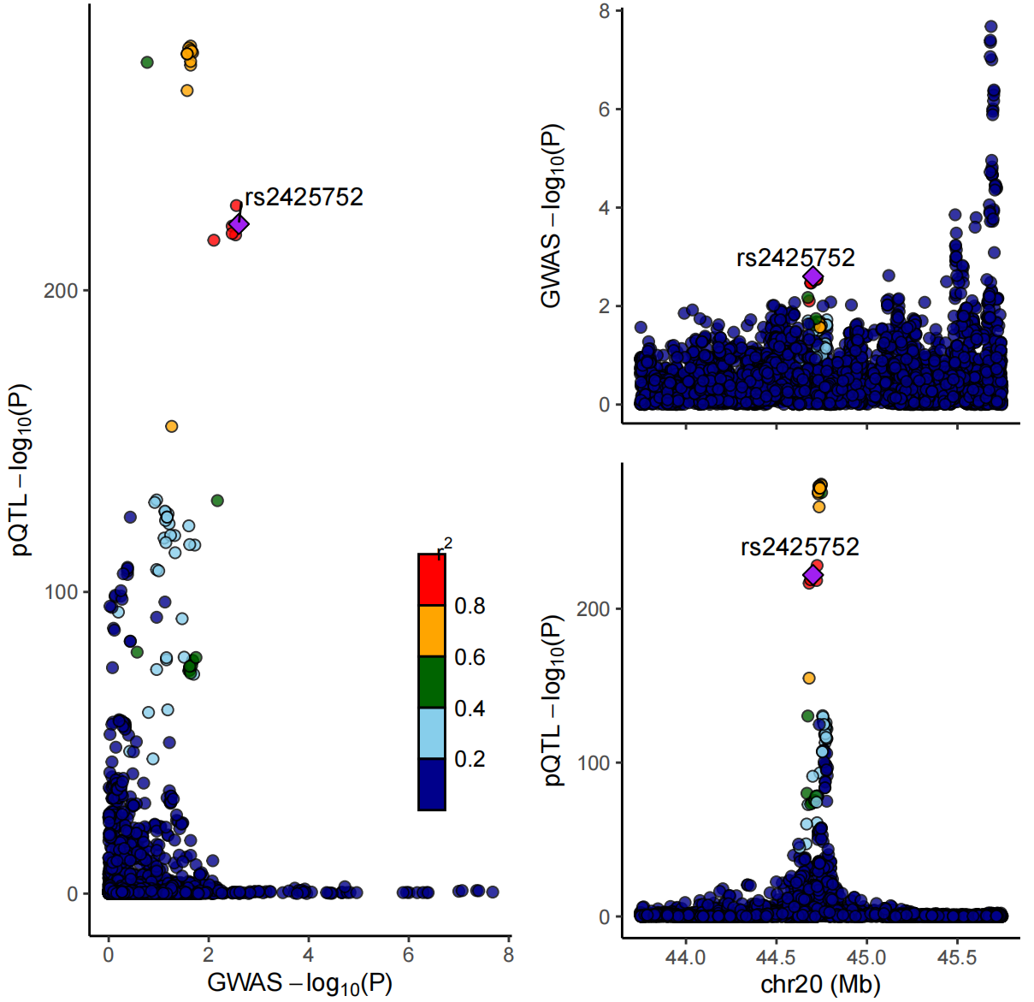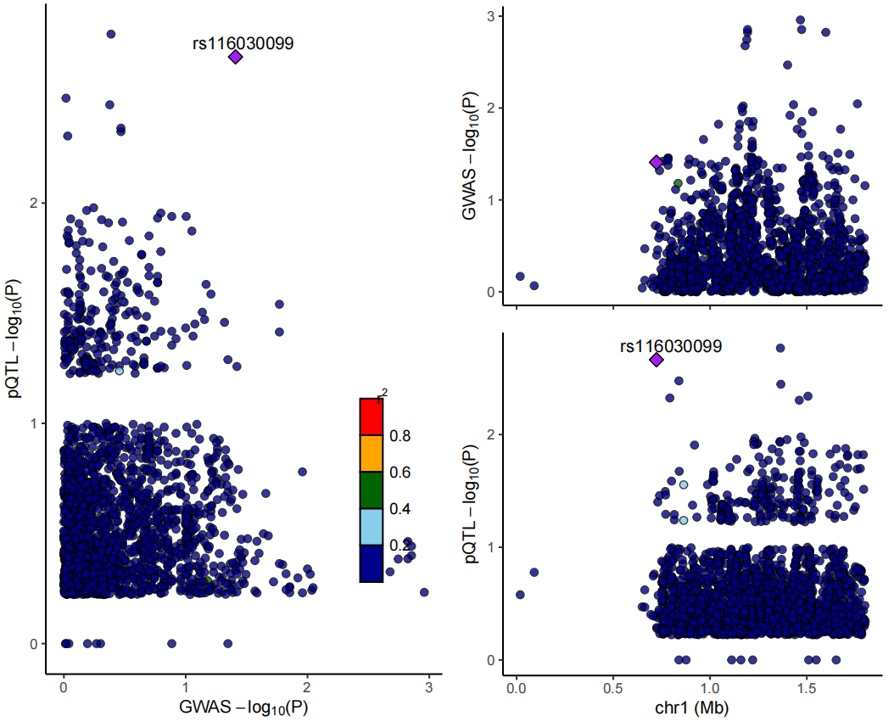
- CXCL6-COA (J) IL12B-COA
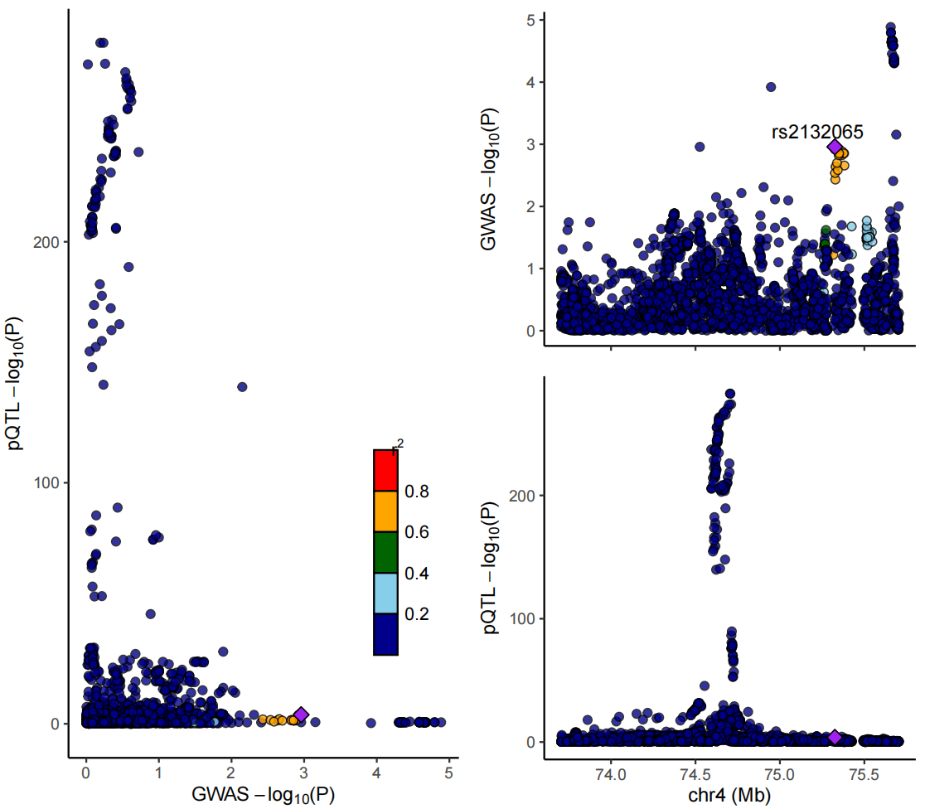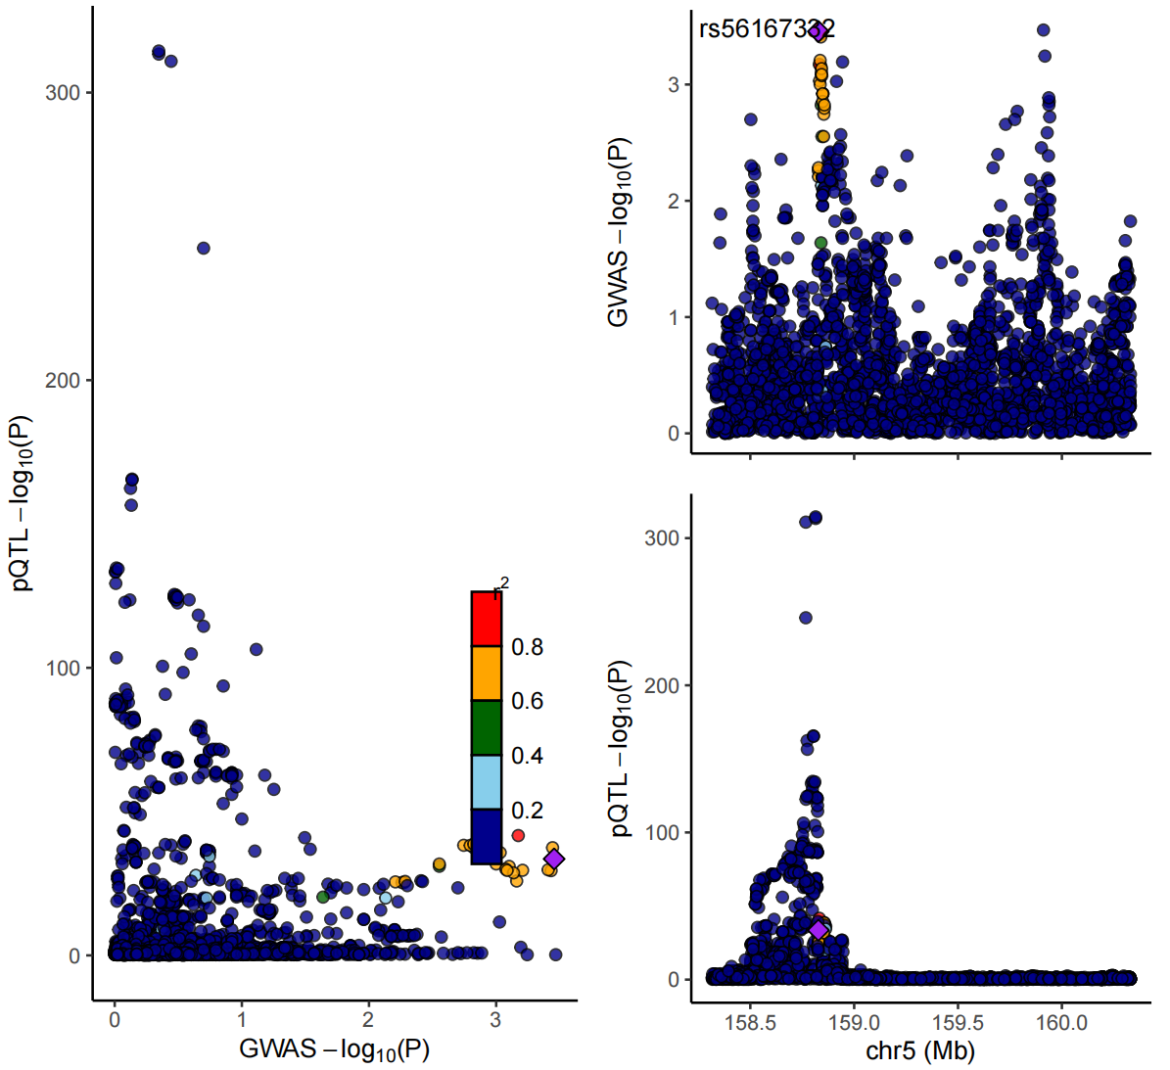
- MMP1-COA (L) TNFSF14-COA
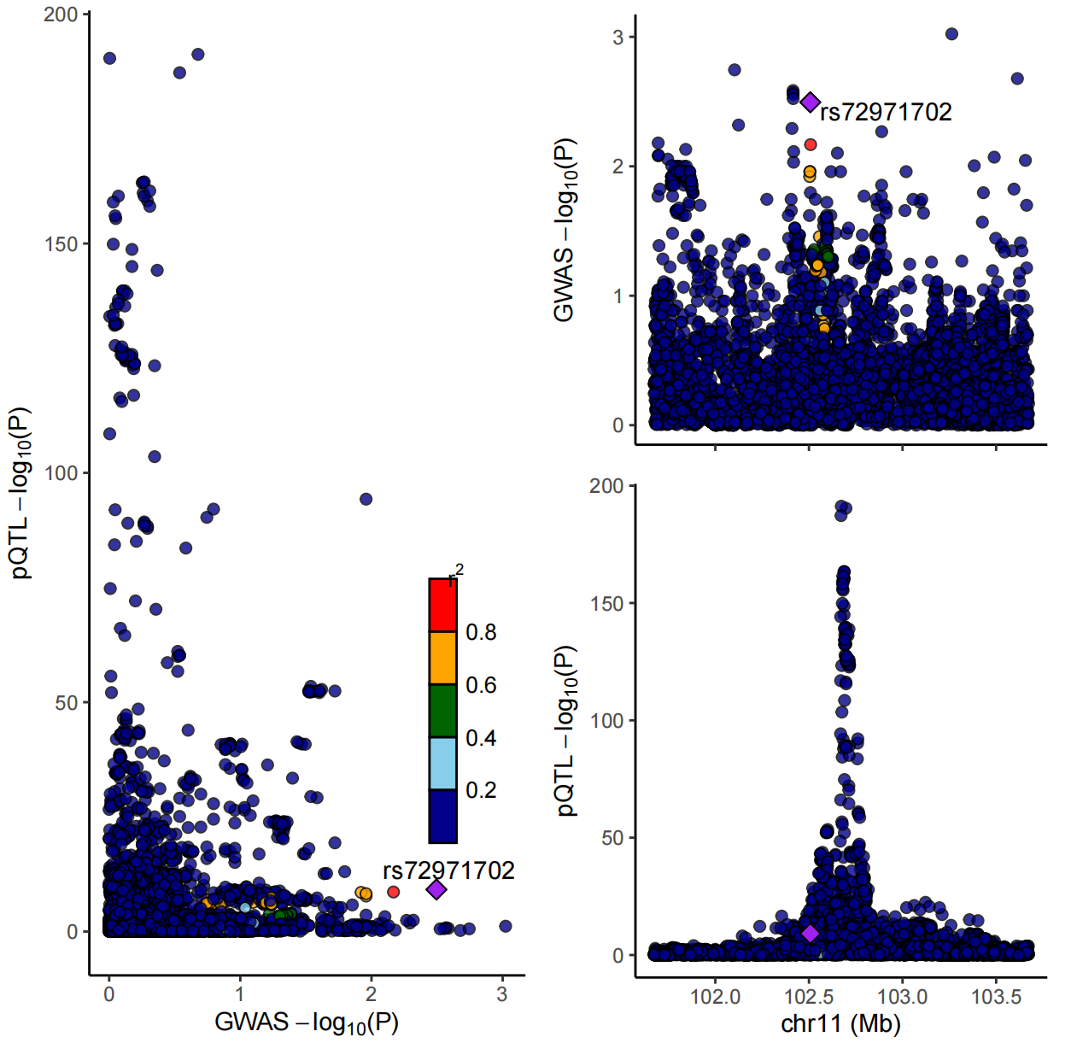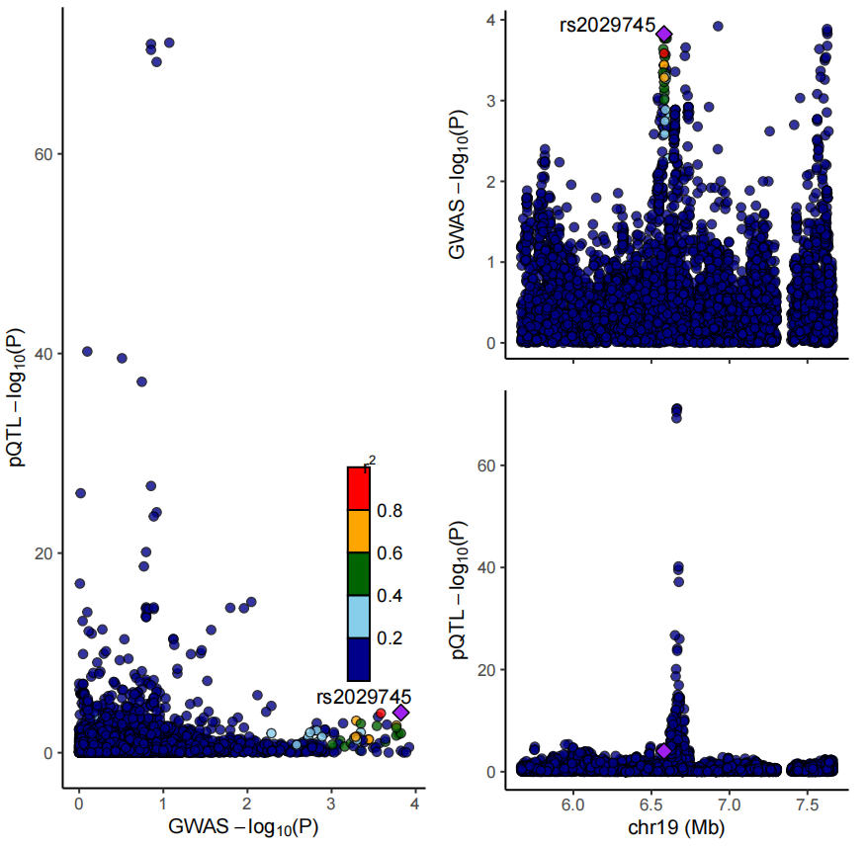
Supplementary Figure 2 Colocalization plots of pQTLs and genetic associations of asthma. Colocalization analysis of circulating inflammatory-related proteins for (A) ADA, (B) CD40L,
- CST5, (D) IL12B, and (E) MMP1 on AOA; (F)ADA, (G) CD40L, (H) CST5, (I) CXCL6,
- IL12B, (K) MMP1, and (L) TNFSF14 on COA, respectively. Diamond purple points represent SNPs with the minimal sum of P values in the corresponding protein GWAS and asthma GWAS. pQTL: protein quantitative trait loci; AOA: adult-onset asthma; COA: childhood-onset asthma; SNP: single nucleotide polymorphism; GWAS: genome-wide association studies.

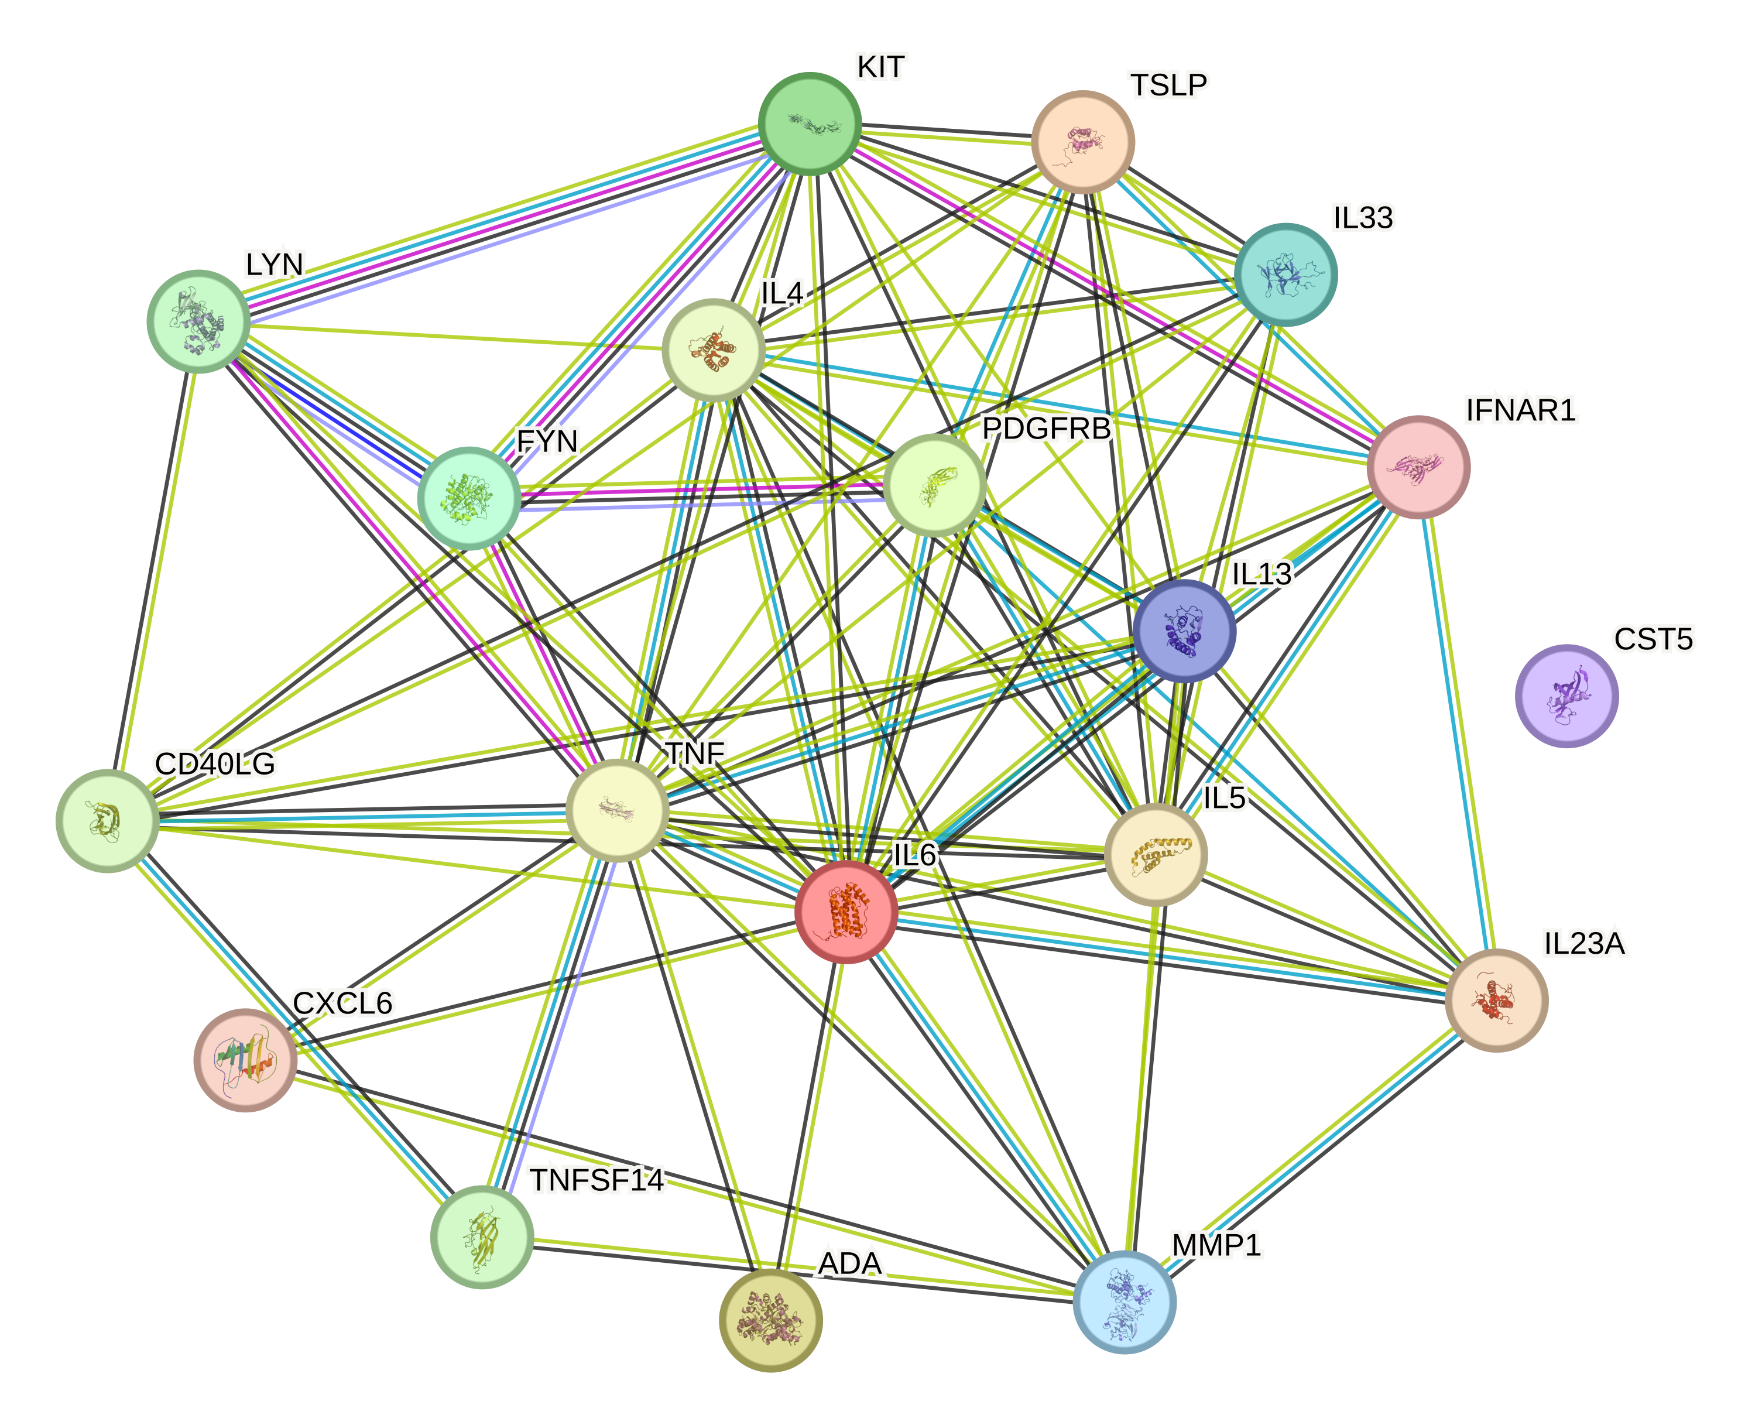
Supplementary Figure 3 Protein-protein interaction network among the identified circulating inflammatory-related proteins (P < 0.05) and current asthma medications targets.

(A) ADA docking PENTOSTATIN
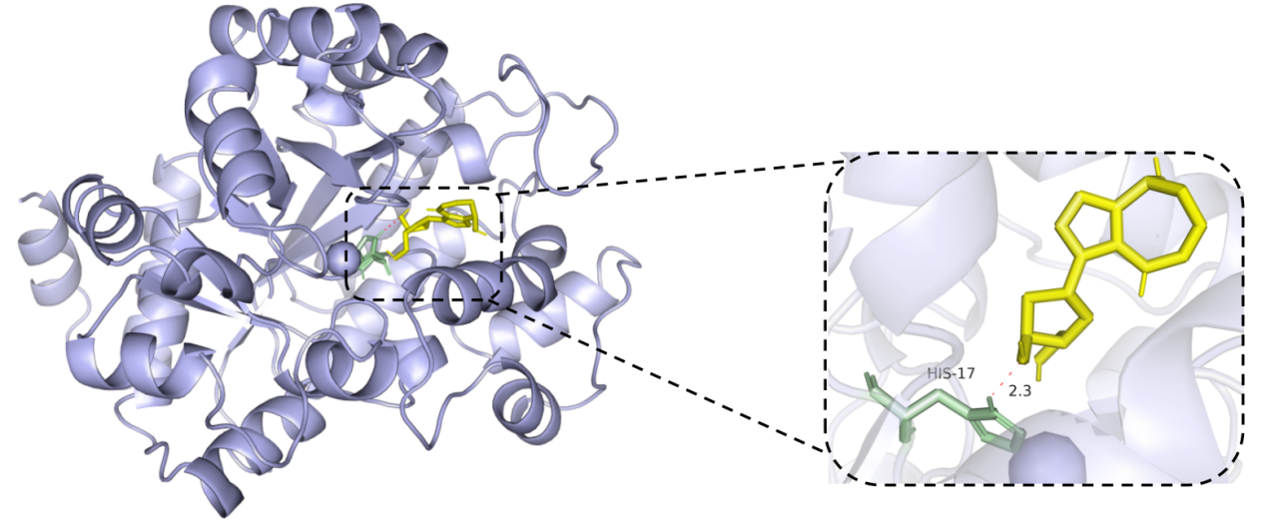
(B) ADA docking COFORMYCIN
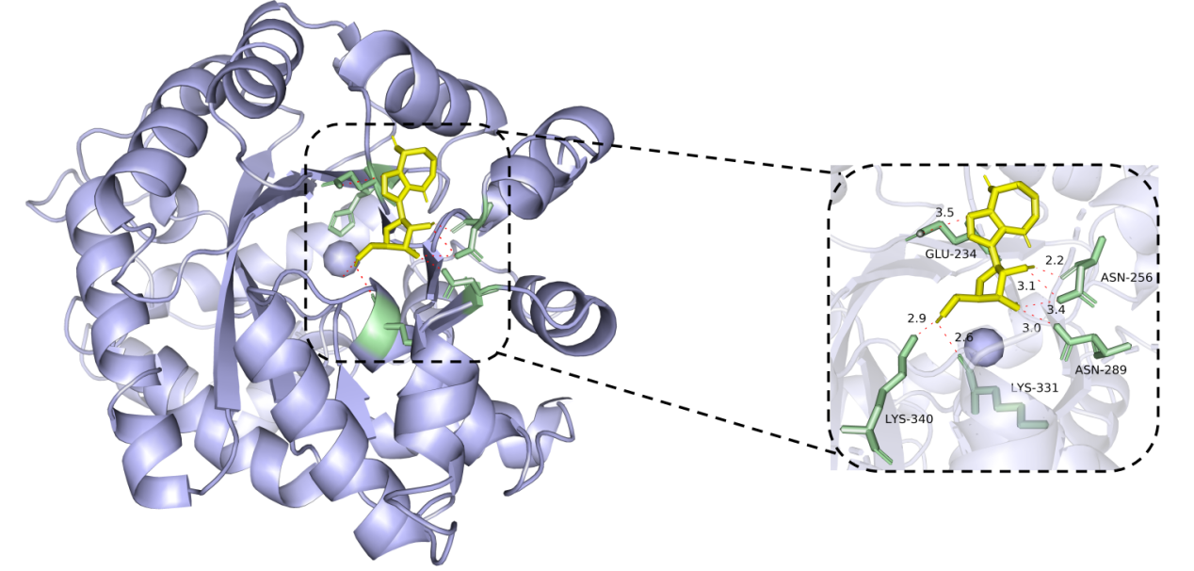
(C) MMP-1 docking DOXYCYCLINE ANHYDROUS
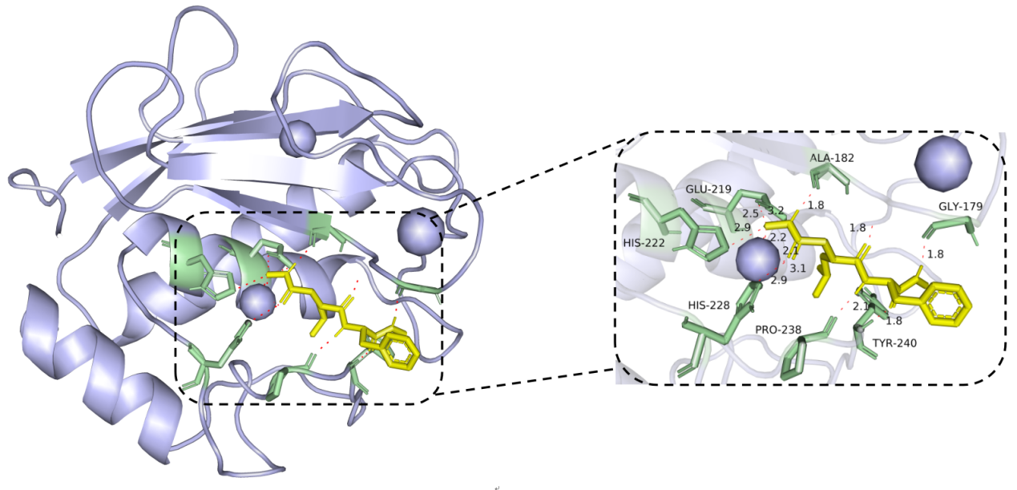
(D) MMP-1 docking MARIMASTAT
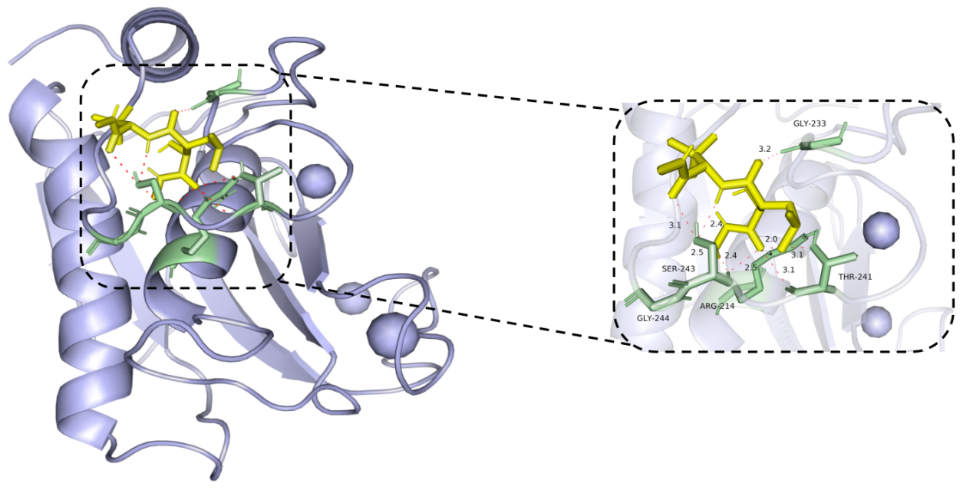
(E) MMP-1 docking REBIMASTAT
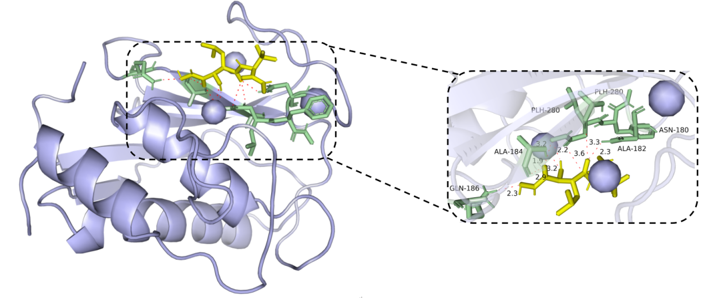
Supplementary Figure 4 Docking results of identified proteins and small molecules. The left portion depicts the location of small molecule drugs on the protein receptor, while the right portion specifies the amino acid to which each protein binds, along with the length and number of hydrogen bonds. (A) ADA docking PENTOSTATIN; (B) ADA docking COFORMYCIN; (C) MMP-1 docking DOXYCYCLINE ANHYDROUS; (D) MMP-1 docking MARIMASTAT; (E) MMP-1 docking REBIMASTAT.

