SUPPLEMENTAL TABLES AND FIGURES

Supplementary Table 1: Primary receptor subtypes (ER, PR, HER2) for paired cohort participants (ER: estrogen receptor, PR: progesterone receptor, HR+: hormone receptor positive, HR-: hormone receptor negative, HER2+: HER2-positive)
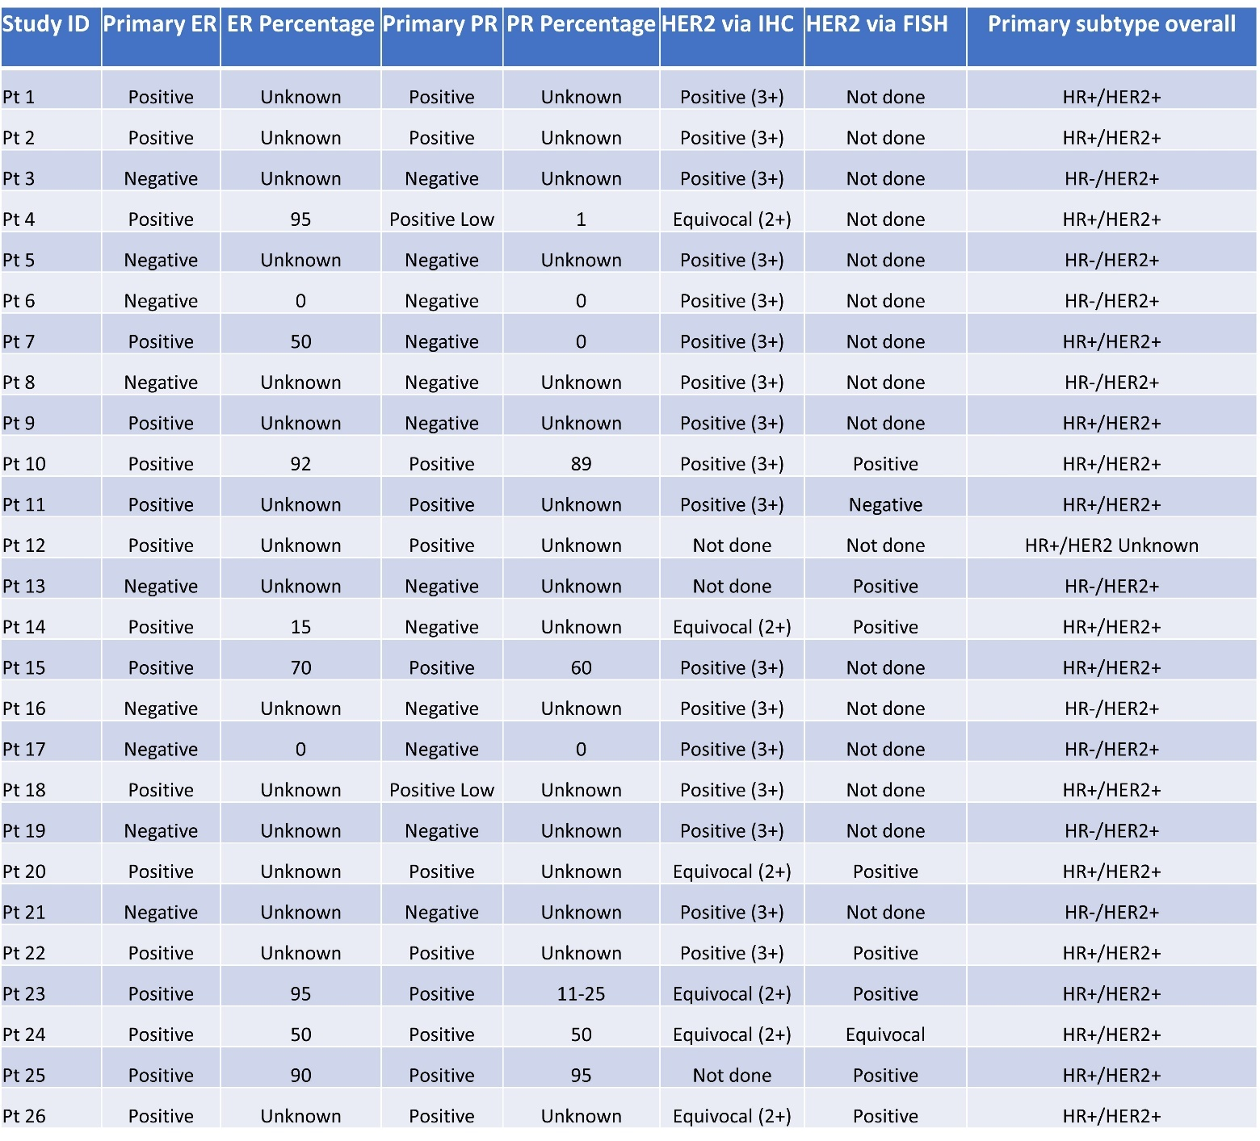

Supplementary Table 2: Metastatic receptor subtypes (ER, PR, HER2) for paired cohort participants (Met: Metastatic, ER: estrogen receptor, PR: progesterone receptor, HR+: hormone receptor positive, HR-: hormone receptor negative, HER2+: HER2-positive) 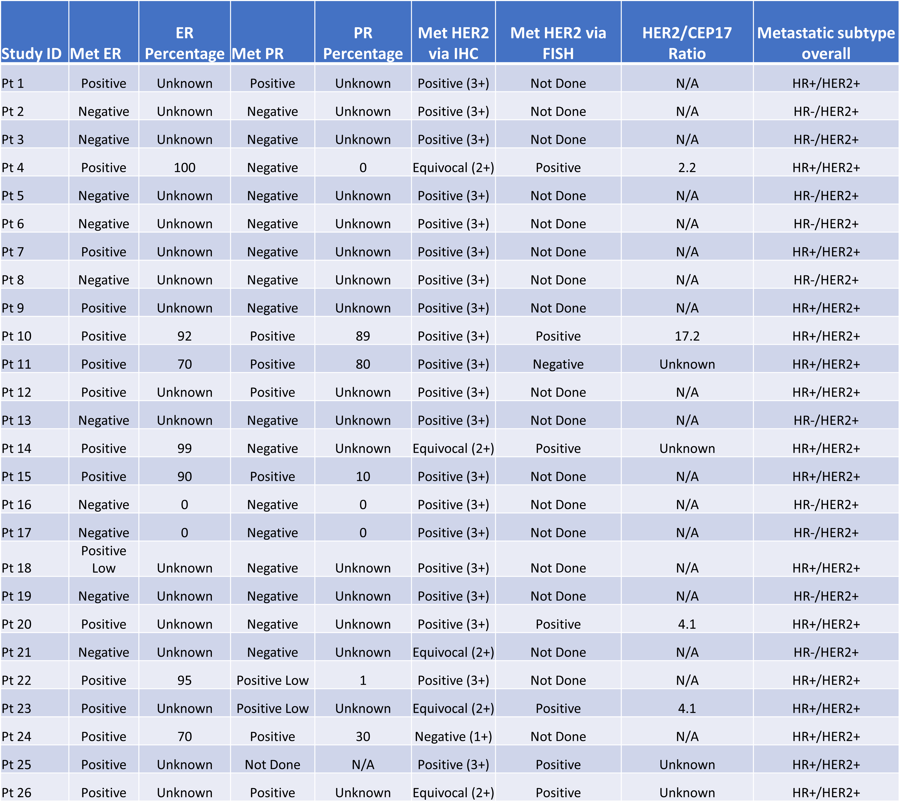

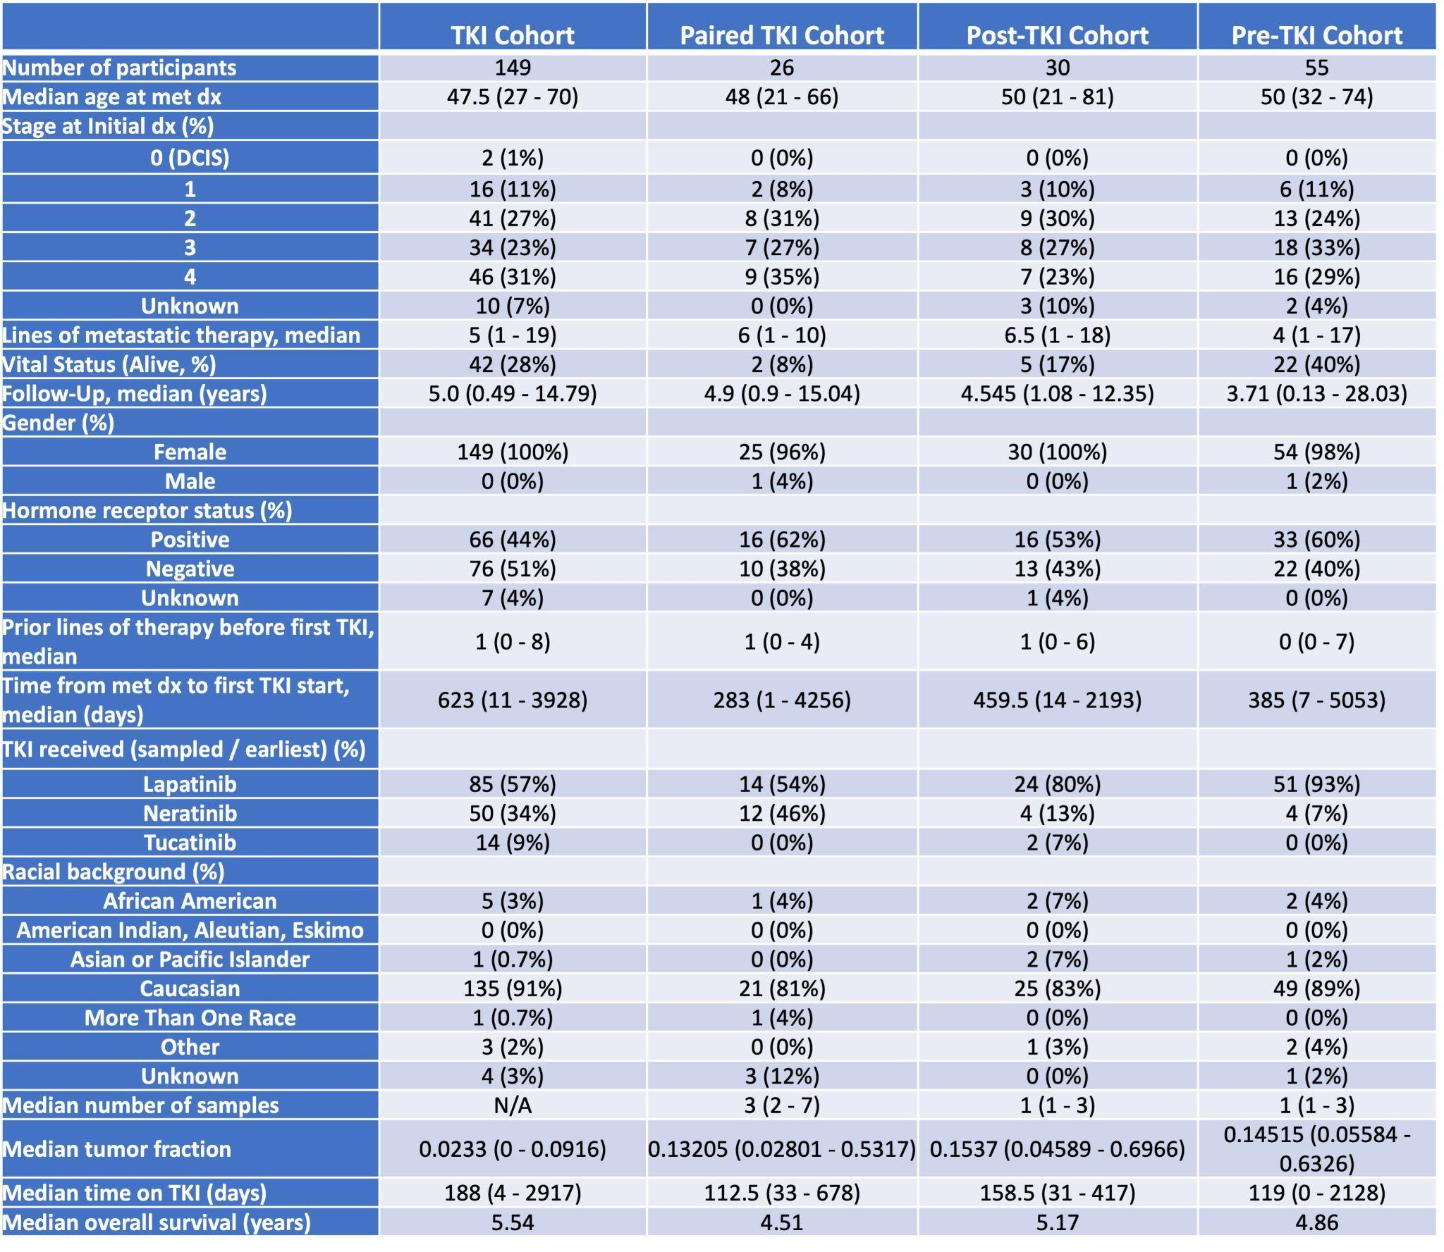
Supplementary Table 3: Patient Characteristics

Supplementary Table 4: All genes included for analysis of the ESR1 and regulators pathway

ESR1 and Regulators Genes
BARX2 | FOXA1 | MTA1 | PRDM1 | SNAI2
BRCA1 | FOXM1 | MUC1 | SALL2 | TWIST1
CTCF | FOXO3 | MYOD1 | SETD1A | WT1
ERUBF1 | GATA3 | NCOA3 | SIN3A | ZBTB7A
ESR1 | KMT2A | PGR | SNAI1 | ZNF217

Supplementary Table 6: Mutations frequencies across the three cohorts for genes of interest

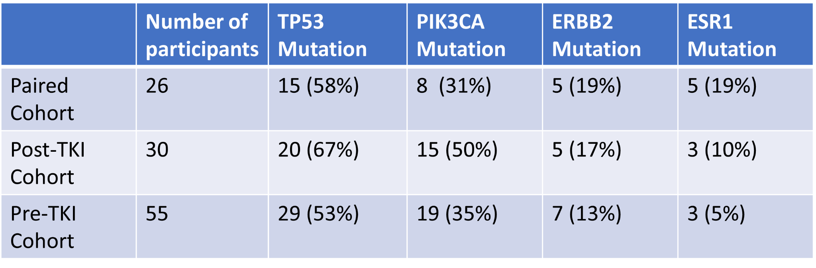

Supplementary Figure 1: A.) Pathway alterations compared between pre-TKI cohort participants (n=55) depicted in decreasing frequency with known and potential mechanisms highlighted, TP53 pathway significantly mutated, and with signatures analysis identifying top three results;
B.) Pathway alterations compared between post-TKI cohort participants (n=30) depicted in decreasing frequency with known and potential mechanisms highlighted, PI3K and TP53 pathways significantly mutated, and with signatures analysis identifying top four results;
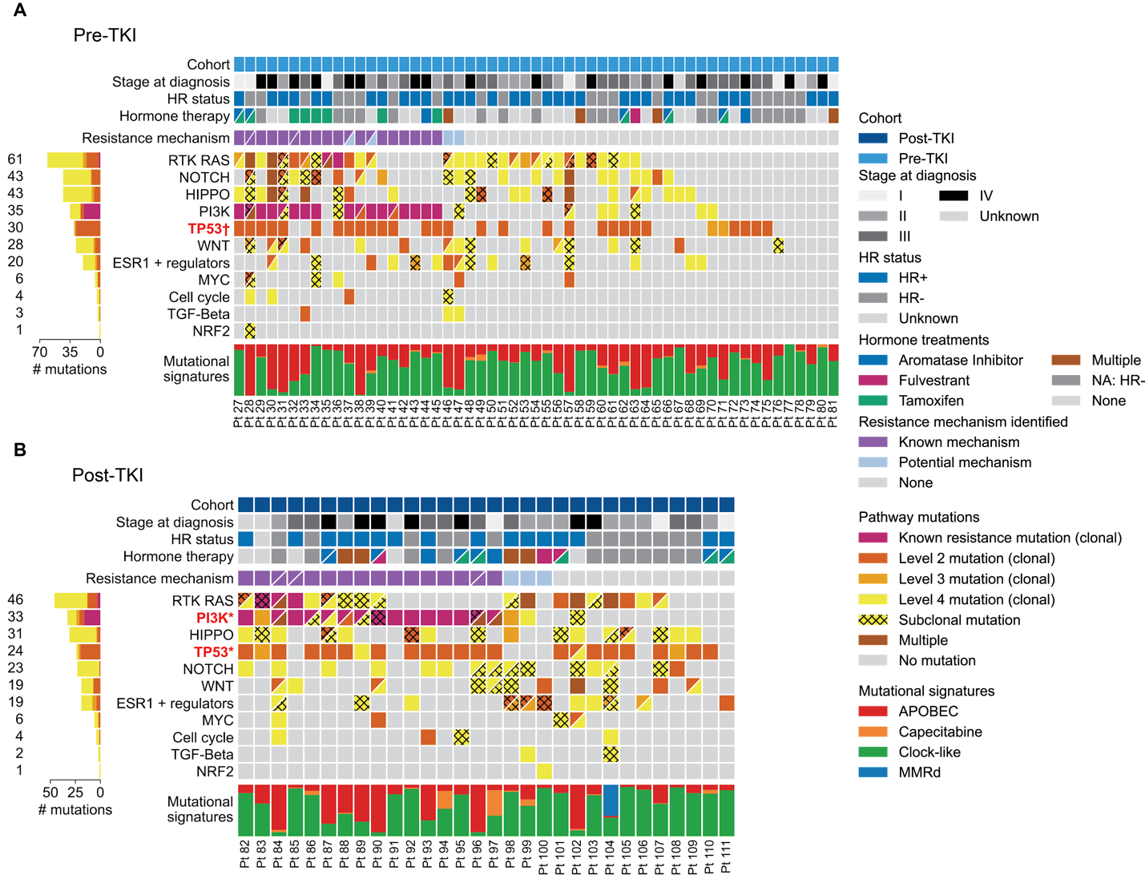

Supplementary Figure 2: ERBB2 copy number (CNAP: copy number above ploidy) by hormone receptor status in pre- and post-TKI paired samples.
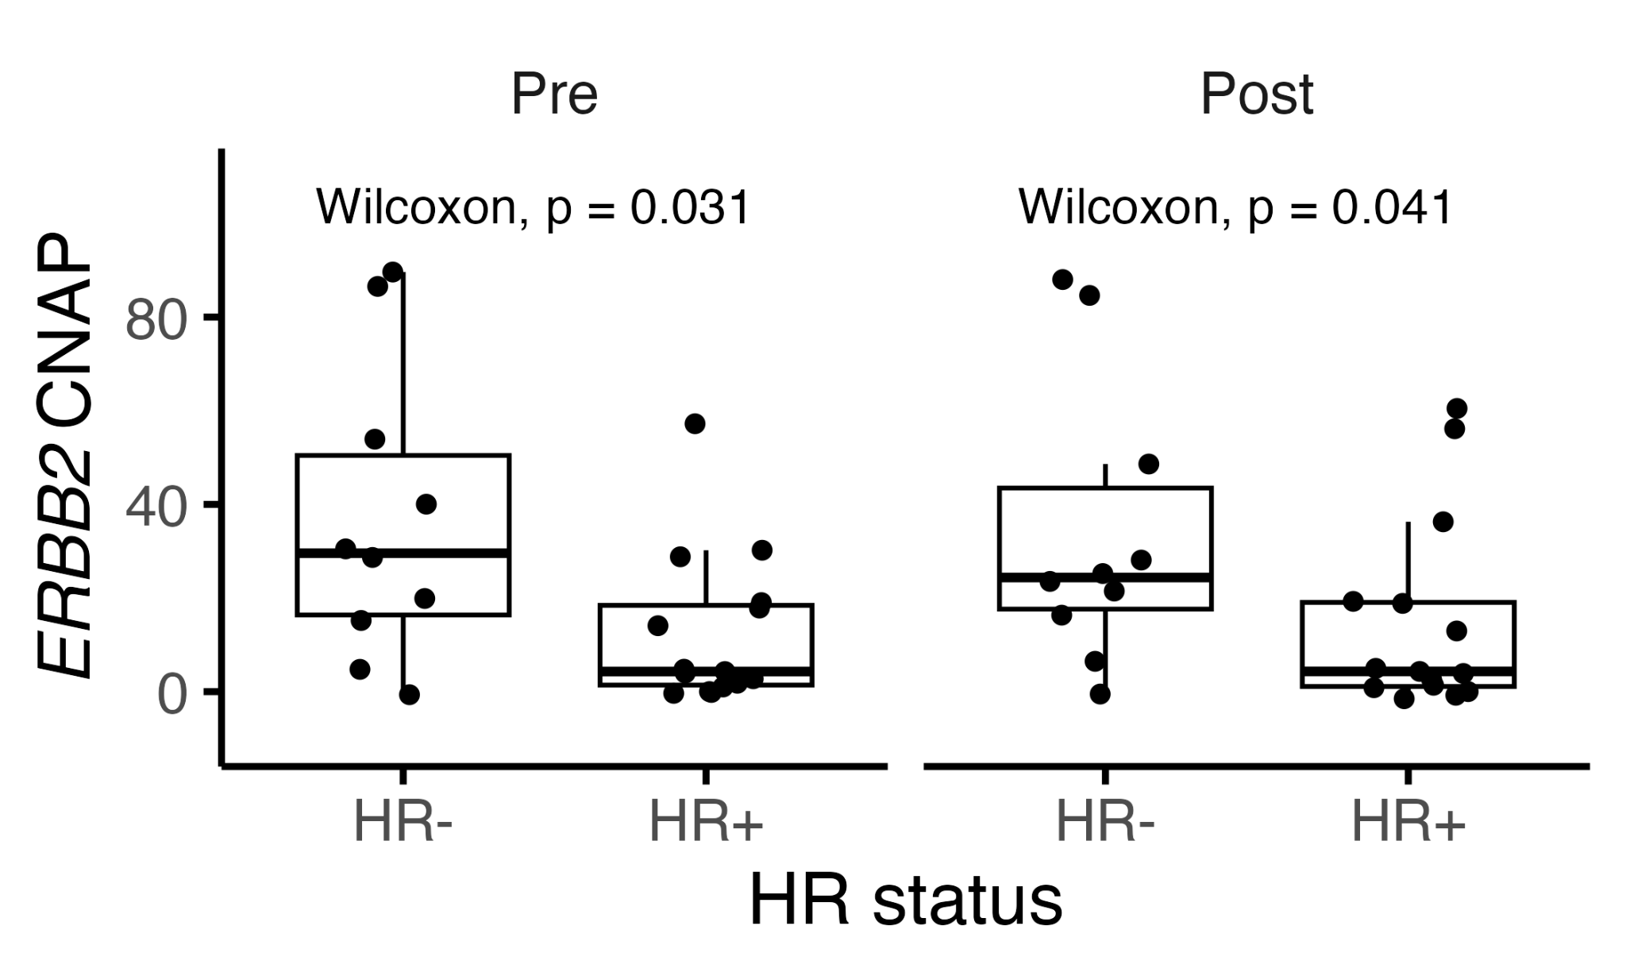
Supplementary Figure 3: ERBB2 copy number (CNAP: copy number above ploidy) by ESR1m status, depicting lower ERBB2 CNAP in pre- and post-TKI paired samples.
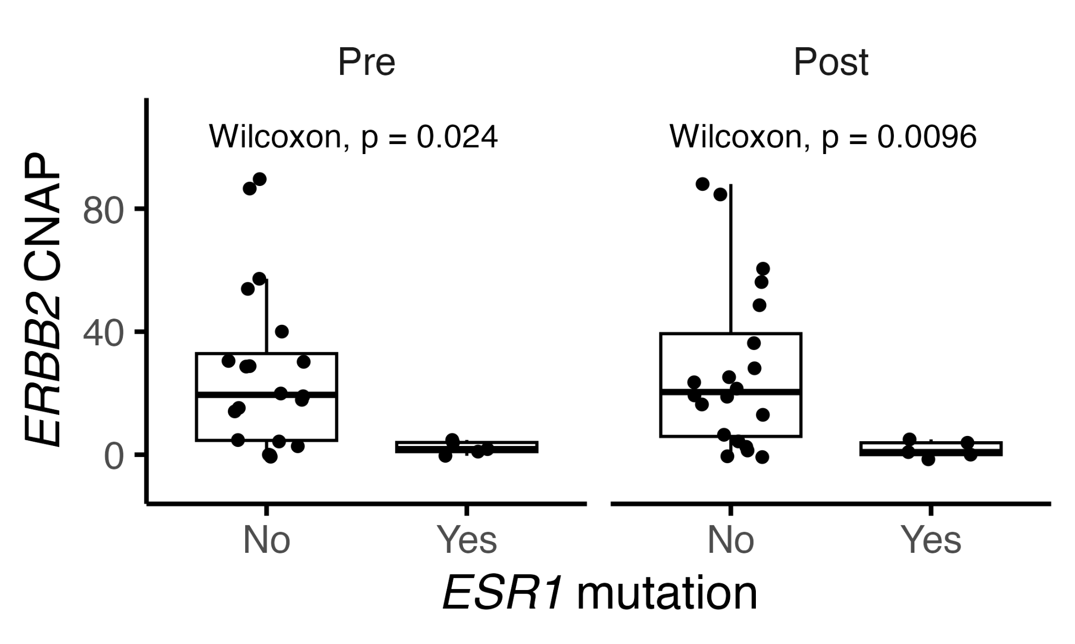
Supplementary Figure 4: Comparison of pathway alterations in the pre- and post-TKI cohorts between participants who did (n = 26) and did not (n = 59) ever develop brain metastases. A one-sided Boschloo’s test was used to assess statistical significance for each pathway of enrichment in mutations among participants who developed brain metastases.
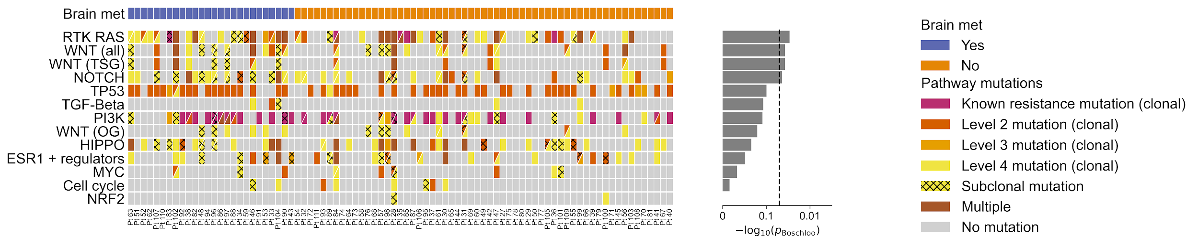
SUPPLEMENTAL METHODS

Classifying tumor subclones and their mutations as growing, shrinking, or stable

The PhylogicNDT CCF distributions were used to classify subclones as growing, shrinking, or stable. When comparing a distribution to a threshold, the 0.95 quantile of the CCF probability density was used. When comparing two CCF distributions, for instance a subclone’s pre-treatment and post-treatment CCFs, the distribution of their difference was estimated via Monte Carlo simulation with 10,000 samples. The 0.05 and 0.95 quantiles of the sampled distribution were used to determine if CCFs were at least 0.05 apart and if so, in what direction (with results being “greater than,” “less than,” or “no significant difference”).

Any subclone with CCF <0.1 in all biosamples or <0.05 in all post-treatment biosamples was excluded from further analysis of resistant mutations, given its persistent low CCF or apparent drug sensitivity, respectively. For all other subclones, growing/shrinking/stable status was calculated using the Monte Carlo sampling procedure described above, comparing between pre-treatment and post-treatment biosamples. That is, a subclone was classified as growing, shrinking, or stable if there was an increase, decrease, or no significant difference between its pre-treatment and post-treatment biosamples, respectively. Special attention was given to the trajectory between the final pre-treatment biosample and the first post-treatment biosample.
These trajectories cannot be used to explicitly denote treatment sensitivity/resistance, as a subclone with decreasing CCF may still be growing in volume/cell count. However, they may indicate subclones’ relative responses to treatment.

Annotating genes with copy number alteration (CNA) events

We used a previously defined method to annotate genes with copy number alterations.⁵⁰ Briefly, given a gene’s copy number and the tumor’s ploidy—both of which were estimated by ABSOLUTE, with copy number defined as rescaled.cn.a1 + rescaled.cn.a2—we calculated copy number above ploidy (CNAP) as the difference between copy number and the ploidy. Thus, a gene’s CNAP takes positive values when its copy number exceeds the tumor’s ABSOLUTE ploidy estimate (which need not be integer-valued). Gains and amplifications of genes were identified for each sample by simple thresholding criteria on CNAP:
- “Gain”: CNAP between 1.5 and 3.
- “Amplification”: CNAP between 3 and 6.
- “High amplification”: CNAP above 6.

Other events were defined by slightly more complex criteria:
- “Focal high amplification”: CNAP above 9; and the gene resides in a segment of the relative copy number profile containing 100 or fewer genes.
- “Deep deletion” (two-copy loss): Because of poor concordance of deep deletions called by ABSOLUTE between cfDNA samples and tissue samples—as observed previously —we called deep deletions at a participant level, considering evidence from all samples from a participant.⁵¹ In particular, we called deep deletions when ABSOLUTE detected a deep deletion for the gene in one or more tissue samples with tumor purity >=10%; or two or more cfDNA samples with tumor purity >=10%.
- “Biallelic inactivation”: ABSOLUTE detects loss-of-heterozygosity (LOH) for the gene, and a loss-of-function (LOF) mutation was called for the gene. The following mutations were considered LOF: those with a “Loss-of-function” or “Likely Loss-of-function” annotation in OncoKB, as well as those with a classification of Nonsense_Mutation, Nonstop_Mutation, Frame_Shift_Del, or Frame_Shift_Ins.

All results involving CNAs were based on these annotations.

For the CNAs shown in the figures, sample-level CNAs were aggregated at a participant level. When samples from a single participant had discrepant CNA calls for a particular gene, the following ordering (high to low priority) was used to determine which CNA to report at the participant level: “Deep deletion,” “Biallelic inactivation,” “Focal high amplification,” “High amplification,” “Amplification,” “Gain.” The figures exclude “Amplification” and “Gain” events.

For the quantitative ERBB2 CNAP analyses, for participants with multiple pre- and/or post-treatment samples, CNAP values were averaged to yield one pre-treatment and one post-treatment CNAP value.

Assigning evolutionary trajectories to CNA events

To classify the evolutionary trajectories of amplifications in the paired cohort, we compared pre-treatment to post-treatment CNAP values as described previously.⁵⁰ For participants with multiple pre- and/or post-treatment samples, CNAP values were averaged to yield one pre-treatment and one post-treatment CNAP value. Briefly, the following evolutionary classifications were used:
- “Shared”: the absolute value of the difference in CNAP from pre- to post-treatment, as a fraction of pre-treatment CNAP, is less than 0.5.
- “Acquired”: the difference in CNAP from pre- to post-treatment, as a fraction of pre-treatment CNAP, is greater than 0.5, and the pre-treatment CNAP does not correspond to a “Focal high amplification.”
- “Loss”: the difference in CNAP from pre- to post-treatment, as a fraction of pre-treatment CNAP, is less than -0.5, and the post-treatment CNAP does not correspond to a “Focal high amplification.”
- “Indeterminate”: all other cases.

For “Biallelic inactivation” CNAs, we assigned an evolutionary trajectory of “Shared” if at least one pre-treatment and one post-treatment sample contained a “Biallelic inactivation.” If the “Biallelic inactivation” was only present in post-treatment samples, we assigned an evolutionary trajectory of “Acquired.”

For “Deep deletion” CNAs, we were unable to assess evolutionary trajectories because of the aforementioned participant-level calling method. Therefore, we assigned all instances of “Deep deletion” an evolutionary trajectory of “Indeterminate.”

Mutational signature methodology details

We inferred mutational signatures de novo for our cohort by running SignatureAnalyzer on their tumor clones. In other words, we relied on PhylogicNDT to assign mutations to tumor clones, and used the clones as independent samples in SignatureAnalyzer (rather than full tumors). Our rationale for doing this was twofold: (i) it increased the effective number of samples used by ARD-NMF, increasing reliability; and (ii) it allowed ARD-NMF to model the cohort’s mutational heterogeneity in a more fine-grained manner than, e.g., fitting on the spectra from full tumors. Note that this population of clones includes both truncal clones and subclones.

SignatureAnalyzer inferred four mutational signatures from our full cohort. Three signatures were unsurprising, aligning with canonical COSMIC3 signatures for clock-like (SBS1; cosine similarity=0.86), Capecitabine (SBS17b; cosine similarity=0.94), and APOBEC-related (SBS2; cosine similarity=0.71) mutations.⁴⁸ The fourth signature was more ambiguous, matching COSMIC3 signatures for sequencing artifact (SBS54) and mismatch repair deficiency (MMRd) (SBS26) equally well (cosine similarity=0.86). However, additional validation (see below) gave evidence that it was in fact MMRd-related.

We projected participants onto the clone-level signatures by running SignatureAnalyzer on the participants’ mutational spectra, holding the signatures fixed. This yielded a summary of each participant’s mutations in terms of the signatures detected in the tumor clones.

It’s important to note that our independent validations of the fourth signature (see below) showed that only one participant from the unpaired post-TKI subcohort had evidence of MMRd. Hence, for all other participants we constrained the contribution from the fourth signature to be zero during the projection step. This prevented the fourth signature from receiving spurious credit for mutations in other participants.

Mutational signature validation

Additional validations gave evidence that the fourth signature indicated MMRd. Importantly, only one participant from the full cohort had a large contribution from this signature (see figure). We refer to them as participant 104, using their anonymized identifier. Participant 104 belonged to the unpaired post-TKI subcohort, and therefore does not appear in the main text’s discussion of results from the paired subcohort.

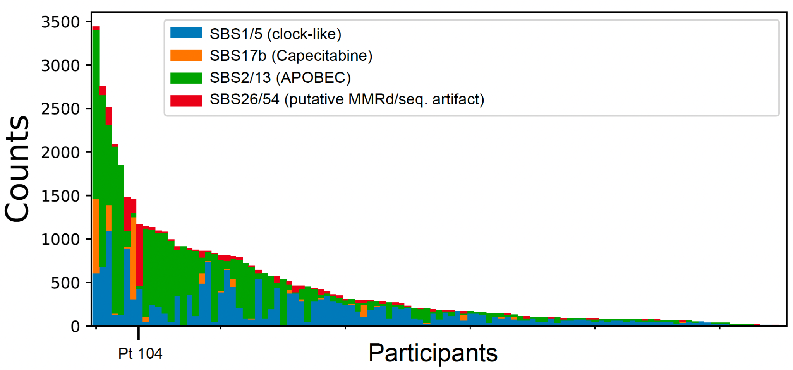

We used MSIDetect (manuscript in preparation) to examine our samples for microsatellite instability (MSI). MSIDetect is a computational tool that infers the presence of MSI from ULP-WGS data. For each sample, MSIDetect computes a score based on the likelihood of MSI, given ULP-WGS reads mapped to predefined loci of the genome. Higher scores imply a higher likelihood of MSI affecting that sample–though tumor purity also needs to be accounted for. Our motive for using MSIDetect was to find evidence of MMRd independent of the mutational signature analysis. The presence of MSI in a sample, inferred from ULP-WGS, would strongly suggest MMRd in that sample.

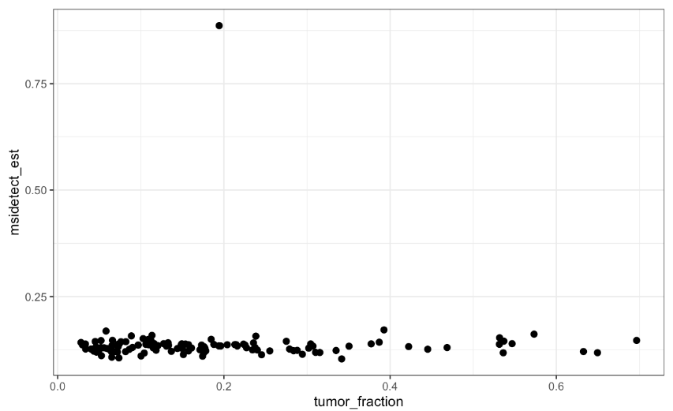
We found that MSIDetect assigned very similar scores to all tumor samples with the exception of participant 104, which scored much higher than all others. This outlier status remained after adjusting for tumor purity in the samples (see figure). This constitutes evidence of (i) MSI highly specific to participant 104; and (ii) corresponding MMRd in participant 104, consistent with our MMRd interpretation for the fourth mutational signature.

