Supplementary Information

Comparison between DBS-ON and DBS-OFF models
Fig. S1 illustrates the changes in mean firing rate and connectivity intensity in the DBS-OFF group compared to the DBS-ON group. Interactions (excitatory and inhibitory) within the cortical region were significantly enhanced, which also resulted to decreased excitatory connectivity in the cortico-STN as a 38.98% reduction in the PY-STN. Note that the excitability effect of STN on the pallidum changes weakly, which may be caused by the large decrease in both the excitatory and inhibitory effects of STN.
We compared the connection strength before and after the DBS switch by a paired-samples t-test for independent samples , and the results are presented in Table S1. It can be found that the synaptic connection strength showed no significant change with a significance level ɑ = 0.05 in the synaptic connection strength between each nucleus before and after DBS programming, with the most significant change in PY-STN connection . In addition, GPe-STN has a small within-group standard deviation and high confidence.
The firing rate of neurons also changed with the DBS. To calculate the resting-state mean firing rate for a region, the number of spikes occurring in the respective population was divided by time and population size. Fig. S1 shows that the mean firing rate of the STN decreased significantly (-33.95%), influenced by changes in the strength of synaptic connections (greater attenuation of excitatory stimuli). The inhibitory stimulation of PY was significantly higher than the excitatory stimulation (25.2%> 0.3%), so the mean firing rate of PY was significantly reduced to -18.40%. We compared the mean firing rates before and after the DBS switch by a paired-samples t-test for independent samples, with a significance level of ɑ = 0.05, and the results are presented in Table S2. Similar to the test results of synaptic connection strength, it is found that there was no significant change in the mean firing rate in the table. However, the mean firing rate of PY and thalamus is more prominent than other nuclei due to the large individual data.

Fig. S1: The relative changes in mean firing rate and connectivity intensity between the DBS-OFF and DBS-ON groups.
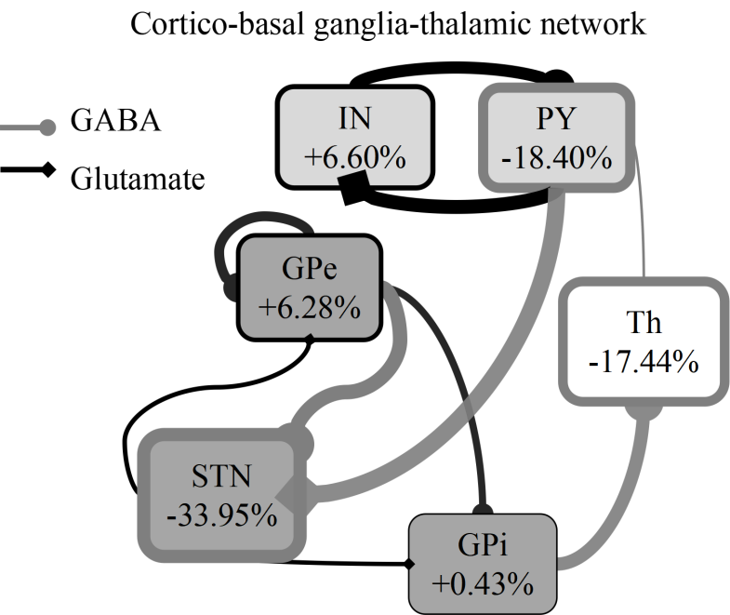

The thickness of the arrow reflects the degree of change in synaptic connection, and the thickness of the rectangular border indicates the change of the average firing rate of each nucleus after DBS is turned on. The greater the thickness, the more pronounced the degree of change. Black indicates enlargement, while gray signifies weakening.
Comparison between HC and DBS-OFF models
To further understand how STN-DBS affects functional connectivity in PD patients by correcting synaptic connection strength and how the correction works, we obtained the changes in connectivity strength associated with PD symptoms by comparing group differences between PD and HC. The Pearson correlation coefficient of each brain interval was calculated using fMRI data in the DBS-OFF state to form a connectivity matrix, from which the average parameter results obtained were fit as within-group data in the PD state. The mean firing rate of PD relative to HC versus synaptic connectivity strength changes is plotted in Fig. S2. Additionally, we compared the strength of synaptic connectivity (Table S6) and mean firing rates between patients and controls by an independent-samples t-test (Table S7) of each region, with a significance level of ɑ = 0.05.

Fig. S2: The relative changes in mean firing rate and connectivity intensity between the DBS-OFF and HC groups.
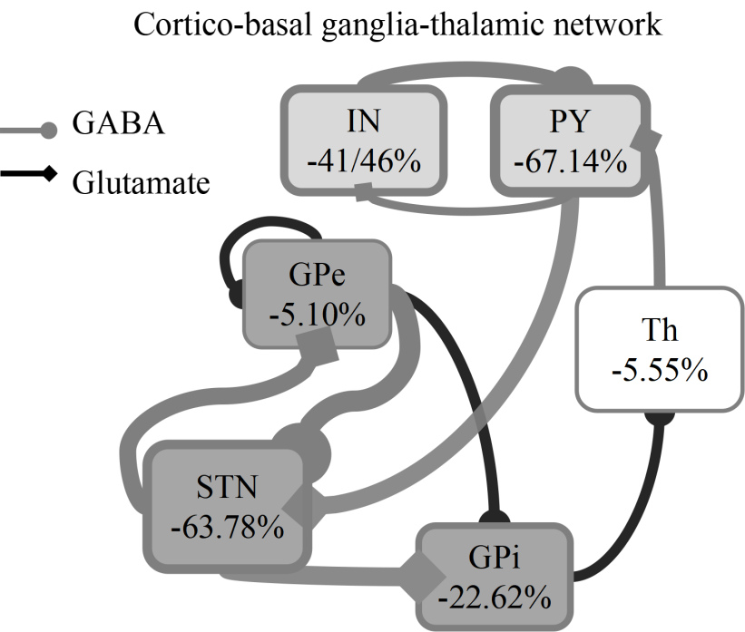
The thickness of the arrow reflects the degree of change in synaptic connection, and the thickness of the rectangular border indicates the change of the average firing rate of each nucleus after DBS is turned on. The greater the thickness, the more pronounced the degree of change. Black indicates enlargement, while gray signifies weakening.

Observing the data of synaptic connection strength in Table S6, we can find that the inhibitory stimulation in the pallidal region of the PD group increased by more than ten percent in comparison to the HC group, while the connection strength in the other areas of the PD group decreased. In expand, the data presents the following characteristics:
- Interactions (excitatory and inhibitory) all decreased within the cortical region, with a significant decrease in inhibitory effects (-33.43%).
- The synaptic connections decreased in both STN received and output. The significant reduction in inhibitory stimulation (68.71%>46.85%) from GPe to STN resulted in a diminished excitatory effect of STN output to the pallidum and a significant decrease in the mean STN firing rate (-63.68%).
- GPi exhibited enhanced internuclear inhibitory effects on Th, which in turn led to decreased excitatory effects of Th on PY.
- The inhibitory effects within GPe, GPe-to-GPi, and GPi output pathways all increased, echoing the study that different pallidum pathways regulate behavioral abnormalities in different stages of PD.
- The mean firing rate of each nuclear in the PD group was lower than that in the HC group.
Table S6 and 7 revealed the following features:
- The synaptic connection strengths of g_{GPe-STN}, g_{PY-STN}, g_{Th-PY}, g_{STN-GPi}, and g_{STN-GPe} varied significantly between the groups, suggesting that the changes in the STN-related response led to the manifestation of PD symptoms.
- There were significant group differences in mean firing rates of STN, GPi and PY.
- Due to the large individual values of PY, the standard deviation is quite different from the other nuclear group data.

Table S1 The mean connection strengths
Connection | Mon | SDon | Moff | SDoff | t | df | P-value | sd
g_{Gpe-GPi} | 1.35 | 0.69 | 1.27 | 0.64 | -0.397 | 26 | 0.69 | 0.97
g_{GPe-GPe} | 1.26 | 0.71 | 1.08 | 0.64 | -1.047 | 26 | 0.30 | 0.86
g_{GPe-STN} | 0.1 | 0.2 | 0.14 | 0.33 | 0.806 | 26 | 0.43 | 0.29
g_{PY-STN} | 0.36 | 0.45 | 0.6 | 0.62 | 2.075 | 26 | 0.048* | 0.58
g_{PY-IN} | 0.43 | 0.52 | 0.33 | 0.58 | -0.623 | 26 | 0.54 | 0.83
g_{Th-PY} | 3.77 | 1.44 | 3.79 | 1.38 | 0.027 | 26 | 0.98 | 2.19
g_{STN-GPi} | 0.72 | 0.74 | 0.72 | 0.64 | -0.029 | 26 | 0.98 | 0.93
g_{STN-GPe} | 0.49 | 0.65 | 0.49 | 0.59 | -0.041 | 26 | 0.97 | 0.61
g_{GPi-Th} | 0.71 | 0.71 | 0.95 | 0.65 | 1.349 | 26 | 0.19 | 0.91
g_{IN-PY} | 0.46 | 0.63 | 0.37 | 0.59 | -0.502 | 26 | 0.62 | 0.96
Mon/SDon are the means/standard deviations of the connection strengths of all models of the DBS-ON group. Moff/SDoff are the means/standard deviations of the connection strengths of all models of the DBS-OFF group. A paired-samples t-test for independent samples was made to compare these two samples. * represents the significance levels of 5%.

Table S2 The mean resting firing rates
Rate | Mon | SDon | Moff | SDoff | t | df | P-value | sd
STN | 10.95 | 11.07 | 16.57 | 17.18 | 1.418 | 26 | 0.17 | 20.61
GPi | 91.81 | 11.09 | 91.42 | 13.68 | -0.166 | 26 | 0.87 | 12.22
GPe | 99.37 | 33.56 | 93.49 | 31.51 | -0.953 | 26 | 0.35 | 32.01
PY | 215.79 | 118.87 | 264.44 | 146.91 | 1.1 | 26 | 0.28 | 229.77
Th | 102.15 | 79.08 | 123.73 | 73.04 | 1.257 | 26 | 0.22 | 89.23
IN | 33.92 | 33.51 | 31.82 | 41.55 | -0.183 | 26 | 0.86 | 59.65
Mon/SDon are the means/standard deviations of the connection strengths of all models of the DBS-ON group. Moff/SDoff are the means/standard deviations of the connection strengths of all models of the DBS-OFF group. A paired-samples t-test for independent samples was made to compare these two samples.

Table S3 Spearman’s correlation between PD symptoms and connectivity strength parameters
Symptoms | relevant parameter | relativity | P-value
Rigidity-Neck | g_{GPi-Th} | +0.376 | 0.0051**
Rigidity-RUE | g_{Th-PY} | +0.321 | 0.018*
Rigidity-LUE | g_{Th-PY} | +0.273 | 0.046*
Finger tapping-Left hand | g_{IN-PY} | -0.309 | 0.023*
Hand movements-Right hand | g_{PY-STN} | +0.278 | 0.042*
Leg agility-Right leg
 | g_{PY-IN} | -0.327 | 0.016*
 | g_{STN-GPi} | -0.272 | 0.046*
 | g_{STN-GPe} | -0.307 | 0.024*
Leg agility-Left leg
 | g_{PY-IN} | -0.408 | 0.002**
 | g_{IN-PY} | -0.291 | 0.033*
** and * represent the significance levels of 1% and 5%, respectively.

Table S4 Spearman’s correlation between parameter change value and symptom improvement rate
Symptoms | relevant parameter | relativity | P-value
Rigidity-Neck | g_{Gpe-GPi} | +0.429 | 0.026*
Rigidity-RUE | g_{Th-PY} | -0.440 | 0.022*
Rigidity-RLE | g_{STN-GPi} | +0.398 | 0.040*
Finger tapping-Right hand | g_{GPe-STN} | -0.419 | 0.029*
Finger tapping-Left hand | g_{PY-STN} | -0.384 | 0.048*
Hand movements-Left hand | g_{GPe-STN} | -0.410 | 0.034*
Pronation- supination movements-Right hand | g_{GPe-STN} | -0.473 | 0.013*
Global spontaneity of movement | g_{GPe-STN} | -0.419 | 0.03*
*P < 0.05.

Table S5 Paired-sample t-test result between DBS-ON and DBS-OFF state
Symptoms | relevant parameter | P-value
Rigidity-Neck
 | g_{Gpe-GPi} | 0.035*
 | g_{GPe-GPe} | 0.019*
Rigidity-LUE | g_{PY-STN} | 0.046*
Finger tapping-Left hand
 | g_{GPe-GPe} | 0.036*
 | g_{PY-STN} | 0.016*
Hand movements-Right hand
 | g_{GPe-GPe} | 0.015*
 | g_{PY-STN} | 0.0027**
Hand movements-Left hand | g_{PY-STN} | 0.020*
Pronation-supination movements-Right hand | g_{PY-STN} | 0.038*
Toe tapping-Left foot | g_{PY-STN} | 0.039*
Global spontaneity of movement | g_{PY-STN} | 0.0036**
DBS-ON=patients with Parkinson’s disease with the deep brain stimulation switched on; DBS-OFF=patients with Parkinson’s disease with the deep brain stimulation switched off.
** and * represent the significance levels of 1% and 5%, respectively.

Table S6 The mean connection strengths
Connection | Mc | SDc | Moff | SDoff | t | df | P-value | sd
g_{Gpe-GPi} | 1.08 | 0.76 | 1.27 | 0.64 | 1.13 | 52 | 0.868 | 0.72
g_{GPe-GPe} | 0.95 | 0.59 | 1.08 | 0.64 | 0.60 | 52 | 0.726 | 0.62
g_{GPe-STN} | 0.46 | 0.51 | 0.14 | 0.33 | -2.86 | 52 | 0.003** | 0.44
g_{PY-STN} | 1.12 | 0.94 | 0.6 | 0.62 | -2.70 | 52 | 0.005** | 0.82
g_{PY-IN} | 0.34 | 0.54 | 0.33 | 0.58 | 0.03 | 52 | 0.511 | 0.57
g_{Th-PY} | 4.82 | 1.88 | 3.79 | 1.38 | -2.39 | 52 | 0.010* | 1.73
g_{STN-GPi} | 1.45 | 0.75 | 0.72 | 0.64 | -3.42 | 52 | 0.001** | 0.71
g_{STN-GPe} | 0.85 | 0.60 | 0.49 | 0.59 | -1.87 | 52 | 0.034* | 0.59
g_{GPi-Th} | 0.82 | 0.42 | 0.95 | 0.65 | 1.13 | 52 | 0.869 | 0.55
g_{IN-PY} | 0.55 | 0.58 | 0.37 | 0.59 | -1.22 | 52 | 0.115 | 0.61
Mc/SDc represent the means/standard deviations of the connection strengths of all models of the HC group. Moff/SDoff are the means/standard deviations of the connection strengths of all models of the DBS-OFF group. An independent-samples t-test was conducted to compare these two samples. ** and * represent the significance levels of 1% and 5%, respectively.

Table S7 The mean resting firing rates
Rate | Mc | SDc | Moff | SDoff | t | df | P-value | sd
STN | 45.76 | 48.49 | 45.76 | 48.49 | -3.18 | 52 | 0.0012** | 37.94
GPi | 118.15 | 34.15 | 118.15 | 34.15 | -3.82 | 52 | 0.0002*** | 27.36
GPe | 98.52 | 27.24 | 98.52 | 27.24 | -0.74 | 52 | 0.2299 | 30.17
PY | 804.83 | 945.40 | 804.83 | 945.40 | -3.06 | 52 | 0.0018** | 715.18
Th | 131.00 | 47.44 | 131.00 | 47.44 | -0.17 | 52 | 0.4314 | 60.91
IN | 54.35 | 62.64 | 54.35 | 62.64 | -1.55 | 52 | 0.0637 | 55.41
Mc/SDc represent the means/standard deviations of resting firing rates of all models of the HC group. Moff/SDoff are the means/standard deviations of resting firing rates of all models of the DBS-OFF group. An independent-samples t-test was conducted to compare these two samples. ***, ** and * represent the significance levels of 0.1%, 1% and 5%, respectively.

Fig. S3 The spearman’s correlation analysis of synaptic connection strength value and symptom scale score. p indicates the significance. ** and * represent the significance levels of 1% and 5%, respectively.
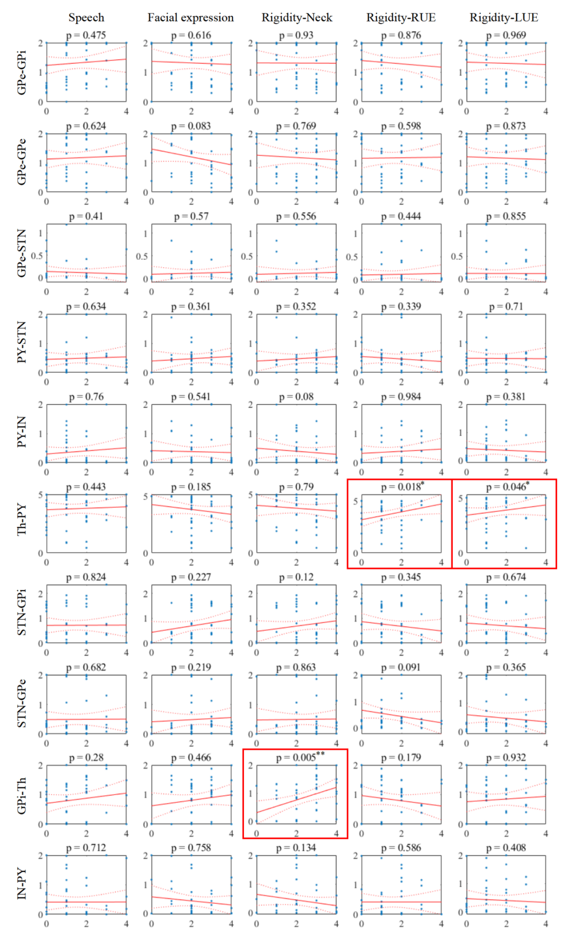
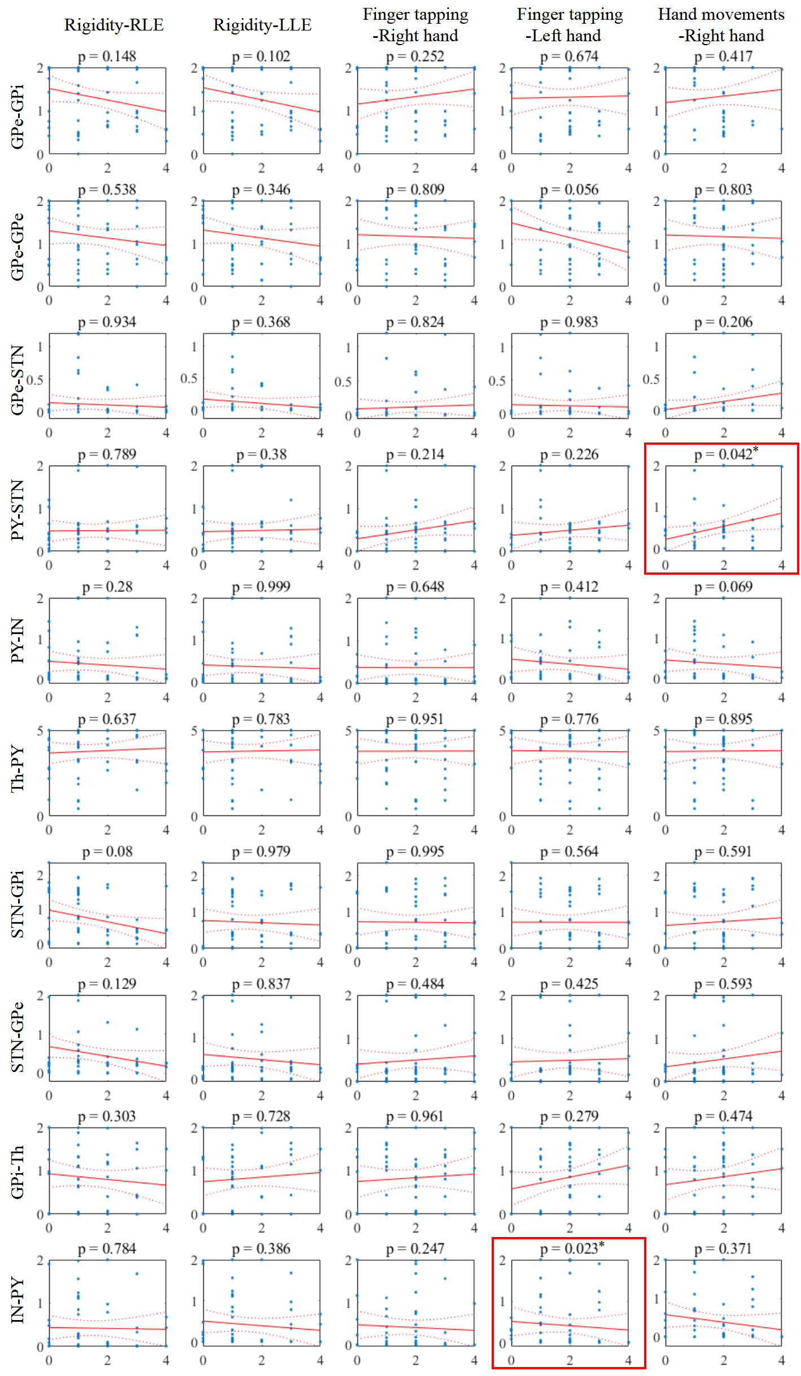
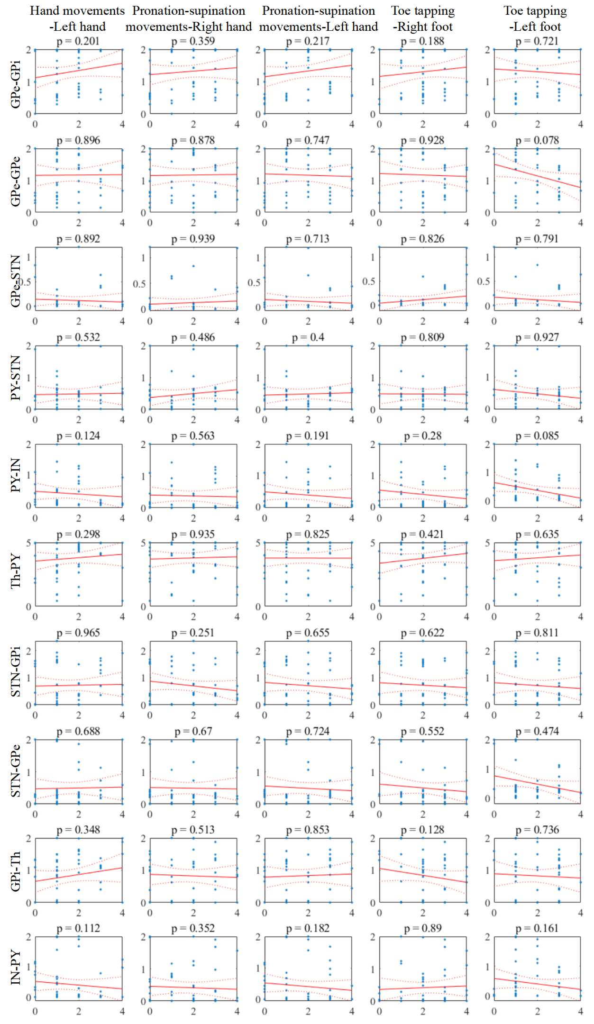
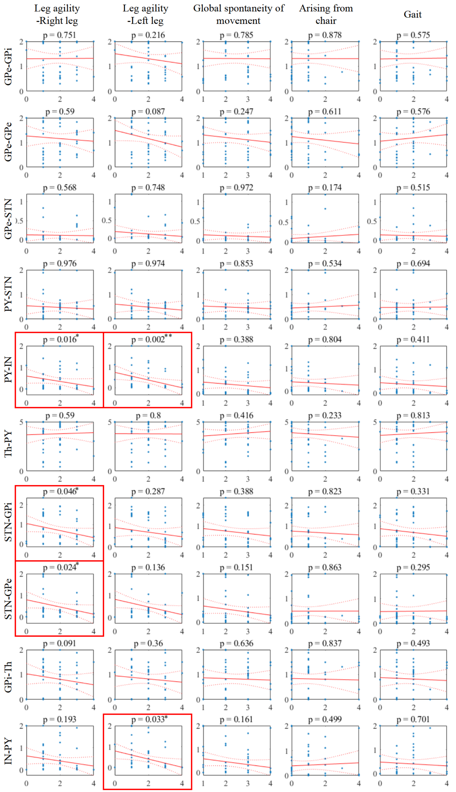
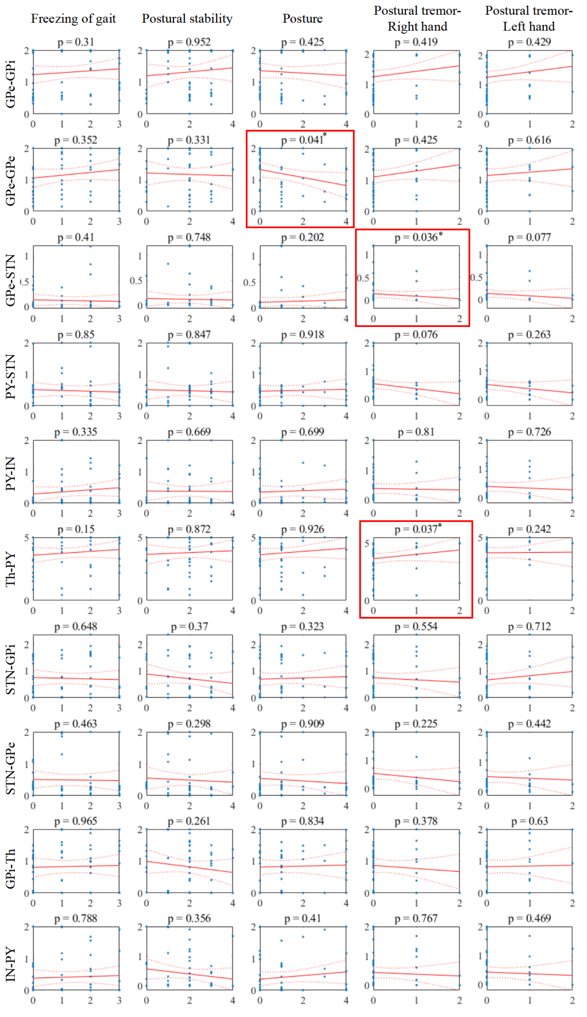
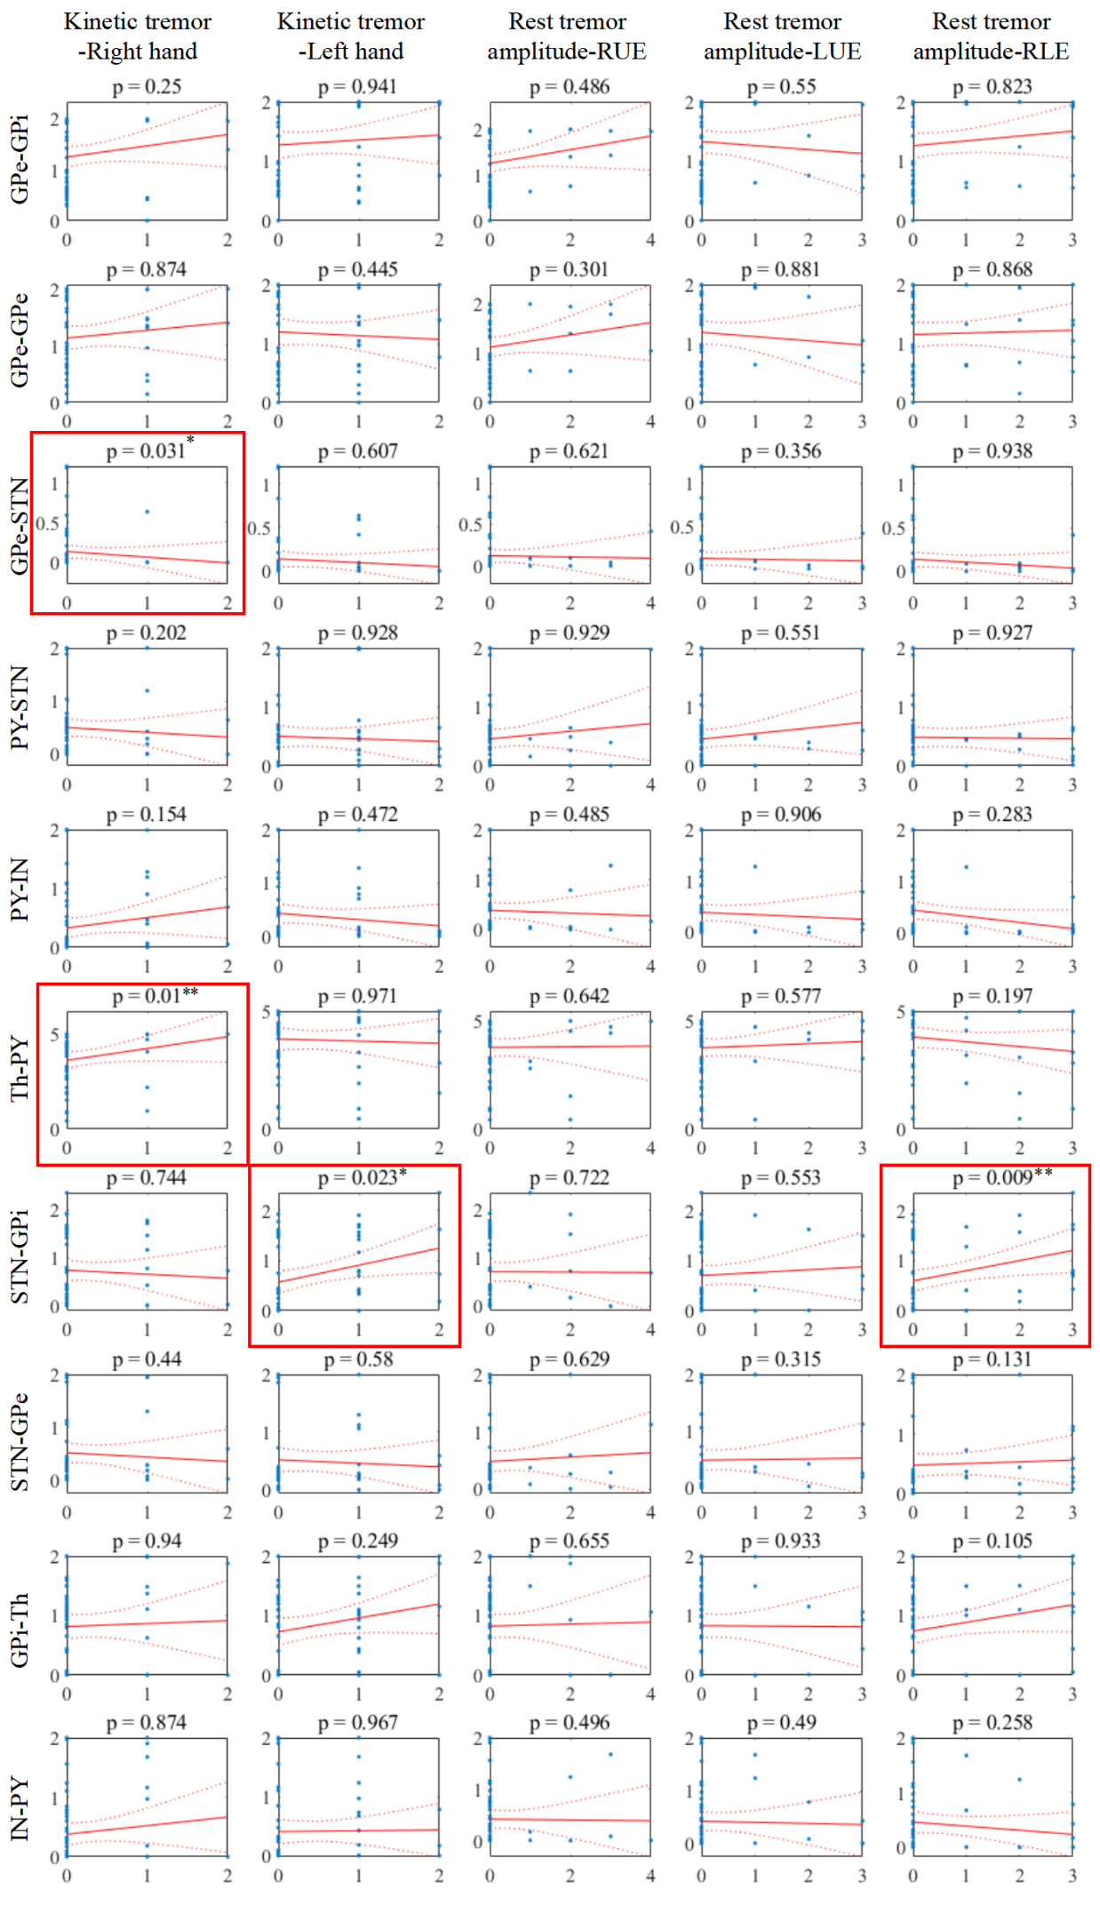
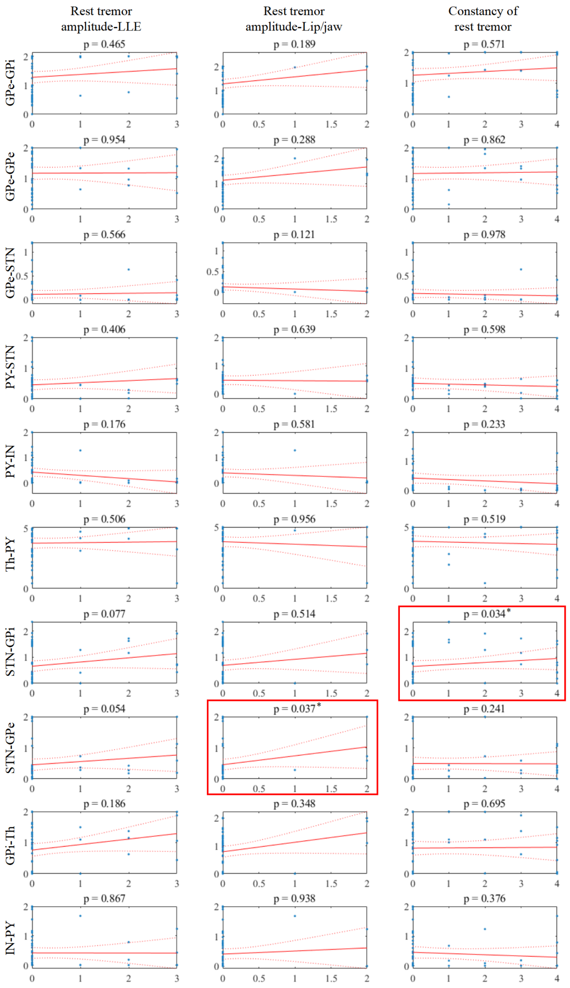
Fig. S4 The spearman’s correlation analysis of synaptic connection strength change value and rate of symptom improvement. R represents the correlation coefficient, and P indicates the significance. ***, ** and * represent the significance levels of 0.1%, 1% and 5%, respectively.
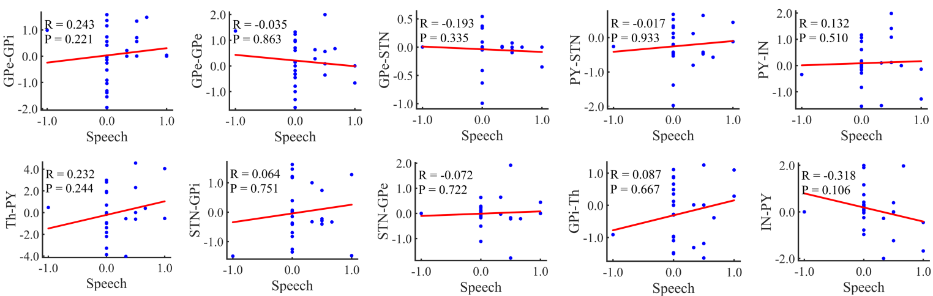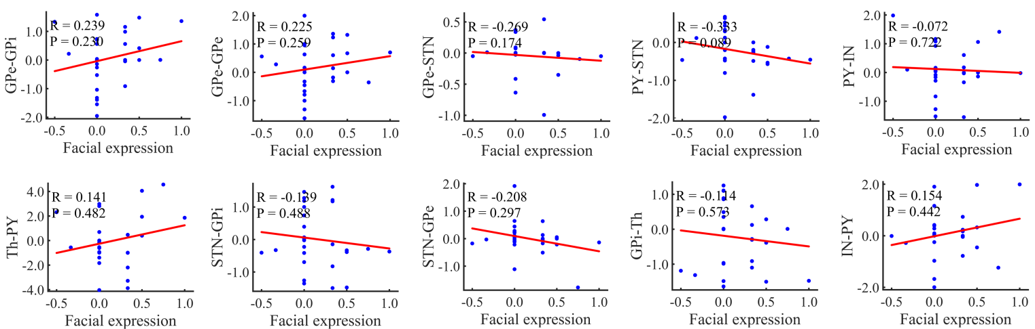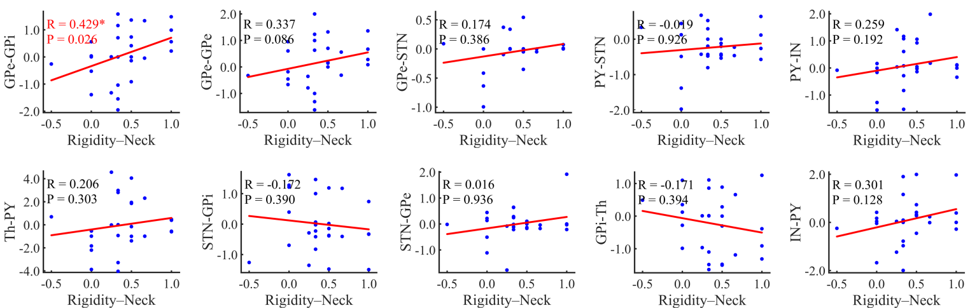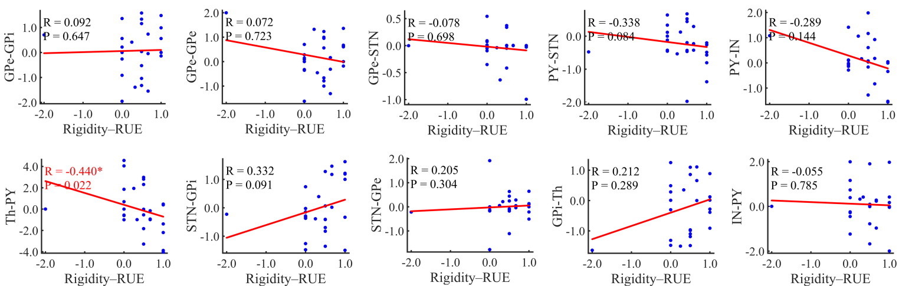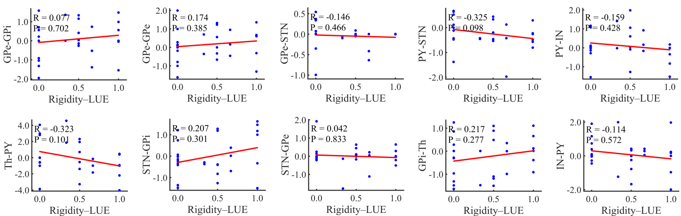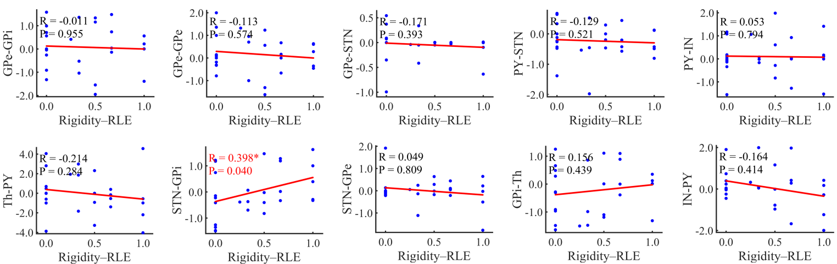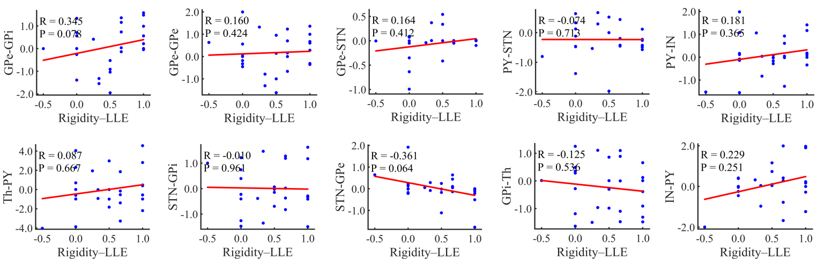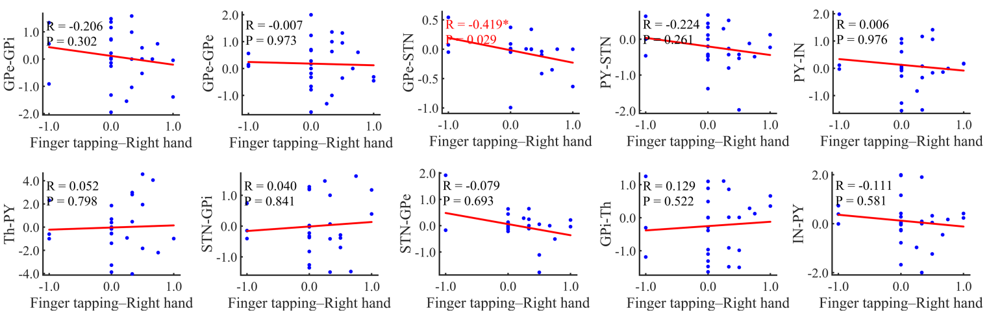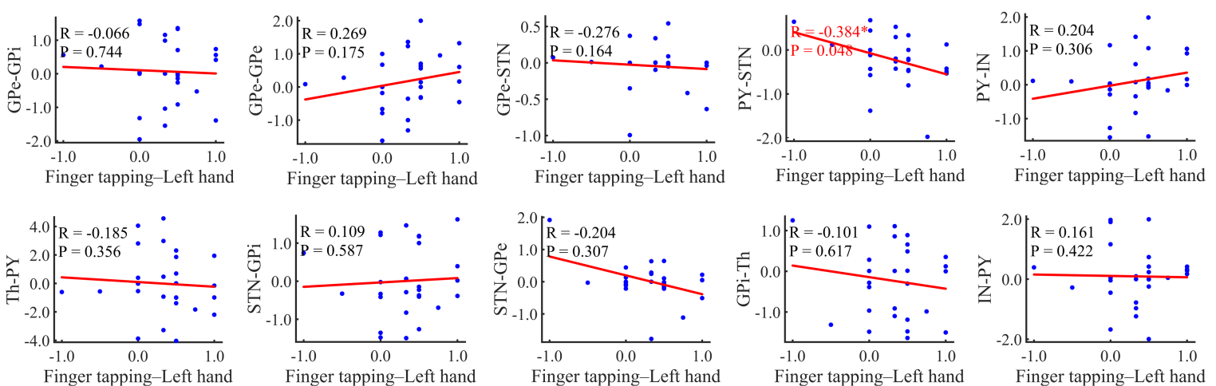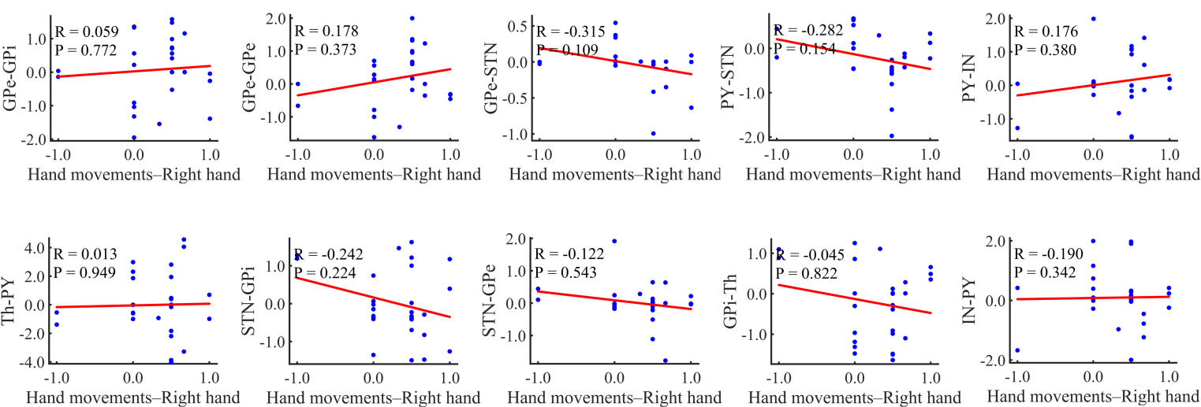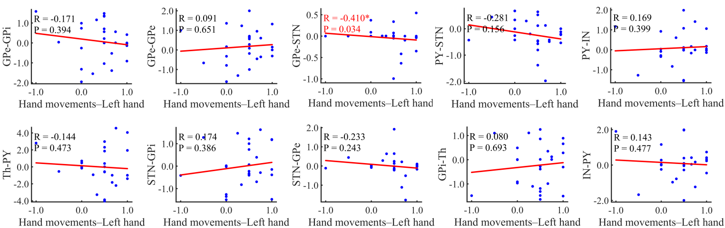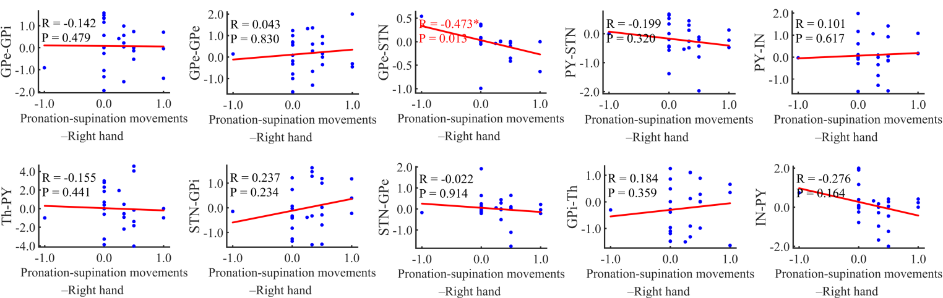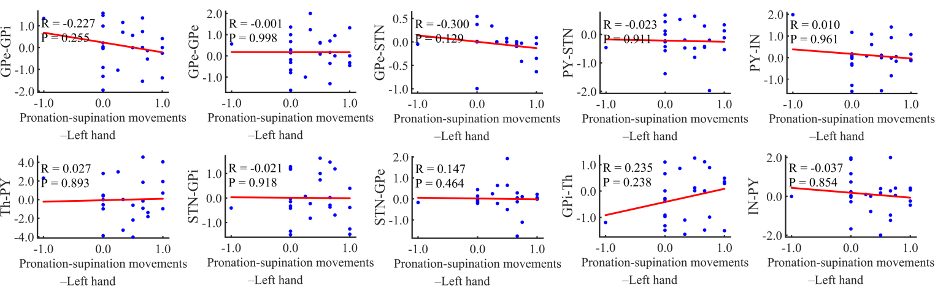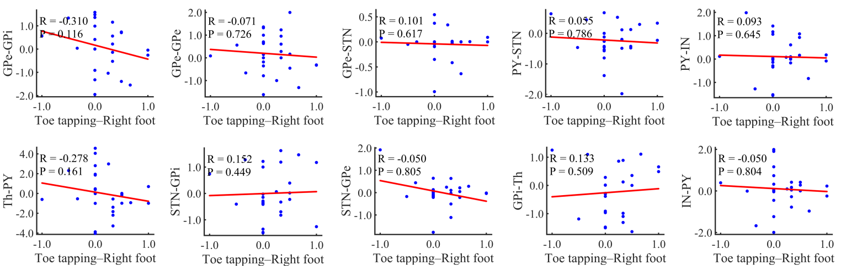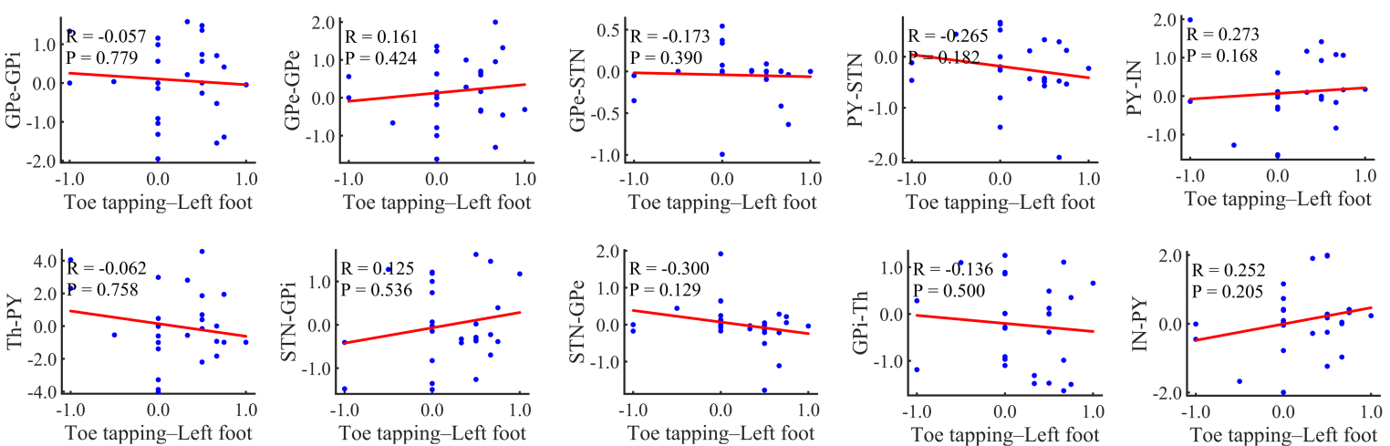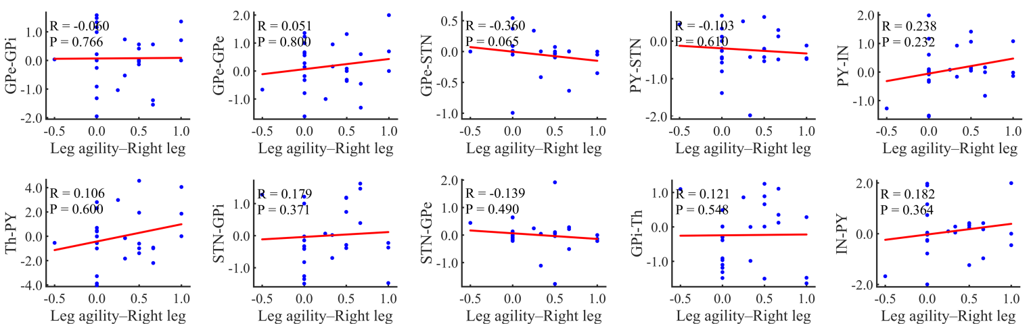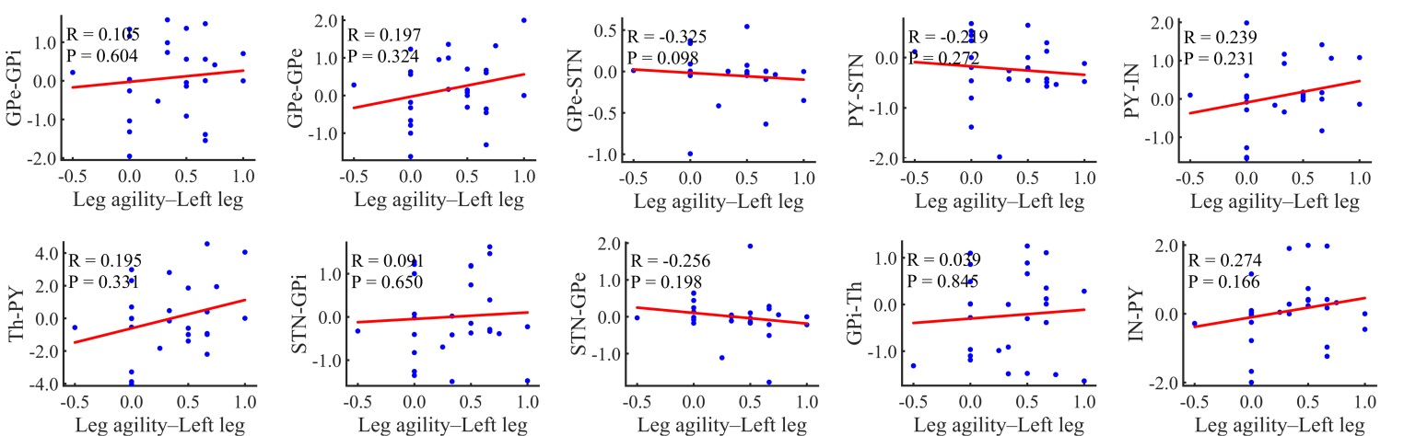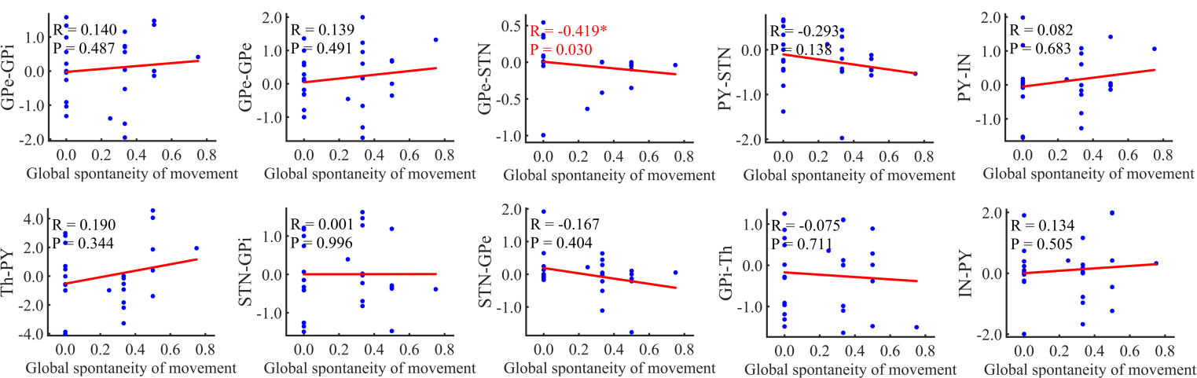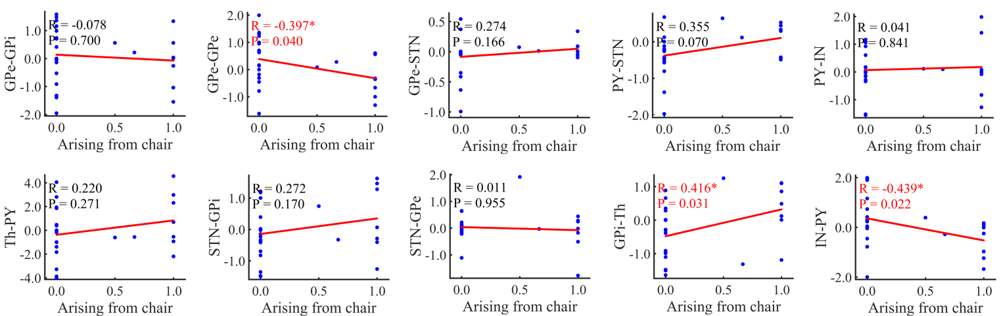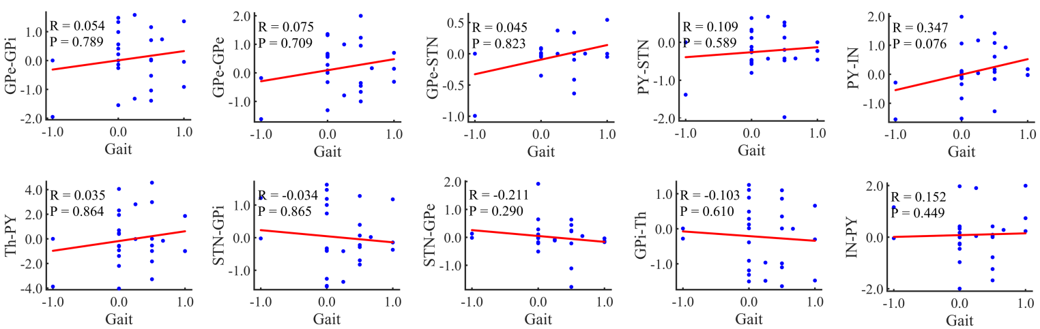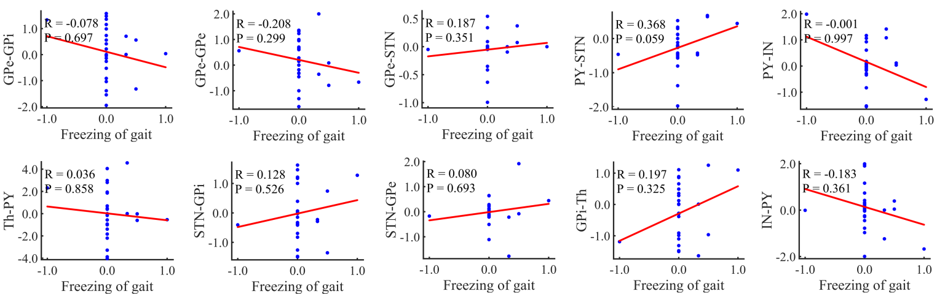
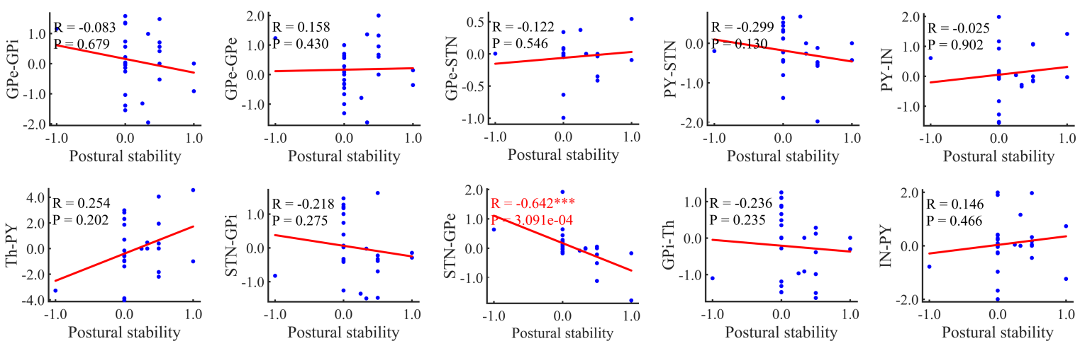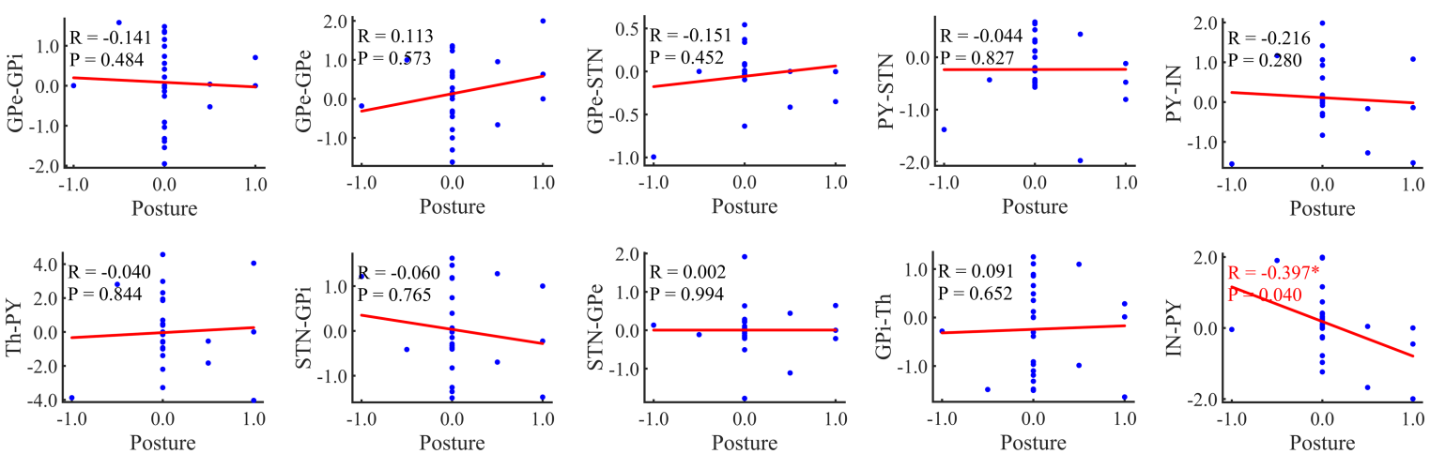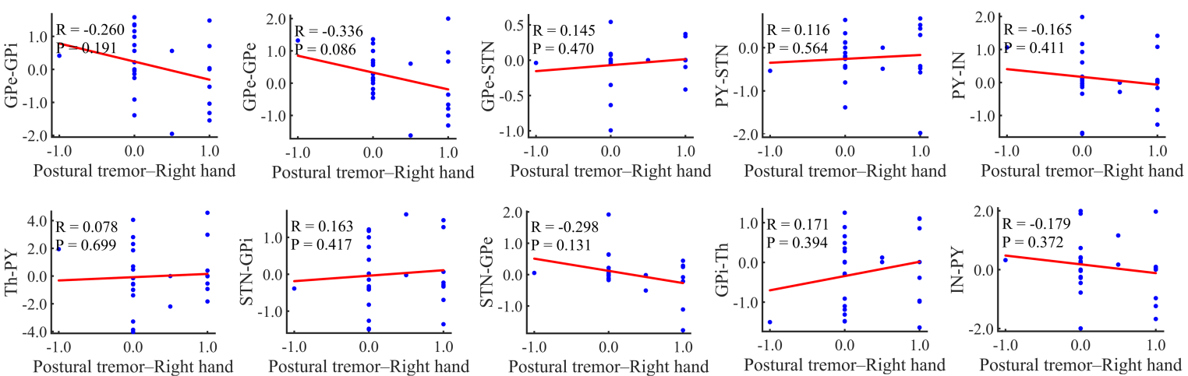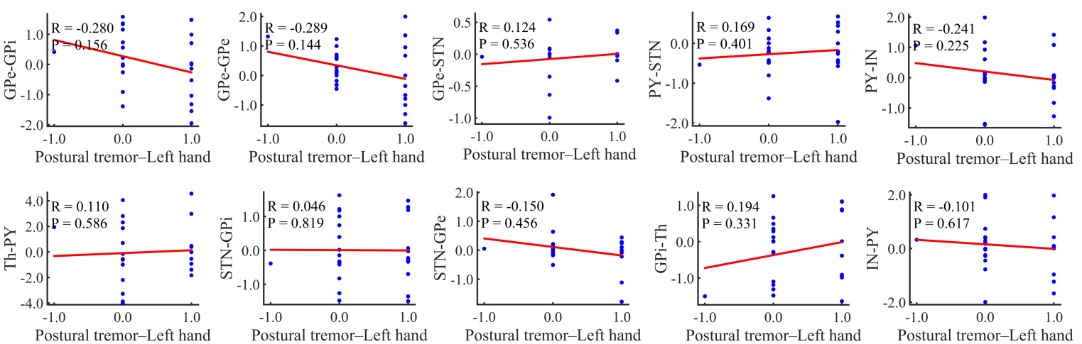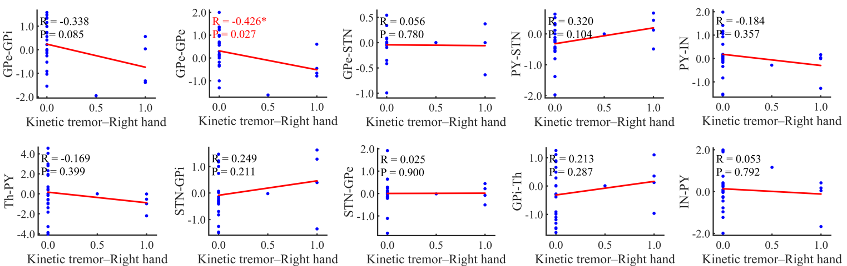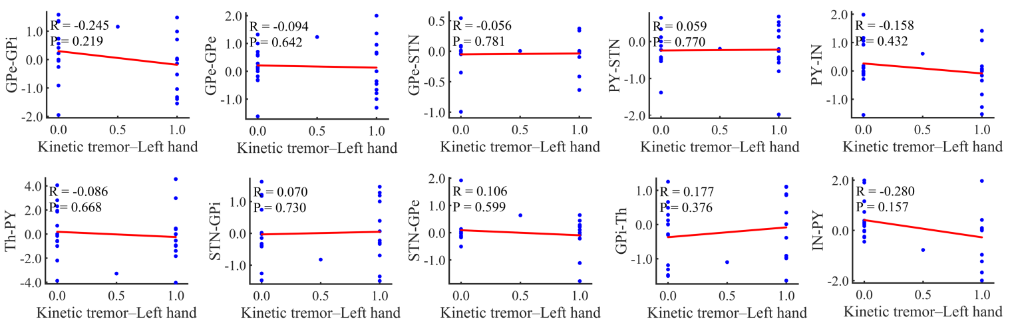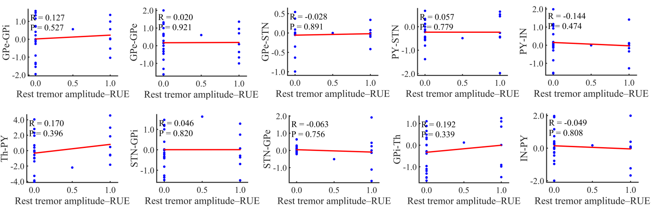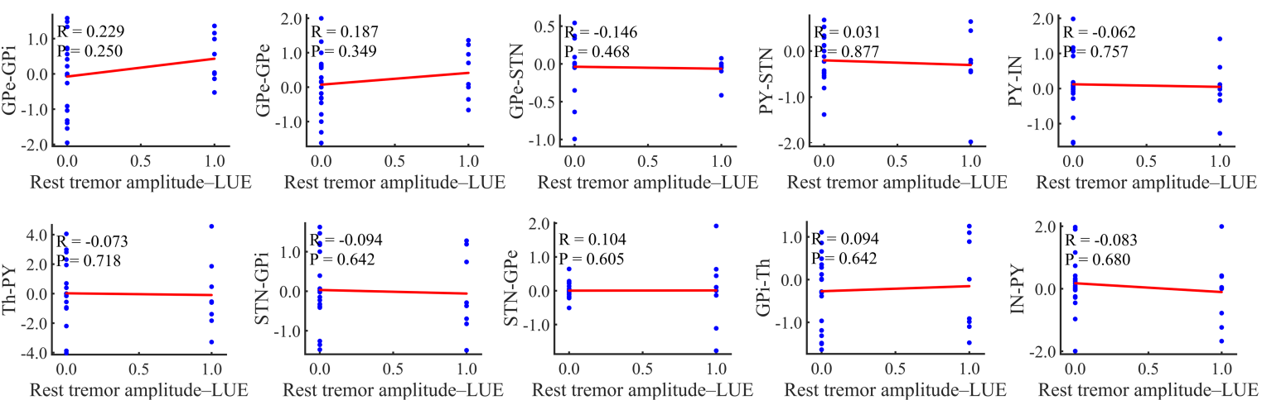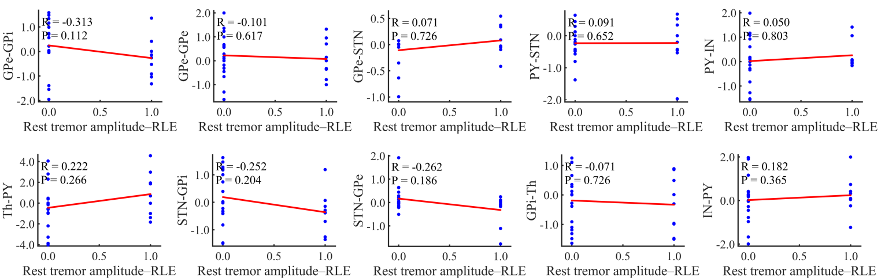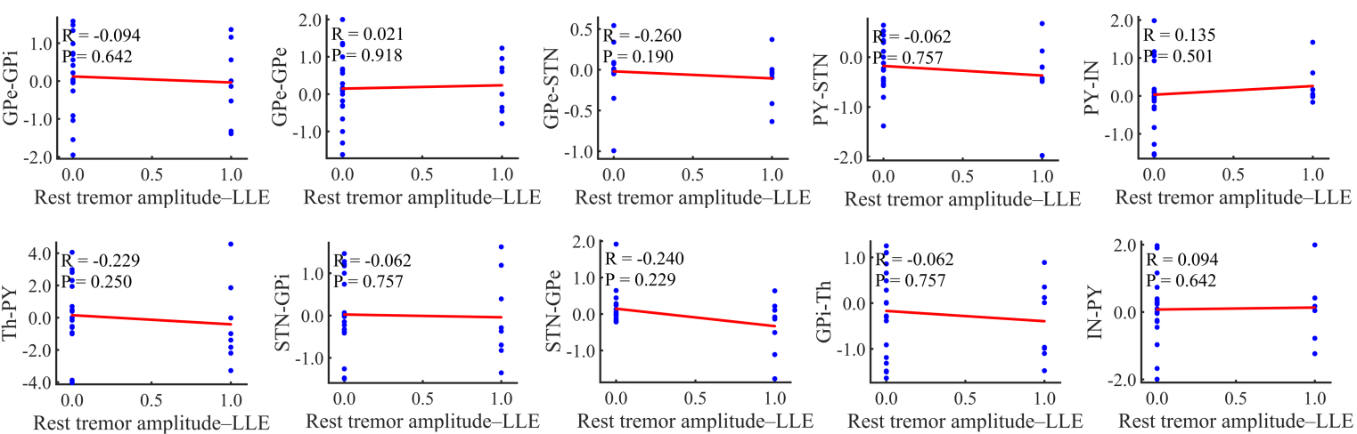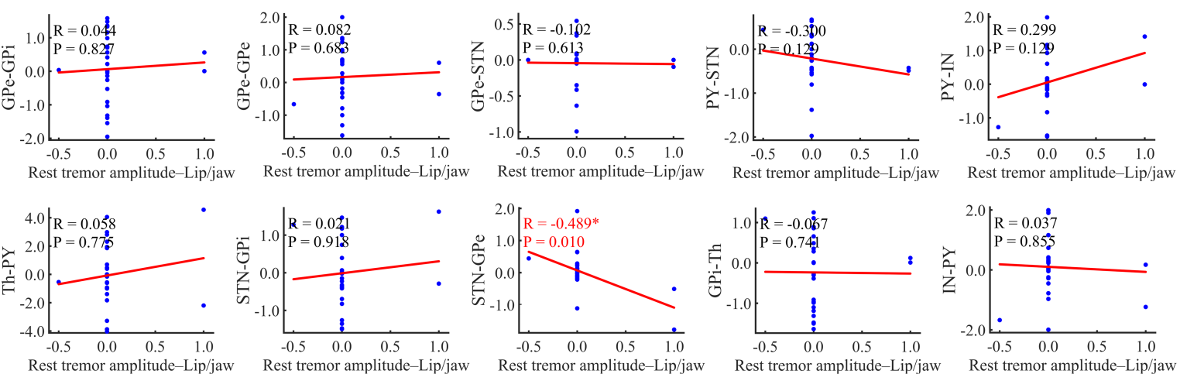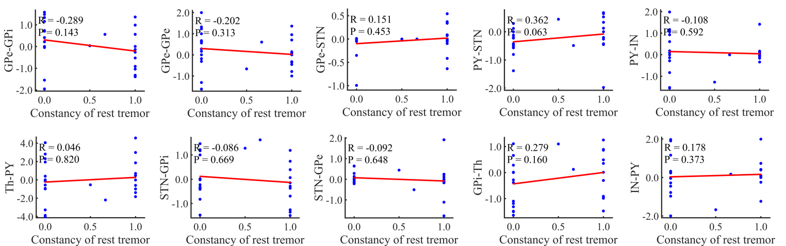

Fig. S5 Paired sample t-test for STN-DBS switch state about synaptic connection strength under different symptoms.
