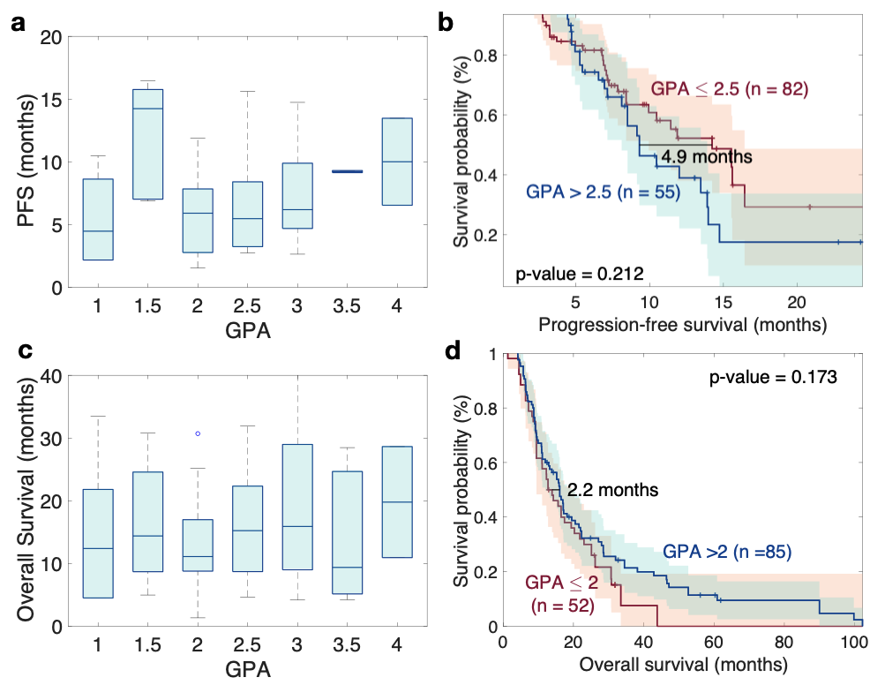
Figure S1. Box plots and Kaplan-Meier curves per-lesion illustrating the relationship between the Graded Prognostic Assessment (GPA) and its association with a-b. progression-free survival (PFS) and c-d. overall survival (n=137).

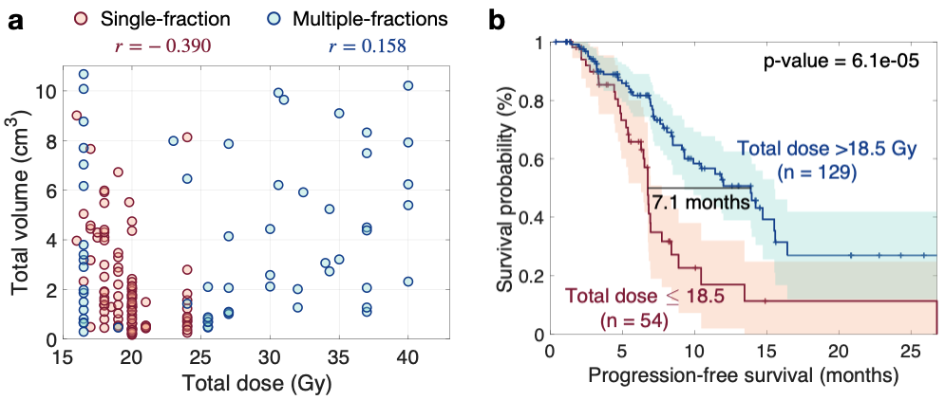
Figure S2. a. Scattering plot for the total volume and the total received dose in both the case of single fraction and multiple fraction radiation therapies. 𝑟-values correspond to the Spearman correlation coefficient. b. Kaplan-Meier curve per-lesion for comparing BMs according to the total received dose.

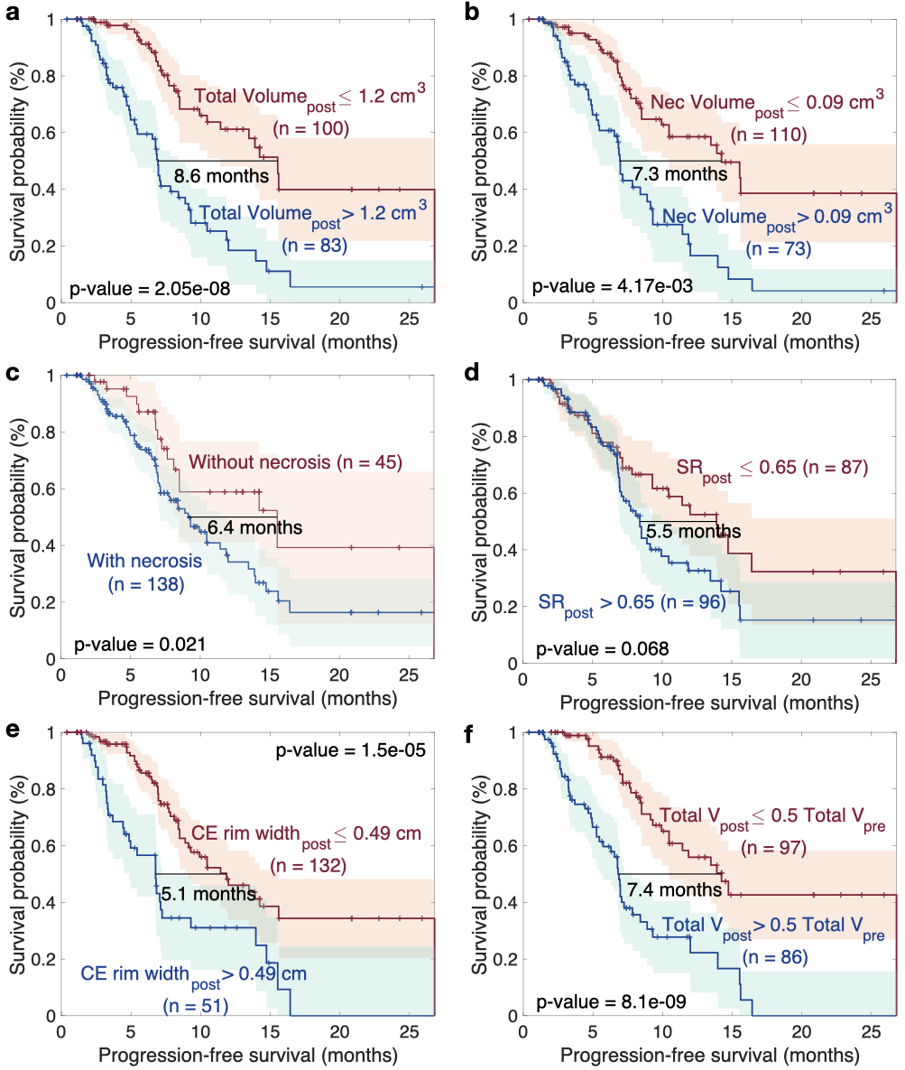
Figure S3. Kaplan-Meier curves per-lesion for biomarkers measured in the first follow-up after treatment, around three months post-treatment. a. Total volume. b. Necrotic volume. c. Presence of absence of necrosis. d. Surface regularity (SR). e. CE rim width and f. The variations in volume with treatment (Total volume after treatment / total volume before treatment). n=183, p-values correspond to the long-rank test.

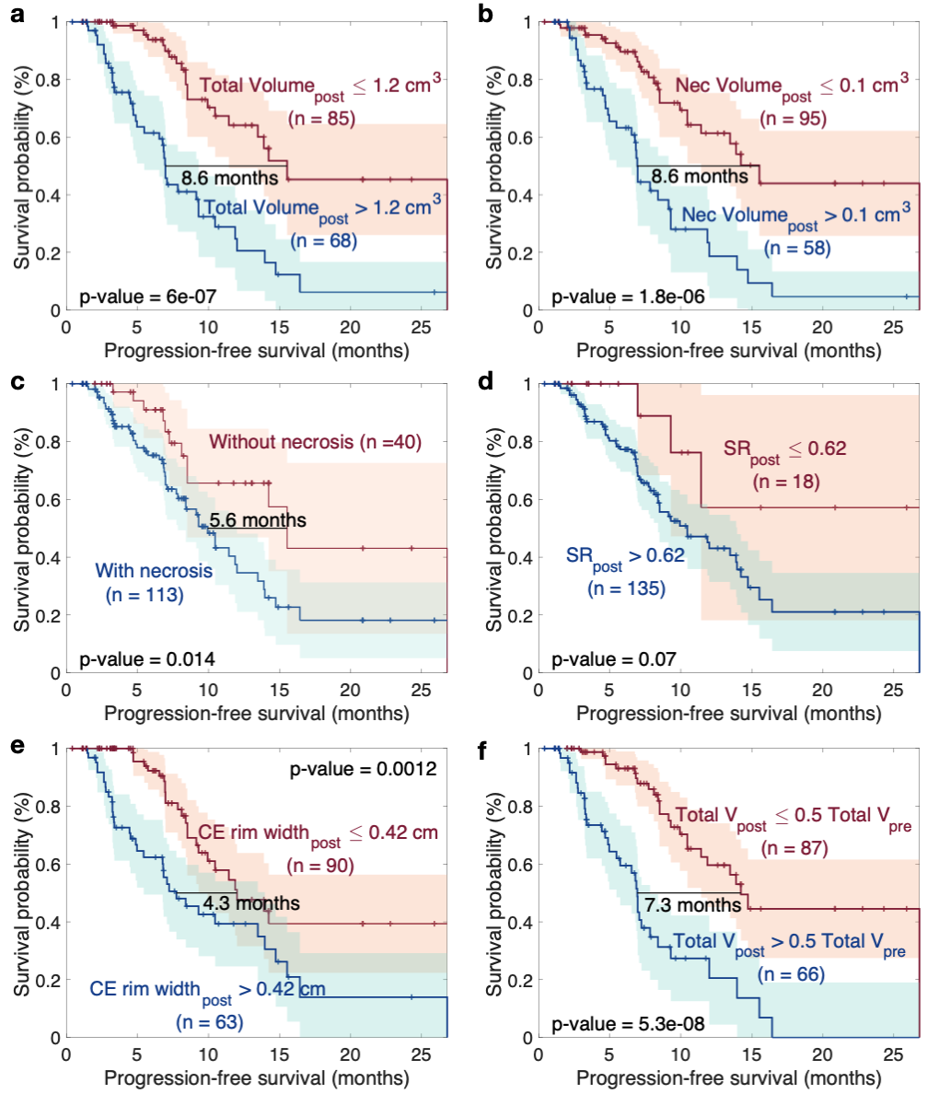
Figure S4. Kaplan-Meier curves per-lesion for biomarkers measured in the first follow-up after treatment, around three months post-treatment, when excluding those previously treated with whole brain radiotherapy (WBRT). a. Total volume. b. Necrotic volume. c. Presence of absence of necrosis. d. Surface regularity (SR). e. CE rim width and f. The variations in volume with treatment (Total volume after treatment / total volume before treatment). n=153, p-values correspond to the long-rank test.

 | Median difference (months) | Best  threshold | p value | HR
Total Volume (pre) +  total dose | 7.1 | -0.9165 | 3.94E-04 | 2.283 (1.427, 3.654)
Total Volume (pre) +  SR (pre) | - | 1.90 | 0.014 | 2,729 (1.180, 6,312)
Total Volume (pre) +  CE rim width (pre) | - | 0.0381 | 0.092 | 1.542 (0.927, 2.566)
Total Volume (post) +  total dose | 7.5 | -1.0826 | 5.49E-11 | 4.215 (2.647, 6.712)
Total Volume (post) + necrosis (yes/no, pre) | 6.7 | 0.1786 | 1.00E-06 | 2.938 (1.856, 4,652)
Total Volume (post) + necrosis (yes/no, post) | 8.6 | 0.430 | 1,30E-08 | 3.571 (2.236, 5.703)
Total Volume (post) +  CE rim width (post) | 7 | 0.3935 | 2.40E-05 | 2.577 (1.631, 4.072)
Total Volume (post/pre) + total dose | 7.7 | -0.3827 | 1.68E-10 | 4.028 (2.543, 6.380)
Total Volume (post/pre) + necrosis (yes/no, pre) | 8.6 | 0.80 | 2.80E-11 | 4.094 (2.612, 6.416)
Total Volume (post/pre) +necrosis (yes/no, post) | 19.0 | 0.35 | 8.56E-07 | 3.783 (2.150, 6.656)
Total Volume (post/pre) + CE rim width (post | 7.1 | 0.919 | 3.52E-08 | 3.274 (2.093, 5.122)
Table S1. Results of multivariate Cox and Kaplan-Meier Analysis for imaging biomarkers obtained from pre-treatment and post-treatment RM images. HR – Hazard Ratio, CE – contrast enhanced. P values correspond to the log rank test and data in parenthesis are 95% confidence intervals for the HR.

