Table S1: Clinical symptoms of the 48 MPS patients

Clinical symptoms | n (%)
Skeletal and joint abnormalities | 36 (75%)
Ear, nose and throat (ENT) symptoms | 34 (71%)
Cardiologic symptoms | 25 (52%)
Psychomotor disability | 24 (50%)
Respiratory symptoms | 20 (42%)
Carpal tunnel syndrome (CTS) | 18 (38%)
Ophthalmologic disease | 15 (31%)
Epilepsy | 7 (15%)
The results are expressed as the number of patients (%).

Table S2: Equipment, supportive care, and analgesic drugs

 | n (%)
Equipment* | 42 (86%)
Supportive care | 46 (98%)
Physiotherapy | 39 (81%)
Speech therapy | 17 (35%)
Psychology | 16 (33%)
Occupational therapy | 13 (27%)
Psychomotricity | 12 (25%)
Rehabilitation center | 9 (19%)
Balneotherapy | 8 (17%)
Other** | 10 (21%)
Regular use of analgesic drugs | 14 (29%)
Nonopioid analgesics (acetaminophen, NSAIDs) | 13 (27%)
Weak opioid agents (tramadol, codeine) | 0
Strong opioid agents (morphine) | 0
Other analgesic drugs (gabapentin, amitriptyline, other) | 3 (6%)
The results are expressed as the number of patients (%). *Equipment includes wheelchairs, hearing aids, glasses, implantable chambers, orthopedic aids, and noninvasive ventilation. **Other supportive care includes equitherapy, relaxation, vestibular rehabilitation, osteopathy, and orthoptics.

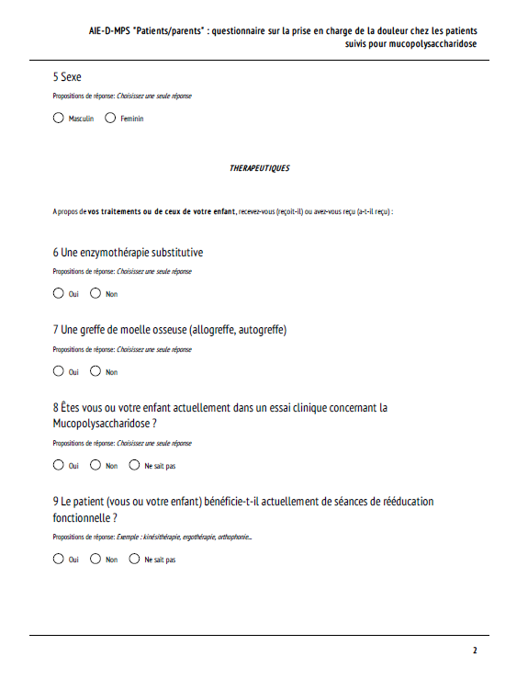
Online questionnaire for patients and/or parents
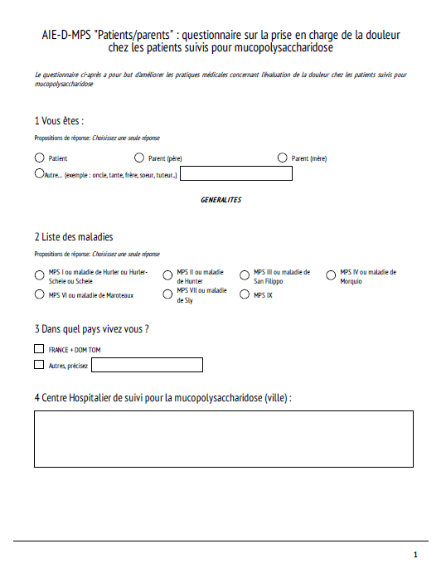

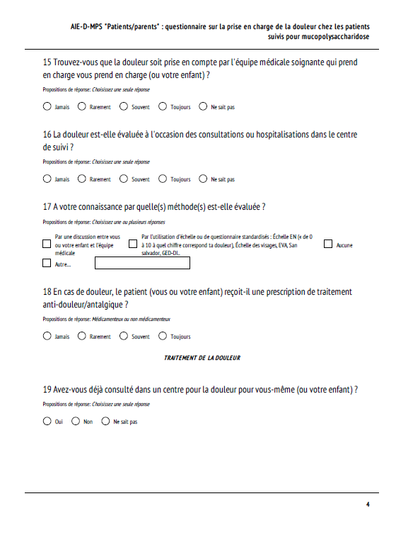
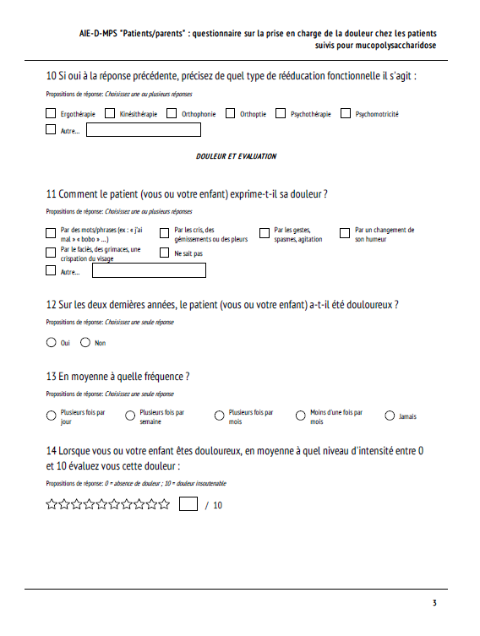

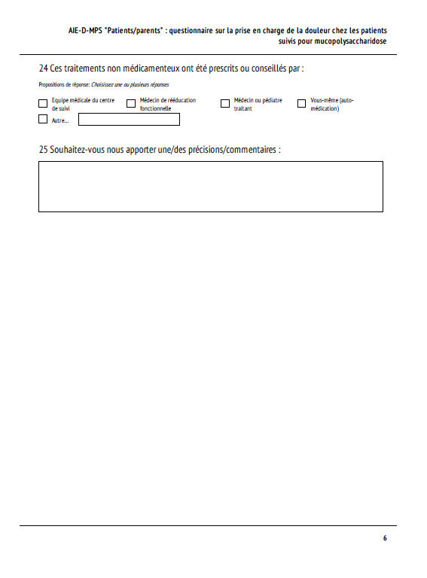
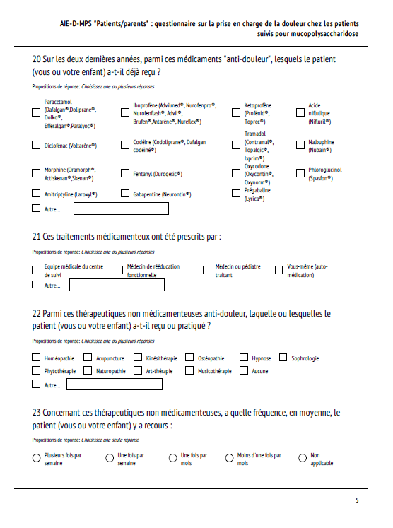

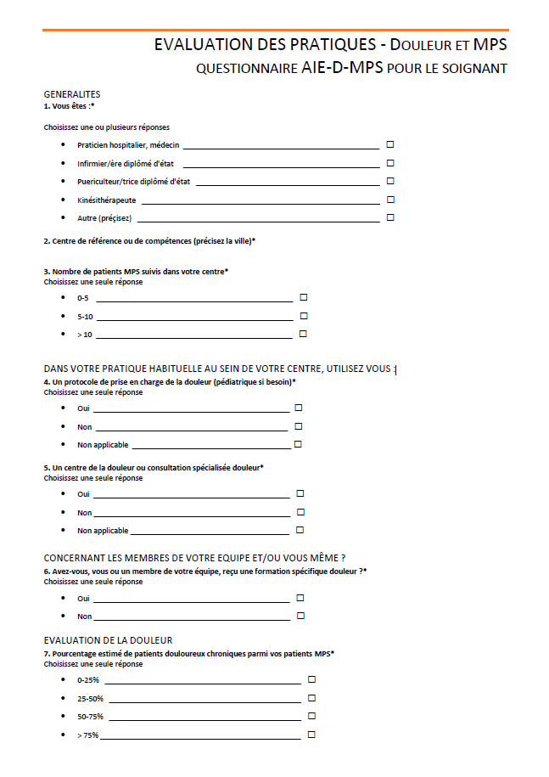
Online questionnaire for healthcare professionals

