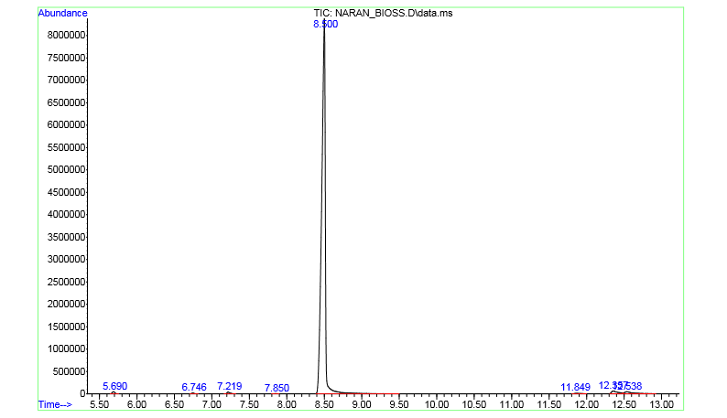
Figure S1. GC–MS chromatogram of the Citrus × sinensis (L.) Osbeck essential oil.

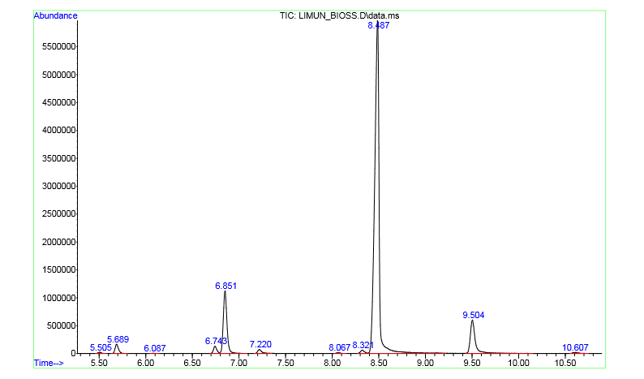
Figure S2. GC–MS chromatogram of the Citrus medica L. essential oil.

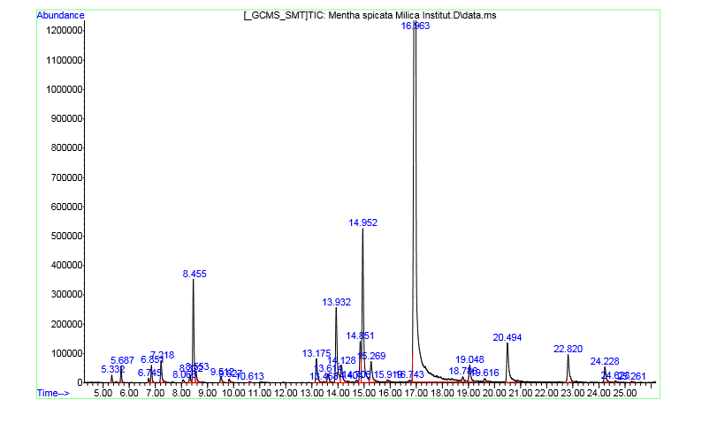
Figure S3. GC–MS chromatogram of the Mentha spicata L. essential oil.

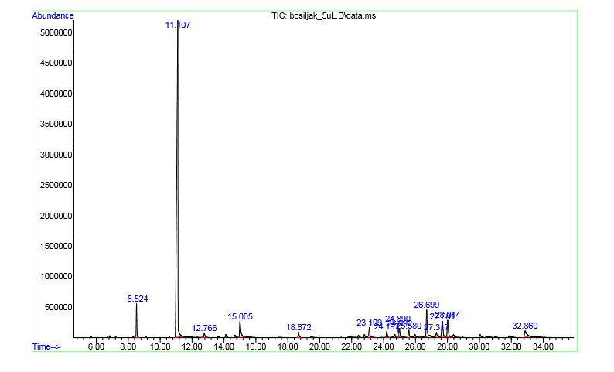
Figure S4. GC–MS chromatogram of the Ocimum basilicum L. essential oil.
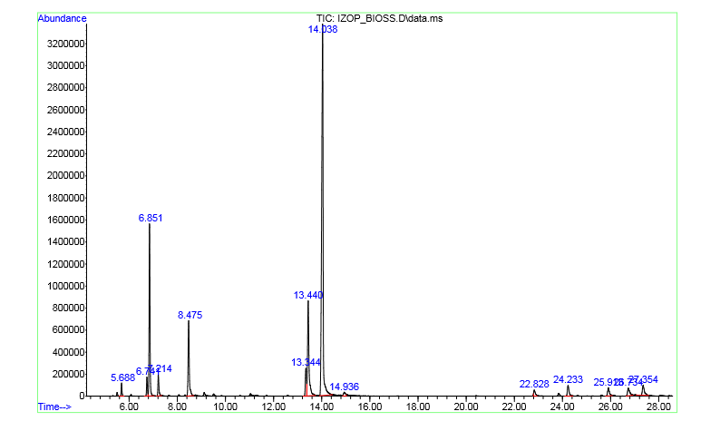
Figure S5. GC–MS chromatogram of the Hyssopus officinalis L. essential oil.

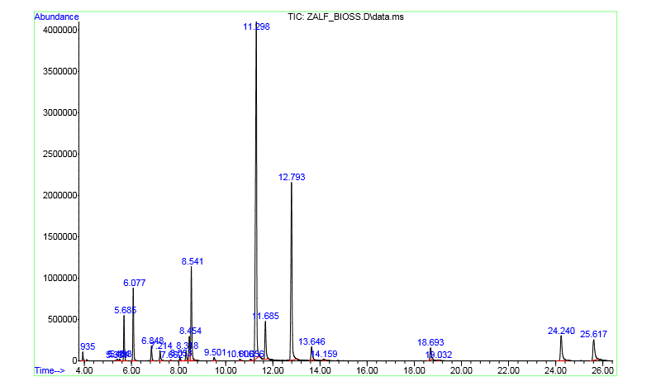
Figure S6. GC–MS chromatogram of the Salvia officinalis L. essential oil.

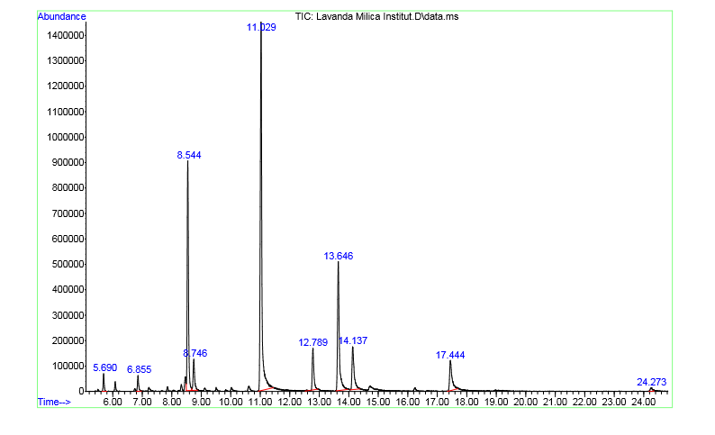
Figure S7. GC–MS chromatogram of the Lavandula angustifolia Mill. essential oil.

