Repair spinal cord injury with a versatile anti-oxidant and neural regenerative nanoplatform
Heng Zhou^{1#}, Ziwei Li^{1#}, Shuili Jing^{1#}, Ben Wang², Zhifei Ye², Wei Xiong¹, Yonghao Liu¹, Ye Liu¹, Chun Xu³, Tushar Kumeria⁴, Yan He^{5,6}, Qingsong Ye^{1,2*}
1 Center of Regenerative Medicine & Department of Stomatology, Renmin Hospital of Wuhan University, Wuhan, 430060, China
2 The Second People’s Hospital of Linhai, Linhai, Zhejiang, 317000, China
3 School of Dentistry, The University of Sydney, Sydney, NSW, 2006, Australia
4 School of Materials Science and Engineering, University of New South Wales, Kensington, Sydney, NSW, 2052, Australia
5 Institute of Regenerative and Translational Medicine, Tianyou Hospital, Wuhan University of Science and Technology, Wuhan, Hubei, 430064, China
6 Department of Oral and Maxillofacial Surgery, Massachusetts General Hospital, Harvard Medical School, Boston, 02114, MA, USA

*Corresponding authors:
Qingsong Ye
Center of Regenerative Medicine, Renmin Hospital of Wuhan University, Wuhan, China. Email: qingsongye@whu.edu.cn
#These authors contributed equally to this work.
Supplementary Data
Figure S1. Identification of Se, SSe, and SSSe NPs.
A-C) TEM images and Size distribution of SSSe, SSe, and Se nanoparticles. D) energy spectrum analysis of ZnLb spectra of SSSe@ZIF-8, SSe@ZIF-8, and Se@ZIF-8.

Figure S2. ROS scavenging of ZIF-8, SSSe@ZIF-8 and Se@ZIF-8 in vitro.
(A-C) The concentration-dependent anti-oxidation of TMB due to •OH elimination by ZIF-8, SSSe@ZIF-8, and Se@ZIF-8 with 100 μM H2O2. (D-F) The concentration-dependent investigation of ABTS•+ in the presence of ZIF-8, SSSe@ZIF-8, and Se@ZIF-8.

Figure S3. Cell cycle analysis of FSZ nanoparticles on PC12 cells. Flow cytometry analysis of cell cycle changes in PC12 cells treated with different concentration of FSZ nanoparticles.

Figure S4. FSZ nanoparticles inhibit apoptosis induced by ROS accumulation.
PC12 cells were co-cultured using 100 μM TBHP and PBS, SSSe, ZIF-8, Fer-1, SSe@ZIF-8, and FSZ nanoparticles. (A) Flow cytometry analysis of annexin‐V/PI staining in PC12 cells treated with TBHP (100 μM). (B) The distribution of apoptosis was quantified.

Figure S5. Cell cycle analysis of FSZ nanoparticles on PC12 cells treated with ROS induction. Flow cytometry analysis of cell cycle changes in PC12 cells treated with different concentration of FSZ nanoparticles with in TBHP (100 μM).

Figure S6. FSZ nanoparticles target mitochondria. PC12 cells were treated with FSZ nanoparticles (100 μg/ml) and TBHP (100 μM). The organelle state and nanoparticle distribution were observed by transmission electron microscopy.

Figure S7. FSZ nanoparticles affect macrophage polarization. Raw264.7 cells were incubated with 20 μg/ml SSe@ZIF-8, Fer-1 (1 μM) and FSZ combination with 1 μg/ml LPS for 24 h. (A-C) Protein levels of iNOS, Arg1, TNFα and IL-10 were detected by Western blot. Data are presented as means ± SD (n = 3). Statistical analysis was performed using one-way ANOVA. *P < 0.05, **P<0.01, ***P < 0.001.

Figure S8. FSZ nanoparticles promote the differentiation of macrophages to M2 phenotype. Raw264.7 cells were incubated with 20 μg/ml SSe@ZIF-8, Fer-1 (1 μM) and FSZ combination with 1 μg/ml LPS for 24 h. The flow cytometry analysis Raw264.7 cells (CD206 and CD86) was shown. Statistical analysis was performed using one-way ANOVA. *P < 0.05.

Figure S9. Immunofluorescence analysis of FSZ nanoparticles on macrophage polarization. Raw264.7 cells were incubated with 20 μg/ml SSe@ZIF-8, Fer-1 (1 μM) and FSZ combination with 1 μg/ml LPS for 24 h. (A) Representative pictures of fluorescence analysis of iNOS and Arg1 were given. (B) Quantitative analysis of iNOS and Arg1 expression. Statistical analysis was performed using one-way ANOVA. *P < 0.05.

Figure S10. FSZ nanoparticles contribute the autonomous differentiation of PC12 cells.
(A) Bright field images of PC12 cells incubated with FSZ for 6 days in ordinary medium. Scale bar: 100 μm. (B) The different ratio of PC12 cells incubated with FSZ for 6 days in ordinary medium. Data are presented as means ± SD (n = 3). Statistical analysis was performed using one-way ANOVA. ***P < 0.001.

Figure S11. FSZ promotes PC12 cell recruitment. (A) Schematic illustration of the co-culture of PC12 cells and FSZ-GelMA. (B) The transport ratios of PC12 cells from apical chamber to FSZ-GelMA after 24 h was determined by CCK-8 assay. Statistical analysis was performed using one-way ANOVA. ***P < 0.001.

Figure S12. FSZ promotes VEGFa expression. PC12 cells were incubated with different concentrations of FSZ (0, 5, 10, 20, 40 and 80 μg/ml) for 24 h. (A) Western blot was used to detect expression of VEGFa and GAPDH. (B) VEGFa expression was quantified. (C) ELISA analysis of VEGF-a of the supernatant from HUVECs incubated with different concentrations of FSZ for 24 h. Data are presented as means ± SD (n = 3). Statistical analysis was performed using one-way ANOVA. *P < 0.05, **P<0.01.

Figure S13. FSZ promotes blood vessel formation. PC12 cells were incubated with different concentrations of FSZ (0, 5, 10, 20, 40 and 80 μg/ml) for 24 h. The conditioned medium was collected to treated with HUVECs to perform tube formation assay for 6 h. Representative images of CalceinAM-labeled HUVECswas given. (B-D) Quantitative analysis of the number of nodes, the number of meshes, and tube length based of tube formation assay. Data are presented as means ± SD (n = 3). Statistical analysis was performed using one-way ANOVA. ***P<0.001.

Figure S14. FSZ promotes migration of HUVECs. PC12 cells were treated with different concentrations of FSZ (0, 5, 10, 20, 40 and 80 μg/ml) and co-cultured with HUVECs for 24 h. (A) Representative images of trans-well migration assay of HUVECs. Scale bar: 100 μm. (B) Quantitative analysis of trans-well migration assay Data are presented as means ± SD (n = 3). Statistical analysis was performed using one-way ANOVA. ***P < 0.001.

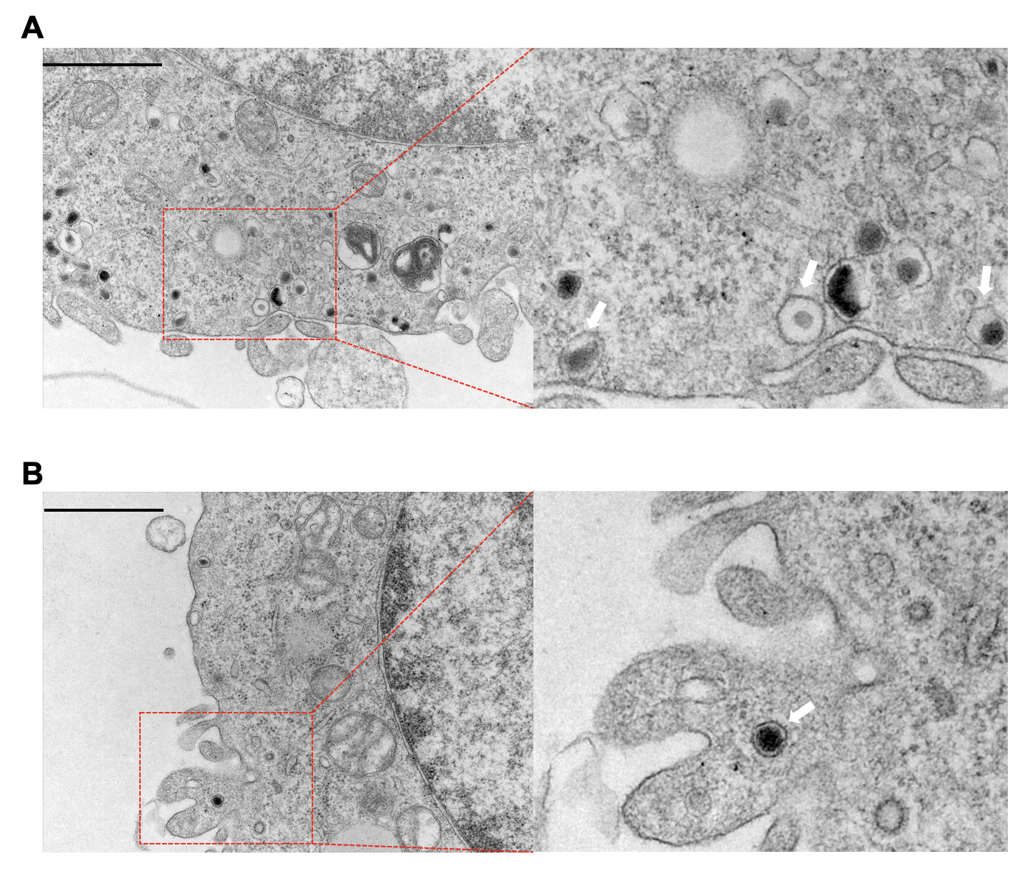
Figure S15. The endocytosis mechanism of SSe@ZIF-8 nanoparticles
A) TEM images of endocytosis of PC12 cells treated with SSe@ZIF-8. B) TEM images of macropinocytosis cups of PC12 cells treated with SSe@ZIF-8. Scale bar: 1 μm. white arrow: SSe@ZIF-8 in lysosomes.

Figure S16. FSZ nanoparticles promote the recovery of motor function in SCI rats
A-D) height from the ground, foot error, spasm duration and forward distance of the motion of mice in the video. Data are presented as means ± SD (n = 3). Statistical analysis was performed using t-test. # P < 0.05, compared with SSe@ZIF-8 group; * P < 0.05, ** P < 0.01, and *** P < 0.001 compared with SCI group.

Figure S17. Safety assessment of FSZ nanoparticles in vivo
A) H&E staining image of heart, liver, spleen, lung, and kidney of mice. B) Blood routine examination of the anticoagulant tail blood of mice.

Figure S18. FSZ nanoparticles promote Zn²⁺ levels in spinal cord injury. (A-B) Quantitative analysis of the content of Zn²⁺ by TSQ staining. White arrow: high concentration of Zn²⁺. Data are presented as means ± SD (n = 3). * P < 0.05 compared with SCI group.

Figure S19. FSZ nanoparticles regulate the release of inflammatory factors in serum. (A-C) ELISA assay was used to detect TNF-α, IL-6 and IL-4 levels in serum. Data are presented as means ± SD (n = 3). * P < 0.05 compared with SCI group.

Figure S20. FSZ nanoparticles promote angiogenesis in vivo. (A) Immunohistochemical images of CD31 indicating angiogenesis. Scale bar: 200 μm. B) Quantitative analysis of the expression of CD31. Data are presented as means ± SD (n = 3). Statistical analysis was performed using t-test. ** P < 0.01, and *** P < 0.001 compared with SCI group.

Supplementary Table 1. The sequences of siRNAs used in the study
si-RNA Sence(5′-3′) antisence(5′-3′)
si-WNT4-1 UCCACACUCGACUCCUUGCTT GCAAGGAGUCGAGUGUGGAGC
si-WNT4-2 AGGAGACGUGCGAGAAACUTT AGUUUCUCGCACGUCUCCUCC
control UUCUCCGAACGUGUCACGUTT ACGUGACACGUUCGGAGAATT

