APPENDICES
Appendix 26 Pearson Correlation Coefficient (PCC) for Trace Metal by Location
 | OGB | IWA | IDO | ISA | ILA | ADE | BAA | IGO | SAG
OGB | 1
IWA | 0.9992 | 1
IDO | 0.9994 | 1.000 | 1
ISA | 0.9994 | 1.000 | 0.9997 | 1
ILA | 0.4854 | 0.496 | 0.4799 | 0.4977 | 1
ADE | 0.5103 | 0.520 | 0.5025 | 0.5212 | 0.9600 | 1
BAA | 0.4975 | 0.507 | 0.4899 | 0.5087 | 0.9604 | 0.9996 | 1
IGO | 0.4651 | 0.474 | 0.4578 | 0.4756 | 0.9935 | 0.9627 | 0.9645 | 1
SAG | 0.9939 | 0.995 | 0.9929 | 0.9952 | 0.5719 | 0.5991 | 0.5874 | 0.5535 | 1

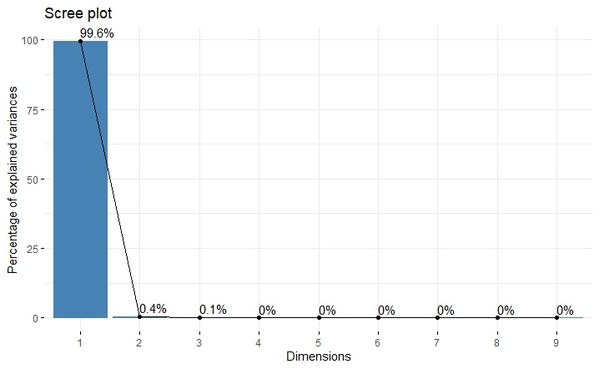
Appendix 6 Scree Plot of Trace metal (mg/L) by Location
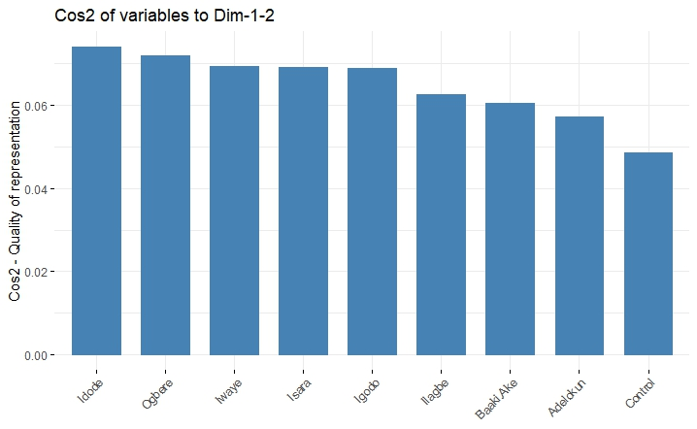
Appendix 7 Cos2 of Location of Trace Metals

Appendix 27 Pearson Correlation Coefficient (PCC) For Heavy Metal by location
 | OGB | IWA | IDO | ISA | ILA | ADE | BAA | IGO | SAG
OGB | 1
IWA | 0.9995 | 1
IDO | 0.9996 | 1.000 | 1
ISA | 0.9997 | 1.000 | 1.0000 | 1
ILA | 0.9996 | 0.998 | 0.9983 | 0.9985 | 1
ADE | 0.9995 | 0.998 | 0.9982 | 0.9984 | 1.0000 | 1
BAA | 1.0000 | 0.999 | 0.9995 | 0.9996 | 0.9997 | 0.9996 | 1
IGO | 0.9998 | 0.999 | 0.9987 | 0.9988 | 1.0000 | 1.0000 | 0.9998 | 1
SAG | 0.9999 | 0.999 | 0.9992 | 0.9993 | 0.9999 | 0.9998 | 1.0000 | 0.9999 | 1

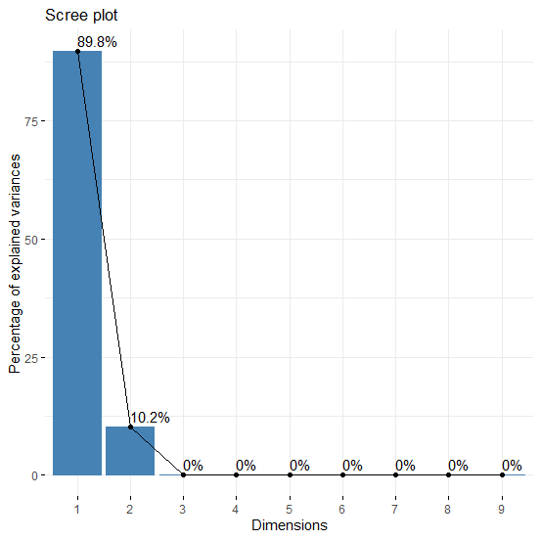
Appendix 8 Scree Plot of Heavy metal (mg/L) by Location

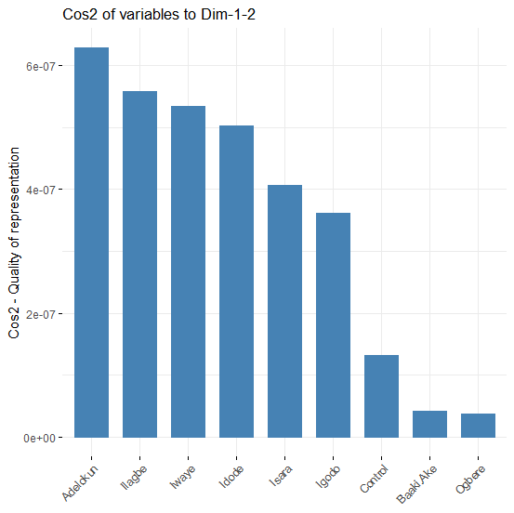
Appendix 9 Cos2 of Location of Heavy Metals

Appendix 28 Correlations of Trace metal (mg/L)
 | Zinc | Magnesium | Silicon | Aluminium | Potassium
Zinc | 1
Magnesium | 0.622796 | 1
Silicon | 0.635046 | -0.00618 | 1
Aluminium | 0.991998 | 0.620486 | 0.613339 | 1
Potassium | -0.11965 | 0.049802 | -0.01137 | -0.13517 | 1

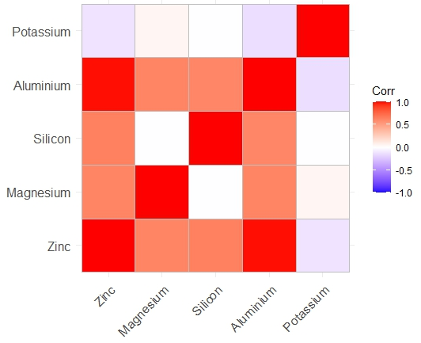
Appendix 10 Heat Map of Trace metal (mg/L)

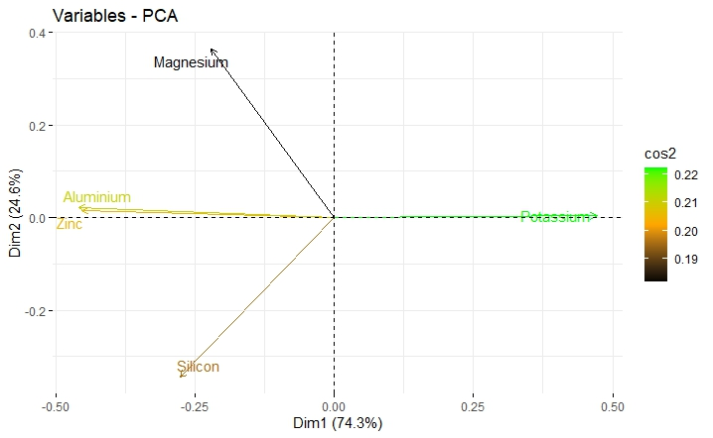
Appendix 11 Biplot of PCA of Trace metal (mg/L)

Appendix 29 Correlations of Heavy metal (mg/L)
 | Lead | Arsenic | Nickel | Selenium | Copper | Iron | Cadmium
Lead | 1
Arsenic | -0.0527 | 1
Nickel | -0.04479 | 0.09968 | 1
Selenium | 0.211115 | 0.440927 | -0.22189 | 1
Copper | 0.147464 | 0.694023 | -0.28631 | 0.818051 | 1
Iron | 0.245206 | 0.394876 | -0.29462 | 0.870233 | 0.873184 | 1
Cadmium | -0.08054 | -0.22302 | 0.129258 | -0.47702 | -0.39017 | -0.41693 | 1

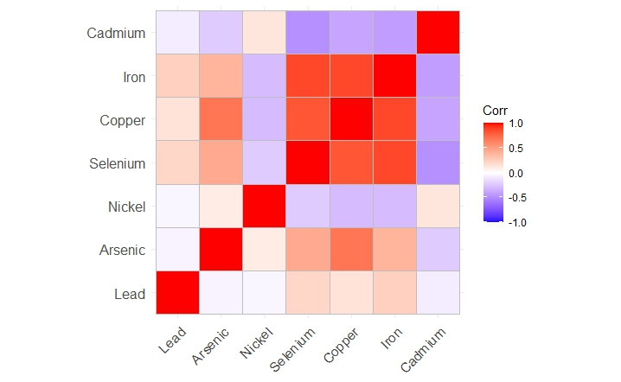
Appendix 12 Heat Map of Heavy metal (mg/L)

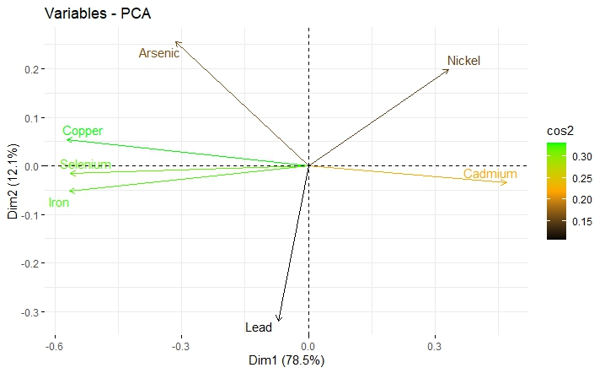
Appendix 13 Biplot of PCA of Heavy metal (mg/L)

