Supplementary Informations

Norovirus Hu/GII.4/New Orleans1805/2009/USA, Complete Genome
GenBank: GU445325.2
LOCUS GU445325 7559 bp RNA linear VRL 18-AUG-2011
DEFINITION Norovirus Hu/GII.4/New Orleans1805/2009/USA, complete genome.
ACCESSION GU445325
VERSION GU445325.2
SOURCE Norovirus Hu/GII.4/New Orleans1805/2009/USA
ORGANISM Norovirus Hu/GII.4/New Orleans1805/2009/USA
Viruses; Riboviria; Orthornavirae; Pisuviricota; Pisoniviricetes; Picornavirales; Caliciviridae; Norovirus.
FEATURES Location/Qualifiers
source 1..7559
/organism="Norovirus Hu/GII.4/New Orleans1805/2009/USA"
/mol_type="genomic RNA"
/strain="Hu/GII.4/New Orleans1805/2009/USA"
/isolation_source="stool"
/host="Homo sapiens"
/db_xref="taxon:722763"
/country="USA"
/collection_date="Nov-2009"
5'UTR 1..4
CDS 5..5104
/codon_start=1
/product="non-structural polyprotein"
/protein_id="ADD10374.2"
/translation="MKMASNDASAAAVANSNDDTAKSSSDGVLSSMAVTFKRALGARP KQPPPREKPQRPPRPPTPELVKNIPPPPPNGEDEIVVSYSVKDGVSGLPDLSTVRQPE ESNTAFSVPPLNQRENRDAKEPLTGTILEMWDGEIYHYGLYVERGLVLGVHKPPAAIS LAKVELAPLSLYWRPVYTPQYLISPDTLKKLSGETFPYTAFDNNCYAFCCWVLDLNDS WLSRRMIQRTTGFFRPYQDWNRKPLPTMDDSKIKKVANIFLCALSSLFTRPIKDIIGK IRPLNILNILASCDWTFAGIVESLILLAELFGVFWTPPDVSAMIAPLLGDYELQGPED LAVELVPVVMGGIGLVLGFTKEKIGKMLSSAASTLRACKDLGAYGLEILKLVMKWFFP KKEEANELAIVRSIEDAVLDLEAIENNHMTTLLKDKDSLATYMRTLDLEEEKARKLST KSASPDIVGTINALLARIAAARSLVHRAKEELSSRPRPVVLMISGRPGIGKTHLAREV AKRIAASLTGDQRVGLIPRNGVDHWDAYKGERVVLWDDYGMSNPIHDALRLQELADTC PLTLNCDRIENKGKVFDSDVIIITTNLANPAPLDYVNFEACSRRIDFLVYAEAPEVEK AKRDFPGQPDMWKNAFSSDFSHIKLALAPQGGFDKNGNTPHGKGVMKTLTTGSLIARA SGLLHERLDEFELQGPALTTFNFDRNKVLAFRQLAAENKYGLIDTMRVGKQLKDVRTM PELKQALKNVSIKKCQIVYSGCTYILESDGKGNVKVDRIQSAAVQTNNELAGALHHLR CARIRYYVKCVQEALYSIIQIAGAAFVTTRITKRMNIQDLWSKPQVENTEETTSKDGC PKPKDDEEFVISSDDIKTEGKKGKNKTGRGKKHTAFSSKGLSDEEYDEYKRIREERNG KYSIEEYLQDRDKYYEEVAIARATEEDFCEEEEAKIRQRIFRPTRKQRKEERASLGLV TGSEIRKRNPDDFKPKGKLWADDDRSVDYNEKLSFEAPPSIWSRIVNFGSGWGFWVSP SLFITSTHVIPQGAKEFFGVPIKQIQVHKSGEFCRLRFPKPIRTDVTGMILEEGAPEG TVVTLLIKRSTGELMPLAARMGTHATMKIQGRTVGGQMGMLLTGSNAKSMDLGTTPGD CGCPYIYKRGNDYVVIGVHTAAARGGNTVICATQGSEGEATLEGGDNKGTYCGAPILG PGSAPTLSTKTKFWRSSTASLPPGTYEPAYLGGKDPRVKGGPSLQQVMREQLKPFTEP RGKPPKPSVLEAAKKTIINVLEQTIDPPEKWSFAQACASLDKTTSSGHPHHMRKNDCW NGESFTGKLADQASKANLMFEEGKNMTPVYTAALKDELVKTDKIYGKIKKRLLWGSDL ATMIRCARAFGGLMDELKAHCVTLPIRVGMNMNEDGPIIFERHSRYTYHYDADYSRWD STQQRAVLAAALEIMVKFSPEPHLAQVVAEDLLSPSVVDVGDFTISINEGLPSGVPCT SQWNSIAHWLLTLCALSEVTNLSPDTIQANSLFSFYGDDEIVSTDIKLDPEKLTAKLR EYGLKPTRPDKTEGPLVISEDLNGLTFLRRTVTRDPAGWFGKLEQSSILRQMYWTRGP NHGDPSETMIPHSQRPIQLMSLLGEAALHGPAFYSKISKLVIAELKEGGMDFYVPRQE
PMFRWMRFSDLSTWEGDRNLAPSFVNEDGVE"
CDS 5085..6707
/note="VP1"
/codon_start=1
/product="major capsid protein"
/protein_id="ADD10375.1"
/translation="MKMASSDANPSDGSTANLVPEVNNEVMALEPVVGAAIAAPVAGQ QNVIDPWIRNNFVQAPGGEFTVSPRNAPGEILWSAPLGPDLNPYLSHLARMYNGYAGG FEVQVILAGNAFTAGKIIFAAVPPNFPTEGLSPSQVTMFPHIIVDVRQLEPVLIPLPD VRNNFYHYNQSNDSTIKLIAMLYTPLRANNAGDDVFTVSCRVLTRPSPDFDFIFLVPP TVESRTKPFSVPVLTVEEMTNSRFPIPLEKLFTGPSSAFVVQPQNGRCTTDGVLLGTT QLSPVNICTFRGDVTHIPGSRNYTMNLASQNWNSYDPTEEIPAPLGTPDFVGKIQGVL TQTTRTNGSTRGHKATVYTGSADFSPKLGRVQFATDTDNDFETNQNTKFTPVGVIQDG STTPRNEPQQWVLPSYSGRNIHNVHLAPAVAPTFPGEQLLFFRSTMPGCSGYPNMDLD CLLPQEWVQYFYQEAAPAQSDVALLRFVNPDTGRVLFECKLHKSGYVTVAHTGQHDLV
IPPNGYFRFDSWVNQFYTLAPMGNGTGRRRAL"
CDS 6707..7513
/note="VP2"
/codon_start=1
/product="minor capsid protein"
/protein_id="ADD10376.1"
/translation="MAGAFFAGLASDVLGSGLGSLINAGAGAINQKVEFENNRKLQQA SFQFSSNLQQASFQHDKEMLQAQIEATKKLQQEMMRVKQAMLLEGGFSETDAARGAIN APMTKTLDWSGTRYWAPDARTTTYNAGRFSTPQPSGALPGRANLRATVPARGSSSTSS NSSIATSVNSNQTTSTRLGSTAGSGTSVSSPPSTARTRSWVEDQNRNLSPFMRGAHNI
SFVTPPSSRSSSQGTVSTVPKEVLDSWTGAFNTRRQPLFAHIRKRGESRV"
3'UTR 7514..7559

Based on these amino acid sequences, nucleic acid sequences coding for proteins were determined.

ORIGIN
1 gtgaatgaag atggcgtcta acgacgcttc cgctgccgct gttgctaaca gcaacgacga
61 caccgcaaaa tcttcaagtg acggagtgct ttctagcatg gctgtcactt tcaaacgagc
121 cctcggggcg cggcctaaac agcctccccc gagggaaaaa ccacaaagac ccccacgacc
181 acctactcca gaactggtta aaaatattcc ccctccccca cccaacggag aggatgaaat
241 agtggtttct tatagtgtca aagatggtgt ttccggcttg cctgaccttt ccaccgtcag
301 gcaaccggaa gaatctaaca cggccttcag tgtccctcca ctcaatcaga gggagaatag
361 agatgctaag gagccactta ctggaacaat tctggaaatg tgggacgggg aaatctacca
421 ttatggcctg tatgtggagc gaggtcttgt attaggtgtg cataaaccac cagctgccat
481 cagcctcgct aaggttgagc tagcaccact ctccttgtac tggagacctg tgtacactcc
541 tcagtacctc atctctccag acactctcaa gaaattatcc ggagaaacgt tcccctacac
601 agcctttgac aacaactgtt atgccttttg ttgctgggtc ctggacctaa atgactcgtg
661 gctgagcagg agaatgatcc agagaacaac tggtttcttc aggccctacc aagattggaa
721 taggaaaccc cttcccacta tggatgactc caaaataaag aaggtagcta acatattcct
781 gtgtgctctg tcctcgctgt tcaccagacc cataaaagat ataataggga agataaggcc
841 tcttaacatc ctcaacatct tagcctcatg tgattggact tttgcaggca tagtggagtc
901 cctgatactc ttggcagaac tctttggagt tttctggaca cccccagatg tgtctgcgat
961 gattgccccc ttacttggtg actacgagct acaaggacct gaggaccttg cagtggagct
1021 cgtccccgtg gtgatggggg gaattggttt ggtgctagga ttcaccaaag agaagattgg
1081 gaaaatgttg tcatctgctg cgtccacctt gagagcttgt aaagaccttg gtgcatatgg
1141 gctagagatc ctaaagttgg tcatgaagtg gttcttcccg aagaaggagg aggcaaatga
1201 gctggctata gtgaggtcta tcgaggatgc agtcctggat ctcgaggcaa ttgaaaacaa
1261 ccatatgacc accttgctca aagacaaaga cagcctggca acctatatga gaacacttga
1321 ccttgaggag gagaaagcca ggaaactctc aaccaagtct gcctcacccg acatcgtggg
1381 cacaatcaac gccctcctgg cgagaatcgc tgccgcacgt tctctggtgc atcgagcgaa
1441 ggaggagctt tccagcagac caagacctgt ggtgttgatg atatcaggca ggccaggaat
1501 agggaagacc cacctcgcta gggaagtggc taagagaatc gcagcctccc ttacaggaga
1561 ccagcgtgtg ggcctcatcc cacgcaatgg cgtcgaccat tgggatgcgt acaaggggga
1621 gagggtcgtc ctatgggacg attatggaat gagcaaccct attcacgatg ccctcaggct
1681 gcaagaactc gctgacactt gccccctcac tctaaactgt gacaggattg aaaataaagg
1741 aaaggtcttt gacagcgatg tcatcattat caccactaat ctggccaacc cagcaccact
1801 ggactatgtc aactttgaag catgctcgag gcgcatcgac ttcctcgtgt atgcagaagc
1861 ccctgaagtc gaaaaggcga agcgtgactt cccaggccag cctgacatgt ggaagaacgc
1921 tttcagttct gatttctcac acataaaact agcactggcc ccacagggtg gtttcgacaa
1981 gaacgggaac accccacacg gaaagggcgt catgaagact ctcaccactg gctcccttat
2041 tgcccgggca tcagggctac tccatgagag gttagatgaa tttgaactac agggcccagc
2101 tctcaccacc ttcaatttcg atcgcaataa agtgcttgcc tttagacagc ttgctgctga
2161 aaataaatat gggttgatag acacaatgag agttgggaaa cagctcaagg atgtcagaac
2221 catgccagaa ctcaaacaag cactcaagaa tgtctcaatc aagaagtgcc aaatagtgta
2281 tagtggttgc acctacatac ttgagtctga tggcaagggc aatgtgaaag ttgacagaat
2341 ccaaagcgcc gccgtgcaga ccaacaatga gctggctggt gccctgcacc atttgaggtg
2401 cgccagaatc agatactacg tcaagtgtgt ccaggaggcc ctgtattcca tcattcaaat
2461 tgctggggct gcatttgtca ccacgcgcat taccaagcgc atgaacatac aagacctatg
2521 gtccaagcca caagtggaaa acacagagga gactaccagc aaggacgggt gcccaaaacc
2581 taaggatgat gaggagtttg tcatttcatc cgacgacatc aaaactgagg gtaagaaagg
2641 gaagaacaaa actggccgcg gcaagaagca cacagcattt tcaagcaaag gcctcagtga
2701 tgaagagtac gatgagtaca agaggattag agaagaaagg aatggcaagt actccataga
2761 agagtacctt caggacaggg acaaatacta tgaggaggtg gccattgcca gggcgactga
2821 ggaagacttc tgtgaagagg aggaggccaa gatccggcaa aggatcttta ggccaacaag
2881 gaaacaacgc aaggaggaaa gagcctctct cggtctggtc acaggctctg aaattaggaa
2941 aagaaaccca gatgacttca aacccaaggg gaaattgtgg gctgacgatg acaggagtgt
3001 ggactacaat gagaaactca gttttgaggc cccaccaagc atctggtcga gaatagtcaa
3061 ctttggttca ggctggggat tctgggtctc ccccagtctg ttcataacat caacccatgt
3121 cataccccag ggcgcaaagg agttctttgg agtccccatc aaacaaatac aggtacacaa
3181 gtcaggcgag ttctgtcgct tgagattccc aaaaccaatc aggactgatg tgacgggcat
3241 gatcttagaa gaaggcgcac ctgagggcac cgtggtcaca ctactcatca aaaggtccac
3301 tggggaactc atgcccctag cagctaggat ggggacccat gcgaccatga agatccaagg
3361 gcgcactgtt ggaggccaga tgggcatgct tctgacagga tccaacgcca agagcatgga
3421 cctgggtact acaccaggtg attgtggctg cccctatatc tacaagagag gcaatgacta
3481 tgtggtcatt ggagtccaca cggctgccgc acgtggggga aacactgtca tatgtgccac
3541 ccaggggagt gaaggagagg ctacacttga aggtggtgac aacaagggga catactgtgg
3601 tgcaccaatc ctaggcccag ggagtgcccc aacacttagc accaagacca aattctggag
3661 atcgtccaca gcatcactcc cacctggcac ctatgaacca gcctatcttg gtggcaagga
3721 ccctagagtc aagggtggcc cttcactgca gcaagtcatg agggaacagt tgaagccatt
3781 cacagagcca aggggcaagc caccaaaacc aagtgtatta gaagctgcca agaagaccat
3841 catcaatgtc cttgagcaaa caattgatcc acctgagaaa tggtcgttcg cacaagcttg
3901 cgcgtccctt gacaagacca cttccagtgg tcatccgcac cacatgcgga aaaacgactg
3961 ctggaacggg gagtccttca caggcaagct ggcagaccag gcttccaagg ccaacctgat
4021 gtttgaagaa gggaagaaca tgaccccagt ctacacagct gcgctcaagg atgagttagt
4081 taaaactgac aaaatttatg gtaagatcaa gaagaggctt ctctggggct cggacttggc
4141 gaccatgatc cggtgtgctc gggcattcgg aggcctaatg gatgaactca aagcacactg
4201 tgtcacactt cccattagag ttggcatgaa tatgaatgag gatggcccca tcatcttcga
4261 gaggcattcc aggtacacat atcactatga tgctgattac tctcgatggg attcaacaca
4321 acagagagcc gtgttggcag cagctctgga aatcatggtt aaattctccc cagaaccaca
4381 tttggctcag gtagtcgcgg aagaccttct ttctcctagc gtggtggacg tgggcgactt
4441 cacaatatca atcaacgagg gtcttccctc tggggtgccc tgtacctccc aatggaactc
4501 catcgcccac tggcttctca ctctctgtgc gctctctgaa gtcacaaacc tatcccctga
4561 taccatacag gctaactccc tcttctcttt ttatggtgat gatgaaattg ttagcacaga
4621 cataaaattg gacccagaga aattgacagc aaagctcaga gaatatgggt taaaaccaac
4681 ccgccctgac aaaactgaag gaccccttgt catctctgaa gacctgaatg gcctaacttt
4741 cctgcggaga actgtgaccc gcgacccagc tggttggttt ggaaaactgg agcagagttc
4801 aatactcagg caaatgtact ggactagggg tcccaaccat ggagacccat ctgaaacaat
4861 gattccacac tcccaaagac ccatacaatt gatgtcccta ctgggggagg ccgctctcca
4921 cggcccagca ttttacagta aaatcagcaa attggtcatt gcagagctaa aagaaggtgg
4981 catggatttt tacgtgccca gacaagagcc aatgttcaga tggatgagat tctcagatct
5041 gagcacgtgg gagggcgatc gcaatctggc tcccagtttt gtgaatgaag atggcgtcga
5101 gtgacgccaa cccatctgat gggtccacag ccaacctcgt cccagaggtc aacaatgagg
5161 ttatggcttt ggagcccgta gttggtgccg ccattgcggc acctgtagcg ggccaacaaa
5221 atgtaattga cccctggatt agaaacaatt ttgtacaagc ccctggtgga gagtttacag
5281 tatcccctag aaacgctcca ggtgaaatac tatggagcgc gcccttaggc cctgatttga
5341 atccctacct ttcccatttg gccagaatgt acaatggtta tgcaggtggt tttgaagtgc
5401 aggtaatcct cgcggggaac gcgttcaccg ccgggaaaat catatttgca gcagtcccac
5461 caaatttccc aactgaaggt ttgagcccca gccaagtcac tatgttcccc cacataatag
5521 tagatgttag gcaattggaa cctgtgttga tccccttacc cgatgttagg aataatttct
5581 accattataa tcaatcaaat gactccacca tcaaattgat agcaatgttg tacacaccac
5641 ttagggctaa taatgccggg gacgatgtct tcacagtttc ttgtcgagtt ctcacgagac
5701 catcccccga ttttgatttc atatttttgg tgccacccac agttgaatca agaactaaac
5761 cattctctgt cccagtttta actgttgagg agatgaccaa ttcaaggttc cccattcctt
5821 tggaaaagtt gttcacgggc cccagtagtg cctttgttgt tcaaccacaa aacggcaggt
5881 gcacgactga tggcgtgctc ctaggtacta cccaactgtc tcctgtcaac atctgcacct
5941 tcagagggga tgtcacccat attccaggca gtcgtaacta cacaatgaat ttggcctccc
6001 aaaattggaa cagttacgat ccaacagaag aaatcccagc ccctctagga actccagatt
6061 tcgtggggaa gattcaaggt gtgctcaccc aaaccacaag gacaaatggc tcgacccgcg
6121 gccacaaagc tacagtgtac actgggagcg ccgacttttc tccaaaactg ggtagagttc
6181 aatttgccac tgacacagac aatgattttg aaactaacca aaacacaaag ttcaccccag
6241 tcggtgttat ccaggatggt agtactaccc cccgaaatga accccaacaa tgggtgctcc
6301 caagttactc aggcagaaac attcataatg tgcacctggc ccccgctgta gcccccactt
6361 tcccgggcga gcagctcctc ttcttcagat ctactatgcc cggatgcagc gggtacccca
6421 acatggactt ggactgtctg ctcccccagg aatgggtgca gtacttctac caggaggcag
6481 ccccagcaca atctgatgtg gctctgttaa gatttgtgaa tccagacaca ggtagggttt
6541 tgtttgagtg taagcttcat aaatcaggct atgttacagt ggctcacact ggccaacatg
6601 acttggttat cccccccaat ggttatttta gatttgattc ctgggtcaac cagttctaca
6661 cacttgcccc catgggaaat gggacggggc gtagacgtgc attataatgg ctggagcttt
6721 ctttgctgga ttggcatctg acgtccttgg ctctggactt ggttccctaa tcaatgctgg
6781 ggctggggcc atcaaccaaa aagttgaatt tgaaaataac agaaaattgc aacaagcttc
6841 cttccaattt agtagcaatc tacaacaggc ttcctttcaa catgacaaag agatgctcca
6901 agcacaaatt gaggccacca aaaagttgca acaggaaatg atgagagtta aacaagcaat
6961 gctcctagag ggtggattct ctgagacaga tgcagcccgt ggagcaatca acgcccccat
7021 gacaaaaact ttggactgga gcgggacaag gtactgggct cccgatgcta ggactacaac
7081 atataatgca ggccgctttt ccacccctca accctcgggg gcactaccag gaagagccaa
7141 tcttagggct actgtccccg cccggggttc ctctagcacg tcttctaact cttctattgc
7201 tacttctgtg aattcaaatc aaaccacctc aacgagactt ggttctacag ctggttctgg
7261 taccagtgtc tcgagccccc cgtcaactgc aaggactagg agctgggttg aggatcaaaa
7321 taggaatttg tcacctttta tgaggggggc ccacaacatc tcgtttgtca ccccaccatc
7381 tagcagatcc tctagccaag gcacagtctc aaccgtgccc aaagaagttt tggactcctg
7441 gactggcgct ttcaacacgc gcaggcagcc tctcttcgct cacattcgca agcgagggga
7501 gtcacgggtg taatgtgaaa agacaaaatt gattatcttt cttttcttca gtgtctttc
//

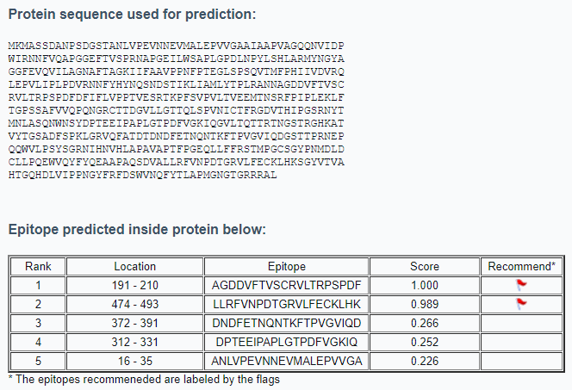
Fig. S1 Possible epitope regions and sequences of VP1

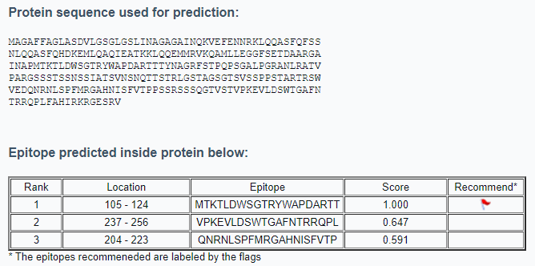
Fig. S2 Possible epitope regions and sequences of VP2

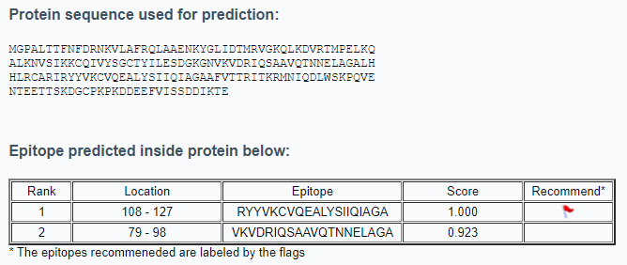

Fig. S3 Possible epitope regions and sequences of p22

EP123 protein sequence

MAGDDVFTVSCRVLTRPSPDFGGGGGGGGGGLLRFVNPDTGRVLFECKLHKGGGG
GGGGGGDNDFETNQNTKFTPVGVIQDGGGGGGGGGGMTKTLDWSGTRYWAPDARTTGGGGGGGGGGVPKEVLDSWTGAFNTRRQPLGGGGGGGGGGQNRNLSPFMRGAHNISFVTPGGGGGGGGGGRYYVKCVQEALYSIIQIAGAGGGGGGGGGGVKVDRIQSAAVQTNNELAGA*

These gene sequences were codon optimized according to the E. coli.

VP1 Optimized Sequence (Optimized sequence length: 1623, %GC: 58.81)

ATGAAGATGGCGAGCAGCGATGCGAACCCGAGCGATGGTAGCACCGCGAACCTGGTTCCGGAAGTGAACAACGAG
GTGATGGCGCTGGAACCGGTGGTTGGTGCGGCGATTGCGGCGCCGGTTGCGGGTCAGCAAAACGTGATCGACCCG
TGGATTCGTAACAACTTTGTTCAAGCGCCGGGTGGTGAATTTACCGTGAGCCCGCGTAACGCGCCGGGTGAAATC
CTGTGGAGCGCGCCGCTGGGTCCGGACCTGAACCCGTACCTGAGCCACCTGGCGCGTATGTACAACGGCTATGCG
GGTGGCTTCGAAGTGCAGGTTATCCTGGCGGGTAACGCGTTCACCGCGGGTAAAATCATTTTTGCGGCGGTGCCG
CCGAACTTTCCGACCGAAGGTCTGAGCCCGAGCCAGGTTACCATGTTTCCGCACATCATTGTGGATGTTCGTCAG
CTGGAACCGGTGCTGATTCCGCTGCCGGATGTTCGTAACAACTTCTACCACTACAACCAAAGCAACGACAGCACC
ATTAAGCTGATCGCGATGCTGTACACCCCGCTGCGTGCGAACAACGCGGGTGATGACGTGTTTACCGTTAGCTGC
CGTGTTCTGACCCGTCCGAGCCCGGACTTTGACTTCATCTTTCTGGTTCCGCCGACCGTGGAAAGCCGTACCAAG
CCGTTTAGCGTTCCGGTTCTGACCGTTGAAGAGATGACCAACAGCCGTTTTCCGATTCCGCTGGAAAAGCTGTTC
ACCGGTCCGAGCAGCGCGTTCGTGGTTCAGCCGCAAAACGGTCGTTGCACCACCGACGGTGTTCTGCTGGGCACC
ACCCAACTGAGCCCGGTTAACATCTGCACCTTCCGTGGTGATGTGACCCACATCCCGGGTAGCCGTAACTACACC
ATGAACCTGGCGAGCCAAAACTGGAACAGCTACGATCCGACCGAAGAGATCCCGGCGCCGCTGGGCACCCCGGAT
TTTGTGGGCAAGATCCAGGGTGTGCTGACCCAGACCACCCGTACCAACGGTAGCACCCGTGGTCACAAGGCGACC
GTGTATACCGGTAGCGCGGACTTCAGCCCGAAACTGGGTCGTGTTCAATTTGCGACCGATACCGACAACGATTTC
GAGACCAACCAGAACACCAAGTTCACCCCGGTTGGTGTGATCCAGGATGGTAGCACCACCCCGCGTAACGAACCG
CAGCAATGGGTTCTGCCGAGCTATAGCGGTCGTAACATCCACAACGTTCACCTGGCGCCGGCGGTTGCGCCGACC
TTTCCGGGTGAACAACTGCTGTTCTTCCGTAGCACCATGCCGGGTTGCAGCGGTTACCCGAACATGGACCTGGAT
TGCCTGCTGCCGCAGGAATGGGTGCAATACTTCTACCAAGAAGCGGCGCCGGCGCAAAGCGATGTGGCGCTGCTG
CGTTTCGTGAACCCGGATACCGGTCGTGTTCTGTTCGAATGCAAGCTGCACAAAAGCGGCTACGTGACCGTTGCG
CACACCGGTCAACACGATCTGGTGATCCCGCCGAACGGCTACTTCCGTTTCGACAGCTGGGTTAACCAATTCTAC
ACCCTGGCGCCGATGGGCAACGGCACCGGTCGTCGTCGTGCGCTGTAA

VP2 Optimized Sequence (Optimized sequence length: 807, %GC: 61.61)

ATGGCGGGTGCGTTTTTCGCGGGTCTGGCGAGCGATGTTCTGGGCAGCGGTCTGGGTAGCCTGATCAACGCGGGT
GCGGGCGCGATCAACCAGAAGGTTGAGTTCGAGAACAACCGTAAACTGCAACAGGCGAGCTTTCAGTTCAGCAGC
AACCTGCAGCAAGCGAGCTTCCAGCACGACAAGGAAATGCTGCAGGCGCAAATTGAGGCGACCAAAAAGCTGCAA
CAGGAGATGATGCGTGTGAAGCAAGCGATGCTGCTGGAAGGTGGCTTTAGCGAAACCGACGCGGCGCGTGGTGCG
ATTAACGCGCCGATGACCAAAACCCTGGACTGGAGCGGCACCCGTTATTGGGCGCCGGACGCGCGTACCACCACC
TACAACGCGGGTCGTTTTAGCACCCCGCAACCGAGCGGTGCGCTGCCGGGTCGTGCGAACCTGCGTGCGACCGTT
CCGGCGCGTGGTAGCAGCAGCACCAGCAGCAACAGCAGCATCGCGACCAGCGTTAACAGCAACCAGACCACCAGC
ACCCGTCTGGGTAGCACCGCGGGTAGCGGCACCAGCGTTAGCAGCCCGCCGAGCACCGCGCGTACCCGTAGCTGG
GTTGAGGATCAGAACCGTAACCTGAGCCCGTTTATGCGTGGTGCGCACAACATTAGCTTCGTTACCCCGCCGAGC
AGCCGTAGCAGCAGCCAGGGCACCGTTAGCACCGTTCCGAAGGAAGTGCTGGATAGCTGGACCGGTGCGTTCAAC
ACCCGTCGTCAACCGCTGTTTGCGCACATCCGTAAGCGTGGCGAAAGCCGTGTTTAA

p22 Optimized Sequence (Optimized sequence length: 543, %GC:54.56)

ATGGGCCCGGCGCTGACCACCTTCAACTTTGACCGTAACAAGGTTCTGGCGTTTCGTCAGCTGGCGGCGGAAAAC
AAGTACGGTCTGATCGATACCATGCGTGTTGGTAAACAGCTGAAAGACGTGCGTACCATGCCGGAACTGAAACAG
GCGCTGAAGAACGTGAGCATCAAAAAGTGCCAGATCGTGTACAGCGGTTGCACCTACATCCTGGAAAGCGATGGT
AAAGGCAACGTGAAGGTTGACCGTATCCAAAGCGCGGCGGTTCAGACCAACAACGAGCTGGCGGGTGCGCTGCAC
CACCTGCGTTGCGCGCGTATCCGTTACTATGTGAAGTGCGTTCAAGAGGCGCTGTACAGCATCATTCAGATCGCG
GGTGCGGCGTTCGTTACCACCCGTATCACCAAGCGTATGAACATCCAGGATCTGTGGAGCAAACCGCAGGTTGAG
AACACCGAAGAGACCACCAGCAAAGACGGTTGCCCGAAACCGAAGGATGACGAAGAGTTCGTGATCAGCAGCGAT
GACATCAAGACCGAGTAA

EP123 Optimized Sequence (Optimized sequence length: 696, %GC: 65.18)

ATGGCGGGTGACGATGTGTTCACCGTTAGCTGCCGTGTTCTGACCCGTCCGAGCCCGGACTTTGGTGGCGGCGGT
GGTGGCGGCGGTGGCGGTCTGCTGCGTTTCGTTAACCCGGACACCGGTCGTGTGCTGTTTGAGTGCAAGCTGCAC
AAAGGTGGCGGCGGCGGCGGTGGCGGTGGCGGTGATAACGACTTCGAGACCAACCAGAACACCAAATTCACCCCG
GTGGGCGTTATTCAGGACGGTGGCGGTGGTGGTGGTGGTGGTGGCGGTATGACCAAGACCCTGGACTGGAGCGGC
ACCCGTTACTGGGCGCCGGATGCGCGTACCACCGGCGGTGGCGGCGGTGGTGGTGGCGGTGGTGTTCCGAAAGAG
GTGCTGGACAGCTGGACCGGTGCGTTTAACACCCGTCGTCAACCGCTGGGTGGCGGTGGTGGCGGTGGCGGCGGC
GGTCAGAACCGTAACCTGAGCCCGTTTATGCGTGGCGCGCACAACATTAGCTTTGTGACCCCGGGTGGTGGCGGC
GGTGGTGGCGGTGGCGGTCGTTACTATGTTAAGTGCGTGCAAGAAGCGCTGTATAGCATTATCCAGATCGCGGGT
GCGGGCGGCGGTGGCGGCGGCGGTGGTGGTGGCGTGAAGGTTGATCGTATCCAGAGCGCGGCGGTTCAGACCAAC
AACGAACTGGCGGGTGCGTAA

The start codon ATG is shown in green, the stop codon TAA is shown in red, and the regions used for primer sequences are shown in yellow.

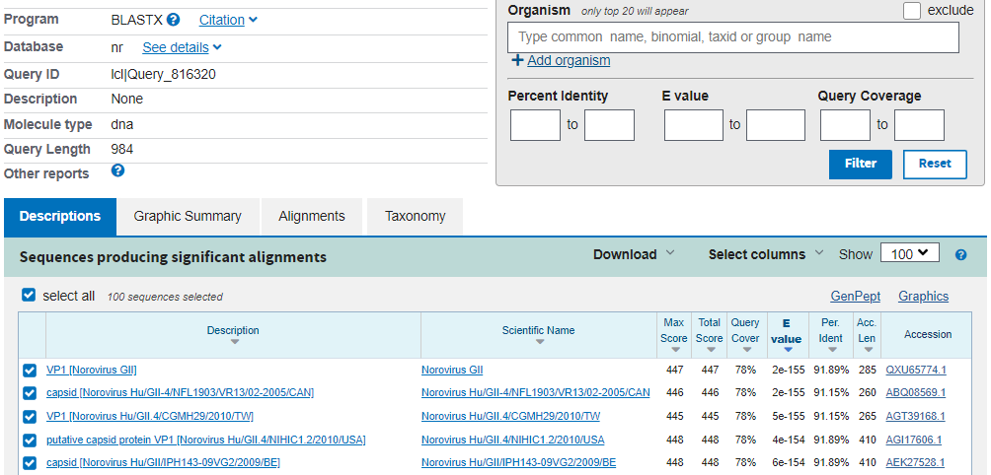

Fig. S4 Sequence result of recombinant VP1 sequence

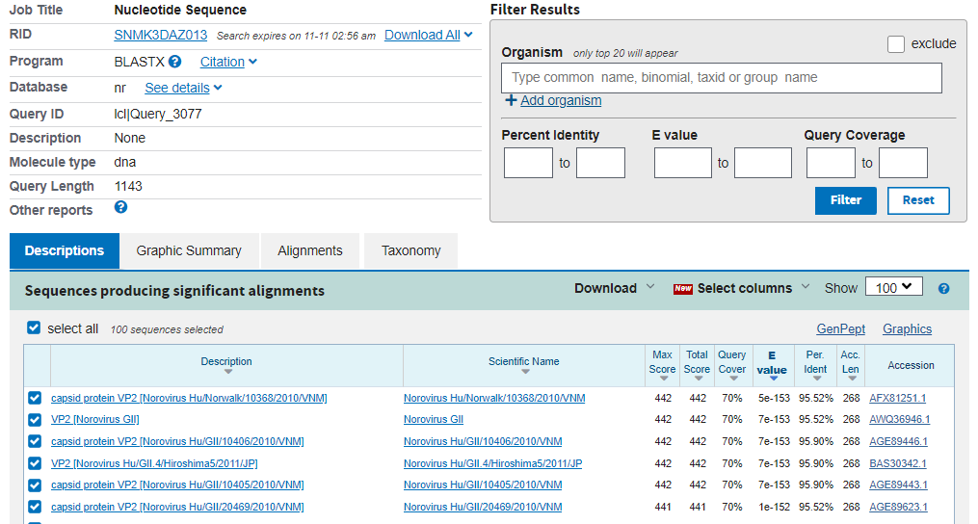

Fig. S5 Sequence result of recombinant VP2 sequence

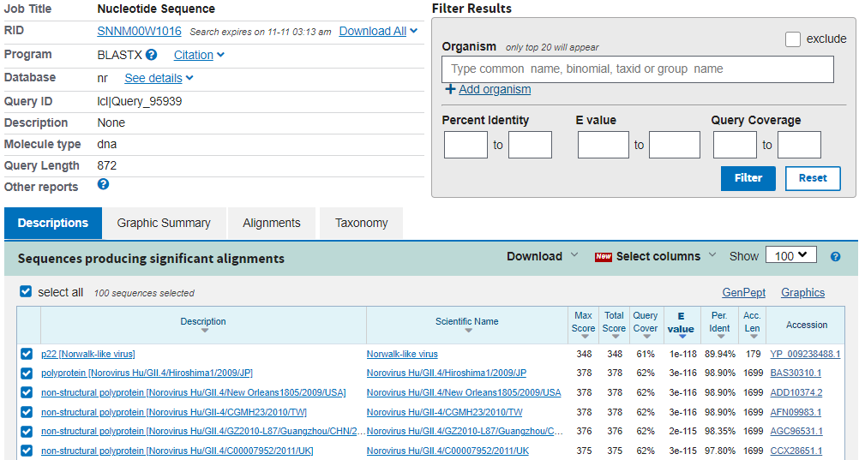

Fig. S6 Sequence result of recombinant p22 sequence

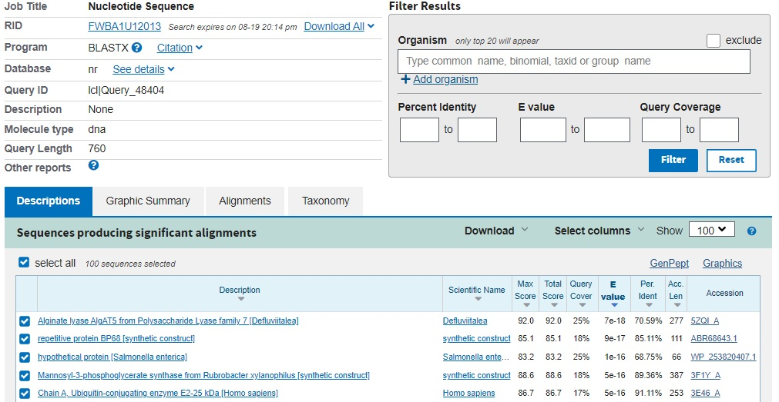

Fig. S7 Sequence result of recombinant EP123 sequence

Table S1 Amounts of proteins before and after desalt process
Recombinant proteins | Amounts of proteins before desalt (mg/mL) | Amounts of proteins after desalt (mg/mL)
VP1 | 0.911 | 0.195
VP2* | 0.347 | 0.341
P22 | 0.952 | 0.325
EP123 | 0.670 | 0.100

