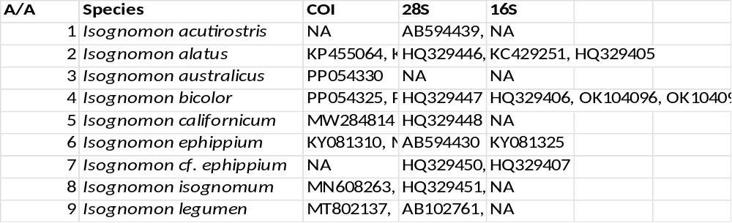Supplementary Table 1. (Sequences and GenBank sequences belonging to the genus Isognomon)

Supplementary Table 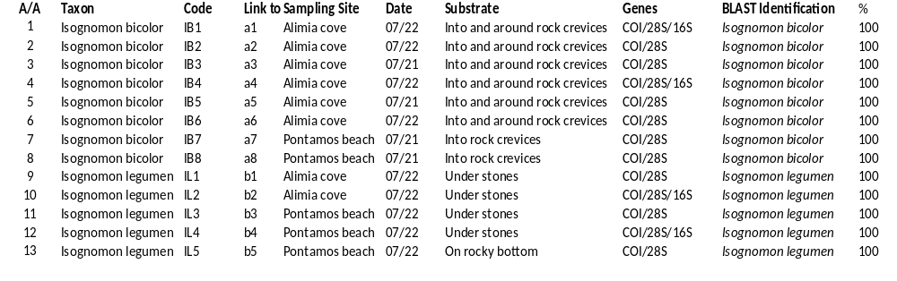2. (Sequence analysis)

Supplementary figure 1. Measurement index
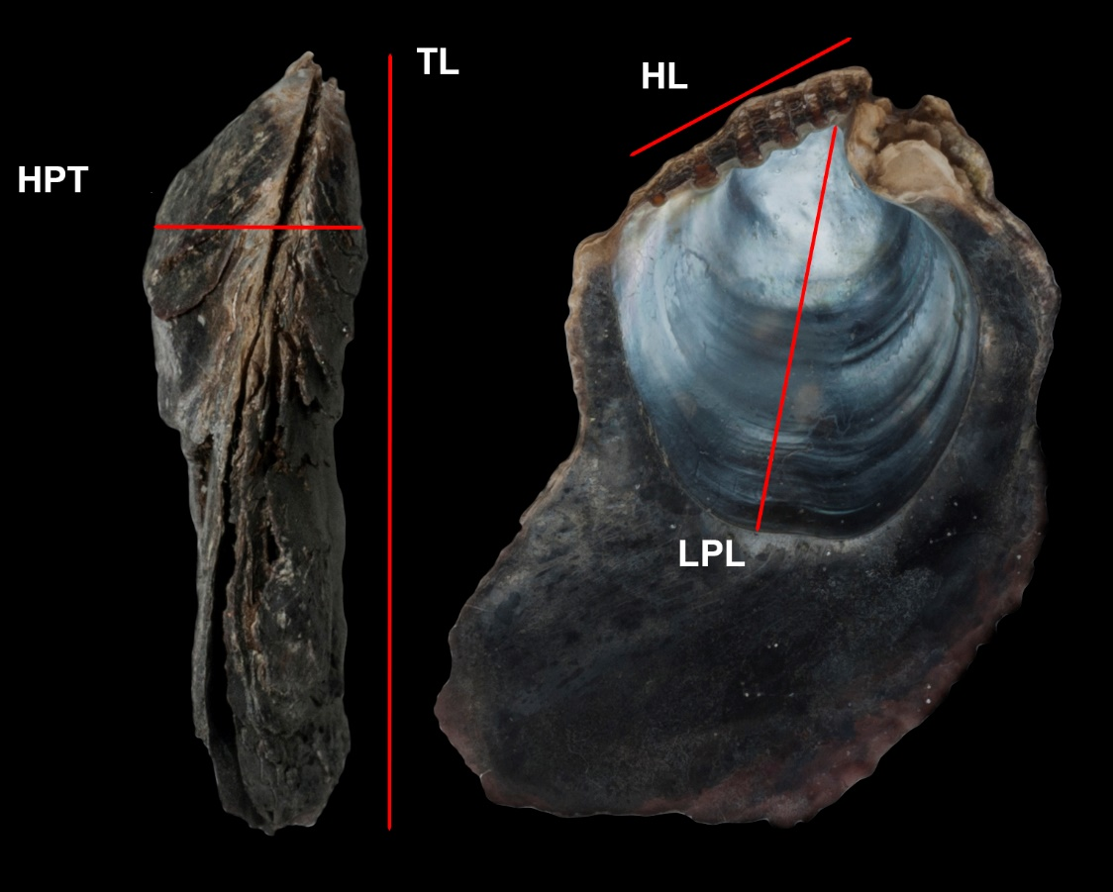

Supplementary Table 3.
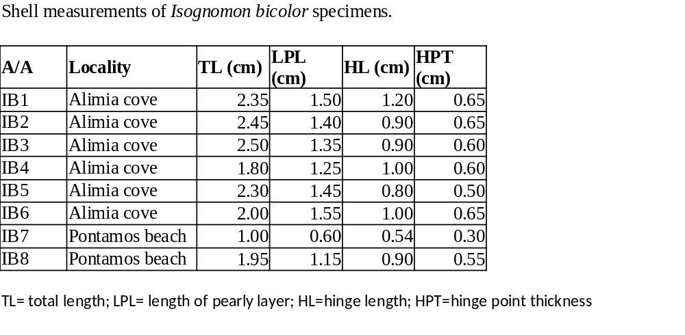
Supplementary Table 4

