Table 2: Model summary of ARIMA of all three timescales (a, b, & c).
(a) SPEI-1
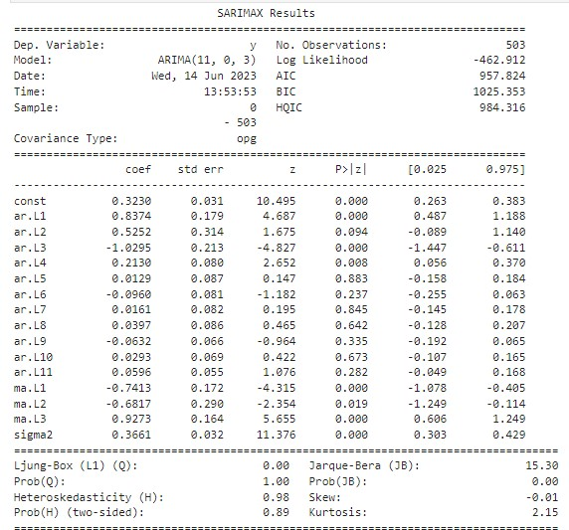

(b) SPEI-3
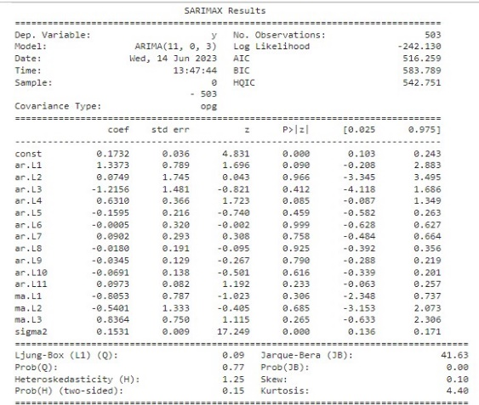

(c) SPEI-6
