Supporting Information for
Estimation of Standardized Precipitation Evapotranspiration Index (SPEI) and drought modeling using ARIMA time series in Raichur, Karnataka, India
Anurag Kashyap¹, Varija K¹, Vikas Poonia^{2,3*}
¹Department of water resources and ocean engineering, NITK Surathkal, Mangaluru, India
²Department of Earth Sciences, Indiana University-Purdue University Indianapolis (IUPUI), USA
³Centre of Excellence in Water Management, Maulana Azad National Institute of Technology Bhopal, M.P, India

*Corresponding Author, email id: vgpcivilengineer@gmail.com

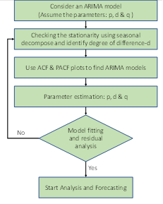
Fig. S1. Flow Diagram of ARIMA Model.

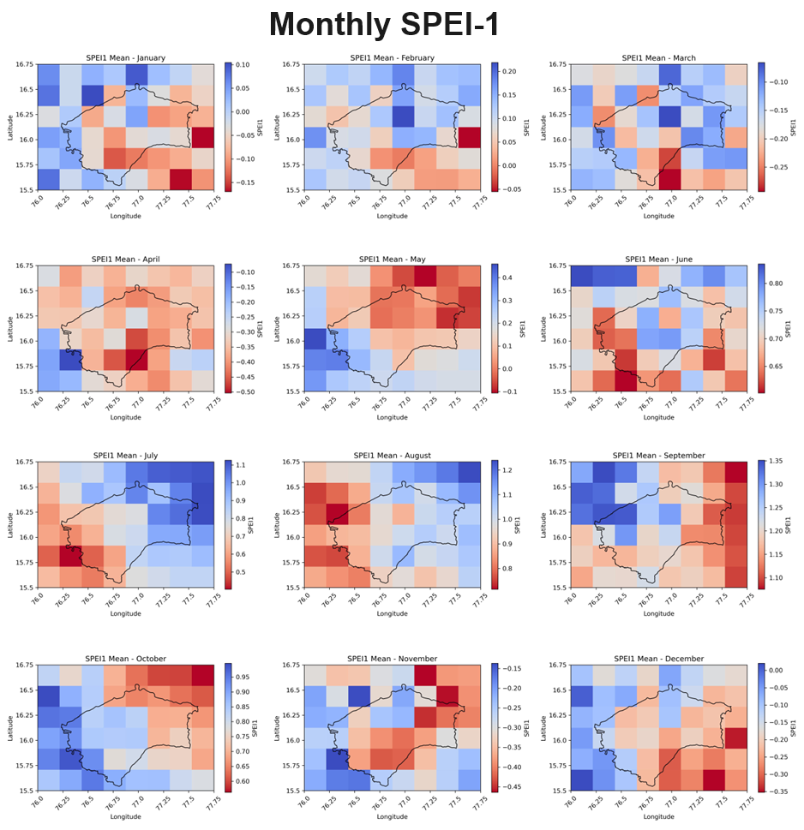
Fig. S2. Monthly plots of SPEI-1

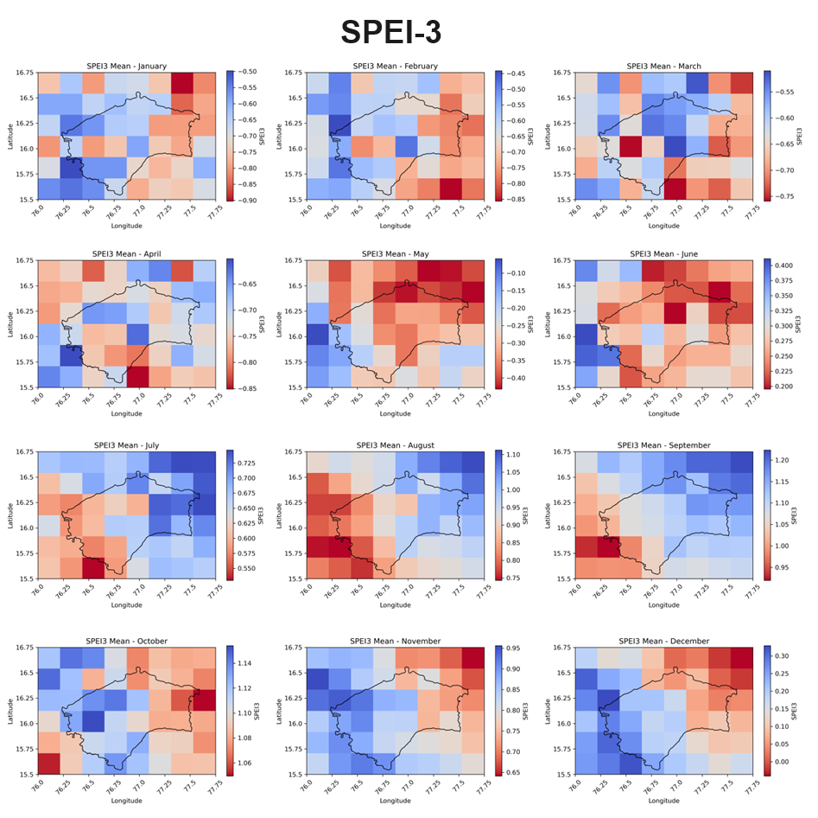
Fig. S3. Monthly plots of SPEI-3

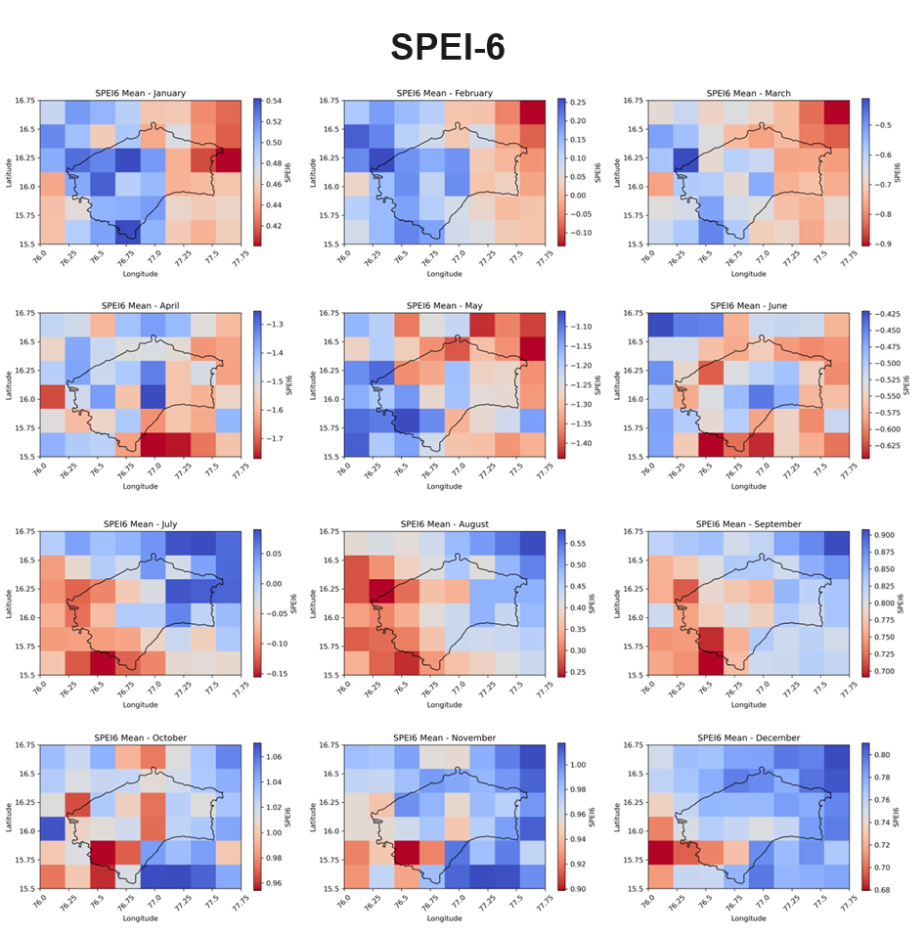
Fig. S4. Monthly plots of SPEI-6

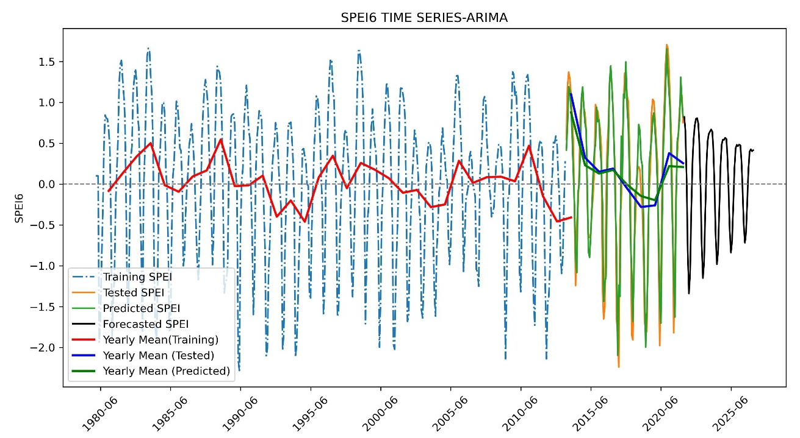
Fig. S5. ARIMA training, testing, prediction and forecast for SPEI-6

