Common Name | Scientific Name | Family Name | Jhum field (15 years back) | Jhum field (5 years back) | Village areas | Photo
Tabby | Pseudorgolis wedah  (Kollar, 1848) | NYMPHALIDAE, Rafinesque, 1815 | 1 | 0 | 0 | 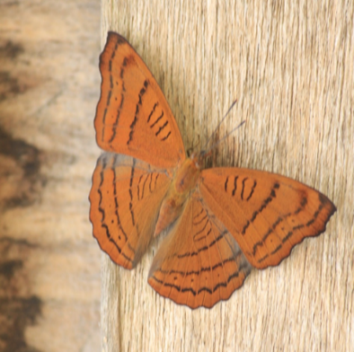
Common Nawab | Polyura athamas  (Drury, 1773) | NYMPHALIDAE, Rafinesque, 1815 | 1 | 1 | 0 | 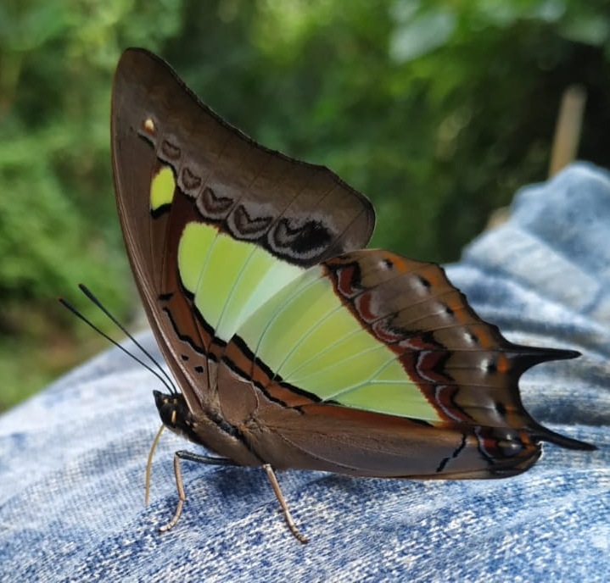
French Duke | Euthalia franciae  (Gray, 1846) | NYMPHALIDAE, Rafinesque, 1815 | 0 | 1 | 0 | 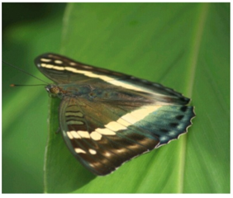
Large Yeoman | Cirrochroa aoris  (Doubleday, 1847) | NYMPHALIDAE, Rafinesque, 1815 | 0 | 1 | 1 | 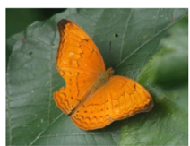
Peninsular Jester | Symbrenthia lilaea  (Hewitson, 1864) | NYMPHALIDAE, Rafinesque, 1815 | 0 | 1 | 0 | 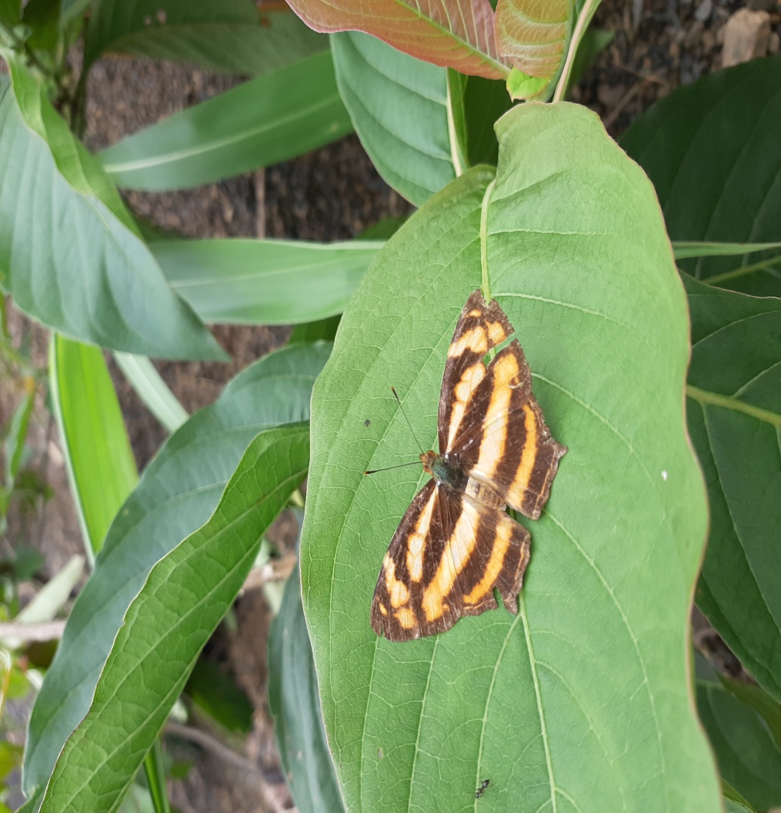
Blue Tailed Jester | Symbrenthi niphanda  (Moore, 1872) | NYMPHALIDAE, Rafinesque, 1815 | 0 | 1 | 0 | 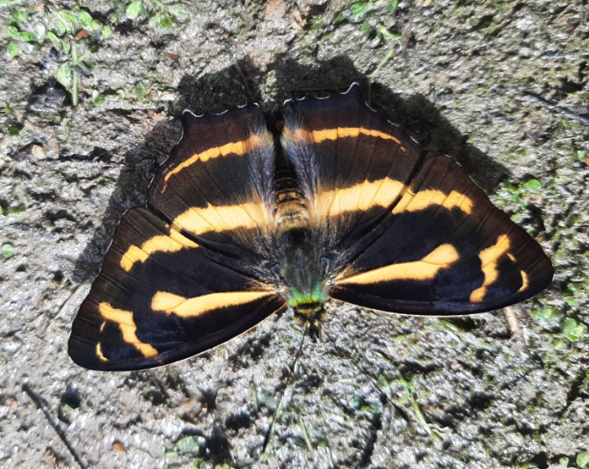
Himalayan Five Ring | Ypthima sakra  (Moore, 1857) | NYMPHALIDAE, Rafinesque, 1815 | 0 | 1 | 0 | 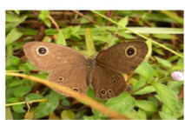
Branded Tree brown | Lethe verma  (Kollar, 1844) | NYMPHALIDAE, Rafinesque, 1815 | 0 | 1 | 0 | 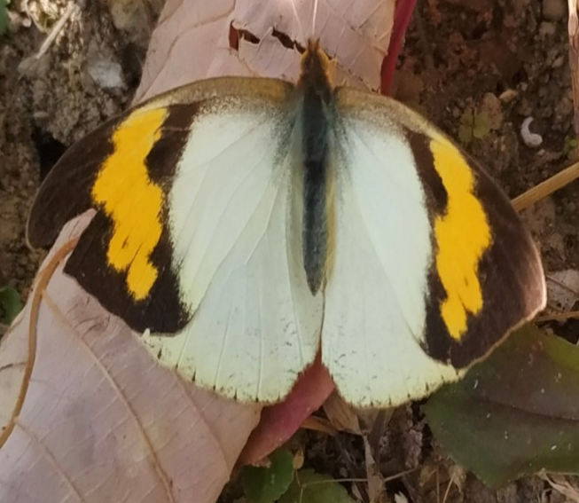
Manipur Map | Araschnia dohertyi  (Moore, 1899) | NYMPHALIDAE, Rafinesque, 1815 | 0 | 1 | 0 | 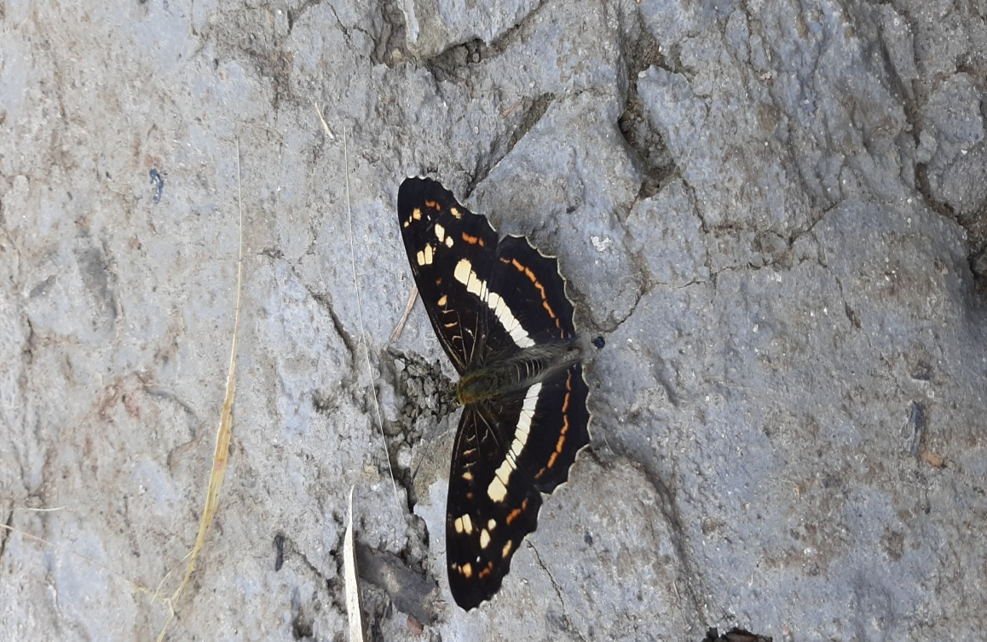
Clear sailor | Neptis nata  (Moore, 1858) | NYMPHALIDAE, Rafinesque, 1815 | 0 | 1 | 1 | 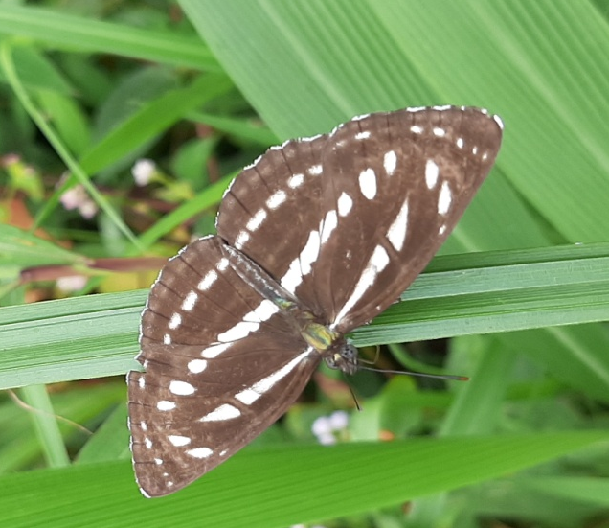
Tiger brown | Orinoma Damaris  (Gray, 1846) | NYMPHALIDAE, Rafinesque, 1815 | 0 | 1 | 1 | 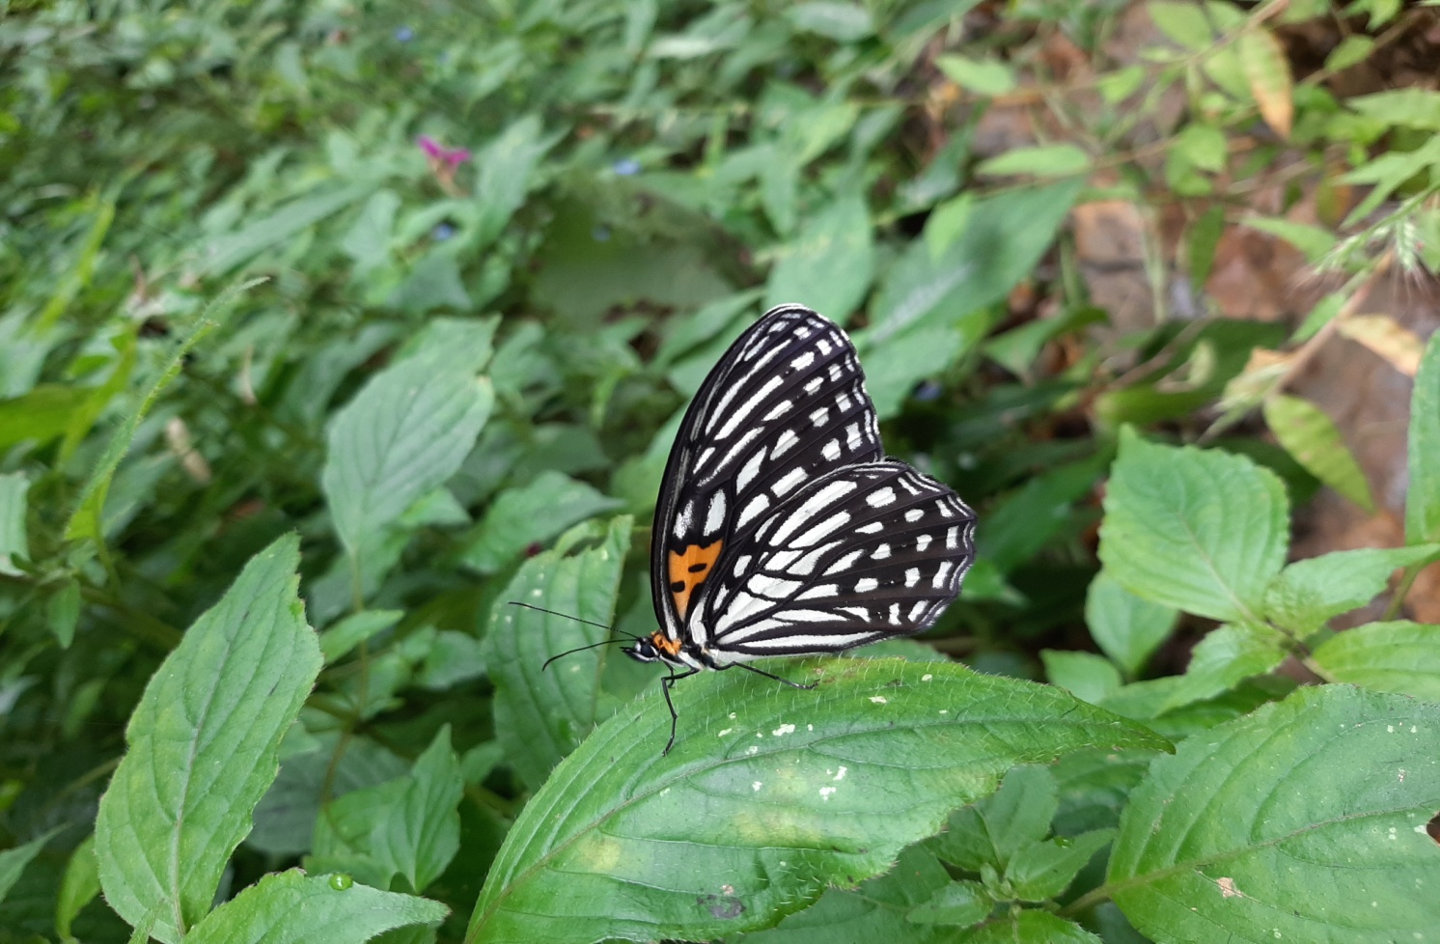
Chocolate tiger | Parantica melaneus  (Cramer, 1775) | NYMPHALIDAE, Rafinesque, 1815 | 0 | 1 | 1 | 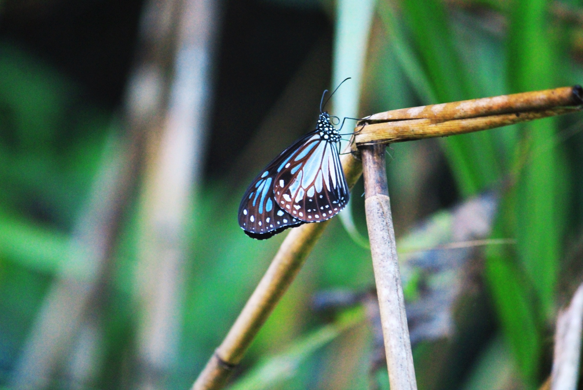
Common wood-Brown | Lethe sidonis  (Hewitson, 1863) | NYMPHALIDAE, Rafinesque, 1815 | 0 | 1 | 0 | 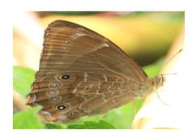
Red Lacewing | Cethosia biblis  (Drury, 1773) | NYMPHALIDAE, Rafinesque, 1815 | 0 | 1 | 1 | 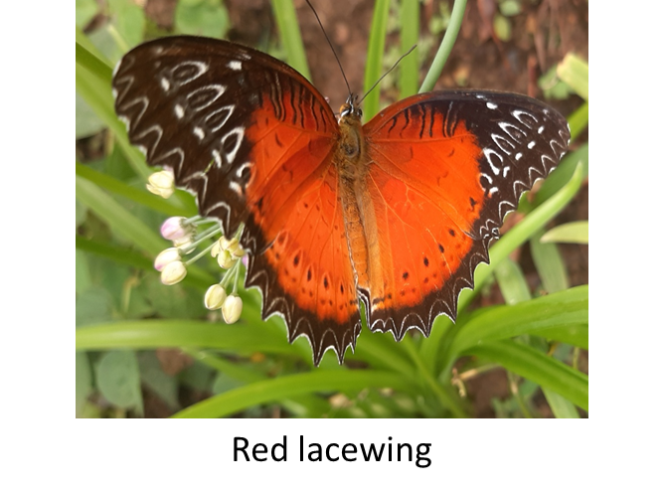
Yellow Coster | Acraea issoria  (Hübner, 1819) | NYMPHALIDAE, Rafinesque, 1815 | 0 | 1 | 1 | 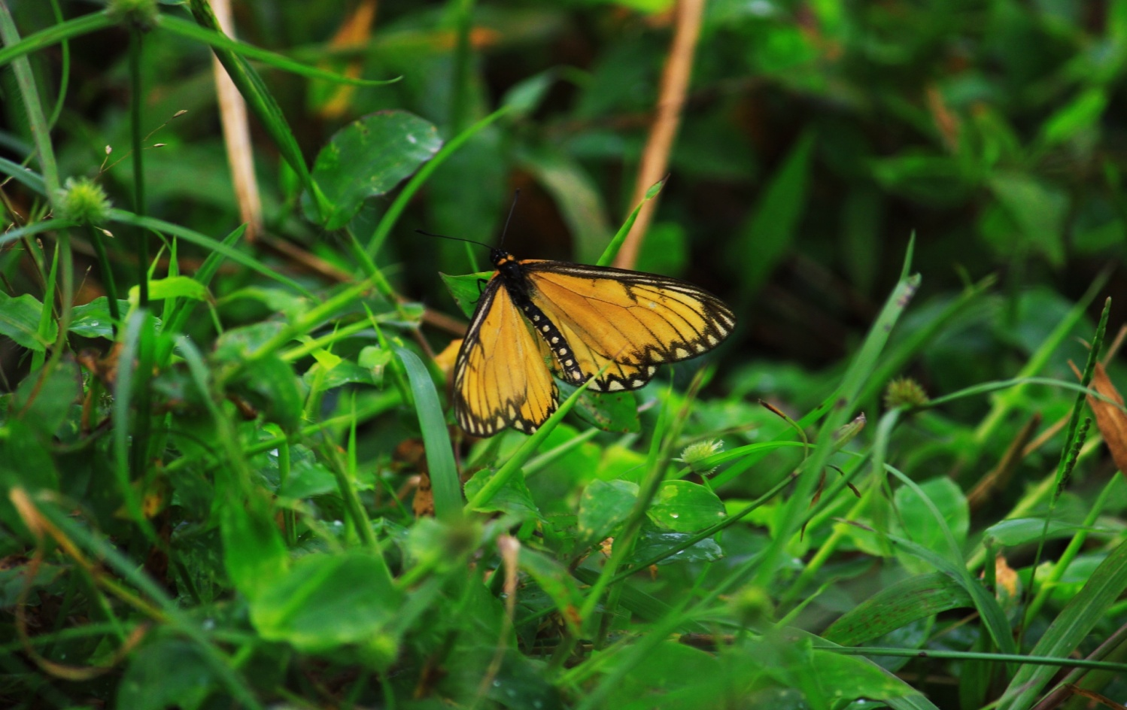
Blue Pansy | Junonia orithya  (Linnaeus, 1758) | NYMPHALIDAE, Rafinesque, 1815 | 0 | 1 | 0 | 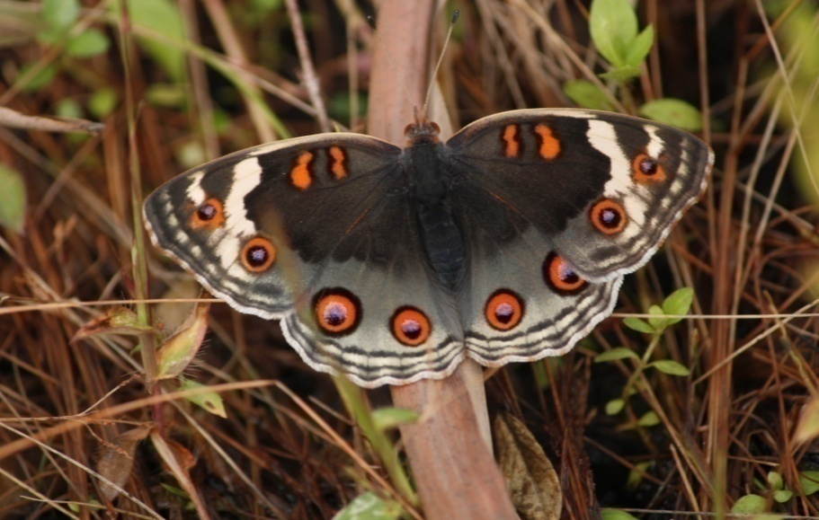
Cruiser | Vindula erota  (Fabricius, 1793) | NYMPHALIDAE, Rafinesque, 1815 | 0 | 1 | 1 | 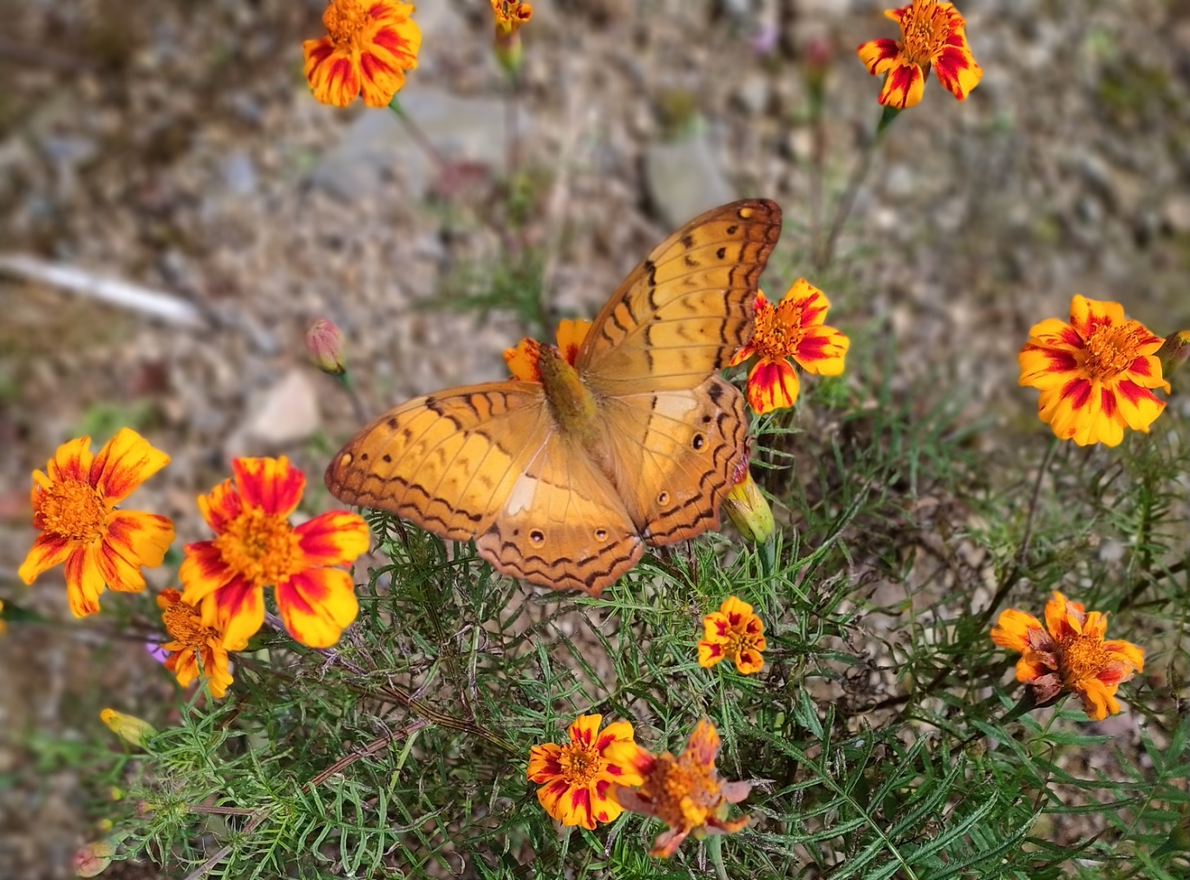
Spotted Sawtooth | Prioneris thestylis  (Doubleday, 1842) | NYMPHALIDAE, Rafinesque, 1815 | 0 | 1 | 1 | 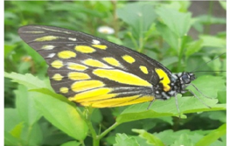
Large silver stripe | Childrena children  (Gray, 1831) | NYMPHALIDAE, Rafinesque, 1815 | 0 | 0 | 1 | 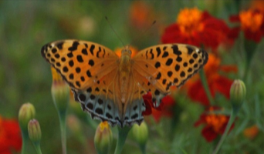
Tropical fritillary | Argynnis hyperbius  (Linnaeus, 1763) | NYMPHALIDAE, Rafinesque, 1815 | 0 | 0 | 1 | 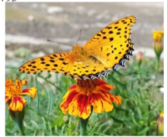
Indian Red Admiral | Vanessa indica  (Herbst, 1794) | NYMPHALIDAE, Rafinesque, 1815 | 0 | 0 | 1 | 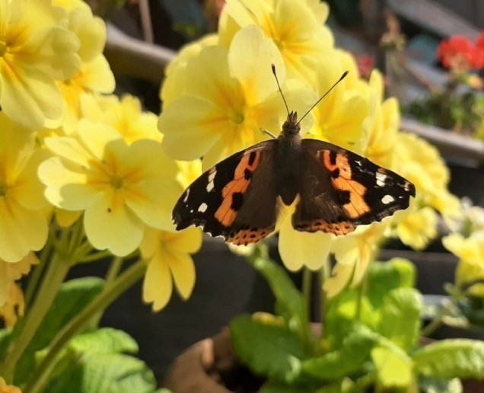
Blue Striped Palmfly | Elymnias patna  (Westwood, 1851) | NYMPHALIDAE, Rafinesque, 1815 | 0 | 0 | 1 | 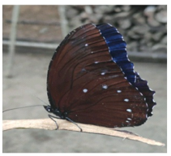
Ringed Argus | Callerebia annada  (Moore, 1858) | NYMPHALIDAE, Rafinesque, 1815 | 0 | 1 | 0 | 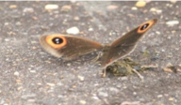
White Owl | Neorina patria  (Leech, 1891) | NYMPHALIDAE, Rafinesque, 1815 | 0 | 1 | 0 | 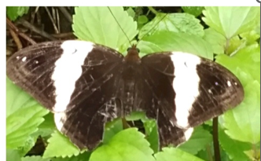
Himalayan Purple Sapphire | Heliophorus episcles latilimbata  (Fruhstorfer, 1908) | LYCAENIDE, Leach, 1815 | 1 | 1 | 0 | 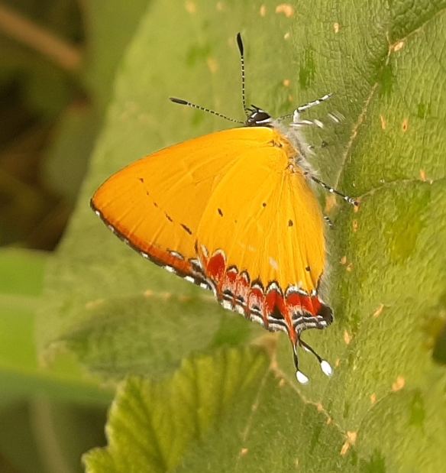
Azure Sapphire | Heliophorus moorei  (Hewitson, 1865) | LYCAENIDE, Leach, 1815 | 1 | 1 | 0 | 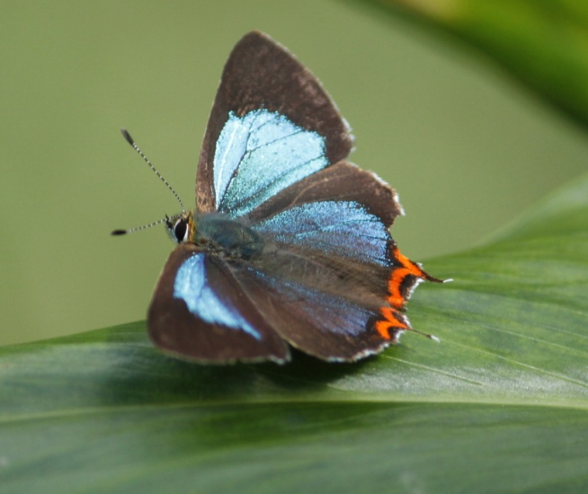
Dark Sapphire | Heliophorus indicus  (Fruhstorfer, 1908) | LYCAENIDE, Leach, 1815 | 1 | 0 | 1 | 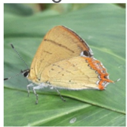
Lime Blue | Chilades lajus  (Stoll, 1780) | LYCAENIDE, Leach, 1815 | 0 | 1 | 1 | 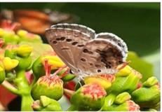
Tailed Judy | Abisara neophron  (Hewitson, 1861) | RIODINIDAE, Grote, 1895 | 1 | 1 | 0 | 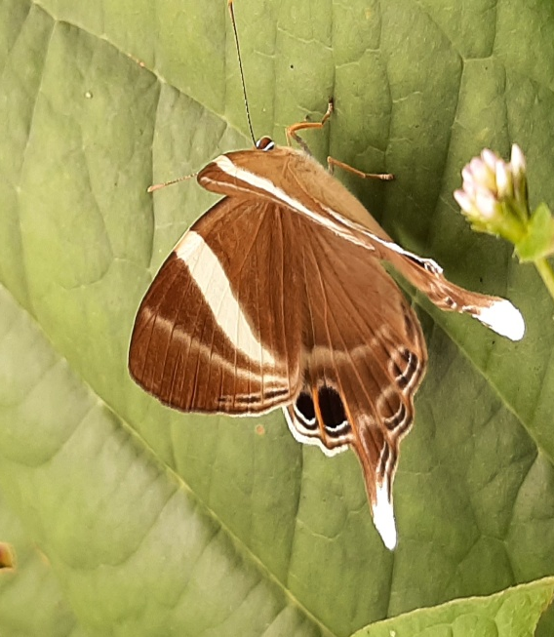
Punchinello | Zemeros flegyas  (Cramer, 1780) | RIODINIDAE, Grote, 1895 | 1 | 1 | 0 | 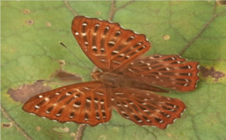
Common grass yellow | Eurema brigitta  (Stoll, 1780) | PIERIDAE, Swainson, 1820 | 1 | 1 | 1 | 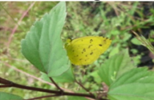
Chocolate albatross | Applas lyncida  (Cramer, [1777]) | PIERIDAE, Swainson, 1820 | 0 | 1 | 0 | 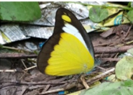
Lesser gull | Cepora nadina  (Lucas, 1852) | PIERIDAE, Swainson, 1820 | 0 | 1 | 1 | 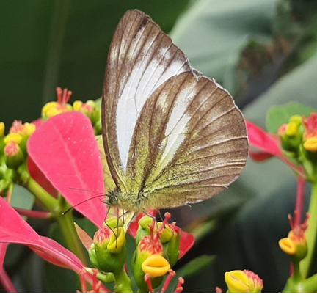
Spot puffin | Appias Lalage  (Doubleday, 1842) | PIERIDAE, Swainson, 1820 | 0 | 1 | 0 | 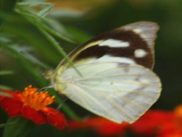
Green veined white | Pieris melete  (Ménétriés, 1857) | PIERIDAE, Swainson, 1820 | 0 | 1 | 1 | 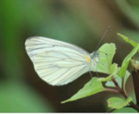
Hill jezebel | Delias belladonna  (Fabricius, 1793) | PIERIDAE, Swainson, 1820 | 0 | 0 | 1 | 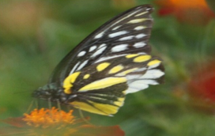
Yellow orange tip | Ixias pyrene  (Linnaeus, 1764) | PIERIDAE, Swainson, 1820 | 0 | 1 | 1
Common windmill | Pyasa polyeuctes  (Doubleday, 1842) | PAPILIONIDAE, Latreille, 1802 | 0 | 1 | 0 | 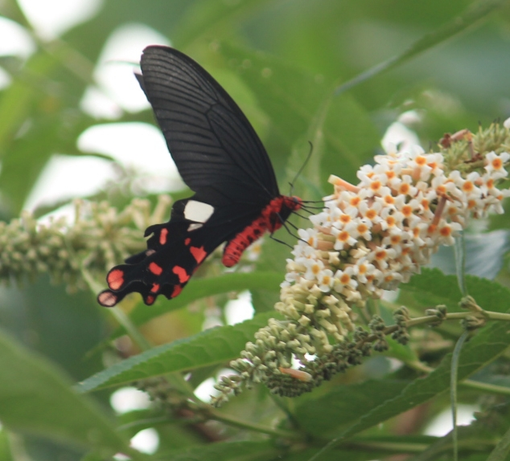
Red Helen Swallowtail | Papilio helenus  (Linnaeus, 1758) | PAPILIONIDAE, Latreille, 1802 | 0 | 1 | 1 | 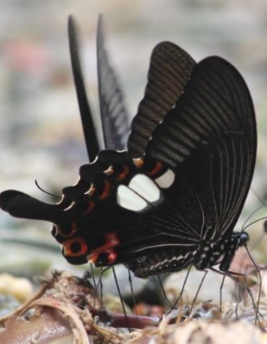
Spangle Swallowtails | Papilio protenor  Cramer, (1775) | PAPILIONIDAE, Latreille, 1802 | 0 | 1 | 0 | 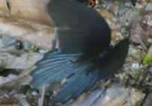
Green Awlet | Burara vasutana  (Moore, 1866) | HESPERIIDAE, Latreille, 1809 | 0 | 0 | 1 | 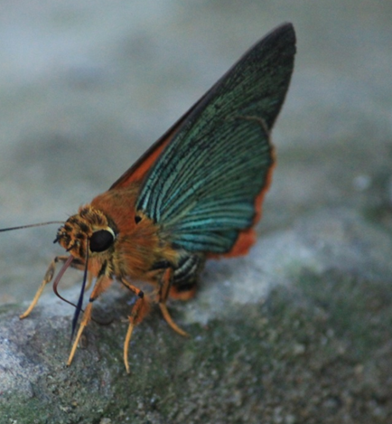
Broad Bident Dart | Potanthus trachala  (Mabille, 1878) | HESPERIIDAE, Latreille, 1809 | 0 | 1 | 0 | 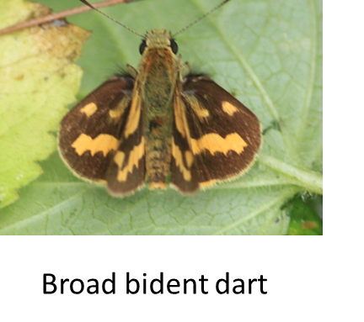
Chocolate Demon | Ancistroides nigrita  (Latreille, 1824) | HESPERIIDAE, Latreille, 1809 | 0 | 0 | 1 | 