Supplementary Materials: The following supporting information can be downloaded at www.mdpi.com/xxx/s1. Figure S1: The process of hyperparameter optimization in the Deepsurv model: (A) hyperparameter optimization history; (B) hyperparameter importance; (C) high-dimensional relationships of hyperparameters. Figure S2: The Schoenfeld residuals test in the Cox regression model. Figure S3: Selecting the optimal cut-off value for SMD via the X-tile tool. Figure S4. Selecting the optimal cut-off value for risk scores via the X-tile tool.
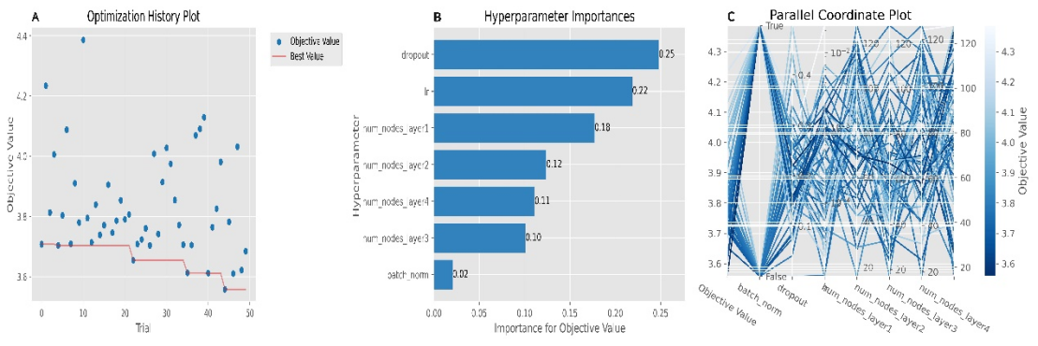
Figure S1. The process of hyperparameter optimization in the Deepsurv model: (A) hyperparameter optimization history; (B) hyperparameter importance; (C) high-dimensional relationships of hyperparameters.
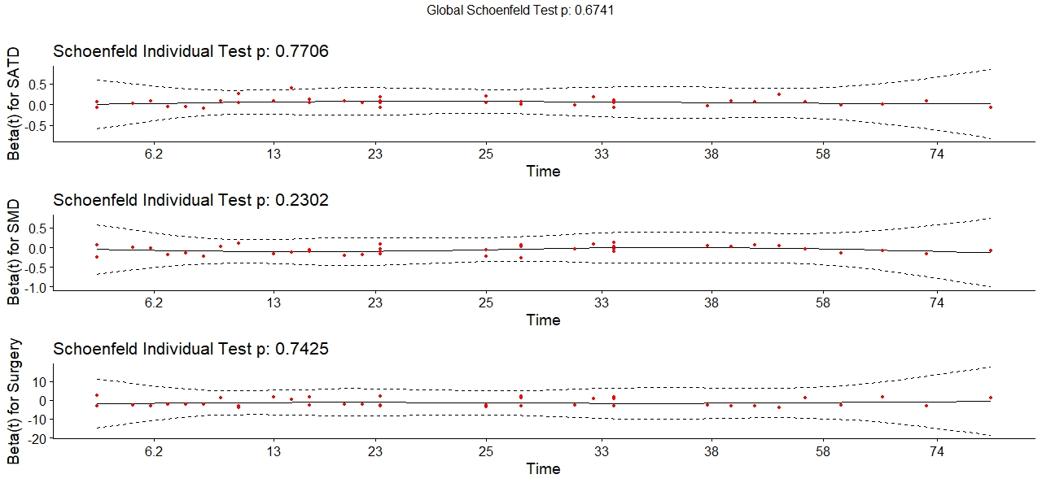
Figure S2. The Schoenfeld residuals test in the Cox regression model.
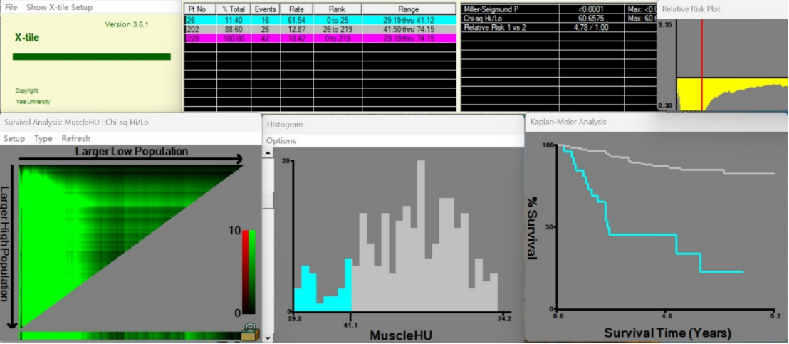
Figure S3. Selecting the optimal cut-off value for SMD via the X-tile tool.
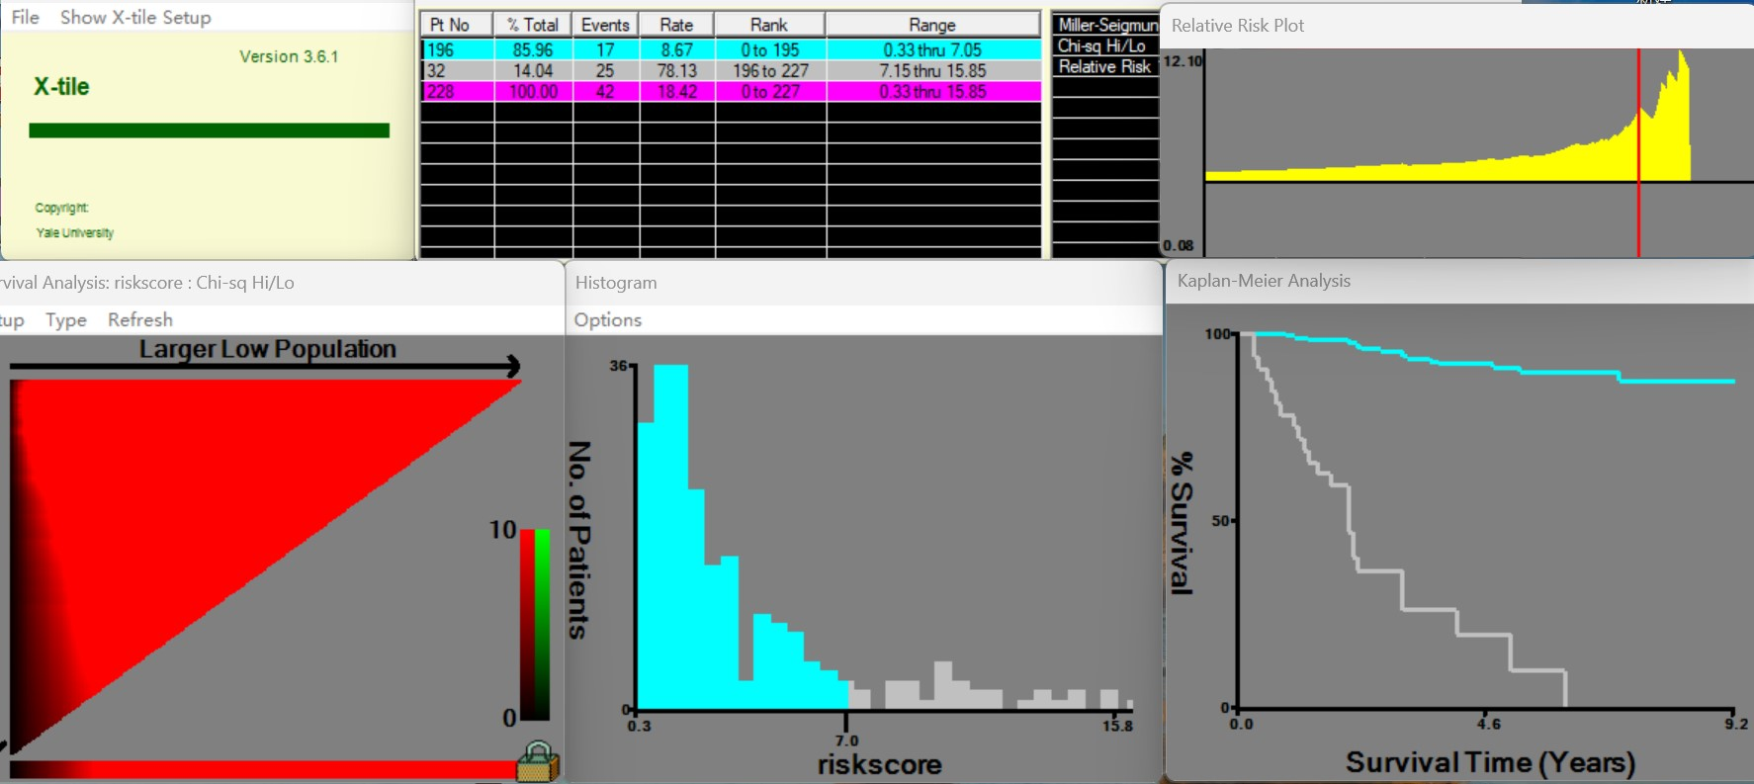
Figure S4. Selecting the optimal cut-off value for risk scores via the X-tile tool.

