Supplementary Information for

Deciphering Earth’s deep mantle hemispheric geochemical dichotomy with machine learning

Shang Ma¹, Zefeng Li^{1,2*}, Ling Chen^{3*}, Ji Shen¹, Yunguo Li¹, Wenzhong Wang¹ and Wei Leng¹

- School of Earth and Space Sciences, University of Science and Technology of China, Hefei, China
- Mengcheng National Geophysical Observatory, University of Science and Technology of China, Mengcheng, China
- State Key Laboratory of Lithospheric Evolution, Institute of Geology and Geophysics, Chinese Academy of Sciences, Beijing, China

*Corresponding authors: Zefeng Li (zefengli@ustc.edu.cn),
Ling Chen (lchen@mail.iggcas.ac.cn)

Manuscript submitted to Nature Communications
May 4, 2024
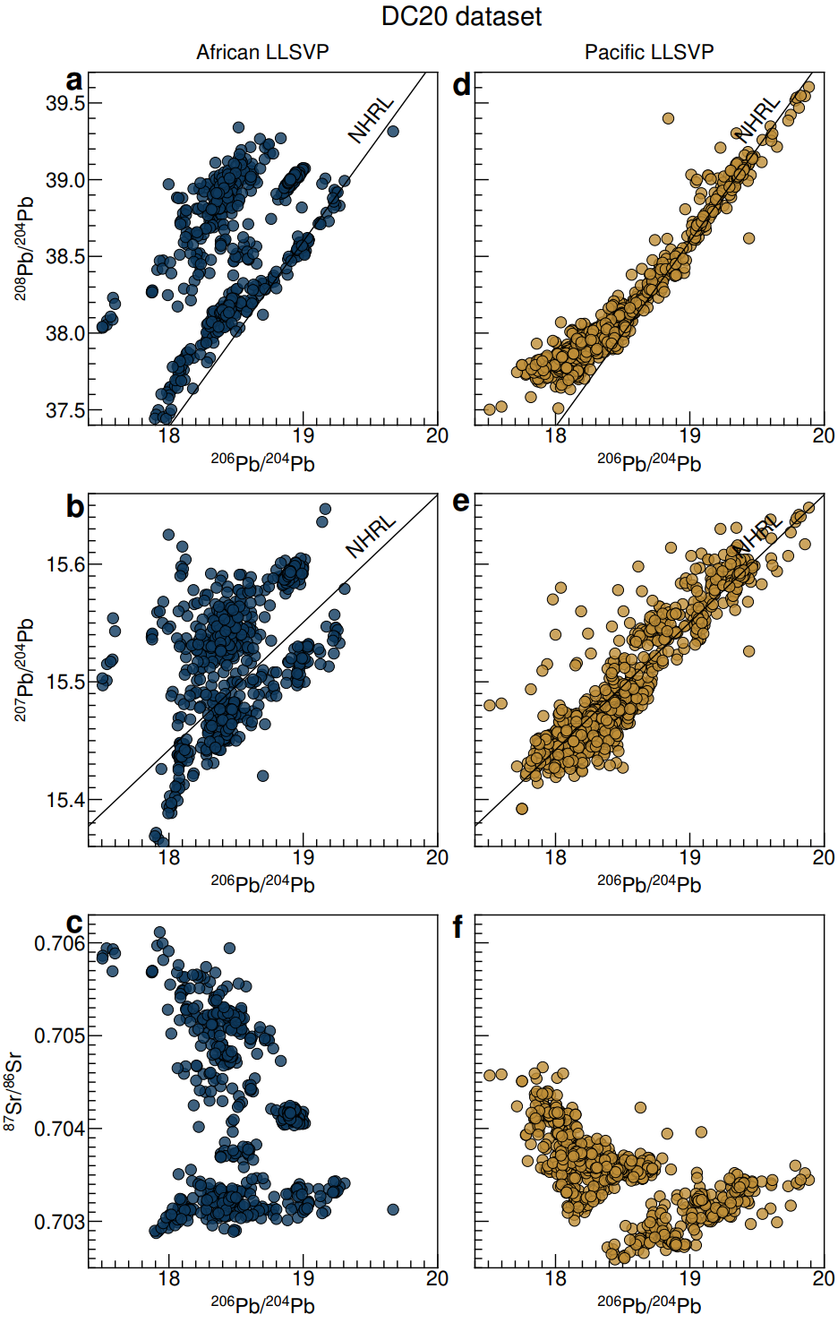
Figure S1. Isotopic signatures of the DC20 dataset divided by African and Pacific LLSVPs. A total of 625 samples from the African LLSVP region and 1,184 samples from the Pacific LLSVP region are represented by blue and yellow dots, respectively. (a), (d) ²⁰⁸Pb/²⁰⁴Pb versus ²⁰⁶Pb/²⁰⁴Pb. (b), (d) ²⁰⁷Pb/²⁰⁴Pb versus ²⁰⁶Pb/²⁰⁴Pb. (c), (f) ⁸⁷Sr/⁸⁶Sr versus ²⁰⁶Pb/²⁰⁴Pb. The black lines show the North Hemispherical Reference Line (NHRL)¹.
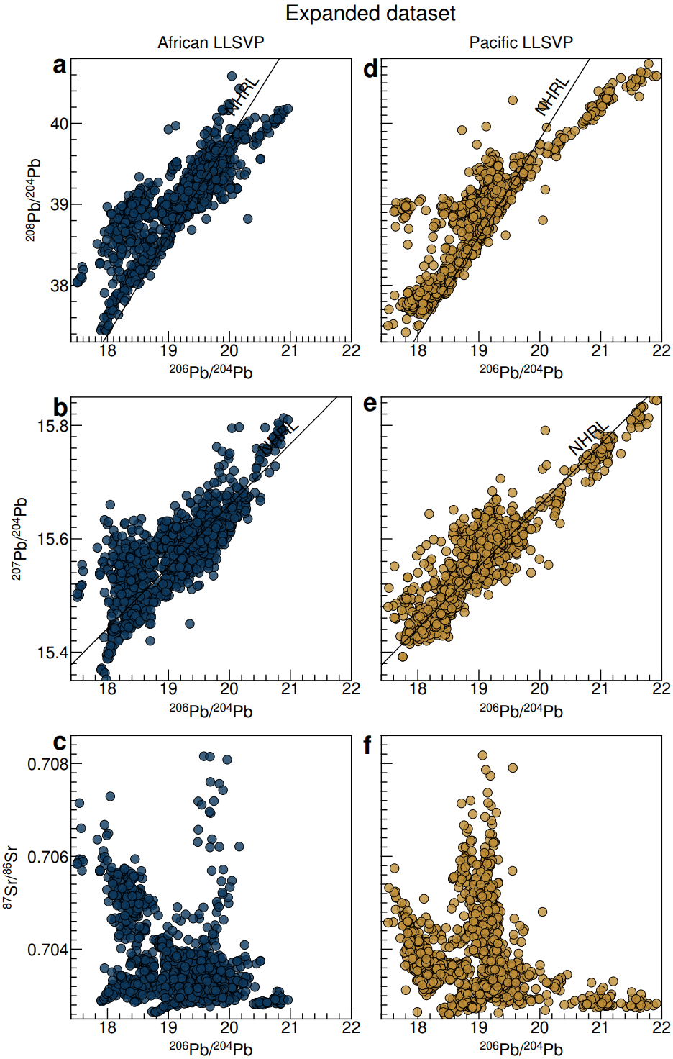
Figure S2. Isotopic signatures of the expanded dataset divided by African and Pacific LLSVPs. A total of 1,522 samples were obtained from the African LLSVP, and 1,942 samples were obtained from the Pacific LLSVP.
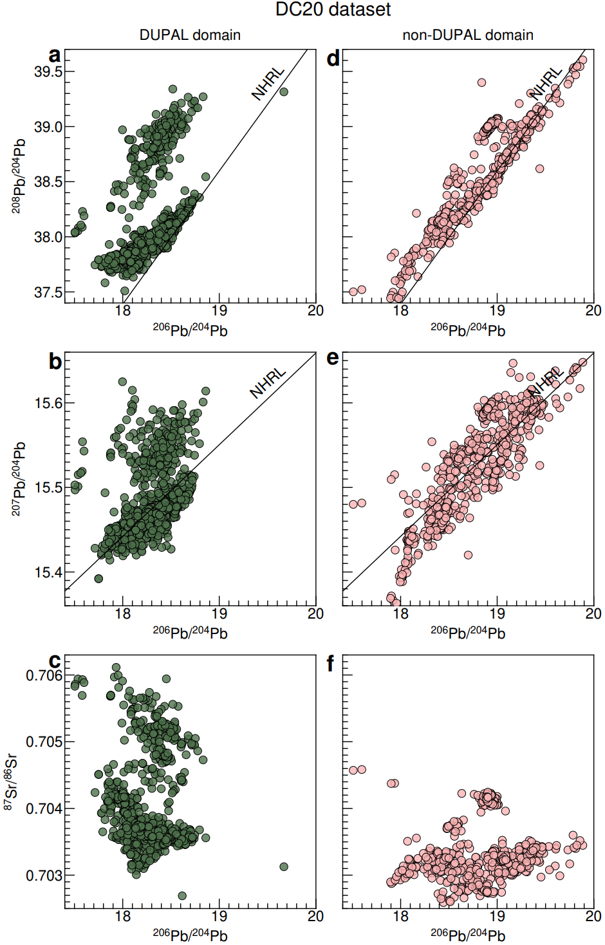
Figure S3. Isotopic signatures of the DC20 dataset divided by the DUPAL and non-DUPAL domains. A total of 1,150 samples from the DUPAL domain and 659 samples from the non-DUPAL domain are represented by green and pink dots, respectively. (a), (d) ²⁰⁸Pb/²⁰⁴Pb versus ²⁰⁶Pb/²⁰⁴Pb. (b), (e) ²⁰⁷Pb/²⁰⁴Pb versus ²⁰⁶Pb/²⁰⁴Pb. (c), (f) ⁸⁷Sr/⁸⁶Sr versus ²⁰⁶Pb/²⁰⁴Pb.
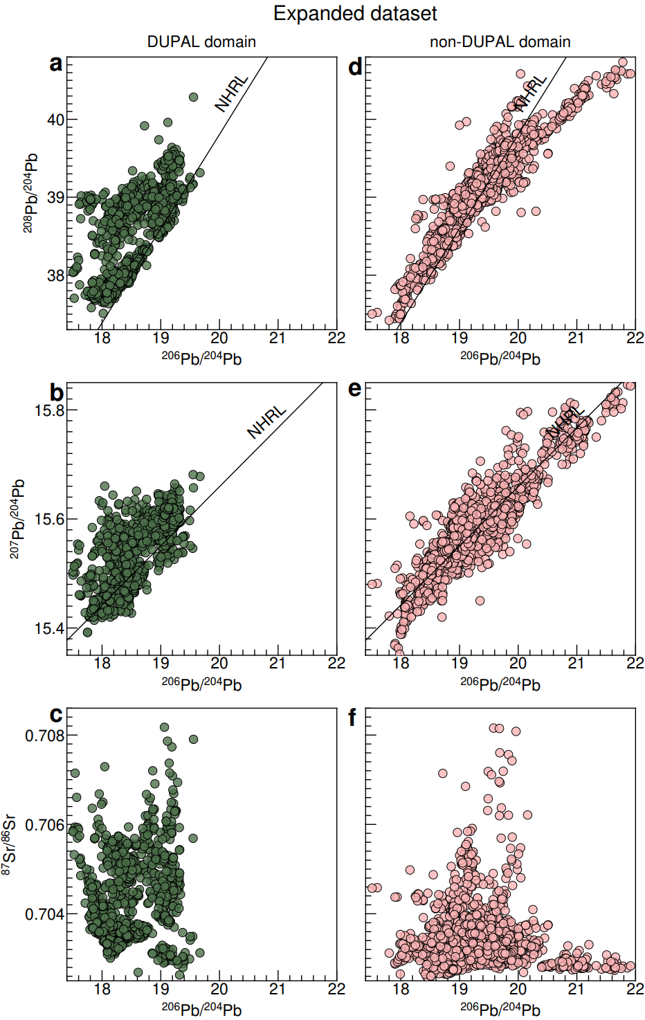
Figure S4. Isotopic signatures of the expanded dataset divided by the DUPAL and non-DUPAL domains. A total of 1,571 samples were from the DUPAL domain, and 1,893 samples were from the non-DUPAL domain.
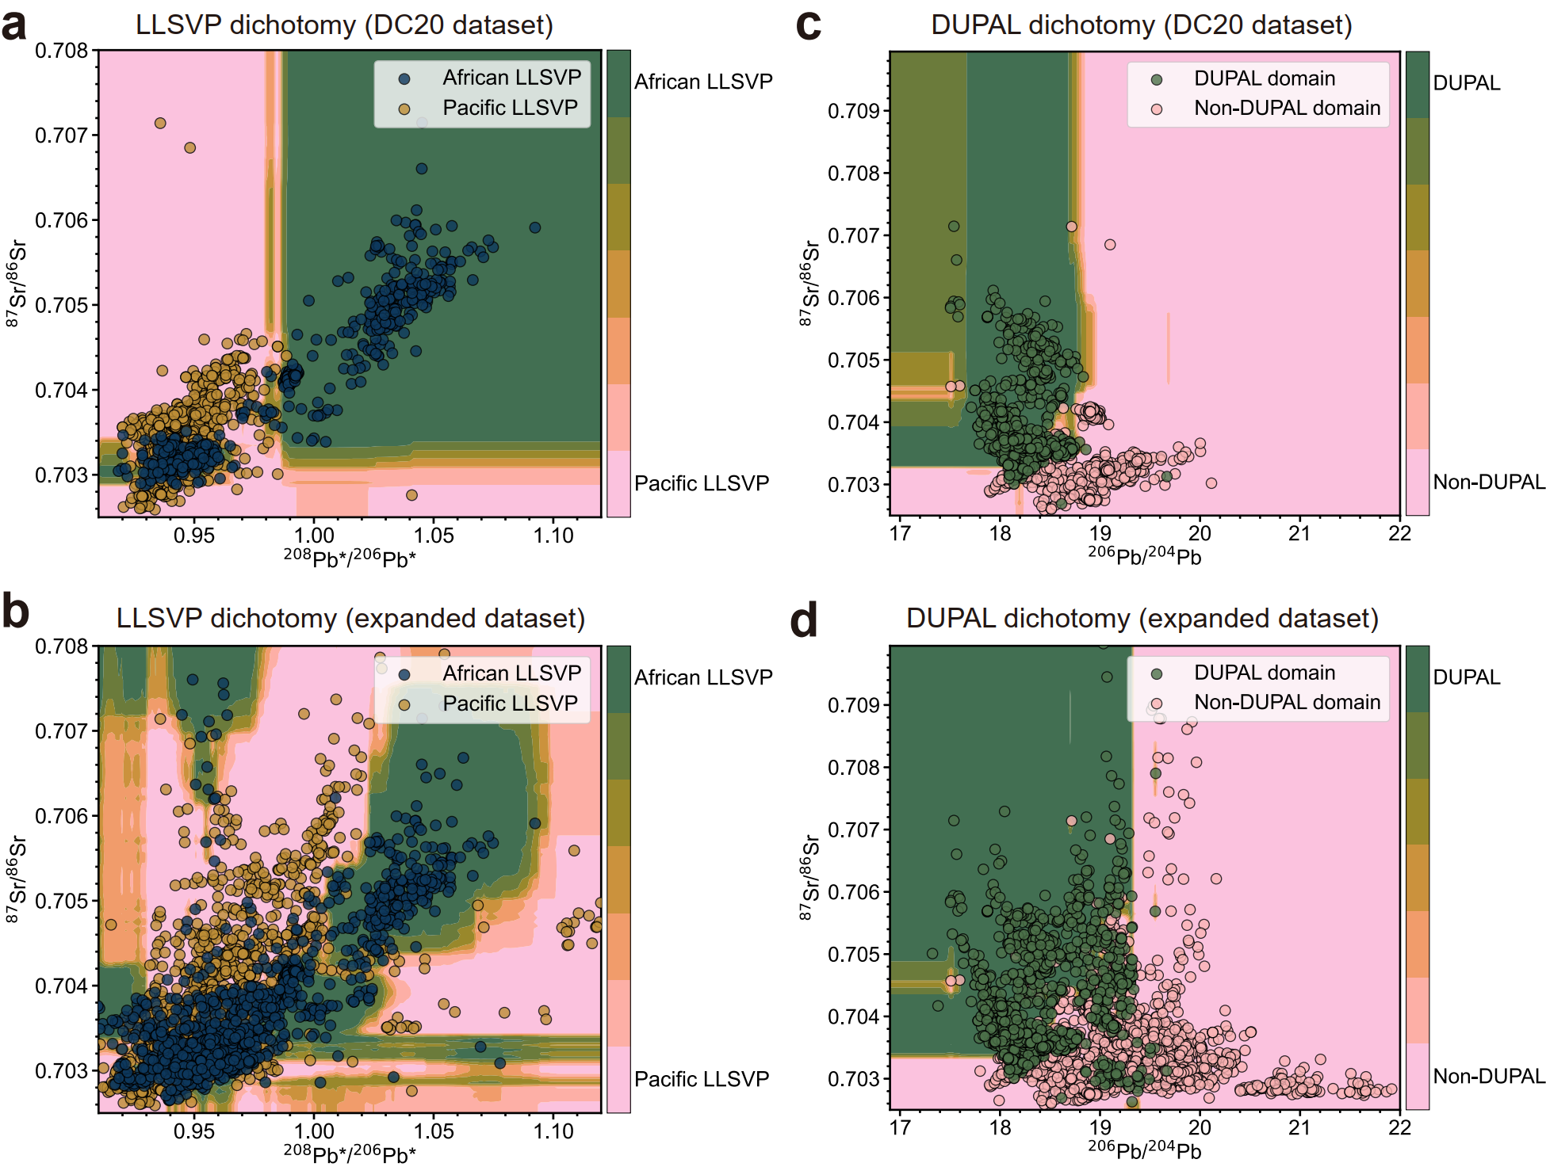
Figure S5. Isotopic distributions and decision boundaries for the LLSVP (a, b) and DUPAL (c, d) dichotomies using the DC20 and expanded datasets. (a) Decision boundary of random forest classifications from 1000 sampling runs in the ⁸⁷Sr/⁸⁶S versus ²⁰⁸Pb*/²⁰⁶Pb* isotopic space for the LLSVP dichotomy using the DC20 dataset. The blue and yellow dots are from African and Pacific LLSVPs, respectively. (b) Similar to (a) but for the LLSVP dichotomy using the expanded dataset. (c) Similar to (a) but in the isotopic space of ⁸⁷Sr/⁸⁶Sr and ²⁰⁶Pb/²⁰⁴Pb for the DUPAL dichotomy using the DC20 dataset. The green and pink dots are from the DUPAL and non-DUPAL domains, respectively. (d) Similar to (c) but for the DUPAL dichotomy using the expanded dataset.
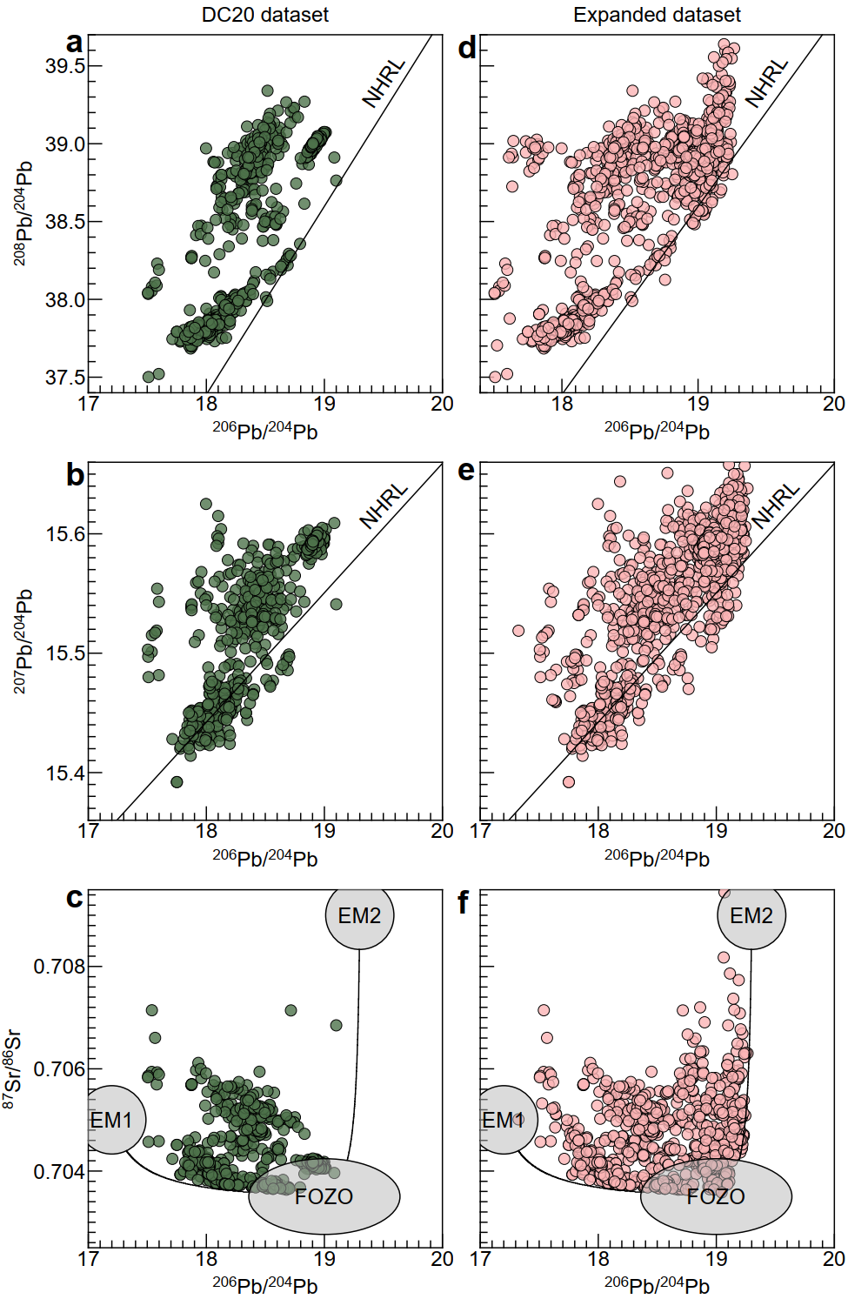
Figure S6. Isotopic signatures of samples that satisfy the refined definition of the DUPAL anomaly. (a), (d) ²⁰⁸Pb/²⁰⁴Pb versus ²⁰⁶Pb/²⁰⁴Pb. (b), (e) ²⁰⁷Pb/²⁰⁴Pb versus ²⁰⁶Pb/²⁰⁴Pb. (c), (f) ⁸⁷Sr/⁸⁶Sr versus ²⁰⁶Pb/²⁰⁴Pb.

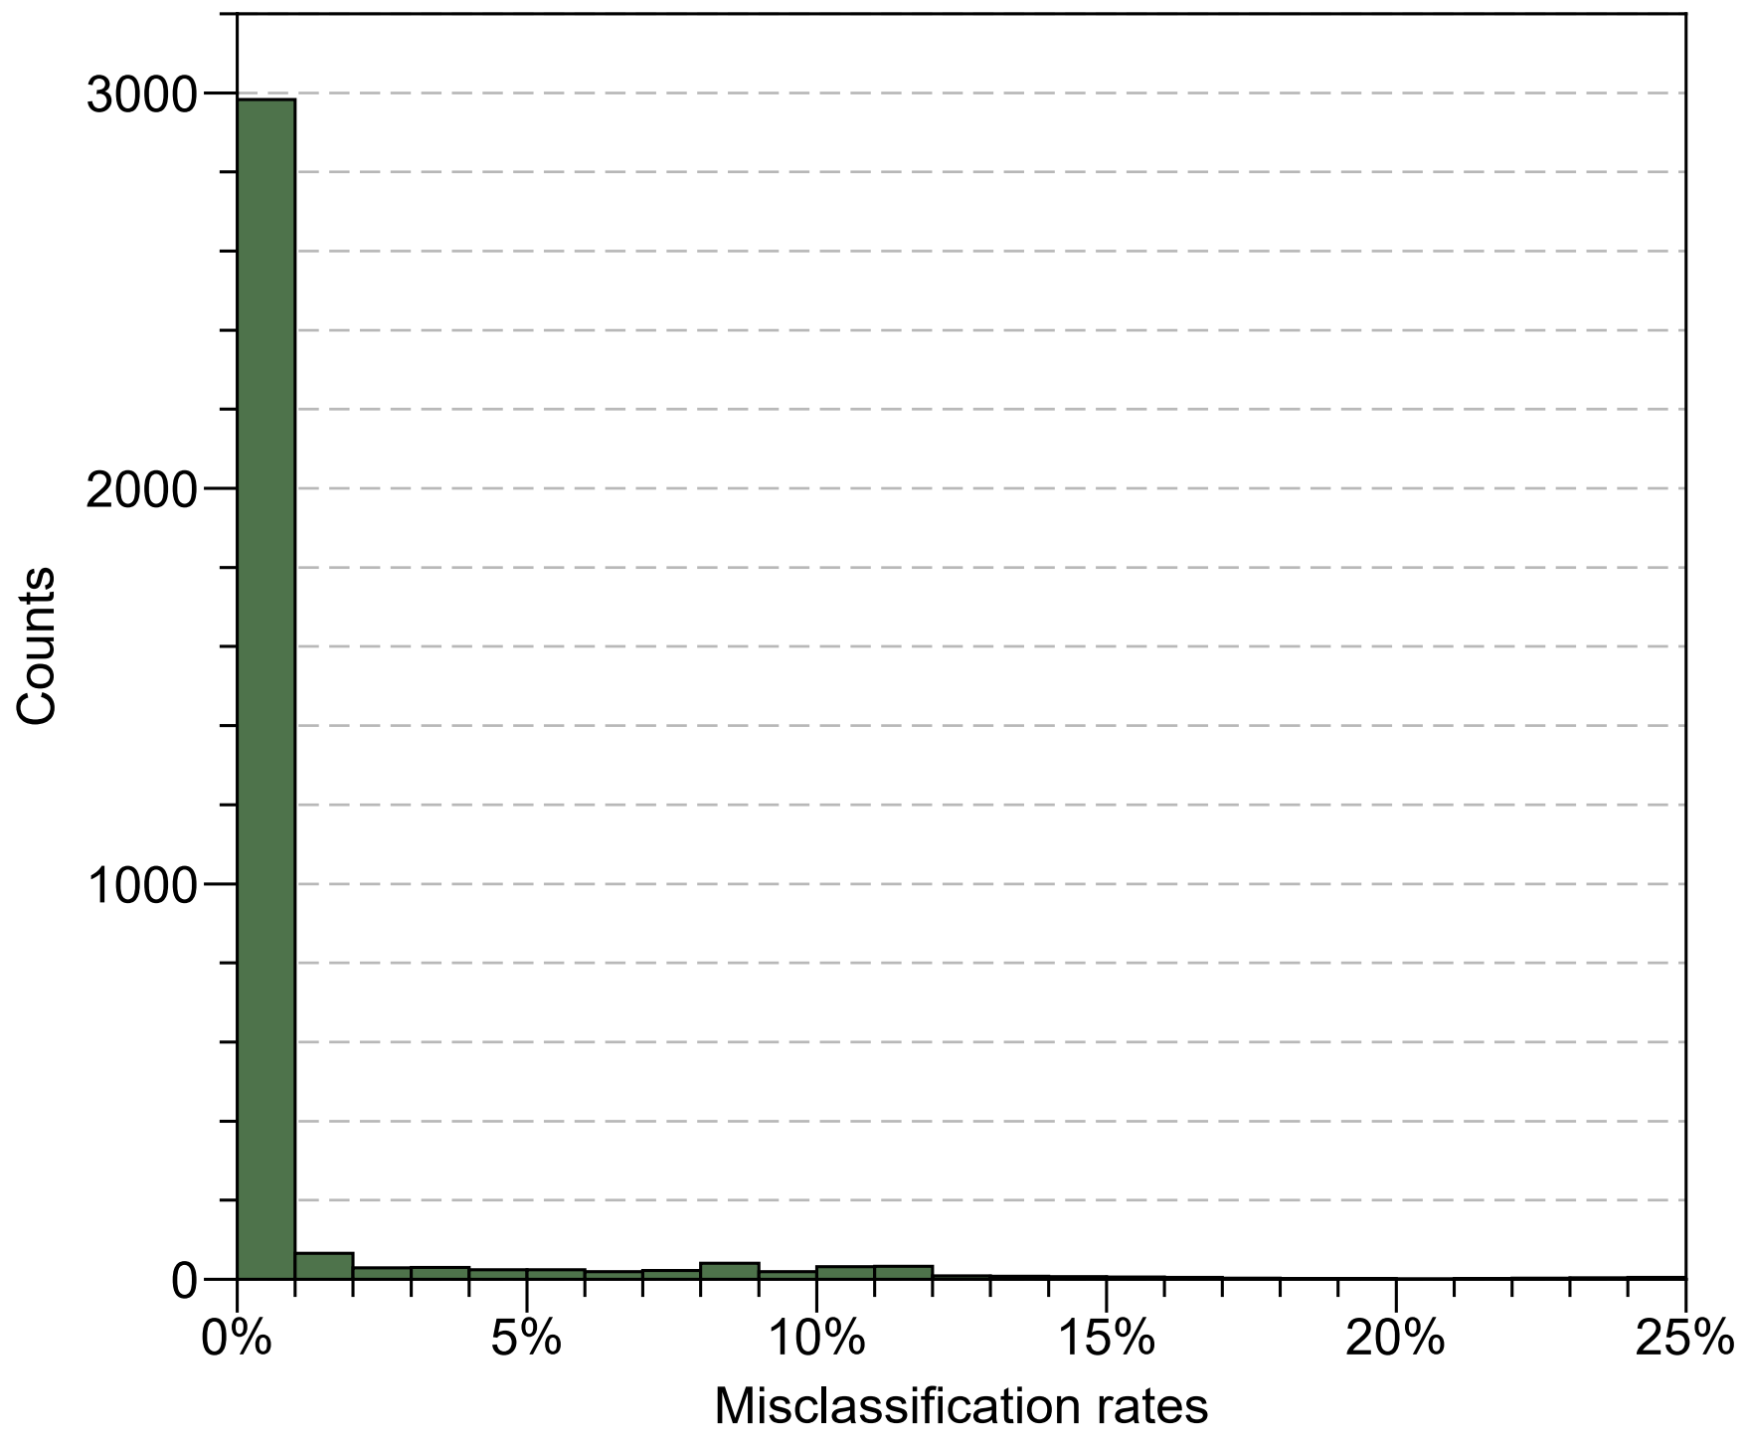
Figure S7. Distribution of misclassification rates from 1000 bootstrapping tests for the DUPAL dichotomy using the expanded dataset.
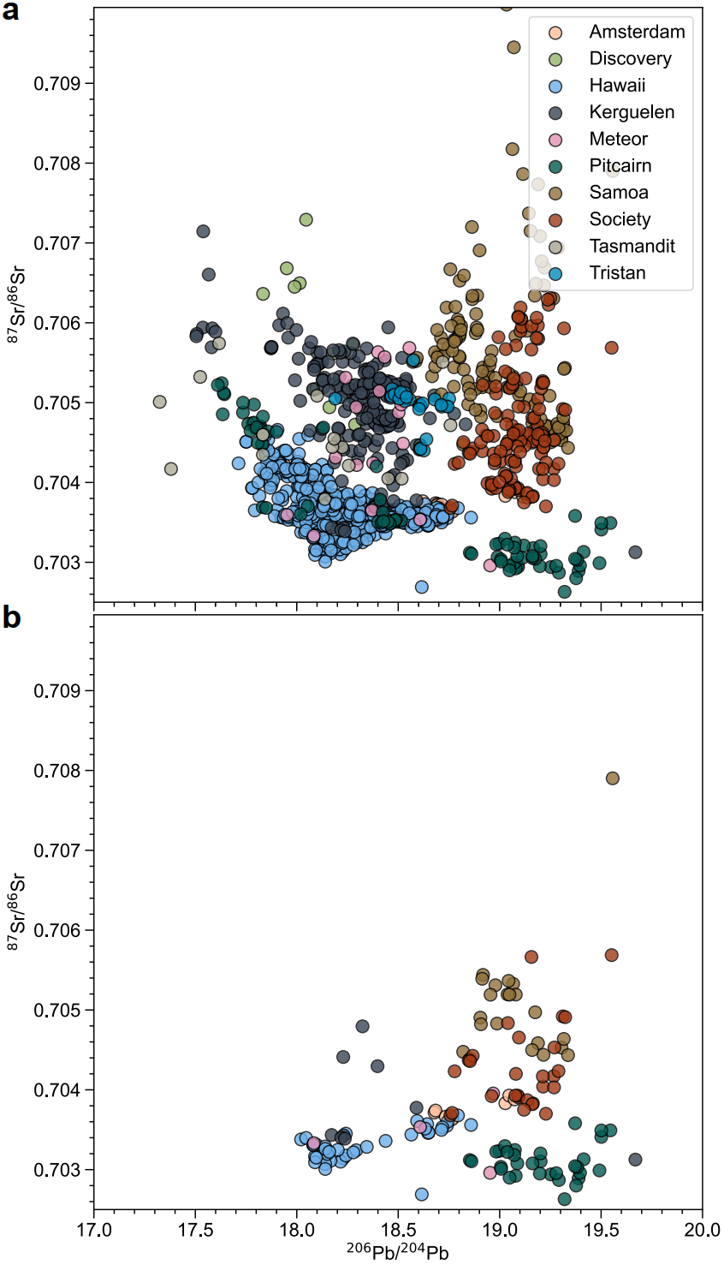
Figure S8. Isotopic variations within different hotspots within the DUPAL domain according to the expanded dataset. (a) ⁸⁷Sr/⁸⁶Sr versus ²⁰⁶Pb/²⁰⁴Pb for all samples. (b) Similar to (a) but for samples with a misclassification rate > 10%.
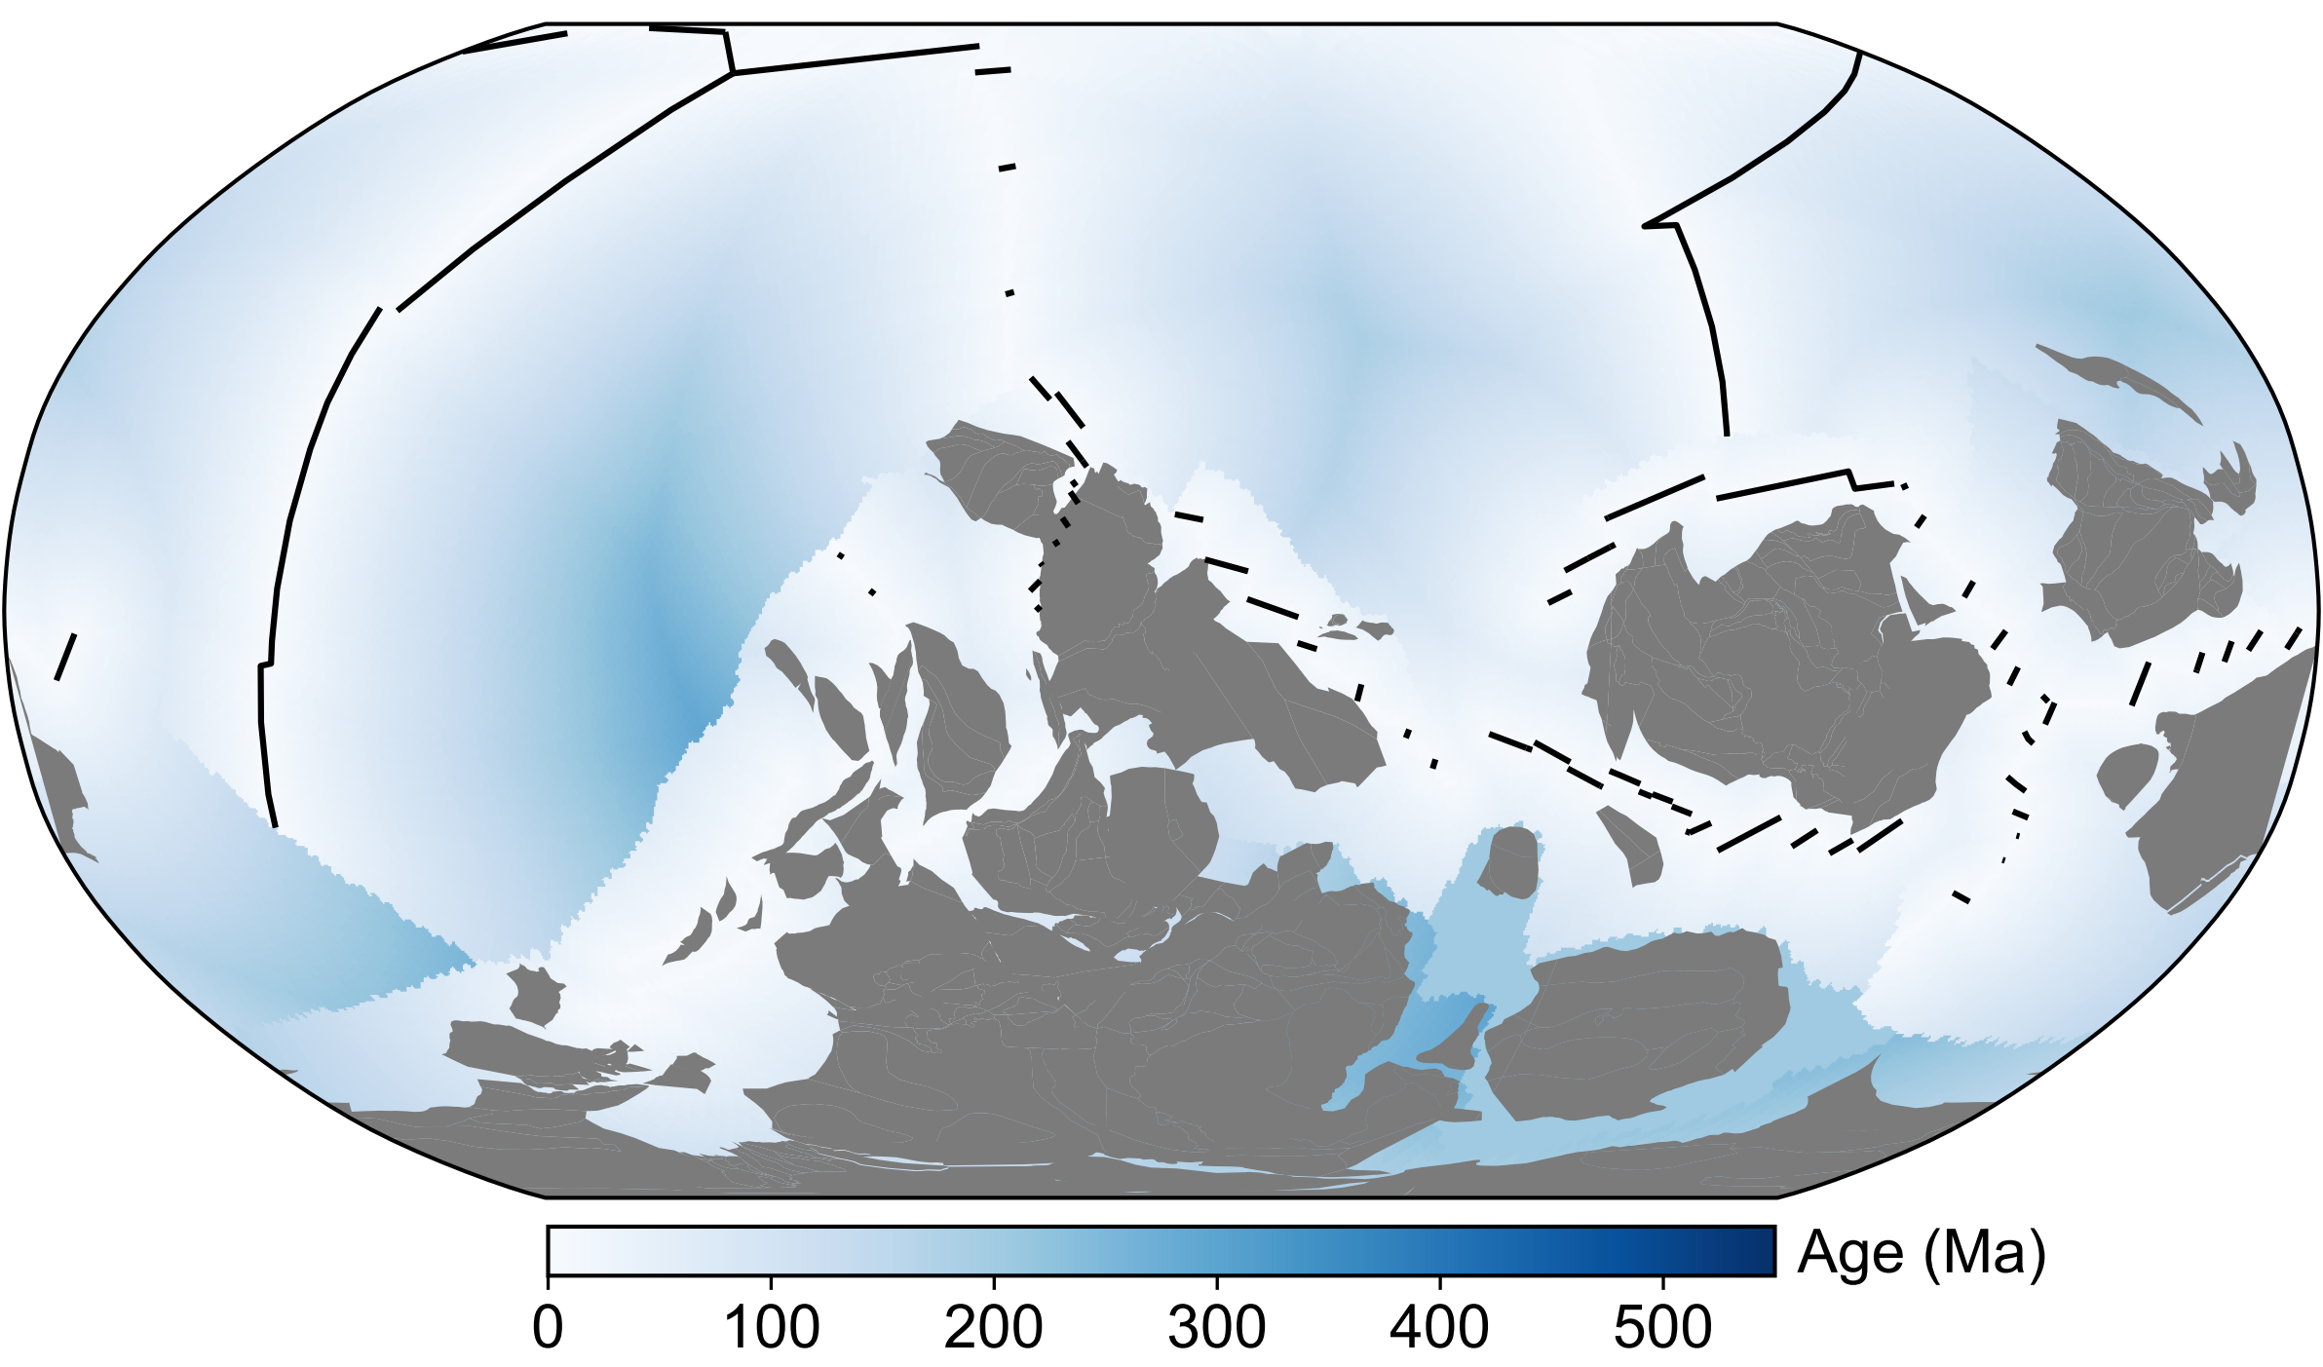
Figure S9. Geographic distribution of the Gondwana continent at 550 Ma⁴⁸. The blue background represents the seafloor age. The black lines mark the oceanic ridges.

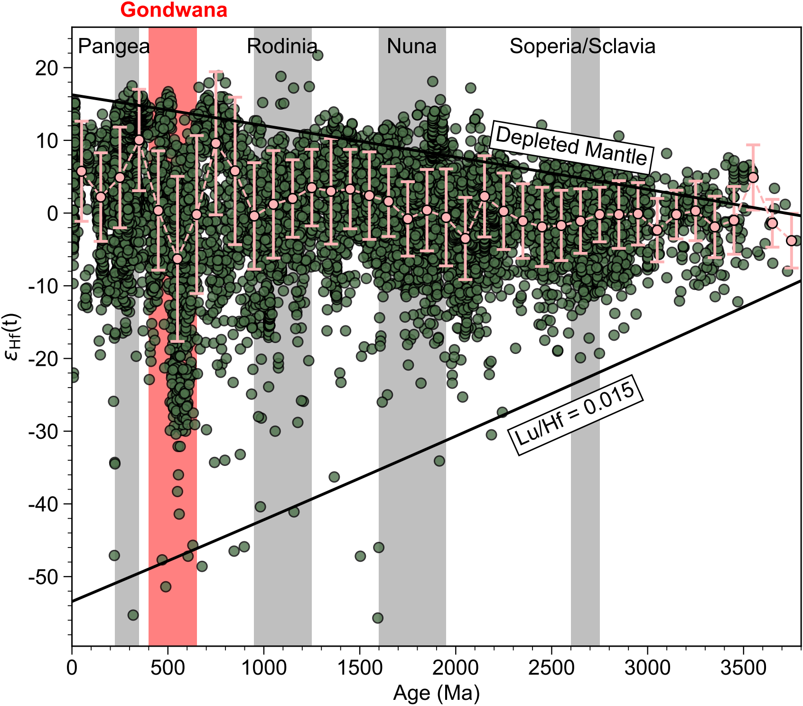
Figure S10. ε_{Hf} versus U‒Pb ages of global zircon data. The green dots are from global zircon data³². The pink dots and bars represent the median ε_{Hf} values and standard deviations, respectively, within a 100 Myr window. The upper black line represents the evolution of depleted mantle, whereas the lower black line represents the evolution of crust with Lu/Hf = 0.015³². Supercontinent assembly periods are shaded by red and gray areas⁴⁹. (modified from Belousova et al. ³²)
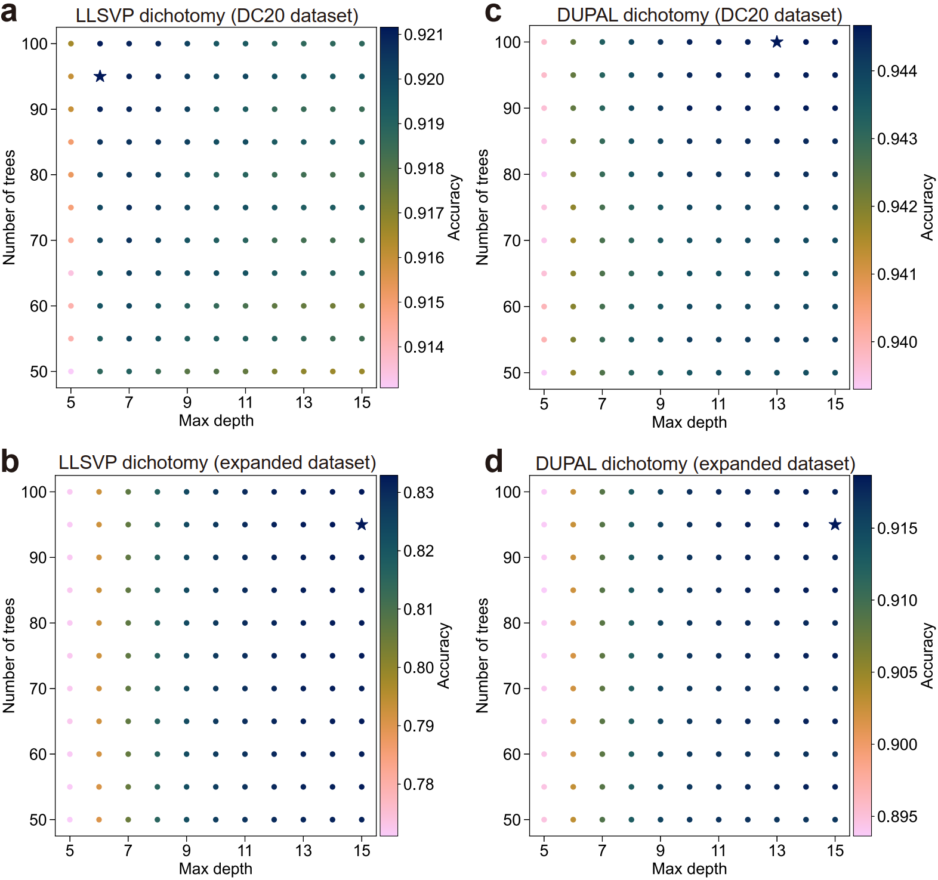
Figure S11. Hyperparameter selection from 1000 bootstrapping tests. (a) LLSVP dichotomy using the DC20 dataset. The highest classification accuracy, 92.116%, is achieved with tree depth and forest size (star). (b) LLSVP dichotomy using the expanded dataset. The highest classification accuracy, 83.290%, is achieved with tree depth and forest size (star). (c) DUPAL dichotomy using the DC20 dataset. The highest classification accuracy, 94.467%, is achieved for tree depth and forest size (star). (d) DUPAL dichotomy using the expanded dataset. The highest classification accuracy, 91.865%, is achieved with tree depth and forest size (star).

References
1. Hart, S. R. A large-scale isotope anomaly in the Southern Hemisphere mantle. Nature 309, 753–757 (1984).
32. Belousova, E. A. et al. The growth of the continental crust: Constraints from zircon Hf-isotope data. Lithos 119, 457–466 (2010).
48. Merdith, A. S. et al. Extending full-plate tectonic models into deep time: Linking the Neoproterozoic and the Phanerozoic. Earth-Science Reviews 214, 103477 (2021).
49. Campbell, I. H. & Allen, C. M. Formation of supercontinents linked to increases in atmospheric oxygen. Nature Geosci 1, 554–558 (2008).

