Supplementary Information: Self-assembled rectorite films with remarkable mechanical performance: preparation, structural characterization and properties

Maria T. Atanasova^{1,2}, Walter W. Focke² and Theodor Loots³
¹Council for Geoscience, 280 Pretoria Street, Private Bag X112, Pretoria, South Africa. E-mail: mtg@geoscience.org.za
²Institute of Applied Materials, Department of Chemical Engineering, University of Pretoria, Private Bag X20, Hatfield 0028, South Africa. E-mail: walter.focke@up.ac.za
³Department of Statistics, University of Pretoria, Private Bag X20, Hatfield 0028, South Africa. E-mail: theodor.loots@up.ac.za

Film preparation
Rectorite clay films were prepared by a suspension-casting process. The aqueous clay dispersions were poured into shallow pans and allowed to evaporate and dry slowly at ambient conditions. Aqueous suspensions of the purified rectorite clays and the ion-exchanged Li⁺, Na⁺, NH₄⁺, K⁺, Cs⁺, Mg²⁺, Ca²⁺, Sr²⁺ and Ba²⁺ modifications of sample RT3, were prepared in the concentration range 1.0 to 5.8 wt.%. Parameters such as clay concentration, sonication time, stirring time and the nature of the casting pans were varied to tune the method for optimum mechanical performance of the films.
Prior to film casting, all suspensions were ultrasonically dispersed in ultra-pure water for either 5 or 30 min using a Braun Labsonic sonicator fitted with a 2000U probe. The instrument settings were optimized experimentally by the interactive measurements of the degree of dispersion i.e. obscuration in a particle sizer. In order to prevent overheating, low power output settings were selected, i.e. the instrument amplitude dial was set close to the minimum and a duty cycle of 1 was chosen. After sonication the suspensions were cast immediately or subjected to further agitation by stirring for either 4 or 24 h before casting.
Tensile testing was performed on an Ametek Lloyd Instrument LRX Plus single column tensile tester fitted with a 50 N load cell. Film thickness was measured using a Mitutoyo Digimatic micrometer with a measurement precision of ± 0.2 µm. The average of multiple measurements taken along the tests strip is reported. Film strips with dimensions 100 mm long and 10 mm wide were cut and conditioned in a desiccator at room temperature for at least 48 h prior to measurements (ASTM & International, 2012, 2013a, b). The humidity in the desiccator was maintained at ca. 55% RH by the presence of a saturated Ca(NO₃)₂⋅4H₂O solution. The ends of the strips were sandwiched between two pieces of carton before clamping in the grips of the tensile tester. The gauge length (grip separation) set at 75 mm. The tensile tests were conducted at a draw speed of 20 mm min⁻¹. At least three tensile tests strips were obtained and tested per cast sample film. The maximum recorded value is reported together with the overall standard deviation. This approach was followed as the objective was to determine the ultimate strength of these type of films.

Statistical Analysis
The statistical analysis of the available experimental data was carried out in two steps. First, a global fit of the tensile strength (or the Young’s modulus) of the films was modelled and analysed using extreme value analysis (EVA) by means of the generalized extreme value (GEV) distribution (Beirlant et al., 2005; Reiss & Thomas, 2007). Parameter estimation was carried out using generalized maximum likelihood (gimlet) (Gilleland & Katz, 2016). The location and scale parameters of the GEV distribution were considered to be linear combinations of possible additional variables. Based on the outcomes the data was split into three groups. Permutational multivariate analysis of variance (MANOVA), using distance matrices (Anderson, 2001; McArdle & Anderson, 2001), was performed to check whether a data split into these three sets, according to the Interlayer Charge variable (corresponding to values of 0, 0.75 and 1 depending on the mole fraction of divalent ions present in the interlayer), can be justified from a statistical point of view. This was followed-up by the Kruskal-Wallis rank sum test (Hollander & Wolfe, 1973) to test for testing the individual effects. Secondly, a peak-over-threshold (POT) model was fitted to each of the 6 possible permutations in determining the maximum potentially attainable values for tensile strength and Young’s’ modulus. Maximum likelihood estimation (MLE) was used to fit the exponential distribution to all the cases. The parametric bootstrap (Efron & Tibshirani, 1993) was then used in each case in deriving 95% upper confidence limits.

Measured tensile properties of the cast films
The tensile properties of clay films from neat- and ion-exchanged rectorite modifications are presented in Figure S1, Figure S2, and Table S1. Figure S1 shows examples of the stress-strain curves for the stronger monovalent, divalent and mixed valent rectorite samples. In all cases the strain at break was very small, seldom exceeding 2 %. Noteworthy (from visual observations) is the fact that most samples failed by either developing a tear that started at an edge defect or right at the end where the sample was gripped. This means that the intrinsic mechanical properties were not achieved. Rather, the measured values were significantly influenced by the numerous defects present in the cast films, e.g. caused by handling during testing, and perhaps even small alignment errors when they were clamped into the tensile tester.

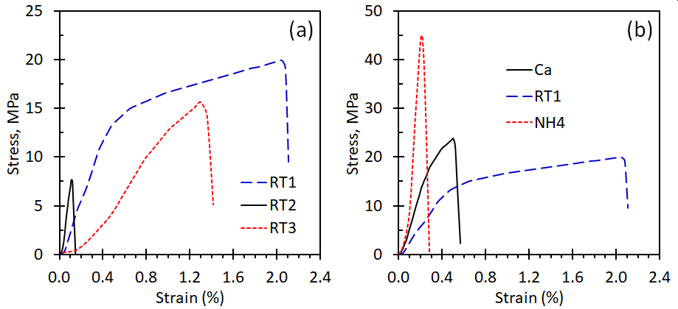
Figure S1. (a) Representative stress-strain curves for rectorite films prepared from three purified rectorite samples and (b) a comparison of films from neat, monovalent and divalent exchanged rectorite.

The films with the best tensile properties did not necessarily originate from suspensions prepared under the same dispersion conditions. However, the dispersion regime of sonicating for 30 min with subsequent stirring for 4 h, proved most effective for producing strong films from each of the three groups – monovalent, divalent and neat rectorite. The exceptions are RT1 where 5 min sonication followed by 24 h stirring, RT2 and Mg²⁺- films with 30 min sonication followed by 24 h stirring yielded the best results. Dispersions of Li⁺- and Cs⁺-based films and divalent Sr²⁺ and Ba²⁺ proved more suited to cast after 30 min sonication without stirring.
The data show considerable scatter in both the strength and the modulus characteristics of the rectorite films (Figure S2, Figure S3 and Table S1). Significant variabilty was found, not only between films from different rectorite modifications but also within ion-exchanged samples, notwithstanding of all attemps made to strictly controll the processing parameters used in the film preparations.

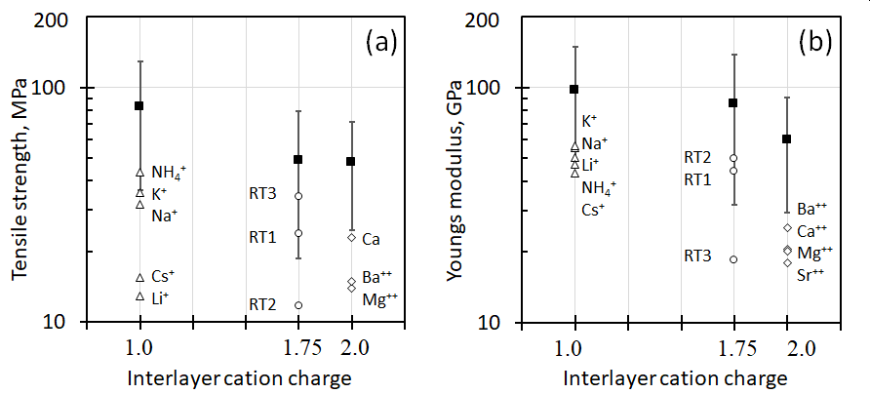
Figure S2. Tensile strength and Young’s modulus of films from natural and cation exchanged rectorite. The black square symbols indicate the projected maximum values possible and the error bars indicate 95% confidence intervals. The open symbols indicate actual maximum measured values.

Estimating the ultimate mechanical property values for rectorite films
The reported mechanical property measurements do not represent the intrinsic values that can potentially be attained. This is because of the many flaws and defects in the films caused by limitations of the preparation methods. The measurement process itself was flawed including the way the samples were clamped. Therefore, a statistical analysis was performed to estimate the likely limits for the ultimate material properties. It was found that, for both modulus and tensile strength, a significant improvement was observed when the interlayer cation was included as a variable in the linear model for the location and scale parameters of the GEV distribution. The p-values corresponding to the significant categories for interlayer cation of the location and scale parameters of the fitted distributions were location = (0.0025371, 0.0025370) and scale = (0.0166080, 0.0448101), for tensile strength, and with location = 0.0235088 and scale = 0.0065562 for Young’s modulus. The nature of the interlayer cation determines the interlayer charge. The data were therefore split in groups that contained monovalent cations (122 samples; dummy variable assigned = 0), divalent cations (48 samples; dummy variable assigned unity), and the mixed cation situation for the RT samples (77 samples; dummy variable = 0.75).
The resultant p-value obtained for the permutational multivariate analysis of variance (MANOVA), test was 0.007 which signifies an overall effect. This showed that the data split into three sets according to the Interlayer Charge variables was justified from a statistical point of view. The results obtained using the Kruskal-Wallis rank sum test (Hollander & Wolfe, 1973), for testing the individual effects, confirmed that this was indeed the case for both tensile strength (p-value = 0.0019) and Young's modulus (p-value = 0.0004) as dependent variables, and with interlayer charge as independent variable. Finally, the outcome of the peak-over-threshold (POT) model data fits generated the 95% upper confidence limits for these mechanical property values, are listed in Table 4. The highest value actually measured in each case is also listed.

The values projected by the statistical analysis for the ultimate mechanical properties are not unrealistic. For example, Ballard and Rideal (1983) reported an ultimate tensile strength of 160 MPa and a Youngs modulus of 14.3 GPa for films made using n-butylammonium exchanged vermiculite. This value for the tensile strength is significantly higher than the upper value projected for rectorite-based clay films.

Table S2. Best experimental values for tensile strength and Young’s modulus obtained experimentally compared to projected values based on a statistical analysis of the data.
Cation type | Experimental# | Estimate† | 95% lower CI | 95% upper CI
Tensile strength (MPa)
Monovalent | 44 | 83 | 37 | 129
Divalent | 23 | 48 | 25 | 71
Mixed valent | 25 | 49 | 19 | 79
Young’s modulus (GPa)
Monovalent | 56 | 97 | 46 | 149
Divalent | 25 | 60 | 29 | 91
Mixed valent | 50 | 85 | 32 | 139
#Highest value actually measured. †Statistical projection for maximum attainable value.

References
Anderson, M.J. (2001) A new method for non-parametric multivariate analysis of variance. Austral Ecology, 26, 32-46.
ASTM & International. (2012) Astm standard e104, 2002 (2012a). Standard practice for maintaining constant relative humidity by means of aqueous solutions. Pp.
-. (2013a) Astm standard d618, 2013a. Practice for conditioning plastics for testing. Pp.,Title -- A to Z.
-. (2013b) Astm standard d1708 2013a. Standard test method for tensile properties of plastics
by use of microtensile specimens. Astm international 2013. . Pp.
Ballard, D.G.H. & Rideal, G.R. (1983) Flexible inorganic films and coatings. Journal of Materials Science, 18, 545-561.
Beirlant, J., Goegebeur, Y., Teugels, J., Segers, J., De Waal, D. & Ferro, C. (2005) Statistics of extremes: Theory and applications. Pp. 1-490.
Efron, B. & Tibshirani, R.J. (1993) An introduction to the bootstrap. Chapman-Hall New York.
Gilleland, E. & Katz, R.W. (2016) Extremes 2.0: An extreme value analysis package in r. Journal of Statistical Software, 72, 1-39.
Hollander, M. & Wolfe, D.A. (1973) Nonparametric statistical methods. John Wiley & Sons, New York.
McArdle, B.H. & Anderson, M.J. (2001) Fitting multivariate models to community data: A comment on distance-based redundancy analysis. Ecology, 82, 290-297.
Reiss, R.D. & Thomas, M. (2007) Statistical analysis of extreme values: With applications to insurance, finance, hydrology and other fields: Third edition. Pp. 1-511.

