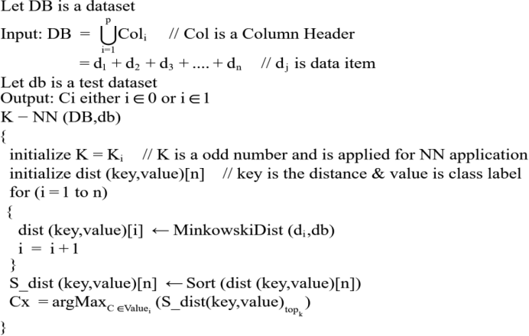

Alog.1. Algorithm for K-NN (General Procedure)

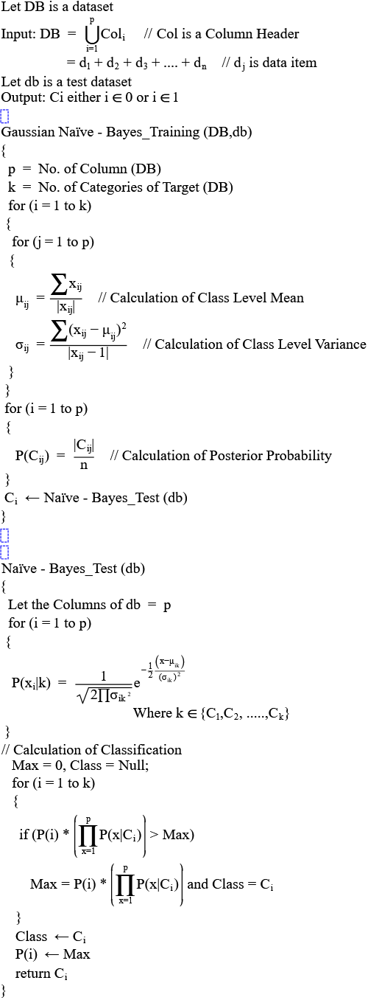

Alog.2. Algorithm for Naïve-Bayes (General Procedure)

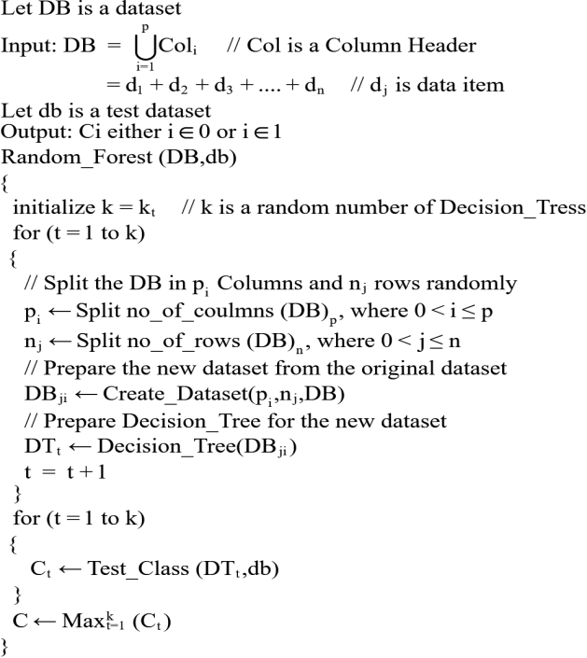

Alog.3. Algorithm for Random Forest (General Procedure)

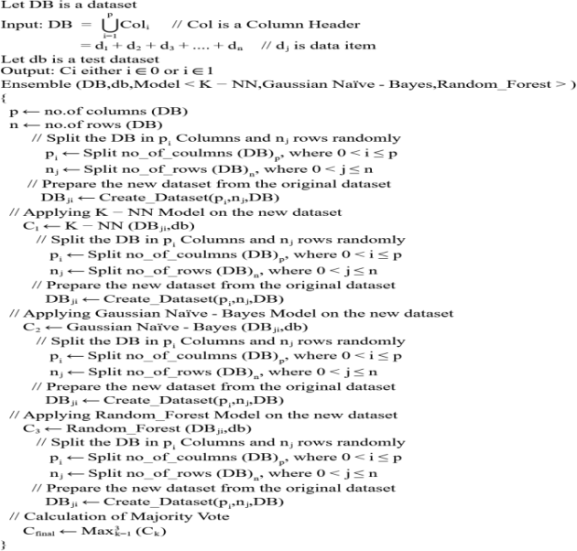

Alog.4. Algorithm for Proposed Ensemble Model (Own Preparation)

