Supplementary Information

Example model code

#Fit cox model

coxFit <- coxph(Surv(Time, Dep) ~ gender + SES + EstimatedTotalIntraCranialVol, data = data_wide, x = TRUE)

#Fit mixed effects model

lmeFit <- lme(M_rostralanteriorcingulate_area ~ Time, random = ~ Time | id, data = data_long)

#Specify association structure

fForms <- list("M_rostralanteriorcingulate_area" = ~ value(M_rostralanteriorcingulate_area))

#Fit joint model

jointFit <- jm(coxFit, lmeFit, time_var = "Time", functional_forms = fForms, n_iter = 300000L, n_burnin = 2000L, n_thin = 5L)

In the above code, Time = time since baseline, Dep = onset of depressive disorder (yes/no).
Table S1. Thickness slope
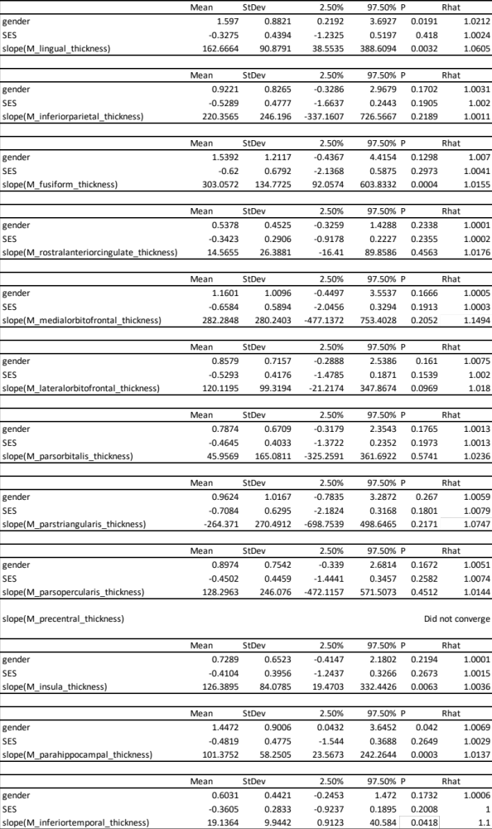
Table S2. Thickness value
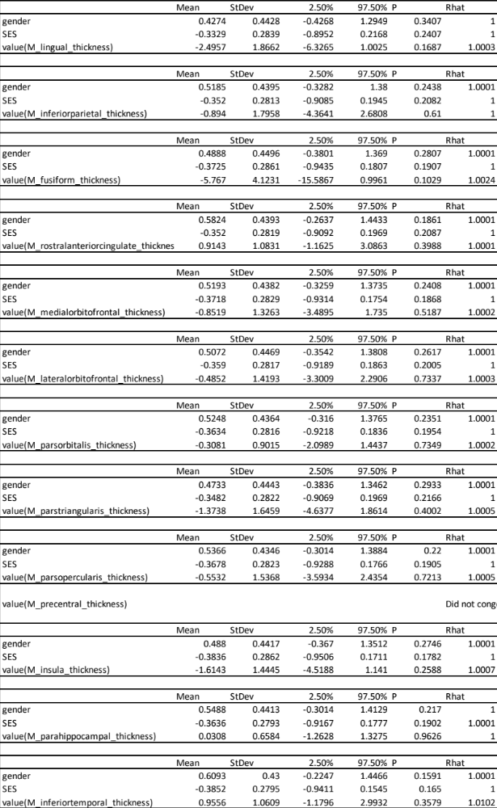

Table S3. Surface area slope
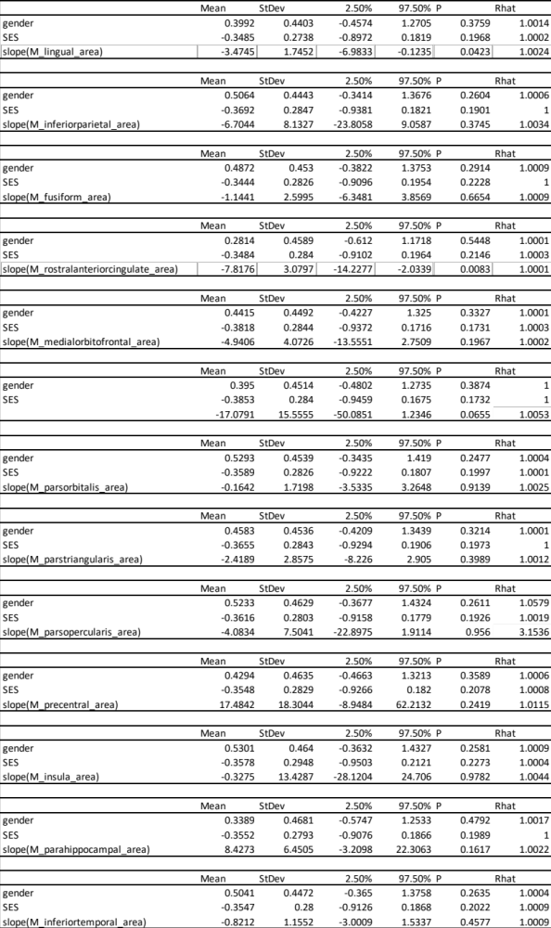

Table S4. Surface area value
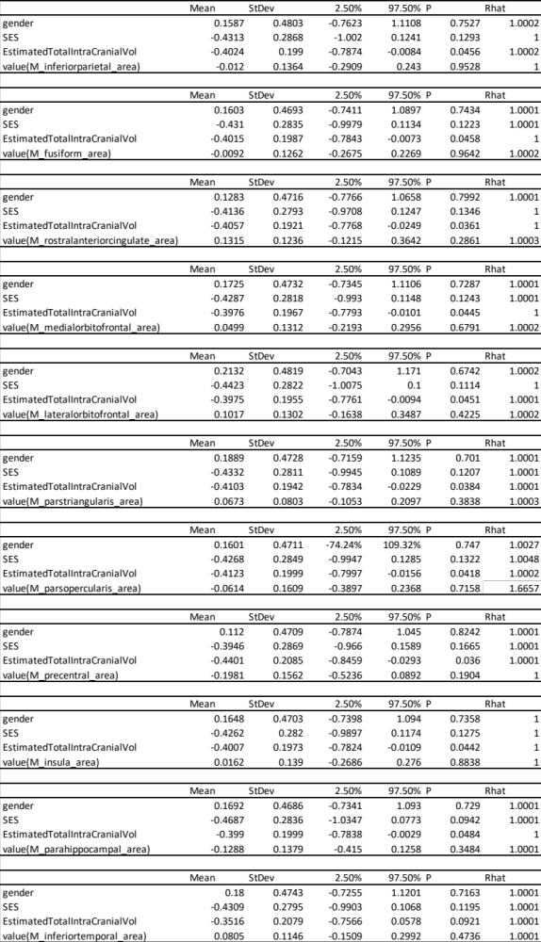
Table S5. Subcortical slope
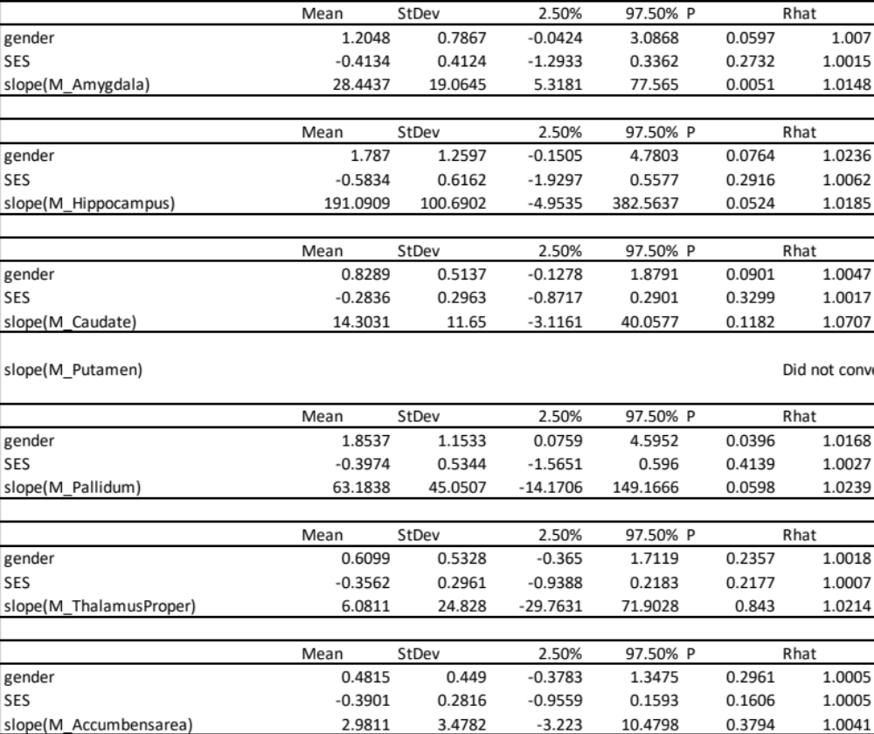

Table S6. Subcortical value
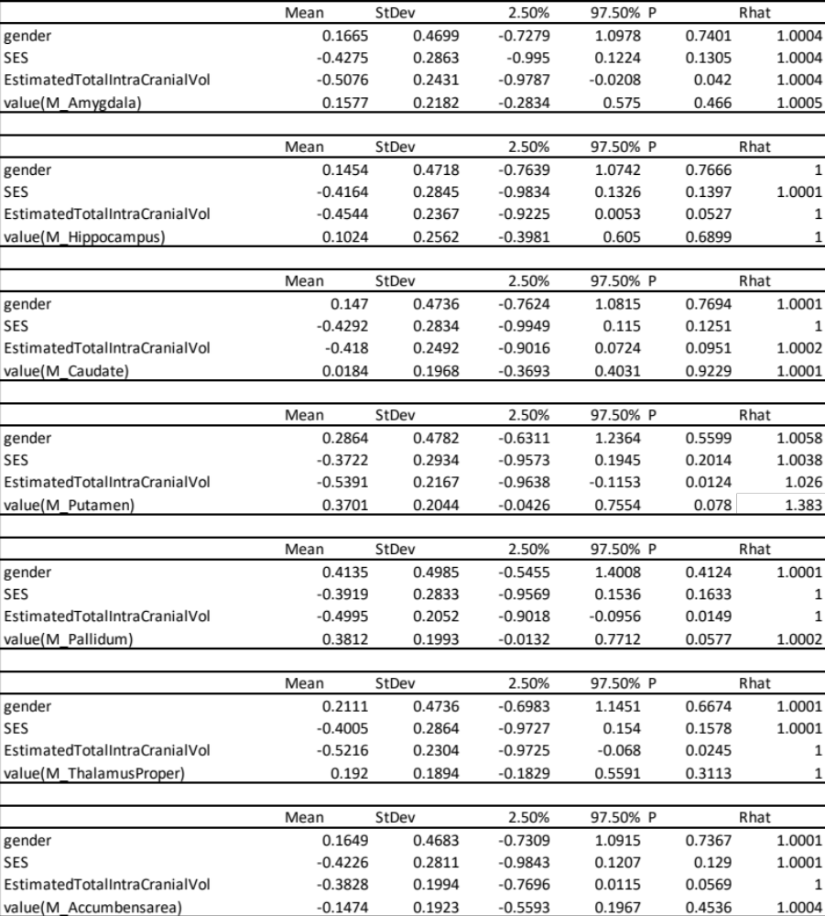

Table S7. Thickness slope * gender
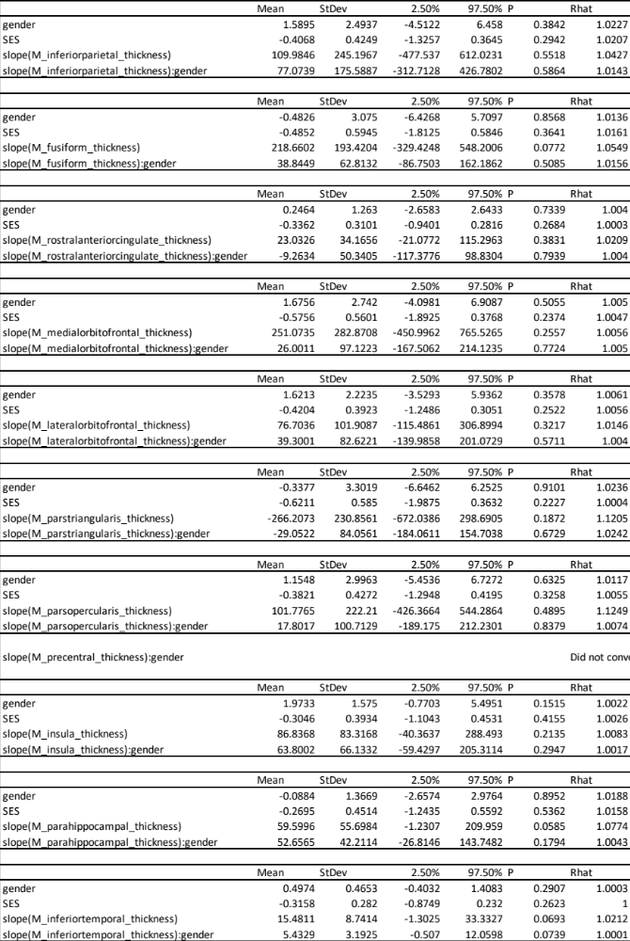

Table S8. Thickness value * gender
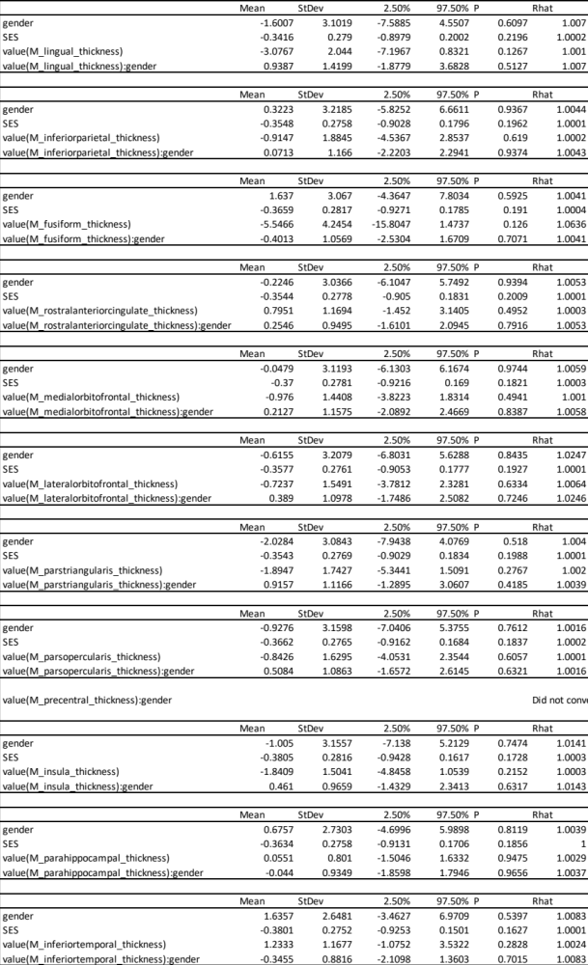
Table S9. Surface area slope * gender
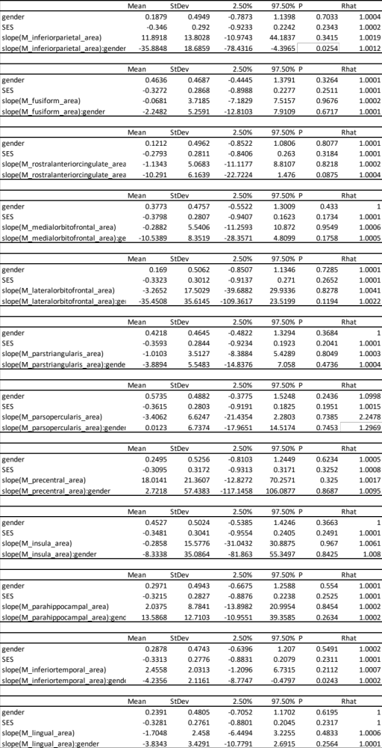
Table S10. Surface area value * gender
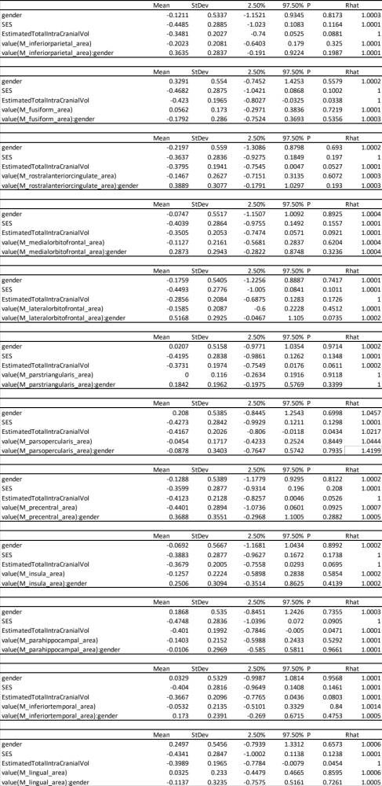
Table S11. Subcortical slope * gender
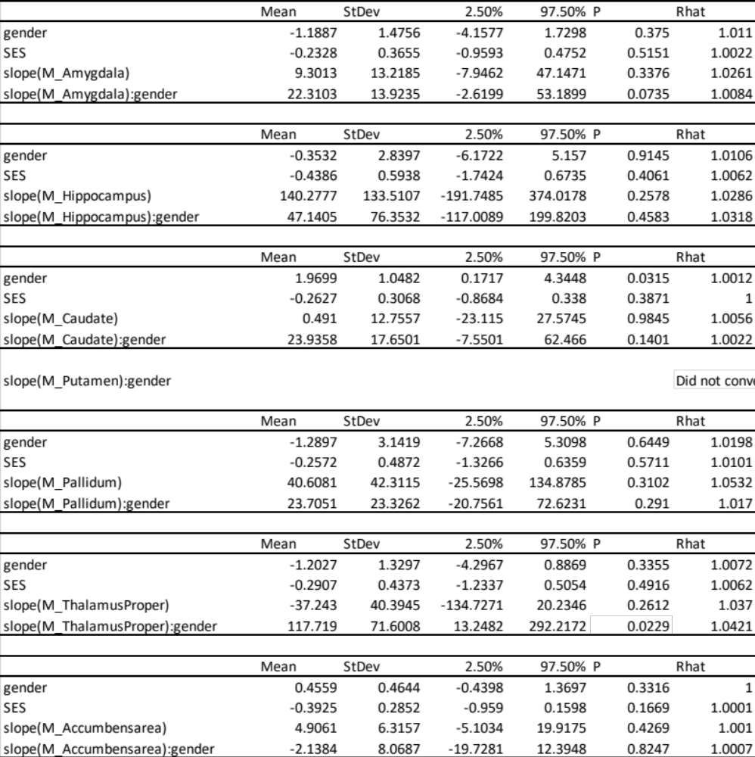

Table S12. Subcortical value * gender

Table S13. Significant models with the addition of baseline symptoms and pubertal status.
