Comparative genome analysis of the genus Marivirga and proposal of two novel marine species: Marivirga arenosa sp. nov., and Marivirga salinae sp. nov.

Neak Muhammad^{1, 2}, Forbes Avila^{1, 2}, Song-Gun Kim^{1, 2}*
¹Biological Resource Center/Korean Collection for Type Cultures (KCTC), Korea Research Institute of Bioscience and Biotechnology, Jeongeup, Jeonbuk 56212, the Republic of Korea
²Department of Environmental Biotechnology, KRIBB School, University of Science and Technology (UST), Daejeon 34113, the Republic of Korea
*Corresponding author:
Song-Gun Kim
Email: sgkim@kribb.re.kr

Table S1. Comparison of similarity values (%) of the 16S rRNA gene among the genus Marivirga. Strains: 1, BKB1-2^{T}; 2, ABR2-2; 3, BDSF4-3^{T}; 4, M. tractuosa DSM 4126^{T}; 5, M. harenae JK11^{T}; 6, M. sericea DSM 4125^{T}; 7, M. atlantica SM 1354^{T}; 8, M. lumbricoides CGMCC 1.10832^{T}; 9, M. aurantiaca S37H4^{T}.

 | 1 | 2 | 3 | 4 | 5 | 6 | 7 | 8 | 9
1 | 100 | 99.8 | 97.3 | 97.7 | 97.7 | 97.5 | 96.4 | 95.7 | 91.7
2 | 99.8 | 100 | 97.3 | 97.9 | 97.7 | 97.7 | 96.4 | 95.7 | 92.9
3 | 97.3 | 97.3 | 100 | 98.6 | 97.9 | 98.6 | 95.7 | 95.6 | 93.2
4 | 97.7 | 97.7 | 98.6 | 100 | 98.7 | 99 | 96 | 95.7 | 95.2
5 | 97.7 | 97.7 | 97.9 | 98.7 | 100 | 98.5 | 95.9 | 96.1 | 93.1
6 | 97.5 | 97.7 | 98.6 | 99 | 98.5 | 100 | 95.9 | 96 | 91.3
7 | 96.4 | 96.4 | 95.7 | 96 | 95.9 | 95.9 | 100 | 95.8 | 92.8
8 | 92.5 | 95.7 | 95.6 | 95.7 | 96.1 | 96 | 95.8 | 100 | 93.2
9 | 91.7 | 92.9 | 93.2 | 95.2 | 93.1 | 91.3 | 92.8 | 93.2 | 100

Table S2. Cellular fatty acid compositions (%) of three isolated strains and reference strains in genus Marivirga. Strains: 1, BKB1-2^{T}; 2, ABR2-2; 3, BDSF4-3^{T}; 4, M. tractuosa KCCT 2958^{T}; 5, M. harenae KCTC 92433^{T}; 6, M. sericea KCTC 2899^{T}; 7, M. atlantica KCTC 42392^{T}; 8, M. lumbricoides KCTC 92621^{T}.
Fatty acid | 1 |  | 2 | 3 | 4 | 5 | 6 | 7 | 8
Saturated:
C_{16;0} | 2.1 |  | 1.3 | 3.9 |  | 6.6 | 5.9 | 2.0 | 5.9
C_{18;0} |  |  |  | 1.6 |  | 6.6 | 7.6 |  | 2.0
Unsaturated:
C_{16:1} ω5c |  |  |  | 1.2 |  | 1.0 |  |  | 2.4
C_{18:1} ω9c |  |  |  | 2.6 |  | 1.6 | 1.5 |  | 1.5
Branched:
iso-C_{11:0} |  |  |  |  |  |  | 1.8 |  | 1.9
iso-C_{13:0} |  |  | 1.0 |  | 1.3
iso-C_{14:0} | 1.8 |  | 1.8 |  |  | 1.2 |  | 1.3
iso-C_{15:0} | 21.1 |  | 37.4 | 40.8 | 38.3 | 18.7 | 23.9 | 28.8 | 19.1
iso-C_{15:1} G | 16.3 |  | 16.7 | 19.1 | 20.5 | 15.2 | 18.9 | 17.0 | 18.2
anteiso-C_{15:0} | 1.9 |  | 2.9 | 1.4 |  | 2.4 | 1.0 | 1.5
anteiso-C_{17:0} A |  |  |  |  |  | 1.58
iso-C_{16:0} | 4.6 |  | 3.2 | 2.2 | 3.3 | 4.0 | 1.4 | 3.9 | 1.8
iso-C_{16:0} G | 1.3 |  |  |  | 1.0 | 1.6
iso-C_{17:0} |  |  |  | 1.0 |  |  | 1.5
Hydroxy:
C_{16:0} 3-OH |  |  |  |  |  |  |  | 1.2 | 3.0
iso-C_{15:0} 3-OH | 6.0 |  | 5.5 | 3.4 | 3.3 | 2.8 | 3.4 | 4.0 | 3.6
iso-C_{16:0} 3-OH | 9.8 |  | 6.0 | 3.3 | 3.8 | 2.3 | 2.9 | 5.0 | 1.7
iso-C_{17:0} 3-OH | 5.9 |  | 5.5 | 9.6 | 14.7 | 10.0 | 14.2 | 12.9 | 13.9
Summed features: *
3 | 20.8 |  | 12.9 | 4.6 | 3.2 | 8.1 | 5.7 | 16.6 | 18.9
8 |  |  |  |  |  | 1.0 | 1.3 |  | 1.1
*Summed features are fatty acids that cannot be resolved reliably from another fatty acid using the chromatographic conditions chosen. The MIDI system groups these fatty acids together as one feature with a single percentage of the total. summed feature 3 comprises C_{16:1} ω7c or C_{16:1} ω6c; summed feature 8 comprises C_{18:1} ω6c and/or C_{18:1} ω7c.

Figure S1. Two-dimensional thin-layer chromatography illustrating polar lipid profile of three isolated strains. A, BKB1-2^{T}; B, ABR2-2; C, BDSF4-3^{T}. The plate was sprayed with molybdophosphoric acid for total lipid detection.
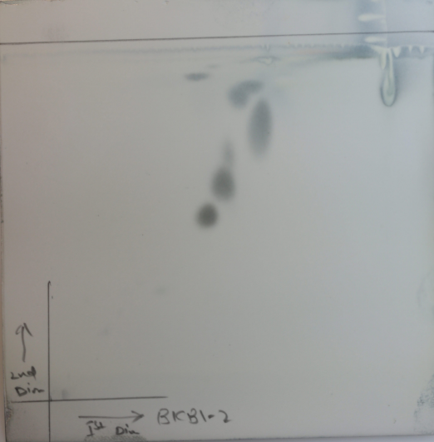
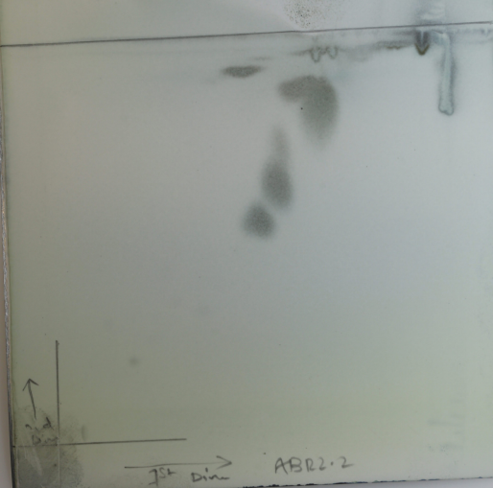
PE
AL
L1
L2
L3
L4
L5
PE
AL
L1
L2
L3
L5
L6
L4
B
A

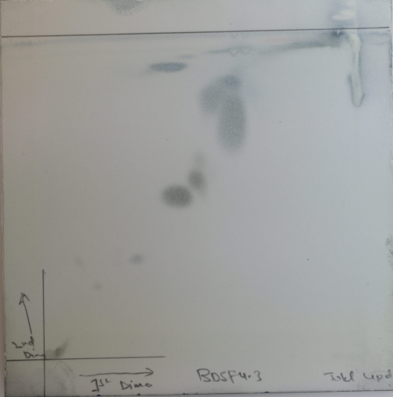
PE
AL1
AL2
L1
L2
L3
L4
L5
L6
C

AL, unidentified amino lipid; PE, phosphatidylethanolamine; L, unidentified lipid

Table S3. Determination of Biosynthetic gene clusters among three isolates and reference strains within the genus Marivirga. Strains: 1, BKB1-2^{T}; 2, ABR2-2; 3, BDSF4-3^{T}; 4, M. tractuosa DSM 4126^{T}; 5, M. harenae JK11^{T}; 6, M. sericea DSM 4125^{T}; 7, M. atlantica SM 1354^{T}; 8, M. lumbricoides CGMCC 1.10832^{T}; 9, M. aurantiaca S37H4^{T}. PKS, polyketide synthases; NRPS, non-ribosomal peptide synthetase; RiPP, ribosomally synthesized and post-translationally modified peptides.
Strain | Type | *From (nt) | **To (nt) | Most similar known cluster | Similarity (%)
1 | Type III PKS | 414320 | 455438
 | Lanthipeptide class I | 1350457 | 1388554
 | Terpene | 2269904 | 2290800
 | Terpene | 3442081 | 3462923 | carotenoid, terpene | 57
2 | Type III PKS | 1463061 | 1504179
 | Terpene | 2500819 | 2519710 | carotenoid, terpene | 57
 | Terpene | 3577660 | 3598808
3 | Type III PKS | 626125 | 667222
 | Terpene | 1758638 | 1778423 | carotenoid, terpene | 57
 | Terpene | 3028583 | 3049782
4 | Terpene | 498343 | 518823
 | Terpene | 1772773 | 1793615 | carotenoid, terpene | 57
 | Type III PKS | 2627369 | 2668499
5 | Type III PKS | 1327752 | 1368840
 | Terpene | 2512133 | 2531933 | carotenoid, terpene | 57
 | Terpene | 3463727 | 3484875
6 | Type III PKS | 321695 | 362783
 | RiPP-like | 430098 | 443064
 | Terpene | 109593 | 130435 | carotenoid, terpene | 57
 | Terpene | 817105 | 838250
7 | Type III PKS | 466026 | 504910
 | Type III PKS | 856953 | 898011
 | Terpene | 912156 | 932998 | carotenoid, terpene | 57
 | Resorcinol | 1540155 | 1582005
 | Terpene | 934250 | 955428
8 | NRPS-like | 605991 | 646534
 | Type III PKS | 187787 | 230869
 | Terpene | 214480 | 235322 | carotenoid, terpene | 57
 | Type I PKS | 16100 | 62303
 | Resorcinol | 1 | 31846
 | Terpene | 90149 | 110163
 | Lanthipeptide class I | 31840 | 61577
9 | Terpene | 1225254 | 1246417
 | Arylpolyene | 367935 | 412204 | flexirubin | 16
 | Terpene | 1 | 15329 | carotenoid, terpene | 57
 | Type III PKS | 59034 | 100116
*From indicates the gene's initiation position of biosynthetic gene cluster (BGC)
**To indicates the gene's termination positions of biosynthetic gene cluster (BGC)
Table S4. Characteristics of genome of three isolated strains and all reference strains within the genus Marivirga. The strain numbers are same as used in Table S3.

Strains | Genome Size (Mbp) | Number of Genes | Number of CAZyme | (%) of CAZyme | Number of GHs | Ratio of GHs/Mbp
1 | 4.02 | 3471 | 53 | 1.52 | 17 | 4.23
2 | 3.94 | 3417 | 56 | 1.64 | 21 | 5.33
3 | 4.49 | 3807 | 59 | 1.55 | 16 | 3.56
4 | 4.51 | 3800 | 65 | 1.71 | 25 | 5.54
5 | 4.34 | 3738 | 62 | 1.66 | 22 | 5.07
6 | 4.74 | 4082 | 72 | 1.76 | 25 | 5.27
7 | 4.19 | 3630 | 70 | 1.93 | 30 | 7.16
8 | 5.93 | 4978 | 152 | 3.05 | 75 | 12.65
9 | 4.2 | 3628 | 74 | 2.04 | 28 | 6.67

Table S5. Number of polysaccharide-degrading gene families based on the dbCAN meta server, and in vitro activities of three isolated strains within the genus Marivirga

Strains | Polysaccharides | *CAZyme families | in vitro polysaccharide degradation activities
1 | Agarose | GH50 (0) | -
 | Alginate | PL6 (0), PL7 (0) | -
 | Cellulose | GH5 (0), GH9 (0) | +
 | Chitin | GH3 (3) GH23 (3) | +
 | κ-Carrageenan | GH16 (2) | -
 | λ-carrageenan | GH110 (0) | -
 | ι-carrageenan | GH82 (0) | -
 | Laminarin | GH16 (2) | +
 | Starch | GH13 (3) GH16 (2) | +
 | Xylan | GH3 (3) | -
2 | Agarose | GH50 (0) | -
 | Alginate | PL6 (0), PL7 (0) | -
 | Cellulose | GH5 (0), GH9 (0) | -
 | Chitin | GH3 (5) GH23 (2) | +
 | κ-Carrageenan | GH16 (3) | -
 | Laminarin | GH16 (3) | +
 | λ-carrageenan | GH110 (0) | -
 | ι-carrageenan | GH82 (0) | -
 | Starch | GH13 (3) GH16 (3) | +
 | Xylan | GH3 (5) | -
3 | Agarose | GH50 (0) | -
 | Alginate | PL6 (0), PL7 (0) | -
 | Cellulose | GH5 (0), GH9 (0) | -
 | Chitin | GH3 (2) GH23 (2) | +
 | κ-Carrageenan | GH16 (6) | -
 | Laminarin | GH16 (2) | +
 | λ-carrageenan | GH110 (0) | -
 | ι-carrageenan | GH82 (0) | -
 | Starch | GH13 (2) GH57 (1) | +
 | Xylan | GH3 (2) | +
Strains: 1, BKB1-2^{T}; 2, ABR2-2; 3, BDSF4-3^{T}
*CAZyme families with the number of genes in parentheses that are expected to participate in degradation of the polysaccharides. GH, glycoside hydrolase; PL, polysaccharide lyase
+, degradation of polysaccharide; -, no degradation of polysaccharide

