Supplementary Information
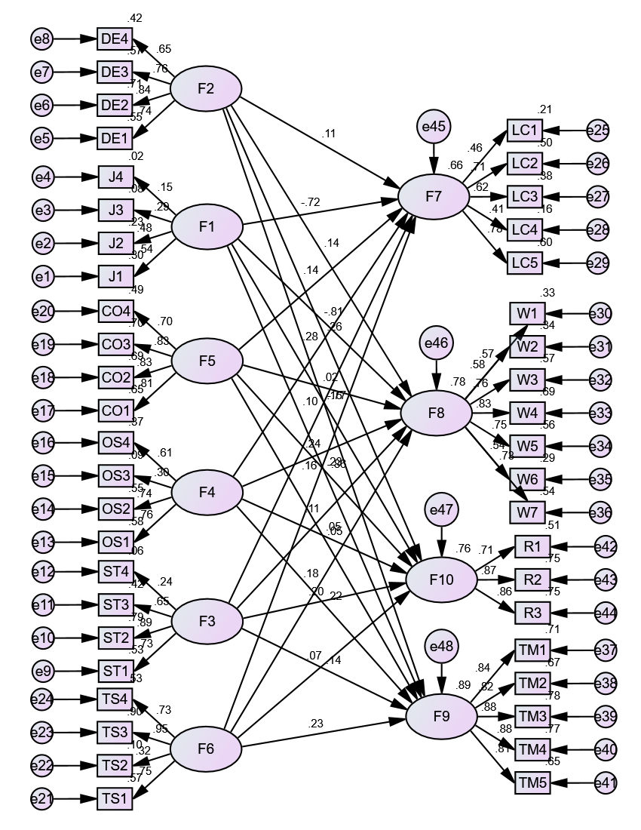
Figure 1. Structural Model for Dimensions of Curiosity and AIT

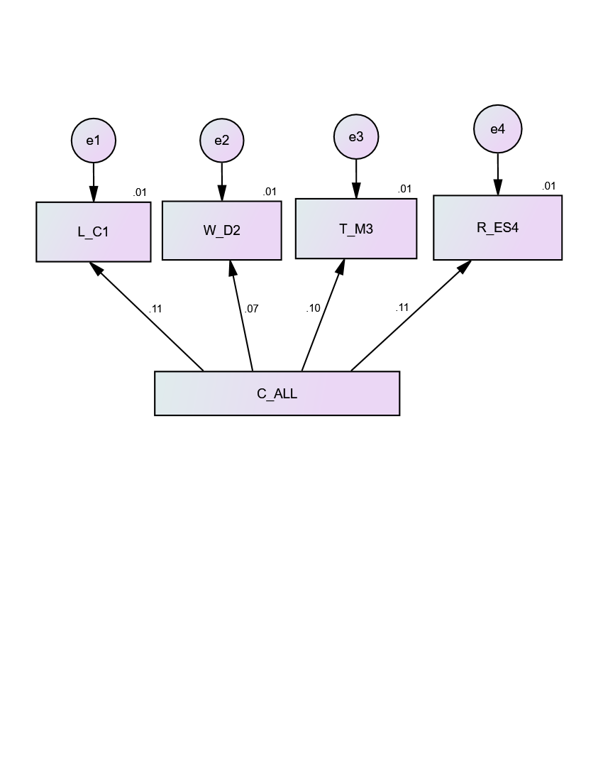
Figure 2. Structural Model of Curious Behaviours Composite and Dimensions of Internet Addictive Behaviours

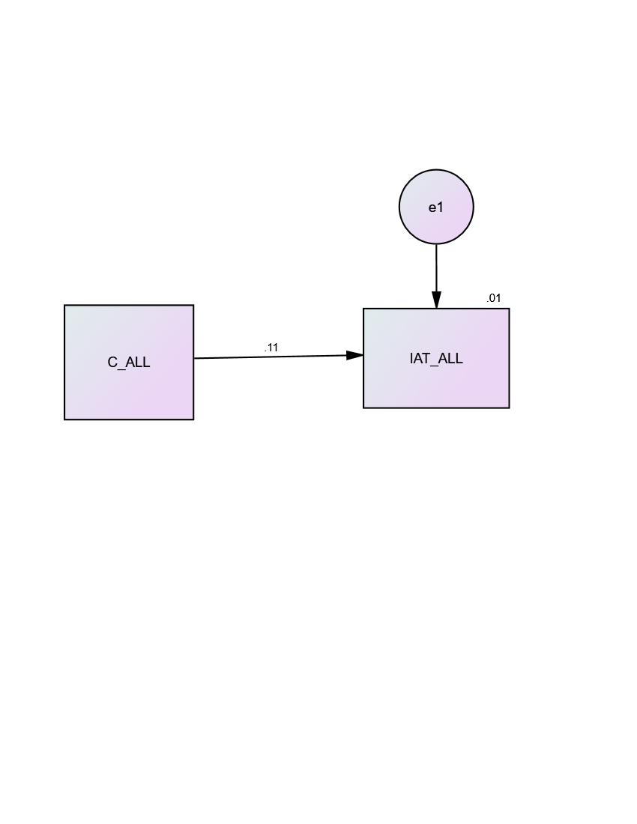
Figure 3. Curious Behaviours Composite Predicting Dimensions of Internet Addictive Behaviours

