Supplementary Tables and Figures

Table s1: Parameters of patients excluded or not from GDF15 analysis.
 |  |  | No GDF15 Data | GDF 15 Data | p-value
N | Treatment / condition | Units | 22 | 32
Treatment | CRT+Metformin | N (%) | 10 (45.5) | 16 (50.0) | 0.79
Stage | 3B | N (%) | 7 (31.8) | 14 (43.8) | 0.41
Stratum Treatment | Carboplatin | N (%) | 4 (18.2)  7 (31.8)  11 (50.0) | 2 (6.3)  8 (25.0)  22 (68.8) | 0.27
Stratum Treatment | Cisplatin | N (%)
Stratum Treatment | No stratum listed | N (%)
Sex | Female | N (%) | 12 (54.6) | 18 (56.3) | 1.00
ECOG |  | N (%) | 13 (59.1) | 15 (46.9) | 0.31
ECOG | 1+
Age | Mean (sd) |  | 66.9 (8.3) | 64.7 (7.1) | 0.36
BMI | Mean (sd) |  | 26.9 (4.8) | 26.0 (4.9) | 0.62
Histology | SCC | N (%) | 8 (36.4) | 12 (37.5) | 0.48
Histology | Adenocarcinoma | N (%) | 11 (50.0) | 19 (59.4)
Histology | Mixed | N (%) | 1 (4.5) | 0 (0)
Histology | NOS | N (%) | 2 (9.1) | 1 (3.1)
Chemothereapy &  Cycles | 1 |  | 1 (11.1) | 2 (10.0)
Chemothereapy &  Cycles | 2 |  | 8 (88.9) | 18 (90.0) | 1.00
Chemothereapy &  Cycles | Missing |  | 13 | 12
Duration of Chemo
Duration of Chemo | >=35 days | N (%) | 14/20 (70.0) | 24 (75.0) | 0.75
Immunotherapy@ | Yes | N (%) | 4/19 (21.1) | 6/31 (19.4) | 1.00
Radiation Dose | <60 |  | 2 (10.0) | 2 (6.3) | 0.27
Radiation Dose | 60 |  | 10 (50.0) | 16 (50.0)
Radiation Dose | >60 |  | 8 (40.0) | 14 (43.7)
GTV |  | Median (cc) (IQR) | 151 (58, 264) | 122 (52, 172) | 0.36
ITV |  | Median (cc) (IQR) | 227 (117, 436) | 164 (52, 323) | 0.24
PTV |  | Median (cc) (IQR) | 448 (289, 785) | 422 (287, 540) | 0.31
RFS* | Months  (95% CI) | N (%)  Median (range)  1-year (%) | 11 (50.0)  7.3 (5.9, NR)  41.4 (18.2, 63.3) | 19 (59.4)  14.0 (6.4, 18.5)  58.1 (39.0, 73.1) | 0.75
OS* | Events  Months  1-year | N (%)  Median (95% CI)  (%) (95% CI) | 10 (45.4)  10.9 (7.6, NR)  44.9 (20.6, 66.6) | 10 (31.3)  Not Reached  80.3 (61.2, 90.6) | 0.038

* based on the primary analysis after 16.6 months of follow up.
& Chemotherapy schemas included: cisplatin (50mg/m² on days of radiotherapy fractions 1, 6, 21, and 26) combined with etoposide (50mg/m² on days of radiotherapy fractions 1-5 and 21-25) or cisplatin (80mg/m² on days of radiotherapy fractions 1 and 16) plus vinorelbine (12.5-15 mg/m² on days of radiotherapy fractions 1, 6, 11, 16, 21, and 26). Carboplatin (area under the curve = 2 weekly) in combination with etoposide or paclitaxel (50mg/m² weekly) was also permitted. Consolidation chemotherapy of 2 additional cycles was allowed in patients treated with the carboplatin/paclitaxel combination.
@ Consolidation anti-programmed death receptor ligand 1 (PD-L1) immunotherapy (durvalumab) treatment was permitted for all eligible patients after an amendment in May 2018.

Table s2. Levels of GDF15 in response to cCRT alone or with metformin.

A. Summary of median values from all patients.
 | Median (range) Absolute Value | Median (range) Absolute Change from Baseline | Wilcoxon rank sum p-value (is change sign.) | Median (range) Relative Change from Baseline | Wilcoxon rank sum p-value (is change sign.)
Baseline | 1030 (417, 2445) | -
Week 1 | 2835 (1117, 16595) | 1521 (-328, 14955) | <0.001 | 165.5 (-13.4, 1227)) | <0.001
Week 6 | 2552 (1175, 16320) | 1682 (-556, 15218) | <0.001 | 171.7 (-27, 1382) | <0.001
Week 26 | 1175 (473, 3714) | 190 (-1674, 2219) | 0.035 | 20.4 (-69, 148) | 0.011
Absolute Change = week X value – baseline
Relative Change = (week x value – baseline)/baseline value * 100%

B. Summary of the change in GDF15 from baseline in the cCRT arm and the cCRT+metformin arm.
Median (range)
 | cCRT  Median (range) |  |  | cCRT + Metformin  Median (range) |  |  | Wilcoxon rank sum p-value
 | Absolute Value | Absolute Change | Relative Change | Absolute Value | Absolute Change | Relative Change | Absolute Change
Baseline | 964 (476, 2073) |  |  | 1094 (417, 2445)
Week 1 | 2041 (1117,16595) | 1065 (-32, 14955) | 147 (-2, 912) | 3267 (1579, 14610) | 2333 (-328, 13509) | 261 (-13, 1227) | 0.12
Week 6 | 2305 (1175,12986) | 1221 (-556, 7226) | 148 (-27, 638) | 3718 (1732, 16320) | 2913 (128, 15218) | 362 (8, 1382) | 0.039
Week 26 | 612 (1168, 473) | 143 (-905, 1140) | 12 (-44, 101) | 1520 (706, 3714) | 673 (-1674, 2219) | 79 (85, -69) | 0.071
Figure s1. Kaplan-Meier survival curves illustrating overall (OS) and relapse free (RFS) survival of patients participating in this analysis. A. Overall Survival of patients treated with concurrent chemoradiotherapy (cCRT) alone (red dotted line) or cCRT + metformin (black full line). B. RFS of patients treated with cCRT alone (red dotted line) or cCRT + metformin (black full line).

A. B.
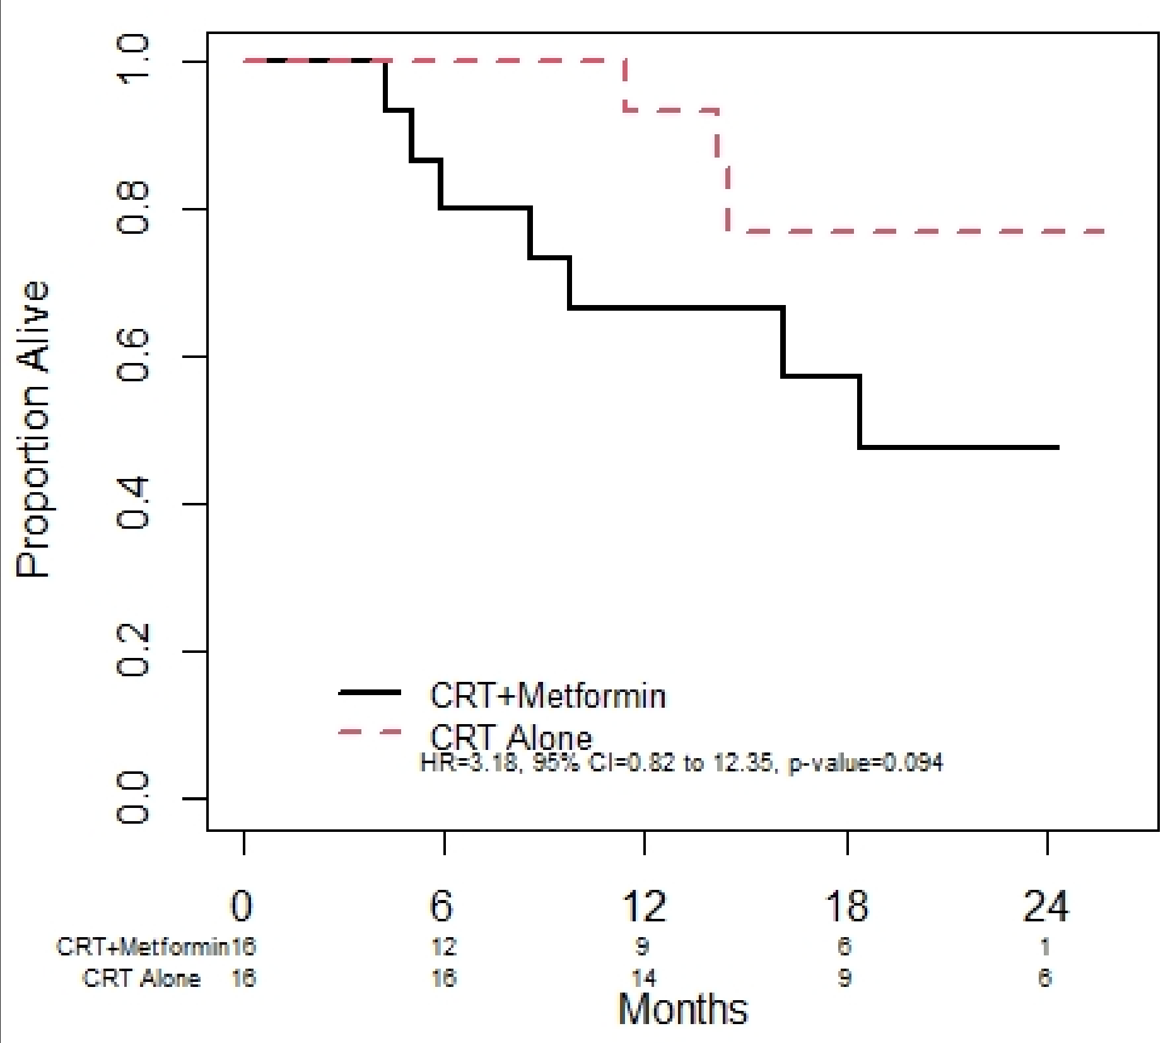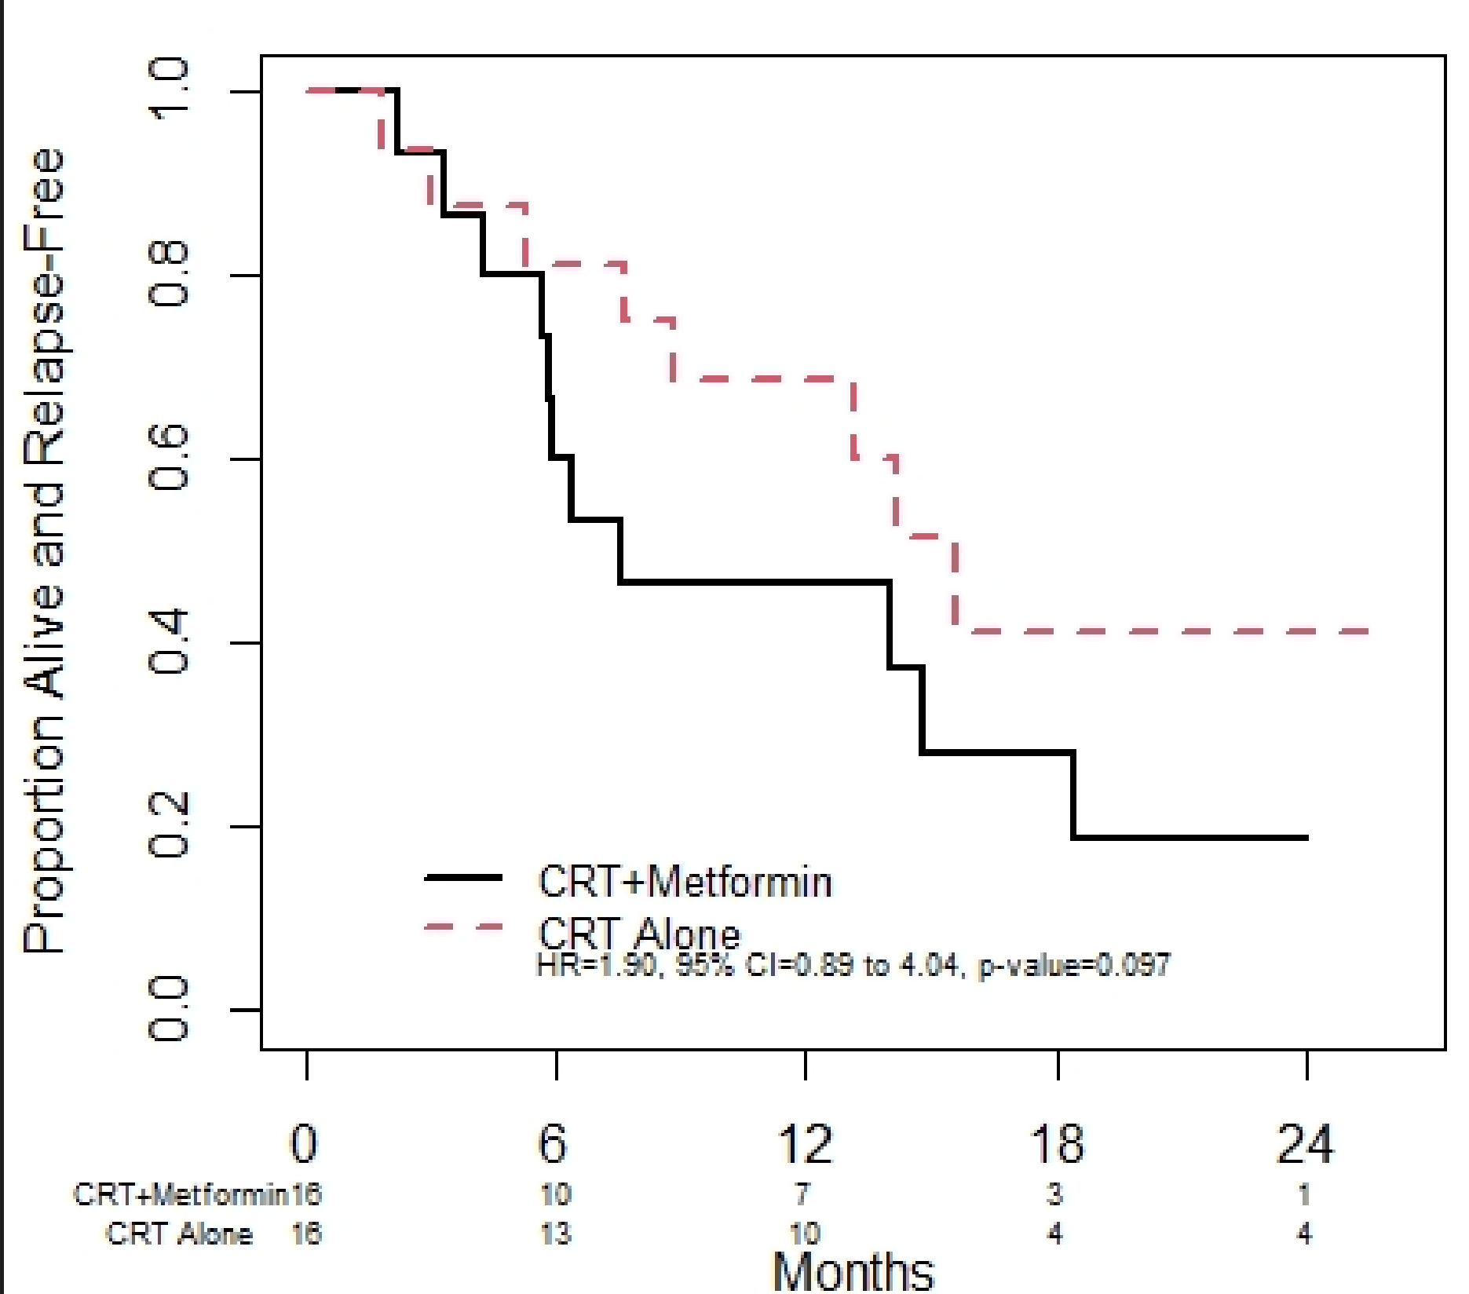

Table s3. Distribution of baseline GDF15 values per stage category. Prognostic value compared to tumor volumes and stage factors (Univariate analysis).

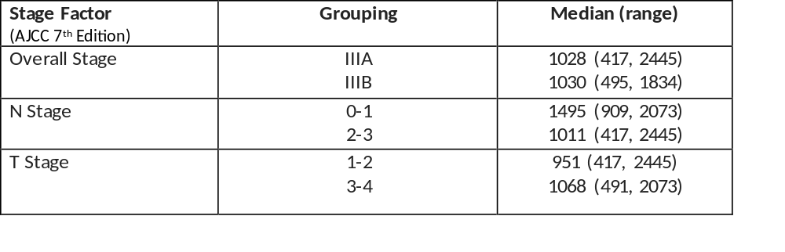

Table s4. Sensitivity analysis of the predicitive value of GDF15 cutoff levels relative to Overall (OS) and Relapse-Free (RFS) survival. The table illustrates Hazard Ratios (HR), confidence intervals (CI) and p values of the ability of indicated baseline GDF15 levels to predict OS and RFS.

