Supplementary Information
Efficient Synaptic Emulation and Ultralow Power Digital-Analog Conversion in Cellulose-Based Neural Devices through Molecular Polarization
Kuan-Chang Chang¹, Yihua Xu¹, Mingge Wang¹, Zehui Peng¹, Dar-Jen Hsieh², Lei Li¹*
^{1*}School of Electronic and Computer Engineering, Peking University Shenzhen Graduate School, Shenzhen, 518055, China.
²R&D Center, ACRO Biomedical Co., Kaohsiung City, 82151, Taiwan

*Corresponding author(s). E-mail(s): lilei@pkusz.edu.cn;
Contributing authors: kcchang@pkusz.edu.cn; yhxu@stu.pku.edu.cn; 2201212780@stu.pku.edu.cn; zehui_peng@stu.pku.edu.cn; dj@acrobiomedical.com;

1 Experimental Section
1.1 Manufacturing of a Neuro Device Based on Cellulose
Initially, carboxymethyl cellulose powder is dissolved in deionized water and magnetically stirred at room temperature for 6 hours to achieve complete dissolution, resulting in a cellulose solution. Subsequently, 20 mL of the cellulose solution, with a mass fraction of 0.25 wt%, is poured into a polytetrafluoroethylene (PTFE) mold containing a clean 5 cm × 5 cm glass slide. The assembly is then left undisturbed at a temperature of 60 °C for 12 hours, allowing the carboxymethyl cellulose to form a uniform film on the glass surface (measured thickness of the film was 3.4 μm), which is subsequently peeled off the glass substrate. A masking template is applied over the surface of the cellulose film. Thereafter, synaptic-shaped electrodes with a thickness of approximately 120 nm are deposited onto the surface of the cellulose via direct current sputtering, followed by patterning through a shadow mask.
1.2 Synaptic Functions Characterization
All the electrical measurements were performed inside shielding box by Agilent B1500A semiconductor parameter analyzer at room temperature. Presynaptic spike was applied on the top electrode via probe and postsynaptic current was measured at the bottom electrode via another probe. The voltage spike signals were generated by the Keysight B1525A high voltage semiconductor spike generator unit (HV-SPGU). For flexible characteristics, presynaptic spike was applied on the top electrode via probe and postsynaptic current was measured via another probe.
1.3 Material Analysis
Fourier transform infrared spectroscopy (FTIR) was applied to analyze the element composition and chemical bonds in the material. Utilize a 3D microscope and scanning electron microscope (SEM) respectively to capture images of the device and the cellulose film. Light transmittance was carried out by N&K 1280 analyzer.
1.4 Correlation Analysis
In order to explore the strength of the correlation between two variables (X and Y), we calculated the Pearson product-moment correlation coefficient (PCC), which can be expressed as:
$$\begin{aligned}r\left(X,Y\right)=\frac{\operatorname{Cov}\left(X,Y\right)}{\sqrt{\operatorname{Var}\left[X\right]\operatorname{Var}\left[Y\right]}}\#\left(S1\right)\end{aligned}$$
where $\operatorname{Cov}\left(X,Y\right)$ represents the covariance between X and Y, and $\operatorname{Var}\left[X\right]$ and $\operatorname{Var}\left[Y\right]$ are the standard deviations of X and Y, respectively. The calculated result $r\left(X,Y\right)$ represents the PCC, which falls within the range of -1 to 1. The larger the absolute value of PCC, the stronger the correlation between variables X and Y; conversely, a weaker correlation is indicated by values closer to zero.
1.5 Biodegradation
Plants used for biodegradation testing were placed in an outdoor environment with temperatures ranging from 25 to 30 degrees Celsius and humidity levels between 40% and 70%. Furthermore, the soil pH was controlled at 6.
2 Supporting Figures
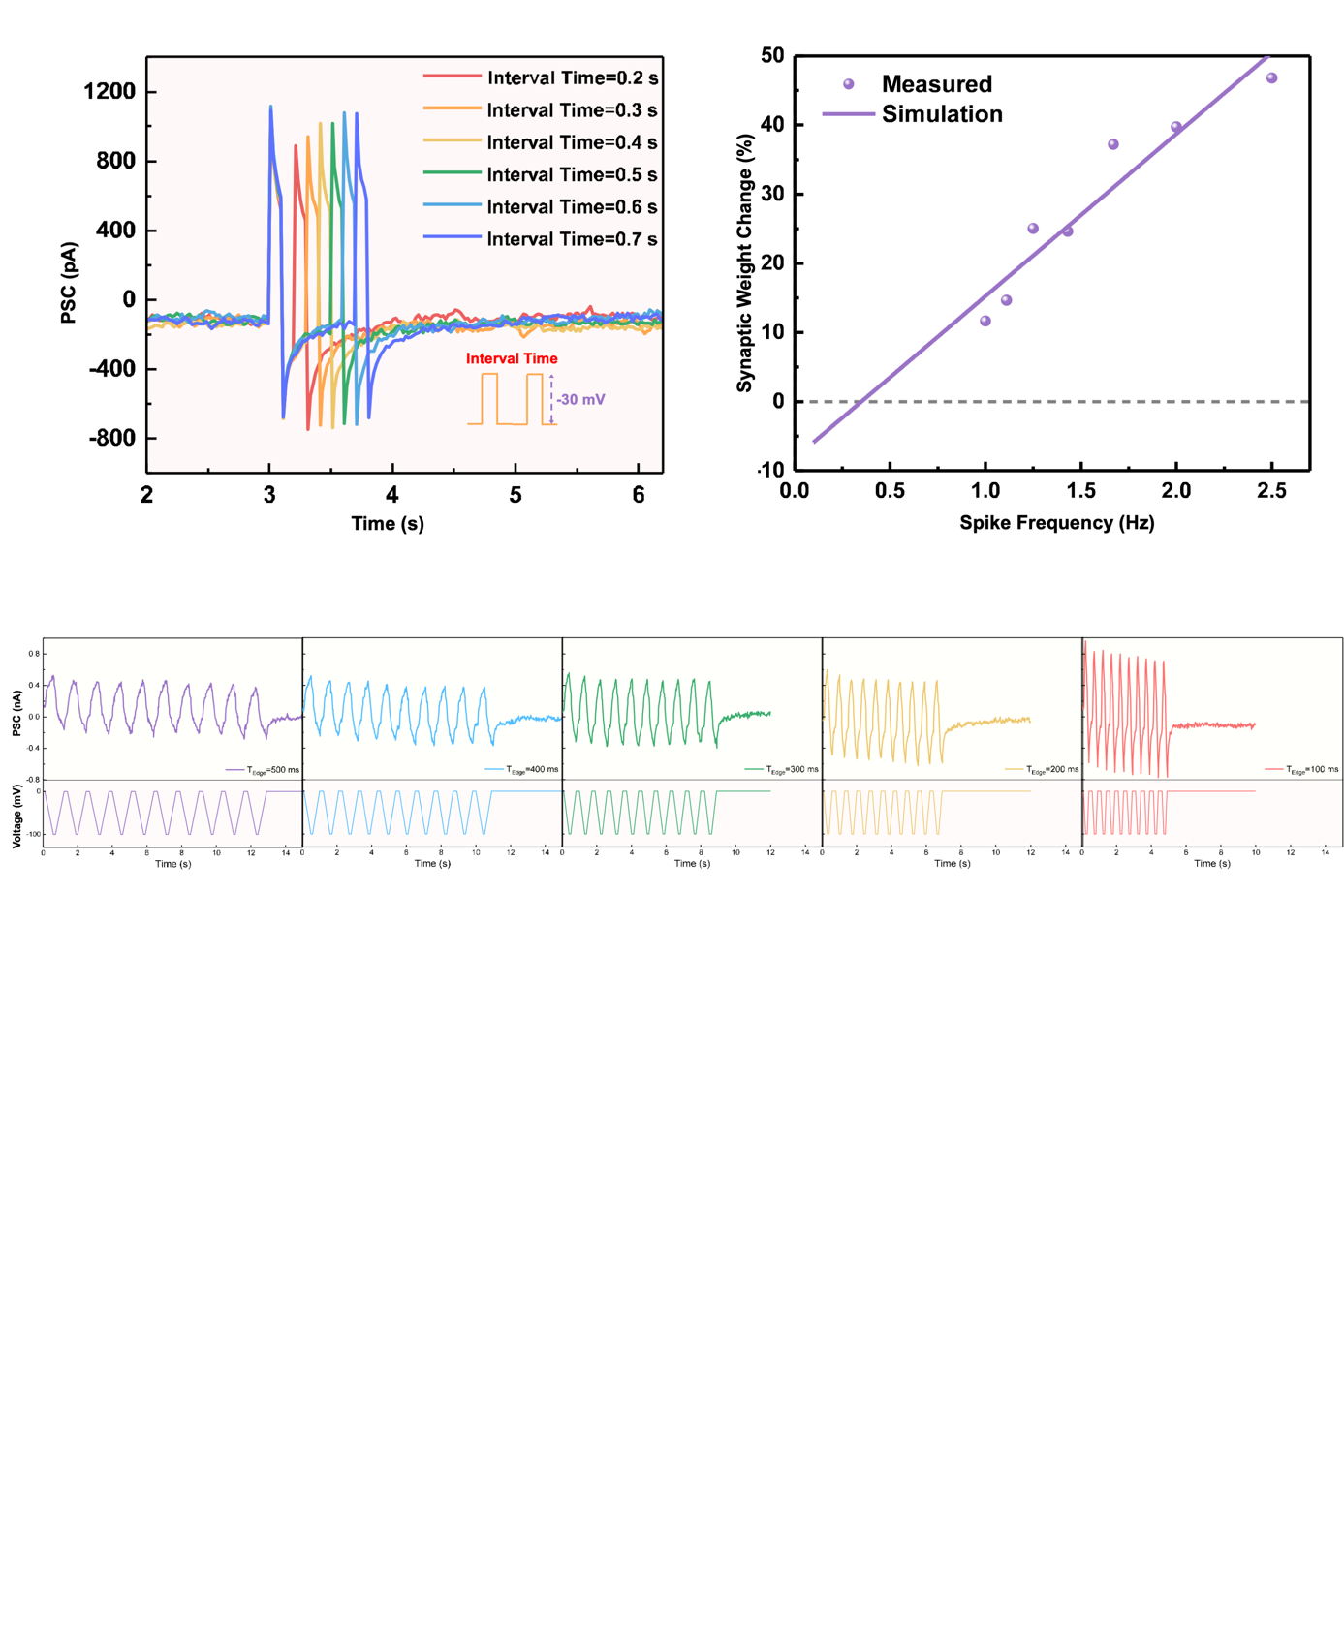
Fig. S1 The cellulose device exhibits paired-pulse depression when stimulated by two consecutive negative voltage pulses

Fig. S2 SRDP with spike frequency varying from 1 to 2.5 Hz

Fig. S3 The cellulose device demonstrates stable signal conversion functionality under continuous pulse stimulation

