SUPPLEMENTARY INFORMATION

Machine Learning Prediction of Intestinal α-Glucosidase Inhibitors Using a Diverse Set of Ligands: A Drug Repurposing Effort with DrugBank Database Screening

Adeshina I. Odugbemi^{1,4}, Clement Nyirenda², Alan Christoffels¹, Samuel A. Egieyeh^{3,4}*

¹ South African Medical Research Council Bioinformatics Unit, South African National Bioinformatics Institute, University of the Western Cape, Bellville, Cape Town 7535, South Africa.
² Department of Computer Science, University of the Western Cape, Cape Town 7535, South Africa.
³ School of Pharmacy, University of the Western Cape, Bellville, Cape Town 7535, South Africa.
⁴ National Institute for Theoretical and Computational Sciences (NITheCS), South Africa.
* Corresponding author
E-mail: segieyeh@uwc.ac.za

Contents

Figure S1: Confusion Matrices for all test sets across the 2D and 3D descriptors, and the ECFP dataset 3

Figure S2: Confusion Matrices for all training sets across the 2D and 3D descriptors, and the ECFP dataset 4

Figure S3: Learning curves for the untuned RF and SVM models 5

Table S1: Docking scores and MM-GBSA free binding energies of virtual screening hits. 5

Figure S4: The 2D ligand interaction diagram of α-glucosidase (2QMJ) binding with (a) Dihydro-Acarbose (DB04226) (b) N-[2-(1-maleimidyl) ethyl]-7-diethylaminocoumarin-3-carboxamide (DB02799) (c) Hygromycin B (DB11520) (d) Apramycin (DB04626) (e) Amikacin (DB00479) 6

Figure S5: Ligand-protein percentage contacts for (a) Dihydro-Acarbose (DB04226) (b) N-[2-(1-maleimidyl) ethyl]-7-diethylaminocoumarin-3-carboxamide (DB02799) (c) Hygromycin B (DB11520) (d) Apramycin (DB04626) and (e) Amikacin (DB00479) for at least 30% of the simulation time. 7

 | 2D Dataset | 3D Dataset | ECFP4 Dataset
RF | 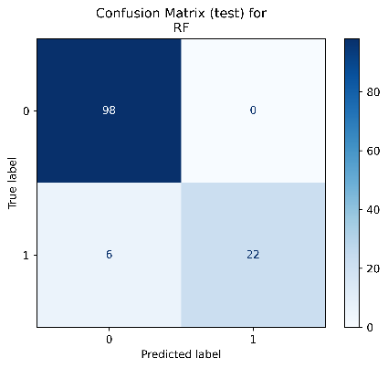 | 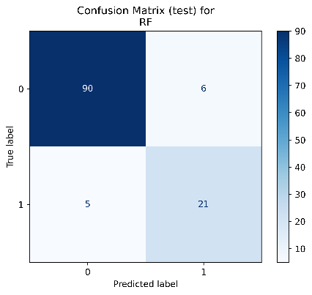 | 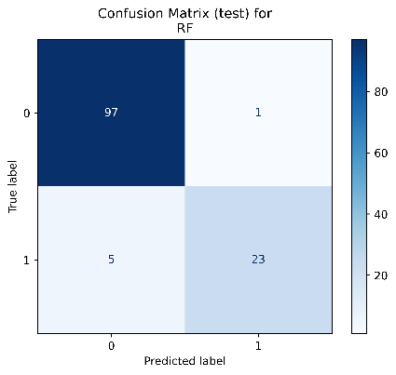
RF Tuned | 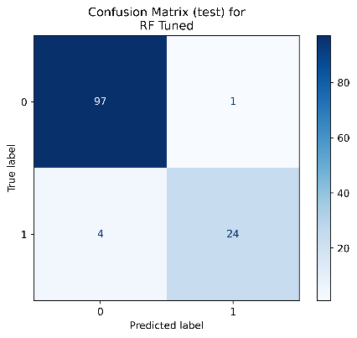 | 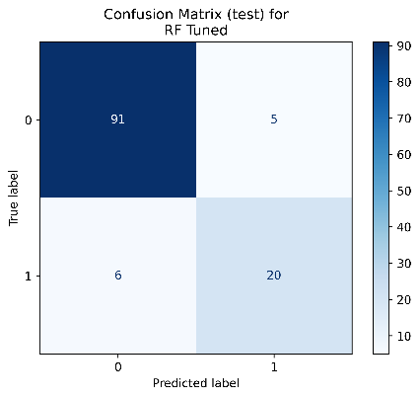 | 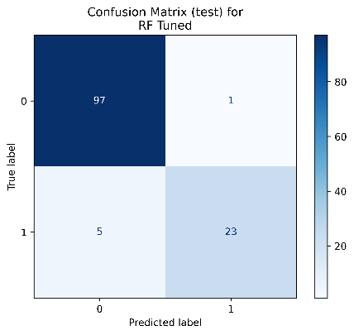
SVM | 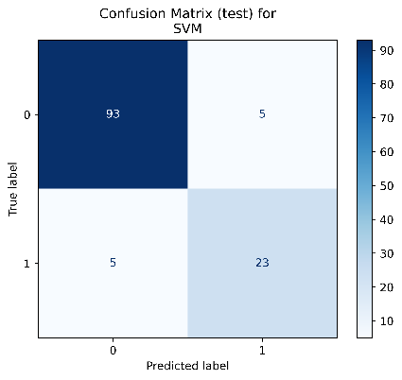 | 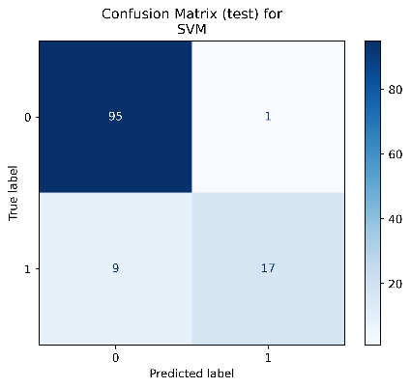 | 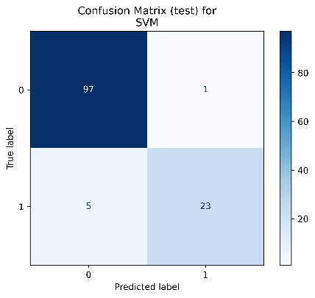
SVM Tuned | 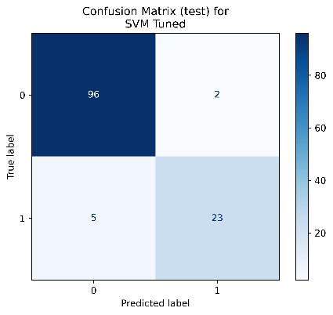 | 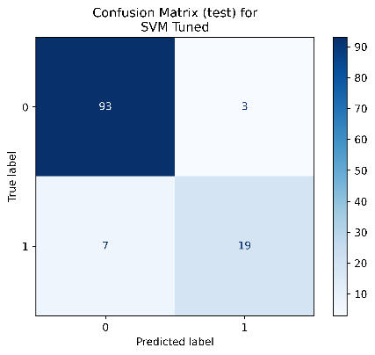 | 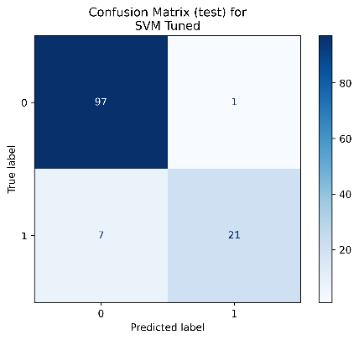

Figure S1: Confusion Matrices for all test sets across the 2D and 3D descriptors, and the ECFP dataset

 | 2D Dataset | 3D Dataset | ECFP4 Dataset
RF | 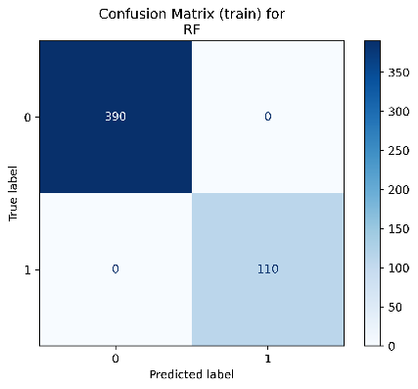 | 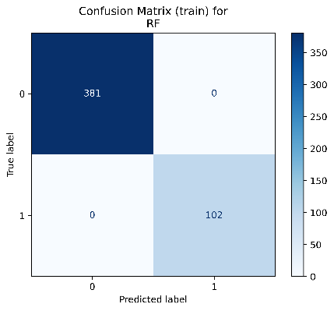 | 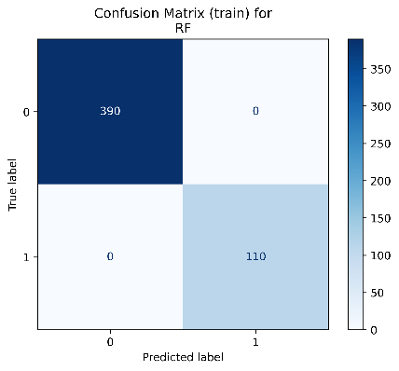
RF Tuned | 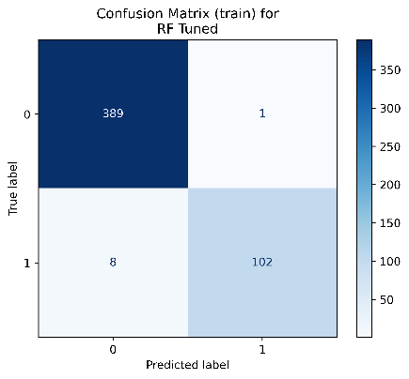 | 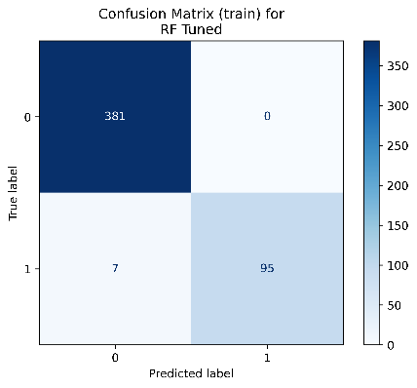 | 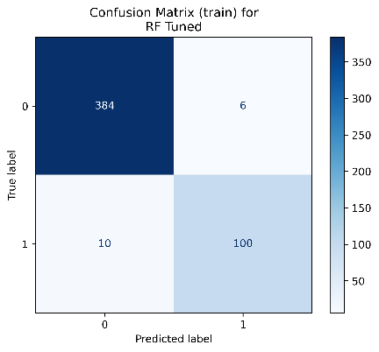
SVM | 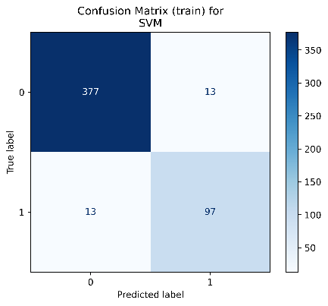 | 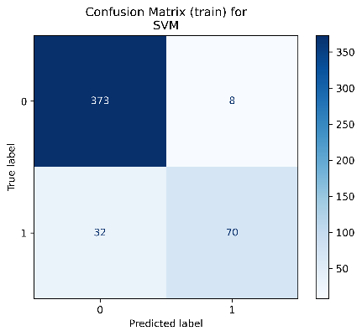 | 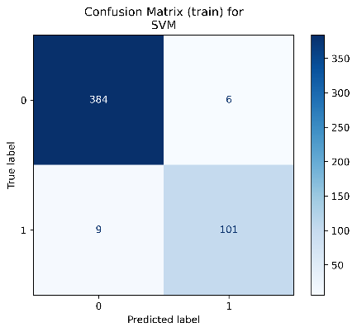
SVM Tuned | 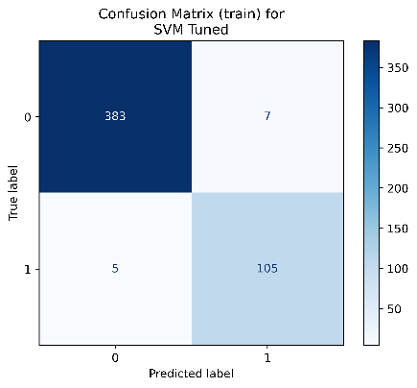 | 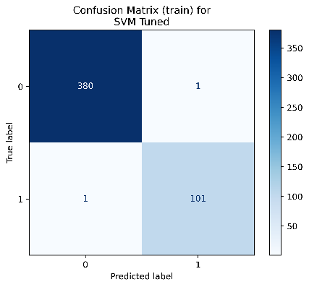 | 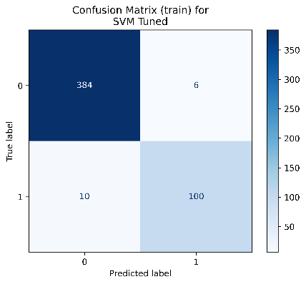

Figure S2: Confusion Matrices for all training sets across the 2D and 3D descriptors, and the ECFP dataset

 | 2D Dataset | 3D Dataset | ECFP4 Dataset
RF | 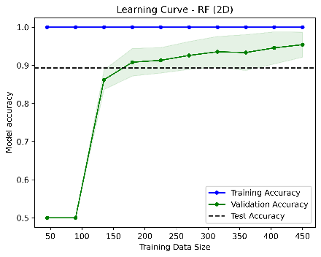 | 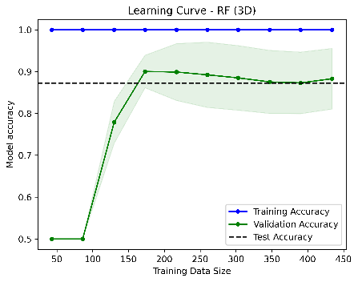 | 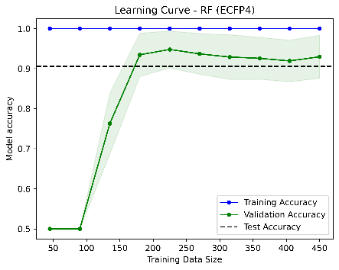
SVM | 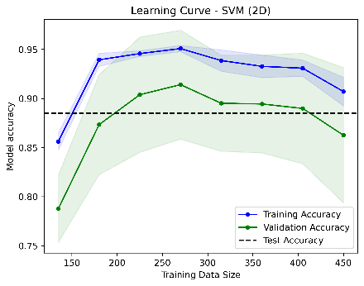 | 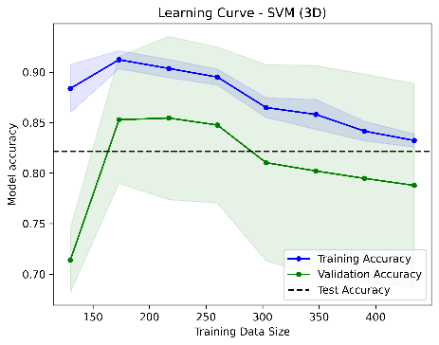 | 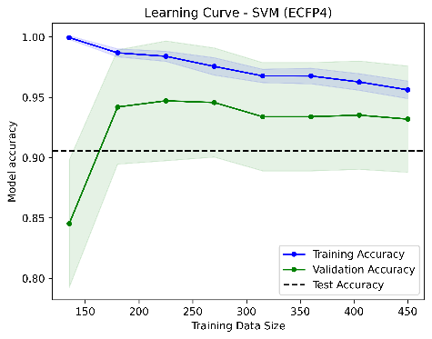

Figure S3: Learning curves for the untuned RF and SVM models

Table S1: Docking scores and MM-GBSA free binding energies of virtual screening hits.
Drug name | DrugBank ID | Docking Score (Kcal/mol) | MMGBSA dGbind (Kcal/mol)
Dihydro-Acarbose | DB04226 | -10.94 | -27.03
N-[2-(1-maleimidyl)ethyl]-7-diethylaminocoumarin-3-carboxamide | DB02799 | -2.86 | -15.03
Hygromycin B | DB11520 | -13.28 | -22.93
Apramycin | DB04626 | -9.77 | -55.28
Amikacin | DB00479 | -13.32 | -39.43

(a) | 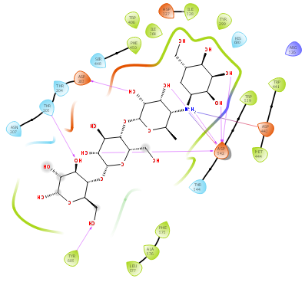 | 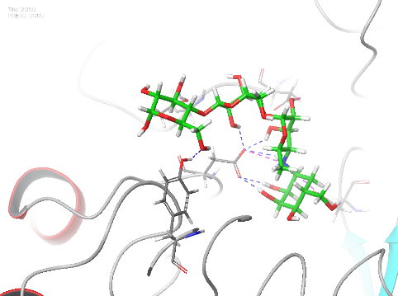
(b) | 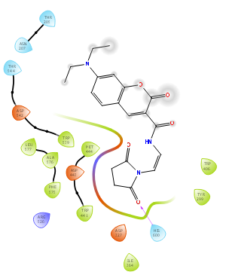 | 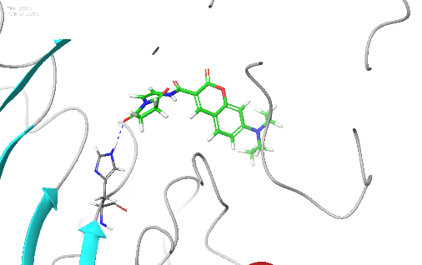
(c) | 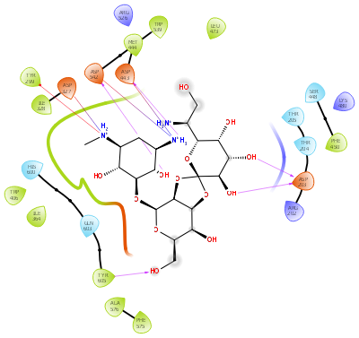 | 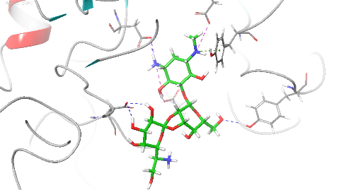
(d) | 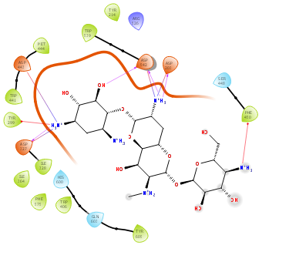 | 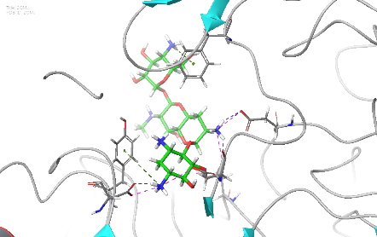
(e) | 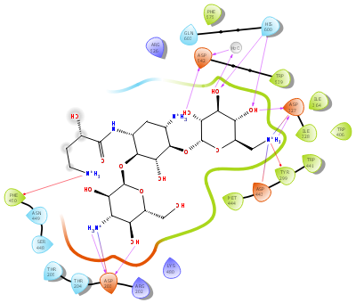 | 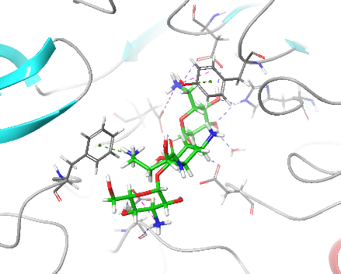
 | 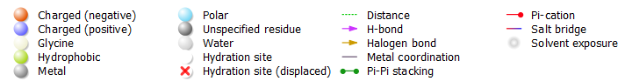

Figure S4: The 2D ligand interaction diagram of α-glucosidase (2QMJ) binding with (a) Dihydro-Acarbose (DB04226) (b) N-[2-(1-maleimidyl) ethyl]-7-diethylaminocoumarin-3-carboxamide (DB02799) (c) Hygromycin B (DB11520) (d) Apramycin (DB04626) (e) Amikacin (DB00479)

(a)  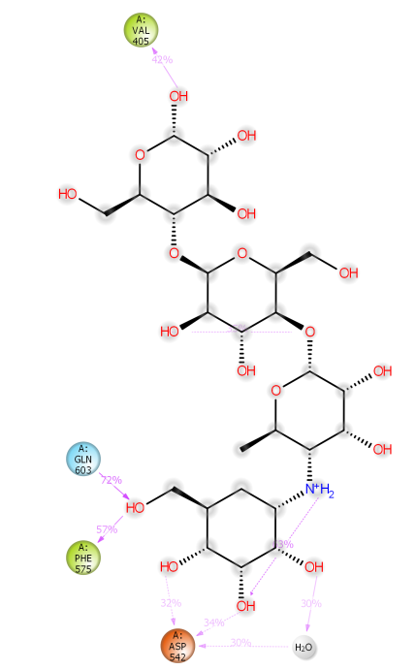 | (b)  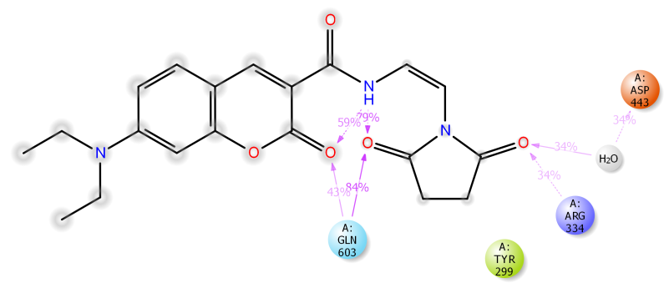
(c)
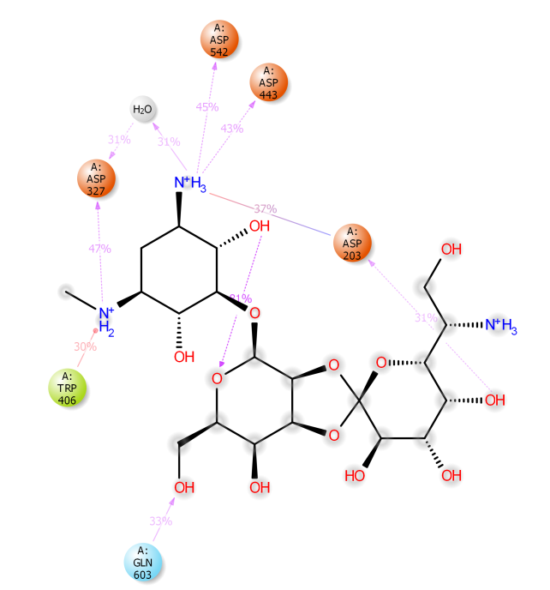
(d)  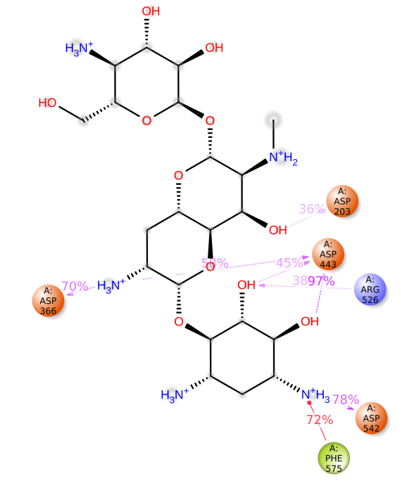 | (e)  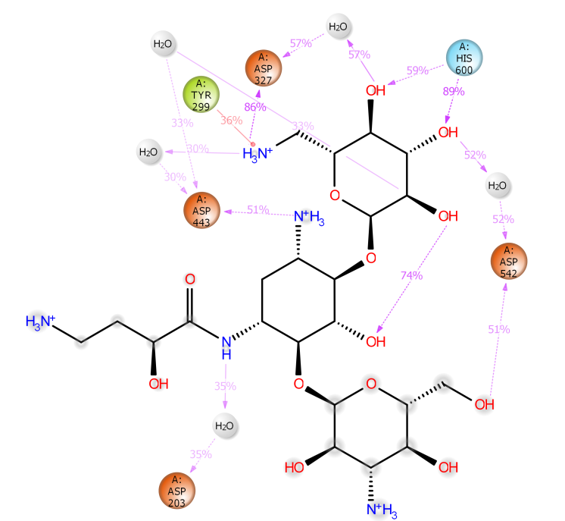

Figure S5: Ligand-protein percentage contacts for (a) Dihydro-Acarbose (DB04226) (b) N-[2-(1-maleimidyl) ethyl]-7-diethylaminocoumarin-3-carboxamide (DB02799) (c) Hygromycin B (DB11520) (d) Apramycin (DB04626) and (e) Amikacin (DB00479) for at least 30% of the simulation time.

