Distinct Neurodevelopmental Patterns and Intermediate Fusion-Based Predictive Modeling in Autism

Supplementary Methods and Materials:

MRI acquisition

All T1-weighted scans were chosen from 1112 ABIDE-I participants (539 ASD participants and 573 TC), 1114 ABIDE-II participants (521 ASD participants and 593 TC participants), and 323 KQJH participants (237 ASD participants, 86 TC participants). A detailed introduction of the participants and scan parameters in each center for ABIDE dataset (ABIDE-I [1] and ABIDE-II [2]) is available at http://fcon_1000.projects.nitrc.org/indi/abide/. KQJH dataset was acquired in the sagittal plane on 3 T scanners (Siemens Skyra) using a magnetization prepared rapid gradient echo (MPRAGE) sequence. Acquisition parameters were as follows: TR/TE/TI = 2020/2.11/900 ms; flip angle: 8°; FOV = 224 × 224 mm²; and 1 × 1 × 1 mm3 isotropic voxel. Before scanning, the sedation was performed with 10% chloral hydrate (50 mg/ml) orally or by enema to reduce the influence of children's head movement on image quality.

Quality assurance (QA)
The quality control was assessed by inspecting the image and the cortical reconstructed results across individual brains by two independent reviewers (YL.W. and S.T.). To enhance the accuracy of QA and to investigate the reason for exclusion, we use quality control software for MRI data (MRIQC [3]) to compute image quality metrics for each dataset.
In ABIDE-I dataset, out of the 238 inaccurately segmented scans, 116 had abnormally low contrast-to-noise ratio (CNR), and the remaining 122 scans showed evidence of high subject motion, as estimated using the entropy focus criterion (EFC). For these reasons, the data from these 238 participants were excluded from further analyses, resulting in a final sample size of N = 874 subjects.
In ABIDE-II dataset, out of the 243 inaccurately segmented scans, 63 had abnormally low CNR, and the remaining 180 scans showed evidence of high subject motion, as estimated using the EFC. For these reasons, the data from these 243 participants were excluded from further analyses, resulting in a final sample size of N = 871 subjects.
KQJH dataset were subjected to the same quality assurance steps as ABIDE-I & II. out of the 59 inaccurately segmented scans, 32 had abnormally low CNR, and the remaining 27 scans showed evidence of high subject motion, as estimated using the EFC. For these reasons, the data from these 107 participants were excluded from further analyses, resulting in a final sample size of N = 216 subjects.
After the QA steps described above, ABIDE I consisted of 393 ASD participants (N=58 female), age range 7-64 (M = 12.72, SD = 6.38) and 481 TD participants (163 female) age range 6-56 (M = 12.65, SD = 6.69). ABIDE II consisted of 402 ASD participants (N=54 female), age range 7-64 (M = 17.04, SD = 7.95) and 469 TD participants (90 female) age range 6-56 (M = 16.85, SD = 7.23). KQJH consisted of 216 ASD participants (N=38 female), age range 1-6 (M = 2.65, SD = 0.83) and 48 TD participants (23 female) age range 0-6 (M = 2.13, SD = 0.97). Moreover, age at time of scan in years per collection (sites) was plotted in Figure S1.

Image preprocessing and feature extraction
For 0-2 Years:
The T1-weighted images of participants between 0-2 years of age were analyzed using Infant Freesurfer software (https://surfer.nmr.mgh.harvard.edu/fswiki/infantFS). Infant Freesurfer is a pipeline of automated segmentation and surface extraction based on Freesurfer for T1-weighted neuroimaging data for infants [4]. Automatic processing steps include intensity normalization, skull stripping, and segmentation of the cortex, white matter, and subcortical structures. Segmentation involves using a multi-atlas approach in which multiple atlases are first registered to subject space and the labels are transferred. The atlases were developed from infant MRI scans [5]. To create the atlas, manually segmented labels were developed using MRI scans from a representative sample of infants (0–2 years of age). A total of 68 regionally distributed measurements (grey matter volume, surface area, and cortical thickness) were extracted from the “aparc” [6] in each subject.
For 3-6 Years:
The T1-weighted images of participants between 3-6 years of age were estimated using FreeSurfer (version 7.1.117) and ANTs (version 2.0). Since the brain size and gray-white matter contrast change with age during childhood periods, we first applied the age-specific brain templates [7] and created prior probabilistic tissue maps/masks including gray matter, white matter, cerebrospinal fluid (CSF), subcortical structures, brain stem, and cerebellum (see Data and Code availability). Then, all images were transformed and inputted to the FreeSurfer "recon-all" pipeline, and the corresponding white matter and brain extraction masks obtained above were injected into the pipeline for tissue segmentation. The detailed information of MRI preprocessing process sees the blow descriptions (over 6 Years).
Over 6 Years:
Cortical reconstruction and volumetric segmentation for all participants were performed with the FreeSurfer software, version 7.1.117 (http://surfer.nmr.mgh.harvard.edu/). It begins with transformation to Talaraich space, intensity inhomogeneity correction, bias field correction [8], and skull-stripping [9]. Thereafter, WM is separated from GM and other tissues and the volume within the created WM–GM boundary is filled. After this, the surface is tessellated and smoothed. After these preprocessing steps are completed, the surface is inflated [10] and registered to a spherical atlas. This method adapts to the folding pattern of each individual brain, utilizing consistent folding patterns such as the central sulcus and the sylvian fissure as landmarks, allowing for high localization accuracy. FreeSurfer uses probabilistic approach based on Markov random fields for automated labeling of brain regions. Cortical thickness is calculated as the average distance between the WM–GM boundary and the pial surface on the tessellated surface. The FreeSurfer algorithm automatically parcellates the cortex and assigns a neuroanatomical label to each location on a cortical surface model based on probabilistic information. The parcellation scheme of the Desikan–Killiany atlas [6, 11] was used to divide the cortex into 34 regions per hemisphere.

Table. S1. MCT quality of a model fit in the train set in TD.

Model | AIC | $∆$AIC | AIC weights | BIC | $∆$BIC | BIC weights
m1a | -1176.384 | 0 | 5.399 | -1096.167 | 9.999 | 9.999
m1b | -1176.460 | 0 | 5.608 | -1078.056 | 1.167 | 1.167
m1c | -1194.451 | 0.452 | 4.523 | -1070.866 | 3.205 | 3.205
m1d | -1189.003 | 0.03 | 2.968 | -1045.918 | 1.226 | 1.226
m1e | -1194.722 | 0.518 | 5.179 | -1067.457 | 5.828 | 5.828

Table. S2. MCT quality of a model fit in the train set in ASD.

Model | AIC | $∆$AIC | AIC weights | BIC | $∆$BIC | BIC weights
m1a | -1013.294 | 0 | 2.216 | -921.794 | 0.017 | 0.017
m1b | -1019.747 | 0 | 5.583 | -910.376 | 0 | 0
m1c | -1042.971 | 0.617 | 6.165 | -928.077 | 0.248 | 0.248
m1d | -1037.891 | 0.049 | 4.863 | -899.374 | 0 | 0
m1e | -1041.751 | 0.335 | 3.349 | -930.264 | 0.741 | 0.741
Table. S3. TSA quality of a model fit in the train set in TD.

Model | AIC | $∆$AIC | AIC weights | BIC | $∆$BIC | BIC weights
m1a | 5917.143 | 0 | 0 | 5981.542 | 0 | 0
m1b | 5797.215 | 0.179 | 0.179 | 5881.842 | 0.003 | 0.003
m1c | 5794.407 | 0729 | 0729 | 5893.745 | 0 | 0
m1d | 5798.538 | 0.092 | 0.092 | 5915.035 | 0 | 0
m1e | 5812.53 | 0 | 0 | 5917.205 | 0 | 0

Table. S4. TSA quality of a model fit in the train set in ASD.

Model | AIC | $∆$AIC | AIC weights | BIC | $∆$BIC | BIC weights
m1a | 6178.629 | 0 | 0 | 6243.123 | 0 | 0
m1b | 6088.446 | 0.018 | 0.018 | 6165.992 | 0.999 | 0.999
m1c | 6091.601 | 0.002 | 0.002 | 6180.681 | 0 | 0
m1d | 6079.592 | 0.986 | 0.986 | 6193.296 | 0 | 0
m1e | 6114.621 | 0 | 0 | 6228.230 | 0 | 0

Table. S5. TGV quality of a model fit in the train set in TD.

Model | AIC | $∆$AIC | AIC weights | BIC | $∆$BIC | BIC weights
m1a | 7513.614 | 0 | 0 | 7585.569 | 0 | 0
m1b | 7413.831 | 0 | 0 | 7486.466 | 0.002 | 0.002
m1c | 7506.856 | 0 | 0 | 7580.772 | 0 | 0
m1d | 7399.117 | 0.507 | 0.507 | 7485.263 | 0.003 | 0.003
m1e | 7399.172 | 0.493 | 0.493 | 7473.871 | 0.995 | 0.995

Table. S6. TGV quality of a model fit in the train set in ASD.

Model | AIC | $∆$AIC | AIC weights | BIC | $∆$BIC | BIC weights
m1a | 7664.468 | 0 | 0 | 7730.337 | 0 | 0
m1b | 7599.203 | 0.103 | 0.103 | 7671.842 | 0.198 | 0.198
m1c | 7663.216 | 0 | 0 | 7737.914 | 0 | 0
m1d | 7597.303 | 0.265 | 0.265 | 7678.852 | 0.006 | 0.006
m1e | 7595.564 | 0.632 | 0.632 | 7669.058 | 0.796 | 0.796

Table. S7. The results of the whole-brain analysis in brain morphological parameters (ASD vs. TD groups). All p-values are Holm-Bonferroni corrected (< 0.05).
Brain region | Hemisphere | Contrast | T-value | $p$-value
Gray Matter Volume
Medial orbitofrontal | L | ASD>TD | 3.96 | 0.005
Isthmus cingulate | L | ASD>TD | 4.21 | 0.002
Lateral occipital | L | ASD>TD | 5.12 | <0.001
Rostral anterior cingulate | L | ASD<TD | -3.49 | 0.034
Caudal middle frontal | L | ASD<TD | -3.57 | 0.0245
Precuneus | R | ASD>TD | 3.51 | 0.031
Lateral occipital | R | ASD>TD | 4.51 | <0.001
Precentral | R | ASD<TD | -4.38 | <0.001
Caudal anterior cingulate | R | ASD<TD | -3.59 | 0.023
Rostral anterior cingulate | R | ASD<TD | -3.44 | 0.04
Caudal middle frontal | R | ASD<TD | -3.87 | 0.007
Surface Area
Isthmus cingulate | L | ASD>TD | 4.13 | 0.003
Transverse temporal | L | ASD>TD | 4.51 | <0.001
Lateral occipital | L | ASD>TD | 7.74 | <0.001
Precuneus | L | ASD>TD | 3.7 | 0.015
Rostral anterior cingulate | L | ASD<TD | -3.84 | 0.009
Lateral orbitofrontal | L | ASD<TD | -4.86 | <0.001
precuneus | R | ASD>TD | 3.7 | 0.015
Rostral anterior cingulate | R | ASD<TD | -4.7 | <0.001
Lateral orbitofrontal | R | ASD<TD | -3.81 | 0.01
Medial orbitofrontal | R | ASD<TD | -4.21 | 0.002
Cortical Thickness
Medial orbitofrontal | L | ASD>TD | 6.14 | <0.001
Rostral middle frontal | L | ASD>TD | 4.17 | 0.002
Lateral occipital regions | L | ASD>TD | 3.71 | 0.015
Precentral | L | ASD<TD | -5.82 | <0.001
Parahippocampal | L | ASD<TD | -4.16 | 0.002
Caudal middle frontal | R | ASD<TD | -4.13 | 0.003
Opercularis | R | ASD<TD | -3.39 | <0.049
Precentral | R | ASD<TD | -7.58 | <0.001
Paracentral | R | ASD<TD | -4.08 | 0.003
Parahippocampal | R | ASD<TD | -4.65 | <0.001
Lingual | R | ASD>TD | -3.50 | 0.033
Lateral occipital | R | ASD>TD | 4.71 | <0.001

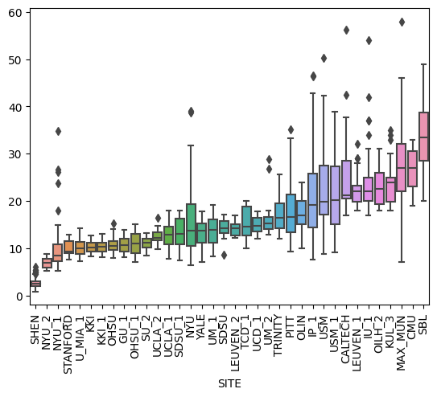
Figure S1. Age at time of scan in years per collection (ordered by mean age per collection), irrespective of diagnostic group.

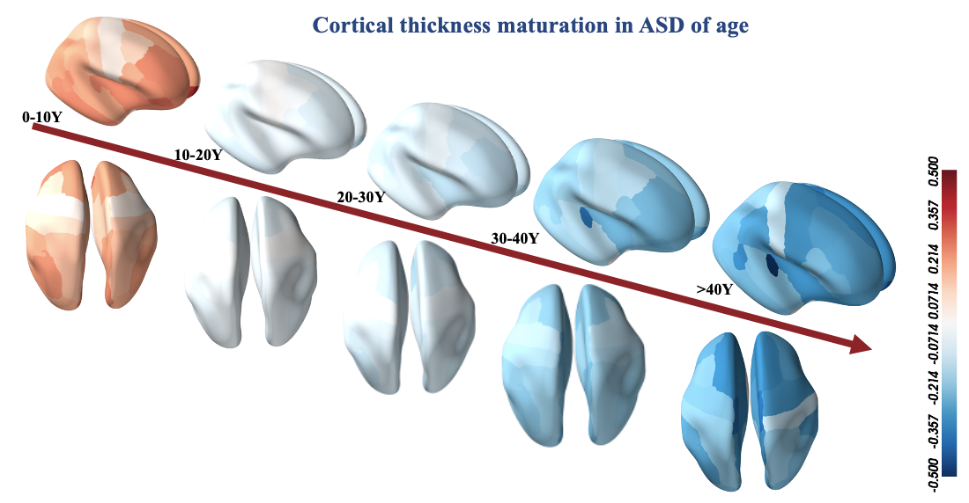
Figure S2. Ununiform maps of mean cortical thickness in ASD groups across the lifespan (the interval is ten years). The colors indicate the atypical patterns of cortical thickness across different stages of life.
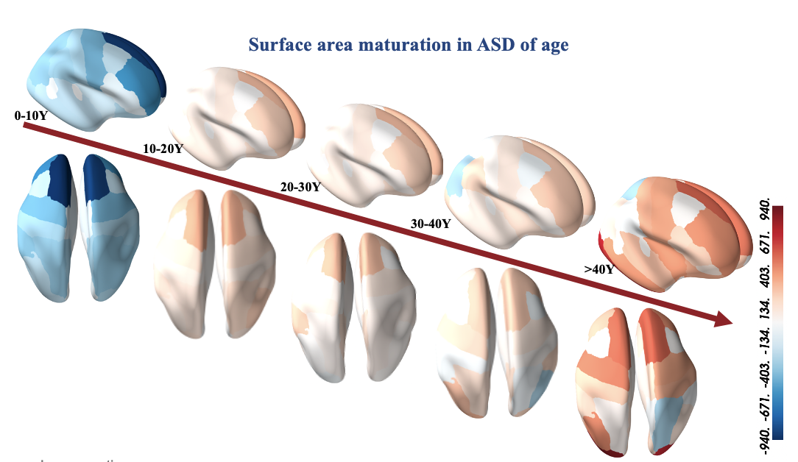
Figure S3. Ununiform maps of total surface area in ASD groups across the lifespan (the interval is ten years). The colors indicate the atypical patterns of surface area across different stages of life.
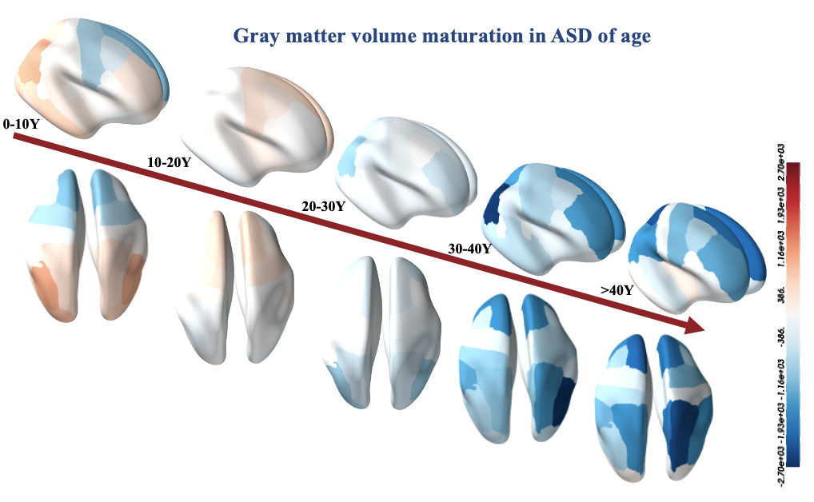
Figure S4. Ununiform maps of total gray matter volume in ASD groups across the lifespan (the interval is ten years). The colors indicate the atypical patterns of gray mater volume across different stages of life.

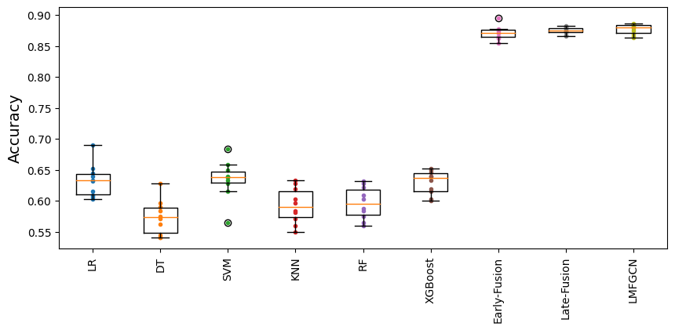
Figure S5. 10-fold cross-validation of LMFGCN performance in comparison to various fusion methods, and classical machine learning models. Boxplots summarize accuracy scores obtained across CV-folds.

References

[1] A. Di Martino et al., "The autism brain imaging data exchange: towards a large-scale evaluation of the intrinsic brain architecture in autism," (in eng), Mol Psychiatry, vol. 19, no. 6, pp. 659-67, Jun 2014, doi: 10.1038/mp.2013.78.
[2] A. Di Martino et al., "Enhancing studies of the connectome in autism using the autism brain imaging data exchange II," Scientific Data, vol. 4, no. 1, p. 170010, 2017/03/14 2017, doi: 10.1038/sdata.2017.10.
[3] O. Esteban, D. Birman, M. Schaer, O. O. Koyejo, R. A. Poldrack, and K. J. Gorgolewski, "MRIQC: Advancing the automatic prediction of image quality in MRI from unseen sites," PloS one, vol. 12, no. 9, p. e0184661, 2017.
[4] L. Zöllei, J. E. Iglesias, Y. Ou, P. E. Grant, and B. Fischl, "Infant FreeSurfer: An automated segmentation and surface extraction pipeline for T1-weighted neuroimaging data of infants 0–2 years," NeuroImage, vol. 218, p. 116946, 2020/09/01/ 2020, doi: https://doi.org/10.1016/j.neuroimage.2020.116946.
[5] K. de Macedo Rodrigues et al., "A FreeSurfer-compliant consistent manual segmentation of infant brains spanning the 0-2 year age range," (in eng), Front Hum Neurosci, vol. 9, p. 21, 2015, doi: 10.3389/fnhum.2015.00021.
[6] R. S. Desikan et al., "An automated labeling system for subdividing the human cerebral cortex on MRI scans into gyral based regions of interest," Neuroimage, vol. 31, no. 3, pp. 968-80, Jul 1 2006, doi: 10.1016/j.neuroimage.2006.01.021.
[7] H. Zhang et al., "Growth charts of brain morphometry for preschool children," (in eng), Neuroimage, vol. 255, p. 119178, Jul 15 2022, doi: 10.1016/j.neuroimage.2022.119178.
[8] J. G. Sled, A. P. Zijdenbos, and A. C. Evans, "A nonparametric method for automatic correction of intensity nonuniformity in MRI data," (in eng), IEEE Trans Med Imaging, vol. 17, no. 1, pp. 87-97, Feb 1998, doi: 10.1109/42.668698.
[9] F. Ségonne et al., "A hybrid approach to the skull stripping problem in MRI," (in eng), Neuroimage, vol. 22, no. 3, pp. 1060-75, Jul 2004, doi: 10.1016/j.neuroimage.2004.03.032.
[10] B. Fischl and A. M. Dale, "Measuring the thickness of the human cerebral cortex from magnetic resonance images," (in eng), Proc Natl Acad Sci U S A, vol. 97, no. 20, pp. 11050-5, Sep 26 2000, doi: 10.1073/pnas.200033797.
[11] A. Klein and J. Tourville, "101 labeled brain images and a consistent human cortical labeling protocol," (in eng), Front Neurosci, vol. 6, p. 171, 2012, doi: 10.3389/fnins.2012.00171.

