Supplementary Data

Solvent extraction of lithium from brines with high magnesium/lithium ratios; Investigation on parameter interactions
Anahita Kazemi Kia, Hamid Reza Mortaheb*, Mahsa Baghban Salehi*, Ali Asghar Nozaeim
Chemistry and Chemical Engineering Research Center of Iran, P.O. Box: 14335-186, Tehran, Iran

Table S1. Parameters and their levels based on DEP.
Independent variable | Factor | Variable levels
Independent variable | Factor | -α | -1 | 0 | +1 | +α
Fe/Li molar ratio [-] | A | 0.50 | 1.01 | 1.75 | 2.49 | 3.00
HCl concentration [M] | B | 0 | 0.10 | 0.25 | 0.40 | 0.50
TBP vol percent [%] | C | 10.00 | 26.22 | 50.00 | 73.78 | 90.00

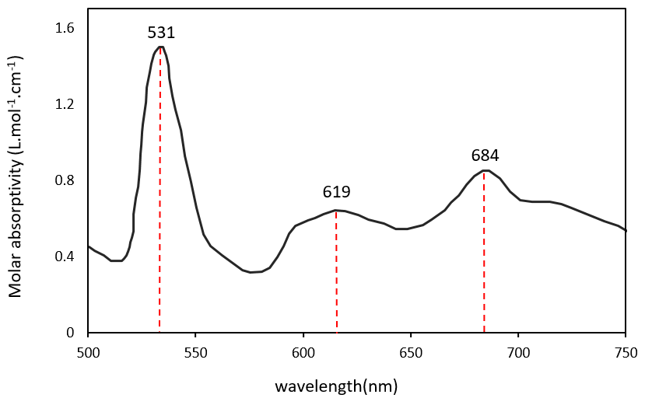
Fig. S1. UV-VIS spectra for determination of extraction complex wavelengths.

Fig. S2. Response sensitivity to major parameters (A, B, and C: Mean).

