Supplementary Information

Polygenic scores for psychiatric traits mediate the impact of multigenerational history for depression on offspring psychopathology

Eunji Lee*, Milenna T. van Dijk*, Bogyeom Kim, Gakyung Kim, Eleanor Murphy, Ardesheer Talati, Myrna M. Weissman, Yoonjung Y. Joo, Jiook Cha

(* denotes equal contributions)

Supplementary Methods. Genotype data and measures

Supplementary Figure 1. Effects of family history of depression on original PGSs in multi-ancestry children

Supplementary Figure 2. Effects of family history of depression on residualized PGSs in European-ancestry children

Supplementary Figure 3. Effects of family history of depression on original PGSs in European-ancestry children

Supplementary Figure 4. Effects of family history of depression on residualized PGSs in multi-ancestry children (without family history of mania)

Supplementary Figure 5. Effects of family history of depression on residualized PGSs in European-ancestry children (without family history of mania)

Supplementary Figure 6. Effects of depression PGS on clinical outcomes in European-ancestry children

Supplementary Figure 7. Mediation analysis with depression PGS in European-ancestry children

Supplementary References

Supplementary Methods. Genotype data and measures

Genotype Data
Genotyping was done using saliva samples of ABCD study participants at the baseline visit. The samples were genotyped at the Rutgers University Cell and DNA Repository using the Affymetrix NIDA Smokescreen array (733,293 SNPs). We removed any SNPs with genotype call rate<95%, sample call rate<95%, and rare variants with minor allele frequency (MAF)<0.01. The variants were imputed with the Michigan Imputation Server (Das et al., 2016) using the 1000 Genome phase 3 version 5 multiethnic GRCh37/hg19 reference panel (Auton et al., 2015) with Eagle v2.4 phased output (Loh et al., 2016). With the imputed 12,046,090 variants, we additionally filtered out the data with any individuals with>5% missing genotypes; with extreme heterozygosity (F coefficient>3 SDs from the population mean); and SNPs with imputation quality INFO score<0.4, missingness rate>5%, MAF<0.01 and Hardy-Weinberg equilibrium p<10⁻⁶. The ABCD release 3.0 provided the genetic ancestry of each participant, determined with the fastSTRUCTURE algorithm (Raj et al., 2014). Considering that the samples had diverse genetic ancestries and included related family members, we estimated kinship coefficients (KCs) and ancestrally informative principal components (PCs) using PC-Air (Conomos et al., 2015) and PC-Relate (Conomos et al., 2016) to control familial relatedness and admixed ancestry. In addition, we retained genetically unrelated participants more distant than 4th-degree relatives (KC>0.022) and removed any outliers deviating significantly from the center of PC space (>6 SD limits). We finally used total genotype data of 11,301,999 variants in 10,199 unrelated multiethnic samples, including 7,893 European-ancestry participants.

Validation of polygenic scores
For 14 PGS traits (i.e., depression, MDD, ADHD, general happiness, happiness-health, happiness-life, SWB, insomnia, snoring, BMI, PTSD, CP, EA, IQ) that have related phenotypes measured in the ABCD study, we manually validated for the optimal hyperparameter of PGSs. The global shrinkage hyperparameter (phi, φ) in the PRS-CSx was optimized with small-scale grid search (φ = 1, 1E-2, 1E-4, 1E-6) in the held-out validation set of 1,579 unrelated participants, who were excluded from the final samples. We validated the hyperparameter with linear models, regressing phenotype variables related to complex traits of each PGS. The regression models included sex, age, and the first ten ancestrally informative PCs as covariates, and the model performance was evaluated with the R² and beta coefficient of PGS. The rest of 16 PGS traits were validated automatically using PRS-CS-auto (Ge et al., 2019) that select the optimal value of hyperparameter with a fully Bayesian method. The final PGSs were residualized with the first ten genetic PCs for population stratification.

Potential confounders
Variable | Description | Number of missing values | Imputation method
CHILD’S CHARACTERISTICS
demo_brthdat_v2 | Age | 11 | predictive mean matching
demo_sex_v2 | Sex | 1 | logistic regression
demo_ethn_v2 (Hispanic), demo_race_a_p___10 (White), demo_race_a_p___11 (Black) | Race/Ethnicity | 106 | polytomous logistic regression
kbi_p_c_gay | Sexual orientation (parent report) | 6 | polytomous logistic regression
kbi_y_sex_orient | Sexual orientation (child report) | 14 | polytomous logistic regression
demo_gender_id_v2 | Gender identity (parent report) | 12 | polytomous logistic regression
demo_relig_v2 | Religious preferenceª | 414 | polytomous logistic regression
demo_origin_v2 | Country of birth^{b} | 12 | logistic regression
PARENT/CAREGIVER’S CHARACTERISTICS
demo_prim | Relationship with child | 1 | polytomous logistic regression
demo_prnt_age_v2 | Age | 62 | predictive mean matching
demo_prnt_marital_v2 | Marital status | 75 | polytomous logistic regression
demo_comb_income_v2 | Total household income | 717 | predictive mean matching
demo_prnt_ed_v2 | Parental education level | 12 | predictive mean matching
ªReligious preference: A variable with three categories was created from the scratch variable with 17 categories (‘demo_relig_v2’) into (1) “Denominational” from categories 1-13 and 16, (2) “Non-denominational” from category 17, and (3) “Agnostic/Atheist” from categories 14-15.
^{b}Country of birth: A variable with two categories was created from the scratch variable of parents’ place of birth (‘demo_origin_v2’) into (1) “Born in USA and territories” from category 189, (2) “Foreign-born” from all other categories.

Family history of depression
Family history variable was created from ABCD Family HIstory Assessment-Part I (‘fhxp102’), adapted from van Dijk et al. (2021) (Van Dijk et al., 2021). The question for depression history was “Has ANY blood relative of your child ever suffered from depression, that is, have they felt so low for a period of at least two weeks that they hardly ate or slept or couldn’t work or do whatever they usually do?”. If at least one of four scratch variables for paternal and maternal grandparents (‘fam_history_q6b_depression’, ‘fam_history_q6c_depression’, ‘fam_history_q6e_depression’, ‘fam_history_q6f_depression’) has been coded ‘yes’, generation 1[G1] was considered as having depression. Likewise, if at least one of two scratch variables for biological father and mother (‘fam_history_q6a_depression’, ‘fam_history_q6d_depression’), generation 2 [G2] was considered as having depression.

Child psychiatric disorders
Each variable for lifetime diagnosis of psychiatric disorder was coded dichotomously from Kiddie Schedule for Affective Disorders and Schizophrenia (KSADS) of parent ('abcd_ksads01’) and child (‘abcd_ksads501’) reports. Nine psychiatric disorders reported by both parent and child (a total of 18 variables; major depressive disorder (MDD), any depressive disorder (including MDD, persistent depressive disorder, and depressive disorder not otherwise specified), social anxiety disorder (SAD), generalized anxiety disorder (GAD), any anxiety disorder (including GAD, SAD, and specific anxiety disorder not meeting criteria for GAD or SAD), bipolar disorder, sleep problems, suicidal behaviors (including active or passive ideation, plans/intention/preparation, and attempts), and any psychiatric disorder/condition) and eight reported only by parent (agoraphobia, simple/specific phobia, separation anxiety disorder, obsessive-compulsive disorder (OCD), post-traumatic stress disorder (PTSD), attention-deficit hyperactivity disorder (ADHD), conduct/oppositional defiant disorder (meeting criteria for conduct disorder or oppositional defiant disorder), and psychotic disorder) were adapted from van Dijk et al. (2021) (Van Dijk et al., 2021).
Additionally, we included suicidal plan, suicidal ideation, and suicidal attempt reported by parents and children, and self-harm, eating disorder, conduct disorder, panic disorder reported by parents only. A total of 36 variables were used in this study.
Supplementary Figure 1. Effects of family history of depression on original PGSs in multi-ancestry children
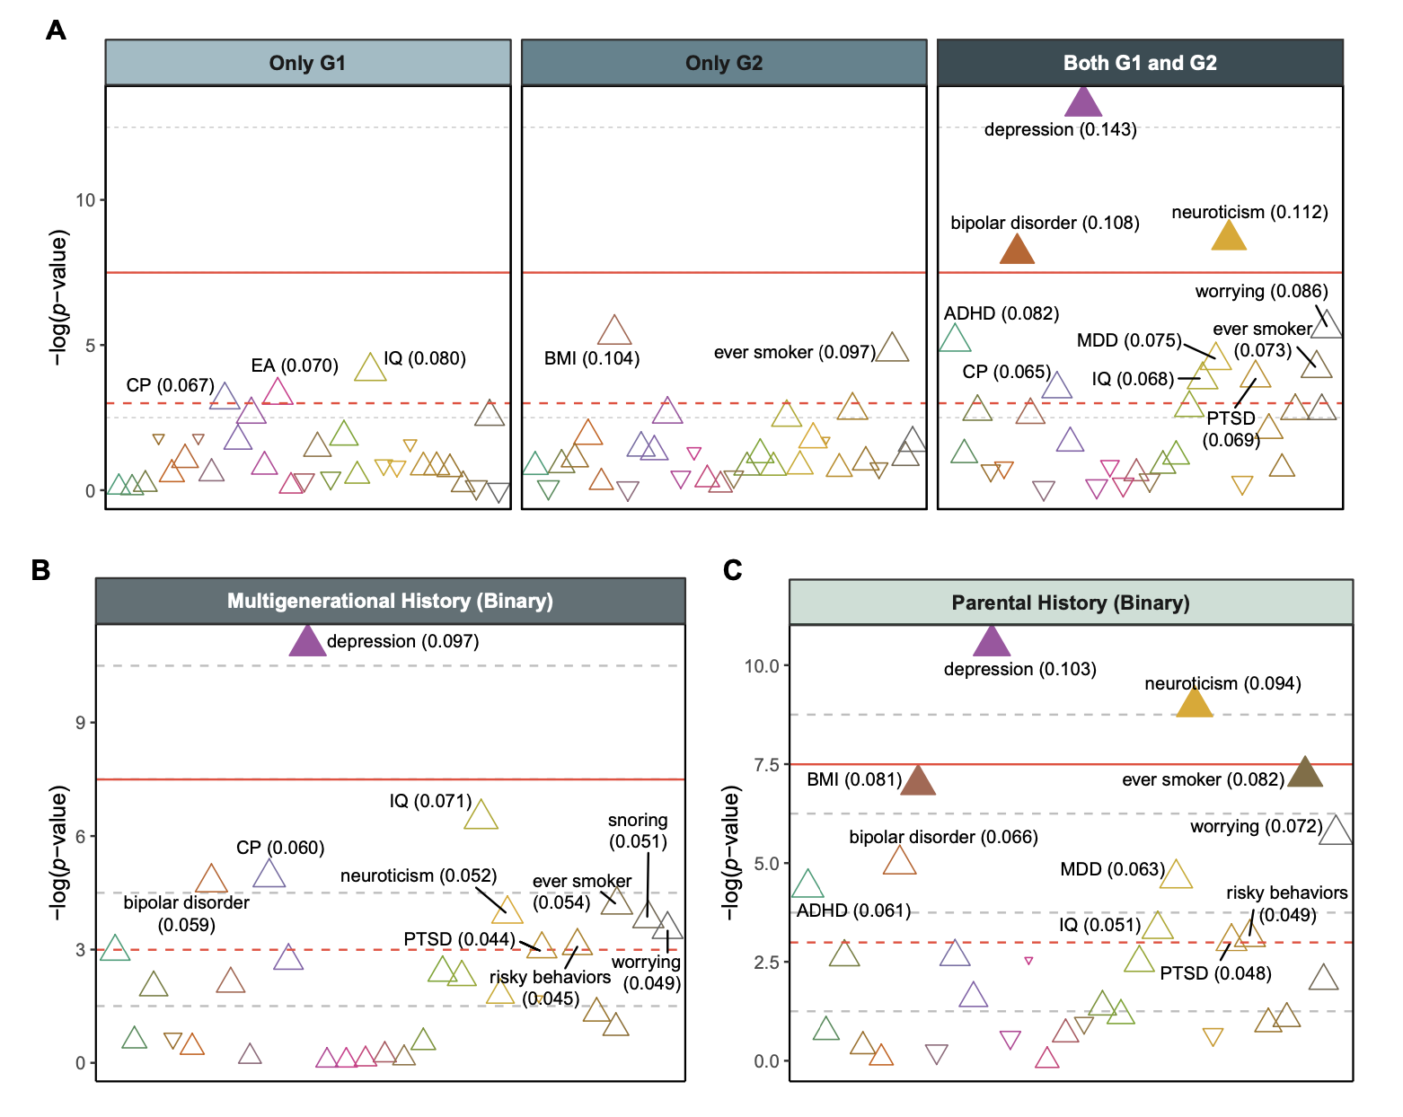
Dashed red line indicates 0.05 of unadjusted P. Solid red line indicates 0.05 of Bonferroni-corrected P. Each triangle represents a PGS with the odds ratio (OR) of family risk. Triangles filled with color denote PGSs with FDR-corrected P<.05. P values were adjusted for 30 tests. (A) Regression of four risk levels of family history from the two generations: no depression history (G1−/G2–; reference level), only grandparent (G1+/G2−), only parent (G1−/G2+), and both generations (G1+/G2+). (B) Regression of two-level familial risk: no depression history (G1−/G2–; reference level) and the rest of the groups (FamHist+). (C) Regression of parental depression history: no history in the parent (G2–; reference level) and depression in the parent (G2+). ADHD, attention-deficit/hyperactivity disorder; MDD, major depressive disorder; BMI, body mass index; EA, educational attainment; CP, cognitive performance; IQ, intelligence quotient; PTSD, post-traumatic stress disorder.

Supplementary Figure 2. Effects of family history of depression on residualized PGSs in European-ancestry children
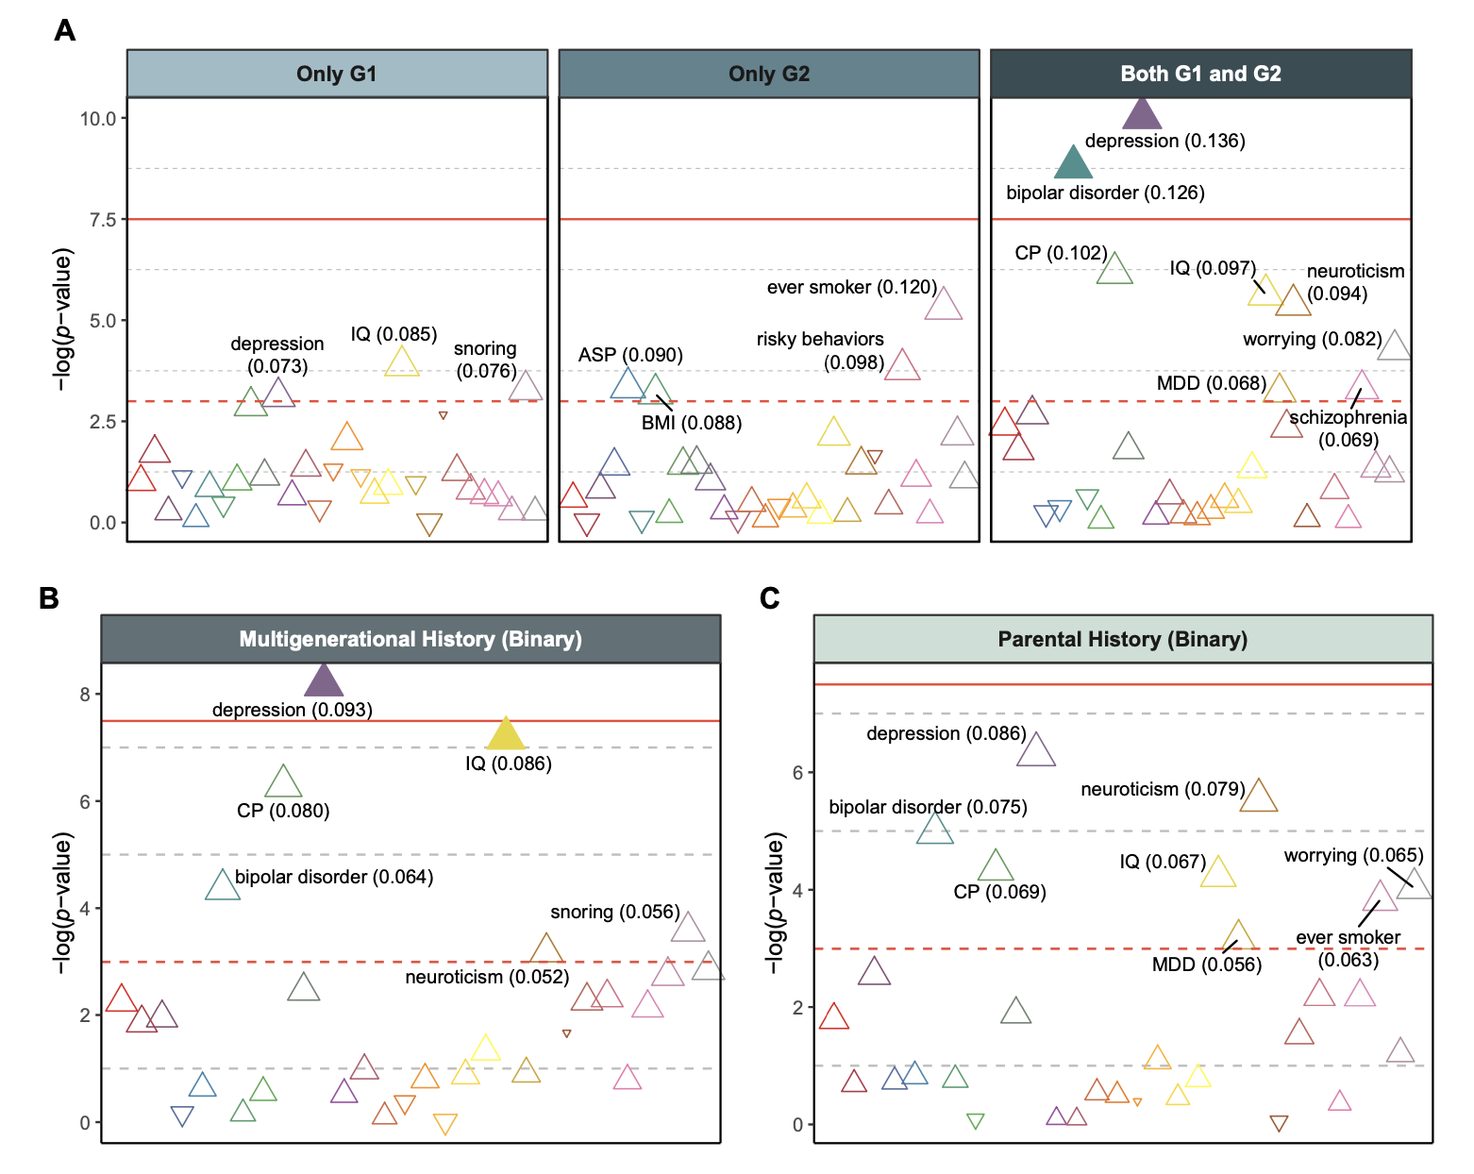
Dashed red line indicates 0.05 of unadjusted P. Solid red line indicates 0.05 of Bonferroni-corrected P. Each triangle represents a PGS with the odds ratio (OR) of family risk. Triangles filled with color denote PGSs with FDR-corrected P<.05. P values were adjusted for 30 tests. (A) Regression of four risk levels of family history from the two generations: no depression history (G1−/G2–; reference level), only grandparent (G1+/G2−), only parent (G1−/G2+), and both generations (G1+/G2+). (B) Regression of two-level familial risk: no depression history (G1−/G2–; reference level) and the rest of the groups (FamHist+). (C) Regression of parental depression history: no history in the parent (G2–; reference level) and depression in the parent (G2+). MDD, major depressive disorder; BMI, body mass index; ASP, automobile speed propensity; CP, cognitive performance; IQ, intelligence quotient.

Supplementary Figure 3. Effects of family history of depression on original PGSs in European-ancestry children
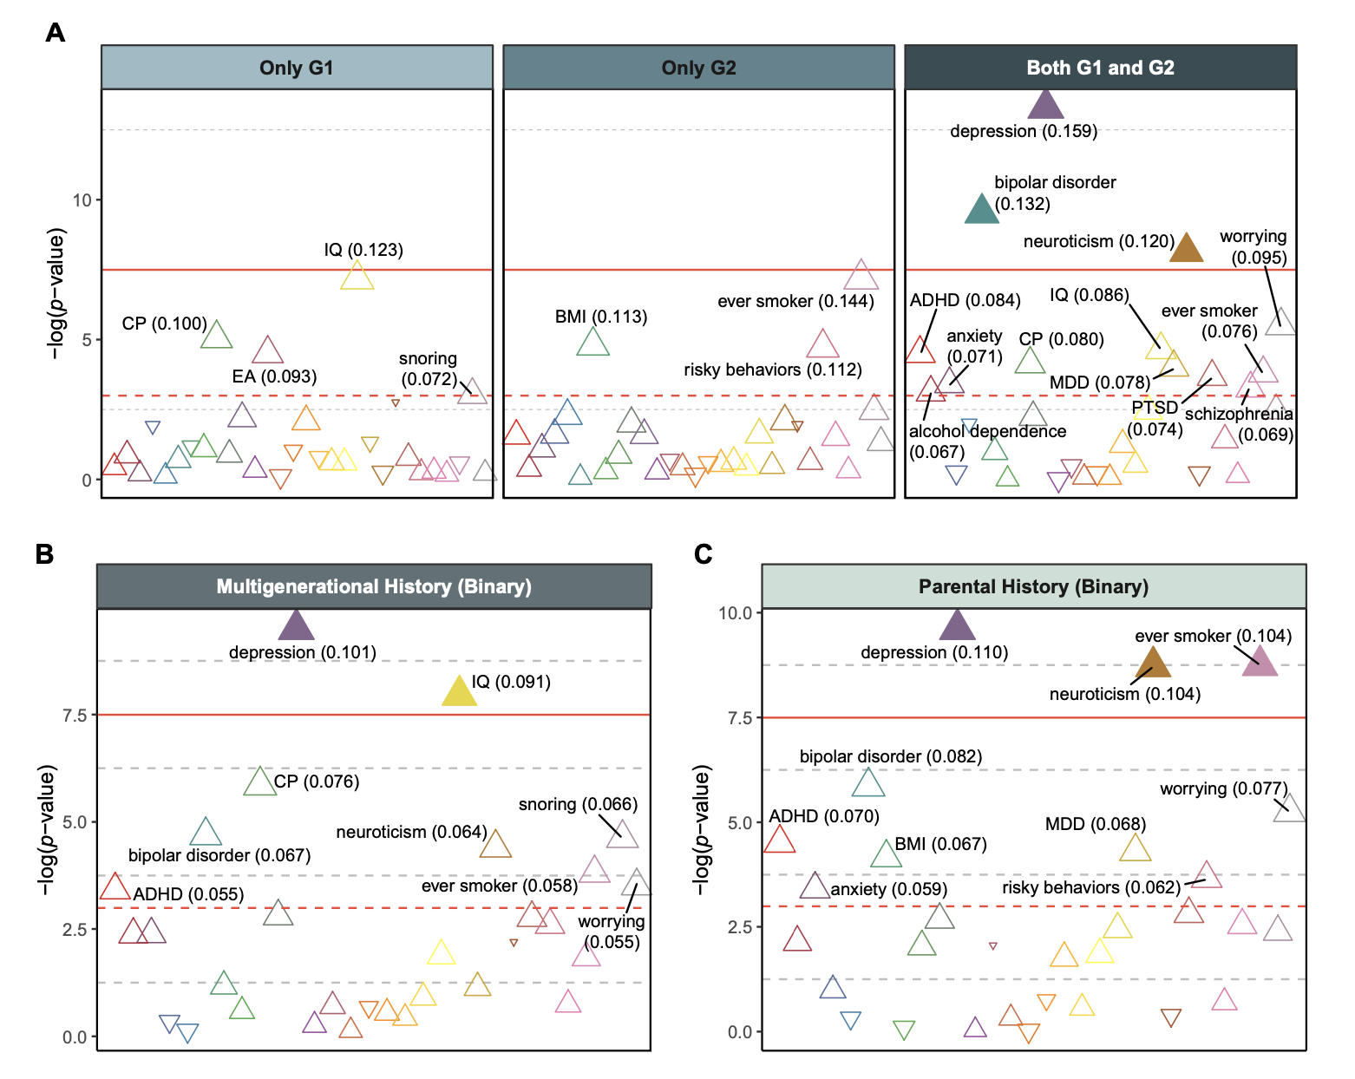
Dashed red line indicates 0.05 of unadjusted P. Solid red line indicates 0.05 of Bonferroni-corrected P. Each triangle represents a PGS with the odds ratio (OR) of family risk. Triangles filled with color denote PGSs with FDR-corrected P<.05. P values were adjusted for 30 tests. (A) Regression of four risk levels of family history from the two generations: no depression history (G1−/G2–; reference level), only grandparent (G1+/G2−), only parent (G1−/G2+), and both generations (G1+/G2+). (B) Regression of two-level familial risk: no depression history (G1−/G2–; reference level) and the rest of the groups (FamHist+). (C) Regression of parental depression history: no history in the parent (G2–; reference level) and depression in the parent (G2+). ADHD, attention-deficit/hyperactivity disorder; MDD, major depressive disorder; BMI, body mass index; EA, educational attainment; CP, cognitive performance; IQ, intelligence quotient; PTSD, post-traumatic stress disorder.

Supplementary Figure 4. Effects of family history of depression on residualized PGSs in multi-ancestry children (without family history of mania)
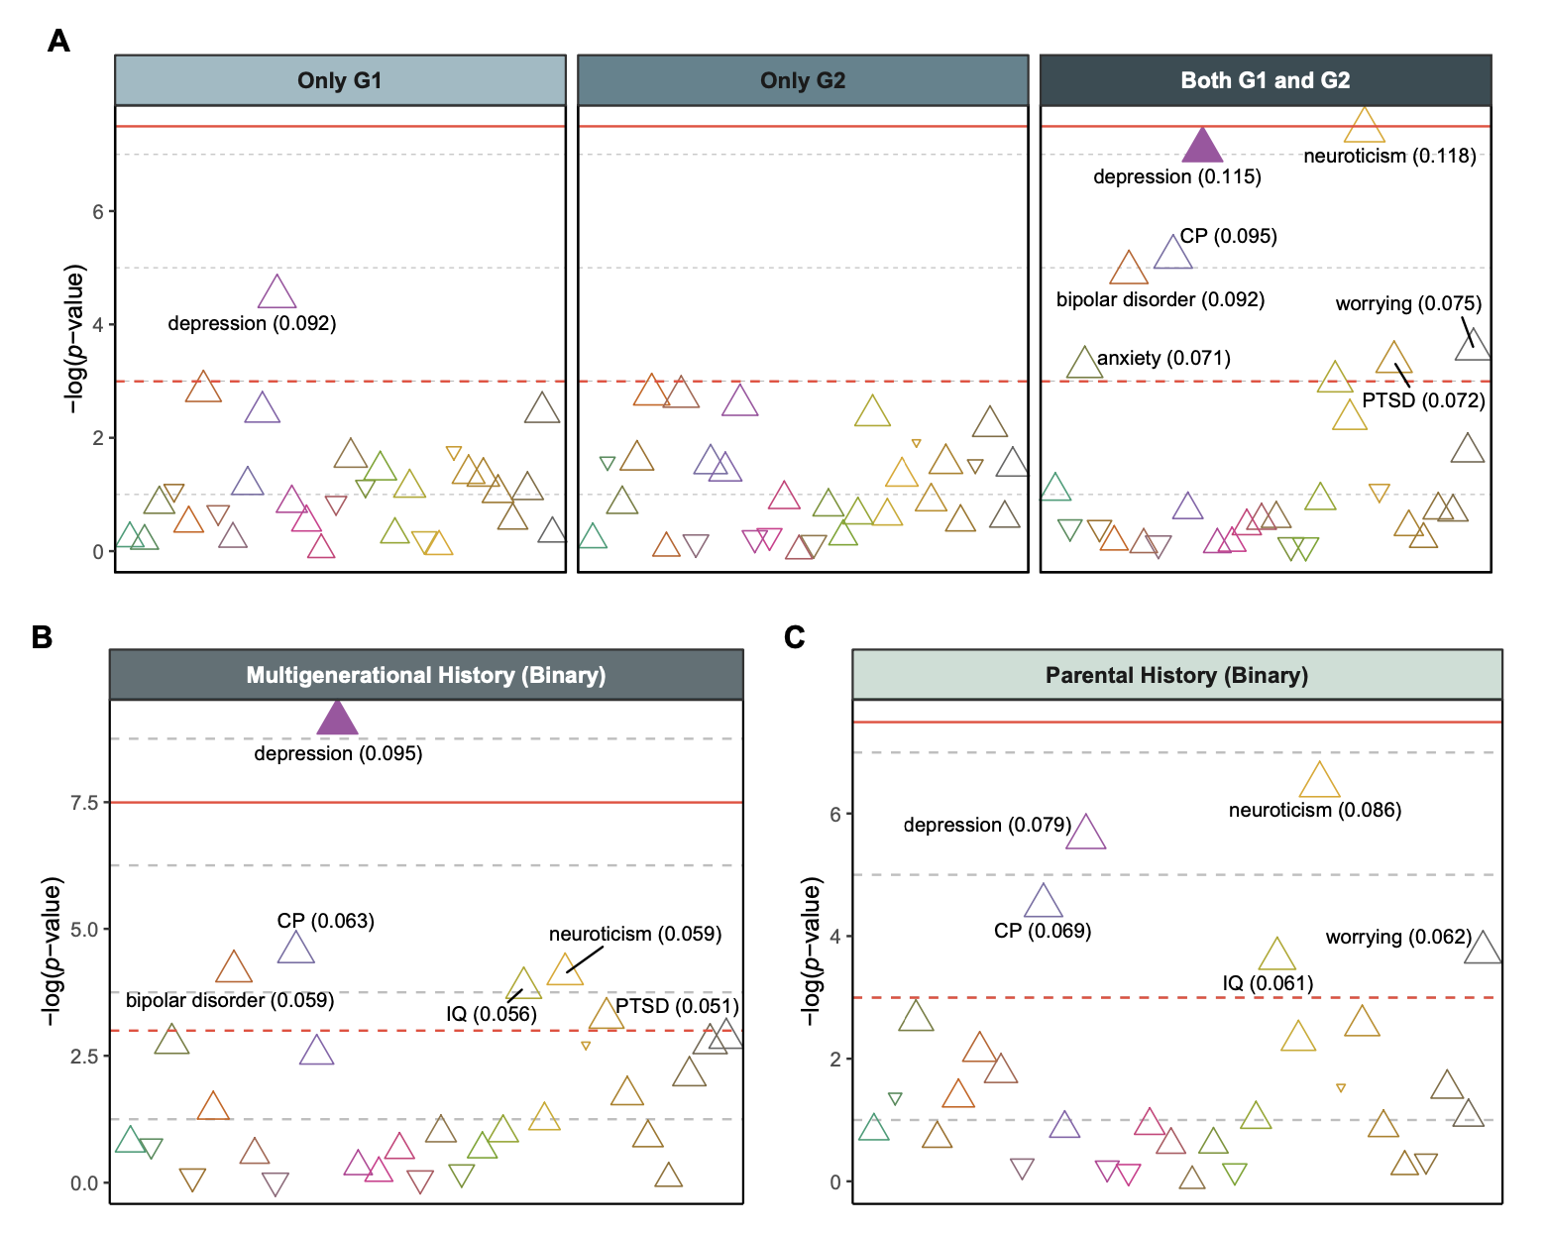
Dashed red line indicates 0.05 of unadjusted P. Solid red line indicates 0.05 of Bonferroni-corrected P. Each triangle represents a PGS with the odds ratio (OR) of family risk. Triangles filled with color denote PGSs with FDR-corrected P<.05. P values were adjusted for 30 tests. (A) Regression of four risk levels of family history from the two generations: no depression history (G1−/G2–; reference level), only grandparent (G1+/G2−), only parent (G1−/G2+), and both generations (G1+/G2+). (B) Regression of two-level familial risk: no depression history (G1−/G2–; reference level) and the rest of the groups (FamHist+). (C) Regression of parental depression history: no history in the parent (G2–; reference level) and depression in the parent (G2+). ADHD, attention-deficit/hyperactivity disorder; MDD, major depressive disorder; BMI, body mass index; EA, educational attainment; CP, cognitive performance; IQ, intelligence quotient; PTSD, post-traumatic stress disorder. CP, cognitive performance; IQ, intelligence quotient; PTSD, post-traumatic stress disorder.

Supplementary Figure 5. Effects of family history of depression on residualized PGSs in European-ancestry children (without family history of mania)
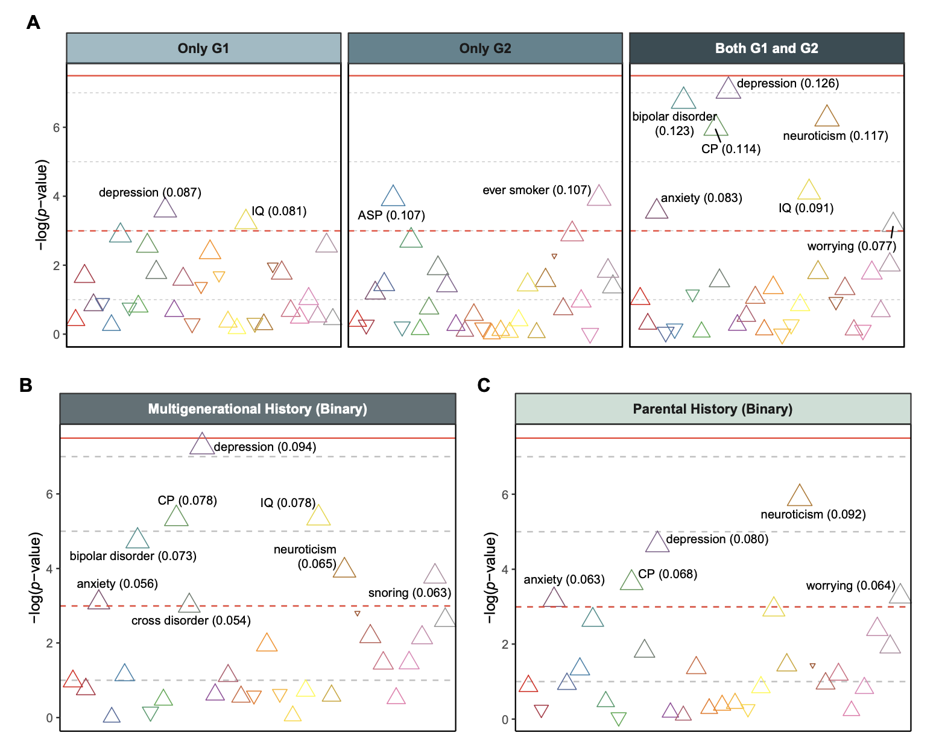
Dashed red line indicates 0.05 of unadjusted P. Solid red line indicates 0.05 of Bonferroni-corrected P. Each triangle represents a PGS with the odds ratio (OR) of family risk. Triangles filled with color denote PGSs with FDR-corrected P<.05. P values were adjusted for 30 tests. (A) Regression of four risk levels of family history from the two generations: no depression history (G1−/G2–; reference level), only grandparent (G1+/G2−), only parent (G1−/G2+), and both generations (G1+/G2+). (B) Regression of two-level familial risk: no depression history (G1−/G2–; reference level) and the rest of the groups (FamHist+). (C) Regression of parental depression history: no history in the parent (G2–; reference level) and depression in the parent (G2+). CP, cognitive performance; IQ, intelligence quotient; ASP, automobile speed propensity.

Supplementary Figure 6. Effects of depression PGS on clinical outcomes in European-ancestry children

ªreported by child; otherwise reported by parent

Presented results in the figure were from the models with significant effects of depression PGS after the FDR correction. No significant result was found with bipolar disorder PGS. Error bar indicates 95% confidence interval. P values were adjusted for 72 tests (36 outcomes and 2 PGSs of depression and bipolar disorder). Detailed information underlying this figure are available in Supplementary Table 6. ΔMcFadden’s R², the proportion of variance explained by polygenic score; ADHD, attention-deficit/hyperactivity disorder; MDD, major depressive disorder.

Supplementary Figure 7. Mediation analysis with depression PGS in European-ancestry children

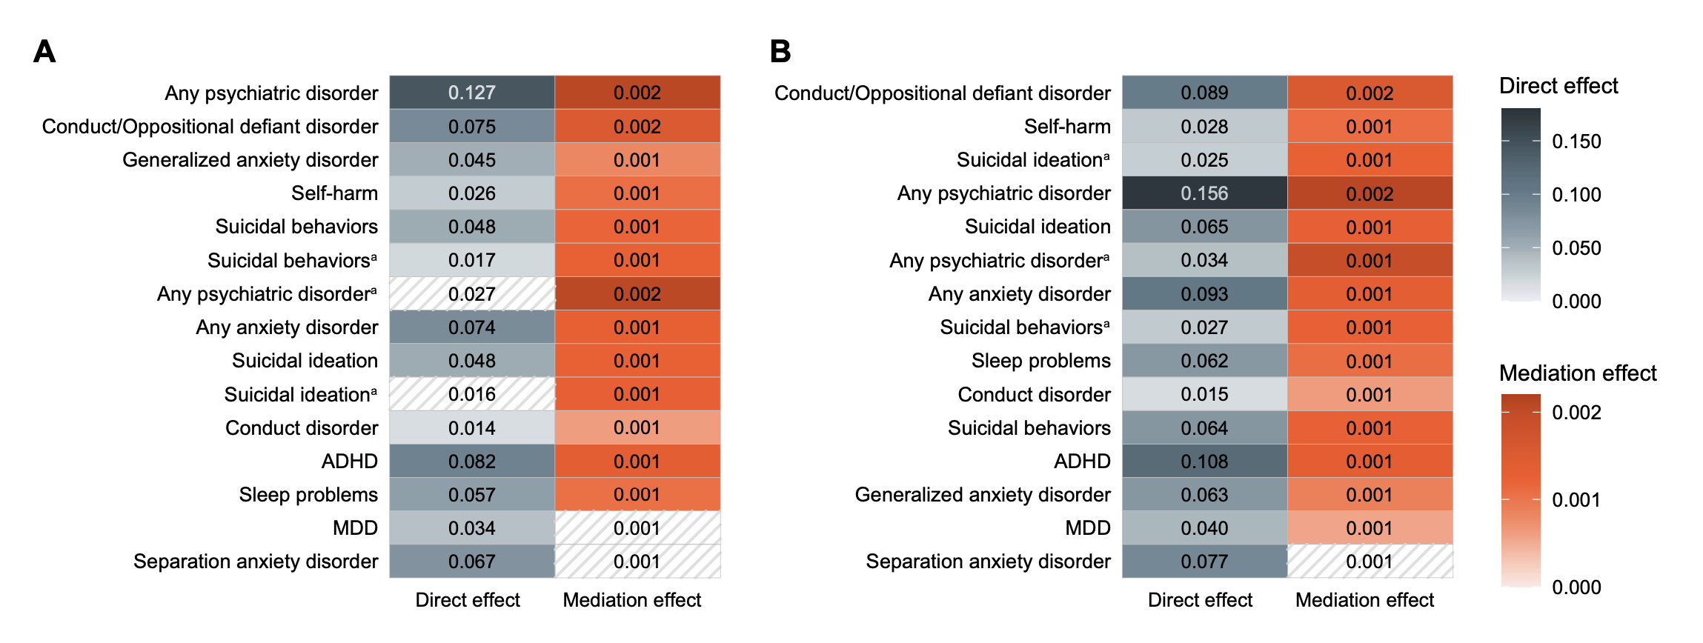
ªreported by child; otherwise reported by parent

(A) Multigenerational family history of depression as treatment variable. (B) Parental history of depression as treatment variable. Boxes filled with color are the effects with FDR-corrected P<.05. P values were adjusted for 30 tests (2 versions of family history and 15 clinical outcomes). ADHD, attention-deficit/hyperactivity disorder; MDD, major depressive disorder.

Supplementary References

Auton, A., Abecasis, G. R., Altshuler, D. M., Durbin, R. M., Abecasis, G. R., Bentley, D. R., Chakravarti, A., Clark, A. G., Donnelly, P., Eichler, E. E., Flicek, P., Gabriel, S. B., Gibbs, R. A., Green, E. D., Hurles, M. E., Knoppers, B. M., Korbel, J. O., Lander, E. S., Lee, C., . . . Abecasis, G. R. (2015). A global reference for human genetic variation. Nature, 526(7571), 68-74. https://doi.org/10.1038/nature15393
Conomos, M. P., Miller, M. B., & Thornton, T. A. (2015). Robust inference of population structure for ancestry prediction and correction of stratification in the presence of relatedness. Genet Epidemiol, 39(4), 276-293. https://doi.org/10.1002/gepi.21896
Conomos, M. P., Reiner, A. P., Weir, B. S., & Thornton, T. A. (2016). Model-free Estimation of Recent Genetic Relatedness. Am J Hum Genet, 98(1), 127-148. https://doi.org/10.1016/j.ajhg.2015.11.022
Das, S., Forer, L., Schönherr, S., Sidore, C., Locke, A. E., Kwong, A., Vrieze, S. I., Chew, E. Y., Levy, S., Mcgue, M., Schlessinger, D., Stambolian, D., Loh, P.-R., Iacono, W. G., Swaroop, A., Scott, L. J., Cucca, F., Kronenberg, F., Boehnke, M., . . . Fuchsberger, C. (2016). Next-generation genotype imputation service and methods. Nature Genetics, 48(10), 1284-1287. https://doi.org/10.1038/ng.3656
Ge, T., Chen, C.-Y., Ni, Y., Feng, Y.-C. A., & Smoller, J. W. (2019). Polygenic prediction via Bayesian regression and continuous shrinkage priors. Nature Communications, 10(1). https://doi.org/10.1038/s41467-019-09718-5
Loh, P.-R., Danecek, P., Palamara, P. F., Fuchsberger, C., A Reshef, Y., K Finucane, H., Schoenherr, S., Forer, L., Mccarthy, S., Abecasis, G. R., Durbin, R., & L Price, A. (2016). Reference-based phasing using the Haplotype Reference Consortium panel. Nature Genetics, 48(11), 1443-1448. https://doi.org/10.1038/ng.3679
Raj, A., Stephens, M., & Pritchard, J. K. (2014). fastSTRUCTURE: variational inference of population structure in large SNP data sets. Genetics, 197(2), 573-589. https://doi.org/10.1534/genetics.114.164350
Van Dijk, M. T., Murphy, E., Posner, J. E., Talati, A., & Weissman, M. M. (2021). Association of Multigenerational Family History of Depression With Lifetime Depressive and Other Psychiatric Disorders in Children. JAMA Psychiatry, 78(7), 778. https://doi.org/10.1001/jamapsychiatry.2021.0350

