Supplement
Triple oxygen isotope evidence for the pathway of nitrous oxide production in a forested soil with increased emission on rainy days

Weitian Ding¹, Urumu Tsunogai¹, Tianzheng Huang¹, Takashi Sambuichi¹, Wenhua Ruan^{1*}, Masanori Ito ¹, Hao Xu¹, Yongwon Kim ², Fumiko Nakagawa¹

¹Graduate School of Environmental Studies, Nagoya University, Furo-cho, Chikusa-ku, Nagoya 464-8601, Japan
²International Arctic Research Center, University of Alaska Fairbanks, Fairbanks, Alaska 99775-7320, USA

Corresponding author: Weitian Ding
Email: dwt530754556@gmail.com

Text S1. Calculation of WFPS
WFPS was calculated using Eq. S1 (Liu et al., 2007):
WFPS (%) = (Ɵ_{v}/P)*100 (S1)
where Ɵ_{v} denotes the volumetric water content (%) and P represents the total soil porosity.
The volumetric water content (Ɵ_{v}) was calculated using Eq. S2:
Ɵ_{v} (%) = Ɵ_{g}*B_{d} (S2)
where Ɵ_{g} denotes the gravimetric water content (%) and B_{d} denotes the bulk density (g/cm³). B_{d} (1.12±0.1 g/cm³ on average; n = 3) was estimated by dividing the dry weight of each soil sample by the volume of the forested soil. The average value of B_{d} estimated in this study corresponds well with those determined in forested soils (Han et al., 2016; Jalabert et al., 2010; Teepe et al., 2003).
The gravimetric soil water content (Ɵ_{g}) was calculated using Eq. S3:
Ɵ_{g} (%) = (M_{soil} − M_{dry}) / M_{dry,} (S3)
where M_{soil} denotes the initial weight of the sampled soil and M_{dry} denotes the final weight of the soil that had been dried for 48 h in an oven at 80 °C.
Total soil porosity (P) was calculated using Eq. S4:
P (%) = (1 − (B_{d}/P_{d}))*100 (S4)
where P_{d} denotes the soil density. In this study, we used a regular soil density of 2.65 g/cm³ for P_{d} (Blake, 2008).

Text S2. Approximating 1/[N₂O] as 0
During the nitrification reaction, only N₂O is the gaseous component. However, because of the further reduction of N₂O to N₂ during denitrification in soils, the emission of N₂O from soil was typically accompanied by N₂ emission (Figure 1). Consequently, the concentration of N₂O ([N₂O]) in the gas emitted from the soil could be diluted by N₂ to some extent; thus, [N₂O] emitted from the soil could be less than 100 %. If [N₂O] emitted from the soil was smaller than 100 %, the Δ¹⁷O value of N₂O emitted from the soil (“true” Δ¹⁷O value) should deviate from that determined using the linear correlation between 1/[N₂O] and the Δ¹⁷O, assuming that the 1/[N₂O] was 0 in the gas emitted from the soil (Figures 3, 5, and S5). However, the N₂O/(N₂O + N₂) ratios of soil gas were always higher than 3% (Domeignoz-Horta et al., 2015; Scheer et al., 2020; Wang et al., 2020), which corresponds to 1/[N₂O] being less than 3.3 *10⁻⁸ ppb⁻¹ for N₂O emitted from the soil. Because almost all slopes found in the linear correlation between 1/[N₂O] and Δ¹⁷O showed were less than 2600 ‰ per ppb⁻¹ (Figures 3, 5, and S5), the deviations in the Δ¹⁷O values from the “true” value of each were always less than 0.0001 ‰. Consequently, we ignored the deviation and used a 1/[N₂O] value of 0 for N₂O emitted from the soil.

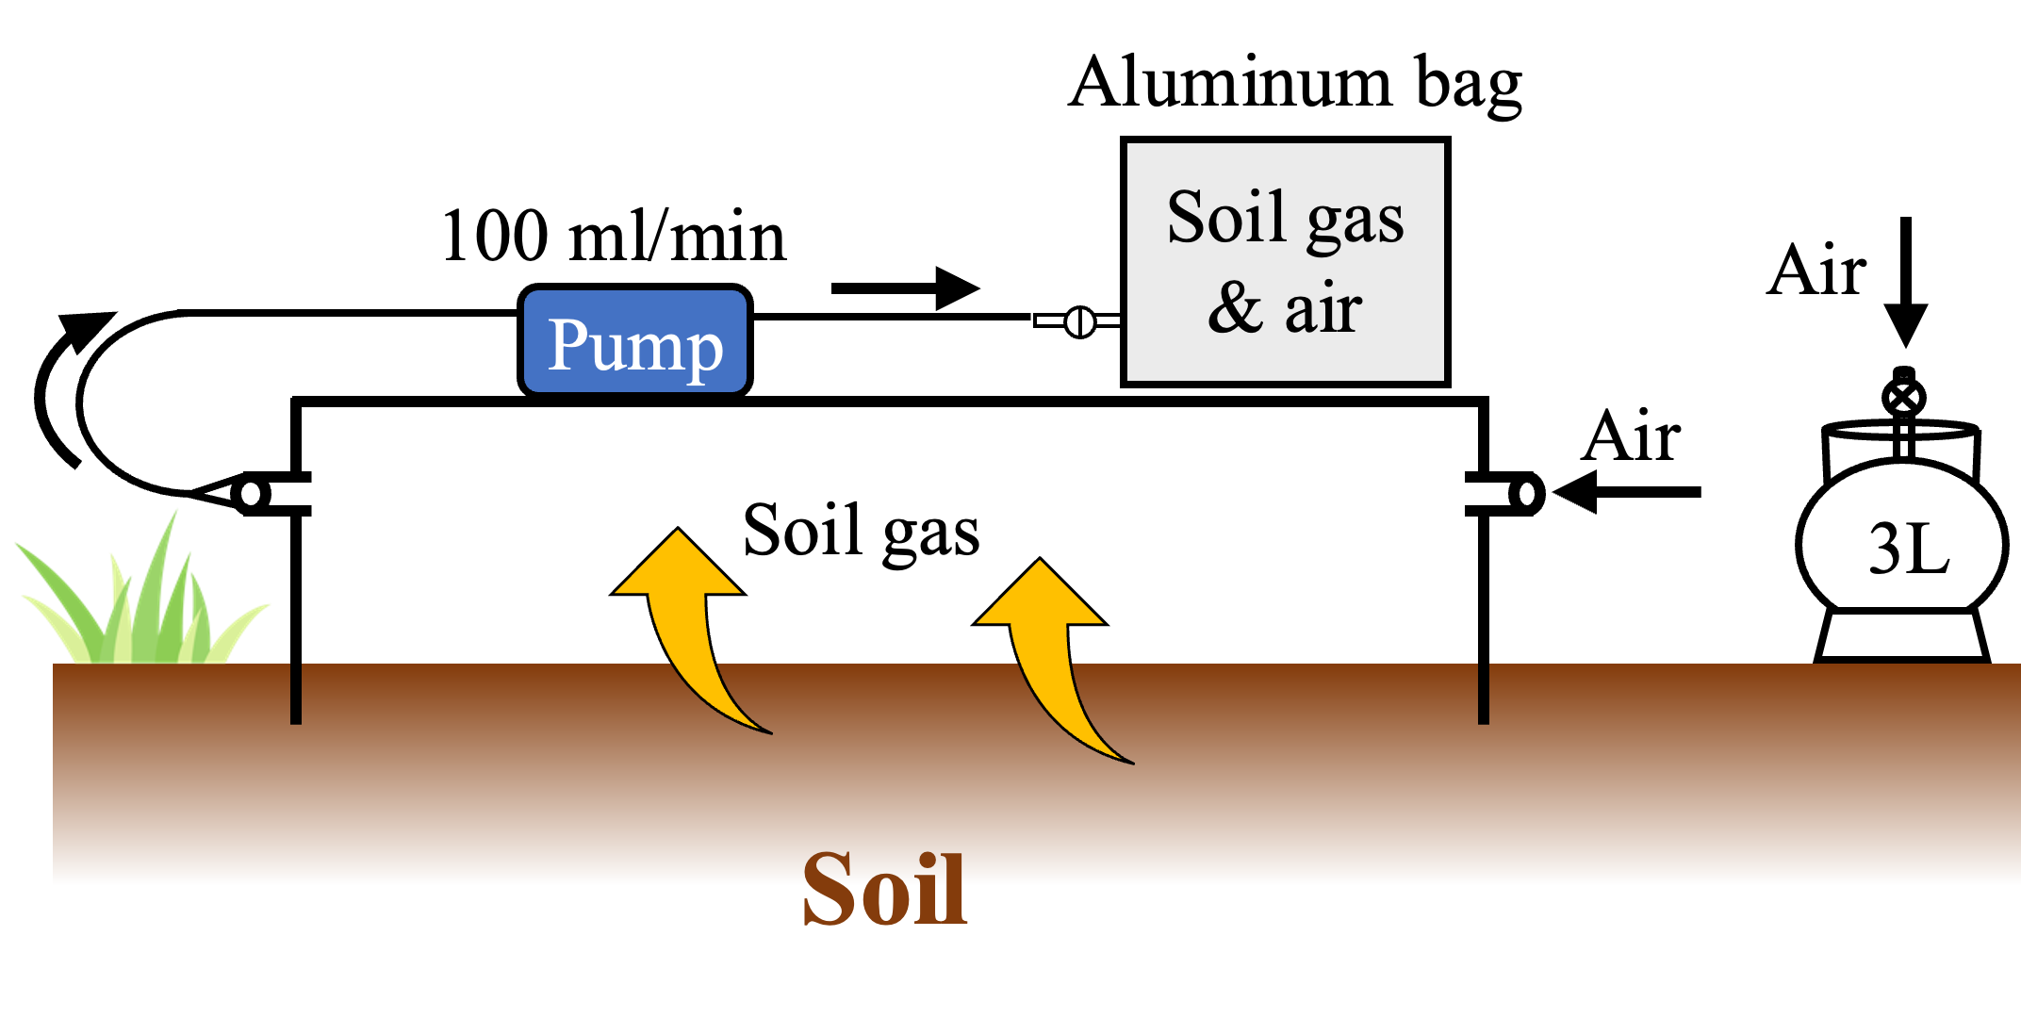
Figure S1. Schematic showing the flow chamber system used for sampling gases emitted from soil.
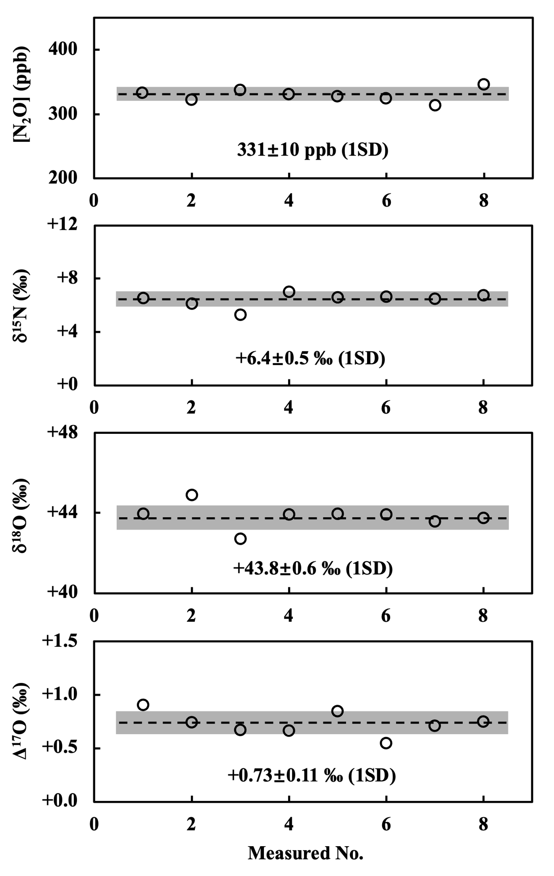
Figure S2. Results of repeated measurements of N₂O in an atmospheric sample collected at Nagoya University.

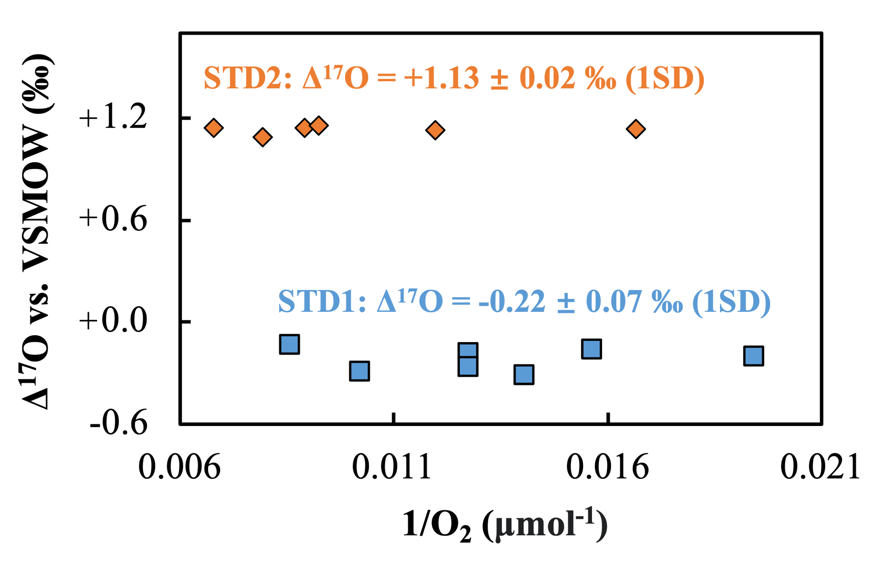
Figure S3. Δ¹⁷O values of N₂O in the standards (STD1 and STD2) determined on the VSMOW scale plotted as a function of the reciprocal of the O₂ quantities evolved through offline reactions with NiO and BrF₅.
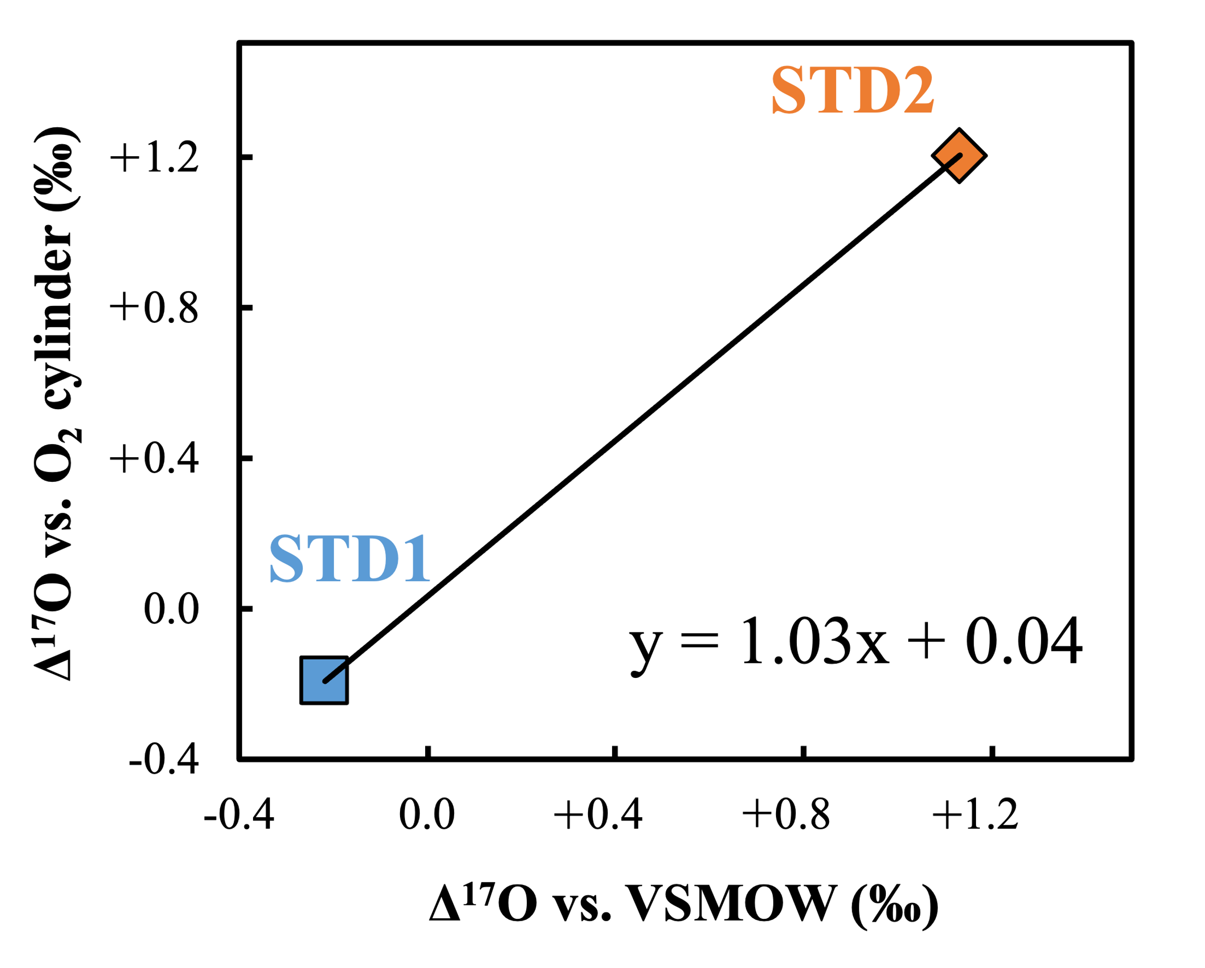
Figure S4. Relationship between the Δ¹⁷O values of the N₂O standards determined using the CF-IRMS system and those of the same N₂O standards determined using the offline method. During the measurements using the CF-IRMS system, pure O₂ in a cylinder with Δ¹⁷O values calibrated to the VSMOW scale was used as the reference gas.
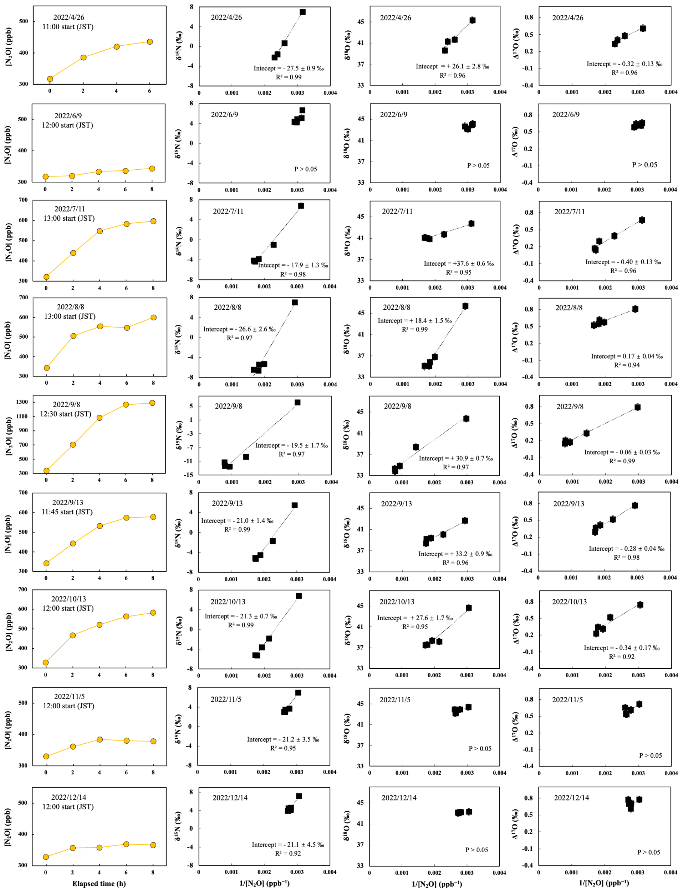
Figure S5. Changes in [N₂O] of the gas samples collected from the forested soil plotted as a function of the elapsed time since the deployment of the flow chamber, and the δ¹⁵N, δ¹⁸O, and Δ¹⁷O values of N₂O plotted as a function of the reciprocal of [N₂O] (1/[N₂O]).
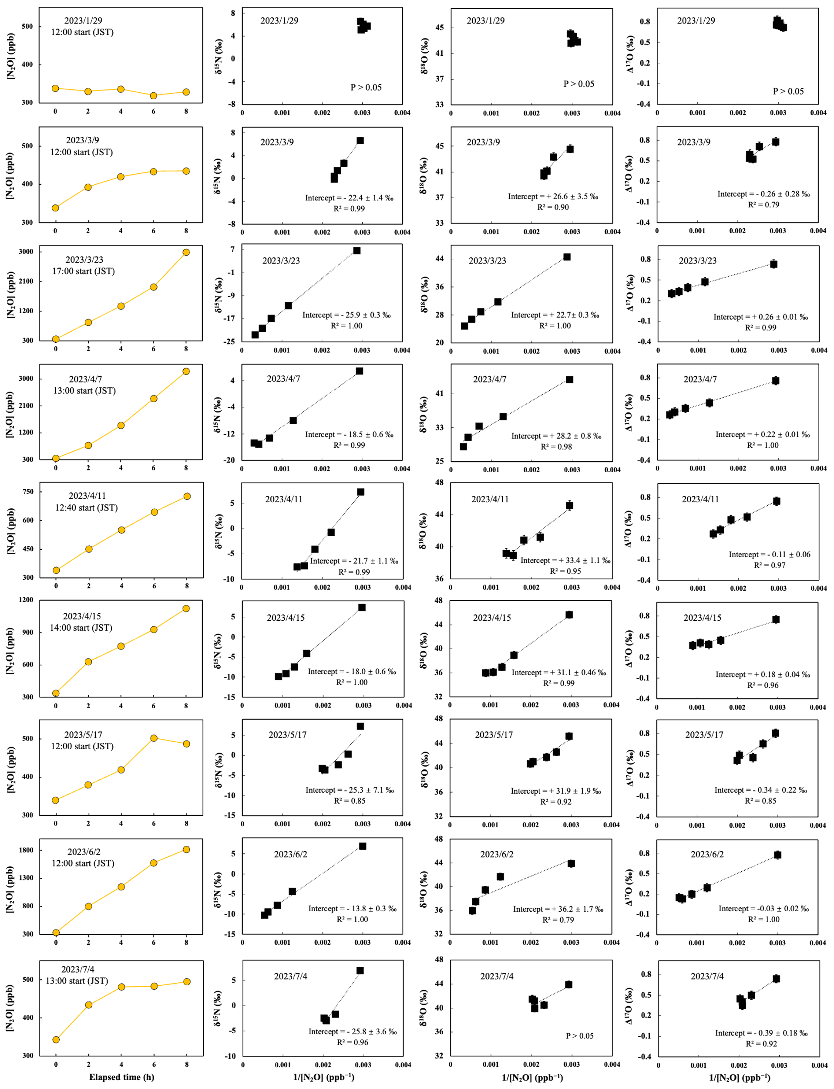
Figure S5. (continued). Changes in [N₂O] of the gas samples collected from the forested soil plotted as a function of the elapsed time since the deployment of the flow chamber, and the δ¹⁵N, δ¹⁸O, and Δ¹⁷O values of N₂O plotted as a function of the reciprocal of [N₂O] (1/[N₂O]).
Table S1. Data obtained in this study.
Soil type | Time | P# | WFPS# | [NH₄⁺] | [NO₃⁻] | [NO₂⁻] | Flux-N₂O | δ¹⁸O  (NO₂⁻) | Δ¹⁷O (NO₂⁻) | δ¹⁵N  (N₂O) | δ¹⁸O (N₂O) | Δ¹⁷O (N₂O)
 |  | mm | % | mg N kg⁻¹ |  |  | μg N m⁻² h⁻¹ | ‰
Natural soil | 2022/4/26 | 0 | 71.6 | 11.5 | 1.2 | 0.03 | 3.6 | +12.03 | +0.50 | -27.5 | +26.1 | -0.32
 | 2022/6/9 | 0 | 60.5 | 7.6 | 0.9 | 0.01 | 0.6 | +6.72 | +0.04 | - | - | -
 | 2022/7/11 | 0 | 77.4 | 10.1 | 0.4 | 0.16 | 6.9 | +5.19 | +0.25 | -17.9 | +37.6 | -0.40
 | 2022/8/8 | 17.5 | 61.1 | 8.9 | 0.4 | 0.17 | 6.9 | +6.98 | +0.29 | -26.6 | +18.4 | +0.17
 | 2022/9/8 | 11.5 | 92.3 | 9.5 | 0.5 | 0.09 | 23.7 | +7.37 | +0.06 | -19.5 | +30.9 | -0.06
 | 2022/9/13 | 0 | 69.7 | 12.5 | 1.6 | 0.12 | 6.0 | +2.42 | +0.13 | -21 | +33.2 | -0.28
 | 2022/10/13 | 0 | 60.9 | 16.9 | 1.6 | 0.21 | 6.5 | +3.10 | +0.09 | -21.3 | +27.6 | -0.34
 | 2022/11/5 | 0 | 59.6 | 0.7 | 5.9 | 0.03 | 1.1 | +4.51 | +0.21 | -21.2 | - | -
 | 2022/12/14 | 0 | 63.7 | 9.7 | 2.2 | 0.15 | 0.8 | +5.84 | +0.11 | -21.1 | - | -0.31
 | 2023/1/29 | 0 | 74.3 | 8.5 | 2.5 | 0.16 | -0.2 | +6.22 | +0.24 | - | - | -
 | 2023/3/9 | 0 | 68.7 | 8.6 | 6.0 | 0.12 | 2.4 | +5.55 | +0.25 | -22.4 | +26.6 | -0.26
 | 2023/3/23 | 16.5 | 91.5 | 13.0 | 3.2 | 0.45 | 67.3 | +5.93 | +0.29 | -25.9 | +22.7 | +0.26
 | 2023/4/7 | 32.5 | 113.7 | 11.7 | 1.2 | 0.16 | 77.4 | +6.91 | +0.23 | -18.5 | +28.2 | +0.22
 | 2023/4/11 | 0 | 66.2 | 11.6 | 1.1 | 0.23 | 9.8 | +6.85 | +0.20 | -21.7 | +33.4 | -0.11
 | 2023/4/15 | 33.5 | 108.4 | 11.7 | 0.9 | 0.19 | 20.0 | +4.24 | +0.25 | -18.0 | +31.1 | +0.18
 | 2023/5/17 | 0 | 61.7 | 10.1 | 0.7 | 0.13 | 3.7 | +5.75 | +0.40 | -25.3 | +31.9 | -0.34
 | 2023/6/2 | 137 | 106.7 | 6.2 | 0.03 | 0.04 | 37.4 | +5.79 | +0.19 | -13.8 | +36.2 | -0.03
 | 2023/7/4 | 0 | 58.7 | 7.6 | 0.1 | 0.15 | 3.8 | +6.25 | +0.40 | -25.8 | - | -0.39
Fertilized soil | 2023/7/18NF | 0 | 71.9 | 12.4 | 2.0 | 0.20 | 5.2 | +2.69 | +0.42 | -17.1 | +36.1 | -0.37
Fertilized soil | 2023/7/22NF | 0 | 59.4 | 12.0 | 2.6 | 0.26 | 4.2 | +1.33 | +0.35 | -12.2 | +40 | -0.32
 | 2023/7/18U | 0 | 80.3 | 410.2 | 5.4 | 0.10 | 70.6 | +7.64 | +0.31 | -39.3 | +34.4 | -0.14
 | 2023/7/22U | 0 | 62.9 | 435.9 | 20.5 | 0.07 | 56.7 | +5.40 | +0.17 | -33.3 | +25.7 | -0.16
 | 2023/7/18CS | 0 | 47.6 | 12.9 | 247.8 | 0.09 | 112.3 | +28.98 | +8.26 | -19.3 | +54.1 | +8.22
 | 2023/7/22CS | 0 | 37.9 | 18.7 | 309.0 | 0.07 | 39.4 | +45.24 | +12.32 | -11.3 | +58.7 | +7.36
P#: Precipitation
WFPS#: water-filled pore space

References
Blake, G. R.: Particle density, in: Encyclopedia of Soil Science, edited by: Chesworth, W., Springer Netherlands, Dordrecht, 504–505, https://doi.org/10.1007/978-1-4020-3995-9_406, 2008.
Domeignoz-Horta, L., Spor, A., Bru, D., Breuil, marie-christine, Bizouard, F., Leonard, J., and PHILIPPOT, L.: The diversity of the N₂O reducers matters for the N₂O:N₂ denitrification end-product ratio across an annual and a perennial cropping system, Frontiers in Microbiology, 6, 2015.
Han, Y., Zhang, J., Mattson, K. G., Zhang, W., and Weber, T. A.: Sample Sizes to Control Error Estimates in Determining Soil Bulk Density in California Forest Soils, Soil Science Society of America Journal, 80, 756–764, https://doi.org/10.2136/sssaj2015.12.0422, 2016.
Jalabert, S. S. M., Martin, M. P., Renaud, J.-P., Boulonne, L., Jolivet, C., Montanarella, L., and Arrouays, D.: Estimating forest soil bulk density using boosted regression modelling, Soil Use and Management, 26, 516–528, https://doi.org/10.1111/j.1475-2743.2010.00305.x, 2010.
Liu, X. J., Mosier, A. R., Halvorson, A. D., Reule, C. A., and Zhang, F. S.: Dinitrogen and N₂O emissions in arable soils: Effect of tillage, N source and soil moisture, Soil Biology and Biochemistry, 39, 2362–2370, https://doi.org/10.1016/j.soilbio.2007.04.008, 2007.
Scheer, C., Fuchs, K., Pelster, D. E., and Butterbach-Bahl, K.: Estimating global terrestrial denitrification from measured N₂O:(N₂O + N₂) product ratios, Current Opinion in Environmental Sustainability, 47, 72–80, https://doi.org/10.1016/j.cosust.2020.07.005, 2020.
Teepe, R., Dilling, H., and Beese, F.: Estimating water retention curves of forest soils from soil texture and bulk density, Journal of Plant Nutrition and Soil Science, 166, 111–119, https://doi.org/10.1002/jpln.200390001, 2003.
Wang, R., Pan, Z., Zheng, X., Ju, X., Yao, Z., Butterbach-Bahl, K., Zhang, C., Wei, H., and Huang, B.: Using field-measured soil N₂O fluxes and laboratory scale parameterization of N₂O/(N₂O+N₂) ratios to quantify field-scale soil N₂ emissions, Soil Biology and Biochemistry, 148, 107904, https://doi.org/10.1016/j.soilbio.2020.107904, 2020.

